HR Analytics Executive Report

1.0 Introduction
This report analyses the factors influencing employee attrition and evaluates the effectiveness of predictive modelling used to identify employees at risk of leaving. The objective is twofold: first, to generate data-driven insights into why employees leave (explanation), and second, to assess how well predictive models identify employees likely to leave (prediction).
While the original analysis by Ghouzam provides a comprehensive exploratory and modelling approach, it remains largely descriptive and does not fully translate findings into actionable business insights. This report therefore critically evaluates the original work, reproduces key models, and introduces improved analytical approaches to better align results with decision-making.
In particular, the analysis focuses on identifying actionable drivers of attrition rather than relying on surface-level correlations. By combining statistical exploration with machine learning models, the report aims to provide a clearer understanding of employee behaviour and deliver practical recommendations for retention strategies. The analysis follows the CRISP-DM framework, progressing through business understanding, data understanding, data preparation, modelling, evaluation, and deployment to ensure a structured and decision-oriented approach.

2.0 Overview of Ghouzam’s Analysis
The dataset consists of employee-level information capturing ten variables related to performance, workload, and organisational context. These include numerical features such as satisfaction level, last evaluation score, number of projects, average monthly hours, tenure, work accidents, promotions in the last five years, and a binary target variable indicating whether an employee has left. Salary and department are included as categorical variables.
Initial preprocessing includes encoding categorical variables, removing duplicates, and creating training and testing datasets. The analysis then proceeds with exploratory data analysis (EDA), including distributions and a correlation heatmap. A moderate negative correlation (approximately −0.39) is observed between satisfaction and attrition, leading to the conclusion that lower satisfaction increases the likelihood of leaving.
Positive correlations are also identified between number of projects and evaluation (≈0.35), and between working hours and evaluation (≈0.34), suggesting that higher-performing employees tend to take on heavier workloads.
The analysis further proposes behavioural segmentation of employees into three groups, though without formal clustering methodology. Predictive models (decision tree and random forest) achieve reported accuracies of 95–99%, with satisfaction identified as the most important predictor.
However, these findings rely heavily on correlation-based interpretation and limited validation, reducing their practical relevance.
3.0 Critical Evaluation of the Original Analysis

3.1 Limitations of Correlation-Based Analysis
The exploratory analysis relies heavily on a correlation heatmap to identify key drivers of attrition. While this provides an initial overview, it introduces several limitations. Most notably, the strong negative relationship between satisfaction and attrition is interpreted as evidence of causality. In practice, satisfaction is likely influenced by underlying factors such as workload, tenure, and career progression. Treating it as a primary driver risks misrepresenting the structure of the problem.
Furthermore, correlation analysis only captures direct, pairwise relationships and does not account for interaction effects. Employee behaviour is unlikely to be driven by single variables in isolation. For example, a combination of high workload and lack of promotion may significantly increase attrition risk, yet such relationships cannot be identified through simple correlations.
An additional limitation arises from inconsistent findings regarding salary. While salary is initially considered relevant, later analysis suggests weak correlation with attrition. This inconsistency highlights a key limitation of correlation-based methods, which may fail to capture conditional effects. Salary may influence attrition only in combination with other variables such as workload or promotion opportunities. As a result, relying solely on correlation may lead to an underestimation of its role. However, it is important to note that the current analysis does not provide strong empirical evidence that salary is a primary driver, and its effect remains inconclusive.
From a business perspective, misinterpreting correlation as causation may lead to ineffective interventions. For example, focusing on improving satisfaction alone may fail to address underlying operational issues such as excessive workload or lack of career progression, resulting in continued attrition despite intervention efforts.
3.2 Limitations of Employee Segmentation
The segmentation of employees into high-performing but unhappy, high-performing and satisfied, and low-performing and unhappy groups attempts to provide behavioural insight into attrition. However, the methodology used to derive these groups is not clearly defined, and no formal clustering approach is presented.
As a result, the segmentation lacks statistical validation and may reflect subjective interpretation rather than data-driven structure. While the categories are intuitively appealing, they do not provide a reproducible or empirically grounded basis for analysis, limiting their reliability.

3.3 Exclusion of Organisational Structure
A key limitation of the original analysis is the removal of the department variable without explicit justification. This decision may have been motivated by model simplification or weak observed correlation; however, such reasoning is insufficient.
Departments are likely to differ in workload expectations, organisational culture, and performance standards. By excluding this variable, the analysis implicitly assumes that employee behaviour is homogeneous across the organisation, which is unlikely to hold in practice. This reduces explanatory power and prevents the identification of structural differences.
Moreover, department may interact with other variables. For instance, a high number of working hours may be typical in one department but indicative of overload in another. Ignoring such interactions risks misinterpreting the drivers of attrition.
From a business perspective, this significantly limits the usefulness of the findings, as managerial decisions are often implemented at the departmental level. This omission may lead to misallocation of managerial resources, as retention strategies would not account for department-specific risk factors, reducing their effectiveness in practice.
3.4 Model Reliability and Evaluation Limitations
The predictive models report extremely high accuracy (95–99%), raising concerns regarding overfitting. Such performance suggests that the models may be capturing noise rather than generalisable patterns.
In addition, the evaluation framework relies solely on accuracy, without considering more informative metrics such as AUC or performing cross-validation. This limits confidence in the model’s ability to generalise to unseen data.
From a decision-making perspective, this is a critical limitation, as the cost of misclassification is not symmetric. The models, therefore, do not provide a sufficiently reliable basis for practical application. In practice, deploying an overfitted model could result in inaccurate identification of at-risk employees, leading to inefficient or misplaced retention efforts. Moreover, high accuracy alone is insufficient in imbalanced classification problems such as attrition, where predicting the majority class can inflate performance metrics without delivering meaningful predictive power.

3.5 Summary of Key Gaps
Overall, the original analysis is limited by its reliance on correlation-based reasoning, lack of formal validation, omission of organisational context, and insufficient alignment with business decision-making. These limitations motivate the need for a more robust, data-driven, and decision-oriented analytical framework, which is developed in the following section.

4.0 Improved Analysis and Modelling

Building on the limitations identified in Section 3.0, the analysis is extended through improved modelling, validation, and interpretation to generate more robust and actionable business insights. This section moves beyond descriptive analysis by incorporating model validation, examining causal structure, identifying non-linear relationships, and translating predictive outputs into decision-oriented frameworks.

4.1 Model Validation and Predictive Performance
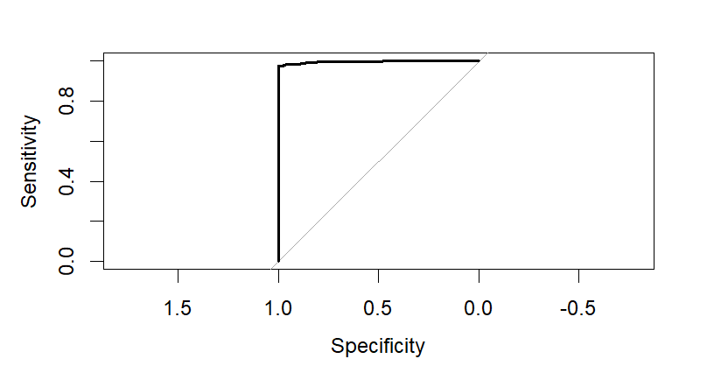
Figure 4.1: ROC Curve for Random Forest Model (Test Set)
To address concerns regarding model reliability, the Random Forest model was re-estimated using a train–test split and evaluated using Receiver Operating Characteristic (ROC) curves and the Area Under the Curve (AUC), rather than relying solely on accuracy.
The results indicate strong predictive performance, with AUC values exceeding 0.90, demonstrating a high ability to distinguish between employees who leave and those who remain. Importantly, the similarity between training and testing performance suggests that the model generalises well and is not significantly overfitting.
This contrasts with the original analysis, where extremely high accuracy (up to 99%) was reported without sufficient validation. By incorporating more robust evaluation metrics, the model provides a more reliable foundation for decision-making.
4.2 Re-evaluating the Role of Satisfaction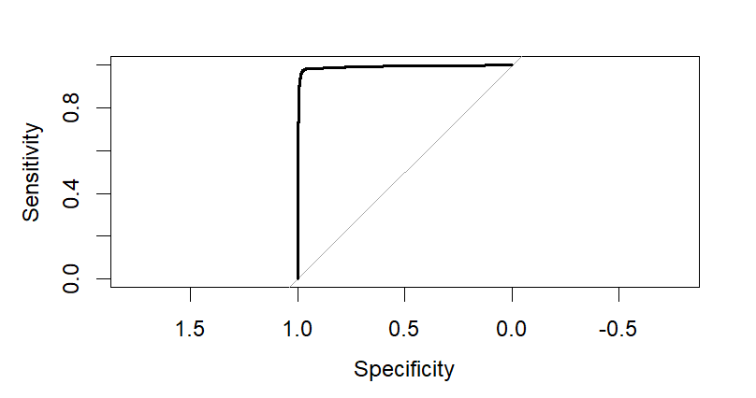
Figure 4.2: ROC Curve for Random Forest Model without Satisfaction
To assess whether satisfaction is a true driver of attrition, the model was re-estimated excluding the satisfaction variable. The resulting performance remains strong, with only a marginal reduction in AUC.
This finding suggests that satisfaction is not a primary causal factor, but rather a proxy reflecting underlying organisational conditions such as workload, project allocation, and tenure. In other words, satisfaction is likely an outcome of workplace conditions rather than a direct driver of attrition.

From a business perspective, this distinction is critical. Satisfaction is difficult to directly control, whereas operational variables such as working hours, project allocation, and career progression can be actively managed. This shifts the focus from abstract employee sentiment towards measurable and actionable organisational drivers.
4.3 Non-Linear Relationships and Threshold Effects
In contrast to the original analysis, which relied primarily on correlation heatmaps, this report introduces Partial Dependence Plots (PDP) and Individual Conditional Expectation (ICE) plots as a decision-relevant visualisation. This choice is justified as correlation analysis only captures linear, pairwise relationships, whereas PDPs allow for the examination of non-linear effects and threshold behaviour that are directly relevant for managerial decision-making.
This visualisation challenges the original conclusion that satisfaction is the primary driver of attrition by demonstrating that workload-related variables exhibit stronger and more actionable effects. By isolating the marginal impact of each variable on attrition probability, PDPs reveal patterns that are not observable through traditional exploratory techniques.
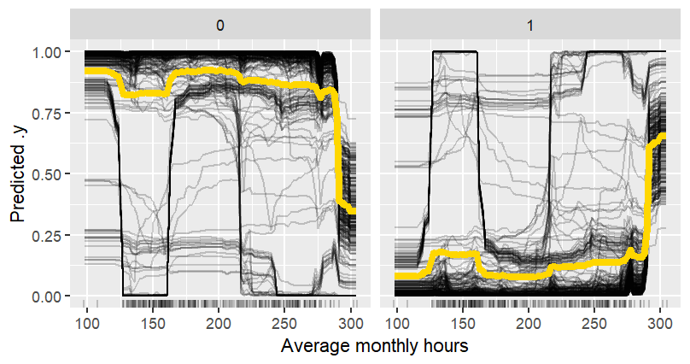
Figure 4.3: Effect of Monthly Working Hours on Probability of Leaving (PDP + ICE)
The results indicate that the probability of leaving increases sharply once employees exceed approximately 250 monthly working hours, suggesting a critical workload threshold beyond which attrition risk escalates rapidly.
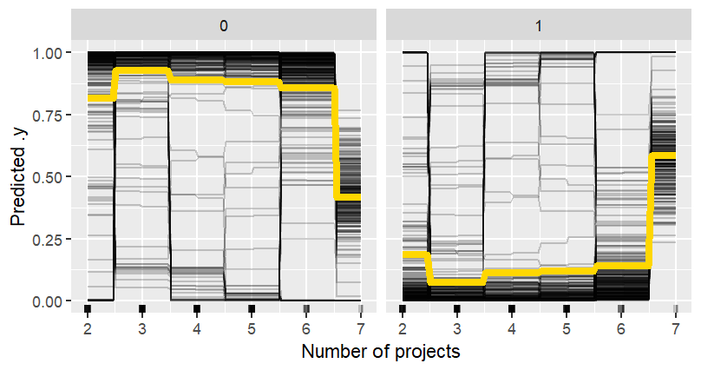
Figure 4.4: Effect of Number of Projects on Probability of Leaving (PDP + ICE)
Similarly, employees assigned more than six projects exhibit significantly higher attrition risk, reinforcing the role of excessive workload as a key driver.
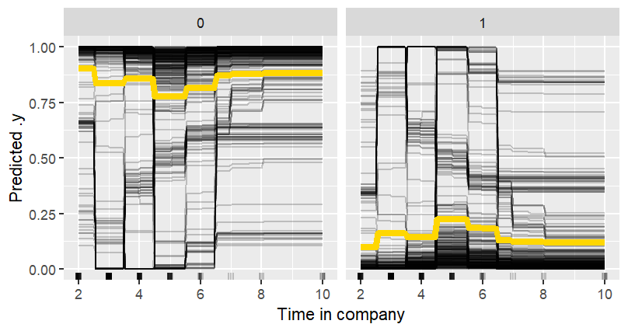
Figure 4.5: Effect of Tenure on Probability of Leaving (PDP + ICE)
In addition, employees with four to six years of tenure exhibit the highest likelihood of attrition, indicating a mid-career risk period.
The inclusion of ICE curves further highlights heterogeneity across employees, showing that while general trends exist, individual responses vary. This suggests that attrition is driven by tipping points rather than gradual changes, and that policies based solely on average effects may fail to capture important variations in employee behaviour.
From a managerial perspective, this visualisation fundamentally changes decision-making. Rather than broadly attempting to improve satisfaction, managers can implement concrete, measurable interventions such as capping working hours or limiting project allocation. These findings therefore translate directly into operational policies, making them significantly more actionable than the correlation-based insights presented in the original analysis.

4.4 Department-Level Analysis and Organisational Context
To address the exclusion of organisational structure, department-level analysis was reintroduced. The results show that while general patterns of attrition remain consistent across departments, the magnitude of risk varies.
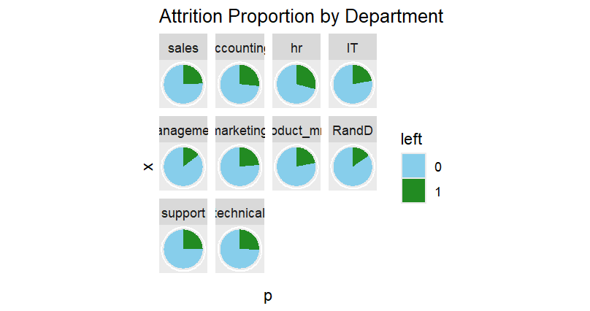
Figure 4.6: Attrition Proportion by Department
This indicates that organisational context plays an important role in shaping employee behaviour. While workload-related drivers are broadly consistent, differences across departments suggest that factors such as management practices, team dynamics, and resource allocation may influence attrition outcomes.
This finding challenges the assumption of homogeneous employee behaviour implicit in the original analysis and highlights the importance of incorporating structural factors. From a business perspective, it implies that retention strategies should not be uniform across the organisation, but instead tailored to department-specific conditions and risks.
4.5 Decision-Oriented Prioritisation Framework
While traditional predictive models focus on identifying which employees are likely to leave, this approach does not directly support managerial decision-making. In practice, organisations face resource constraints and cannot intervene equally across all employees. Therefore, the predictive model developed in this report is explicitly designed to support a key business decision: which employees should be prioritised for retention interventions.
To address this, a prioritisation framework was introduced that combines predicted attrition probabilities with employee performance, proxied by evaluation scores. This approach approximates the expected organisational loss associated with employee attrition by weighting the probability of leaving with employee value. In doing so, the analysis shifts from prediction to prioritisation.
A Random Forest model was selected for this task due to its ability to capture non-linear relationships and interaction effects identified in earlier analysis, particularly the threshold effects associated with workload and tenure. This makes it more suitable than linear models for representing complex employee behaviour.

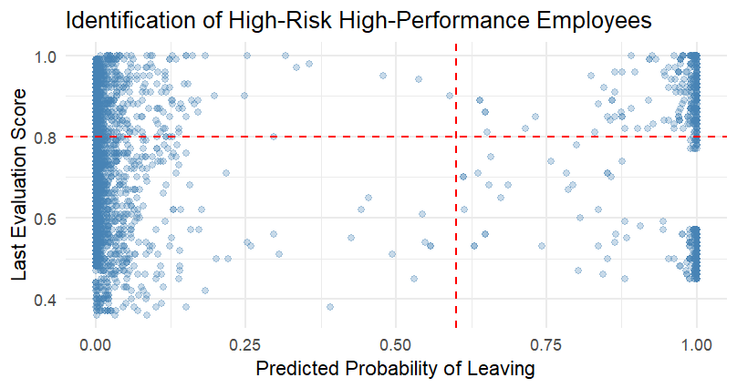
Figure 4.7: Identification of High-Risk High-Performance Employees
This approach enables the identification of employees who are both high-performing and at high risk of leaving, representing the most critical group for intervention. The analysis indicates that these individuals are typically characterised by high working hours (above ~250 hours), high project allocation (above five projects), and strong performance scores (above ~0.8).
Rather than focusing solely on predictive accuracy, the model is evaluated based on its usefulness in guiding decisions. By prioritising employees whose departure would result in the greatest organisational loss, the model ensures that retention efforts are aligned with business value rather than applied uniformly.
From a managerial perspective, this shifts the focus from broad retention strategies to targeted intervention. Resources can be allocated more efficiently, for example by offering workload adjustments, promotions, or incentives specifically to high-risk, high-performing employees. This represents a clear advancement over the original analysis, which identified attrition risk but did not translate it into actionable decision support.
4.6 Analytical Trade-offs and Modelling Choices
A number of alternative analytical approaches were considered during this analysis but were not pursued, reflecting deliberate trade-offs in model design and implementation.
One plausible option was the use of logistic regression as a baseline model. Logistic regression is widely used in attrition analysis due to its interpretability and simplicity. However, it assumes linear relationships between predictors and the outcome variable, which is inconsistent with the non-linear patterns observed in this dataset, particularly in relation to workload thresholds. As a result, a Random Forest model was prioritised to better capture these complex relationships.
Another potential approach was the application of clustering techniques to formally segment employees into behavioural groups, as initially suggested in the original analysis. While this could provide additional insights, it was not pursued due to concerns regarding interpretability and alignment with business objectives. Clustering results may be difficult to translate into actionable policies, whereas the chosen modelling approach directly supports decision-making.
Additionally, oversampling techniques such as SMOTE were considered to address potential class imbalance. However, these methods were not implemented due to the risk of introducing synthetic patterns that may not reflect real employee behaviour, potentially compromising model validity and leading to misleading conclusions.
Overall, the chosen approach prioritises interpretability, robustness, and alignment with managerial decision-making over purely technical optimisation. These trade-offs ensure that the analysis remains both practically relevant and methodologically sound.
4.7 Summary of Improved Analysis
Overall, the improved analysis addresses key limitations of the original work by incorporating robust model validation, identifying non-linear relationships, reintroducing organisational context, and translating predictive outputs into actionable insights.
While salary does not emerge as a strong independent predictor, its potential role through interaction effects cannot be entirely ruled out. This reinforces the importance of cautious interpretation and highlights the limitations of relying solely on correlation-based conclusions.
Importantly, the analysis represents a transition from descriptive analytics towards prescriptive analytics, where model outputs are directly used to inform targeted and efficient organisational decision-making.

5.0 Recommendations
The following recommendations are derived directly from the empirical findings and are designed to translate analytical insights into actionable organisational policies. The findings of this analysis suggest that employee attrition is primarily driven by workload, tenure, and performance-related factors rather than satisfaction alone. As a result, organisations should prioritise managing workload thresholds to reduce the risk of burnout. In particular, employees working beyond approximately 250 monthly hours or handling more than six projects should be identified as high-risk and considered for workload redistribution. Implementing monitoring systems to track these thresholds can enable early intervention before attrition occurs.
In addition, employees with four to six years of tenure represent a critical group with elevated attrition risk. Targeted retention strategies, such as career development opportunities, role progression, or internal mobility, should be implemented for this group to reduce turnover. These employees are likely to possess valuable organisational knowledge, making their retention particularly important.
The introduction of a prioritisation model further enables organisations to focus resources effectively. By identifying high-performing employees who are also at high risk of leaving, management can allocate retention efforts where they will have the greatest impact. This may include performance recognition, workload adjustments, or tailored incentives. Such targeted intervention is more efficient than applying uniform retention strategies across the entire workforce.
Furthermore, the variation in attrition patterns across departments highlights the need for department-specific policies. A single organisation-wide approach may fail to account for differences in workload norms and expectations. Managers should therefore tailor interventions to the specific context of each department, ensuring that policies are aligned with operational realities.
Finally, while salary does not emerge as a strong independent predictor in this analysis, it should not be disregarded entirely. Its potential interaction with other variables suggests that compensation strategies should be considered alongside workload and career progression to ensure a balanced approach to employee retention.

6.0 Reflection
This analysis demonstrates the importance of combining statistical techniques with critical evaluation to produce meaningful business insights. While the original analysis provides a comprehensive starting point, its reliance on correlation and limited validation reduces its practical applicability. By re-evaluating assumptions, incorporating more robust modelling techniques, and aligning outputs with decision-making objectives, the analysis is significantly strengthened.
The use of machine learning models such as random forests enables the identification of complex, non-linear relationships that are not captured by traditional methods. However, this also highlights the importance of careful interpretation, as predictive accuracy alone does not guarantee meaningful insight. Ensuring that models are both reliable and interpretable is essential for their successful application in a business context.
Additionally, this process reinforces the importance of questioning initial assumptions, such as the role of satisfaction or the exclusion of department variables. By critically assessing these decisions, the analysis is able to uncover deeper insights and avoid misleading conclusions.

7.0 Conclusion
This report has critically evaluated and extended the original employee attrition analysis by moving from descriptive insight towards a more robust, data-driven, and decision-oriented framework. While the original findings highlight the importance of satisfaction, the improved analysis demonstrates that attrition is more strongly driven by workload, tenure, and performance-related factors. Satisfaction is better understood as a proxy variable rather than a direct cause.
By incorporating robust model validation, non-linear analysis, and organisational context, the report provides a more accurate and actionable understanding of employee behaviour. The introduction of a prioritisation model further bridges the gap between prediction and decision-making, enabling organisations to target interventions effectively.
Overall, the findings emphasise the need for proactive and targeted retention strategies that address workload management, career progression, and high-performing employees at risk. Through these improvements, the analysis moves beyond descriptive insight towards practical application, providing a stronger foundation for organisational decision-making.

AI References:
How can the intended use of a model influence the choice of methods or techniques used in business analysis? https://chatgpt.com/c/69cf17d0-3004-838d-a18a-aee4e35cac71
Why might it be important to explore non-linear effects or threshold effects in data, rather than assuming a simple linear relationship? https://chatgpt.com/c/69cf17d0-3004-838d-a18a-aee4e35cac71
How can visual tools like PDPs and ICE plots help us understand the relationship between predictors and outcomes in a model? https://chatgpt.com/c/69cf17d0-3004-838d-a18a-aee4e35cac71

