

**SOCIAL GREEN**

**REPORT**

**Nurseli BAL 201611656**

**Özlem Simay CELKAN 201511009**

**Öznur ÖZTÜRK 201511045**

**Mert KIZILDAĞ 201411032**

**CONTENT**

**INTRODUCTION …………………………………………………………………3**

**CONTENT OF SOCIAL GREEN………………………………………………4**

**WHAT WE USED AS PROGRAMMING LANGUAGE?...............5**

**HOW TO USE IT?..................................................................6**

**CONCLUSION……………………………………………………………………13**

**INTRODUCTION**

**What is Social Green ?**

Social Green is an applicationwhose purpose is to evaluate habits or inform addicts, in order to deter those habits or addictions by seeing how much time you have spent on a given action.

Social green’s main purpose is that to reduce the usage of social media. People spend their time in these platforms. Our purpose as the creaters of socailgreen to reduce the usage and to present a tree to nature.

**CONTENT OF SOCIAL GREEN**

Social green has some functionalties to give a tree.

You can record usage of social media daily. By doing it, you will help us create the percantage of the current tree.

In that case we can see that percantage of tree is another functionality. In this fınctionality you can also get the number of your tree You can easily see the percantage of your current tree and the number of trees you have had up to now.

**WHAT WE USED AS PROGRAMMING LANGUAGE?**

**For Backend:**

We used PHP and Javascript as programming language. Since PHP runs fast and most tools associated with the program are open source software such as WordPress, so you do not need to pay for them. And Javascript is dynamic and interactive.

**For Frontend:**

We used HTML,CSS and Bootstrap. Bootstrap is an open-source and FREE front-end web framework used for designing web applicaitons and websites. It contains CSS and HTML based design templates used for navigation buttons, Javascript extensions, forms, typography, and additional interface components. It also contains Responsive feature.

**WHAT WE USED AS DATABASE?**

We used Phpmyadmin for database since it is a popular and free open source tool used for administering MySQL with a web browser.

**HOW TO USE IT?**

Firstly, if you have not registered the system, you need to register. Register page looks like this:

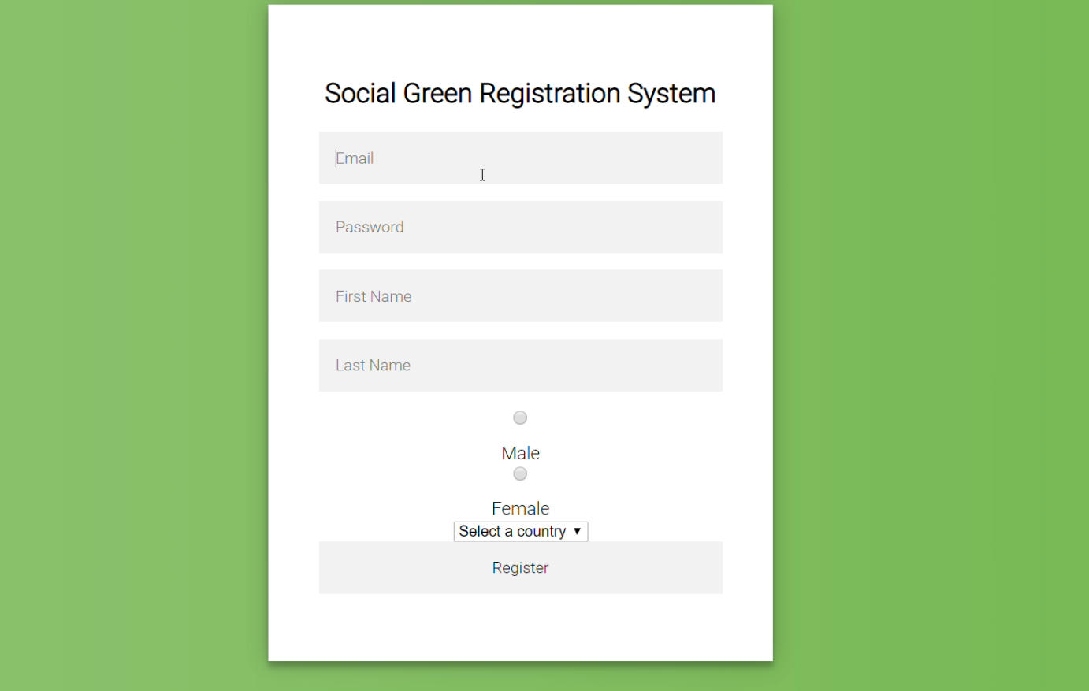

Then you can login the system to use it.

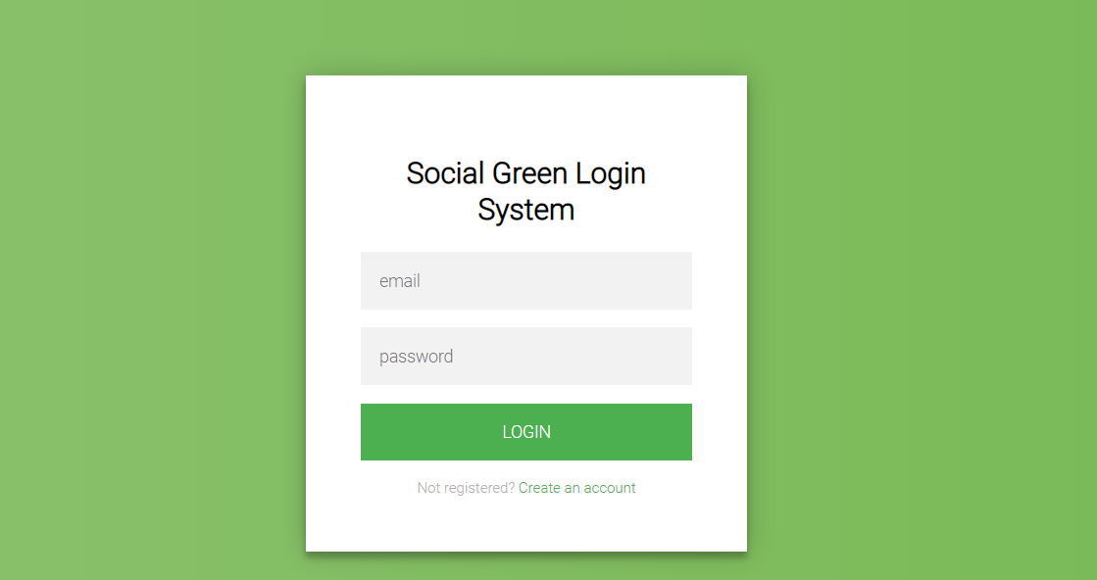

After logining the system, you can see the home page.

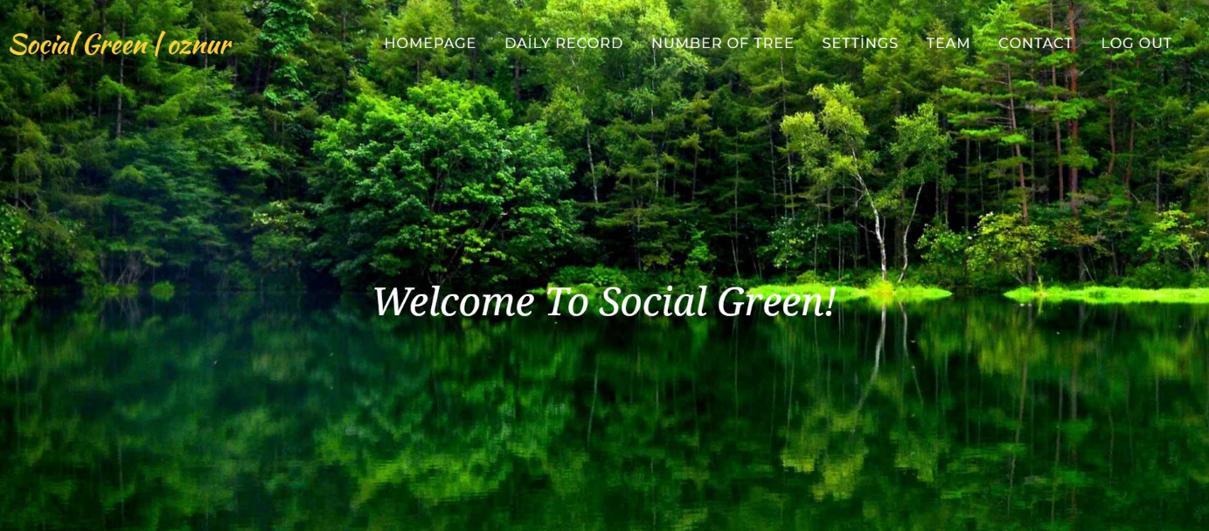

And you can see your name at the left corner of the page.

In homepage you can go through the subpages. It includes Daily Record which you can record your usage information in social media and you can increase your percantage of tree with this information.

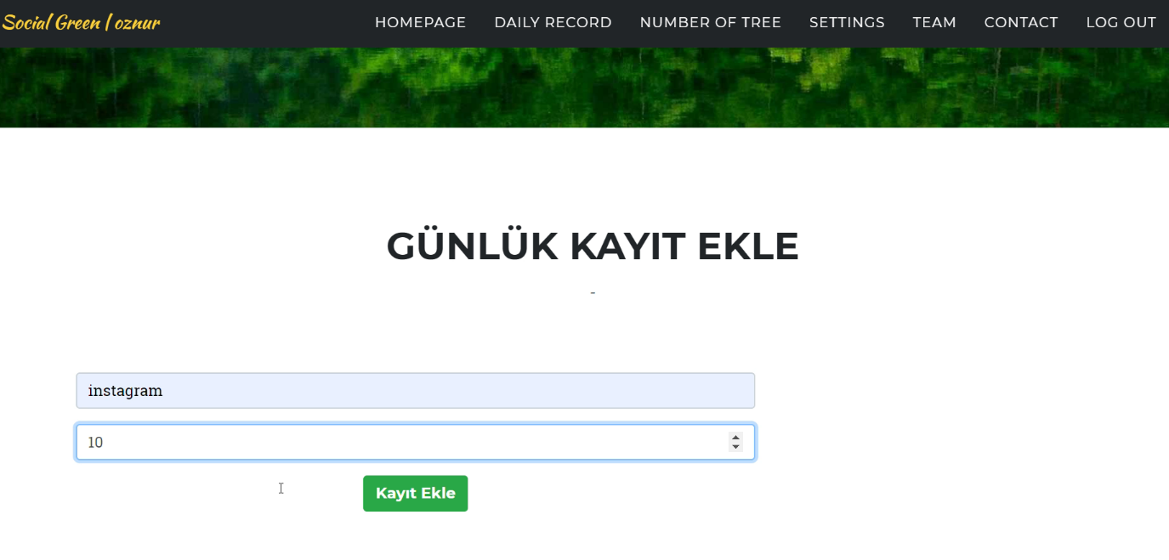

After that, the system records the information to increase the percantage of tree to the database. Our database table is:

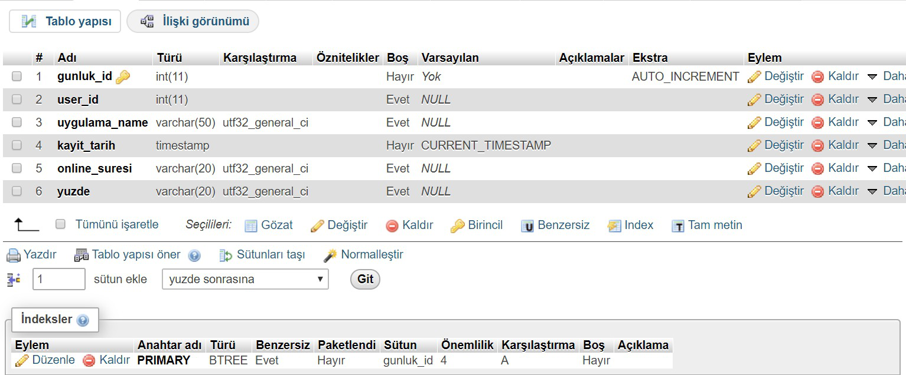

After recording it, the system makes some calculations. You can see this calculation on one of the subpages called Number Of Tree. The percantage and the number of trees will be shown on the screen.

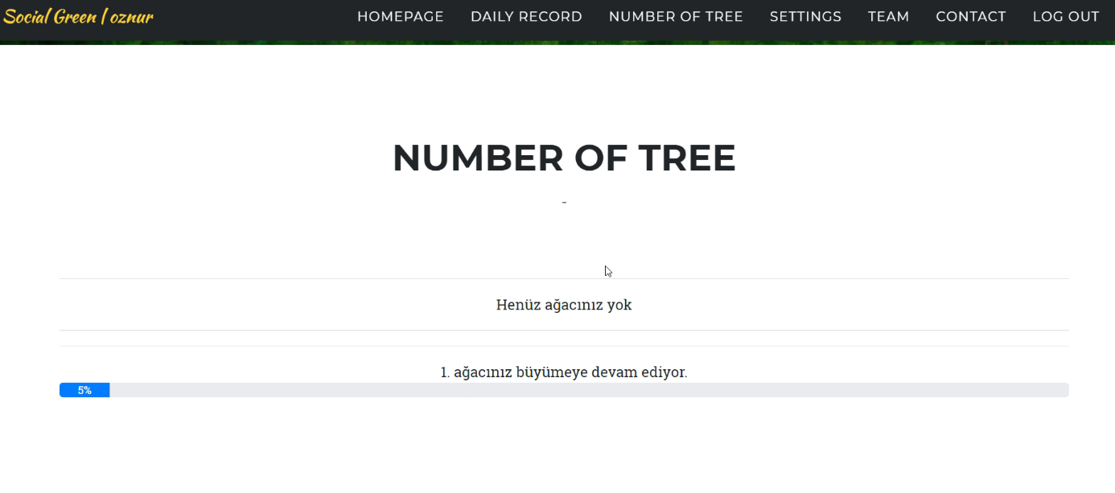

After you have done with the operations on this system, you can easily log out from the system using log out button.

Our system has also validation to avoid some problamatic records. For instance,

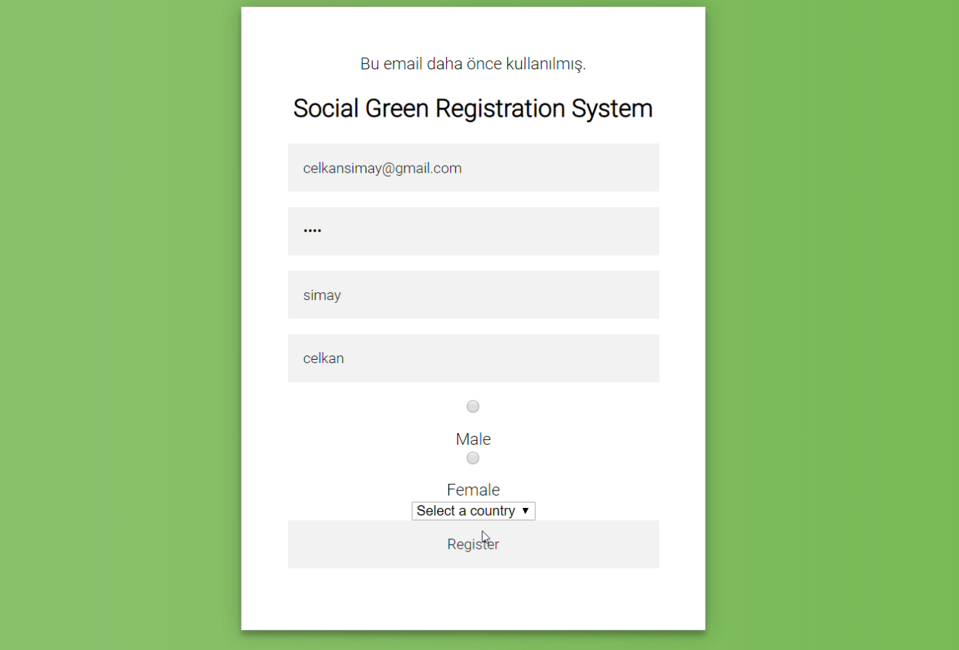

You can see, above picture shows the validation of the system. The e-mail address shown on the screen has already registered before and the system does not allow a user enter the system by using another e-mail address has already registered the system.

This is another validation example:

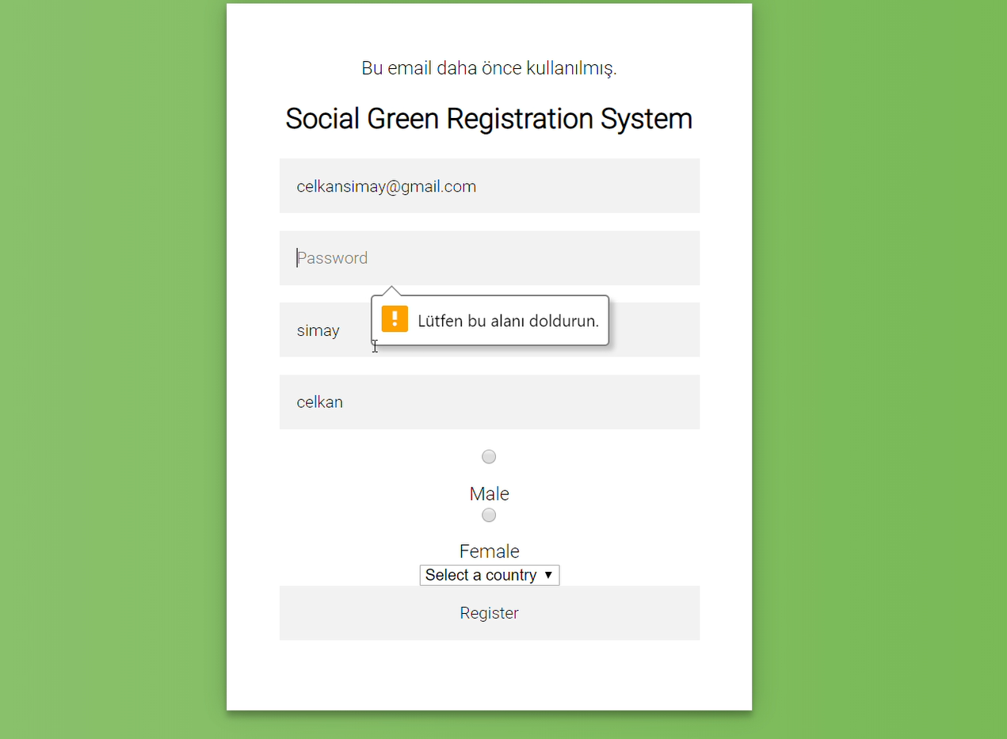

On the Contact Page you can see us as the creater of SOCIAL GREEN.

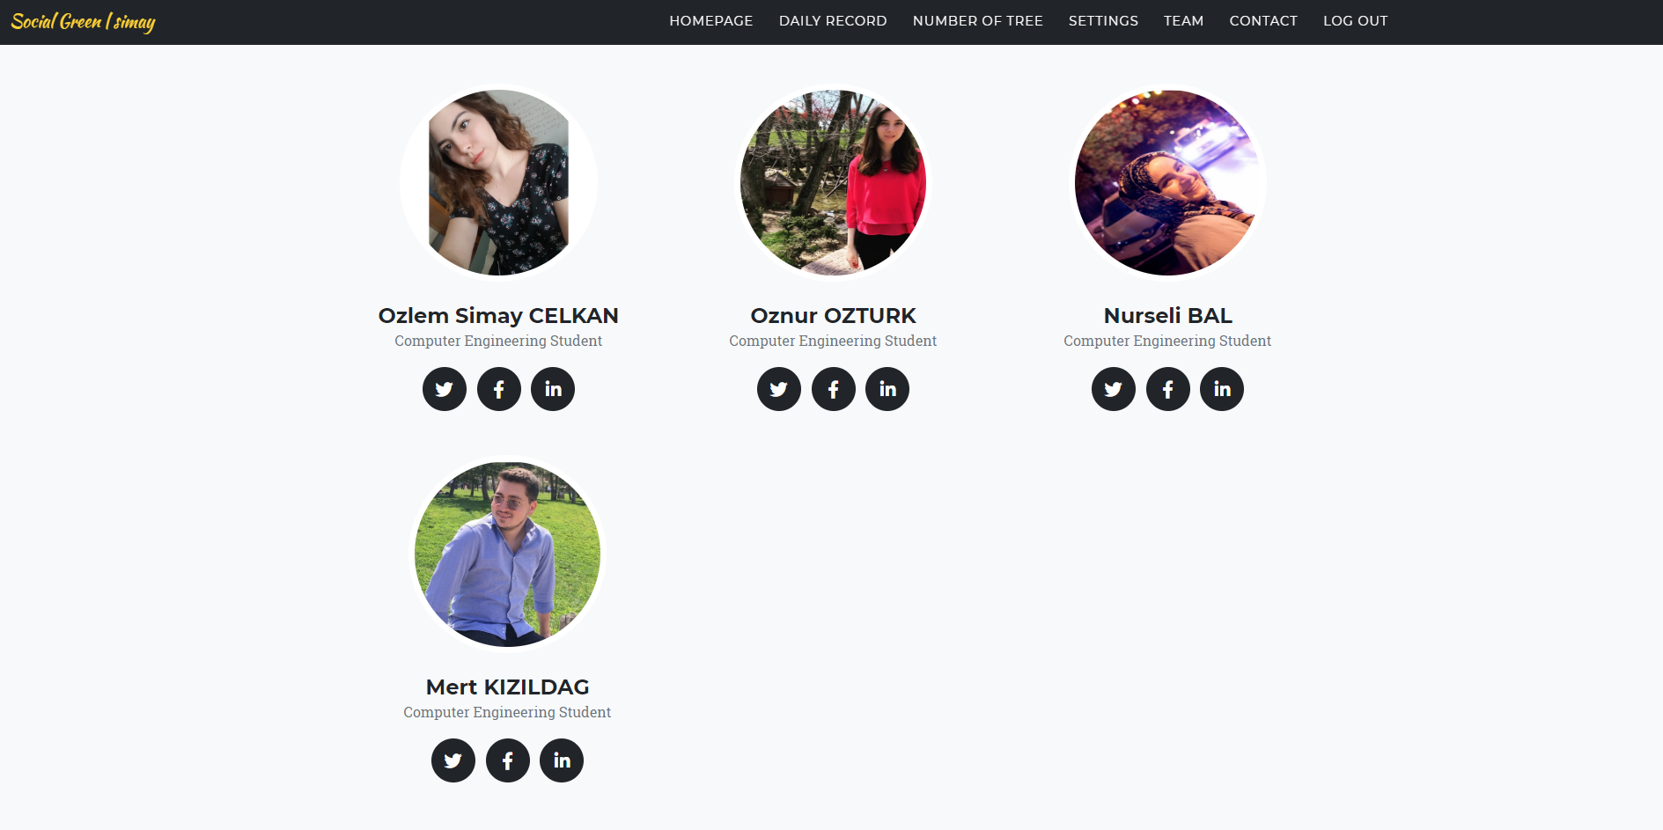

**CONCLUSION**

We have created a system where you can easily measure the usage of Social Media. By doing this, you will understand how addicted you are. But you can avoid this to think of the trees you will give to the nature for your name.

In this way, we think that there will be a lot of people to reduce the use of social media. Ease of use and with the contribution of the environment, I hope our application will be improved. This could be really excellent.