**Investigating the Perceptions of Background Music on Concentration Levels When Performing Tasks among Introverted and Extroverted Undergraduate Students in CUHKSZ**

Cellinie (122040006-Class L55)

School of Data Science

ENG2001 English for Academic Purposes II

Prof. Yingxin Liu

13 December 2023



**Abstract**

Recent technology resembles the ease of music accessibility. Previous research focused on personality and music genre separately and thus has been unable to connect both factors–a potentially important solution to tackle the duality effects of music on concentration, where music may or may not decrease performance. Hence, the study informs personalized strategies for optimizing work conditions and well-being based on personality traits. 41 students from the Chinese University of Hong Kong, Shenzhen were involved in the process of data collection, and mixed methods were implemented as the prediction model and its factors on concentration levels. The study found that both groups exhibited higher odds of concentration without music. In addition, music has the potential to serve as a facilitator in both groups with preferred music.

**Introduction**

While many students believe that listening to music improves concentration, some perceive it as a distraction, highlighting its significant impact on concentration. Kiss and Linnell (2021) emphasize self-selected music that improves the accuracy of the study in this field (p. 2323), compared to researcher-selected music in other studies (e.g., Arboleda et al., 2022; Chitwood & Vaughn, 2018). In addition, Erdal, B. and Tepe, Y. K. (2021) note introverts’ preference for both mellow and energetic music, while extroverts preferred more intense music genres (p. 550). Hence, this study aims to link preferred music genres to personality traits and concentration levels. Understanding these connections can optimize concentration among students and learners in various settings. To find the relation, the present study employed both qualitative and quantitative methods and aimed at:

1. Investigating whether concentration levels vary by personality traits and music genres.
2. Examining the best music genres in both categories for better concentration.
3. Investigating the factors contributing to concentration when using preferred genres.

**Literature Review**

Some research findings have already shown the effects of background music on performing tasks. Arboleda et al. (2022) found music increased cognitive effort but decreased task performance, contrasting Mohan and Thomas’s (2020) findings that background music enhances a sense of enjoyment that leads to improved reading comprehension (p. 567). One reason could be that the role of background music may differ depending on the individual characteristics of the listener and music preference (McDonald, 2013, p. 13). McDonald (2013) claims that in the high extraversion group, “there was a marginally significant increase in scores in the preferred music condition when compared to the silence condition” (p. 15). However, the study conducted by Chitwood and Vaughn (2018) shows that studying with pink noise, pop music, or studying in silence did not influence performance (p. 12). Chitwood’s findings do not support McDonald’s research, as McDonald’s findings only focus on the level of extraversion and music conditions while Chitwood and Vaughn randomly assigned participants to some genres of music. Hence, the current study aims to further investigate these gaps by conducting a study to better understand the connection between self-selected genres and individual traits to concentration.

**Methods**

This study involved 41 university students from the Chinese University of Hong Kong, Shenzhen, chosen via stratified random sampling to represent introvert and extrovert subgroups. The choice of CUHKSZ was intentional due to its diverse student population, including both international and Chinese students. The data were collected using a mixed method that combined quantitative surveys via Microsoft Forms, providing ordinal data, and qualitative thematic analysis of open-ended responses. Statistical tools such as Microsoft Excel and IBM SPSS were employed for data analysis, including descriptive analysis and ordinal regression. Furthermore, the thematic data analysis used in vivo coding to illustrate the point that different languages and cultures of the students can view the same things differently and avoid interpretation errors.

**Results**

The study comprised three main analyses: the correlation between preferred genres for concentration and personality, the prediction of concentration levels, and factors contributing to concentration when using preferred genres.

**Preferred genres for concentration and personality**

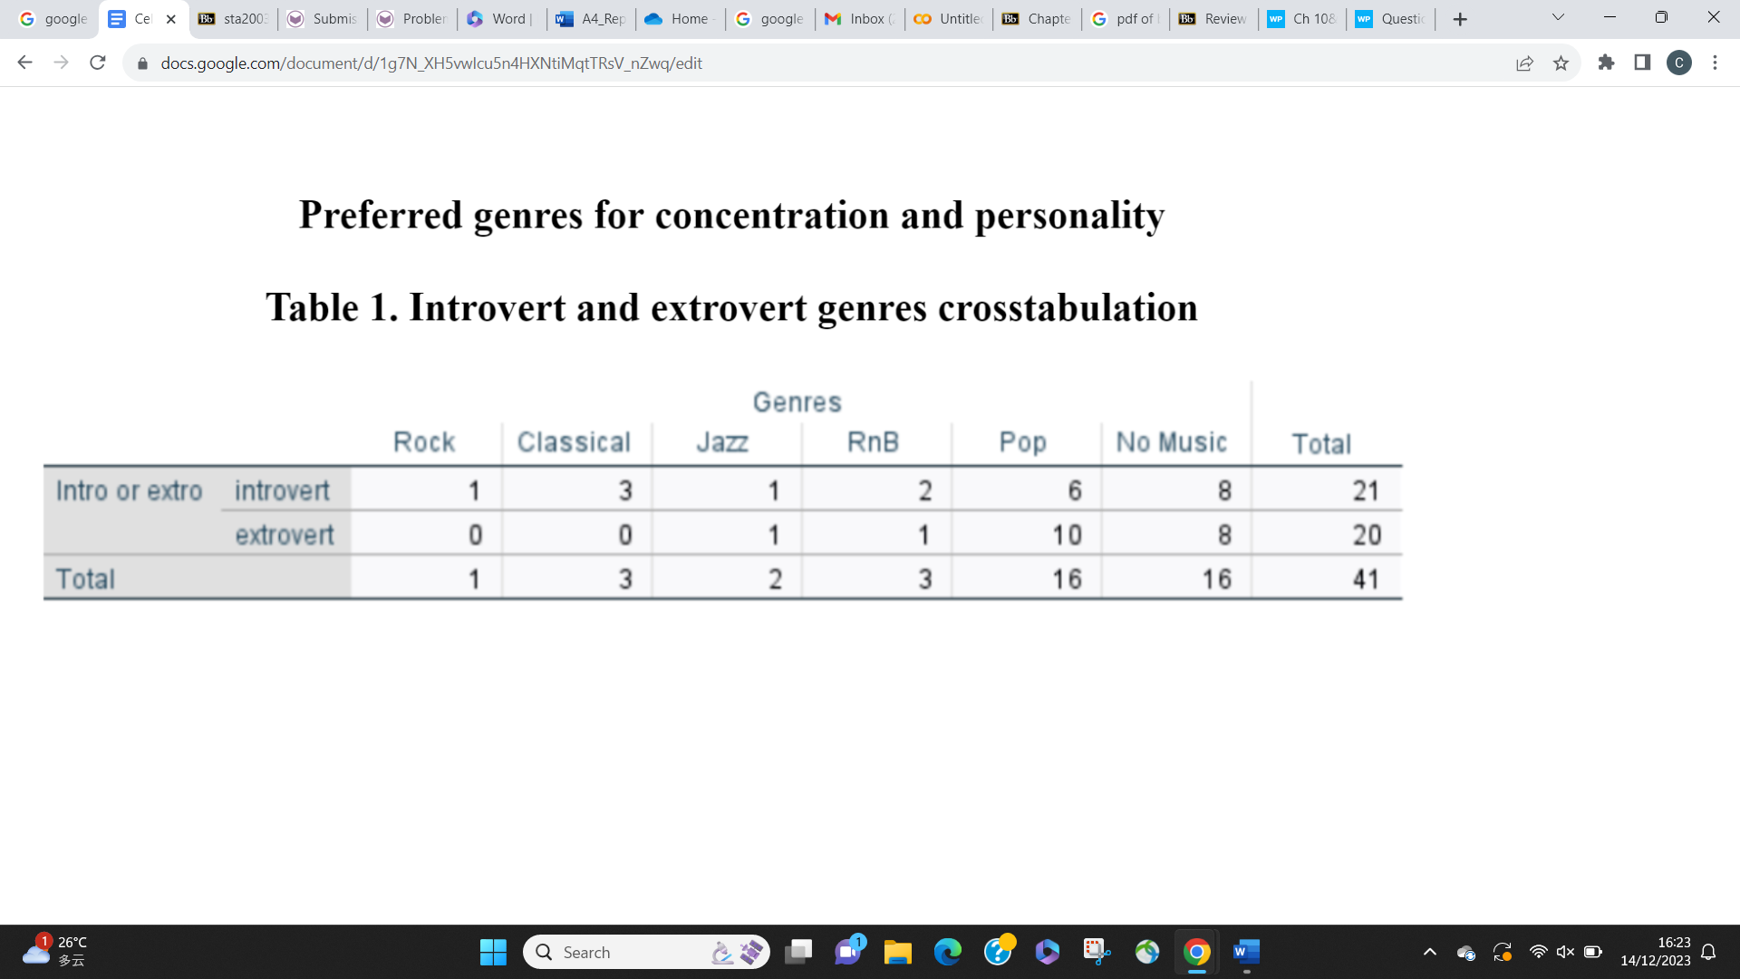

Table 1 shows the relationship between personality traits and preferred music genres for concentration by recording the frequency of observations.

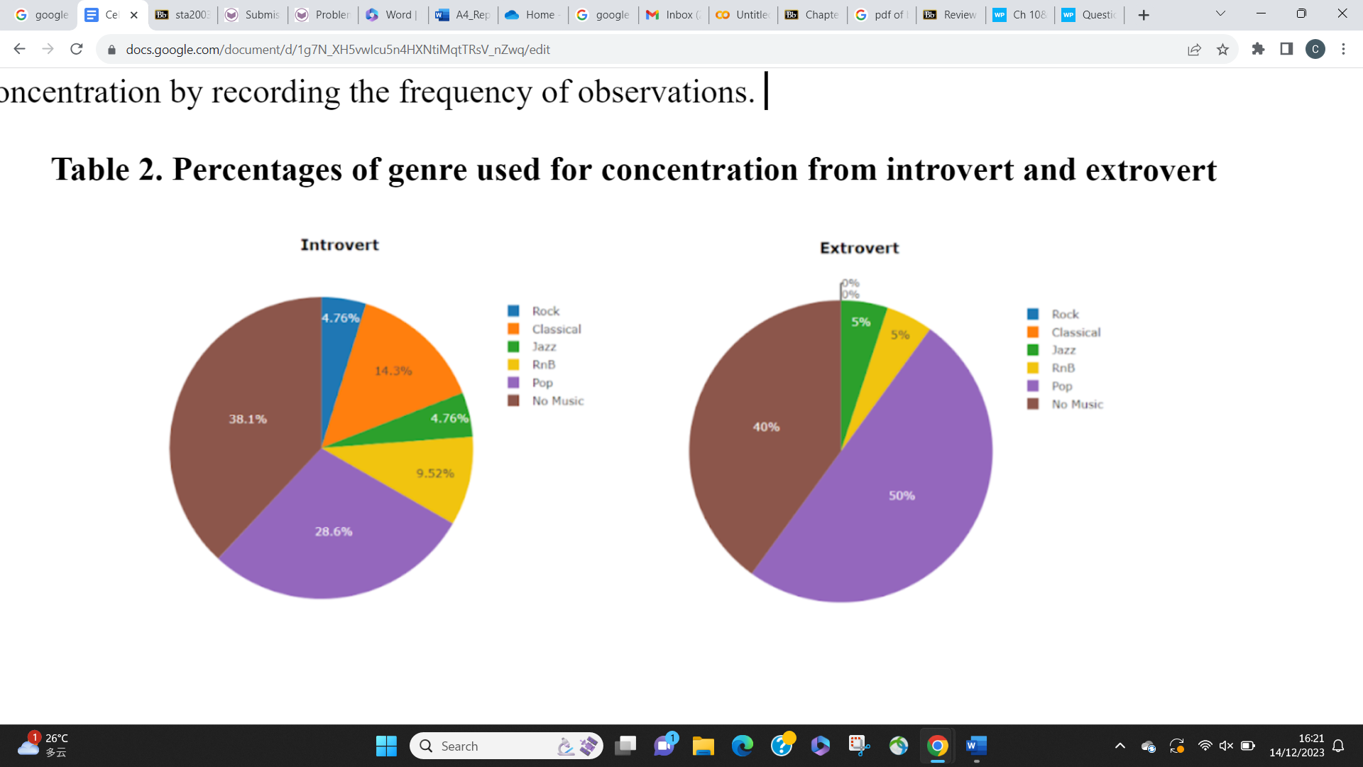

The pie charts in Table 2 show introverts’ preference for “No Music” (38.1%) over other genres like “Pop” (28.6%), “Classical” (14.3%), and “RnB” (9.52%). Meanwhile, extroverts favored “Pop” (50%) slightly more than “No Music’’ (40%), with “Jazz’’ and “RnB” at 5%. “Rock” and “Classical” found no preference among extroverts.

**Prediction of concentration levels**

The second analysis was separated into 2 different groups, the introvert and extrovert group. The analysis aimed to find the connection between each genre’s capability of concentration and compare them with the reference model “No Music”.

**Introvert**

The case processing summary below in Table 3 provides the number of individuals (N) for all categories in the introvert group. A total of 21 introverted participants were analyzed in the study.

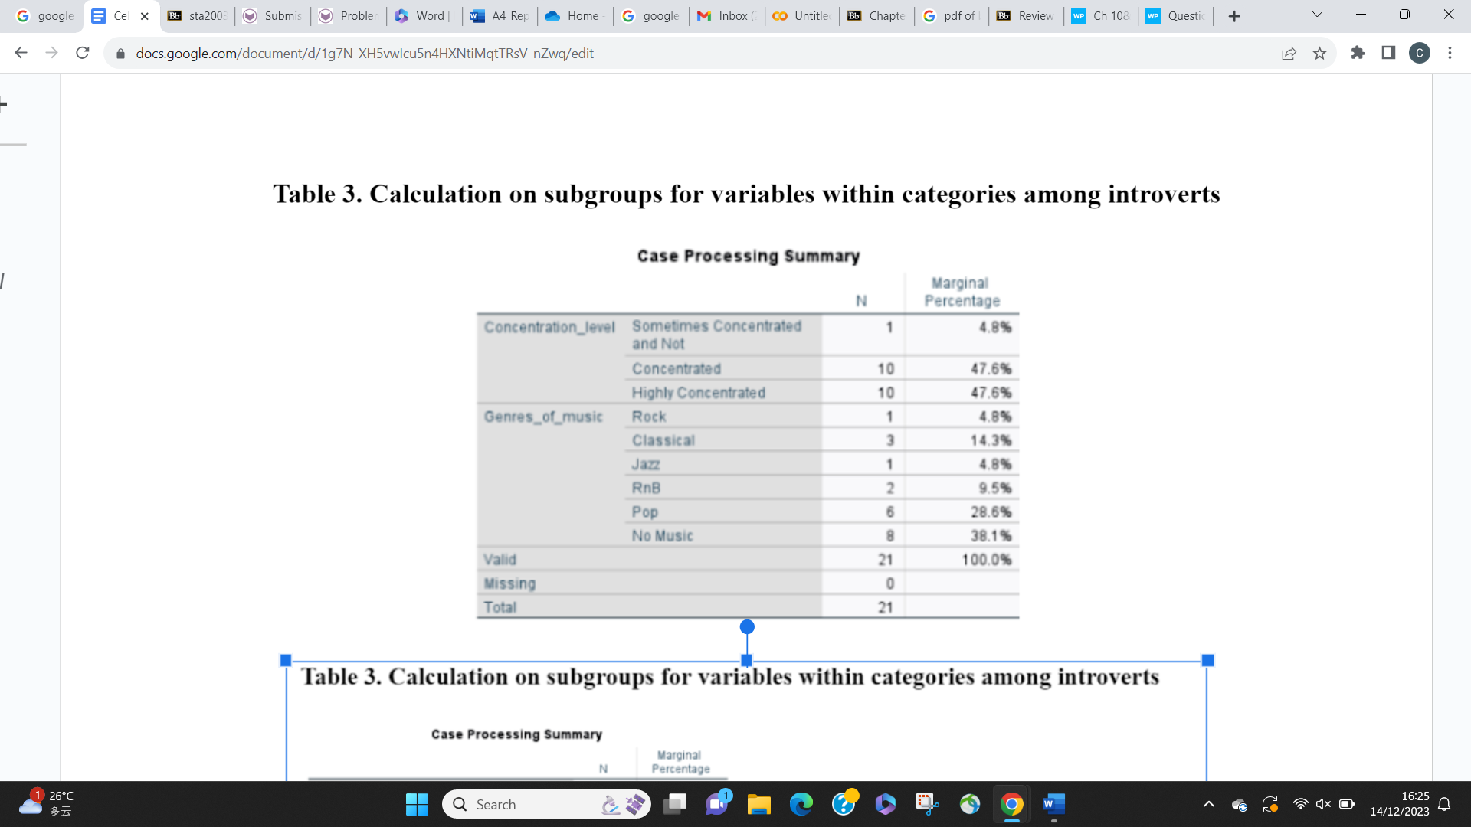

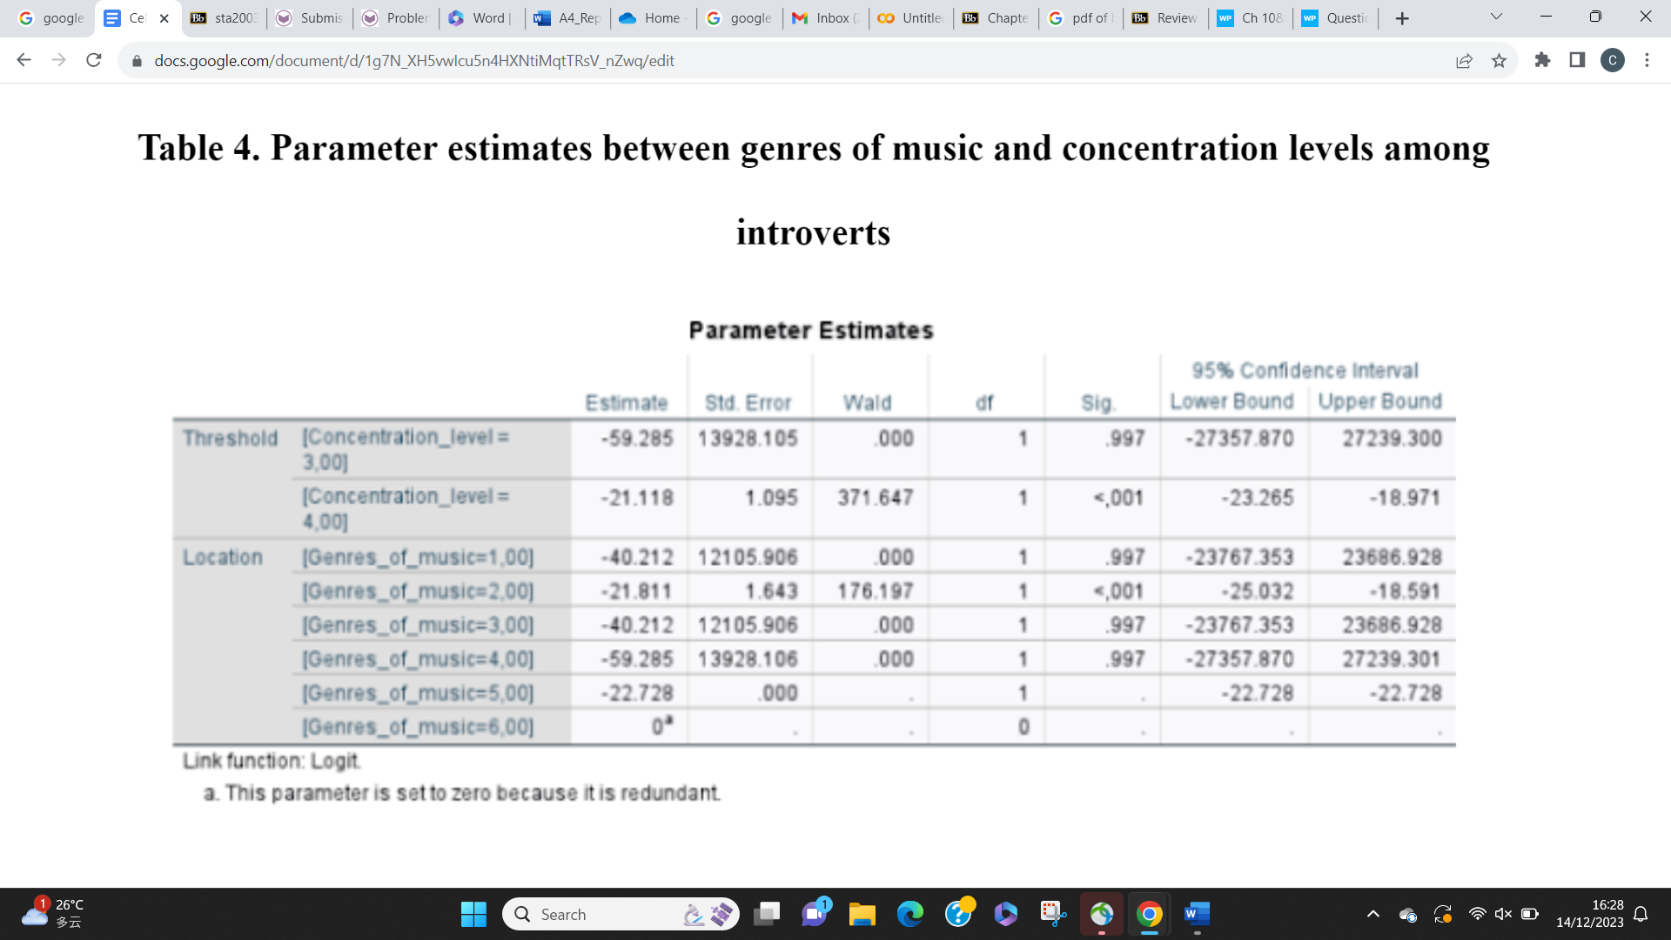

The study emphasizes parameter estimates derived from ordinal regression analysis to determine the behavior of concentration from genres containing independent variables. Table 4 compares the relations between concentration levels (1=Strongly not concentrated, 2=Not concentrated, 3=Sometimes concentrated and not, 4=Concentrated, 5=Strongly concentrated) and music genre levels (1=Rock, 2=Classical, 3=Jazz, 4=RnB, 5=Pop, 6=No Music).

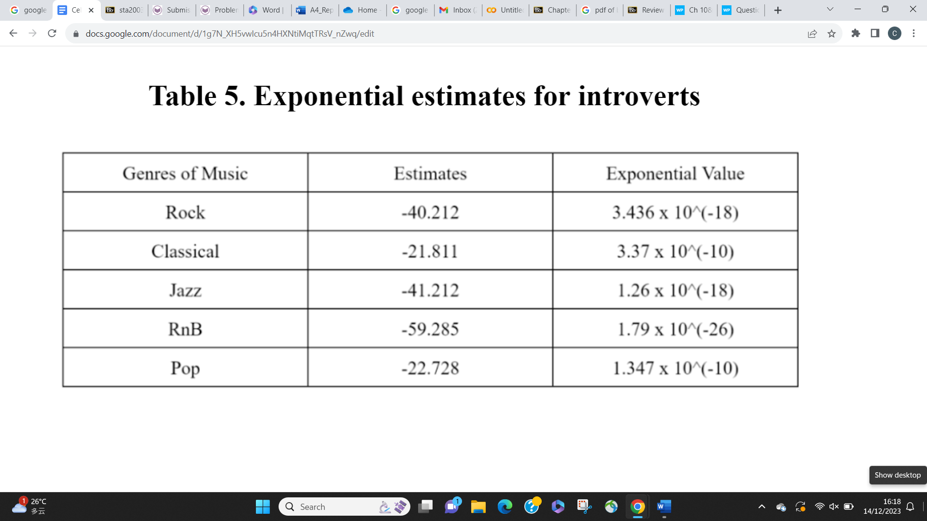

The negative estimates for each genre suggest a decrease in concentration levels compared to the reference category of No Music. Table 5 below summarizes the factors for each genre compared to “No Music”. The odds of “Genres of Music” is the exponential value times the odds of “No Music”**.** In essence, a higher odds ratio implies a stronger likelihood between the presence of a specific music genre and its impact on concentration levels compared to “No Music”.

**Extrovert**

The same analysis was conducted on extroverts. The case processing summary below in Table 6 provides the number of individuals (N) for all categories in the extrovert group. A total of 20 extroverted participants were analyzed in the study.

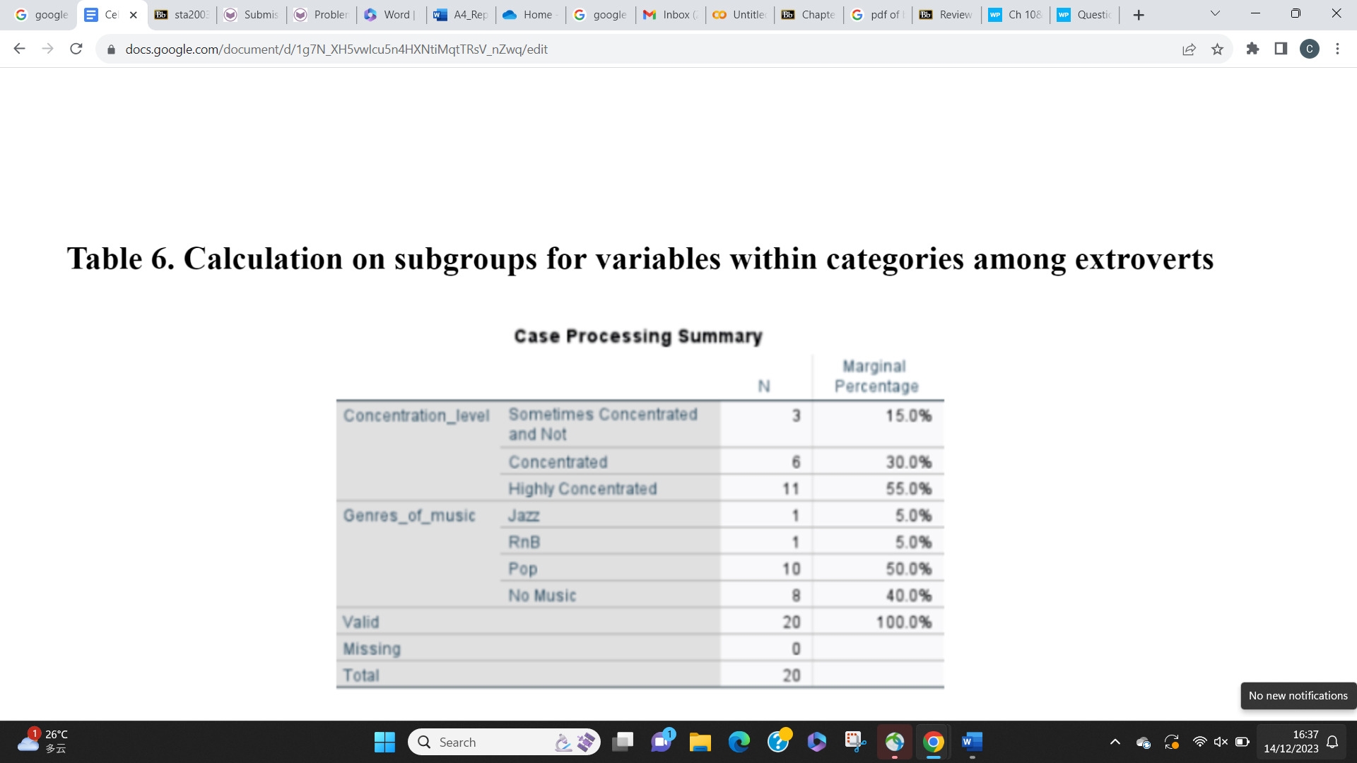

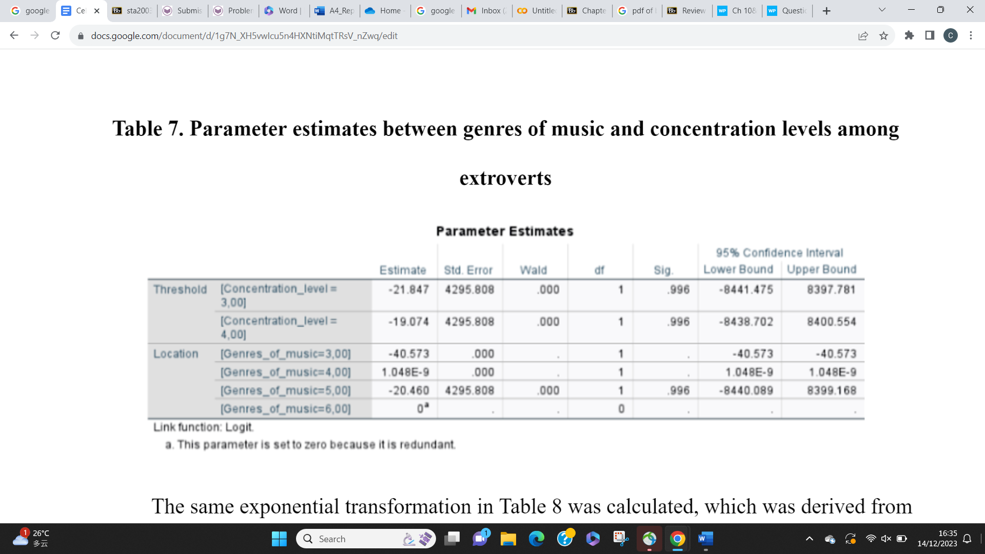

The same exponential transformation in Table 8 was calculated, which was derived from the same variables as conducted before. In contrast to introverts, a positive estimate was found in “RnB” and calculated as 1, suggesting an equal likelihood of impacting concentration levels whether RnB music is present or absent.

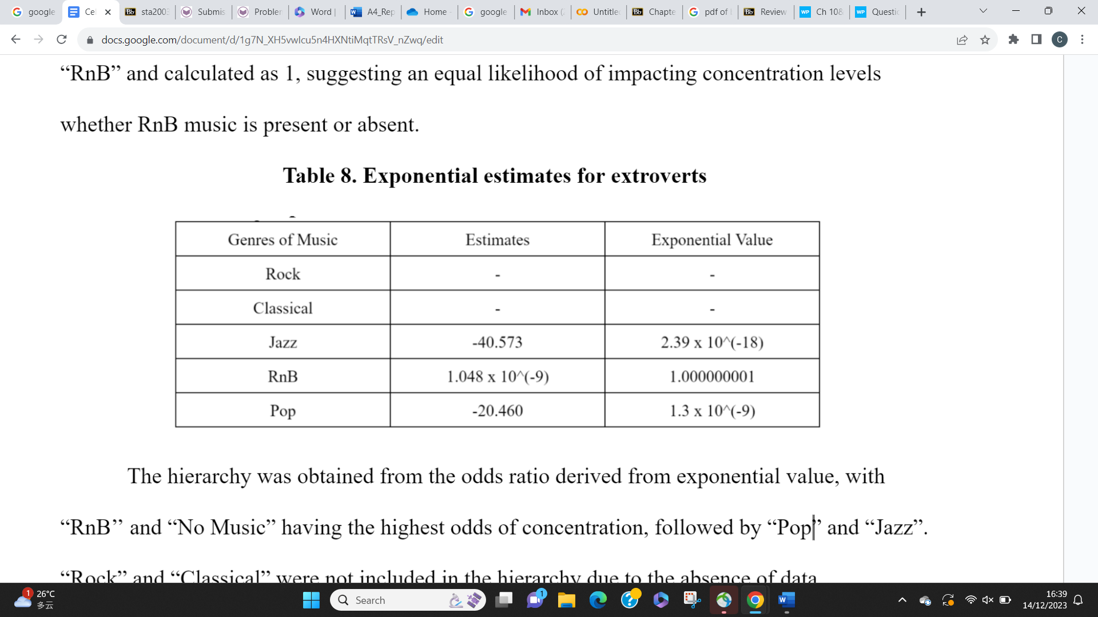

The hierarchy was obtained from the odds ratio derived from exponential value, with “RnB’’ and “No Music” having the highest odds of concentration, followed by “Pop” and “Jazz”. “Rock” and “Classical” were not included in the hierarchy due to the absence of data.

**Factors contributing to concentration when using preferred genres**

Qualitative thematic analysis was conducted by grouping positive and negative comments towards each genre. The table is shown below.

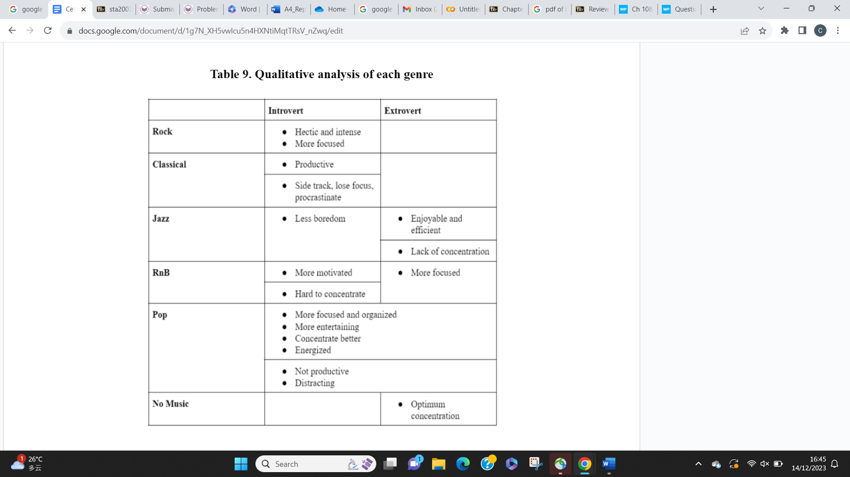

**Discussion**

The study found that introverts had a more balanced distribution among various genres compared to extroverts. The findings are aligned with Eysenck, H.J. (1963) findings, where introvert has a higher natural base level of excitation while extrovert has a lower base arousal. This implies that the former do not need to seek out stimulating environments, while the latter need a more stimulating environment (p. 1033). This is proven as the top category of the list for introverts is “No Music” and extrovert is “RnB”. However, “No Music” was also dominating in the extrovert group, contrasting with the initial hypothesis extroverts that need more stimulation.

Despite the best genres for each category, the odds of getting concentration were not 0. This does not close the possibility that background music can serve as a facilitator for both groups with preferred music. This supports the findings from Aghajani, M. (2019), who concluded that favorite background music has the potential to serve as an effective aid for reading (p. 24). By implementing in vivo coding, common themes were identified, such that participants who listen to music for concentration prefer enjoyability to perform their task with a sense of motivation.

It is important to note that the disproportionate representation of participants’ preferences among music genres may have been an impactful factor in the study and data collection. This is due to the limited number of participants which restricts the reliability and generality of the findings. Future studies should aim for a more balanced distribution of participant preferences across various music genres. In addition, incorporating major-based analyses may allow a deeper understanding of how music influences concentration among students with diverse academic pursuits.

**Conclusion**

The importance of the study lies in its potential to explore the correlation between individual characteristics and a specific musical style, providing insight into how music plays an important role in concentration. The study informs personalized strategies for optimizing work conditions and well-being based on personality traits, contributing to previous research with the addition of genre and personality factors. This revealed distinct perceptions toward music genres among introverts and extroverts, with introverts leaning towards “No Music”, aligning with their preference for calming stimuli. Extroverts, although initially expected to prefer more stimulating genres, also showed a significant preference for “No Music” along with “RnB”. Despite this, both groups exhibited higher odds of concentration without music.

**References**

Aghajani, M. (2019). The effect of background music on reading comprehension regarding extroverts/introverts personality dimensions. *Contemporary Research in Education and English Language Teaching, 1*(2), 19-24.

10.33094/26410230.2019.12.19.24

Arboleda, A., Arroyo, C., Rodriguez, B., & Arce-Lopera, C. (2022). A stressful task is when to turn off the music: Effect of music on task performance mediated by cognitive effort. *Psychology of Music, 50*(1), 298-311.

<https://doi.org/10.1177/0305735621996027>

Chitwood, M. R., & Vaughn, K. E. (2018). Cognitive performance and sounds: The effects of lyrical music and pink noise on performance. *Psychological Sciences, 1*, 9-14.

<https://www.researchgate.net/publication/329916144_Cognitive_Performance_and_Sounds_The_Effects_of_Lyrical_Music_and_Pink_Noise_on_Performance>

Eysenck, H. J. (1963). The biological basis of personality. *Nature 199*, 1031–1034.

https://doi.org/10.1038/1991031a0

Kiss, L., & Linnell, K. J. (2021). The effect of preferred background music on task-focus in sustained attention. *Psychological Research, 85*, 2313–2325.

<https://doi.org/10.1007/s00426-020-01400-6>

McDonald, J. (2013). The effect of music preference on complex task performance. *Social Sciences, 7*(10), 1-25.

<https://digitalcommons.pepperdine.edu/cgi/viewcontent.cgi?article=1089&context=globaltides>

Mohan, A., & Thomas, E. (2020). Effects of background music and the cultural preference to music on adolescents’ task performance. *International Journal of Adolescence and Youth, 25*(1), 562-573.

<https://doi.org/10.1080/02673843.2019.1689368>

**Appendices**

