Report

Lelys

7/9/2021

# Introduction

In this project we are going to construct models to predict PM2.5. Data comes from <https://archive.ics.uci.edu/ml/datasets/Beijing+PM2.5+Data>.

# EDA

Exploratory Data Analysis will be conducted in this section, we make some graphical displays of the data and numerical summaries of the data.

## No Year Month Day Hour PM2.5 DEWP TEMP PRES CBWD LWS LS LR  
## 1 1 2010 1 1 0 NA -21 -11.00 1021.00 NW 1.79 0 0  
## 2 2 2010 1 1 1 NA -21 -12.00 1020.00 NW 4.92 0 0  
## 3 3 2010 1 1 2 NA -21 -11.00 1019.00 NW 6.71 0 0  
## 4 4 2010 1 1 3 NA -21 -14.00 1019.00 NW 9.84 0 0  
## 5 5 2010 1 1 4 NA -20 -12.00 1018.00 NW 12.97 0 0  
## 6 6 2010 1 1 5 NA -19 -10.00 1017.00 NW 16.10 0 0

## [1] "No" "Year" "Month" "Day" "Hour" "PM2.5" "DEWP" "TEMP" "PRES"   
## [10] "CBWD" "LWS" "LS" "LR"

## No Year Month Day   
## Min. : 1 Min. :2010 Min. : 1.000 Min. : 1.00   
## 1st Qu.:10957 1st Qu.:2011 1st Qu.: 4.000 1st Qu.: 8.00   
## Median :21913 Median :2012 Median : 7.000 Median :16.00   
## Mean :21913 Mean :2012 Mean : 6.524 Mean :15.73   
## 3rd Qu.:32868 3rd Qu.:2013 3rd Qu.:10.000 3rd Qu.:23.00   
## Max. :43824 Max. :2014 Max. :12.000 Max. :31.00   
##   
## Hour PM2.5 DEWP TEMP   
## Min. : 0.00 Min. : 0.00 Min. :-40.000 Length:43824   
## 1st Qu.: 5.75 1st Qu.: 29.00 1st Qu.:-10.000 Class :character   
## Median :11.50 Median : 72.00 Median : 2.000 Mode :character   
## Mean :11.50 Mean : 98.61 Mean : 1.817   
## 3rd Qu.:17.25 3rd Qu.:137.00 3rd Qu.: 15.000   
## Max. :23.00 Max. :994.00 Max. : 28.000   
## NA's :2067   
## PRES CBWD LWS LS   
## Length:43824 Length:43824 Min. : 0.45 Min. : 0.00000   
## Class :character Class :character 1st Qu.: 1.79 1st Qu.: 0.00000   
## Mode :character Mode :character Median : 5.37 Median : 0.00000   
## Mean : 23.89 Mean : 0.05273   
## 3rd Qu.: 21.91 3rd Qu.: 0.00000   
## Max. :585.60 Max. :27.00000   
##   
## LR   
## Min. : 0.0000   
## 1st Qu.: 0.0000   
## Median : 0.0000   
## Mean : 0.1949   
## 3rd Qu.: 0.0000   
## Max. :36.0000   
##

## No Year Month Day   
## Min. : 1 Min. :2010 Min. : 1.000 Min. : 1.00   
## 1st Qu.:10957 1st Qu.:2011 1st Qu.: 4.000 1st Qu.: 8.00   
## Median :21913 Median :2012 Median : 7.000 Median :16.00   
## Mean :21913 Mean :2012 Mean : 6.524 Mean :15.73   
## 3rd Qu.:32868 3rd Qu.:2013 3rd Qu.:10.000 3rd Qu.:23.00   
## Max. :43824 Max. :2014 Max. :12.000 Max. :31.00   
##   
## Hour PM2.5 DEWP TEMP   
## Min. : 0.00 Min. : 0.00 Min. :-40.000 Min. :-19.00   
## 1st Qu.: 5.75 1st Qu.: 29.00 1st Qu.:-10.000 1st Qu.: 2.00   
## Median :11.50 Median : 72.00 Median : 2.000 Median : 14.00   
## Mean :11.50 Mean : 98.61 Mean : 1.817 Mean : 12.45   
## 3rd Qu.:17.25 3rd Qu.:137.00 3rd Qu.: 15.000 3rd Qu.: 23.00   
## Max. :23.00 Max. :994.00 Max. : 28.000 Max. : 42.00   
## NA's :2067 NA's :2   
## PRES CBWD LWS LS   
## Min. : 991 Length:43824 Min. : 0.45 Min. : 0.00000   
## 1st Qu.:1008 Class :character 1st Qu.: 1.79 1st Qu.: 0.00000   
## Median :1016 Mode :character Median : 5.37 Median : 0.00000   
## Mean :1016 Mean : 23.89 Mean : 0.05273   
## 3rd Qu.:1025 3rd Qu.: 21.91 3rd Qu.: 0.00000   
## Max. :1046 Max. :585.60 Max. :27.00000   
## NA's :2   
## LR   
## Min. : 0.0000   
## 1st Qu.: 0.0000   
## Median : 0.0000   
## Mean : 0.1949   
## 3rd Qu.: 0.0000   
## Max. :36.0000   
##

## No Year Month Day Hour PM2.5 DEWP TEMP PRES CBWD LWS LS LR  
## 1 1 2010 1 1 0 NA -21 -11 1021 NW 1.79 0 0  
## 2 2 2010 1 1 1 NA -21 -12 1020 NW 4.92 0 0  
## 3 3 2010 1 1 2 NA -21 -11 1019 NW 6.71 0 0  
## 4 4 2010 1 1 3 NA -21 -14 1019 NW 9.84 0 0  
## 5 5 2010 1 1 4 NA -20 -12 1018 NW 12.97 0 0  
## Date_H Date_D  
## 1 2010-01-01 00:00:00 2010-01-01  
## 2 2010-01-01 01:00:00 2010-01-01  
## 3 2010-01-01 02:00:00 2010-01-01  
## 4 2010-01-01 03:00:00 2010-01-01  
## 5 2010-01-01 04:00:00 2010-01-01

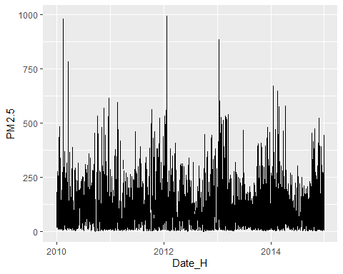

## 'data.frame': 1826 obs. of 9 variables:  
## $ Date_D : Date, format: "2010-01-01" "2010-01-02" ...  
## $ Avg_Day_PM2.5: num NaN 146 78.8 31.3 42.5 ...  
## $ Avg_Day_DEWP : num -18.8 -8.5 -10.1 -20.9 -24.6 ...  
## $ Avg_Day_TEMP : num -6.75 -5.12 -8.54 -11.5 -14.46 ...  
## $ Avg_Day_PRES : num 1017 1025 1023 1029 1034 ...  
## $ Max_Day_LWS : num 43.8 55.4 127.8 198.4 218.6 ...  
## $ Max_Day_LS : num 0 4 27 0 0 0 0 0 0 0 ...  
## $ Max_Day_LR : num 0 0 0 0 0 0 0 0 0 0 ...  
## $ Max_Day_CBWD : chr "NW" "SE" "SE" "NW" ...

## Date_D Avg_Day_PM2.5 Avg_Day_DEWP Avg_Day_TEMP   
## Min. :2010-01-01 Min. : 2.958 Min. :-33.333 Min. :-14.458   
## 1st Qu.:2011-04-02 1st Qu.: 42.231 1st Qu.:-10.083 1st Qu.: 1.542   
## Median :2012-07-01 Median : 79.167 Median : 2.021 Median : 13.896   
## Mean :2012-07-01 Mean : 98.653 Mean : 1.817 Mean : 12.448   
## 3rd Qu.:2013-09-30 3rd Qu.:131.167 3rd Qu.: 15.073 3rd Qu.: 23.167   
## Max. :2014-12-31 Max. :552.478 Max. : 26.208 Max. : 32.875   
## NA's :37   
## Avg_Day_PRES Max_Day_LWS Max_Day_LS Max_Day_LR   
## Min. : 994 Min. : 2.69 Min. : 0.0000 Min. : 0.0000   
## 1st Qu.:1008 1st Qu.: 20.68 1st Qu.: 0.0000 1st Qu.: 0.0000   
## Median :1016 Median : 36.23 Median : 0.0000 Median : 0.0000   
## Mean :1016 Mean : 59.97 Mean : 0.2218 Mean : 0.9617   
## 3rd Qu.:1025 3rd Qu.: 64.37 3rd Qu.: 0.0000 3rd Qu.: 0.0000   
## Max. :1043 Max. :585.60 Max. :27.0000 Max. :36.0000   
##   
## Max_Day_CBWD   
## Length:1826   
## Class :character   
## Mode :character   
##   
##   
##   
##

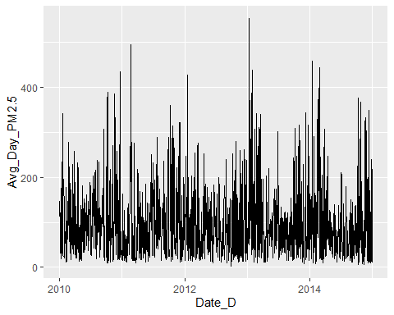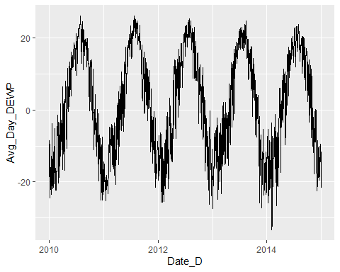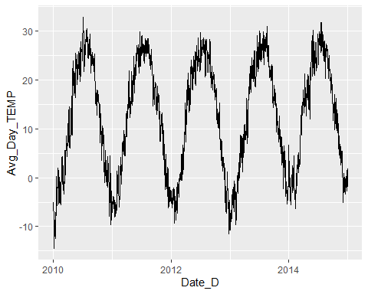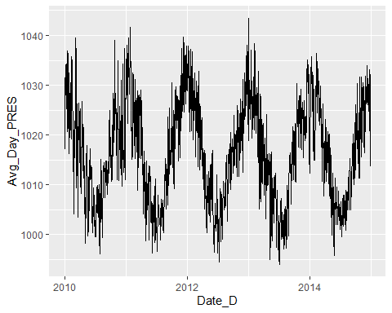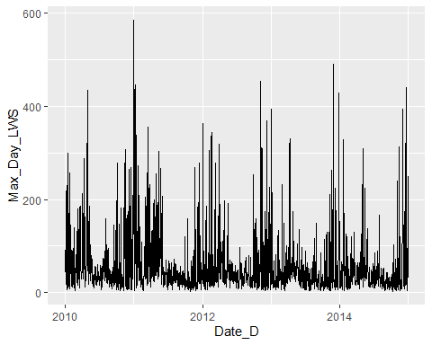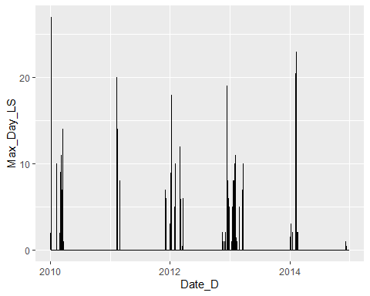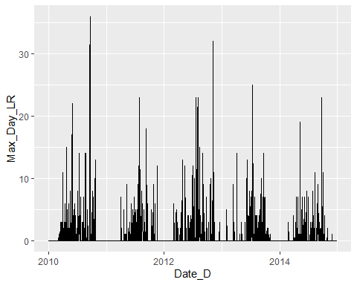

## Date_D Avg_Day_PM2.5 Avg_Day_DEWP Avg_Day_TEMP Avg_Day_PRES Max_Day_LWS  
## 1 2010-01-01 NaN -18.75000 -6.750000 1017.083 43.82  
## 2 2010-01-02 145.95833 -8.50000 -5.125000 1024.750 55.43  
## 3 2010-01-03 78.83333 -10.12500 -8.541667 1022.792 127.84  
## 4 2010-01-04 31.33333 -20.87500 -11.500000 1029.292 198.45  
## 5 2010-01-05 42.45833 -24.58333 -14.458333 1033.625 218.57  
## 6 2010-01-06 56.41667 -23.70833 -12.541667 1033.750 59.00  
## Max_Day_LS Max_Day_LR Max_Day_CBWD Year Month Day  
## 1 0 0 NW 2010 1 1  
## 2 4 0 SE 2010 1 2  
## 3 27 0 SE 2010 1 3  
## 4 0 0 NW 2010 1 4  
## 5 0 0 NW 2010 1 5  
## 6 0 0 NE 2010 1 6