User Guide.

First, Download or clone the matlabMigrationAnalysis repository from github: https://github.com/cells2numbers/matlabMigrationAnalysis

Either download the repository as zip or clone it using

>git clone https://github.com/cells2numbers/matlabMigrationAnalysis.git

This will clone the repository and create the folder matlabMigrationAnalysis. Then start MATLAB, switch to this folder. To start a migration analysis, run the script startMigrationAnalysisGui.m. This opens a simple GUI shown below.

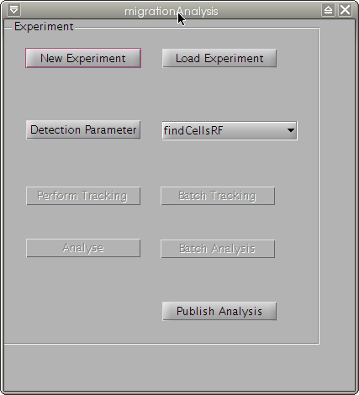Fig. 1. migrationAnalysis GUI

- New experiment. Push this button to load a image series stored as tiff format. An experiment folder with the name of the selected tiff-sequence is created and all image are extracted into the sub folder „images"; additional, the folder „results" is created.
- Load experiment. This button allows to load an experiment simply by selecting the experiment folder.
- Detection parameter. When an new experiment is created or an existing experiment was opened, the detection parameter can be set by pressing this button. This opens a new GUI, see Fig. 2. In this GUI, some detection parameters can be selected, parameters can be loaded and saved and images can be loaded. Important: to perform the tracking, the parameters needs to be saved before the GUI is closed. Note: you can select between two GUIs belonging to two different cell detection methods (segmentation algorithms). The preferred method is based on MATLABs rangefilt function and is called findCellsRF; the corresponding GUI is named findCellsRFParaGUl. You want to select this one.
- Perform Tracking. After the detection parameters are stored, the „perform Tracking" button will be enabled; push this to start the validated cell tracking.
- Batch Tracking. You can use a simple batch tracking. You only need to store all experiments you want to track in one folder. After saving the detection parameters for all experiments, you can choose the folder containing all experiments. Note: If the migrationAnalysis GUI was started with startMigrationAnalysisGui.m, the program automatically searches for MATLABs parallel processing toolbox and, if available, starts a MATLAB pool. Then, several series are tracked in parallel.
- Analyse. After tracking, several parameters are calculated and stored in the folder "results".
The results are stored as MATLAB file migrationDataValidatedPaths.mat and as CSV (comma separated values) that can be loaded into excel (or others programs). The following data is stored:

pathlength, velocity, x-fmi, y-fmi, directionality,a ngle
72, 6.112, -0.080985, -0.010836, 0.081707, -3.0086
….
- Batch Analysis. Similar to the "Batch Tracking" button, the analysis can be runs as batch analysis.
- Publish Analysis. The results are summarized in two plots stored as a website in the results folder.
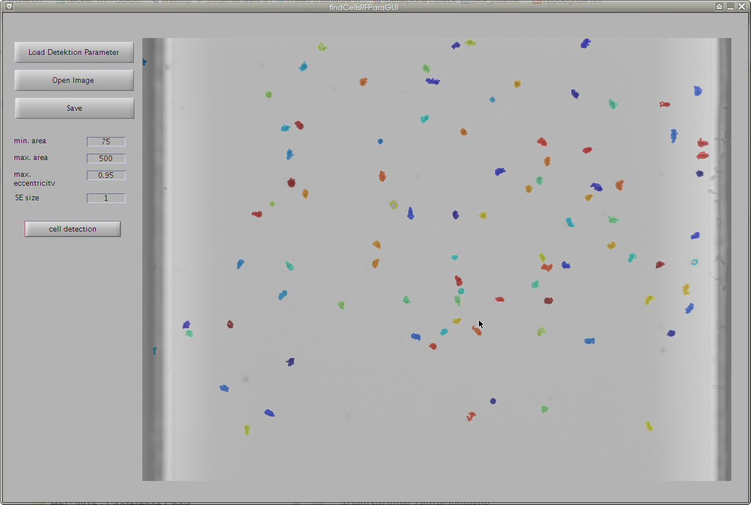Fig. 2: The GUI findCellsRFParaGUI is used to adjust the detection paramters.

