User Guide

Download or clone the matlabMigrationAnalysis repository from github, see <https://github.com/cells2numbers/matlabMigrationAnalysis>

Either download the repository as zip or clone it using

>git clone <https://github.com/cells2numbers/matlabMigrationAnalysis.git>

This clones the repository and creates the folder matlabMigrationAnalysis.

Start MATLAB and open / switch to the folder ”matlabMigrationAnalysis”. To start a migration analysis, run the script startMigrationAnalysisGui.m. This opens a simple GUI shown below.

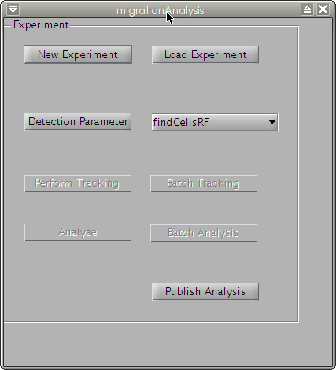

Figure . migrationAnalysis GUI

* **New experiment**. Push this button to load a image series stored as tiff format. An experiment folder with the name of the selected tiff-sequence is created and all image are extracted into the sub folder „images"; additional, the folder „results" is created.
* **Load experiment.** This button allows to load an experiment simply by selecting the experiment folder.
* **Detection parameter**. When an new experiment is created or an existing experiment was opened, the detection parameter can be set by pressing this button. This opens a new GUI, see Fig. 2. In this GUI, some detection parameters can be selected, parameters can be loaded and saved and images can be loaded. Important: to perform the tracking, the parameters needs to be saved before the GUI is closed. Note: you can select between two GUIs belonging to two different cell detection methods (segmentation algorithms). The preferred method is based on MATLABs rangefilt function and is called findCellsRF; the corresponding GUI is named findCellsRFParaGUl. You want to select this one.
* **Perform Tracking.** After the detection parameters are stored, the „perform Tracking" button will be enabled; push this to start the validated cell tracking.
* **Batch Tracking.** You can use a simple batch tracking. You only need to store all experiments you want to track in one folder. After saving the detection parameters for all experiments, you can choose the folder containing all experiments. Note: If the migrationAnalysis GUI was started with startMigrationAnalysisGui.m, the program automatically searches for MATLABs parallel processing toolbox and, if available, starts a MATLAB pool. Then, several series are tracked in parallel.
* **Analyse**. After tracking, several parameters are calculated and stored in the folder "results".

The results are stored as MATLAB file migrationDataValidatedPaths.mat and as CSV (comma separated values) that can be loaded into excel (or others programs). The following data is stored:

pathlength, velocity, x-fmi, y-fmi, directionality,a ngle

72, 6.112, -0.080985, -0.010836, 0.081707, -3.0086

….

* **Batch Analysis.** Similar to the "Batch Tracking" button, the analysis can be runs as batch analysis. Results are stored as CSV file “migrationData.csv”, the parameters are described below.
* **Publish Analysis.** The results are summarized in two plots stored as a website in the results folder.

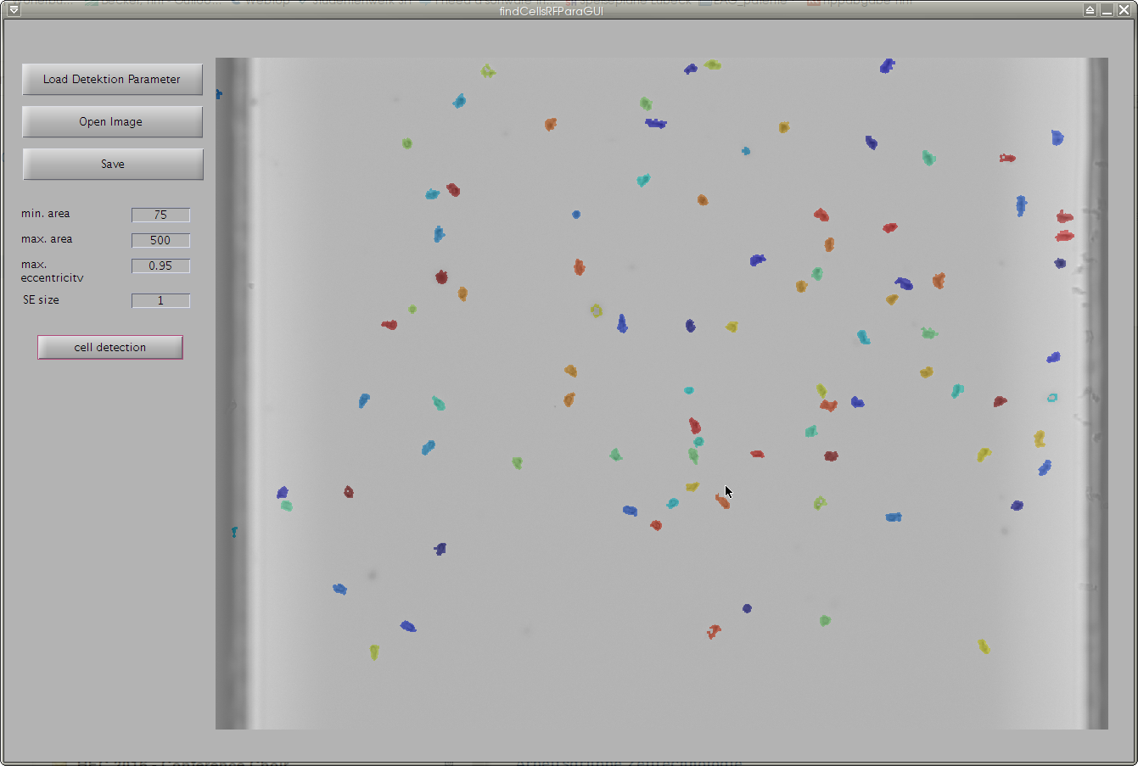

Figure . The GUI findCellsRFParaGUI is used to adjust the detection paramters.

Parameters

The following parameters are calculated.

|  |  |
| --- | --- |
| Number of paths | Number of trajectories |
| Valid paths | Number of trajectories that pass the data validation |
| Perc of valid paths | Percentage of valid paths, ie. “number of all valid paths” / “number of all paths” |
| xFMI | Forward migration index as described in http://ibidi.com/applications/chemotaxis/chemotaxis-parameters/ |
| yFMI | “ |
| Mean velocity | Mean velocity |
| Directionality | Mean directionaliy |
| Valid oberservation time | Sum of the length of all trajectories divided by the sum of the length of all trajectories |
| Perc. Turning left | Fraction of cells moving to the left |
| Perc. Turning right | Fraction of cells moving to the right |
| dist left | The mean displacement per frame of all cells moving to the left |
| acc. dist left | The accumulated distance travelled of all cells moving to the left |
| dist right | The mean displacement per frame of all cells moving to the right |
| acc. dist right | The accumulated distance travelled of all cells moving to the right |
| Velocity left | Mean velocity of all cells moving to the left |
| Velocity right | Mean velocity of all cells moving to the right |
| Velocity neutral | Mean velocity of all cells in the neutral sector |