设计与实现

——夏文馨

自己负责部分的类图：

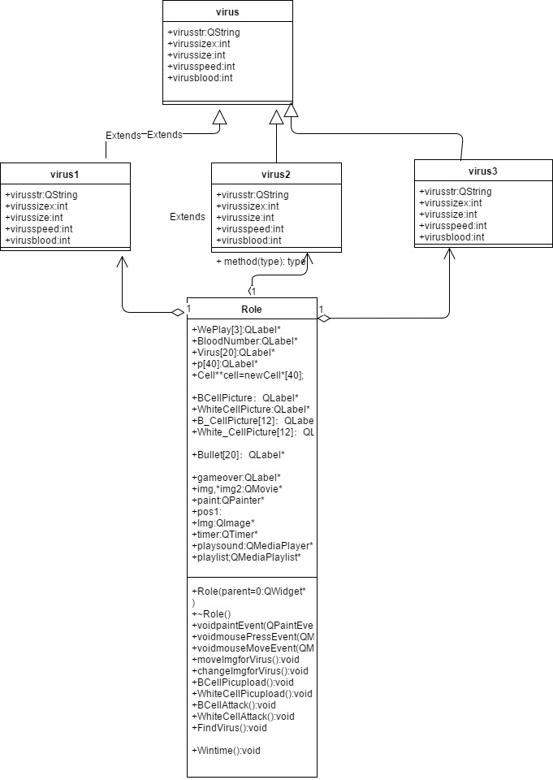

核心代码：

class virus{

public:QString virusstr;

int virussizex;

int virussizey;

int virusspeed;

int virusblood;

};

class virus1:public virus{

public:

QString virusstr=":/virus 1.png";

int virussizex=166;

int virussizey=144;

int virusspeed=3;

int virusblood=150;

};

class virus2:public virus{

public:

QString virusstr=":/virus 2.png";

int virussizex=166;

int virussizey=144;

int virusspeed=3;

int virusblood=240;

};

class virus3:public virus{

public:

QString virusstr=":/virus 3.png";

int virussizex=154;

int virussizey=160;

int virusspeed=4;

int virusblood=400;

};

virus1 v1,v2,v3,v4,v5,v6,v8,v10,v13;

virus2 v7,v9,v14;

virus3 v11,v12;

QString VirusStr[20] = {" ",v1.virusstr,v2.virusstr,v3.virusstr,v4.virusstr,v5.virusstr,v6.virusstr,v7.virusstr,

v8.virusstr,v9.virusstr,v10.virusstr,

v11.virusstr,v12.virusstr,v13.virusstr,v14.virusstr};

QString Attackstr[20] = {" ",v1.virusstr,v2.virusstr,v3.virusstr,v4.virusstr,v5.virusstr,v6.virusstr,v7.virusstr,

v8.virusstr,v9.virusstr,v10.virusstr,

v11.virusstr,v12.virusstr,v13.virusstr,v14.virusstr};

int Virus_x[20]={0,1200,1490,1500,1490,1553,2043,2102,2230,2133,3022,3290,3265,3270,3260}; //病毒初始横坐标

int Virus_line[20] = {0,1,2,3,1,2,3,1,2,3,3,3,2,2,2}; //病毒所在

int VirusSIZE_X[20]={0,v1.virussizex,v2.virussizex,v3.virussizex,v4.virussizex,v5.virussizex,v6.virussizex,v7.virussizex,v8.virussizex,v9.virussizex,v10.virussizex,v11.virussizex,v12.virussizex,v13.virussizex,v14.virussizex};

int VirusSIZE_Y[20]={0,v1.virussizey,v2.virussizey,v3.virussizey,v4.virussizey,v5.virussizey,v6.virussizey,v7.virussizey,v8.virussizey,v9.virussizey,v10.virussizey,v11.virussizey,v12.virussizey,v13.virussizey,v14.virussizey};

int VirusSpeed[20]={0,v1.virusspeed,v2.virusspeed,v3.virusspeed,v4.virusspeed,v5.virusspeed,v6.virusspeed,v7.virusspeed,v8.virusspeed,v9.virusspeed,v10.virusspeed,v11.virusspeed,v12.virusspeed,v13.virusspeed,v14.virusspeed};

int Virus_num=1; //病毒计数

int Virusblood[20]={0,v1.virusblood,v2.virusblood,v3.virusblood,v4.virusblood,v5.virusblood,v6.virusblood,v7.virusblood,v8.virusblood,v9.virusblood,v10.virusblood,v11.virusblood,v12.virusblood,v13.virusblood,v14.virusblood};

int deleteVirus[20]={0};

int dieclock[20]={0};

int Gunnum=0;

void Role::**Virusupload**(int i) //病毒加载图片

{

Virus[i]->setGeometry(QRect(Virus_x[i]+30,VirusPlace(VirusSIZE_Y[i],Virus_line[i]),VirusSIZE_X[i],VirusSIZE_Y[i]));

img = new QMovie(VirusStr[i]);

Virus[i]->setMovie(img);

img->start();

}

void Role::**moveImgforVirus**() //移动病毒

{

int k=1,exp;

for(k=1;k<=Virus_num;k++)

{

if(VirusStr[k]!=":/virus 3.png")

exp=8;

else

exp=10;

if(deleteVirus[k]==0)

{

Virus[k]->move(Virus_x[k],VirusPlace(VirusSIZE_Y[k],Virus_line[k]));

Virus_x[k]-=VirusSpeed[k];

if(Virus_x[k]<=(FindCell(k)-exp))

Virus_x[k]+=VirusSpeed[k];

if((Virus_x[k]<=957||Virus_x[k]<=800||Virus_x[k]<=600)&&call[k]==0)

{

QSound::play(":/VirusCalled.wav");

call[k]=1;

}

if((Virus_x[k]>=801)&&(Virus_x[k]<=803)||(Virus_x[k]>=601)&&(Virus_x[k]<=603))

call[k]=0;

if(Virus_x[k]+80<=245&&Gameover==0)

{

Gameover=1;

playsound->stop();

QSound::play("://losthome.wav");

}

if(Virus_x[k]<=75&&Virus_x[k]>=65&&eatBrain<=6)

{

if(eatBrain%2==0)

QSound::play(":/VirusEat.wav");

eatBrain++;

}

if(Virus_x[k]<65&&cry==0)

{

cry=1;

QSound::play("://cry.wav");

gameover->setGeometry(QRect(400,120,564,468));

img = new QMovie(":/VirusWon.png");

gameover->setMovie(img);

img->start();

}

}

}

}

int Role::**FindCell**(int k)

{

int num;

for(int u=0;u<=8;u++)

{

if( Virus_x[k]+80>=245+u*79&& Virus_x[k]+80<=245+(u+1)*79)

{

num = u;

break;

}

else

num = 8;

}

for(int i=num;i>=0;i--)

if(local[ Virus_line[k]][i+1]==1)

{

return (245+29+(i-1)*79+25);

}

return -150;

}

int Role::**FindCell2**(int k)

{

int num;

for(int u=0;u<=8;u++)

{

if( Virus_x[k]+80>=245+u*79&& Virus_x[k]+80<=245+(u+1)*79)

{

num = u;

break;

}

else

num = 8;

}

for(int i=num;i>=0;i--)

if(local[ Virus_line[k]][i+1]==1)

return (i+1);

}

void Role::**changeImgforVirus**()

{

int k=1,exp;

for(k=1;k<= Virus_num;k++)

{

if(deleteVirus[k]==0)

{

if( VirusStr[k]!=":/virus 3.png")

exp=4;

else

exp=6;

if( Virus_x[k]<=FindCell(k)&& Virus_x[k]>=FindCell(k)-exp)

{

if( VirusStr[k]==":/virus 1.png")

VirusStr[k]=":/virus 1.png";

else if( VirusStr[k]==":/virus 2.png")

VirusStr[k]=":/virus 2.png";

else if( VirusStr[k]==":/virus 3.png")

VirusStr[k]=":/virus 3.png";

img = new QMovie( VirusStr[k]);

Virus[k]->setMovie(img);

img->start();

changeAttack[k]=1;

}

if(changeAttack[k]==1&&Virus_x[k]-FindCell(k)<=exp)

{

CellBlood[localcount[Virus_line[k]][FindCell2(k)]]-=cell[localcount[Virus_line[k]][FindCell2(k)]]->*bloodloss*(); //病毒一次咬10格血

if(eatcount[k]%2==0)

{

QSound::play(":/VirusEat.wav");

}

eatcount[k]++;

if(CellBlood[localcount[ Virus_line[k]][FindCell2(k)]]<=0)

{

CellDelete[localcount[Virus_line[k]][FindCell2(k)]]=1; //该细胞已经被除

Celldelete(localcount[Virus_line[k]][FindCell2(k)]); //调用除细胞的函数

}

}

else if(( Virus_x[k]-FindCell(k)>=exp)&&changeAttack[k]==1)

{

if( VirusStr[k]==":/virus 1.png")

VirusStr[k]=":/virus 1.png";

else if( VirusStr[k]==":/virus 2.png")

VirusStr[k]=":/virus 2.png";

else if( VirusStr[k]==":/virus 3.png")

VirusStr[k]=":/virus 3.png";

img = new QMovie( VirusStr[k]);

Virus[k]->setMovie(img);

img->start();

changeAttack[k]=0;

}

}

}

}

void Role::Wintime()

{

int num=0;

if(Virus_x[11]<=1400&&sound2clock==0)

{

QSound::play("://finally.wav");

WePlay[1]->setGeometry(QRect(1366/2-126,150,252,71));

img = new QMovie("://FinalWave.gif");

WePlay[1]->setMovie(img);

QTimer::singleShot(5000,WePlay[1], SLOT(close()));

img->start();

sound2clock=1;

}

for(int h=1;h<=Virus_num;h++)

{

if(deleteVirus[h]==1)

num++;

}

if(num==Virus_num&&sound1clock==0)

{

playsound->stop();

QSound::play("://winsound.wav");

sound1clock++;

}

}