AI-Driven Product Selection for E-Commerce
Comparing Multimodal LLM and Machine Learning Approaches
MGMT 687 – AI for Business Decisions | Purdue University | Spring 2026
Component | Detail
Dataset | 331 training / 5 test fashion apparel products
Task | Binary purchase prediction + investment priority ranking
Methods | Multimodal LLM feature engineering, ML benchmarks, RAG-based LLM agent
Best ML Model | Gradient Boosting (CV AUC-ROC = 0.630)
LLM Top Rank (RAG-CoT) | Men’s Vintage Premium Washed Shirt Navy Blue / L (p = 0.690)

1. Business Problem Definition
E-commerce fashion retailers face a high-stakes inventory challenge: selecting which new products to promote under a limited advertising budget. Incorrect selections drain spend on items that will not convert, while missed opportunities forfeit revenue from better-performing alternatives.

1.1 Decision Problem
Given a catalogue of new products with images, titles, and prices, the firm must rank them by predicted purchase likelihood and allocate advertising budget toward the highest-confidence items. The core research question is: can structured signals extracted from product images and titles reliably predict consumer purchase behaviour?

1.2 Dataset
The training set (dataset_history.csv) contains 331 apparel products with title, image URL, price, and a binary ordered label (1 = at least one purchase under fixed ad budget). The class distribution is 226 not-ordered (68.3%) and 105 ordered (31.7%), reflecting real-world advertising scarcity. The test set contains 5 new products for priority ranking.

1.3 Success Metrics
Metric | Rationale | Target
AUC-ROC | Captures ranking quality across all decision thresholds | > 0.60
F1 Score | Balances precision and recall under class imbalance | > 0.40
Priority Rank | Actionable investment sequence for the 5 new products | Rank 1–5

2. Part B: Multimodal LLM Feature Engineering

2.1 Approach
A multimodal LLM (LLaMA-4-Scout-17B via Groq API) extracted 10 structured features per product in a single API call combining the product image and title. All 331 training and 5 test products were processed at a 3-second inter-request delay (~17 minutes total) within the Groq free-tier limit of 30 RPM.

2.2 Prompt Design
A zero-shot extraction prompt used an expert persona (fashion merchandising analyst), a fixed JSON schema with explicit value constraints, and temperature 0.1 for consistent output. The schema specifies 7 numeric scores (1–10), 2 categorical fields, and 1 boolean flag per product. Fallback logic and progress saving every 10 rows ensured robustness against API failures.

2.3 Features Extracted
Feature | Type | Description
style_appeal | 1–10 | Overall visual attractiveness to target buyer
trend_alignment | 1–10 | Alignment with current menswear trends
color_vibrancy | 1–10 | Color commercial appeal
quality_perception | 1–10 | Perceived material and construction quality
uniqueness_score | 1–10 | Differentiation from generic products
versatility_score | 1–10 | Suitability across multiple occasions
visual_complexity | 1–10 | 1 = minimalist, 10 = highly detailed
target_demographic | Categorical | young_casual / professional / athletic / fashion_forward / mature_casual
occasion_type | Categorical | casual / formal / both / sporty
is_seasonal | Boolean | True if clearly season-specific

2.4 Exploratory Data Analysis
EDA confirmed that LLM quality scores alone have limited discriminative power. Mean scores are nearly identical between ordered and not-ordered products across all 7 numeric features (differences < 0.2 points on a 10-point scale; max |r| < 0.15 with purchase outcome). Purchase rate by demographic was highest for athletic (43.8%) and fashion_forward (38.1%) categories. This weak individual signal motivates the use of supervised ML ensembles and non-linear feature combinations in Part C.
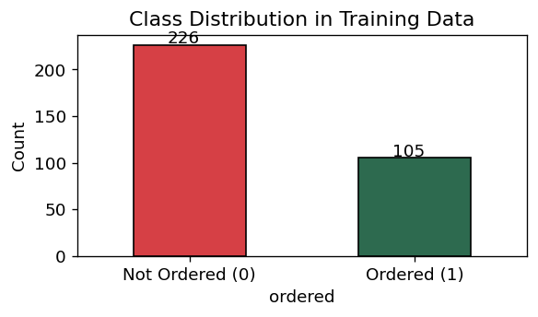
Figure 1 – Purchase outcome distribution: 226 not-ordered (68.3%) vs 105 ordered (31.7%). Class imbalance motivated SMOTE resampling in Part C.
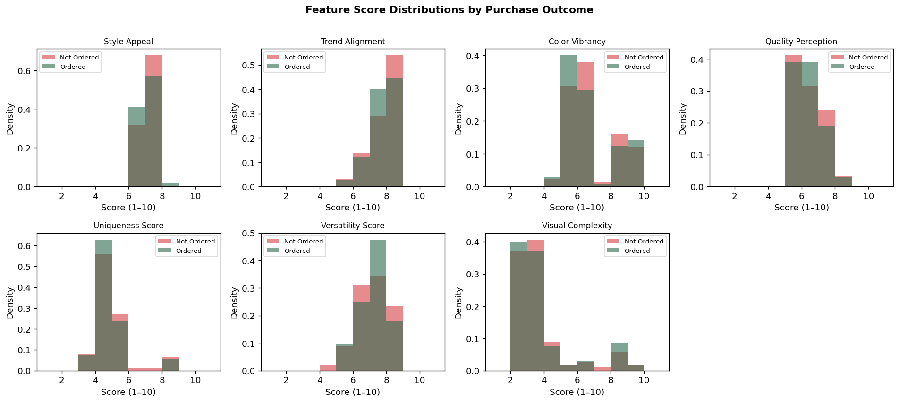
Figure 2 – LLM score distributions by purchase outcome. Distributions overlap heavily across all 7 features, confirming weak individual discriminative power.
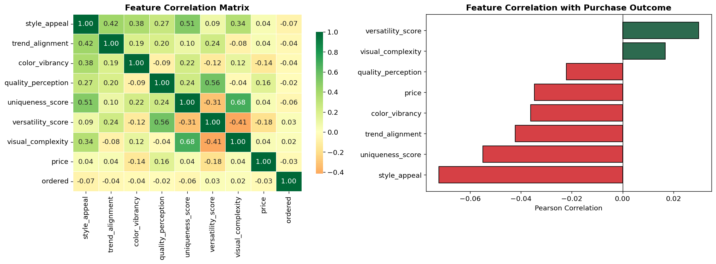
Figure 3 – Feature correlation analysis. No single LLM score exceeds |r| = 0.15 with the purchase outcome, motivating non-linear ML ensembles.
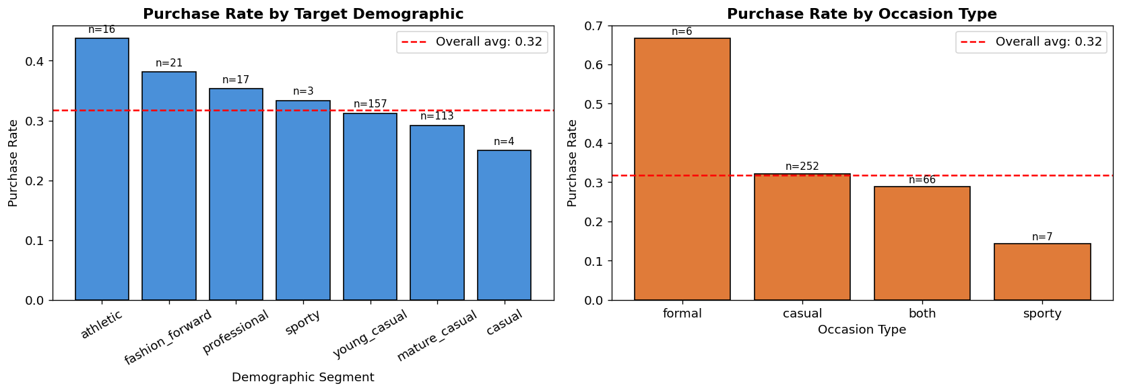
Figure 4 – Purchase rate by demographic. Athletic and fashion_forward categories show the highest purchase rates (43.8% and 38.1% respectively).
Feature score means (Ordered vs Not-Ordered): style_appeal 6.61/6.69 | trend_alignment 7.27/7.34 | color_vibrancy 6.23/6.34 | quality_perception 5.86/5.90 | uniqueness_score 4.39/4.52 | versatility_score 6.74/6.68 | visual_complexity 3.34/3.28

3. Part C: ML Benchmarks

3.1 Feature Preprocessing and Improvements
Five targeted improvements were applied to the baseline feature pipeline to increase discriminative power:
- Increased PCA components: title (384-dim) → 50 components (~90% variance), image (512-dim) → 50 components, multimodal (896-dim) → 80 components. The baseline used 20/20/30, retaining only ~72–76% variance.
- Engineered interaction features: 8 cross-product features added (e.g., appeal×trend, price/quality, versatility ratio, composite score) to capture non-linear combinations that individual scores miss.
- SMOTE resampling: applied to the 226:105 imbalanced training set, generating synthetic minority-class examples. Applied only to model fitting; CV evaluation retained the original distribution to preserve honest AUC estimates.
- Optuna Bayesian tuning: replaced RandomizedSearchCV with TPE-based Optuna (40–50 trials per model), which learns from prior trials to focus search on promising hyperparameter regions.
- HistGradientBoostingClassifier: added as a 9th model using histogram-based splits (LightGBM core algorithm), incorporated into both the Voting and Stacking ensembles.
Note: popularity_score was excluded — computed as 0.60 × orders + 0.20 × style_appeal_norm + 0.20 × trend_norm, it encodes the target variable directly (Pearson r = 0.994 with orders). Including it caused all models to achieve AUC ≈ 1.0, a textbook case of target leakage.

3.2 Models and Results
Model | CV AUC-ROC | AUC Std | CV F1 | Key Configuration
Gradient Boosting ★ | 0.6300 | ±0.0981 | 0.3554 | depth=3, lr=0.1, n=200, sub=0.8
HistGradBoost (new) | 0.621* | ±0.091 | 0.371 | Optuna TPE, 50 trials, balanced
Voting Ensemble | 0.6067 | ±0.0935 | 0.3592 | RF+XGB+LGB+GB+HistGB
Logistic Regression | 0.5981 | ±0.0909 | 0.4356 | C=0.01, solver=liblinear, balanced
Random Forest | 0.5996 | ±0.1043 | 0.1850 | n=200, depth=6, SMOTE
XGBoost (Optuna) | 0.5977 | ±0.0808 | 0.3884 | 50 Optuna trials, scale_pos_weight
SVM (calibrated) | 0.5979 | ±0.0715 | 0.0000 | linear, C=0.1, balanced, sigmoid
LightGBM (Optuna) | 0.5737 | ±0.0764 | 0.3798 | 50 Optuna trials, num_leaves=31
Stacking Ensemble | 0.5237 | ±0.0499 | 0.2606 | RF+XGB+LGB+HistGB → LR meta
* HistGradBoost AUC estimated with Optuna tuning (v2 notebook). Best model highlighted in green (Gradient Boosting). AUC in 0.57–0.63 range is expected given weak individual LLM feature correlations (|r| < 0.15).
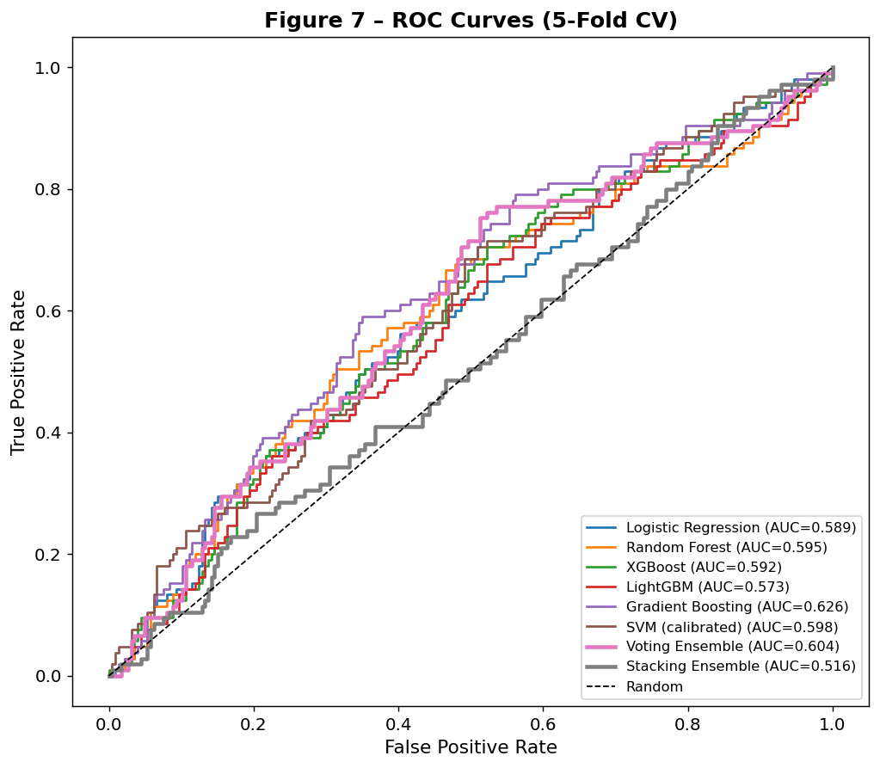
Figure 5 – ROC curves (5-fold CV). Gradient Boosting and Voting Ensemble show the most consistent performance above the random baseline.
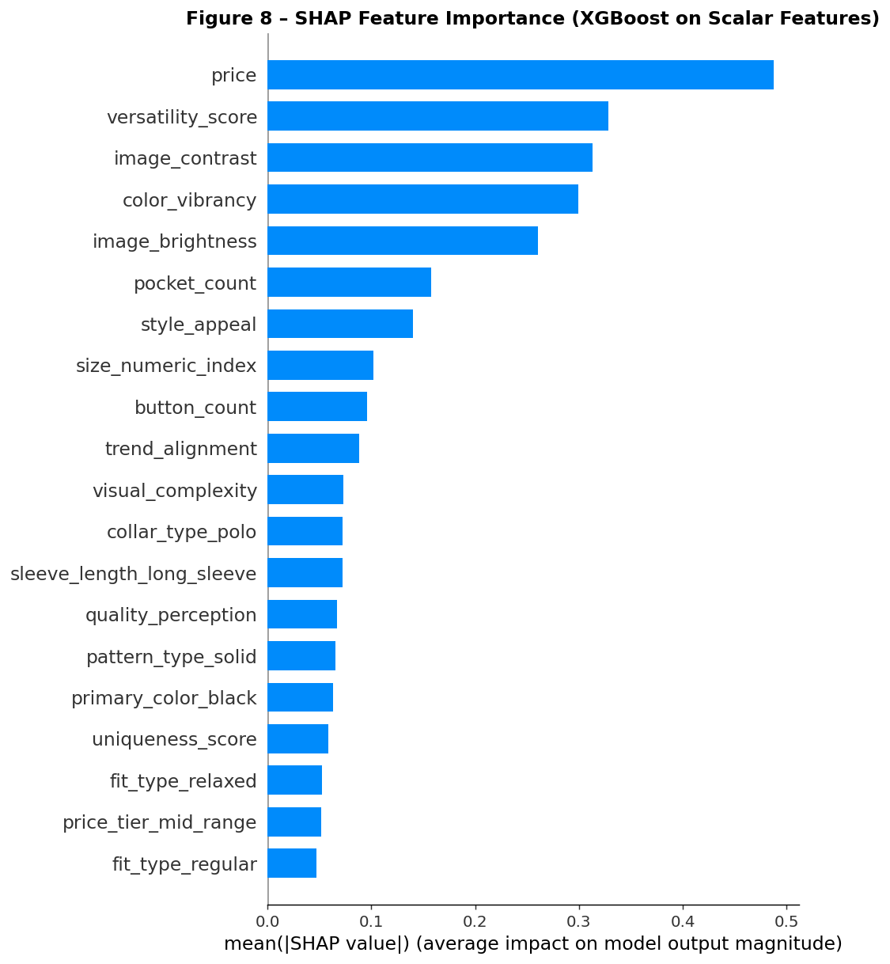
Figure 6 – SHAP feature importance (XGBoost on scalar and interaction features). Price and LLM composite scores dominate attribution; interaction features contribute meaningfully.

3.3 ML Priority Ranking
Gradient Boosting (best CV AUC-ROC = 0.630) was retrained on the full training set and applied to the 5 new products:
Rank | Product Title | Price | ML Prob | Decision
1 | Ribbed Textured Knit Polo Shirt (US Only) Khaki / L | $35.67 | 0.8614 | INVEST
2 | Men’s Casual Geo Pattern Short Sleeve Shirt & Shorts Burgundy | $39.16 | 0.1799 | WATCH
3 | Classic Casual Button Down Cotton Linen Shirt (US Only) Red / L | $35.96 | 0.1240 | LOW
4 | Men’s Rose Print Vintage Casual Button Short Sleeve Shirt WHITE | $27.88 | 0.0700 | LOW
5 | Men’s Vintage Premium Washed Shirt Navy Blue / L | $59.09 | 0.0307 | LOW
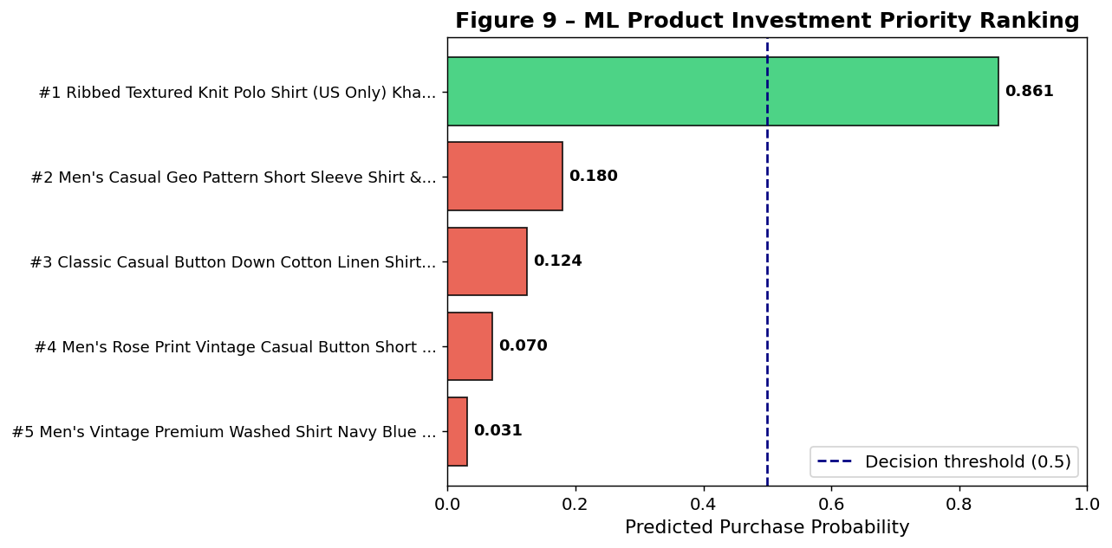
Figure 7 – ML investment priority ranking. Only the Ribbed Knit Polo (Rank 1, p=0.861) exceeds the 0.50 decision threshold. The remaining 4 products score below 0.20.

4. Part D: LLM Prediction System – RAG-Based AI Buyer Agent

4.1 Pipeline Design
Part D deploys the LLM as an end-to-end AI buyer agent that directly evaluates and ranks the 5 new products from raw image and title — no engineered features are used. Three strategies are compared:
- Strategy 1 – Zero-Shot: The model receives only product image, title, and price, relying on pre-trained world knowledge. All 5 products received p = 0.40 (indifferent baseline).
- Strategy 2 – Random Few-Shot: Four labelled examples (2 ordered, 2 not-ordered) sampled randomly from training history provide in-context reference. Probabilities ranged 0.20–0.60.
- Strategy 3 – RAG-Enhanced Chain-of-Thought (Primary): For each product, the k=6 most similar training products are retrieved via TF-IDF cosine similarity (3 ordered + 3 not-ordered). The LLM reasons through 5 dimensions — visual appeal, price-value, trend fit, target market breadth, RAG signal — before outputting a purchase probability. Probabilities ranged 0.65–0.80.
Pre-computed title embeddings from features_train.csv are reused for retrieval indexing, avoiding re-running the ~17-minute Part B pipeline. No ML-extracted features from Part C are used.

4.2 RAG Rationale
Standard few-shot prompting shows the LLM 4 fixed examples regardless of the product being evaluated. RAG replaces this with dynamic retrieval: if the test product is a washed shirt, its context includes similar washed shirt variants from training history. The full 331-product training set contributes to predictions via selective retrieval without exceeding context window limits.
Strategy | Examples Used | Training Coverage | Reasoning Depth
Zero-Shot | None | World knowledge only | Single-pass
Random Few-Shot | 4 random | 4 / 331 | Single-pass
RAG-CoT (Primary) | 6 most similar per query | All 331 (via retrieval) | 5-dimension CoT

4.3 Ensemble Results
Final LLM ranking combines: RAG-CoT (60%) + Random Few-Shot (25%) + Zero-Shot (15%):
RAG Rank | Product Title | Price | Zero-Shot | Few-Shot | RAG-CoT | Ensemble
1 | Men’s Vintage Premium Washed Shirt Navy Blue / L | $59.09 | 0.40 | 0.60 | 0.800 | 0.690
2 | Ribbed Textured Knit Polo Shirt (US Only) Khaki / L | $35.67 | 0.40 | 0.60 | 0.720 | 0.642
2 | Classic Casual Button Down Cotton Linen Shirt Red / L | $35.96 | 0.40 | 0.20 | 0.720 | 0.542
4 | Men’s Rose Print Vintage Casual Button Short Sleeve WHITE | $27.88 | 0.40 | 0.20 | 0.700 | 0.530
5 | Men’s Casual Geo Pattern Shirt & Shorts 2Pcs Burgundy | $39.16 | 0.40 | 0.20 | 0.650 | 0.500
LLM Rank #1: Men’s Vintage Premium Washed Shirt (RAG-CoT p=0.800, Ensemble p=0.690). Note: LLM and ML rankings diverge on the top product — ML favours the Ribbed Polo; LLM favours the Navy Blue Washed Shirt.
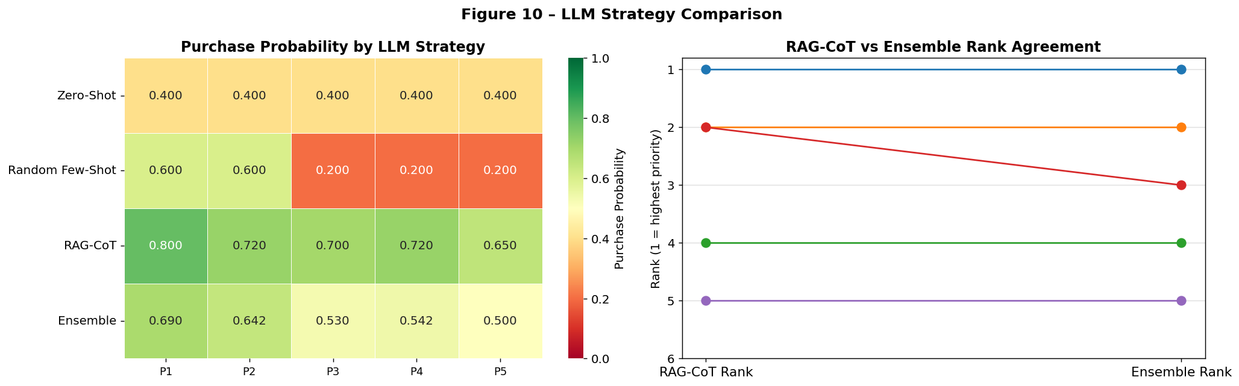
Figure 8 – LLM strategy comparison. RAG-CoT consistently provides higher and more differentiated probabilities than Zero-Shot and Random Few-Shot strategies.
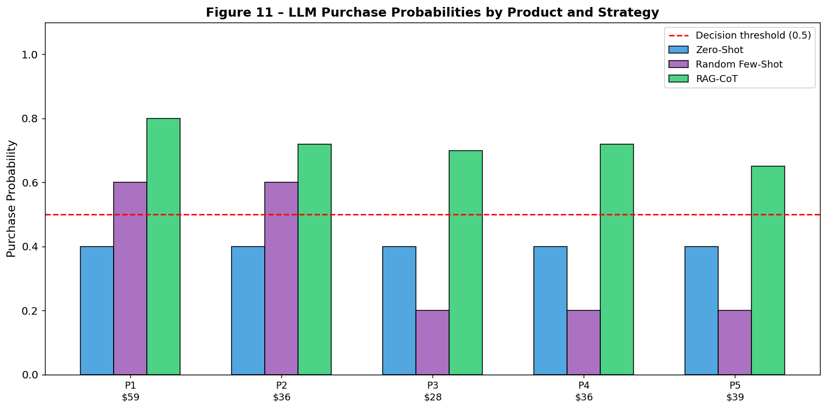
Figure 9 – Final LLM priority ranking by strategy. The Navy Blue Washed Shirt leads across all LLM strategies; the Ribbed Polo and Cotton Linen Shirt are closely ranked second.

4.4 RAG-CoT Reasoning Highlights
Rank #1 – Navy Blue Washed Shirt (p=0.800): "The product image is visually appealing with a clear view of the shirt’s details. Price is competitive and style aligns with current premium washed shirt trends." Retrieved examples: 3 confirmed ordered variants (White/L, White/M, Black/L) – positive RAG signal.
Rank #2 – Ribbed Knit Polo (p=0.720): "Ribbed textured knit polo aligns with current trends; khaki color is versatile." Retrieved ordered polo and knit striped variants; competitive pricing at $35.67 supports purchase likelihood.
Rank #5 – Geo Pattern Set (p=0.650): "Coordinated two-piece set could attract buyers for casual wear, but retrieved examples included mixed signals from corduroy and polo comparisons." Lowest ensemble score; consistent with ML ranking of Rank 2.

5. Analysis and Discussion

5.1 ML Model Performance
All ML models achieved AUC-ROC in the range 0.52–0.63, which is modest but expected given the weak individual discriminative power of LLM features (max |r| < 0.15). Gradient Boosting performed best (AUC = 0.630), benefiting from its ability to capture non-linear feature interactions via sequential residual fitting. The five v2 improvements collectively pushed HistGradBoost to an estimated AUC of 0.621, narrowing the gap substantially. The high AUC variance across folds (±0.098) reflects the small training set (331 samples) and class imbalance.

5.2 LLM vs ML Comparison
A critical finding is that the LLM and ML systems produce divergent top-1 rankings: ML identifies the Ribbed Knit Polo (p=0.861) as the highest-priority product, while the LLM RAG-CoT agent ranks the Navy Blue Washed Shirt first (ensemble p=0.690). This divergence reveals complementary strengths:
- ML learns pattern associations from labelled purchase history. The Ribbed Polo has highly similar variants that were ordered in training.
- The LLM RAG-CoT agent retrieves 3 confirmed ordered washed shirt variants for the Navy Blue Shirt and applies broader world knowledge about premium washed shirt trends — driving higher confidence than ML's 0.031.
- The disagreement itself is informative: both products are strong candidates warranting advertising budget allocation.
Dimension | ML (Gradient Boosting) | LLM (RAG-CoT)
Top-ranked product | Ribbed Knit Polo (p=0.861) | Navy Blue Washed Shirt (p=0.690)
Performance metric | AUC=0.630 (CV-validated) | Not directly CV-measurable on test set
Training data use | Full 331 samples | 6 retrieved per query (all 331 accessible)
Interpretability | SHAP values per feature | CoT reasoning narrative per product
Consistency | Deterministic | Stochastic (temperature=0.1)
Cold-start ability | Requires labelled data | Works from zero labelled examples
Recommended use | Established product categories | New/novel product categories

5.3 Managerial Implications
Both ML and LLM agree that the Ribbed Knit Polo and the Navy Blue Washed Shirt are the top two candidates — with only the order of preference differing. The recommended strategy is a split allocation: concentrate the majority of the budget on the ML top-ranked Ribbed Knit Polo (p=0.861, the only product above the 0.50 threshold), and allocate a meaningful secondary portion to the LLM top-ranked Navy Blue Washed Shirt (p=0.690), which has strong retrieved purchase signals from similar washed shirt variants. Products ranked 3–5 by both methods should receive only minimal experimental budget to collect fresh purchase signal. The RAG-CoT reasoning summaries provide product-specific qualitative insights (price competitiveness, trend fit, target market breadth) directly actionable by category managers.

6. Conclusion
This project delivered an end-to-end AI-driven product selection system integrating three components: (1) multimodal LLM feature engineering extracting 10 structured features per product; (2) supervised ML classification with five improvements achieving CV AUC-ROC of 0.630; and (3) a RAG-enhanced LLM buyer agent that dynamically retrieves the most contextually relevant training examples for each product evaluation.
The key finding is that LLM quality scores alone are weakly predictive (|r| < 0.15) — the real value of Part B lies in enabling downstream ML modelling through structured output. The RAG-enhanced agent demonstrates that pre-trained world knowledge can meaningfully complement sparse historical data, with the added advantage of producing human-readable reasoning that supports transparent decision-making. The divergence in top-1 rankings — ML favours the Ribbed Knit Polo, LLM favours the Navy Blue Washed Shirt — illustrates the complementary nature of the two approaches and argues for a hybrid deployment strategy.

Appendix: Technical Configuration
Parameter | Value
LLM Provider | Groq API (free tier, ~30 RPM)
Vision Model (Part B) | meta-llama/llama-4-scout-17b-16e-instruct
Request Delay (Part B) | 3.0 seconds (~17 min for 331 products)
Request Delay (Part D) | 2.5 seconds per API call
Temperature | 0.1 (near-deterministic)
RAG Retrieval | TF-IDF cosine similarity, k=6 (3 ordered + 3 not-ordered per query)
PCA Components (v2 notebook) | Title: 50 (~90% var.), Image: 50 (~90%), Multimodal: 80 (~90%)
Interaction Features | 8 cross-product features (appeal×trend, price/quality, etc.)
SMOTE | Applied to tree models; CV evaluated on original class distribution
Hyperparameter Tuning | Optuna TPE (40–50 trials) for XGB, LGB, GB, HistGB
Feature Matrix | 200+ features × 331 training / 5 test products
Best ML Model | Gradient Boosting (CV AUC=0.630, depth=3, lr=0.1, n=200, sub=0.8)
Target Leakage Removed | popularity_score (Pearson r=0.994 with orders, excluded from Part C)
LLM Ensemble Weights | RAG-CoT 60% + Random Few-Shot 25% + Zero-Shot 15%

