## Overview of the Election Audit

The election board has to audit the voting results of a US Congressional precinct in Colorado. The Board will use a python program to analyze the tabulated list of results within a CSV (comma separated values) file. The outputs of the analysis will include county, and candidate related statistics. The next section lists the county and candidate information required to perform the audit.

The analysis will be performed using Python programming.

## **Election-Audit Results:** Using a bulleted list, address the following election outcomes. Use images or examples of your code as support where necessary.

* + How many votes were cast in this congressional election?

**There were 369.711 vote cast in this congressional election.**

* + Provide a breakdown of the number of votes and the percentage of total votes for each county in the precinct.

**Jefferson county: 10.5% (38,855)**

**Denver: 82.8% (306,055)**

**Arapahoe: 6.7% (24,801)**

* + Which county had the largest number of votes?

**Denver had the largest number of votes**

* + Provide a breakdown of the number of votes and the percentage of the total votes each candidate received.

**Charles Casper Stockham: 23.0% (85,213)**

**Diana DeGette: 73.8% (272,892)**

**Raymon Anthony Doane: 3.1% (11,606)**

* + Which candidate won the election, what was their vote count, and what was their percentage of the total votes?

**Winner: Diana DeGette**

**Winning Vote Count: 272,892**

**Winning Percentage: 73.8%**

## **Election-Audit Summary:** In a summary statement, provide a business proposal to the election commission on how this script can be used—with some modifications—for any election. Give at least two examples of how this script can be modified to be used for other elections.

In order to be used for any election, the following changes will need to be made

### Modification 1

We have to introduce another CSV file (*Election_Type*) which contains a list of candidates and the office they are candidates. The new file would contain the following format. There would be two sets of data required to perform the analysis. The first file will be the election data as previously and the second file would contain the **<Candidate Name>, <Office Type>, <State>, <Party>. An entry in this new file could look like this:**

*Biden, President, US*

**Another entry could look like this:**

*Phill Murphy, Governor, New Jersey*

Within the program the code, will remain the same. Once the election results file is scanned and candidate winner is computed, we will cross reference from the *Election_Type* file, the winner for the specific election

### Modification 2

The output of the files or the artifacts of analysis have to be adjusted within the code. This would no longer be hardcoded or specified as county related data. It will have to be determined from the accompanying Election_Type. Based on the type we can determine what the output would be. In order to facilitate this, the print statement would have to be dynamic.

For example, if it were a senate election, it would have to include State information as well as party information*.*

### Printout of the Notepad txt file

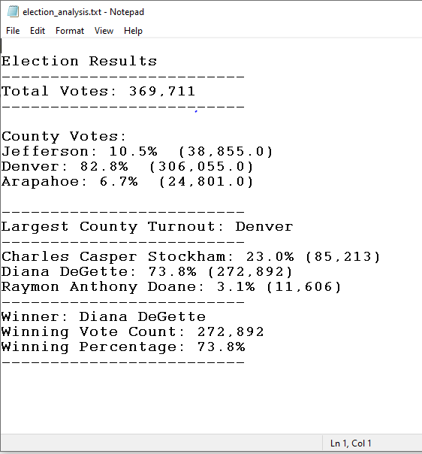

### Printout of the console

