APACHE

sudo apt-get install libapr1-dev libaprutil1-dev





sudo unzip pcre-8.42.zip

./configure --prefix=/usr/local/pcre

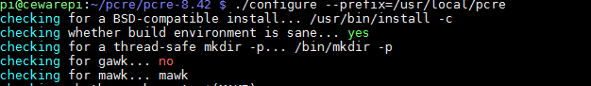

make

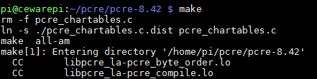

sudo make install

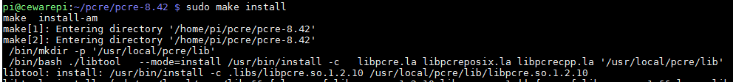

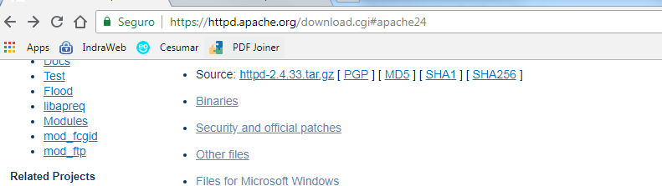

tar –xvzf httpd-2.4.33.tar.gz

sudo ./configure --prefix=/usr/local/apache2 --with-pcre=/usr/local/pcre --enable-module=so

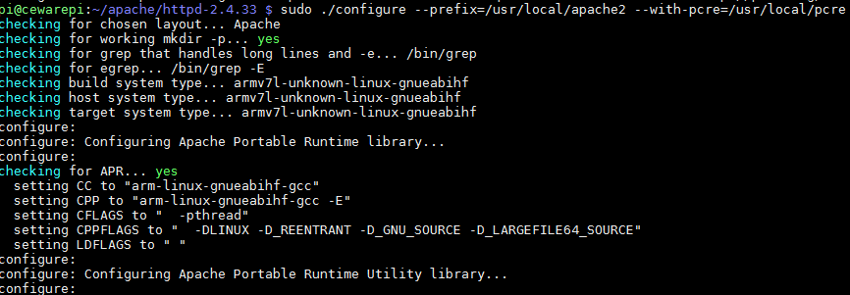

make

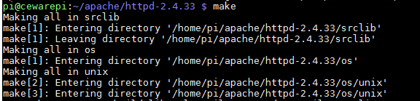

sudo make install

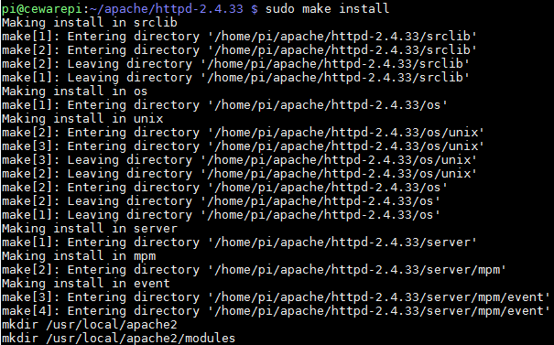

./usr/local/apache2/bin/apachectl start

PHP

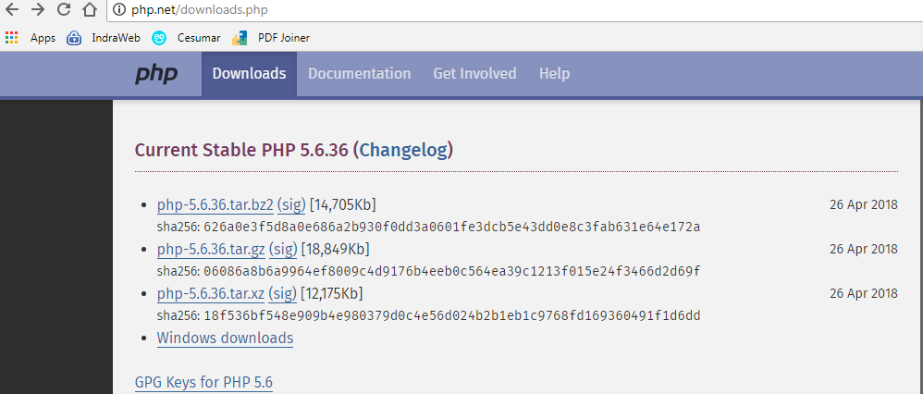

tar –xvzf php-5.6.36.tar.gz

sudo apt-get install libxml2-dev

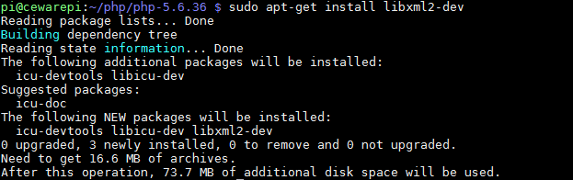

sudo ./configure --prefix=/opt/php-5.6 --with-apxs2=/usr/local/apache2/bin/apxs

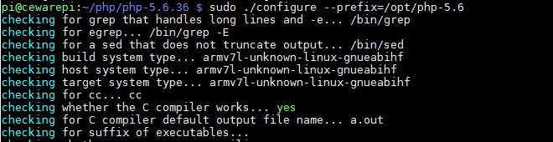

sudo make

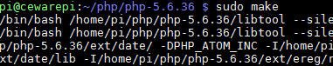

sudo make install

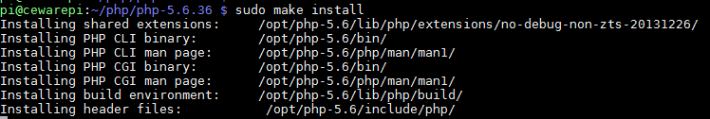

﻿**vi /usr/local/apache2/conf/httpd.conf**

﻿LoadModule php5_module        modules/libphp5.so

﻿DirectoryIndex **index.php** index.html index.html.var

﻿AddType application/x-httpd-php .php

apachectl stop

apachectl start

POSTGRESQL:

wget -c https://ftp.postgresql.org/pub/source/v10.0/postgresql-10.0.tar.gz

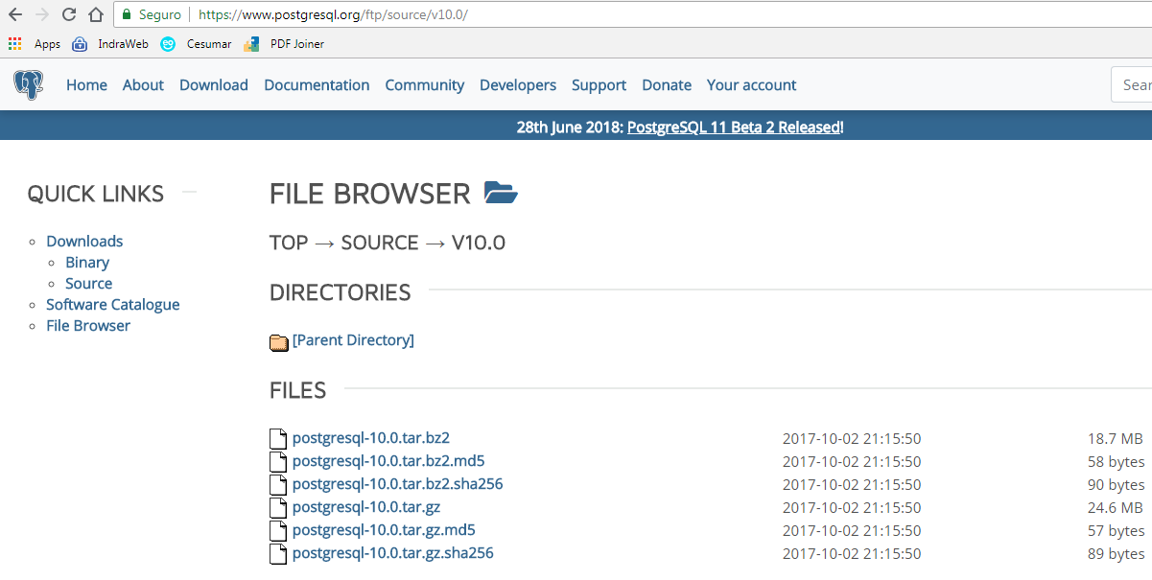

tar -xvzf postgresql-10.0.tar.gz

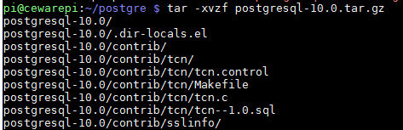

sudo apt-get install libreadline-dev

sudo apt-get install libreadline6

sudo apt-get install zlib1g-dev

sudo apt-get install libxslt1-dev

./configure --prefix=/usr/local/pgsql --with-libxml --with-libxslt

sudo make

sudo make install

﻿useradd -m postgres

su posgtes

bash

mkdir /home/postgres/data

su root

ln -s /home/postgres/data /usr/local/pgsql/data

su postgres

chmod 0700 /home/postgres/data

./initdb -U postgres -E utf8 -W -D /usr/local/pgsql/data

Edite o arquivo /home/postgres/data/postgresql.conf e retire o # da linha:

#listen_addresses = 'localhost'

Edite também o arquivo /home/postgres/data/pg_hba.conf e insira ao final dele a linha:

host all all 127.0.0.1 255.255.255.255 md5

su root

chown -R postgres:postgres /usr/local/pgsql

su postgres

bash

./pg_ctl -D /usr/local/pgsql/data -l /usr/local/pgsql/data/logfile start

#Shell para inciar/parar:

/usr/local/pgsql/startPostgre.sh

#Conectar pelo psql

psql -h 127.0.0.1 -p 5432 -U postgres -W

#PGADMIN

apt install virtualenv python-pip libpq-dev python-dev

cd /home/your_user/

virtualenv pgadmin4

cd pgadmin4

source bin/activate

wget -c <https://ftp.postgresql.org/pub/pgadmin/pgadmin4/v2.1/pip/pgadmin4-2.1-py2.py3-none-any.whl>

pip install /home/ceware/TCC/Instaladores/PostgreSQL/pgadmin4/pgadmin4-2.1-py2.py3-none-any.whl

cd lib/python2.7/site-packages/pgadmin4

touch config_local.py

cd ../../../

python python2.7/site-packages/pgadmin4/pgAdmin4.pyc

<http://127.0.0.1:5050>

CREATE DATABASE tcc

WITH

OWNER = postgres

ENCODING = 'UTF8'

LC_COLLATE = 'pt_BR.UTF-8'

LC_CTYPE = 'pt_BR.UTF-8'

TABLESPACE = pg_default

CONNECTION LIMIT = -1;

POSTGIS:

wget -c <http://download.osgeo.org/geos/geos-3.7.0rc1.tar.bz2>

tar -jxvf geos-3.7.0rc1.tar.bz2

cd geos-3.7.0

./configure

make

make install

wget -c <http://download.osgeo.org/proj/proj-5.1.0.tar.gz>

tar -xvzf proj-5.1.0.tar.gz

cd proj-5.1.0

./configure

make

make install

apt-get install gdal-bin libgdal-dev libgdal20 libsfcgal-dev libsfcgal1

cd postgis-2.4.4

./configure --with-pgconfig=/usr/local/pgsql/bin/pg_config --with-sfcgal=/usr/bin/sfcgal-config

make

make install

cd extensions

cd postgis

make clean

make

make install

cd ..

cd postgis_topology

make clean

make

make install

cd ..

cd postgis_sfcgal

make clean

make

make install

cd ..

cd address_standardizer

make clean

make

make install

make installcheck

cd ..

cd postgis_tiger_geocoder

make clean

make

make install

make installcheck

#Select para ver se a extensão está habilitada:

SELECT name, default_version,installed_version

FROM pg_available_extensions WHERE name LIKE 'postgis%' or name LIKE 'address%';

#Conectar no banco que for usar (não rodar esses commandos no banco postgres)

CREATE EXTENSION postgis;

CREATE EXTENSION postgis_sfcgal;

--CREATE EXTENSION fuzzystrmatch;

CREATE EXTENSION address_standardizer;

CREATE EXTENSION address_standardizer_data_us;

--CREATE EXTENSION postgis_tiger_geocoder;

CREATE EXTENSION postgis_topology;

/*CREATE TABLE gtest ( gid serial primary key, name varchar(20)

, geom geometry(LINESTRING) );*/

/*INSERT INTO gtest (GID, NAME, GEOM)

VALUES (1, 'First Geometry', ST_GeomFromText('LINESTRING(2 3,4 5,6 5,7 8)'));*/

SELECT gid, name, ST_AsText(geom) AS geom FROM gtest;

https://postgis.net/docs/manual-2.4/postgis-br.html