cb-analytics-mcp
A standalone MCP server and admin GUI for Couchbase Enterprise Analytics and Capella Analytics
Version 1.0.0
Documentation
© 2026 Chris Ahrendt — MIT License
https://github.com/celticht32/cb-analytics-mcp

Table of contents
Open in Microsoft Word and press F9 (or right-click the TOC below and choose "Update Field") to populate with page numbers.
1. Overview
2. Installation
3. Configuration
4. Connecting Claude
5. GUI walkthrough
6. Tool reference
7. Observability
8. Security model
9. Deployment
10. Architecture

Overview

A standalone MCP (Model Context Protocol) server plus admin GUI for Couchbase Enterprise Analytics and Couchbase Capella Analytics. Connects to Claude (claude.ai, Claude Desktop, Claude Code) and exposes the full Analytics REST surface as 55 well-typed, audited tools.
© 2026 Chris Ahrendt — MIT licensed

What you get
• 55 MCP tools spanning query execution, schema introspection, ingestion control, link management, UDF libraries, RBAC, cluster admin, and Capella cloud management.
• Paginated queries for large result sets, with TTL caching for repeated reads, an explain_query tool for plan investigation, and a configurable soft cap on full-result queries (default 1000 rows; truncated responses include truncated: true and full_row_count).
• Rate limiting per API key, per tool category (10 query/sec, 60 read/sec, 1 write/sec by default) so a runaway client can't melt your cluster.
• Multi-cluster support out of the box (one process, many Couchbase clusters).
• Bundled web GUI at :8080 with login, SQL++ editor, paginated audit-log viewer with date / tool / failure filters, per-cluster Test Connection buttons, config explorer, and live log tail (WebSocket-streamed, with HTMX polling fallback).
• CLI for testing tools without a running server (cb-analytics-mcp tools call <name> --offline) or against a remote one (--remote URL).
• Structured logging + audit trail + Prometheus metrics + OpenTelemetry tracing — all opt-in but on by default for the basics. Audit log rotates at 10 MB by default and keeps 5 generations.
• Hardened HTTP client with retry, exponential backoff, async-native circuit breaker, and consistent error mapping.
• Strict scans — every release passes pyflakes, ruff, mypy strict, bandit, and pytest with 94 %+ coverage.

Quickstart
# 1. Clone and install
git clone https://github.com/celticht32/cb-analytics-mcp
cd cb-analytics-mcp
make dev

# 2. Configure
cp .env.example .env
$EDITOR .env # set MCP_API_KEY, CB_ANALYTICS_HOST, etc.

# 3. Run
make run # starts MCP server on :8000 + GUI on :8080
Then open http://localhost:8080 in a browser, or point Claude at http://localhost:8000/mcp with the bearer token you set as MCP_API_KEY.
For reproducible builds in CI / Docker, install from the locked requirements.txt instead of pyproject.toml:
pip install -r requirements.txt
pip install --no-deps -e .
Contributors can opt in to pre-commit hooks (ruff, mypy, bandit run on every commit):
pip install pre-commit && pre-commit install

Documentation
• Installation
• Configuration
• Connecting Claude.ai / Desktop / Code
• GUI walkthrough
• Tool reference (all 55 tools)
• Observability — logs, metrics, traces, audit
• Security model
• Deployment (Docker, Compose, TLS)
• Architecture

Project layout
cb-analytics-mcp/
├── src/cb_analytics_mcp/
│ ├── auth.py # bearer-token verifier
│ ├── config.py # env-driven config loader
│ ├── pool.py # connection pool (clusters + Capella)
│ ├── server.py # FastMCP wire-up
│ ├── __main__.py # entrypoint (server / GUI / --check)
│ ├── couchbase/ # internal HTTP client (no SDK dep)
│ ├── observability/ # logging, audit, metrics, tracing
│ ├── tools/ # 10 modules × 55 MCP tools
│ └── gui/ # FastAPI + HTMX admin GUI
├── tests/unit/ # 411 unit tests, mocked I/O
├── docs/ # MkDocs-ready Markdown
├── .claude/skills/ # 8 Claude Code skills
├── scripts/ # deep_scan.sh, make_screenshots.py
└── pyproject.toml

Make targets
target | description
make dev | Install with dev extras (pytest, ruff, mypy, bandit, playwright)
make run | Run MCP server + GUI
make gui | Run just the GUI
make test | Run unit tests
make coverage | Tests with HTML coverage report, 95.66 % currently
make scan | pyflakes + ruff + mypy + bandit + tests
make screenshots | Generate documentation screenshots via Playwright
make docker | Build the Docker image

Quality bar
Every release must pass make scan. Current numbers:
metric | value
Unit tests | 519 ✓
Coverage | 94.04 %
pyflakes / ruff / mypy strict / bandit / pip-audit | ✓ clean
Python | 3.11, 3.12, 3.13

Future possibilities
Things that aren't built yet but would be obvious next steps. Issues and PRs welcome on any of these:
• Query history in the GUI. The query editor loses your statement on page reload. A small dropdown of recent queries (in-memory only, scoped to the current GUI session) would be ergonomic. The audit log already has every executed statement; this is just surfacing it in the editor.
• DDL helper tools. create_dataverse, create_dataset, drop_dataset, create_index, drop_index as typed tools instead of relying on Claude to compose raw SQL++. Safer, less ambiguous.
• Bucket / scope / collection awareness. Today's schema tools work at dataverse level, but real Couchbase deployments use buckets → scopes → collections. list_buckets, list_scopes(bucket), list_collections(...) would help Claude navigate clusters it hasn't seen before.
• Integration tests against a real Couchbase. The 519 unit tests use mocks; a small tests/integration/ suite that spins up couchbase/server:enterprise-7.6 in a Docker container would catch things mocks can't (real timeouts, real auth flows, edge cases in the Analytics REST surface).
• Per-team / per-project API keys. Today the MCP server accepts a single bearer token. Larger deployments would want per-team tokens with their own audit attribution and RBAC scope.
• Tracing across the Couchbase REST boundary. OpenTelemetry currently stops at the MCP boundary. Instrumenting the outgoing httpx requests would give full traces from Claude → MCP → Couchbase.
• Distributed rate limits / pagination state. The current implementations are in-process. Scaling out horizontally would need a shared store (Redis or similar).

Acknowledgements
This project speaks to Couchbase through its public REST API. It is not an official Couchbase product. "Couchbase" and "Couchbase Capella" are trademarks of Couchbase, Inc.

License
MIT — see LICENSE.

Installation

Requirements
• Python 3.11, 3.12, or 3.13
• Network access from the server to your Couchbase management port (8091 / 18091) and Analytics port (8095 / 18095)
• For Capella tools: a Capella Management API key

Install from source
git clone https://github.com/celticht32/cb-analytics-mcp
cd cb-analytics-mcp
make dev
make dev creates a virtualenv at .venv/ and installs runtime + dev dependencies.
If you prefer a one-shot install without the venv wrapper:
pip install -e ".[dev]"

First run
cp .env.example .env
# Edit .env to set MCP_API_KEY, CB_ANALYTICS_HOST, CB_ANALYTICS_PASSWORD,
# GUI_PASSWORD, GUI_SESSION_SECRET.
make run
You should see two ports listening:
[info] server_starting host=0.0.0.0 mcp_port=8000
[info] gui_app_built host=0.0.0.0 gui_port=8080
Visit http://localhost:8080 to see the GUI; sign in with GUI_USERNAME / GUI_PASSWORD.

Validate without running
--check validates the configuration and exits:
cb-analytics-mcp --check
A clean run prints config_valid and exits 0.

Calling tools from the command line
There's a CLI for invoking individual MCP tools without going through Claude. Useful for smoke-testing config, scripting, and debugging.
# List all registered tools
cb-analytics-mcp tools list

# Filter by rate-limit category
cb-analytics-mcp tools list --category write

# Call a tool in offline mode (instantiates the client pool in-process)
cb-analytics-mcp tools call list_dataverses --offline

# Call with arguments — JSON-parses values when possible, falls back to string
cb-analytics-mcp tools call execute_query_readonly \
--arg statement='SELECT * FROM Default.Books LIMIT 5' \
--arg cluster=prod \
--offline

# Call against a running server
cb-analytics-mcp tools call list_users \
--remote http://localhost:8000/mcp
# (reads MCP_API_KEY from the environment for the bearer token)
Offline mode runs the same _impl() function the MCP server would call, using your env config to build a real client pool. Remote mode sends an MCP JSON-RPC tools/call request to a running server. Both pretty-print the response to stdout and exit non-zero on tool-level errors so the CLI works in shell pipelines.

Generating screenshots
The docs include screenshots regenerated locally by:
make screenshots
This launches an in-process FastAPI server, drives a headless Chromium through every page, and writes PNGs into docs/img/.

Docker
A Dockerfile and docker-compose.yml are provided for production use. See Deployment.

Configuration
Every setting is environment-driven. Set them via .env (loaded by your process supervisor) or directly in the shell. The single-source-of-truth example is .env.example at the repository root.

MCP server
variable | default | description
MCP_API_KEY | (required) | Bearer token Claude must send. Min 32 chars. Generate with python -c "import secrets; print(secrets.token_urlsafe(48))".
MCP_HOST | 0.0.0.0 | Bind address.
MCP_PORT | 8000 | Listen port.
MCP_SERVER_URL | http://localhost:8000 | Public URL when behind a TLS proxy. Used in OAuth metadata.
MCP_ISSUER_URL | same as above | OAuth issuer URL.

Couchbase cluster (single-cluster mode)
variable | default | description
CB_ANALYTICS_HOST | (required) | Host or IP of the cluster.
CB_ANALYTICS_USERNAME | Administrator | Couchbase user.
CB_ANALYTICS_PASSWORD | (required) | Password (stored as SecretStr).
CB_ANALYTICS_CLUSTER_NAME | default | Logical name shown in MCP tools.
CB_ANALYTICS_TLS | false | Use HTTPS.
CB_ANALYTICS_VERIFY_SSL | true | Verify cluster TLS certs.
CB_ANALYTICS_MGMT_PORT | 8091 | Management REST port.
CB_ANALYTICS_ANALYTICS_PORT | 8095 | Analytics REST port.
CB_ANALYTICS_TIMEOUT_SECONDS | 60 | Per-request timeout.
CB_ANALYTICS_MAX_RETRIES | 3 | Retries on connection error / 5xx.

Multi-cluster
To serve more than one cluster from one process, point to a JSON file:
CB_ANALYTICS_CLUSTERS_FILE=/etc/cb-analytics-mcp/clusters.json
The file is a JSON array of cluster objects — see config/clusters.example.json. When this variable is set the single-cluster env vars above are ignored.

Capella (optional)
variable | default | description
CB_CAPELLA_API_KEY_SECRET | unset | If set, enables the 9 capella_* tools.
CB_CAPELLA_BASE_URL | https://cloudapi.cloud.couchbase.com | Capella v4 API root.

GUI
variable | default | description
GUI_ENABLED | true | Toggle the bundled admin GUI.
GUI_HOST | 0.0.0.0 | Bind address.
GUI_PORT | 8080 | Listen port.
GUI_USERNAME | admin | Login username.
GUI_PASSWORD | (must be set if GUI on) | Login password.
GUI_SESSION_SECRET | (must be set) | Secret used to sign session cookies. Min 32 chars.

Observability
variable | default | description
LOG_LEVEL | INFO | DEBUG / INFO / WARNING / ERROR.
LOG_FORMAT | json | json (production) or console (dev).
LOG_FILE | (stdout only) | Optional file path. Live log tail in the GUI reads from this file.
AUDIT_LOG_ENABLED | true | Disable to skip the audit log entirely.
AUDIT_LOG_FILE | ./audit.log | Where audit records are appended.
OTEL_ENABLED | false | Enable OpenTelemetry tracing.
OTEL_EXPORTER_OTLP_ENDPOINT | unset | OTLP collector URL when tracing is on.
OTEL_SERVICE_NAME | cb-analytics-mcp | Service name for spans.
METRICS_ENABLED | true | Expose Prometheus metrics.
METRICS_PORT | 9100 | Where the metrics endpoint listens.

Limits
Safety limits with defaults tuned for typical single-operator deployments. Tune them if your traffic shape or dataset size demands it.
variable | default | description
MAX_QUERY_ROWS | 1000 | Soft cap on execute_query / execute_query_readonly. Responses include truncated: true and full_row_count when the cap kicks in. 0 disables the cap entirely. Use execute_query_paginated for the full result.
RATE_LIMIT_QUERY_PER_SEC | 10 | Token-bucket rate for execute_query*, explain_query, infer_schema. Per API key.
RATE_LIMIT_READ_PER_SEC | 60 | Token-bucket rate for read-only tools (list, get, ping, who_am_i, …). Per API key.
RATE_LIMIT_WRITE_PER_SEC | 1 | Token-bucket rate for mutating tools (upsert/delete user, links, cluster restarts, capella mutations, …). Per API key. Intentionally conservative — fingers-crossed-no-runaway.
AUDIT_ROTATE_BYTES | 10485760 (10 MB) | Rotate the audit log when it exceeds this size. 0 falls back to a plain unrotated FileHandler.
AUDIT_ROTATE_KEEP | 5 | How many rotated generations to keep (audit.log.1 … audit.log.N).

When a tool call hits a rate limit, the response is:
{
"ok": false,
"error": "RateLimitExceeded",
"message": "Rate limit exceeded for category 'write' (limit 1/sec). Retry in 0.83s.",
"category": "write",
"rate_per_sec": 1,
"retry_after_sec": 0.83
}
Claude is told about these fields in tool descriptions and will back off automatically. If you're calling tools directly (e.g. via the tools call CLI), respect retry_after_sec.

Validating
Use cb-analytics-mcp --check to validate the active configuration without starting any servers. It returns 0 on success and prints a redacted summary; on failure it returns 2 and prints the errors.
$ cb-analytics-mcp --check
[info] config_valid config={
"mcp": {"host": "0.0.0.0", "port": 8000, "api_key_set": true, ...},
"clusters": [{"name": "prod", "host": "prod.example.com", ...}],
"gui": {"enabled": true, "host": "0.0.0.0", "port": 8080, ...},
"observability": {"log_level": "INFO", "audit_log_enabled": true, ...}
}

Connecting Claude
This server speaks the Model Context Protocol (MCP) over Streamable HTTP. The same endpoint works from claude.ai, Claude Desktop, and Claude Code.

URL & token
URL: http(s)://<your-server>:8000/mcp
Auth: Bearer <MCP_API_KEY>
MCP_API_KEY is the token you set in .env. Treat it as a secret; it has the full power of every tool the server exposes.

claude.ai (web)
1. Open Settings → Connectors → Add custom connector.
2. Name: cb-analytics-mcp (or whatever you like).
3. URL: https://your-server.example.com/mcp (HTTPS required by claude.ai).
4. Auth: paste your MCP_API_KEY.
5. Save and toggle the connector on for a new conversation.
You should see the 55 tools listed when you click the connector's name in the conversation. Ask Claude "Use cb-analytics-mcp to list the dataverses in my production cluster" to confirm.

Claude Desktop
In ~/.config/Claude/claude_desktop_config.json (Linux) or the equivalent on macOS / Windows:
{
"mcpServers": {
"cb-analytics-mcp": {
"url": "http://localhost:8000/mcp",
"headers": {
"Authorization": "Bearer YOUR_MCP_API_KEY"
}
}
}
}
Restart Claude Desktop to pick up the change.

Claude Code
claude mcp add cb-analytics --url http://localhost:8000/mcp --token "$MCP_API_KEY"
Then from any Claude Code session, ask "Show me the recent slow queries in Analytics" — Claude will discover and call the right tools.

Verifying the server is up
The server exposes a streamable HTTP MCP endpoint; the simplest sanity check is to query the GUI (which uses the same process):
curl http://localhost:8080/login
# → HTML response, status 200
And the metrics endpoint:
curl http://localhost:9100/metrics | head
# → # HELP cb_analytics_mcp_clusters_configured ...

What gets sent over the wire
Claude never sees:
• Cluster passwords (held inside SecretStr, not transmitted).
• Capella API keys.
• Session secrets.
• Any value whose key matches the redactor pattern (see Security).
Every tool invocation appears in the audit log with redacted args and the result summary.

Troubleshooting
symptom | cause | fix
401 Unauthorized from claude.ai | wrong / missing MCP_API_KEY | re-paste the token, check for trailing newlines
Connection refused | server not listening on the URL claude.ai sees | ensure the URL is reachable from claude.ai's egress
Tools listed but every call returns AnalyticsAuthError | cluster credentials in .env are wrong | run cb-analytics-mcp --check and try ping_cluster in the GUI
Cluster unreachable in dashboard | network or firewall | open management + analytics ports from MCP server to cluster

GUI walkthrough
The bundled GUI is at http://<host>:8080 and shares the same process as the MCP server. It exists for operators who want a quick, read/write, human-friendly view alongside what Claude is doing.

Login
Credentials come from GUI_USERNAME and GUI_PASSWORD. The submit handler uses hmac.compare_digest to avoid timing leaks.
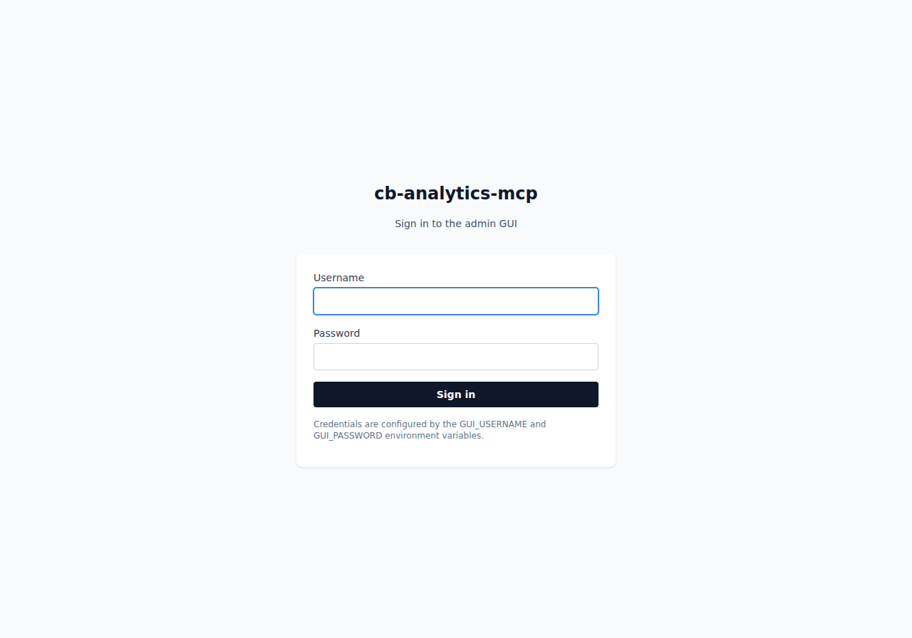
Figure 1. The login page. Credentials come from GUI_USERNAME and GUI_PASSWORD.

Dashboard
The landing page summarises cluster reachability and recent activity. Each cluster gets a row with a live "Reachable" / "Unreachable" badge driven by AnalyticsClient.ping().
Every cluster row has a Test button. Pressing it issues a fresh ping to that cluster (without reloading the page) and replaces the button with either a green "reachable in N ms" indicator or a red "failed after N ms" indicator. Useful for verifying your cluster config after editing .env or restarting Couchbase without waiting for the next page refresh.
The "Recent tool activity" table reads the tail of the audit log, so you can see what Claude is doing in (near) real time.
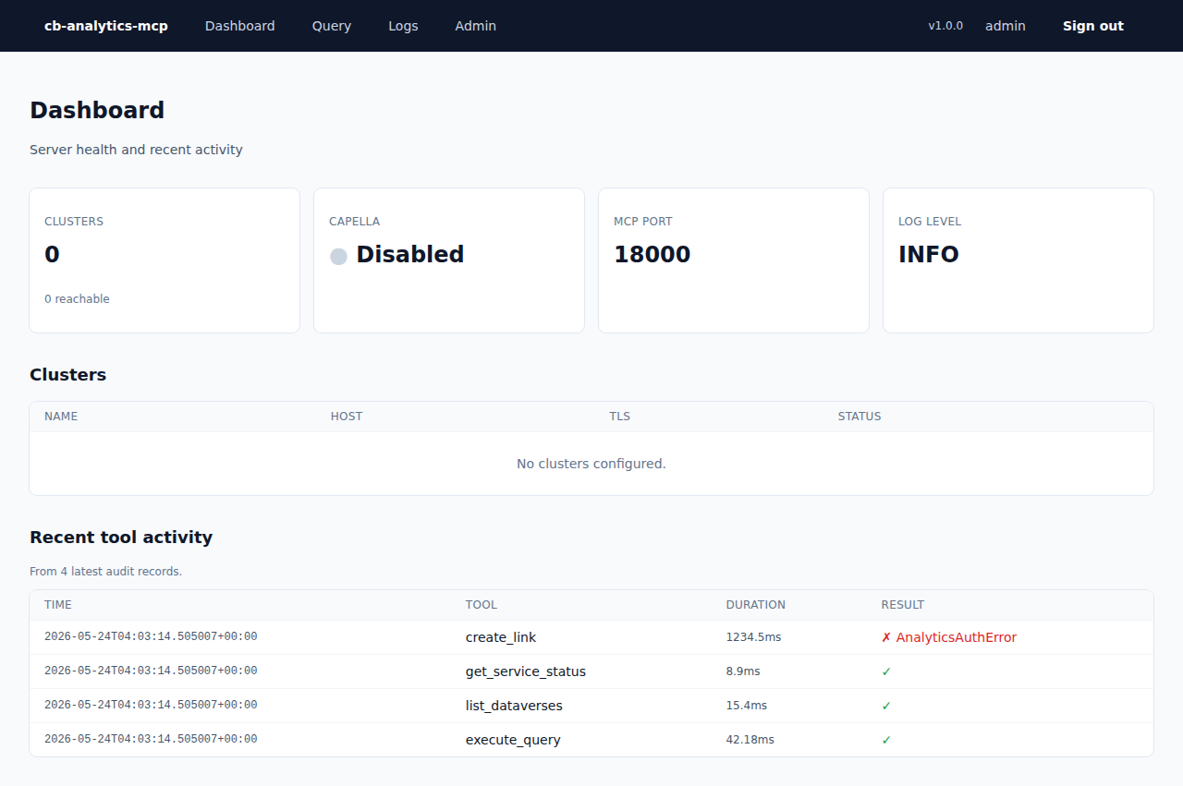
Figure 2. The dashboard — cluster reachability and recent tool activity.

Query editor
/query lets you run arbitrary SQL++ against any configured cluster. The form posts to /query/run and HTMX-swaps the result fragment in place — no full-page reload.
Each result includes:
• Execution and elapsed time
• Result count and processed-object count
• Any warnings from the Analytics service
• The raw JSON in a scrollable code block
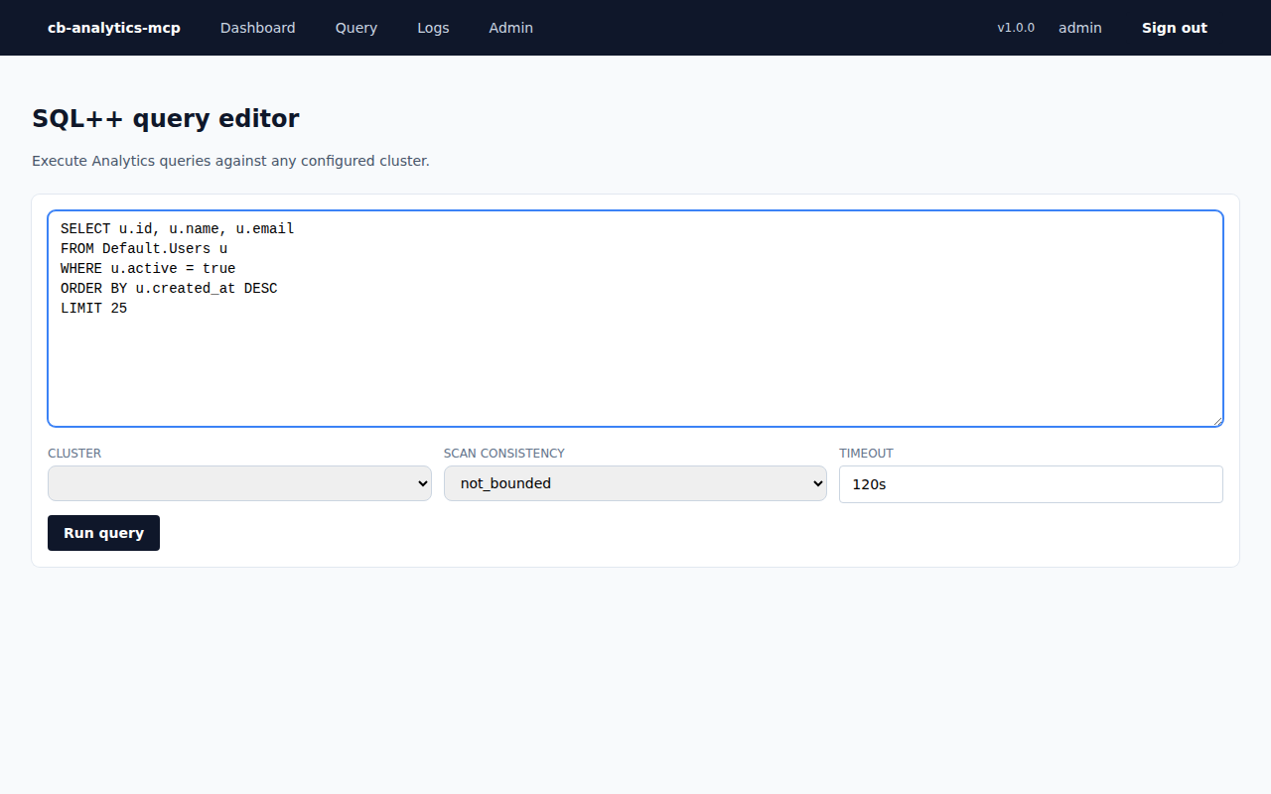
Figure 3. The SQL++ query editor.

Admin & audit log
/admin is the long-form audit-log viewer. The filter form supports four dimensions, applied together:
• From / To dates — single-day or multi-day windows; date-only inputs are inclusive at both ends.
• Tool — dropdown populated with every registered tool name (not just the ones that have appeared in the log so far), so you can pre-filter to a tool you haven't called yet.
• Failures only — checkbox to show only records where success: false.
Changing any filter input updates the table in place via HTMX (no full page reload); the same query parameters work on a plain GET as well, so shareable URLs and no-JS browsers still work.
The config summary at the top is generated by config_summary(), the same function that writes the startup log line, so it's guaranteed to show only non-secret values.
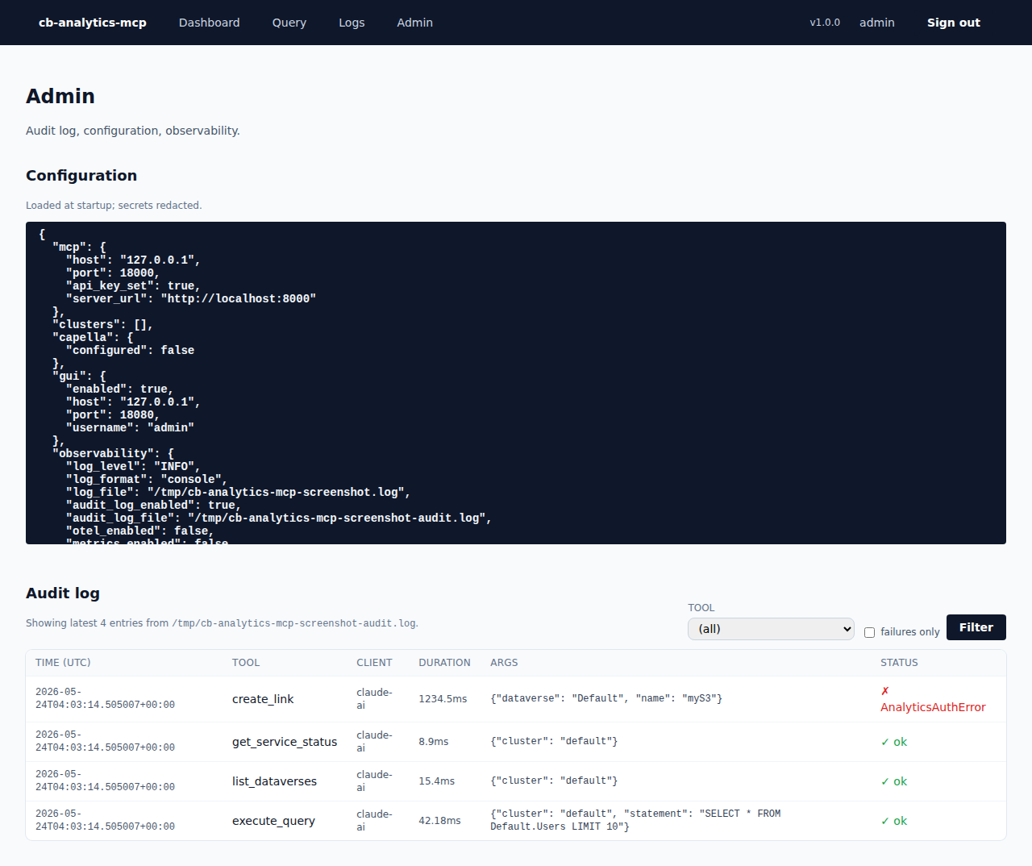
Figure 4. The admin page — audit log and config viewer.

Live logs
/logs streams new log lines from LOG_FILE as they're written, using a WebSocket (/logs/ws). Each line is parsed as JSON when possible — the level badge gets coloured accordingly (info / warning / error / critical) and the structured fields are shown inline. The status indicator at the top of the page shows whether the connection is ● live (WebSocket up) or ● polling (WebSocket unavailable) (fallen back to HTMX polling).
If the browser closes the WebSocket — usually because of a proxy that doesn't allow upgrades, or because JavaScript is disabled — the page automatically falls back to polling /logs/tail every 5 seconds, which serves the same data as a server-rendered HTML fragment.
If LOG_FILE isn't set, the page tells you so. There's nothing to tail when logs go only to stdout.
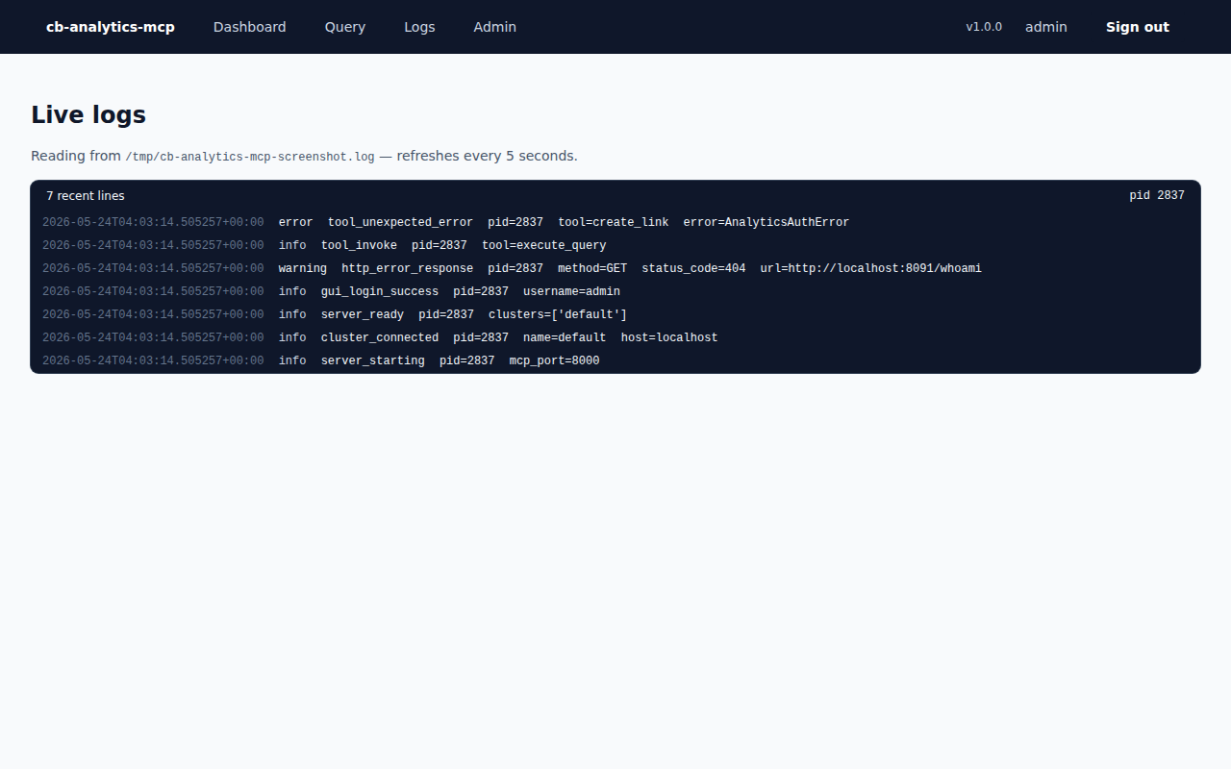
Figure 5. The live log tail page.

Behind the scenes
• Templating: Jinja2 server-side rendering. No SPA, no build step.
• Live updates: WebSocket (/logs/ws) for the log tail, HTMX (hx-get) for everything else. Vanilla JS handles WS message rendering; no client- side framework.
• CSS: Tailwind via CDN — works without any compilation; minor helpers in static/css/app.css.
• Interactivity: HTMX, also via CDN, handles the query result fragment and the live log tail.
• Sessions: starlette.middleware.sessions.SessionMiddleware with a signed cookie keyed by GUI_SESSION_SECRET. 8-hour expiry.

Regenerating screenshots
The PNGs in this directory are produced by scripts/make_screenshots.py, which uses Playwright headless. The script:
1. Seeds the audit log with realistic sample records (so screenshots aren't empty).
2. Starts an in-process FastAPI server on 127.0.0.1:18080.
3. Logs in and visits each page, saving full-page screenshots.
Run it with make screenshots.

Tool reference
All 55 MCP tools, organised by group. Each tool's signature is given as it appears to Claude. Most tools accept an optional cluster parameter; if you omit it the default (first-configured) cluster is used.
Every result follows the same shape:
{ "ok": true, "data": ..., "cluster": "prod" }
or, on failure:
{ "ok": false, "error": "AnalyticsAuthError", "message": "HTTP 401: ..." }
Rate-limit failures use a structured error including retry_after_sec so clients can back off:
{ "ok": false, "error": "RateLimitExceeded",
"message": "Rate limit exceeded for category 'write' (limit 1/sec). Retry in 0.82s.",
"category": "write", "rate_per_sec": 1, "retry_after_sec": 0.82 }
See docs/security.md for the rate-limit categories and defaults.

Meta — 2 tools

`list_clusters()`
Return the configured cluster names, the default, and whether Capella is enabled.

`get_capabilities()`
Return name, version, and the available tool groups.

Schema — 3 tools

`list_dataverses(cluster=None)`
List every dataverse in the cluster's Analytics metadata.

`list_datasets(dataverse=None, cluster=None)`
List datasets, optionally filtered by dataverse.

`infer_schema(dataset, sample_size=100, cluster=None)`
Sample sample_size documents and report observed top-level fields with presence counts and value types. Dataset names are whitelisted by a strict regex before interpolation to prevent SQL++ injection.

Query — 5 tools

`execute_query(statement, named_args=None, positional_args=None, scan_consistency=None, timeout="120s", cluster=None)`
Run any SQL++ statement, including DDL and DML. scan_consistency may be not_bounded, request_plus, or at_plus.
Responses include truncated: true and full_row_count when more rows were available than the MAX_QUERY_ROWS cap (default 1000). Use execute_query_paginated to walk the full result.

`execute_query_readonly(statement, scan_consistency=None, timeout="120s", cluster=None)`
Run a read-only SELECT. The service can apply extra optimisations and the client adds readonly=true to the payload. Results are cached for ~60 seconds keyed by (cluster, statement, scan_consistency); the response includes a cached boolean so Claude can see whether a query hit the cache.

`execute_query_paginated(statement, page_size=100, named_args=None, positional_args=None, scan_consistency=None, timeout="120s", cluster=None)`
Run a SELECT and return the first page (default 100 rows) plus a pagination handle. Use fetch_next_page(handle) to retrieve subsequent pages. The handle expires after 30 minutes of inactivity. Prefer this for any SELECT that might return more than a few thousand rows — sending the full result through the MCP boundary is expensive and the LLM rarely benefits from seeing more than the first few hundred. Pagination is implemented as server-side LIMIT/OFFSET rewriting; a trailing LIMIT/OFFSET on your statement will be stripped so the pagination is applied cleanly.
Response includes pagination_handle, page_size, page_offset, rows_returned, and has_more.

`fetch_next_page(pagination_handle)`
Fetch the next page of a previously paginated query. Returns rows plus a new has_more flag and updated page_offset / total_seen counts. When has_more is false the handle is automatically dropped.

`explain_query(statement, cluster=None)`
Return the Couchbase Analytics query plan (EXPLAIN output) for a SQL++ statement. Use this to investigate slow queries: the plan shows scan/filter/ join order and confirms whether an index is being used. Either pass a plain SELECT (Claude will prepend EXPLAIN) or a statement already starting with EXPLAIN.

Admin — 7 tools
tool | summary
get_service_status(cluster=None) | Analytics service state, replica lag, authorised nodes.
get_ingestion_status(cluster=None) | Per-link ingestion status with pending operations.
get_active_requests(cluster=None) | Currently-running queries.
get_completed_requests(client_context_id=None, cluster=None) | Recently-completed queries (history slice).
cancel_request(client_context_id, cluster=None) | Cancel an in-flight query.
restart_service(cluster=None) | Cluster-wide Analytics restart. Destructive.
restart_node(cluster=None) | Restart only the local Analytics node.

Config — 4 tools
tool | summary
get_service_config(cluster=None) | Service-level config (resultTtl, compilerParallelism, …).
update_service_config(settings, cluster=None) | Update specific keys.
get_analytics_settings(cluster=None) | Cluster-wide settings (numReplicas).
update_analytics_settings(num_replicas, cluster=None) | Change replica count.

Links — 5 tools
tool | summary
list_links(dataverse=None, link_type=None, cluster=None) | List Analytics data-source links.
get_link(name, cluster=None) | Get a single link.
create_link(name, dataverse, config, cluster=None) | Create a link. config is a typed dict matching the link kind (S3, Azure, GCS, Couchbase).
update_link(name, config, cluster=None) | Update an existing link's config.
delete_link(name, cluster=None) | Delete a link.

Link credentials in config are redacted automatically by the audit logger.

Libraries (UDF) — 2 tools
tool | summary
list_libraries(cluster=None) | List installed UDF libraries with their functions.
delete_library(scope, library_name, cluster=None) | Delete a library.

Security / RBAC — 9 tools
tool | summary
list_users(domain=None, cluster=None) | List users (optionally filtered to local / external).
get_user(domain, username, cluster=None) | Get a single user.
upsert_user(domain, username, roles, password=None, full_name=None, cluster=None) | Create or update a user. roles is a comma-separated role list.
delete_user(domain, username, cluster=None) | Delete a user.
list_groups(cluster=None) | List all groups.
upsert_group(groupname, roles, description=None, cluster=None) | Create or update a group.
delete_group(groupname, cluster=None) | Delete a group.
list_roles(cluster=None) | Enumerate all available roles.
check_permissions(permissions, cluster=None) | Test the current user against a comma-separated permission list.

Cluster — 9 tools
tool | summary
ping_cluster(cluster=None) | Liveness check.
get_cluster_info(cluster=None) | UUID + version.
get_cluster_details(cluster=None) | Nodes, memory quotas, rebalance status.
get_cluster_tasks(cluster=None) | In-flight cluster tasks.
get_rebalance_progress(cluster=None) | Current rebalance progress (or none).
get_auto_failover_settings(cluster=None) | Read auto-failover config.
configure_auto_failover(enabled, timeout=120, max_count=1, cluster=None) | Update auto-failover config.
get_system_events(since_time=None, cluster=None) | Recent system events.
who_am_i(cluster=None) | The authenticated user as seen by the cluster.

Capella — 9 tools
These require CB_CAPELLA_API_KEY_SECRET to be set; otherwise the tools return a clear RuntimeError.
tool | summary
capella_list_organizations() | List orgs visible to the API key.
capella_list_clusters(org_id, project_id) | List clusters in a project.
capella_get_cluster(org_id, project_id, cluster_id) | Get cluster details.
capella_create_cluster(org_id, project_id, cluster_spec) | Create a cluster.
capella_delete_cluster(org_id, project_id, cluster_id) | Delete a cluster. Destructive.
capella_list_backups(org_id, project_id, cluster_id) | List backups.
capella_create_backup(org_id, project_id, cluster_id) | Trigger a backup.
capella_restore_backup(org_id, project_id, cluster_id, backup_id, target_cluster_id=None) | Restore a backup.
capella_list_api_keys(org_id) | List API keys for an org.

Observability
This server emits four overlapping but distinct signals. Each can be turned off independently; defaults are sensible for a single-instance deployment.

1. Structured logs
Every line is one JSON object on stdout (and optionally a file via LOG_FILE). Examples:
{"timestamp": "2026-05-24T03:10:00Z", "level": "info", "event": "server_starting", "config": {...}}
{"timestamp": "2026-05-24T03:10:01Z", "level": "info", "event": "cluster_connected", "name": "prod", "host": "prod.example.com"}
{"timestamp": "2026-05-24T03:10:42Z", "level": "warning", "event": "http_error_response", "method": "GET", "status_code": 404, "body_excerpt": "..."}
In development you can switch to a coloured human-readable renderer:
LOG_FORMAT=console
Every record passes through a redactor before it leaves the process. Keys matching password, secret, token, api_key, authorization, credentials, etc. (full list in observability/redact.py) are replaced with ***REDACTED***. Free-text patterns matching Bearer <token> or Basic <base64> are also redacted in any string field.

2. Audit log
A separate JSON line per MCP tool invocation, appended to AUDIT_LOG_FILE (default ./audit.log). One record per call regardless of success or failure. Sample:
{
"timestamp": "2026-05-24T03:11:00Z",
"tool": "execute_query",
"client_id": "claude-ai",
"success": true,
"duration_ms": 42.18,
"pid": 4321,
"args": {"statement": "SELECT * FROM Default.Users LIMIT 10", "cluster": "prod"},
"result_summary": {"result_count": 10}
}
The audit log uses the same redactor; even if a caller passes a secret as a tool argument it never lands on disk in plain form.
The dashboard and /admin GUI views read the tail of this file directly. /admin supports filtering by date range, tool name, and "failures only" — the filter form updates the table in place via HTMX.

Rotation
The audit log uses Python's RotatingFileHandler so the file doesn't grow without bound:
• Rotates when the active file exceeds AUDIT_ROTATE_BYTES (default 10 MB).
• Keeps AUDIT_ROTATE_KEEP generations (default 5): the oldest record is in audit.log.5, the newest in audit.log.
• Set AUDIT_ROTATE_BYTES=0 to disable rotation entirely (fall back to a plain unrotated FileHandler — useful when logrotate or another external rotator is in charge).
Rotation is in-process and does not require an external tool. Records mid- write are not split across files; the handler rotates at line boundaries.

3. Prometheus metrics
Exposed on METRICS_PORT (default 9100) as /metrics. Metric names:
metric | type | labels | description
cb_analytics_mcp_tool_invocations_total | Counter | tool, outcome | Per-tool invocation count.
cb_analytics_mcp_tool_duration_seconds | Histogram | tool | Per-tool duration distribution.
cb_analytics_mcp_http_requests_total | Counter | cluster, method, status | Underlying HTTP calls to Couchbase.
cb_analytics_mcp_cluster_pings_total | Counter | cluster, outcome | Cluster reachability checks.
cb_analytics_mcp_clusters_configured | Gauge | (none) | Count of clusters in the active pool.

Example scrape config:
scrape_configs:
- job_name: cb-analytics-mcp
static_configs:
- targets: ['cb-mcp:9100']

4. OpenTelemetry tracing
Opt-in by setting OTEL_ENABLED=true and OTEL_EXPORTER_OTLP_ENDPOINT. The server then:
• Creates a TracerProvider with service.name=cb-analytics-mcp (configurable).
• Instruments httpx so every outbound Couchbase call is a span.
• Exports spans via OTLP HTTP to your collector.
export OTEL_ENABLED=true
export OTEL_EXPORTER_OTLP_ENDPOINT=http://otel-collector:4318
make run

Choosing what to enable
use case | log | audit | metrics | trace
Local development | console format | optional | optional | off
Single-instance production | json + file | on | on | optional
Multi-instance / k8s | json + stdout | on (rotated) | on | recommended
Hostile network audit posture | json + file + rotation | required | on | on

Security model

Threat model
The MCP server sits between an LLM client (Claude) and one or more Couchbase clusters. It must:
1. Authenticate every MCP request with a bearer token (MCP_API_KEY).
2. Authenticate every GUI session with username + password.
3. Hold cluster credentials at rest only as SecretStr and never log or render them.
4. Cap the blast radius of any tool: errors must never crash the server, secrets must never leak into logs.

Authentication

MCP
• Every MCP call must include Authorization: Bearer <MCP_API_KEY>.
• Comparison uses hmac.compare_digest with length-padding so neither the length nor content of the expected key leaks via timing.
• Minimum key length is 32 characters; the server refuses to start with a shorter key.

GUI
• Login form posts username + password; both compared with hmac.compare_digest.
• Session cookies are signed by GUI_SESSION_SECRET via starlette.middleware.sessions.SessionMiddleware.
• Cookie defaults: SameSite=lax, httpOnly (set by Starlette), 8-hour expiry. Set https_only=True in code (or behind a reverse proxy enforcing TLS) for production.

Secrets handling
secret | source | storage | log/display
MCP_API_KEY | env / .env | SecretStr | redacted everywhere
Cluster passwords | env / clusters.json | SecretStr | redacted
Capella API key | env | SecretStr | redacted
GUI password | env | SecretStr | redacted
Link credentials (S3, GCS, Azure) | tool argument | SecretStr | redacted in audit log

SecretStr.__repr__ returns ***; never use print() on a model that contains one. to_api_dict() methods unwrap to the raw string only at the HTTP-payload boundary.

Redaction rules
The redactor in observability/redact.py enforces two layers:
1. Key-based redaction. A frozen set of key names (password, secret, api_key, bearer, authorization, client_secret, …) is checked case-insensitively against every dict key, recursively.
2. Pattern-based redaction. Free-text patterns catch Bearer <token> and Basic <base64> shapes anywhere in a string.
The redactor runs as a structlog processor, so every log record passes through it before any handler sees it. It also runs over every tool argument before the audit log gets it.

SQL++ injection
infer_schema is the only tool that interpolates an identifier into a SQL++ statement (parameterised identifiers aren't supported by Analytics). The identifier is whitelisted with a strict regex first:
_DATASET_RE = re.compile(rf"^{_SEGMENT}(?:\.{_SEGMENT})*$")
Where _SEGMENT allows plain identifiers ([A-Za-z_][A-Za-z0-9_]*) and backtick-quoted segments. Anything else (semicolons, comments, quotes) raises AnalyticsRequestError before the SQL is built.
All other tools pass user input via named parameters ($id, $dv, etc.).

What Claude can do, what it can't
A connected Claude has every right granted to the cluster user configured in CB_ANALYTICS_USERNAME. Do not connect Claude with a Full Admin account in production. Create a least-privileged user — usually analytics_admin plus the specific buckets / scopes you want exposed — and configure that user's credentials in .env.
The MCP server itself has no notion of "read-only mode"; it relies on Couchbase RBAC to enforce write protection.

TLS
Run behind a TLS-terminating reverse proxy (nginx, Caddy, AWS ALB, etc). Set MCP_SERVER_URL and MCP_ISSUER_URL to the public HTTPS URL so the OAuth metadata that FastMCP advertises matches reality.

Auditing
Every tool invocation produces one audit-log record with timestamp, tool name, client id, duration, success/failure, and redacted args. To meet SOC2 / HIPAA-style requirements you should:
• Rotation is built in (see AUDIT_ROTATE_BYTES / AUDIT_ROTATE_KEEP in docs/configuration.md). The defaults — 10 MB per file, 5 generations kept — give you ~50 MB of in-flight audit before the oldest record falls off the back. For longer retention, ship rotated files to immutable storage (S3 with object-lock, an SIEM sink, etc).
• Disable AUDIT_LOG_ENABLED=false in dev only.

Rate limiting
Every tool invocation is subject to a token-bucket rate limit, applied per API key per category:
category | tools | default
query | execute_query*, explain_query, infer_schema | 10 / sec
read | every other read-only tool (list/get/ping/...) | 60 / sec
write | every mutating tool (upsert/delete user, links, restart, capella mutations, …) | 1 / sec

The defaults are intentional: writes are the most dangerous operations, so they're throttled hard. Reads are cheap enough to allow a burst. Queries sit in the middle.
When a bucket is empty, the tool call returns a structured error with error: "RateLimitExceeded", retry_after_sec, category, and rate_per_sec — Claude is told to back off, and the request is also recorded in the audit log with success: false so you can spot abusive clients.
These limits are the recommended defaults for typical deployments. If your workload genuinely needs more throughput, raise them in env vars (RATE_LIMIT_QUERY_PER_SEC etc.) — but consider whether the right answer might be a circuit breaker further upstream instead. Setting any limit to 0 disables that bucket.
The current implementation is in-process. If you scale this server out horizontally you'll need a shared store (Redis) to make the bucket counts coherent across replicas; that's not in v1.x but it's noted in the README's "Future possibilities" section.

Reporting issues
If you find a security issue please open a private report via the GitHub repository's security advisories tab, not as a public issue.

Deployment
This server is one Python process exposing two ports: 8000 (MCP) and 8080 (GUI). Prometheus metrics live on 9100.

Docker
The Dockerfile produces a small image (~250 MB) with Python 3.12 slim.
make docker # builds cb-analytics-mcp:latest
docker run --rm -p 8000:8000 -p 8080:8080 -p 9100:9100 \
--env-file .env \
cb-analytics-mcp:latest

Docker Compose
A full reverse-proxy + MCP + metrics stack:
docker compose up -d
The compose file wires:
• mcp: this server, reading .env and the optional cluster JSON.
• nginx: TLS termination on :443 proxying to :8000 and :8080.
• (optional) prometheus: scrapes mcp:9100.

Health probes
Two unauthenticated endpoints on the GUI port (:8080 by default):
endpoint | purpose | semantics
/healthz | liveness | always returns 200 with {"status": "ok"} if the process is up. Use for load-balancer health and Kubernetes livenessProbe.
/readyz | readiness | returns 200 only if at least one configured cluster is reachable; 503 if every cluster's ping() fails. Body lists each cluster's state. Use for Kubernetes readinessProbe so the pod is removed from rotation when its cluster is unreachable.

Neither endpoint sets a session cookie or touches the audit log.

Behind a reverse proxy
When TLS-terminating elsewhere, you usually want:
MCP_SERVER_URL=https://mcp.example.com
MCP_ISSUER_URL=https://mcp.example.com
So the OAuth metadata FastMCP advertises matches the URL claude.ai is hitting.
In your proxy, forward:
upstream path | from | comment
/mcp, /mcp/* | claude.ai | MCP streamable HTTP endpoint
/, /login, /query, /admin, /logs, /static, … | browsers | GUI
/metrics | Prometheus | usually firewalled to internal network

An example nginx config is in nginx/nginx.conf.

Kubernetes
A minimal Deployment + Service looks like:
apiVersion: apps/v1
kind: Deployment
metadata:
name: cb-analytics-mcp
spec:
replicas: 2 # stateless; safe to scale
template:
spec:
containers:
- name: mcp
image: ghcr.io/celticht32/cb-analytics-mcp:1.0.0
ports:
- { name: mcp, containerPort: 8000 }
- { name: gui, containerPort: 8080 }
- { name: metrics, containerPort: 9100 }
envFrom:
- secretRef:
name: cb-analytics-mcp-env
readinessProbe:
httpGet: { path: /readyz, port: gui }
initialDelaySeconds: 2
periodSeconds: 10
livenessProbe:
httpGet: { path: /healthz, port: gui }
initialDelaySeconds: 10
periodSeconds: 15
The audit log is best treated as ephemeral inside the pod and shipped to a log aggregator via your existing pipeline. If you need an on-disk audit, mount a volume at AUDIT_LOG_FILE's parent directory.

Hardening checklist
• [ ] MCP_API_KEY is generated cryptographically, ≥48 chars.
• [ ] GUI_SESSION_SECRET is a fresh 48-byte URL-safe token.
• [ ] GUI_PASSWORD is not changeme.
• [ ] Couchbase user has only the roles it needs (not Full Admin).
• [ ] TLS terminates upstream; MCP_SERVER_URL points to the HTTPS URL.
• [ ] :9100 (metrics) is not exposed to the public internet.
• [ ] Audit log is rotated and shipped off-host.
• [ ] Container runs as non-root.

Updates
This project follows semantic versioning. Patch releases (1.0.x) never change tool signatures; minor releases (1.x.0) may add tools; major releases may remove or rename them.

Architecture
A short tour of how the pieces fit together.

Process layout
One Python process, one event loop, two HTTP servers running concurrently:
asyncio loop
├── mcp.run_streamable_http_async() ← bound to MCP_PORT (default 8000)
└── uvicorn(gui_app) ← bound to GUI_PORT (default 8080)
Both share:
• A single ClientPool (one AnalyticsClient per cluster, optional Capella)
• A single AuditLog (one writer thread, one file)
• A single Metrics registry (Prometheus exposition on 9100)
Lifespan is owned by FastMCP; the GUI piggybacks on it.

Layered design
┌─────────────────────────────────────────────────────────────┐
│ Claude (MCP) Browser (GUI) │
└──────────┬────────────────────────┬─────────────────────────┘
│ │
▼ ▼
FastMCP (auth + tool FastAPI (session +
dispatch + lifespan) Jinja2 + HTMX)
│ │
▼ ▼
┌───────────────────────────────────────────┐
│ tools/* (55 tools) │
│ Each tool: _impl() ← business logic │
│ register() ← wraps with │
│ observability │
└───────────────┬───────────────────────────┘
▼
┌──────────────┐
│ ClientPool │ ← keyed by cluster name
└──────┬───────┘
▼
┌──────────────────┐ ┌──────────────────┐
│ AnalyticsClient │ │ CapellaClient │
└────────┬─────────┘ └────────┬─────────┘
▼ ▼
┌────────────────┐ ┌────────────────────┐
│ Couchbase REST │ │ Capella Cloud API │
└────────────────┘ └────────────────────┘

Tool pattern
Each tool module exports an _impl() async function that takes the pool and the tool's typed arguments. register(mcp, pool, audit, metrics) wraps that impl with call_tool_observed(), which:
1. Starts a timer.
2. Calls the impl.
3. Catches AnalyticsError (typed) and any other exception, converting both to {"ok": False, ...} results — the conversation never crashes.
4. Records a Prometheus invocation + duration.
5. Writes one audit-log record with the redacted args and a small result_summary derived from the data.
This separation makes _impl directly unit-testable with a mocked pool (see tests/unit/mcp/test_tool_impls.py — 67 tests).

HTTP client
The internal Couchbase client lives in couchbase/. It is intentionally small:
• http_client.py: an httpx wrapper with: - Basic auth - tenacity-driven exponential backoff for ConnectError, ReadTimeout, RemoteProtocolError, and 5xx - A hand-rolled async-native circuit breaker (_AsyncCircuitBreaker) — pybreaker's call_async is hard-coded for Tornado and not usable here - Status-code → typed-exception mapping
• analytics_api.py, cluster_api.py: one class per REST group. Each method takes typed Pydantic models in and out.
• client.py: the AnalyticsClient facade tying the per-group APIs to one shared HttpClient. The dataclass AnalyticsClientConfig lives at client.cfg; the service-config API lives at client.config.

Configuration
config.py reads env vars (and optionally a JSON cluster file) into a single dataclass tree:
AppConfig
├── ClusterConfig[] (one per cluster)
├── capella_api_key? (SecretStr)
├── GuiConfig
└── ObservabilityConfig
load_config() is the only public entrypoint; validate_config() checks for missing required values and default GUI password / session secret. config_summary() returns a redacted dict suitable for logging.

Observability
concern | module | output
Structured logs | observability/logging.py | stdout + optional file, JSON or console
Audit trail | observability/audit.py | dedicated JSON file, one line per tool call
Metrics | observability/metrics.py | Prometheus HTTP endpoint on :9100
Traces | observability/tracing.py | OTLP HTTP, opt-in
Redaction | observability/redact.py | shared by logs and audit

The redactor is a structlog processor, so every log line that the JSON renderer ever sees has already been through it.

GUI
gui/app.py builds a FastAPI app that attaches the same ClientPool, AuditLog, and Metrics to app.state. Routes:
• routes/auth.py — /login, /logout, require_session() dependency.
• routes/dashboard.py — /, the cluster overview.
• routes/query.py — /query (form) + /query/run (HTMX result fragment).
• routes/admin.py — /admin, audit log + config summary.
• routes/logs.py — /logs + /logs/tail (HTMX poll).
Templates are server-rendered Jinja2; the only client-side library is HTMX, which keeps things crawlable and simple.

Testing
• 411 unit tests, all using either respx (HTTP mocking) or FakePool / FakeClient (in-memory mocks of the client surface). No tests touch a real Couchbase cluster.
• The 52 tool impls are tested at the _impl() level — no FastMCP machinery in the test path.
• The GUI is tested via FastAPI's TestClient against the same mocked pool.

