FunkoDex
Community Catalog Distribution
Architecture & Design Document
Version 1.0
Celtic Heart Steamworks
Status: Draft for review — not yet scheduled for implementation

Contents

1. Purpose & Scope
This document describes a system for keeping the FunkoDex catalog current and accurate across many devices without a central backend service, by treating the bundled catalog as a golden master and distributing community-sourced corrections as dated update packets through a shared GitHub repository.
It is a design document only. Nothing here is built yet. It captures the agreed architecture, the field taxonomy that the entire system depends on, the conflict-resolution model, and a phased build sequence so the work can be scoped and started deliberately rather than discovered mid-implementation.
Problems this solves
- Fresh installs ship the old thin catalog (funko_data.json, ~23,940 records, no UPCs) instead of the enriched data that makes scanning work.
- Manually-added items (convention exclusives, late releases) and corrections live only on the device that made them; there is no path for them to improve the shared catalog.
- There is no mechanism for a device to receive catalog improvements made elsewhere after install.
Explicit non-goals
- Moving a user's collection between devices. That remains the existing backup/restore path (funkodex_backup.json) and is out of scope here.
- Real-time sync. Updates are pulled on a monthly schedule; this is not a live service.
- Syncing any user-private data. Price paid, market value, notes, condition, ownership, and photos never leave the device.

2. Guiding Principles
- Golden master as the base. The bundled catalog is the enriched dataset plus the maintainer's accumulated corrections, frozen at release. It is the authoritative starting point for every new install.
- Core vs. user data separation. Every catalog record splits into objective core fields (shared, syncable) and personal user fields (private, never synced). This split is the keystone of the whole system.
- The user is always in control. No incoming update silently overwrites data the user has asserted. Field-level policy and resettable locks keep the final decision with the user.
- No central server. Distribution rides on GitHub. The “server” is a merge/packaging process that produces static, dated files; clients pull them like any other release artifact.
- Deprecate the import workaround. The current Enriched Catalog Import feature becomes unnecessary once the golden master is the bundled base; it is retired.

3. System Architecture
The system has three tiers: the golden master (bundled at release), the community hub (GitHub merge + dated packets), and the client app (local catalog, update client, contribution export). User collection data sits only in the client and never crosses into the hub.
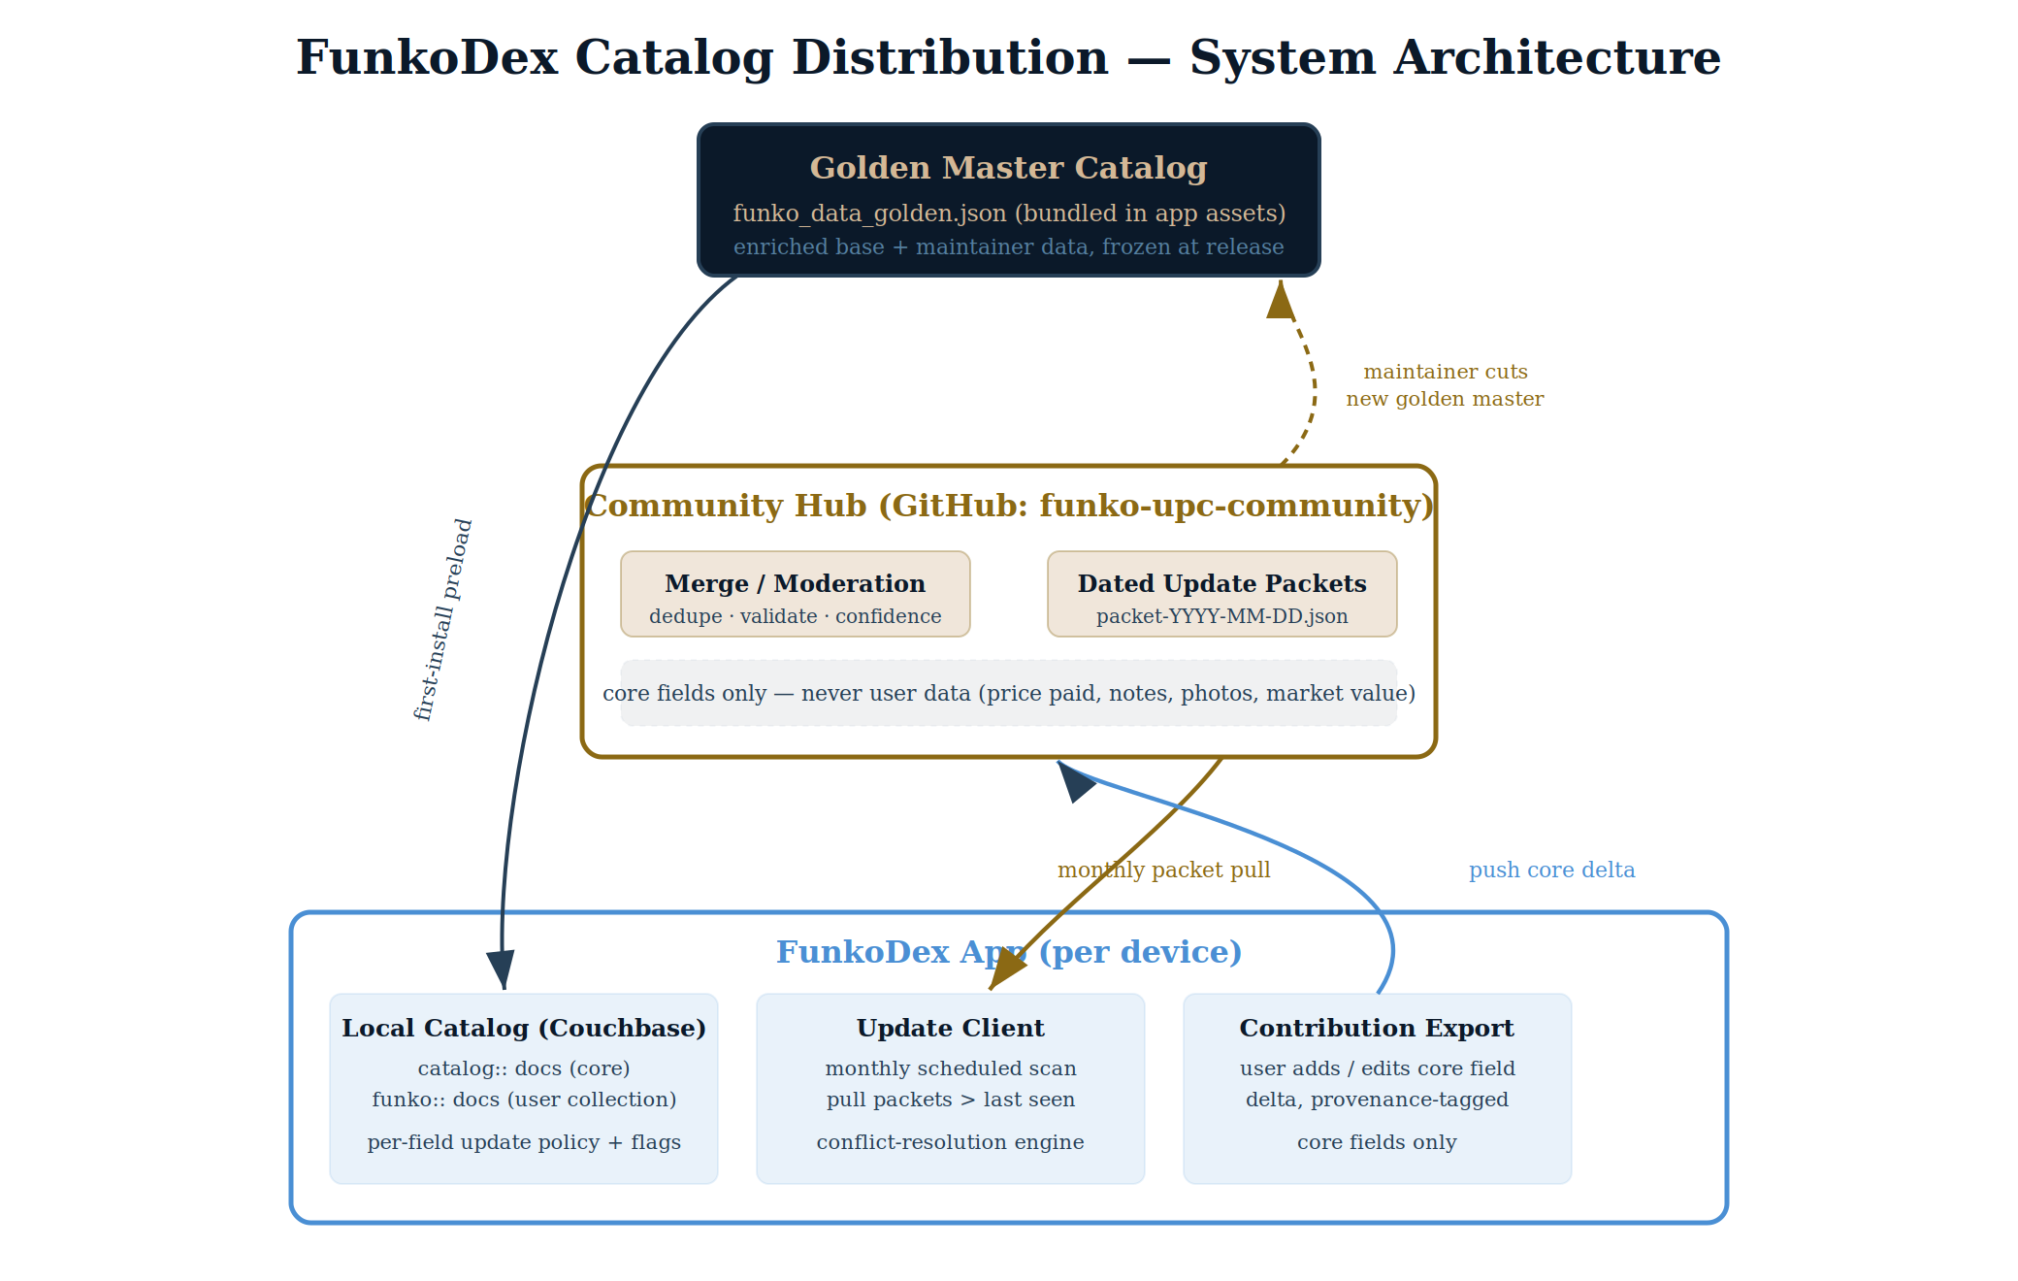
Figure 1 — System architecture. Blue = client, brass = hub/server, navy = golden master. The dashed brass loop is the maintainer periodically cutting a new golden master from accumulated community data.
Golden master
A single shippable file (funko_data_golden.json) bundled in app assets, containing core catalog fields for every known record. It is produced by freezing the current enriched catalog merged with the maintainer's own additions, corrections, and images at a chosen moment — the “release cut.”
Community hub
A GitHub repository (funko-upc-community) plus a merge process. It ingests contribution deltas from many users, deduplicates and validates them, applies a confidence/moderation gate, and emits dated update packets. It stores only core catalog data.
Client app
Each device holds the local catalog (Couchbase catalog:: docs for core data, funko:: docs for the user's collection), an update client that performs the monthly pull, and a contribution exporter that pushes the user's core-field changes upstream.

4. Data Flow Lifecycle
A single correction travels five stages from a user's edit to its arrival on other devices. The first two and the last occur on clients; the middle two are the hub.
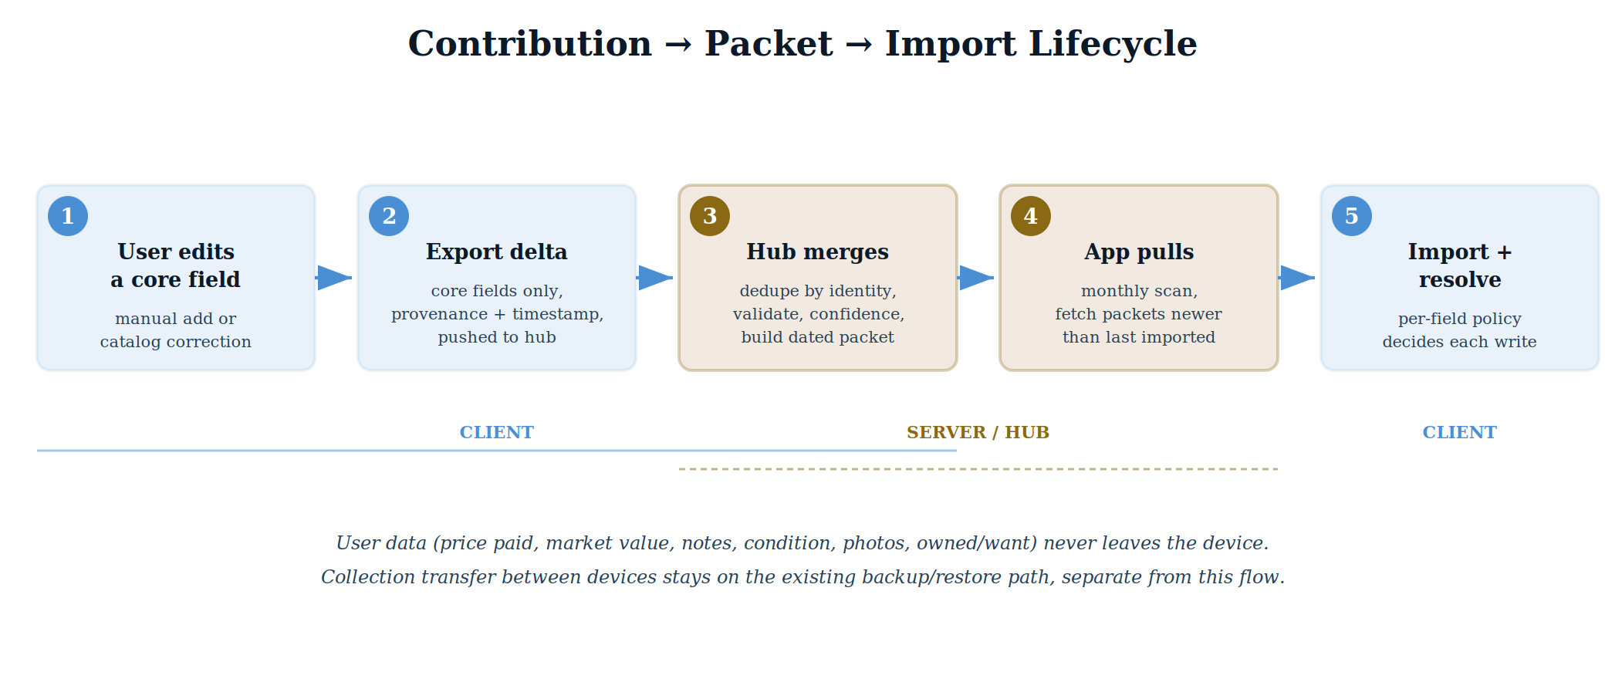
Figure 2 — Contribution-to-import lifecycle. The user-data guarantee holds at every stage: only core fields ever enter the pipeline.
Stage notes
- 1 — Edit. A user adds a new item or corrects a core field on an existing one (e.g. fixing a franchise, adding a missing image URL or UPC).
- 2 — Export. The change is serialized as a delta — core fields only — tagged with provenance (source, contributor, timestamp) and pushed to the hub.
- 3 — Merge. The hub resolves the delta against existing records by identity, validates it, weighs confidence, and folds it into the next dated packet.
- 4 — Pull. Each app runs a monthly scan and downloads every packet newer than the last one it successfully imported.
- 5 — Import & resolve. Each incoming field value is applied through the conflict-resolution engine (Section 6), which decides per field whether to fill, overwrite, ask, or skip.

5. Field Taxonomy
This is the keystone of the system. Every field on a record is classified as core (objective identity of the Funko — shared and syncable) or user (the owner's private relationship to the item — never synced). The classification below is taken directly from the current FunkoItem model.
Core fields — shared, flow through the hub
Field | Meaning | Class
upc | Barcode UPC; strongest cross-device identity key | CORE
name | Display name, e.g. “Mr. Toad with Monocle” | CORE
franchise | IP / property, e.g. “The Wind in the Willows” | CORE
category | Funko product line, e.g. “Pop! Disney” | CORE
genre | Top-level grouping derived from category | CORE
seriesNumber | Pop! box number, e.g. “#1496” | CORE
funkoId | Funko's own product/item number, e.g. 78901 | CORE
isExclusive / exclusiveRetailer | Exclusive flag and the retailer/event | CORE
isChase / isVaulted | Chase variant; vaulted/retired status | CORE
imageUrl | Canonical catalog image link | CORE
retailPrice | Funko MSRP (objective, not what the user paid) | CORE
User fields — private, never leave the device
Field | Meaning | Class
pricePaid | What this user actually paid | USER
marketAvg / marketLow / marketHigh | Market value (fetched or manually set) | USER
marketValueIsManual | Whether the user set market value by hand | USER
condition | This copy's condition grade | USER
notes | Free-text personal notes | USER
isOwned | Owned vs. on the want list | USER
userPhoto / thumbnailBlob | The user's own photo / cached image bytes | USER
dateAdded / dateAcquired | When added to collection / acquired | USER
variants (owned) | Which variant copies this user owns | USER
resolvedRetail / priceLastUpdated | Per-device price-waterfall results | USER
Note: a few fields are core in meaning but are also where a user may have made a personal correction (e.g. they typed a franchise the hub later disagrees with). Those are still core — they sync — but they are exactly the fields the conflict-resolution engine must treat carefully (Section 6). A generalization of the existing marketValueIsManual “user-asserted” bit is proposed to mark them.

6. Conflict Resolution
When a packet delivers a value for a field that already has data locally, the engine decides per field what to do. The rule set is deliberately simple at its core, with user-controlled escalation for the contested case.
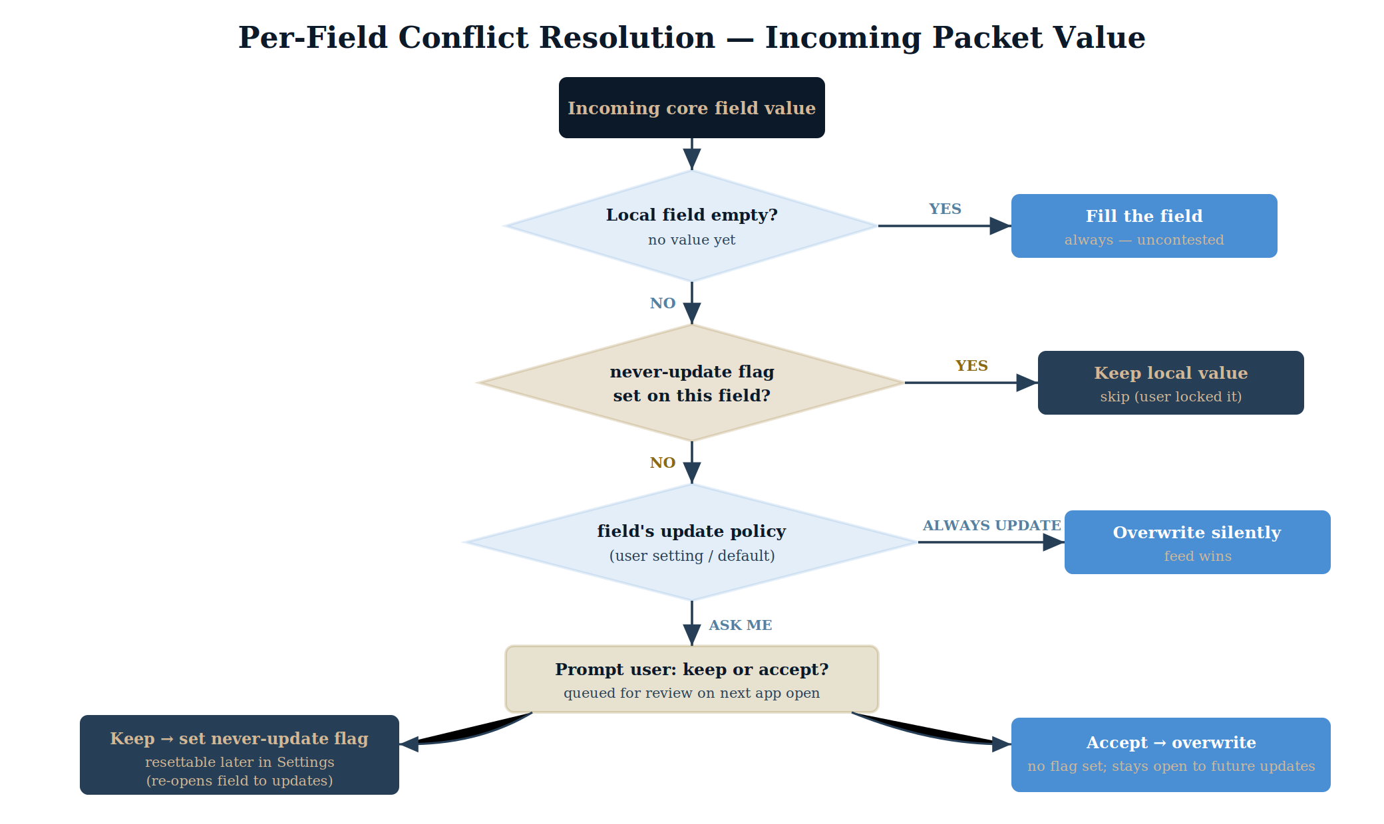
Figure 3 — Per-field decision tree applied to every incoming core value.
The rules
- Empty local field → fill. If the device has no value, take the incoming one. Uncontested and always safe.
- Never-update flag set → keep. If the user has locked this field, skip it. The flag is resettable in Settings, which re-opens the field to future updates.
- Otherwise, the field's update policy decides:
  - Always update — overwrite silently; the feed is treated as ground truth for this field.
  - Ask me — queue a prompt; the user keeps (sets the never-update flag) or accepts (overwrites, no flag).
Policy defaults (proposed)
- Fields the user explicitly hand-entered default to Ask me — their typed value should not vanish without consent.
- Fields auto-filled from a lookup (never user-asserted) default to Always update — the curated hub value is preferable to a guessed one.
- Defaults are global per field and adjustable in Settings; the never-update flag is the per-record exception layered on top.
Two mechanisms, not one
This combines a global field-level default policy (“how should franchise updates behave generally?”) with a per-record never-update flag (“leave this specific record's franchise alone”). Both are needed; conflating them loses either granularity or simplicity. Storage is sparse — a flag exists only where a user has set one, not across all ~14k records.

7. Open Design Decisions
These are unresolved and should be settled before the dependent phase is built. They are called out so they don't surface mid-implementation.
D1 — Record identity across the sync
How a packet record is matched to a local record. UPC is the strongest key but only ~66% of enriched records have one, and exclusives — the records most worth syncing — are exactly where UPCs are spottiest. Proposed: UPC when present, catalog::{handle} as fallback, with funkoNumber as a tiebreak. Must be decided before packet import is built.
D2 — Never-update flag storage & granularity
Confirm flags are stored sparsely (only when set) and confirm the split between global field defaults and per-record exceptions described in Section 6.
D3 — Packet authority for contested fields
Default behavior for a field the user hand-entered vs. one auto-filled. Proposed defaults are in Section 6; needs sign-off.
D4 — Contribution trust & moderation
Once anyone can push core changes, wrong values can arrive. The hub merge needs a confidence model (multi-contributor agreement and/or maintainer review) before a change enters a packet. This shapes what the app sends — provenance, not just values. Server-side concern.
D5 — Packet format: delta vs. cumulative
Delta packets keep downloads small but require in-order application and handling of a missed month. Alternative: cumulative snapshots. Choose one before the update client is built.

8. Phased Build Sequence
Each phase delivers value independently; later phases depend on the field taxonomy and policy model established early. Nothing commits the project to finishing all five to benefit from one.
Phase 1 — Golden master base (foundational)
- Define the core/user field split precisely (Section 5) and build the golden-master exporter: freeze enriched catalog + maintainer data into funko_data_golden.json.
- Update the preloader to read the richer schema. Note: the current CatalogPreloader reads only handle/title/imageName/series — the old thin format — so bundling the enriched file requires reading the enriched fields (upc, funkoNumber, etc.), not just swapping the asset.
- Decide first-install vs. existing-install behavior (re-preload, merge, or leave alone). This is the same update-architecture question the community sync needs — solving it here unlocks Phase 5.
- Deprecate the Enriched Catalog Import feature.
Phase 2 — Field update-policy schema & Settings UI
- Implement the per-field always/ask/never policy model, the resettable never-update flags, and the Settings surface. Buildable before any packet exists.
Phase 3 — Contribution export
- Core-fields-only delta, dated and provenance-tagged — the artifact the hub consumes. Extends the existing CatalogContribution path (already writes USER_MANUAL contributions).
Phase 4 — Client packet import & conflict engine
- Monthly scheduled scan, ordered packet application, and the merge logic driven by the Phase 2 policies.
Phase 5 — Hub merge / moderation & distribution
- The server-side GitHub process that turns contributions into dated packets, including the confidence/moderation model from D4. The largest piece, and the one needing the most design before code — but Phases 1–3 will have already built its inputs.

9. What Already Exists
The project is not starting from zero; several pieces of this design are partially built.
- CatalogContribution model already captures core fields with a source provenance tag (USER_SCAN, USER_MANUAL, etc.) and an isUploaded flag — the shape Phase 3 needs.
- Manual-add flow already writes USER_MANUAL contributions, so the data is being captured today; only the export/merge steps are missing.
- Enriched dataset exists and is confirmed to load (14,314 records, ~66% with UPCs); it is the basis for the golden master.
- Backup/restore (funkodex_backup.json) already handles device-to-device collection transfer, keeping user data cleanly out of this system's scope.
End of document — v1.0, draft for review.

