COUCHBASE
Server Observability

Grafana Dashboard — Implementation & Configuration Guide
Version 1.0
Released under the MIT License
couchbase-grafana-dashboard
Couchbase® is a registered trademark of Couchbase, Inc. This is an unofficial community dashboard project.

Contents
Update this field after opening in Word (right-click → Update Field) to populate page numbers.

1. Executive Summary
This document describes the implementation, deployment, and configuration of a comprehensive, Couchbase-branded Grafana dashboard for monitoring Couchbase Server clusters.
The dashboard exposes every major metric category surfaced by the Couchbase Server 7.0+ native Prometheus endpoint and the official couchbase-exporter sidecar, organized across ten functional sections covering Cluster & Node Health, Data Service (KV), Query (N1QL), Index (GSI), Search (FTS), Analytics (CBAS), Eventing, XDCR, Backup, and a legacy fallback.

1.1 At a Glance
Item | Value
Total panels | 68
Functional sections | 10 (collapsible rows)
Stat KPIs | 12
Time-series charts | 44
Gauges | 1
Branded header | 1 (HTML/SVG)
Variables | 4 (DS_PROMETHEUS, $cluster, $node, $bucket)
Default refresh | 30 seconds
Default time range | now-1h to now
License | MIT
Schema version | 39 (Grafana 10.x+)
Couchbase versions | Server 7.0 and later

1.2 Intended Audience
This guide is written for site reliability engineers, database administrators, and platform engineers responsible for operating Couchbase clusters in development, staging, or production environments. Familiarity with Prometheus, Grafana, and Couchbase Server administration is assumed.

2. Architecture
The monitoring pipeline follows the standard Prometheus pattern. Couchbase Server exposes metrics on each node, Prometheus scrapes and stores them as time-series data, and Grafana queries Prometheus via PromQL to render the dashboard.
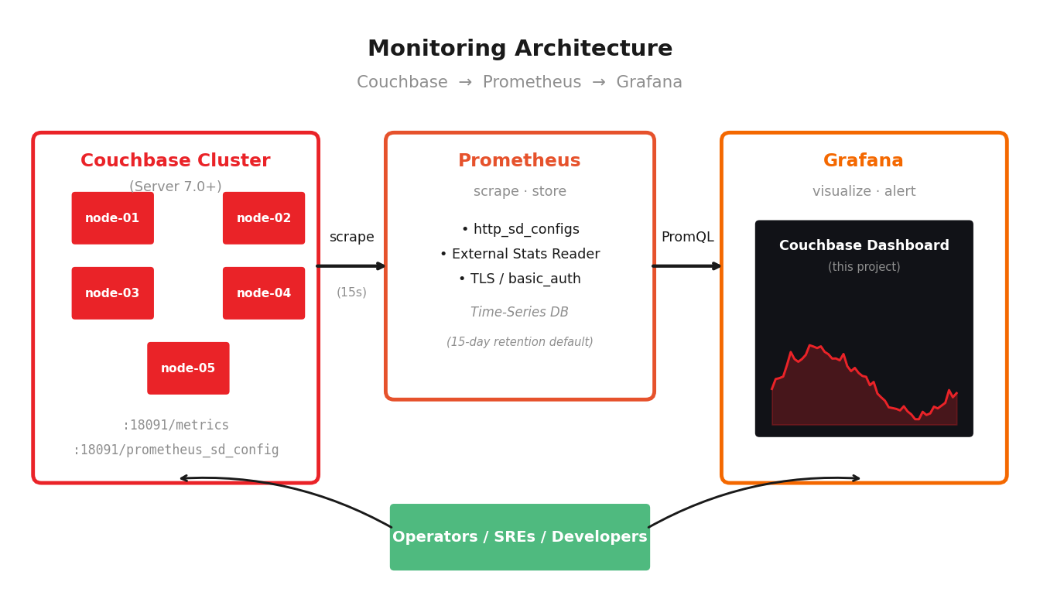
Figure 1. End-to-end monitoring architecture.

2.1 Component Responsibilities
Component | Role | Default port
Couchbase Server 7.0+ | Exposes /metrics in Prometheus exposition format on every node and a /prometheus_sd_config service-discovery endpoint. | 18091 (TLS) / 8091
Prometheus | Scrapes Couchbase nodes on a fixed interval, evaluates alerting and recording rules, and stores results in its TSDB. | 9090
Grafana | Queries Prometheus through the Prometheus data source plugin and renders the dashboard. Supports browser-based exploration and alerting. | 3000
Optional: couchbase-exporter | Sidecar exporter producing the legacy cb_* metric series. Useful for Couchbase 6.x or for parity with older dashboards. | 9091

2.2 Data Flow
On each scrape interval (15 seconds by default), Prometheus calls the discovery endpoint to learn which Couchbase nodes are part of the cluster, then issues an authenticated HTTPS request to each node’s /metrics endpoint. Metrics are stored locally in Prometheus’s time-series database with a default retention of fifteen days.
When a user opens the dashboard, Grafana issues PromQL queries — one per panel target — against Prometheus and renders the results. Variables ($cluster, $node, $bucket) are resolved into concrete label matchers before each query executes.

3. Prerequisites

3.1 Software Requirements
Component | Minimum version | Recommended
Couchbase Server | 7.0 | 7.6 or later
Prometheus | 2.40 | 2.50 or later
Grafana | 9.0 | 10.4 or later
Couchbase exporter (optional) | 1.0.8 | Latest stable

3.2 Network Access
Prometheus must be able to reach every Couchbase node on:
- Port 18091 (TLS) for the metrics and discovery endpoints — recommended.
- Port 8091 if you have explicitly enabled the insecure port.
Grafana must be able to reach the Prometheus HTTP API (port 9090 by default).

3.3 Couchbase RBAC: External Stats Reader
Prometheus must authenticate to Couchbase using a user account that holds the External Stats Reader role. This role grants the minimum permissions required to call the discovery endpoint and to read metrics.
Create the user from the Couchbase Web Console or via the command line:
couchbase-cli user-manage \
--cluster https://node1:18091 \
--username Administrator --password <admin-password> \
--set --rbac-username prometheus \
--rbac-password <strong-password> \
--rbac-name 'Prometheus Scraper' \
--roles external_stats_reader \
--auth-domain local

Save the credentials in a secret manager — never commit them to version control.

3.4 TLS Certificate
In production, scrape over TLS. Export the Couchbase root CA certificate from the Web Console under Security → Certificates → Trusted Root Certificates, and place it where Prometheus can read it (e.g., /etc/prometheus/cb-ca.pem).

4. Installation
This section walks through a complete from-scratch installation of the Prometheus and Grafana stack and the import of the Couchbase dashboard. Three deployment styles are covered: bare metal / VM, Docker Compose, and Kubernetes.

4.1 Option A — Bare Metal or VM

4.1.1 Install Prometheus
On the host that will run Prometheus:
# 1. Create a service user
sudo useradd --no-create-home --shell /sbin/nologin prometheus

# 2. Download Prometheus (replace VERSION with the latest stable)
VERSION=2.54.1
wget https://github.com/prometheus/prometheus/releases/download/\
v${VERSION}/prometheus-${VERSION}.linux-amd64.tar.gz
tar -xzf prometheus-${VERSION}.linux-amd64.tar.gz

# 3. Install binaries and config dirs
sudo mv prometheus-${VERSION}.linux-amd64/{prometheus,promtool} \
/usr/local/bin/
sudo mkdir -p /etc/prometheus /var/lib/prometheus
sudo chown -R prometheus:prometheus /etc/prometheus /var/lib/prometheus

4.1.2 Configure Prometheus to scrape Couchbase
Place the Couchbase CA certificate at /etc/prometheus/cb-ca.pem and the credentials in /etc/prometheus/cb-auth.yml:
# /etc/prometheus/cb-auth.yml
username: prometheus
password: <prometheus-user-password>

Then create /etc/prometheus/prometheus.yml:
global:
scrape_interval: 15s
evaluation_interval: 15s
external_labels:
cluster: prod-east # appears as the $cluster variable

scrape_configs:
- job_name: couchbase
scheme: https
basic_auth:
username: prometheus
password_file: /etc/prometheus/cb-auth-pwd
tls_config:
ca_file: /etc/prometheus/cb-ca.pem
insecure_skip_verify: false
http_sd_configs:
- url: https://node1.example.com:18091/prometheus_sd_config
basic_auth:
username: prometheus
password_file: /etc/prometheus/cb-auth-pwd
tls_config:
ca_file: /etc/prometheus/cb-ca.pem
relabel_configs:
- source_labels: [__address__]
target_label: node
regex: '([^:]+):.*'
replacement: '$1'
- target_label: cluster
replacement: prod-east

The relabel_configs block is the most common source of confusion. The dashboard expects cluster, node, and bucket labels on every metric. Adjust the regex if your hostnames use a non-default format.

4.1.3 Install Grafana
# Debian/Ubuntu
sudo apt-get install -y software-properties-common
sudo wget -q -O /usr/share/keyrings/grafana.key \
https://apt.grafana.com/gpg.key
echo 'deb [signed-by=/usr/share/keyrings/grafana.key] \
https://apt.grafana.com stable main' | \
sudo tee /etc/apt/sources.list.d/grafana.list
sudo apt-get update
sudo apt-get install -y grafana
sudo systemctl enable --now grafana-server

Browse to http://your-host:3000 and sign in (default credentials admin / admin).

4.2 Option B — Docker Compose
For a quick evaluation deployment that runs on a single host:
# docker-compose.yml
version: '3.9'
services:
prometheus:
image: prom/prometheus:v2.54.1
restart: unless-stopped
ports: ['9090:9090']
volumes:
- ./prometheus.yml:/etc/prometheus/prometheus.yml:ro
- ./cb-ca.pem:/etc/prometheus/cb-ca.pem:ro
- prom-data:/prometheus
command:
- '--config.file=/etc/prometheus/prometheus.yml'
- '--storage.tsdb.path=/prometheus'
- '--storage.tsdb.retention.time=30d'

grafana:
image: grafana/grafana:11.2.0
restart: unless-stopped
ports: ['3000:3000']
environment:
GF_SECURITY_ADMIN_PASSWORD: changeme
volumes:
- grafana-data:/var/lib/grafana
- ./provisioning:/etc/grafana/provisioning:ro
- ./dashboards:/var/lib/grafana/dashboards:ro

volumes:
prom-data:
grafana-data:

Drop couchbase-grafana-dashboard.json into the local ./dashboards directory and start the stack with docker compose up -d.

4.3 Option C — Kubernetes (Prometheus Operator)
If you run the Couchbase Autonomous Operator and kube-prometheus-stack, no scrape configuration is required. Create a ServiceMonitor that targets the metrics service exposed by the Couchbase pods:
apiVersion: monitoring.coreos.com/v1
kind: ServiceMonitor
metadata:
name: couchbase
namespace: default
labels:
release: kube-prometheus-stack # selector your Prometheus uses
spec:
selector:
matchLabels:
app: couchbase
endpoints:
- port: metrics
interval: 15s
basicAuth:
username:
name: cb-prom-creds
key: username
password:
name: cb-prom-creds
key: password
tlsConfig:
ca:
secret:
name: cb-prom-creds
key: ca.pem

4.4 Importing the Dashboard
Once Prometheus is scraping Couchbase and Grafana has the Prometheus data source configured, importing the dashboard is straightforward.
- In Grafana, navigate to Dashboards → New → Import.
- Click Upload JSON file and choose dashboards/couchbase-grafana-dashboard.json from this repository.
- When prompted for the DS_PROMETHEUS variable, select your Prometheus data source.
- Click Import. The dashboard appears immediately.
The imported dashboard auto-populates its $cluster, $node, and $bucket variables from the labels present in your Prometheus instance. If any selector shows no values, check the Variables section of the dashboard settings — the most common cause is a label-name mismatch in your scrape configuration.

5. Dashboard Walk-Through
This section presents each functional area of the dashboard with a representative screenshot, the metrics it draws on, and guidance on how to read it.

5.1 Header & KPI Overview
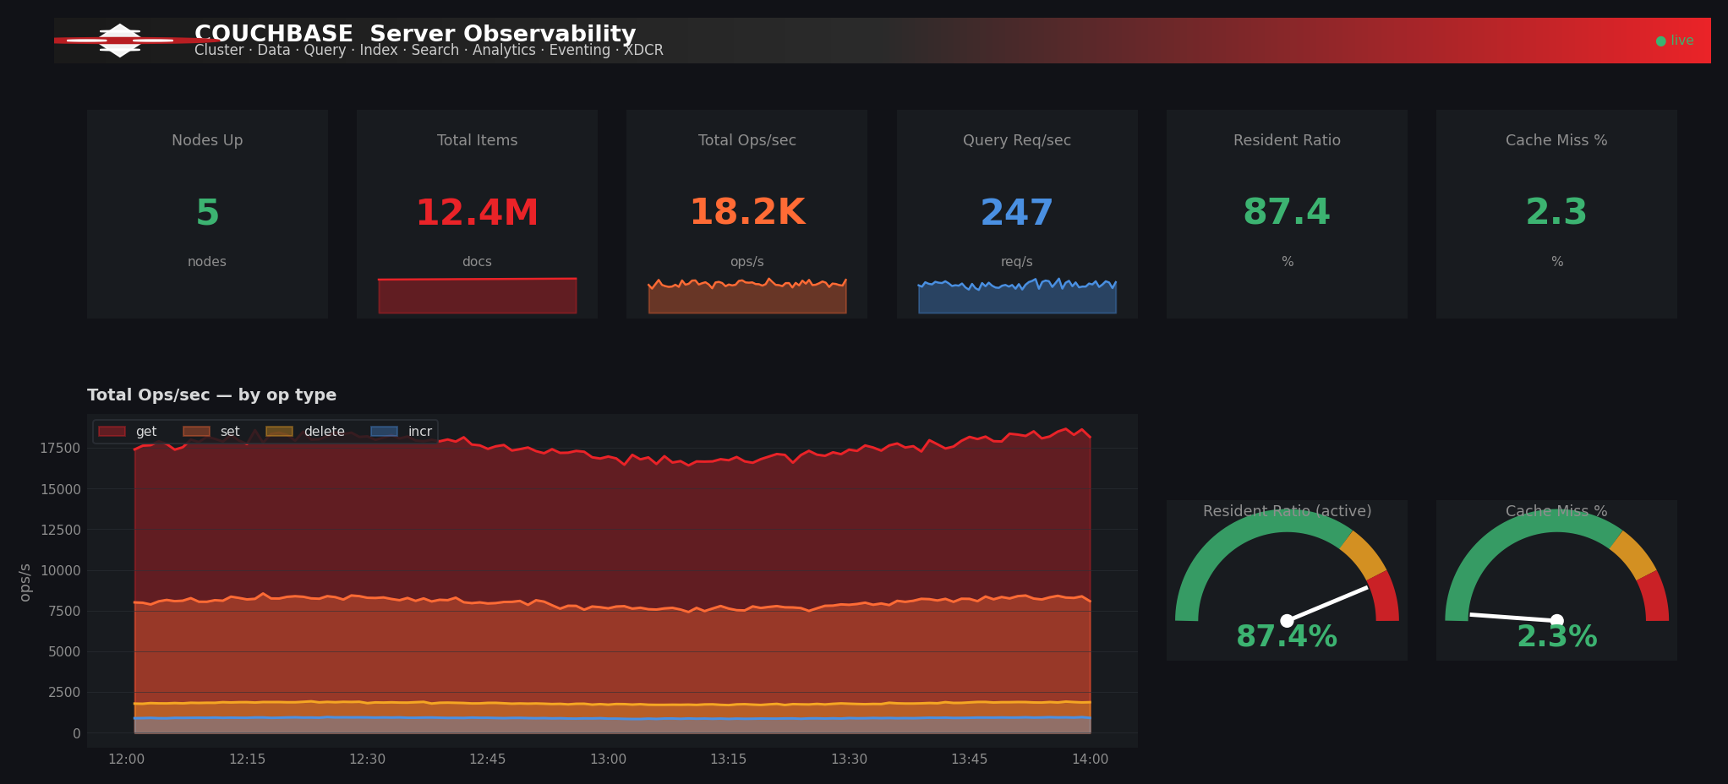
Figure 2. Couchbase-branded header, top KPI row, and total ops chart.
The top of the dashboard combines the brand header (a gradient bar from charcoal to Couchbase red with the cluster mark) with six summary stat panels and a wide stacked time-series of total operations per second. The two gauges on the right reflect resident ratio and cache miss rate at a glance.

5.1.1 KPI panels
Panel | PromQL | Threshold logic
Nodes Up | count(sys_cpu_utilization_rate{cluster=~"$cluster"}) | Red < 1, amber < 3, green ≥ 3
Total Items | sum(kv_curr_items{...}) | Static red — directional only
Total Ops/sec | sum(rate(kv_ops{...}[1m])) | Static orange — directional only
Query Req/sec | sum(rate(n1ql_requests{...}[1m])) | Static blue — directional only
Resident Ratio | avg(kv_ep_resident_items_ratio{state="active"}) | Red < 50%, amber < 80%, green ≥ 80%
Cache Miss % | 100 × bg_fetched / get_ops | Green < 5%, amber < 15%, red ≥ 15%

5.2 Cluster & Node Health
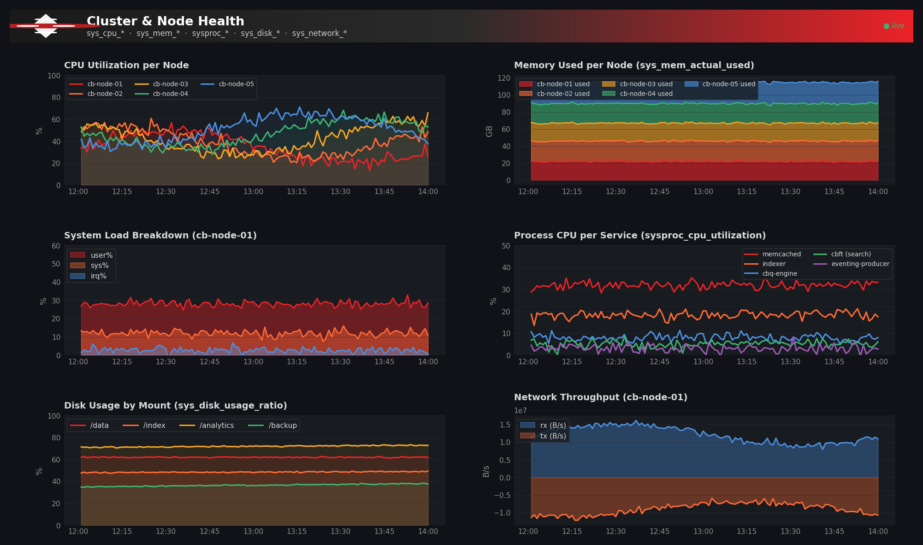
Figure 3. Per-node CPU, memory, system load breakdown, process CPU, disk usage, and network throughput.
This section answers the question Is my hardware healthy? Six panels track CPU and memory at the node level, the user / sys / irq breakdown, per-process CPU consumption (memcached, indexer, cbq-engine, cbft, eventing-producer), disk usage by mount point, and total network throughput.
Sustained high CPU on the indexer or cbq-engine processes usually points to a query-side issue: an index that needs to be added, a query that should be prepared, or insufficient indexer threads. Sustained memcached CPU above 80% indicates that the data service is the bottleneck and warrants a scale-out conversation.

5.3 Data Service (KV)
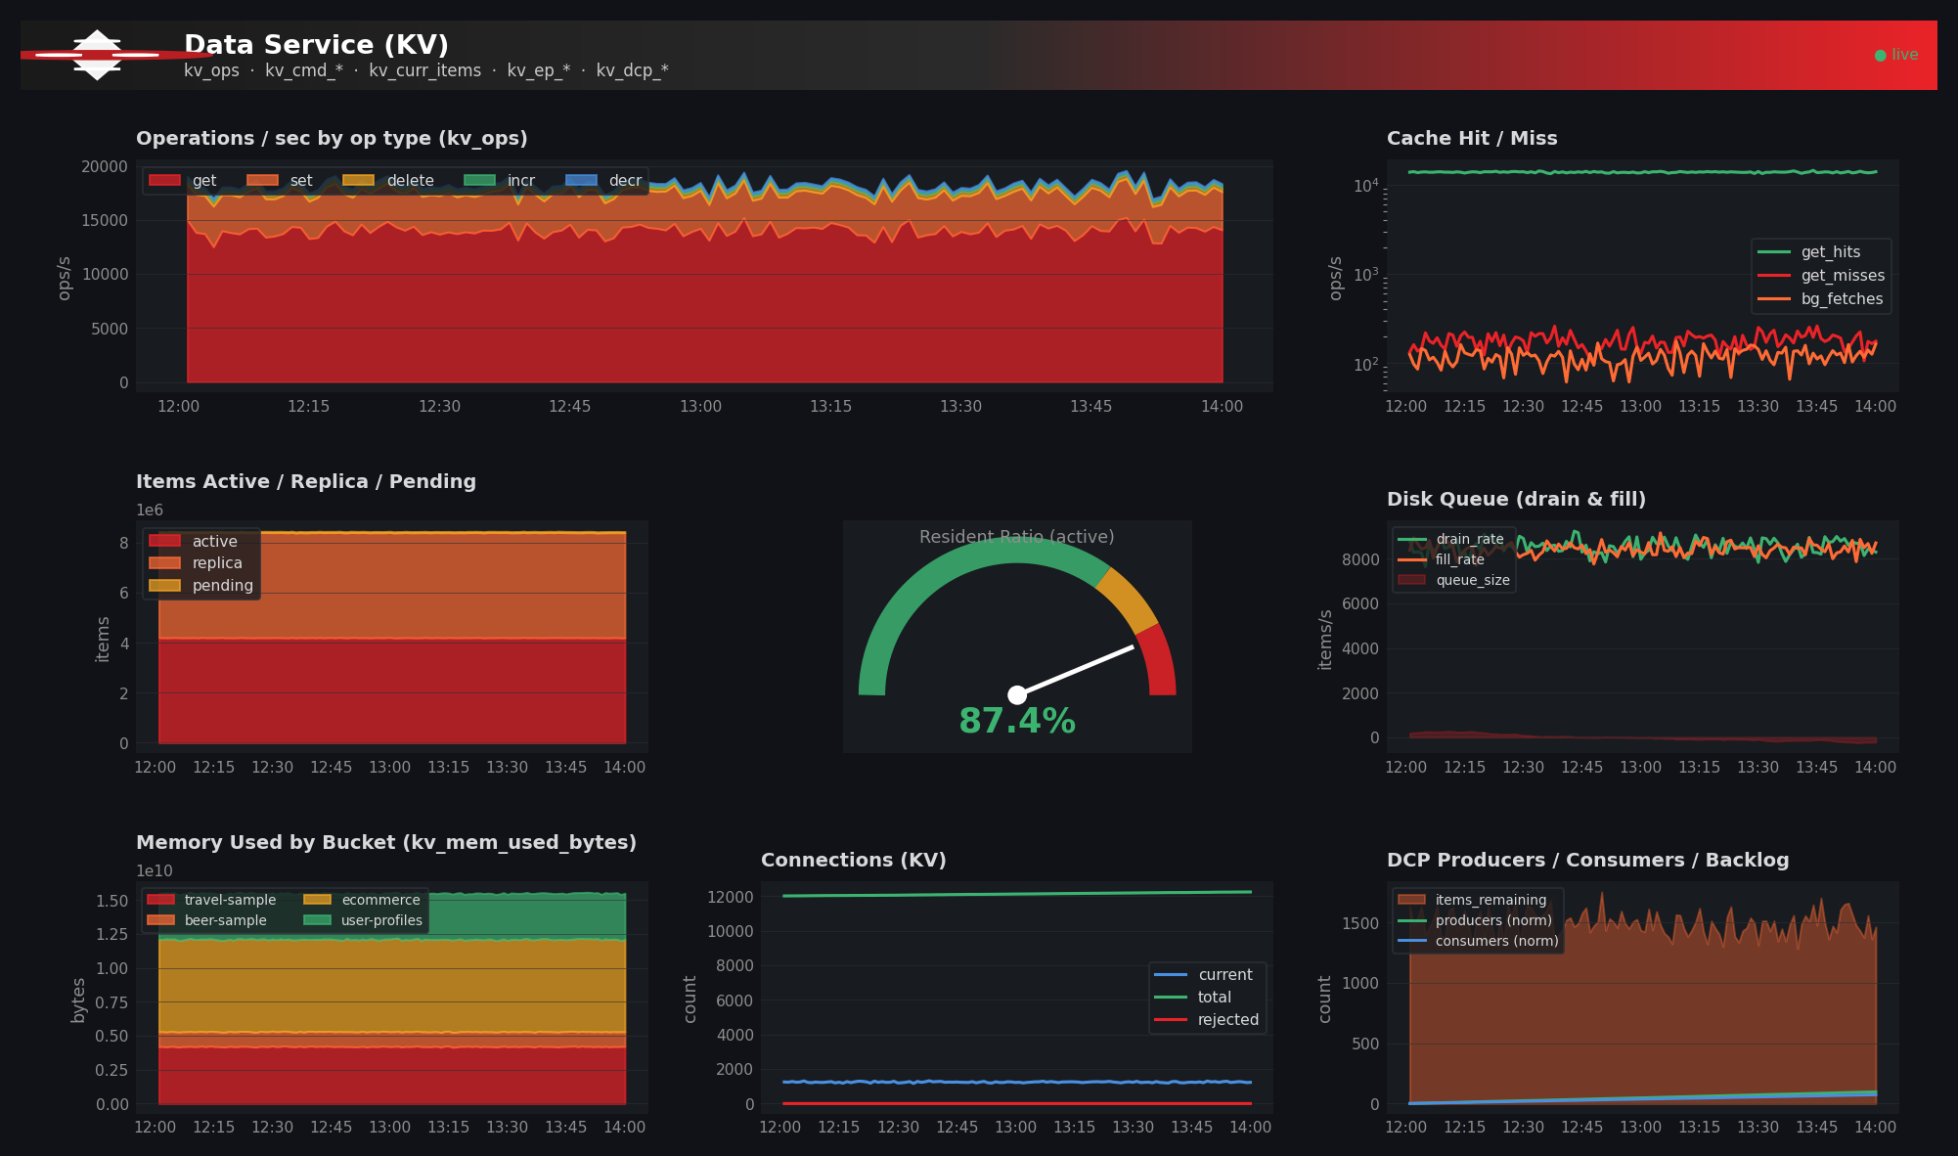
Figure 4. Operations by op type, cache hit/miss, items by vBucket state, resident ratio gauge, disk queues, memory by bucket, and DCP statistics.
The Data Service is the heart of any Couchbase deployment. Eight panels cover everything from raw operation rates to cache behavior, vBucket distribution, disk persistence, and DCP (Database Change Protocol) flow.
Watch the disk-queue panel during write spikes: when fill_rate consistently exceeds drain_rate, the persistence queue grows and items remain in memory longer. Combined with a falling resident ratio, this is the textbook signature of memory pressure on the data service.

5.4 Query Service (N1QL)
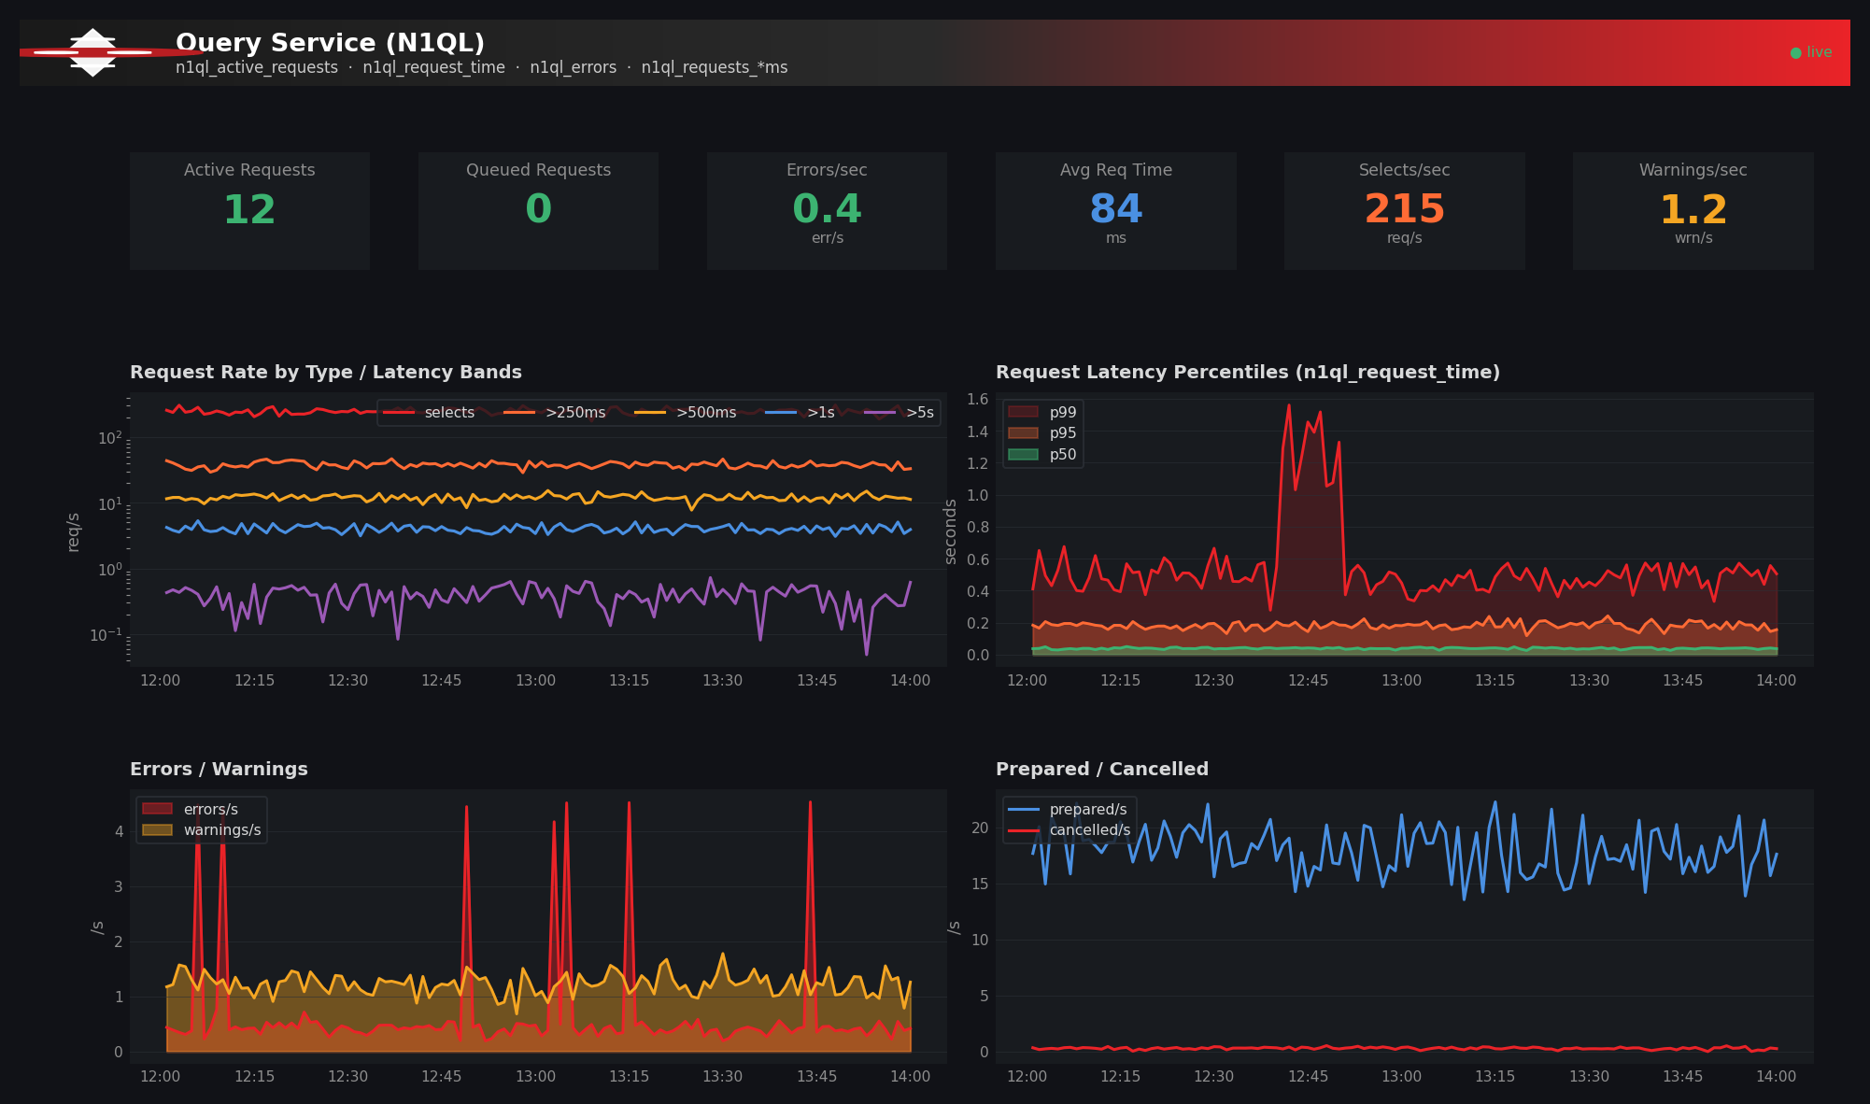
Figure 5. Query KPIs, request rate by latency band, percentile latency, errors and warnings, and prepared / cancelled rates.
The Query Service section uses the standard latency-band approach: a single time-series chart shows requests crossing the 250 ms, 500 ms, 1 s, and 5 s thresholds. A percentile view (p50/p95/p99) is computed from the n1ql_request_time histogram alongside it.
The KPI strip at the top — Active, Queued, Errors/sec, Avg Req Time, Selects/sec, Warnings/sec — gives an at-a-glance pulse on query health. Queued requests rising above zero is an early warning that you have run out of query threads.

5.5 Index Service (GSI)
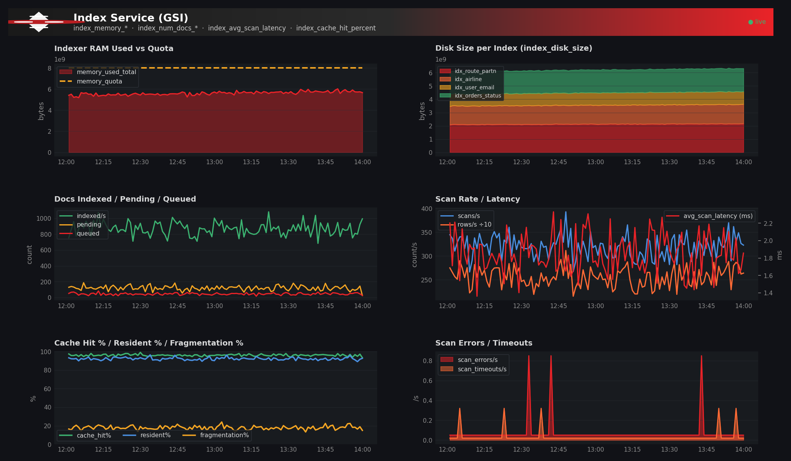
Figure 6. Indexer RAM vs quota, disk size per index, indexing throughput, scan rate / latency, cache hit and resident percentages, and scan errors / timeouts.
The GSI section emphasizes three signals that, together, diagnose most index-side problems:

5.6 Search Service (FTS)
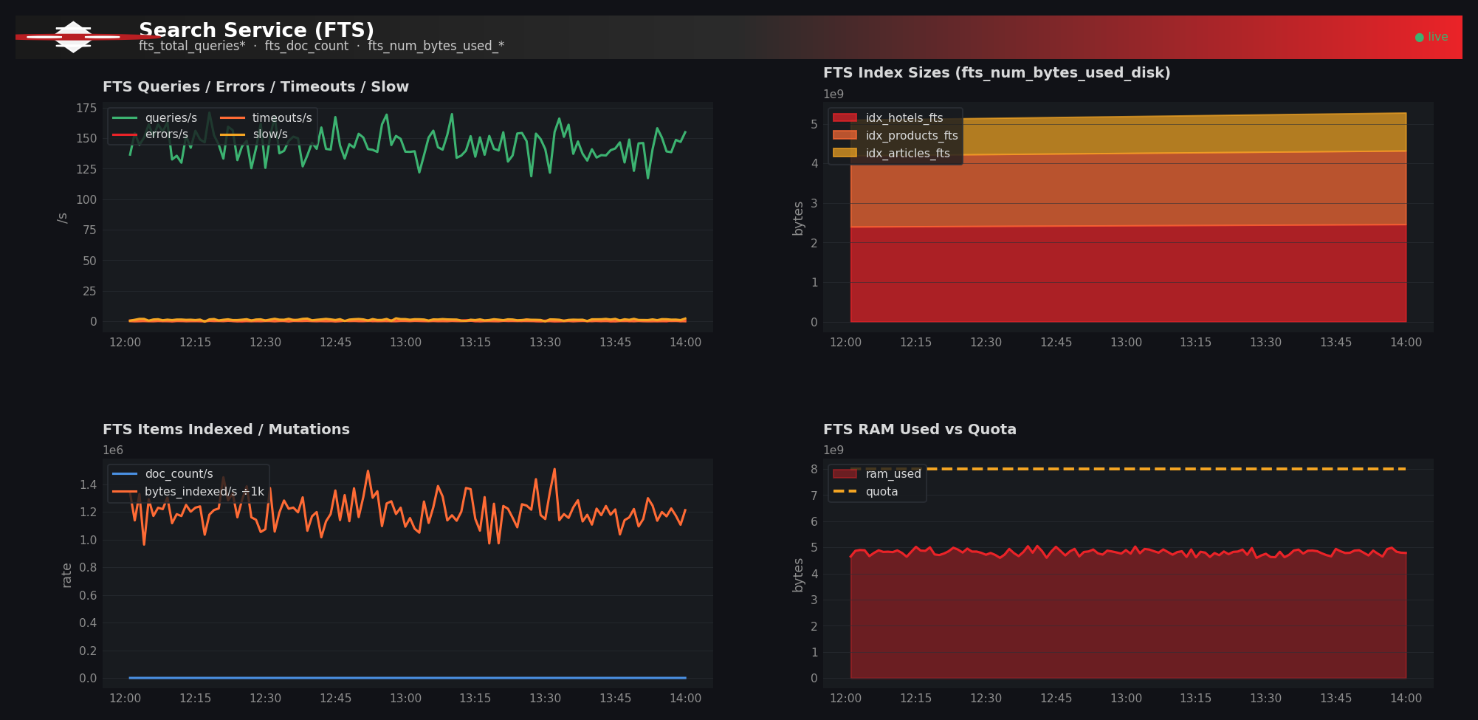
Figure 7. FTS query rate and error breakdown, index sizes, indexing throughput, and RAM utilization.
The Search Service section breaks query traffic into four buckets: successful queries, errors, timeouts, and slow queries. The slow query rate is particularly useful — it tracks queries that completed but exceeded the slow-query threshold, so it surfaces performance regressions before users complain.

5.7 XDCR — Cross-Datacenter Replication
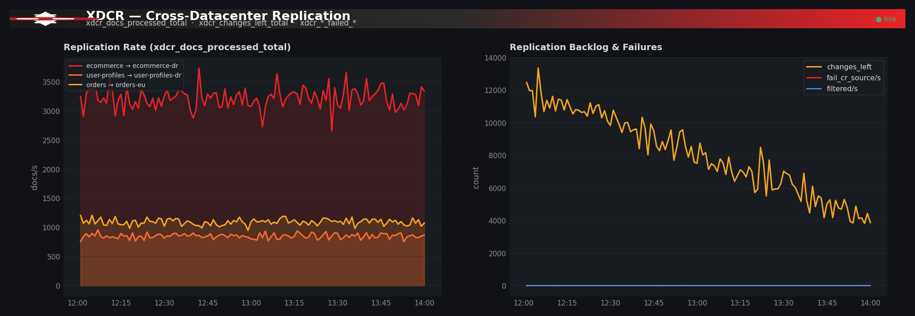
Figure 8. Replication rate per source-to-target link and replication backlog, conflict-resolution failures, and filtered documents.
The XDCR section is split into two charts: the per-link replication rate (one series per source → target pair) and a rollup of backlog plus failures. The backlog series — xdcr_changes_left_total — is the single most important XDCR metric: a steadily growing backlog means replication is not keeping up, and you will eventually run out of mutation log space.

5.8 Eventing and Analytics
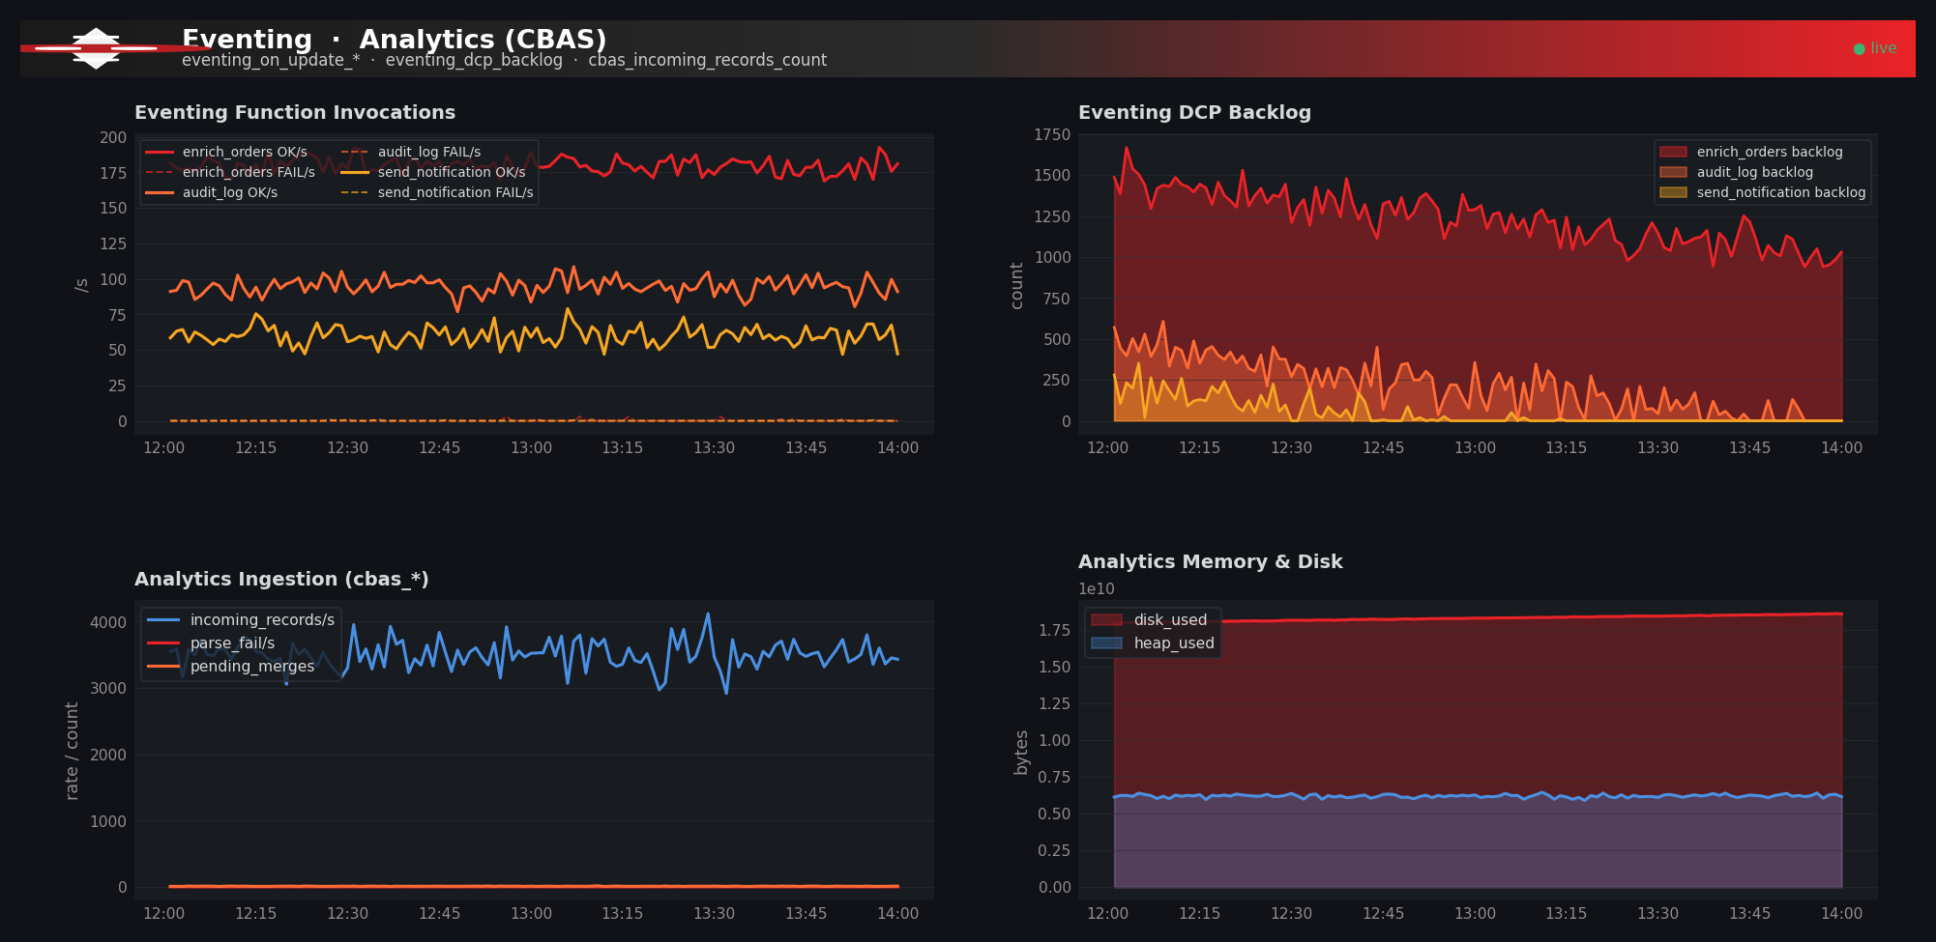
Figure 9. Eventing function invocations and DCP backlog, Analytics ingestion, and Analytics resource utilization.
Eventing functions are tracked by name. For each function, successful and failed on_update and on_delete invocations are rendered side-by-side. The DCP backlog panel shows how far each function is lagging the data service — a backlog that grows without bound usually means the function is too expensive for the current rate of mutations.
The Analytics section (CBAS) tracks ingestion of records into the analytics shadow datasets, parser failures, pending merge operations, and the disk and heap consumption of the analytics service.

6. JSON Reference — What Each Section Does
The dashboard is shipped as a single Grafana dashboard JSON file. This section documents every top-level key, every panel type, and every PromQL expression it contains.
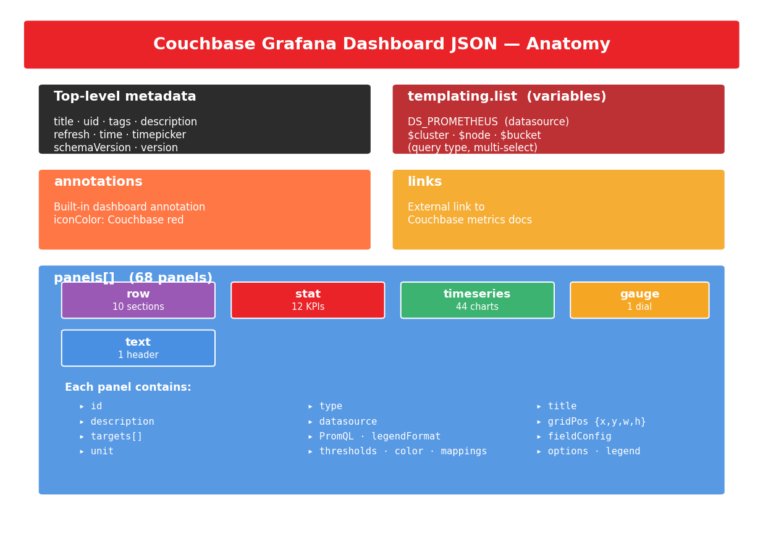
Figure 10. Anatomy of the dashboard JSON document.

6.1 Top-Level Keys
These are the top-level fields of the dashboard JSON, in the order Grafana expects them.
Key | Type | Purpose
title | string | Display name shown in the Grafana sidebar (Couchbase Server — Full Observability).
uid | string | Stable identifier used in URLs and in deep links. Set to couchbase-full-obs.
tags | array | Searchable tags: couchbase, nosql, database, prometheus.
description | string | Long-form description shown when the dashboard is hovered over in the listing.
editable | bool | Whether the dashboard can be edited in the browser. Set to true.
schemaVersion | int | Grafana JSON schema version. 39 corresponds to Grafana 10.x and is forward-compatible with 11.x.
graphTooltip | int | 0 = default, 1 = shared crosshair (used here), 2 = shared tooltip.
refresh | string | Default auto-refresh interval. 30s.
time | object | Default time range — { from: now-1h, to: now }.
timepicker | object | Refresh-interval choices in the picker.
timezone | string | browser uses the user's local timezone.
templating | object | Holds the variables array. See section 6.2.
annotations | object | Built-in dashboard-level annotation marker.
links | array | External links shown in the dashboard header. Includes a link to the Couchbase metrics reference.
panels | array | The 68 panels that make up the dashboard. See section 6.3.

6.2 Variables (templating.list)
Variables make the dashboard reusable across clusters, nodes, and buckets. They are evaluated in order and may reference earlier variables.
Name | Type | Definition | Behavior
DS_PROMETHEUS | datasource | type: prometheus | Resolved at import time. All panels use this UID.
$cluster | query | label_values(sys_cpu_utilization_rate, cluster) | Multi-select, defaults to All. The .* allValue is used so panel queries match every cluster when All is selected.
$node | query | label_values(sys_cpu_utilization_rate{cluster=~"$cluster"}, node) | Cascades from $cluster — selecting a cluster narrows the node list.
$bucket | query | label_values(kv_curr_items{cluster=~"$cluster"}, bucket) | Cascades from $cluster. Bucket-aware panels filter by this variable.

6.3 Panel Types
The dashboard mixes five Grafana panel types. The choice of type for each metric is intentional — KPIs use stat for scannability, time-evolving metrics use timeseries, the memory-pressure indicator uses a gauge for spatial intuition, section headers use row, and the brand header uses text.
Type | Count | Used for | Example panels
row | 10 | Collapsible section headers. Each row begins a functional area. | Cluster & Node Health, Data Service (KV), Query Service (N1QL)
stat | 12 | Single-value KPIs with optional sparkline. Color logic uses thresholds. | Nodes Up, Total Items, Active Requests, Errors/sec
timeseries | 44 | All time-evolving metrics. Smooth line interpolation; legend shows last/max/mean. | Operations by op type, CPU per node, latency percentiles
gauge | 1 | Resident ratio dial with green/amber/red bands. | Resident Ratio (active)
text | 1 | Couchbase-branded HTML/SVG header rendered at the top of the page. | Header

6.4 Panel Anatomy
Every Grafana panel shares the same structural skeleton. The snippet below shows a representative time-series panel from the dashboard, with each field annotated.
{
"id": 17, // unique within the dashboard
"type": "timeseries", // panel-renderer plugin id
"title": "CPU Utilization per Node", // shown in the panel header
"description": "sys_cpu_utilization_rate", // hover tooltip on the title
"datasource": { // which Prometheus to query
"type": "prometheus",
"uid": "${DS_PROMETHEUS}"
},
"gridPos": { "x": 0, "y": 8, // grid coords
"w": 12, "h": 8 }, // 24-col grid; w=12 = half width
"targets": [
{
"refId": "A", // letter ID (A, B, C…)
"editorMode": "code", // raw-PromQL editor
"expr": "sys_cpu_utilization_rate{cluster=~\"$cluster\",node=~\"$node\"}",
"legendFormat": "{{node}}", // template using a label
"range": true // range query (vs instant)
}
],
"fieldConfig": {
"defaults": {
"unit": "percent", // axis & tooltip formatting
"decimals": 2,
"color": { "mode": "palette-classic" },
"custom": { // visualization-specific options
"drawStyle": "line",
"lineInterpolation": "smooth",
"lineWidth": 2,
"fillOpacity": 15,
"gradientMode": "opacity",
"showPoints": "never",
"spanNulls": true,
"stacking": { "group": "A", "mode": "none" }
},
"thresholds": { // value bands for color logic
"mode": "absolute",
"steps": [
{ "color": "green", "value": null },
{ "color": "yellow", "value": 70 },
{ "color": "#EA2328", "value": 85 } // Couchbase red
]
}
},
"overrides": [] // per-series overrides
},
"options": {
"legend": {
"calcs": ["lastNotNull", "max", "mean"],
"displayMode": "table",
"placement": "bottom",
"showLegend": true
},
"tooltip": { "mode": "multi", "sort": "desc" }
}
}

6.5 PromQL Expression Catalog
The full list of PromQL expressions used in the dashboard, grouped by section. Variable substitutions ($cluster, $node, $bucket) are shown literally.

6.5.1 Cluster & Node Health
Panel | PromQL
CPU Utilization per Node | sys_cpu_utilization_rate{cluster=~"$cluster",node=~"$node"}
Memory Used per Node (used) | sys_mem_actual_used{cluster=~"$cluster",node=~"$node"}
Memory Used per Node (free) | sys_mem_actual_free{cluster=~"$cluster",node=~"$node"}
System Load — sys% | sys_cpu_sys_rate{...}
System Load — user% | sys_cpu_user_rate{...}
System Load — irq% | sys_cpu_irq_rate{...}
Swap Used / Total | sys_swap_used / sys_swap_total
Process CPU per Service | sysproc_cpu_utilization{...}
Process RSS per Service | sysproc_mem_resident{...}
Disk Usage by Mount | sys_disk_usage_ratio{...} * 100
Network rx/tx | rate(sys_network_bytes_received[1m]) / rate(sys_network_bytes_sent[1m])

6.5.2 Data Service (KV)
Panel | PromQL
Operations / sec by op type | sum by (op) (rate(kv_ops{...}[1m]))
Cmd Get / Set / Delete | sum(rate(kv_cmd_lookup[1m])) + kv_cmd_mutation + kv_delete_*
Cache Hit / Miss | kv_get_hits / kv_get_misses / kv_ep_bg_fetched
Items by State | sum by (state) (kv_curr_items{...})
Resident Ratio (gauge) | avg(kv_ep_resident_items_ratio{state="active"})
Disk Queue (drain & fill) | kv_ep_queue_size + drain/fill rates
Memory Used by Bucket | sum by (bucket) (kv_mem_used_bytes{...})
Bucket HWM/LWM vs Used | kv_ep_mem_high_wat / kv_ep_mem_low_wat / kv_mem_used_bytes
KV Connections | kv_curr_connections / kv_total_connections / kv_rejected_conns
DCP Producers / Consumers | kv_dcp_producer_count / kv_dcp_consumer_count / kv_dcp_items_*

6.5.3 Query Service (N1QL)
Panel | PromQL
Active Requests | sum(n1ql_active_requests{cluster=~"$cluster"})
Queued Requests | sum(n1ql_queued_requests{...})
Errors / sec | sum(rate(n1ql_errors[1m]))
Average Request Time | rate(n1ql_request_time[5m]) / rate(n1ql_requests[5m])
Selects / sec | sum(rate(n1ql_selects[1m]))
Warnings / sec | sum(rate(n1ql_warnings[1m]))
Latency Bands (>250/500/1k/5k ms) | sum(rate(n1ql_requests_*ms[1m]))
Latency p50 / p95 / p99 | histogram_quantile(0.50|0.95|0.99, sum(rate(n1ql_request_time_bucket[5m])) by (le))
Prepared / sec | sum(rate(n1ql_prepared[1m]))
Cancelled / sec | sum(rate(n1ql_cancelled[1m]))

6.5.4 Index, Search, Analytics, Eventing, XDCR, Backup
Section | Key metrics
Index (GSI) | index_memory_used_total, index_memory_quota, index_disk_size, index_num_docs_indexed, index_num_docs_pending, index_num_docs_queued, index_num_requests, index_num_rows_returned, index_avg_scan_latency, index_cache_hit_percent, index_resident_percent, index_frag_percent, index_num_scan_errors, index_num_scan_timeouts
Search (FTS) | fts_total_queries, fts_total_queries_error, fts_total_queries_timeout, fts_total_queries_slow, fts_doc_count, fts_total_bytes_indexed, fts_total_bytes_query_results, fts_num_bytes_used_disk, fts_num_bytes_used_ram, fts_memory_quota
Analytics (CBAS) | cbas_incoming_records_count, cbas_failed_at_parser_count, cbas_pending_merge_ops, cbas_disk_used, cbas_heap_used, cbas_system_load_average
Eventing | eventing_on_update_success, eventing_on_update_failure, eventing_on_delete_success, eventing_dcp_backlog, eventing_processed_count
XDCR | xdcr_docs_processed_total, xdcr_changes_left_total, xdcr_docs_failed_cr_source_total, xdcr_docs_filtered_total, xdcr_num_failedckpts_total
Backup | backup_location_total_size_bytes, backup_tasks_running
Legacy cb_* | cb_bucket_ops_per_second, cb_bucket_item_count, cb_bucket_ram_used, cb_node_systemstats_cpu_utilization_rate, cb_node_systemstats_mem_actual_used

6.6 Field Configuration Conventions
Every panel in the dashboard follows the same conventions for the fieldConfig block:
Convention | Detail
Color mode | palette-classic for time-series, thresholds for stat and gauge.
Line interpolation | smooth — easier to read at a glance than the default linear.
Fill opacity | 15 (gradientMode: opacity) — colored areas remain readable when many series overlap.
Show points | never — points clutter dashboards with hundreds of data points.
Span nulls | true — keeps lines continuous across short scrape gaps.
Legend | Table at the bottom showing last/max/mean. The table form is much more useful than the default list when comparing many series.
Tooltip | Multi-series with descending sort — the highest-value series appears at the top of the tooltip.
Threshold colors | Couchbase red (#EA2328) is used as the high-warning color throughout.
Stat thresholds | Direction depends on the metric — high resident ratio is good, high cache miss is bad.

7. Customization

7.1 Renaming Variables and Labels
If your Prometheus relabel rules produce different label names (for example, instance instead of node, or env instead of cluster), you have two options:
- Edit your relabel_configs to produce the expected names — recommended.
- Open the dashboard JSON in an editor and run a global find-and-replace: replace cluster=~ with env=~, node=~ with instance=~, and update the matching variable definitions in templating.list.

7.2 Adjusting Thresholds
The default thresholds in the KPI stat panels are deliberately conservative. To tune them for your environment, edit the thresholds.steps array on the relevant panel:
"thresholds": {
"mode": "absolute",
"steps": [
{ "color": "red", "value": null }, // < first step
{ "color": "yellow", "value": 1 },
{ "color": "green", "value": 3 } // ≥ this is green
]
}

Thresholds operate on the panel’s last value; for stat panels this is the most recent scrape, and for time-series panels they act as colored bands when thresholdsStyle is set to area or line+area.

7.3 Adding Alert Rules
The dashboard ships without alert rules; alerting is best configured at the Prometheus level so that alerts fire even when nobody has the dashboard open. A starter set of rules based on the same metrics:
groups:
- name: couchbase
rules:
- alert: CouchbaseNodeDown
expr: up{job="couchbase"} == 0
for: 2m
labels: { severity: critical }
annotations:
summary: 'Couchbase node {{ $labels.instance }} is down'

- alert: CouchbaseLowResidentRatio
expr: avg by (cluster, bucket)
(kv_ep_resident_items_ratio{state="active"}) < 50
for: 10m
labels: { severity: warning }
annotations:
summary: 'Resident ratio < 50% on {{ $labels.bucket }}'

- alert: CouchbaseQueryQueueGrowing
expr: sum(n1ql_queued_requests) > 10
for: 5m
labels: { severity: warning }
annotations:
summary: 'N1QL request queue is growing'

- alert: CouchbaseXDCRBacklogGrowing
expr: delta(xdcr_changes_left_total[15m]) > 0
for: 30m
labels: { severity: warning }
annotations:
summary: 'XDCR replication is falling behind'

7.4 Re-skinning
The Couchbase brand colors are concentrated in three places:
- The HTML header in the first text panel — replace the gradient and the inline SVG.
- The threshold colors on stat panels — search the JSON for #EA2328 and replace with your brand color.
- The annotation icon color — the annotations object near the top of the JSON.

8. Troubleshooting
Symptom | Likely cause | Resolution
No data on any panel after import | DS_PROMETHEUS not bound to a real data source. | Open the dashboard, click Settings → Variables → DS_PROMETHEUS, and select your Prometheus data source.
No data on KV panels but some on Cluster panels | Bucket label is missing from the kv_* metrics in your Prometheus instance. | Confirm in the Prometheus UI that kv_curr_items has a bucket label. If not, verify your scrape job and the Couchbase exporter version.
$cluster, $node, or $bucket dropdowns are empty | Label name mismatch. | Edit the variable definitions to match the labels your scrape config produces (see 7.1).
Latency panels show p99 = 0 | n1ql_request_time_bucket is not exposed (older Couchbase versions emit a summary instead). | Replace histogram_quantile expressions with n1ql_request_time{quantile="0.99"}.
Resident-ratio gauge is grey | kv_ep_resident_items_ratio not present, or the state=active label is missing. | Confirm the bucket type — ephemeral and memcached buckets do not emit this series.
Dashboard pinwheels indefinitely | PromQL request timing out at the data source. | Reduce the time range or shorten the rate() / histogram_quantile() windows. Consider precomputing with recording rules.
“Templating: failed to upgrade legacy queries” warning | Imported into a Grafana older than 9.0. | Upgrade Grafana to 9.0 or later. The dashboard targets schemaVersion 39.
Header looks broken | Markdown sanitization stripped the inline SVG. | Set GF_PANELS_DISABLE_SANITIZE_HTML=true in Grafana, or replace the header with a plain markdown banner.

9. References
Couchbase documentation:
- Configure Prometheus to Collect Couchbase Metrics — docs.couchbase.com
- Prometheus Discovery API
- Metrics Reference (Data, Query, Index, Search, Analytics, Eventing)
- Couchbase Prometheus Exporter (GitHub)
Tooling:
- Prometheus
- Grafana
- Prometheus Operator (kube-prometheus-stack)

Couchbase® is a registered trademark of Couchbase, Inc. This is an unofficial community project; the dashboard does not bundle, redistribute, or modify any Couchbase trademark asset. The brand colors are referenced in panel-styling rules only.

End of document.

