Blast Voyage — Original Game Concept
Table of Contents

BLAST VOYAGE

Original Game Concept — Casual Tap-to-Blast Puzzle Game
Case Study Part 2 — Product Specialist Position, Dream Games
Prepared by: [Candidate Name] Date: July 2026

Table of Contents
- Brief Introduction of the Game Concept
- Core Rules & Player Commands (foundation for everything below)
- Gameplay Mechanics for the First 50 Levels (Obstacles, Power-Ups, Boosters — with a full level-by-level plan)
- Concept Ideas — Basic Match Elements, Power-Ups, Boosters, Obstacles
- Meta-Game Design
- Level Design Strategy
- UI Design — Home Screen & Gameplay Screen (Wireframes)
- Why This Game Wins Globally — Closing Argument

1. Brief Introduction of the Game Concept
Blast Voyage is a level-based, tap-to-blast casual puzzle game about a joyful journey around the world. The player pops groups of two or more adjacent same-colored balloons to clear thousands of hand-crafted puzzle levels, and every level flown wins carries Coco — a warm-hearted red panda balloon pilot — one stop further on a world tour, restoring beloved public places in the world's most iconic cities: a carousel in Paris, a cherry-blossom park in Tokyo, a tea garden in Istanbul, a beach promenade in Rio. The core promise to the player: five seconds from app open to first pop, a fair puzzle every level, and a beautiful world that grows because you played.
One-line pitch: Toon Blast's instant tap satisfaction × Royal Match's frictionless meta and live-ops discipline × a travel theme with universal, borderless appeal.
The core loop: spend a life → enter the next level → pop balloon groups to clear the level goals within a move limit → earn coins and event progress → watch the current city district restore itself one landmark piece at a time → repeat. Five lives, one regenerating every 30 minutes. No forced ads, IAP-only monetization driven by honestly-flagged difficulty — the Dream Games model, because it is the model that builds decade-long trust.
Design pillars (every decision in this document traces to one of these):
- One verb, zero friction. Tapping a visible group is the lowest-friction input in the genre. Nothing in Blast Voyage — no meta choice, no gate, no second currency — ever stands between the player and the next tap.
- Skill you can see. Power-up creation is fully deterministic and previewed on the board before the tap (§2.4). Good players get better in ways they can feel; casual players never need to notice.
- Hope is a mechanic. The signature Paper Plane system (§2.5) guarantees that even a struggling board keeps producing goal-seeking help, converting near-losses into near-wins — protecting session mood and continue-purchase intent.
- A world worth restoring. The travel meta gives progress a face (Coco), a place (the current city), and a payoff (the restored landmark) — without a single decoration decision or story gate slowing the ladder down.
Target audience: the broad global casual puzzle audience, 25–55, all genders, session length 3–8 minutes. The travel theme is deliberately borderless: unlike themes anchored in one culture's fiction, "the world's beautiful places" is aspirational everywhere, localizes perfectly (your own country's chapter becomes a marketing beat), and supports endless content (there is always another city) and endless seasonal live-ops (every culture's festivals become event themes: Hanami, Carnival, Diwali, Oktoberfest).
Why balloons as the match element: popping a balloon is the single most universally satisfying tactile fantasy that maps onto "tap to blast" — the theme explains the verb. And balloons connect the board to the meta: Coco travels by balloon; the thing you pop is the thing that carries you.

2. Core Rules & Player Commands
(Defined once here so the 50-level plan in §3 and the concept catalog in §4 can build on it without forward references.)

2.1 The Board and the View
Portrait orientation, one-handed play. A fixed, fully visible board (typically 9×9, shape varies per level) of colored balloons, framed top by the goal panel and moves counter, bottom by the booster tray, and on the left edge by the Breeze Meter (§2.5). No avatar, no camera movement, no scrolling: the player acts directly on the board.

2.2 Commands — the Complete Input List
# | Command | Input | Effect | Costs a Move?
1 | Blast | Tap any group of 2+ adjacent same-colored balloons (orthogonal adjacency) | The whole group pops; balloons above fall; new balloons drop in from the top | Yes
2 | Activate power-up | Tap a power-up on the board | Fires it; if another power-up is orthogonally adjacent, they merge automatically into a combo (§2.6) | Yes
3 | Use item booster | Tap a tray booster (arms it), then tap a target tile | Applies the item's effect (§4.3) | No
4 | Pause | Tap the settings button | Pause overlay (resume / sound / quit-with-warning) | —
Edge cases, spelled out (nothing left for the implementer to assume):
- Tapping a lone balloon (no same-colored orthogonal neighbor): wiggle animation + soft sound, no move consumed. Mistaps are always free.
- Balloons cannot be moved by the player — only popped. All board manipulation happens through what you choose to pop and what gravity does next.
- Falling balloons do not auto-pop. New groups formed by gravity simply become tappable — the player harvests every cascade by hand, keeping 100% of agency in the player's finger (the correct choice for a blast game; luck-cascades belong to swap games).
- Dead board (no group of 2+ anywhere): automatic free shuffle with a brief notice. The player is never softlocked and never charged for board state they did not create.
- Input during resolution: taps during gravity are buffered for a beat, never silently dropped.

2.3 Power-Up Creation — Deterministic and Previewed
Popping a large enough group creates a power-up on the exact tile the player tapped (placement is a player skill, not luck). Thresholds:
Group Size at Tap | Creates | Preview on Board
5–6 | Firework (row/column rocket) | Group displays a small firework badge including its orientation
7–8 | Confetti Bomb (radius-2 blast) | Bomb badge on the group
9+ | Globe (clears every balloon of that group's color) | Globe badge on the group
Novel rule #1 — shape decides the Firework's direction (per Note 4, deliberately different from existing games): the Firework's orientation is not random. If the popped group's bounding box is wider than tall → horizontal Firework; taller than wide → vertical; on a tie → it points toward the side of the board containing more remaining goal tiles. Because the badge previews the orientation before the tap, aiming a Firework by sculpting the shape of a group becomes Blast Voyage's signature skill — visible to experts, invisible to casuals (who still get a rocket either way).

2.4 The Skill Economy of Group Growing
The pre-tap badge system makes every board a visible market: pop a 4-group now, or spend taps elsewhere so gravity grows it to 5 and mints a Firework? At 7? At 9? Because the badge, the placement rule, and the orientation rule are all deterministic, high-level play is manufacturing the right power-up, pointed the right way, on the right tile — a genuine skill ceiling built from a single verb.

2.5 Novel Rule #2 — The Breeze Meter and the Paper Plane
Every level has a Breeze Meter on the left edge of the board. Every balloon popped adds one point to the meter (power-up clears count too). When it fills (baseline 25 balloons; tunable per level), a Paper Plane spawns on the tile of the pop that filled it, and the meter resets.
The Paper Plane, when tapped, flies to the nearest remaining goal item, pops it, and clears the tile it lands on. It is the game's guaranteed frustration valve — the answer to blast-genre's classic dead end, "I can see the last crate but no group can reach it." Design properties, spelled out:
- The meter charges from the one thing the player is always doing (popping), so help flows faster exactly when the player is grinding a stubborn board.
- Spawning at the filling tap's location keeps placement in player hands; timing the fill is another quiet skill layer.
- The Plane is deliberately modest alone (one goal tile) but is a delivery vehicle in combos (§2.6) — experts save it to carry a Bomb into a fortress.
- Meter fill requirement is a first-class difficulty dial (§6.2): generous on recovery levels, tight on Super Hard walls.
(Reference point for the review team: this deliberately fuses the reliability of Royal Match's Propeller with a charge economy the player can pace — but its creation rule, placement rule, and combo behavior are original to this design, per Note 4.)

2.6 Power-Up Combinations (adjacency + one tap)
Tapping a power-up orthogonally adjacent to another merges them automatically:
Combination | Result
Firework + Firework | Cross blast — full row and full column
Firework + Confetti Bomb | Giant cross — three rows and three columns wide
Confetti Bomb + Confetti Bomb | Radius-3 mega blast with screen shake
Globe + Firework | Every balloon of the Globe's color becomes a Firework; all fire (orientations auto-balanced rows/columns)
Globe + Confetti Bomb | Every balloon of that color becomes a Bomb; all detonate
Globe + Globe | Clears the entire board — the game's ultimate moment
Paper Plane + (Firework / Bomb / Globe) | The Plane carries its partner and detonates the partner's full effect on arrival at a goal — precision delivery of heavy ordnance
Paper Plane + Paper Plane | Three Planes launch at three separate goals
The table is monotonic — any combo is at least as strong as its parts — so experimentation is always safe and always rewarded.

2.7 Winning, Losing, Continuing
- Win: all goal counters reach zero → level ends immediately → remaining moves convert into random board power-ups that chain-detonate for bonus coins (efficiency is directly rewarded; every win ends in fireworks — literally, on brand).
- Lose: moves reach zero with goals remaining → Continue offer: +5 moves for coins, keeping all board progress → declining ends the attempt and the life.
- Lives: 5 max, 30-minute regen, teammate gifting, timed unlimited-lives event rewards.

3. Gameplay Mechanics for the First 50 Levels
The first 50 levels are the game's most important product surface: they must convert an installer into a believer. The plan below follows a strict introduce → isolate → combine teaching cadence (one new thing at a time, in a level built around it, then mixed with known elements), a pulsed difficulty curve with honestly flagged walls, and a meta unlock schedule that adds one layer of meaning roughly every 10 levels.

3.1 What Exists by Level 50 — Summary
Category | Introduced in the First 50 Levels | Level
Core verb | Tap-to-blast (2+ adjacent) | 1
Power-ups | Firework (5+) | 4
 | Confetti Bomb (7+) | 7
 | Globe (9+) | 14
 | Combos (adjacency merge) | 17
 | Breeze Meter + Paper Plane | 20
Obstacles | Luggage crates (1- and 2-layer) | 10 / 12
 | Bubbles (encased balloons) | 26
 | Souvenirs (gravity collectibles) | 32
 | Mailboxes (postcard spawners) | 38
 | Fog (spreading obstacle) | 46
Boosters (items) | Pin (single tile) | 9
 | Boomerang (row) / Anchor (column) | 19 / 24
 | Whirlwind (shuffle) | 31
 | Pre-level loadout slots (Firework / Bomb / Globe at start) | 21
Difficulty tiers | First Hard level | 25
 | First Super Hard level | 50
Meta beats | Paris chapter (levels 1–25) → carousel restored; Tokyo chapter (26–50) → hanami park restored; Jet Stream streak (13), Voyage League (30), Travel Crews/teams (35) | —

3.2 Level-by-Level Plan (Levels 1–50)
Colors = balloon colors in the spawn pool (the strongest difficulty dial in a blast game — more colors fragment groups). Target = first-attempt win-rate target used for tuning (§6.4).
Lv | Colors | New / Focus | Goals & Board Intent | Target
1 | 3 | Tutorial: tap-to-blast | Pop 20 red balloons; giant pre-seeded groups; hand cursor shows first tap; unloseable | ~99%
2 | 3 | Two simultaneous goals | 15 blue + 15 yellow; teaches reading the goal panel | ~97%
3 | 4 | Fourth color; full 9×9 board | 40 balloons across three colors; first "real" board | ~95%
4 | 4 | Firework intro (5+ group) | Guided level: board pre-seeded with two obvious 5-groups; goal "use 2 Fireworks"; badge preview explained | ~97%
5 | 4 | Firework practice | Color goals sized so Fireworks are clearly the efficient path | ~92%
6 | 4 | Orientation teaching | Tall narrow board where only vertical Fireworks help; tutorial explains shape→direction rule | ~90%
7 | 4 | Confetti Bomb intro (7+) | Pre-seeded 7-cluster; goal "use 2 Bombs"; radius shown with a ring preview on first use | ~95%
8 | 4 | Bomb practice | Dense center goals rewarding radius damage | ~90%
9 | 4 | Pin booster granted (×3 free) | Board with a deliberate lone straggler goal; tutorial: tray items cost no move | ~92%
10 | 4 | Luggage crates intro (1-layer) | 12 crates in open field; teaches "blasts adjacent to obstacles damage them"; Paris area beat 1 restores after win | ~92%
11 | 4 | Crates on edges | Crates ring the border where groups are geometrically harder — first spatial lesson | ~85%
12 | 4 | 2-layer crates | Visible damage states (cracked after first hit); fewer crates, deeper | ~85%
13 | 4 | Jet Stream unlocks (win-streak meter, §5.4) | Comfortable crate mix so the first streak starts warm | ~90%
14 | 4 | Globe intro (9+ group) | Big open board, generous single color; goal "use 1 Globe"; the wow moment is engineered to happen | ~95%
15 | 4 | Globe practice | 60-blue goal; player discovers Globe = goal-color nuke | ~88%
16 | 4 | Crates + Fireworks together | First real "combine known things" level | ~82%
17 | 4 | Combo tutorial | Two Fireworks pre-seeded adjacent; guided merge; combo table begins unlocking in player's head | ~95%
18 | 5 | Fifth color debuts | Same layout class as 16 but fragmented groups — player feels the color dial | ~80%
19 | 5 | Boomerang booster granted (row-clear, ×3) | Wide crate rows built to showcase it | ~85%
20 | 5 | Breeze Meter + Paper Plane intro | Two crates sealed in a corner pocket no group can reach; the filling meter and first Plane rescue them; the "this game is fair" moment | ~93%
21 | 5 | Pre-level loadout unlocks | Level-start popup now offers arming Firework/Bomb/Globe at start (first one free) | ~85%
22 | 5 | Planes + corner crates | Layout rewards timing the meter fill near the pocket | ~80%
23 | 5 | Crates + 5 colors, tighter moves | First level most players need 2 attempts on | ~65%
24 | 4 | Anchor booster granted (column-clear, ×3); breather | Confidence rebuild before the wall; 4 colors feels luxurious now | ~90%
25 | 5 | HARD #1 (red-flagged) | Chapter finale: double ring of 2-layer crates, tight moves; pre-level boosters + Jet Stream become strategic; Paris carousel fully restored on win — biggest meta payoff yet | ~30%
26 | 4 | Tokyo chapter begins; Bubbles intro | Balloons encased in bubbles (one adjacent hit frees the balloon, which then becomes matchable); friendly dose | ~92%
27 | 4 | Bubble rows | Teaches that freed balloons rejoin the color economy | ~87%
28 | 4 | Bubbles + crates — first obstacle pairing | The two known obstacles interleaved | ~80%
29 | 4 | Bubble cluster center | Bombs visibly optimal; combo practice | ~82%
30 | 4 | Voyage League unlocks (weekly leaderboard, §5.5); breather | Open playground level so the first league win is easy | ~92%
31 | 5 | Whirlwind booster granted (shuffle, ×3) | Fragmented 5-color board where a shuffle demonstrably rescues | ~80%
32 | 4 | Souvenirs intro (gravity collectibles) | 3 snow-globe souvenirs fall to the bottom collector row when their columns clear; wide lanes | ~90%
33 | 4 | Souvenir routing | 2 souvenirs, narrow lanes; teaches column control | ~82%
34 | 5 | HARD #2 | Souvenirs above 2-layer crates: dig and route; vertical Fireworks (shape-sculpting!) are the expert path | ~30%
35 | 4 | Travel Crews unlock (teams, §5.6); breather | Lives-gifting tutorial; warm level | ~90%
36 | 5 | Souvenirs + bubbles | Freed balloons feed the lanes | ~78%
37 | 5 | Chokepoint board | Two chambers joined by a 2-wide channel; souvenir must transit; Planes shine | ~72%
38 | 4 | Mailbox intro (spawner) | Each hit on a mailbox ejects a postcard collectible onto the board; goal counts postcards; teaches repeated attention to one region | ~88%
39 | 5 | Two mailboxes on opposite edges | Split attention; Firework orientation play | ~78%
40 | 5 | HARD #3 | Mailboxes + bubbles; postcards spawn inside bubble fields | ~28%
41 | 5 | Postcards + souvenirs | Two collectible streams sharing lanes | ~75%
42 | 4 | Breather: combo playground | Low-stakes open board seeded to produce Globe+Firework moments | ~92%
43 | 5 | Crates + bubbles + tight moves | Compound puzzle, no new elements | ~68%
44 | 5 | Mailboxes center chokepoint | Board geometry as the antagonist | ~70%
45 | 6 | Sixth color debuts (unflagged but spicy) | Big board so 6 colors reads as variety, not cruelty — calibrating the player for endgame color counts | ~72%
46 | 4 | Fog intro (spreader) | If no fog tile is cleared in a turn, fog spreads to one adjacent tile; small dose, big board; the game's first pressure mechanic | ~85%
47 | 5 | HARD #4 | Fog + crates: triage under pressure | ~28%
48 | 5 | Fog + souvenirs | Protect the lanes while containing spread | ~70%
49 | 4 | Confidence builder | Generous Breeze Meter (15-balloon fill) rains Planes; sets up the finale emotionally | ~93%
50 | 6 | SUPER HARD #1 (dark-flagged) | Chapter finale: fog field + bubbled postcards + mailbox behind 2-layer crates; every system in one board; Tokyo hanami park fully restored on win, chapter-complete celebration, Osaka teased | ~12%

3.3 Why the Plan Is Shaped This Way
- Every element gets a solo level before it gets a partner. No level in 1–50 asks a player to learn two things at once. This is the single most protective rule for early funnel retention.
- Walls arrive only after the player is armed. Hard #1 (25) lands after streak rewards (13) and loadout (21) exist — difficulty always intersects a resource decision, never a dead end.
- Breathers directly follow walls (24→25→26, 49→50): the emotional loop is cruise → tension → spike → triumph → recovery, and the recovery levels are also where meta unlocks land so good news stacks on relief.
- Meta payoff is synchronized with difficulty payoff: the two flagged chapter finales (25, 50) are the same levels that complete the landmark restorations — the hardest fight and the biggest reward are one memory.
- Every event and social system unlocked by 35 consumes the same action — winning the next level. The decision space never grows; only the meaning of a win does. (This is the Royal Match live-ops lesson, applied from day one.)

4. Concept Ideas — Basic Match Elements, Power-Ups, Boosters, Obstacles
(Per Note 2: concepts are described precisely enough to brief an artist, with reference anchors from live games where useful. Only the UI wireframes in §7 are drawn.)

4.1 Basic Match Elements — the Balloons
Round, glossy, softly-3D balloons with a visible knot at the base and a candy-like highlight — tactile, "poppable" at a glance. Six colors, tuned for maximum hue separation and each carrying a unique printed symbol for colorblind accessibility and instant group parsing:
Color | Symbol Motif (travel-themed) | Personality
Red | Heart stamp | Warm, primary accent color of the brand
Blue | Compass rose | Cool anchor color
Yellow | Sun | Highest luminance; reads at any size
Green | Leaf | Mid-tone; never adjacent in hue to blue
Purple | Star | Rare/special-feeling; used in 5+ color pools
Orange | Paper plane stamp | Sixth color, endgame pools only
Balloons squash on landing, bulge on popping, and bob idly with a one-pixel float loop so the board always feels lighter than air. (Feel reference: the tactile softness of Royal Match cubes; silhouette-first readability discipline of Toon Blast.)

4.2 Power-Ups (created in-board by play)
- Firework — a rolled paper rocket with a fuse, its nose visibly pointing in its firing direction (orientation is gameplay information, so it is worn on the art). Launch: fizzing fuse anticipation, then a screen-length trail of confetti sparks.
- Confetti Bomb — a round striped party popper; pulses gently. Detonation: radial confetti burst, shockwave ring, brief screen shake (shake is reserved for Bomb-and-above so big plays keep a physical signature).
- Globe — a slowly spinning glassy globe that refracts the board behind it; on activation it flares and fires light beams to every balloon of its color. The rarest single power-up and drawn like the prize it is.
- Paper Plane — a crisp white origami plane that idles with a hover bob. On tap it banks, loops once (0.4s of pure charm), then darts to its goal with a pencil-line trail. When carrying a combo partner, the partner is visibly strapped beneath it — the player sees the payload they're delivering.

4.3 Boosters (owned consumables — the player's inventory)
Pre-level loadout (armed on the level-start popup, up to 3): board-spawned Firework, Confetti Bomb, Globe at move one. Earned from Jet Stream streaks, chests, events; purchasable with coins.
In-level tray (bottom of gameplay screen; never cost a move):
Booster | Effect | Concept
Pin | Pops any single tile | A jaunty map pin — the "surgical" tool for the last stubborn goal
Boomerang | Clears a chosen row | Thrown from off-screen left, sweeps the row, returns
Anchor | Clears a chosen column | Drops from the top through the column with a splash of rope
Whirlwind | Reshuffles all balloons (obstacles stay) | A tiny friendly tornado crosses the board rearranging everything
Tray slots show owned counts; a zero-count slot shows its coin price in place — the purchase path is one tap and never a navigation trip.

4.4 Obstacles — Behavioral Grammar First
All obstacles obey two universal rules (learned once, true forever): (1) they are damaged only by adjacent blasts and power-up effects; (2) their remaining state is always drawn on the object (cracks, layers, counters) — no hidden health anywhere. The first-50 roster:
Obstacle | Behavior Class | Concept & Reference Anchor
Luggage Crates | Multi-layer adjacent-clear | Vintage travel trunks plastered with destination stickers; each hit tears stickers and splinters a layer. (Class reference: Toon Blast crates / Royal Match boxes)
Bubbles | Shield/container | Soap bubbles encasing balloons; one adjacent hit pops the bubble, freeing the balloon into the color economy — obstacle clearance that feeds the player, a deliberately generous design
Souvenirs | Gravity collectible | Snow globes that ride gravity; collected at the bottom row. Introduces column/lane control. (Class reference: Toon Blast ducks / Royal Match diamonds)
Mailboxes | Spawner/carrier | Cheerful red post boxes; each hit ejects a stamped postcard collectible onto a nearby tile; goal counts postcards — forces repeated attention to one region
Fog | Spreader (pressure) | Soft grey cloud tiles; if no fog is cleared in a turn, it drifts onto one adjacent tile. The only obstacle that acts back, reserved for late-chapter drama. (Class reference: Candy Crush chocolate, modernized with gentler pacing)
Post-50 pipeline (concept backlog, one new behavior class per chapter): Customs Gates (colored locks opened only by popping a group of the matching color adjacent), Ticket Booths (obstacles that consume an adjacent balloon each turn — a reverse-spawner), Lanterns (chain-linked pairs that must be cleared in the same turn — introduces simultaneity), Cuckoo Clocks (countdown obstacles that must be cleared within N moves of first exposure). Each is a new rule, not a re-skin — the grammar stays small while the puzzle space compounds.

5. Meta-Game Design
The meta thesis, learned from Dream Games' own playbook: protect the loop; iterate the meaning around it. Every meta system below consumes exactly one player action — winning the next level — and adds meaning to it. Nothing adds decisions, gates, or friction.

5.1 The World Tour — Spatial Progression
Levels group into chapters of ~25, each a beloved district of an iconic world city (Paris → Tokyo → Istanbul → Rio → New York → Cairo → Seoul → …). Each win restores one element of the district — the carousel turns, the lanterns light, the cherry trees bloom — automatically, with zero decoration choices, in short skippable vignettes starring Coco. The chapter finale (always the flagged wall level) completes the district in a full transformation scene and lifts off the balloon toward the next city.
Why this beats abstract area progression: the player's progress monument is a place they recognize and may love. Localization becomes marketing ("your city is in the game"), and the content roadmap is inexhaustible and globally inclusive by construction.

5.2 Coco — the Mascot Layer
Coco the red panda pilot is the game's face: expressive, silent (no localization burden in the acting), reacting to wins, losses, and streaks from the home screen and celebrating restorations. Design intent mirrors King Robert's role in Royal Match: a character the player is for, giving emotional address to what would otherwise be a number going up. Seasonal outfits per city/event double as live-ops dressing.

5.3 Economy
- One currency: coins. Earned from wins (base + leftover-move bonus), chests, events. Spent on continues (+5 moves), booster purchases, and lives refills. Single-currency discipline keeps every price legible and every reward meaningful.
- Lives: 5 / 30-minute regen / crew gifting / timed unlimited-lives rewards. The session pacing valve and the social glue, unchanged from the proven model because it is load-bearing.
- Monetization: IAP only, difficulty-driven, no forced ads. Spend moments are the continue at a near-miss, the loadout before a flagged wall, and the refill mid-binge. The tuning covenant (§6.4) exists to keep every near-miss feeling earned by the level, because trust is the asset that compounds.

5.4 Jet Stream (win-streak system) — unlocks level 13
Consecutive wins climb a three-stage meter granting escalating free pre-level power-ups (1 → 2 → 3 armed automatically). A loss resets it. The streak converts wins into momentum, makes the next level always worth one more life, and quietly raises continue-purchase intent on walls ("I'm not losing this streak to two crates"). (Role model: Royal Match's Butler's Gift.)

5.5 Live-Ops Calendar
A dense rotation in the Royal Match mold, all feeding on level wins:
- Voyage League (unlocks lv 30): weekly division-based leaderboard of levels won; promotion/demotion; the competitive spine.
- Balloon Regatta: recurring 3-day race — first to N wins along a route claims tiered chests.
- Tailwind Rush: timed event where each win pre-charges the next level's Breeze Meter — a streak event expressed through the signature mechanic.
- Festival Days: seasonal themed events aligned with real global festivals (Hanami, Carnival, Diwali, Lunar New Year) — the travel theme makes every culture's celebration an authentic event skin, a live-ops advantage most fictions can't match.
- Passport Album: season-long collection meta — event wins award stamped passport stamps; completed pages pay chests; a completed passport pays the season's grand reward and a cosmetic Coco outfit. (Role model: Book of Treasure / sticker-album metas, tied into the travel fiction.)

5.6 Travel Crews (teams) — unlocks level 35
Up to 50 players: lives gifting, chat, and the Crew Cup (weekly team-vs-team wins race with shared chest tiers). Deliberately lightweight — the crew is a reason to log in and a place to feel useful, not a second game.

5.7 Session Architecture (how it all composes)
A typical mid-game session: open app (Coco greets, streak meter glows) → one obvious Play button → win two levels (coins, league points, regatta progress, album stamp all tick from the same wins) → hit the flagged wall → spend the streak-earned loadout → near-miss → continue decision → triumph → district restoration vignette → out of lives → request from crew → close app with tomorrow's reason pre-loaded. Every system above appears in that sentence, and none of them required a decision beyond "play the next level."

6. Level Design Strategy

6.1 Principles
- Hand-crafted, single ladder. Every level is authored, numbered, and shared by all players — no procedural boards. The map always focuses the next level; "what do I do now?" never exists.
- Introduce → isolate → combine. Every new element gets a tutorial level, then solo-practice levels, then pairings — never two new things at once (as executed in §3.2).
- One new thing every ~15–20 levels, forever. The obstacle backlog (§4.4) sustains novelty cadence deep into the ladder, because "something new is near" is a retention promise, not an onboarding trick.
- Fail-with-hope rule. Losing boards should end visibly close: goal counters nearly done, a Plane half-charged. Authoring and tuning both serve this — near-miss losses drive both retries and fair-feeling continues.
- Boards obey their own physics. No scripted rescues, no rubber-banding the spawn pool against the player. Randomness stays within declared bounds; trust is a feature.

6.2 The Difficulty Dials
Each independent, each tunable per level:
- Move budget vs. goal counts — the master dial.
- Color count (4 → 6): the blast genre's strongest lever; extra colors shatter group connectivity and starve power-up minting.
- Obstacle depth (layers, shields, spawner counts).
- Board geometry (chokepoints, pockets, notches — hostility through shape).
- Goal dispersion (spread dilutes power-up value; clusters reward one big combo).
- Breeze Meter fill cost (15 = generous rescue flow; 35 = walls where Planes must be earned).
- Group-size starvation (layouts that make 7+ groups rare, throttling Bomb/Globe production).

6.3 Curve Shape
A pulse, not a slope: 3–6 comfortable levels → a flagged wall → a breather → repeat, with wall frequency rising slowly over hundreds of levels. Difficulty tiers are announced honestly — Hard (red flag) and Super Hard (dark purple flag) on the map node and the level-start popup — because announced walls convert frustration into consent and budgeting into strategy (the single most important tuning-culture lesson from Royal Match and Toon Blast).

6.4 Tuning Targets and Process (the Product Specialist's chapter)
- First-attempt win-rate targets: Normal 65–90% (position-dependent, per §3.2), Hard 25–35%, Super Hard 10–15%. Attempts-to-pass targets: Normal ≤2, Hard 3–6, Super Hard 7–12.
- Instrumentation per level: attempts distribution, win rate by attempt number, quit-without-retry rate, continue take-rate, booster usage rate, move-surplus on wins (a win with 12 moves left means the budget is wrong), and loss proximity (average % of goals done at failure — the fail-with-hope metric).
- Red-flag thresholds: any level with quit-without-retry above baseline or a D1-churn spike in its cohort goes to re-tuning within the weekly content cycle regardless of revenue — a level that monetizes today and churns tomorrow is net-negative.
- Playtest funnel: internal solver pass (bounds check: is the level winnable at target percentile play?) → designer play → fresh-player lab tests for the first-200 band → soft-launch cohort telemetry → global, with A/B slots reserved for move budgets and meter costs.
- Weekly content cadence: new levels ship weekly at the top of the ladder; the tuning team re-visits the trailing 200 levels on telemetry continuously. Levels are content and economy — they are operated, not just shipped.

7. UI Design — Home Screen & Gameplay Screen (Wireframes)
Two wireframes are provided as companion files, referenced below. Design rationale follows each.

7.1 Home Screen Wireframe
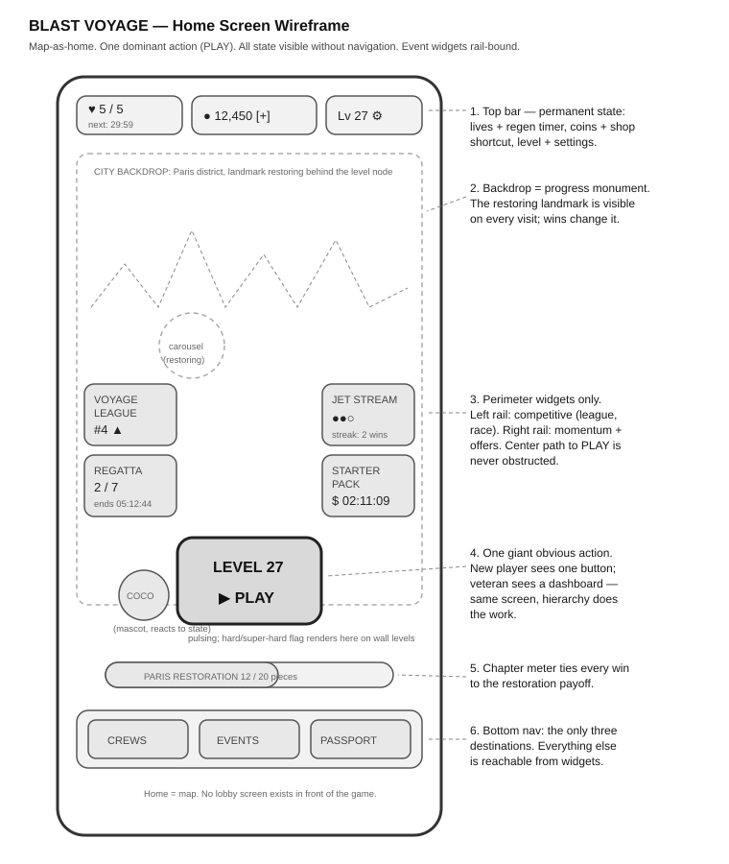
Text schematic of the same layout:
┌─────────────────────────────────────┐
│ [♥5 29:59] [🪙 12,450 +] [⚙] │ ← Top bar: lives+timer, coins+shop, settings
│ │
│ ┌────────┐ ┌─────────┐ │
│ │VOYAGE │ │JET │ │ ← Perimeter widgets:
│ │LEAGUE │ │STREAM │ │ left = competitive,
│ │ #4 ▲ │ │ ●●○ │ │ right = momentum/offers
│ └────────┘ └─────────┘ │
│ ┌────────┐ PARIS ┌─────────┐ │
│ │REGATTA │ (city │STARTER │ │
│ │ 2/7 🎈 │ skyline, │PACK $ │ │
│ └────────┘ carousel └─────────┘ │
│ rebuilding) │
│ │
│ ╭───────────╮ │
│ │ LEVEL 27 │ │ ← The one giant obvious action,
│ │ ▶ PLAY │ │ centered, pulsing
│ ╰───────────╯ │
│ (Coco waves beside it) │
│ │
│ [ CREWS ] [ EVENTS ] [ PASSPORT ] │ ← Bottom nav
└─────────────────────────────────────┘
Rationale: the map is the home screen — no lobby in front of the game. One dominant Play button on the current level node; everything else is perimeter. Lives, coins, streak state, and event timers are permanently visible so the player never navigates to learn whether they can afford to play. A brand-new player sees one button; a veteran sees a dashboard; it is the same screen because hierarchy, not hiding, does the work. Event widgets are compact, animated, and strictly rail-bound — the center path from thumb to Play is never obstructed. The restoring landmark sits behind the node so every visit to the home screen is also a look at the progress monument.

7.2 Gameplay Screen Wireframe
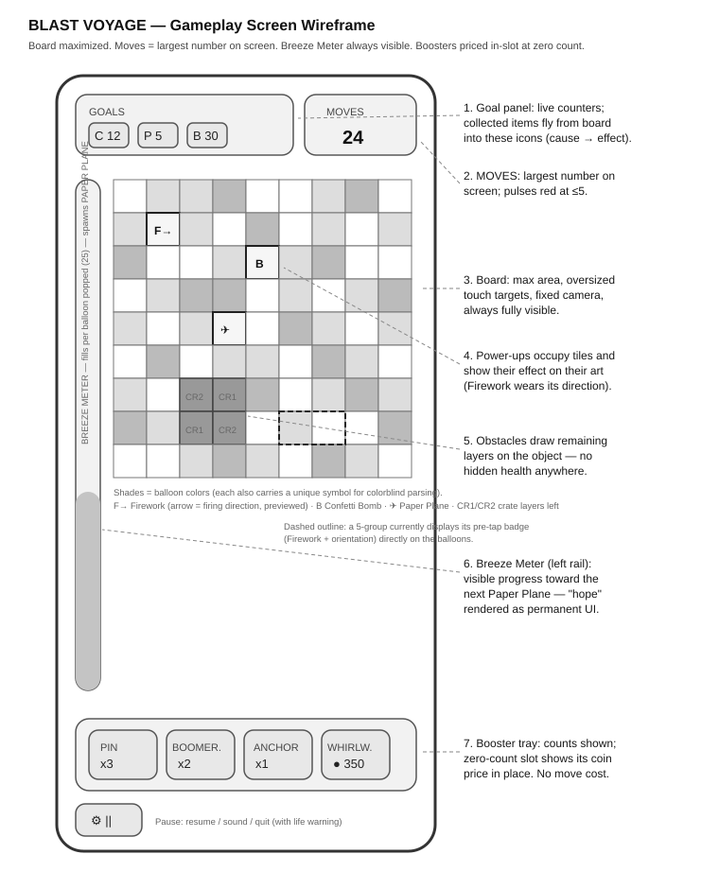
Text schematic:
┌─────────────────────────────────────┐
│ GOALS: [📦12] [💌 5] MOVES: 24 │ ← Goal panel + moves (largest number on screen)
│─────────────────────────────────────│
│ B │ ┌───────────────────────────┐ │
│ R │ │ ● ● ● ▲ ▲ ● ■ ■ ● │ │
│ E │ │ ● ▲ [F]▲ ● ● ■ ● ● │ │ ← Board 9×9:
│ E │ │ ▲ ▲ ● ● [B] ● ● ▲ ● │ │ ●▲■ = balloon colors
│ Z │ │ ● ■ ■ ▲ ● ● ▲ ▲ ● │ │ [F]irework [B]omb
│ E │ │ ■ ● ▲ ●(✈)● ■ ● ▲ │ │ (✈) = Paper Plane
│ │ │ ▲ ● ● ■ ▲ ▲ ● ● ■ │ │ ⬛ = crate obstacle
│ ▓ │ │ ● ▲ ⬛ ⬛ ● ● ▲ ■ ● │ │
│ ▓ │ │ ■ ● ⬛ ⬛ ▲ ● ● ● ▲ │ │
│ ▓ │ └───────────────────────────┘ │
│ ▲ │ Breeze Meter (fills per pop) │
│─────────────────────────────────────│
│ [📍3] [🪃2] [⚓1] [🌪 $] [⚙] │ ← Booster tray (counts / price-in-slot) + pause
└─────────────────────────────────────┘
Rationale: the board takes maximum area with oversized, forgiving touch targets; the moves counter is the largest number on screen and pulses red at ≤5. Goal items visibly fly from board to counter on collection, so cause-and-effect never needs explaining. The Breeze Meter lives on the left rail — visible progress toward the next Paper Plane at all times, which is the "hope" pillar rendered as UI. The tray shows counts, or the coin price in the slot when a booster is at zero — the purchase path is one tap long and appears exactly at the moment of need. Nothing overlays the board except modal moments (continue / win / lose), which dim but never hide the level behind them.

8. Why This Game Wins Globally — Closing Argument
- The verb is the most accessible in the genre, and both novel systems deepen it without touching it: shape-aimed Fireworks reward mastery invisibly; the Breeze Meter guarantees hope mechanically. Casual players feel generosity; expert players feel a ceiling. That pairing is what carries a puzzle game from level 50 to level 5,000.
- The theme is borderless by construction. "The world's beautiful places, restored by you" excludes no market, flatters every market it enters, converts every real-world festival into authentic live-ops, and never runs out of chapters.
- The meta is Dream Games-disciplined: one currency, one action, zero friction, honest difficulty, no ads — every system stacks meaning onto the next level instead of competing with it. It is a design that respects why Royal Match works, then adds its own signature (the Plane, the shape-aiming, the passport, the world) in the layers where innovation belongs.
- It is operable as a product, not just playable as a game: §6.4 ships with tuning targets, red-flag thresholds, and a telemetry plan, because a Product Specialist's level design strategy has to survive contact with a live dashboard.
Thank you for reviewing this concept. I would be glad to walk through any system in depth — particularly the Breeze Meter economy tuning and the first-50 win-rate curve — in person.

