

User Manual for the NWC/GEO: NWCSAF2ADAGUC software suite

NWC/CDOP3/GEO/AEMET/SW/UM/NWCSAF2ADAGUC, Issue 1, Rev. 1

*17 March 2020*

*Applicable to NWCSAF2ADAGUC*

*for SAFNWC/GEO*

**Prepared by AEMET, NMA**

REPORT SIGNATURE TABLE

|  |  |  |  |
| --- | --- | --- | --- |
| **Function** | **Name** | **Signature** | **Date** |
| **Prepared by** | Llorenç Lliso (AEMET)  Oana Nicola (NMA) |  | February 2020 |
| **Reviewed by** |  |  |  |
| **Endorsed by** |  |  |  |
| **Authorised by** |  |  |  |

**DOCUMENT CHANGE RECORD**

|  |  |  |  |
| --- | --- | --- | --- |
| **Version** | **Date** | **Pages** | **Changes** |
| 1.0 | 3 March 2020 | 22 | First version, applicable to NWCSAF2ADAGUC v1.0 |
| 1.1 | 17 March 2020 | 23 | Change the name of the cleaner.py to Updater.py  Change the name of the CLEANER.sh to UPDATER.sh |
| 1.2 | 8 April 2020 | 24 | In order to ensure the complete xml production, second test order changed  Some typos corrected |

Table of Contents

1 Introduction 6

1.1 Purpose 6

1.2 References 6

1.2.1 Applicable documents 6

1.2.2 Reference documents 6

2 Functional Description 7

3 Installation of NWCSAF2ADAGUC 8

3.1 Environment 8

3.2 Previous conditions and licenses 8

3.2.1 NWC/GEO 8

3.2.2 python 8

3.2.3 ADAGUC 9

3.2.4 Disclaimer of warranties 10

3.3 Installation of the NWCSAF2ADAGUC software suite 10

4 Operation of NWCSAF2ADAGUC suite 10

4.1 SUITE LOGIC 10

4.2 SUITE CONFIGURATION 15

4.2.1 SETTING THE PATHS 15

4.2.1.1 Editing TM.conf 15

4.2.1.2 Editing rdt.conf, pixel.conf, hrw.conf, exim.conf 15

4.2.2 ALLOWING the xml production. 16

4.2.3 RDT Processing and Visualization Configuration 16

4.2.3.1 Setting the number of geoJSON files 16

4.2.3.2 Setting the content of the geoJSON files 17

4.2.3.3 Copy the xml 18

4.2.4 Connecting the Updater with the files 18

5 TESTS 19

5.1 FIRST TEST (oFFline TEST) 19

5.2 SECOND TEST (ONLINE TEST) 21

5.3 THIRD TEST (DATABASE UPDATE TEST) 22

6 MAKING THE VIEWER ACCESSIBLE IN YOUR NETWORK 23

7 TAILORING Add layers 23

8 INCLUDING OTHER DATA SOURCES 24

9 FURTHER INFORMATION: 24

**List of Tables and Figures**

Table 1: List of Applicable Documents 6

Table 2: List of Referenced Documents 7

Table 3: Minimum configuration 8

Table 4: Python packages tested with NWCSAF2ADAGUC 9

Figure 1: TM concept 12

Figure 2: Updater concept 12

Figure 3: SUITE Concept 12

Figure 4: TM Flowchart 13

Figure 5: Updater Flowchart 14

Figure 6: Where to find the service and the layer 24

# Introduction

## Purpose

In the frame of the NWC SAF project, a software suite for NWC/GEO output conversion and ingestion into ADAGUC database (NWCSAF2ADAGUC) has been developed. The NWCSAF2ADAGUC has been designed to read NWC/GEO output products in netCDF[1] format and convert them to be ADAGUC and java/GDAL based viewers compatible.

The software suite has two main tools, one (NWCSAF2ADAGUCTMVFS.py) processes the files and places the output files in the configured folder and the other one (Updater.py) updates the ADAGUC database and cleans the output directory. The document presents the functionalities of the NWCSAF2ADAGUC software suite and the procedures needed in order to configure and to operate it.

## References

### Applicable documents

The following documents, of the exact issue shown, form part of this document to the extent specified herein. Applicable documents are those referenced in the Contract or approved by the Approval Authority. They are referenced in this document in the form [AD.X].

For dated references, subsequent amendments to, or revisions of, any of these publications do not apply. For undated references, the current edition of the document referred applies.

Current documentation can be found at the NWC SAF Helpdesk web: http:/nwc-saf.eumetsat.int

|  |  |  |  |  |
| --- | --- | --- | --- | --- |
| Ref | Title | Code | Vers | Date |
| [AD.1] | Proposal for the Third Continuous Development and Operations Phase (CDOP3) March 2017 – February 2022 | NWC SAF: CDOP-3 proposal | 1.0 | 11/04/16 |
| [AD.2] | Data Output Format of the NWC/GEO | NWC/CDOP3/GEO/AEMET/SW/DOF | 1.0 | 21/01/19 |
| [AD.3] | User Manual for the Tools of the NWC/GEO | NWC/CDOP3/GEO/AEMET/SCI/UM/Tools | 1.0 | 21/01/19 |
| [AD.4] | User Manual for the Wind product processors of the NWC/GEO: Science Part | NWC/CDOP3/GEO/AEMET/SCI/UM/Wind | 1.0 | 21/01/19 |
| [AD.5] | Git repository | <https://gitlab.aemet.es/xcalbeta/ADAGUC-utilities> |  |  |

Table 1: List of Applicable Documents

### Reference documents

The reference documents contain useful information related to the subject of the project. These reference documents complement the applicable ones, and can be looked up to enhance the information included in this document if it is desired. They are referenced in this document in the form [RD.X].

For dated references, subsequent amendments to, or revisions of, any of these publications do not apply. For undated references, the current edition of the document referred applies.

Current documentation can be found at the NWC SAF Helpdesk web: http:/nwc-saf.eumetsat.int

|  |  |  |  |  |
| --- | --- | --- | --- | --- |
| Ref | Title | Code | Vers | Date |
| [RD.1] | The Nowcasting SAF Glossary | NWC/CDOP2/SAF/AEMET/MGT/GLO |  |  |
| [RD.2] | KNMI adaguc page | <http://adaguc.knmi.nl/> |  |  |

Table 2: List of Referenced Documents

# Functional Description

The NWCSAF2ADAGUC suite implements the following high-level requirements:

|  |  |
| --- | --- |
| Id | Description |
| 010 | The NWCSAF2ADAGUC suite shall convert NWC/GEO products to be ADAGUC compatible |
| 020 | The NWCSAF2ADAGUC application shall be developed as a tool apart from the NWC/GEO, so that a user can run it without installing the NWC SAF software |
| 030 | The application shall be able to read all PGE products in native netCDF format (including EXIM products) |
| 040 | The application shall also allow the reading of Satellite Channel products in netCDF as generated by the NWC/GEO extra tool GEO-L1SD (See [AD.3]) |
| 050 | Given a netCDF NWCSAF product file, the application shall read the data corresponding to a certain variable, including its attributes and colour palette. |
| 060 | The application should allow adding user data/products (e.g. radar data) to ADAGUC. The user files should be in a format that is compliant with the ADAGUC supported formats and the xml corresponding files should also be provided. |

# Installation of NWCSAF2ADAGUC

## Environment

This section describes HW/SW prerequisites needed to install and execute the NWCSAF2ADAGUC software suite.

NWCSAF2ADAGUC suite has been tested in Ubuntu18.04 64 bits environment. Correct execution in other environments cannot be currently guaranteed.

|  |  |
| --- | --- |
|  | Intel/Linux |
| O.S | UBUNTU 18.04.3 LTS |
| CPU | 4x  Intel(R) Core(TM) i5-4440  CPU @ 3.10GHz |
| Arch | x86_64 |
| Memory | 32 GB |
| Disk | 500 GB /data  100 GB /  200GB /home |
| Shell | bash; ksh |
| Compilers | GCC compilers 8.3.0;  gcc; g++; gfortran |
| java | openJDK 1.8.0 |
| Python | 3.6.9 |

Table 3: Minimum configuration

When using virtual systems with the disk on the network, SSD disks with optical fibre connection are recommended. Using slower NFS disks could raise in errors and slow system performance.

## Previous conditions and licenses

### NWC/GEO

The NWCSAF2ADAGUC has been designed and developed to be self-dependant. Therefore, the NWC/GEO package is not required to execute this tool.

### python

The NWCSAF2ADAGUC has been developed in python. Python3 is required to execute the NWCSAF2ADAGUC suite.

In addition, the following python packages are required and should be installed in the platform using apt-get (e.g. sudo apt-get install python3-netCDF4). Only in the case that the tests fail for your system configuration, install with pip3 or conda the version referred in Table 4.

Table 4: Python packages tested with NWCSAF2ADAGUC

|  |  |  |
| --- | --- | --- |
| Module name | Description | Tested version |
| datetime | Basic date and time types | default |
| time | Time access and conversions*.* | default |
| calendar | Functions for working with calendars | default |
| h5py | Pythonic interface to the HDF5 binary data format | 2.7.1 |
| netCDF4 | Python interface to the netCDF C library. | 1.4.1 |
| numpy | Package for scientific computing with Python | 1.16.2 |
| scipy | Software for mathematics, science, and engineering. | 1.1.0 |
| math | Mathematical functions | default |
| os | Miscellaneous operating system interfaces | default |
| sys | System-specific parameters and functions | default |
| json | json encoder and decoder | default |
| shapely | Manipulation and analysis of planar geometric objects. | 1.6.4.post2 |
| geographiclib | Algorithms for geodesics | 1.49 |
| pandas | Python Data Analysis Library | 0.24.1 |
| geopandas | Python Data Analysis Library extended with shapes | 0.4.1 |
| cv2 | Python interface for openCV | opencv-python==3.4.3.18 |
| logging | Flexible event logging system for applications. | default |
| multiprocessing | Process-based parallelism. | default |

### ADAGUC

To have ADAGUC running on your system please follow the instructions <https://dev.knmi.nl/projects/adagucserver/wiki/Install_Adaguc_on_Ubuntu>.

If an error is triggered compiling with java, please make sure that you are using java 8. To do this execute in a terminal:

~ sudo update-alternatives --config java

Then choose java-8-openjdk. If java 8 is not listed please install it with:

~ sudo apt-get install openjdk-8-jre

~ sudo apt-get install openjdk-8-jdk

After that you should run again:

~ sudo update-alternatives --config java

Then choose java-8-openjdk.

ADAGUC is not a NWCSAF software. NWCSAF2ADAGUCTMVFS.py does not require ADAGUC in order to convert the files. The converted files will be compatible with several other viewers. On the other hand, the second component of the software suite, the Updater.py is using the ADAGUC Server and relies on it. The visualization through ADAGUC Viewer is highly recommended.

### Disclaimer of warranties

When installing the components of NWCSAF2ADAGUC you are under the **Licence for the Use of the NWC/PPS and /or NWC/GEO Software** concerning the disclaimer of warranties as follows:

**Article 2: Disclaimer of Warranties**

1. To the best of EUMETSAT’s knowledge the Software is not subject to any rights or claims of third parties, except for the pre-existing elements of the Software identified in **NWC**SAF website at [**nwc-saf.eumetsat.int**](http://nwc-saf.eumetsat.int/#_blank) EUMETSAT does not accept liability in this respect, nor for any consequences, whether direct or indirect, of any use of this Software by the Licensee.

2.  Neither EUMETSAT, its Member States nor the **NWC**SAF Partners are liable for the usefulness or proper functioning of the Software, nor do they accept any liability for any consequences, whether direct or indirect, of any use of the Software or for any results related to the use of the Software or for any right or claims by third parties related to all or any part of the Software or its use.

## Installation of the NWCSAF2ADAGUC software suite

The NWCSAF2ADAGUC package is available on gitlab. You need to have git installed on you system to clone the project. If git is not present in your system, please install it with:

~ sudo apt-get install git

Go to the directory under which you will clone the project, then execute:

~ git clone https://gitlab.aemet.es/xcalbeta/ADAGUC-utilities.git

Then you will have the project and some documentation copied on your folder. To follow a condensed configuration document please refer to: QuickStartNWCSAF2ADAGUC.pdf and FIRST_STEPS_With_Adaguc_viewer.pdf documents.

# Operation of NWCSAF2ADAGUC suite

## SUITE LOGIC

The suite has two main components: the Task Manager and the Updater.

The **Task Manager** takes care of looking for new files and launching the processes needed in order to convert the files to be ADAGUC and Java/GDAL viewers compatible. The processing of a new product will start automatically when a new file is found by the Task Manager in the configured directory or in its subdirectories.

The Task Manager has to be launched only once.

In NWCSAF2ADAGUCTMVFS.py from the git distribution, the number of simultaneous processes is hardcoded to one (in the line 349). The advanced users can modify this lin in order to allow the parallel conversion of several products. The products will be converted in a shorter time, but the Updater.py is not able to run in parallel mode.

The purpose of having the multiprocessing activated, but running only one process at time, is to secure the TM execution, in case of errors in individual product conversion.

The **Updater** scans the /data/adaguc-autowms subdirs and updates the database with the products that have an associated xml file in /data/adaguc-datasets **and** in TM.conf. The Updater is not an infinite loop and have to be launched by crontab or by a user script.

The two components, the Task Manager and the Updater, are linked with the files through a configuration file: TM.conf. Please see the following figures to have a first conceptual approach of the software suite:

Software Suite

Figure 1: TM concept

Figure 2: Updater concept

Figure 3: SUITE Concept

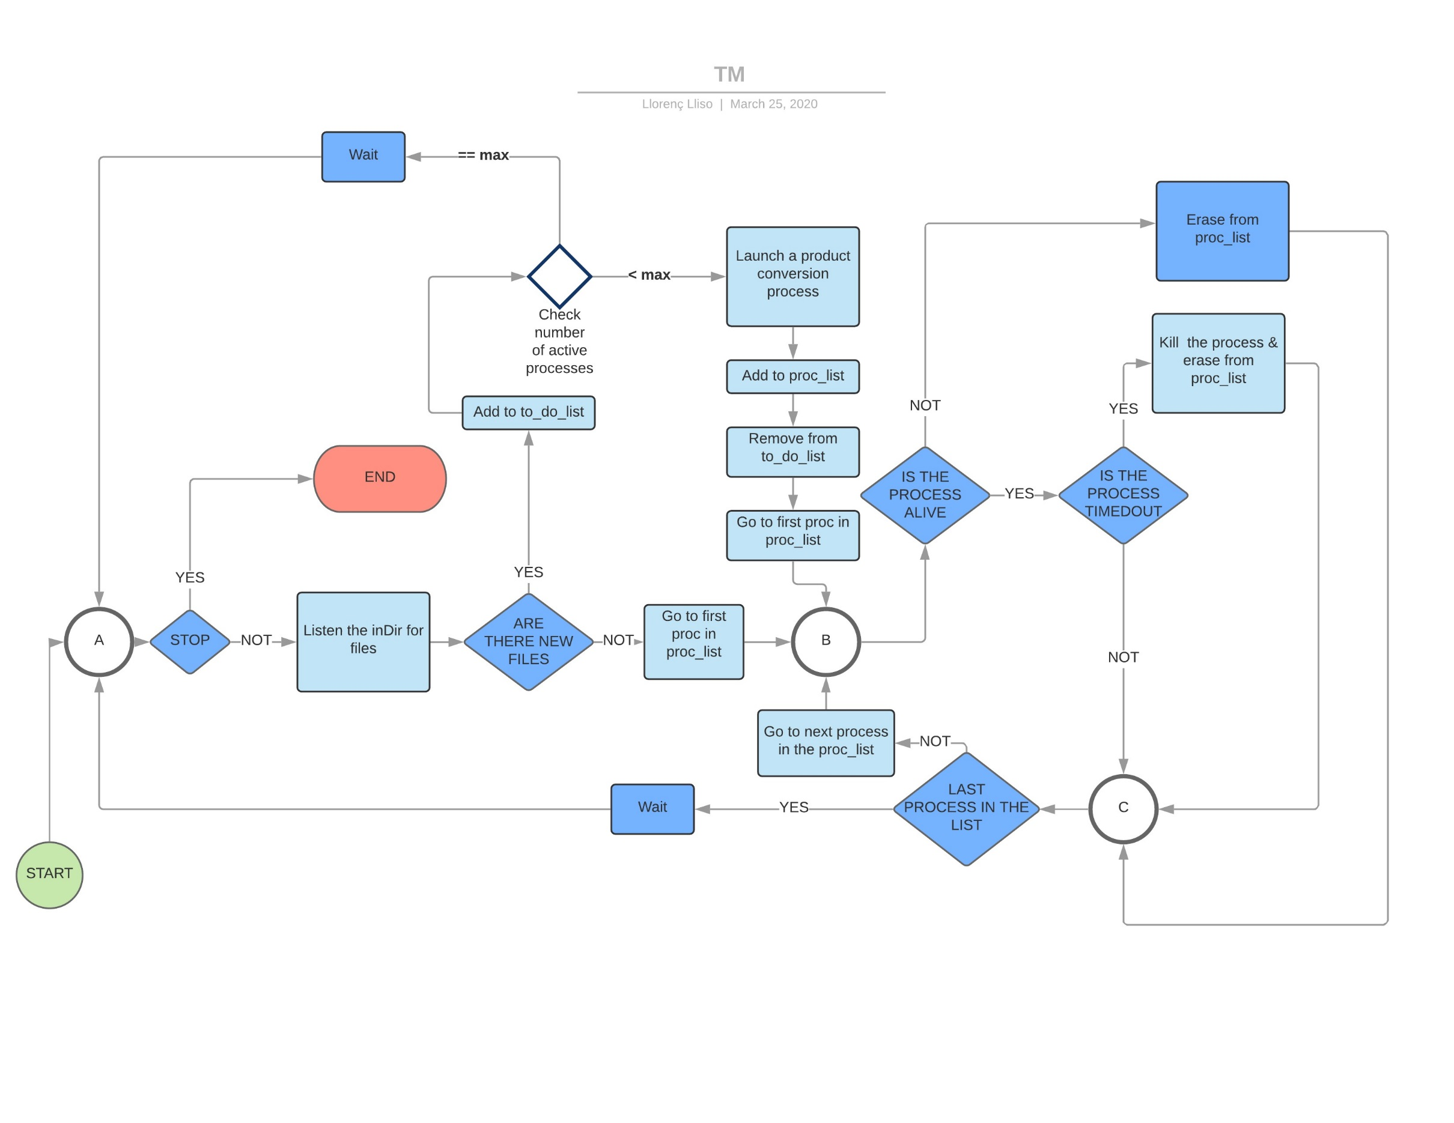

Figure 4: TM Flowchart

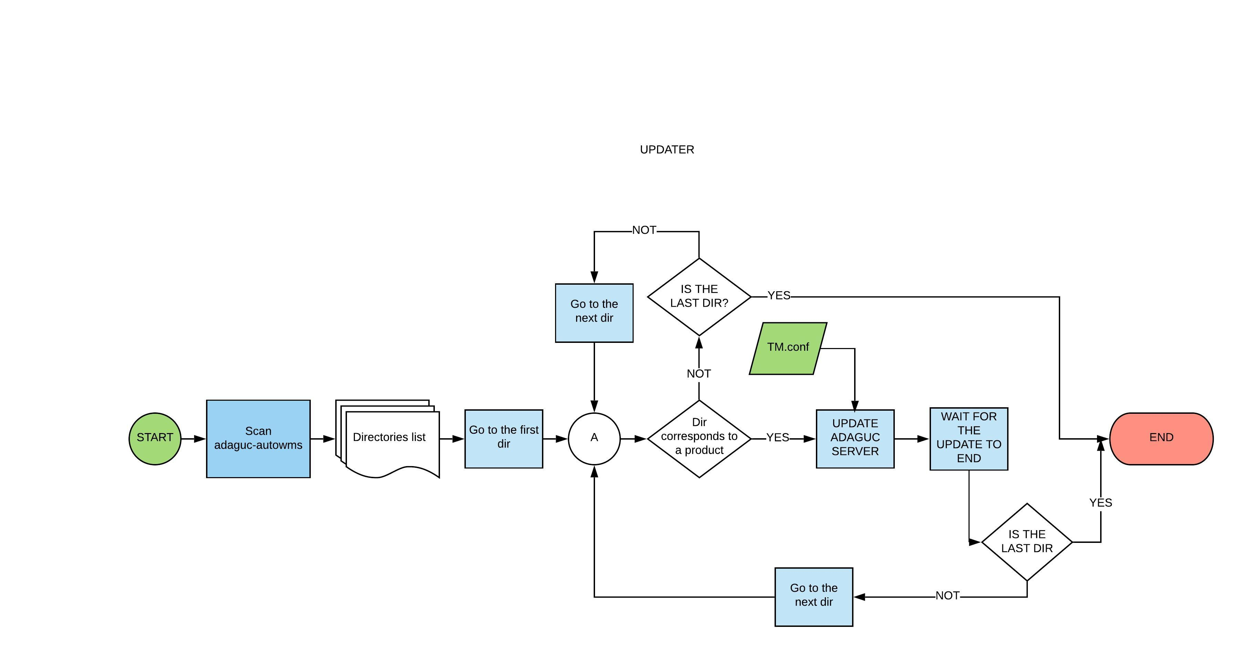

Figure 5: Updater Flowchart

## SUITE CONFIGURATION

Once the NWCSAF2ADAGUC software suite is git cloned in your system and ADAGUC Server/Viewer are installed, you need to edit the configuration files. Each file with the extension **.conf** is an auto descriptive configuration file.

The lines preceded with **“#”** are commented lines.

The lines have three items, the first one is the block identifier, the second a variable name and the third is the value of this variable.

THE CONFIGURATION FILES HAVE TO BE EDITED BEFORE RUNNING THE APPLICATIONS.

### SETTING THE PATHS

Please do not set relative paths, this could have unexpected results.

#### Editing TM.conf

In the file TM.conf search for the PATH block:

**& PATH & inDir = /ARCHIVOSAF/NATIVO**

& PATH & outDir = /data/adaguc-autowms

& PATH & ADAGUCdatasets = /data/adaguc-datasets

Then edit only the first line and change the value of inDir, to point to the directory where the NWCSAF output files will be placed or copied.

The Task Manager will listen to the cofigured inDir, waiting for the new files to appear. When a new file is founded a conversion process is launched.

#### Editing rdt.conf, pixel.conf, hrw.conf, exim.conf

In the files rdt.conf, pixel.conf, exim.conf and hrw.conf edit the PATH block:

& PATH & inDir = **/home/adaguc/NWCSAF2ADAGUC/PIXEL/**in_data

& PATH & outDir = /data/adaguc-autowms

**& PATH & tempDir =/home/adaguc/NWCSAF2ADAGUC/PIXEL/temp**

*#& PATH & outDir =* ***/home/adaguc/NWCSAF2ADAGUC/PIXEL/****out_data*

& PATH & debugInDir = **/home/adaguc/NWCSAF2ADAGUC/PIXEL/**debug_in_data

& PATH & debugOutDir = **/home/adaguc/NWCSAF2ADAGUC/PIXEL/**debug_out_data

Change the temporary directory tempDir to your convenience temporary directory, where your user have write permission.

Make sure that your outDir is pointing to your adaguc-autowms directory.

To avoid bottlenecks using net directories, the files are produced first in a temporary directory and are moved to a subdirectory of the outDir, after finished. Is highly recommended that the temporary directory is not on the network. A good advice is to create a set of temporary directories like:

* ../NWCSAF2ADAGUC/PIXEL/temp
* ../NWCSAF2ADAGUC/RDT/temp
* ../NWCSAF2ADAGUC/HRW/temp
* ../NWCSAF2ADAGUC/EXIM/temp

Please include them in the configuration files.

### ALLOWING the xml production.

To update properly the ADAGUC layers and temporarily aggregate them in your adaguc-server, you will need to have in place one or more configuration files (.xml) for each product. The directory where the configuration files are located is /data/adaguc-datasets.

You can set in the configuration file if the software suite writes the .xml files for you. If you don’t have the required .xml files in adaguc-datasets, this is a mandatory step.

Please, in the files exim.conf, pixel.conf, hrw.conf files search for the block:

#############################################################################

# xml update configuration

############################################################################

**& XML & UPDATE = false**

#& XML & UPDATE = true

**& XML & outDir = /data/adaguc-datasets**

…

Uncomment the second option and comment the first option.

After the first execution it is recommended to revert to the previous status: & XML & UPDATE = false.

In all the .xml files you can adapt the palettes to your needs and change the legends, text, etc.

### RDT Processing and Visualization Configuration

The converter transforms a set of RDT files to geoJSON file(s). The content that is passed from the netcdf to the geoJSON file is filtered by a configurable criteria (in the rdt.conf file).

#### Setting the number of geoJSON files

The first step is to search for the following block in the **rdt.conf**.

############################################################################

# This block allow to select the forecasts contained in each geojson

# the second item will be used as a subdir of the output dir

# you could freely add more lines

############################################################################

**& FCTS & ALL = [060, 045, 030, 015, 000]**

**& FCTS & NOW = [000]**

#& FCTS & 60 = [060]

Each uncommented line of this block triggers a single file generation.

With the above configuration block two directories will be created under your outDir (/data/adaguc-autowms), with the following structure, corresponding to the predefined rdt.conf:

/data/adaguc-autowms

/RDT-CW

/ALL

/NOW

In the FCTS block you can edit the content of the brackets (third item) and add more forecasts.

You can also add more lines. Each line will create a RDT-CW subdirectory. For example, if you want to generate a geoJSON that contains the forecasts of the cells at +15 min you should add the line:

**& FCTS & Q1 = [015]**

When your RDT sets will be processed, a geoJSON file will be generated with the cells at +15min, placed in ../RDT-CW/Q1/

#### Setting the content of the geoJSON files

As a second step, in the RDT.conf file, the user can change the second item of each line (in green in the next example):

& CELL & SeverityTipe = SeverityType

The second item, in green above, is what will be displayed as label in the popups when clicking an individual cell.

The user can also control what is passed from the netcdf set to the geoJSON file by commenting/uncommenting lines in the RDT.conf file, as follows, for example:

& **CELL** & SeverityTipe = SeverityType

Or

& **CELL+** & Motion_speed_of_cloud_cell = MvtSpeed

Or

& **OT** & MinimumBT = BTminOT

#### Copy the xml

The RDT processor does not produce the corresponding xml files. In the third step you have to copy the xml files to adaguc-datasets directory.

In the current example the user have to copy the files RDT_ALL.xml and RDT_NOW.xml to adaguc-datasets dir. Please edit the paths in the xml file and change them accordingly.

### Connecting the Updater with the files

As commented in section 4.1 the software suite has two high level components, the first is the Task Manager and the second one is the Updater.

The Updater scans the /data/adaguc-autowms subdirs and update the ADAGUC database with the products that have an associated xml file in /data/adaguc-datasets AND in TM.conf

Please see in your TM.conf the following block:

#############################################################################

# xml datatabase update configuration for ADAGUC

# you can select wich xml files will be updated after postprocessing the

# NWCSAF files, your own new xml could be included or you could also suppress

# & XML & <product> = <xmls>

#############################################################################

& XML & CMA = ['CMA.xml']

& XML & CT = ['CT.xml']

& XML & CTTH = ['CTTH.xml']

& XML & CMIC = ['CMIC.xml']

& XML & PC = ['PC.xml']

& XML & PC-Ph = ['PC-Ph.xml']

& XML & CRR = ['CRR.xml']

& XML & CRR-Ph = ['CRR-Ph.xml']

& XML & RDT-CW = ['RDT_NOW.xml', 'RDT_ALL.xml']

For example, if the line & XML & RDT-CW = ['RDT_NOW.xml', 'RDT_ALL.xml'] is present in the RDT.conf and the directory /data/adaguc-autowms/RDT-CW already exists, at every run of the Updater the ADAGUC database will be updated using both RDT_NOW.xml and RDT_ALL.xml filters.

If a non-configured directory exists in adaguc-autowms the Updater will not act on it.

# TESTS

To help the users in order to configure and understand the system, some step by step tests are designed. Ending with success, all the tests will result in having your system up.

## FIRST TEST (oFFline TEST)

1, Please complete the following check list:

* In TM.conf file point inDir to a new empty directory

**& PATH & inDir = /XXX/YYY**

* In the following conf files:
  + pixel.conf
  + rdt.conf
  + hrw.conf
  + exim.conf

make sure that the correct tempDir is configured and that you have write permission to this tempDir.

* To be sure that the xml generation is set to true, you have to check if the line

& XML & UPDATE = true

is uncommented and the line

#& XML & UPDATE = false

is commented.

The same lines should commented/uncommented in the conf files (not in rdt.conf):

* + pixel.conf
  + hrw.conf
  + exim.conf

1. The next steps have to be followed:

* Open a terminal in NWCSAF2ADAGUC directory and run the script using python3:

~ python3 NWCSAF2ADAGUCTMVFS.py

Read the screen messages. If no errors are raised keep the application running. In case of errors, first check the versions of the python modules installed on your system (Table 4).

* Copy the test NWCSAF files (provided with the software suite) to your empty directory **/XXX/YYY.** 
  + Copy CMA dir
  + Copy CTTH dir
  + Copy CT dir
  + Copy CMIC dir
  + Copy ASII dir
  + Copy CI dir
  + Copy CRR dir
  + Copy iSHAI dir
  + Copy PC dir
  + Copy HRW dir
  + Copy RDT-CW dir
  + Copy EXIM dir

¨The files will be processed and new ones will populate your adaguc-autowms and adaguc-datasets directories.

* Check your /data/adaguc-autowms directory, one subdir has to be present for each product. Wait until all the test output files are present in the corresponding dir. For RDT and HRW the files will be located in nested subdirs. If some files are not produced check the version of your python modules in particular netCDF4 module.
* Check if your /data/adaguc-datasets contains the required xml files.
* Ensure that you have copied the RDT_ALL.xml and RDT_NOW.xml files to adaguc-datasets dir and that the filePath is correctly configured, pointing to existing directories.
* Try to update manually the database (the following example assumes that you have updated with the test files). Open a python terminal and execute:

export ADAGUC_TMP=/tmp

export ADAGUC_PATH=/src/KNMI/adaguc-server/

/src/KNMI/adaguc-server/bin/adagucserver --updatedb --config /src/KNMI/adaguc-server/data/config/adaguc.vm.xml,CTTH.xml

/src/KNMI/adaguc-server/bin/adagucserver --updatedb --config /src/KNMI/adaguc-server/data/config/adaguc.vm.xml,RDT_NOW.xml

/src/KNMI/adaguc-server/bin/adagucserver --updatedb --config /src/KNMI/adaguc-server/data/config/adaguc.vm.xml,HRW.xml

/src/KNMI/adaguc-server/bin/adagucserver --updatedb --config /src/KNMI/adaguc-server/data/config/adaguc.vm.xml,EXIM-CTTH.xml

* Open the adaguc-viewer: <http://localhost:8080/adaguc-viewer/>
  + Click the *Settings and option* wheel
  + Click autoWMS
  + On the right panel click adaguc::dataset
  + Click on the datasets:
    - CTTH, check that the layer is rendered.
    - EXIM-CTTH, check that the layer is rendered.
    - RDT_NOW, check that the layer is rendered.
    - HRW, check that the layer is rendered.
* Change the name of the file TM.howTo.stop to TM.stop
* Check if your first terminal has returned to the prompt
* TEST PASSED!

## SECOND TEST (ONLINE TEST)

Now is time to connect the converter with your own NWCSAF chain.

Please complete the following check list:

* In TM.conf file point inDir to a dir where the NWCSAF output files are stored:

**& PATH & inDir = ../export**

Once the software suite reconfigured the next steps have to be followed:

* Open a terminal in NWCSAF2ADAGUC dir and launch:

~ python3 NWCSAF2ADAGUCTMVFS.py

* Wait for an hour or more, to have at least four slots
* Check if your new files are arriving to /data/adaguc-autowms
* Make sure that, for each product, you have an xml file in adaguc-datasets. If not, wait until adaguc-dataset was totally populated.
* Change the xml generation to false:

#& XML & UPDATE = true

& XML & UPDATE = false

in the following files:

* + pixel.conf
  + hrw.conf
  + exim.conf

This step is optional, but by setting the xml generation to false you avoid re-writting the same file for every slot. After disabling the automatic xml update, you can edit manually the xml files.

* Change the name of the file TM.howTo.stop to TM.stop
* Check if your last terminal has returned to the prompt

Now launch the TM detached:

* Open a terminal in NWCSAF2ADAGUC dir and execute:

~ nohup python3 NWCSAF2ADAGUCTMVFS.py &

* Take note of the PID of your process.
* Close the terminal or disconnect, typing ctrl button and D button at the same time.
* Open a new terminal and look if your process is running with

~ top

* Close the terminal, the process will be still running.
* TEST PASSED!

## THIRD TEST (DATABASE UPDATE TEST)

Now your Task Manager is generating the files and it is time to start the automatic database update. When you finish this third part you will have all the system functionalities up.

Please complete the following check list:

* Locate in NWCSAF2ADAGUC dir the file named UPDATER.sh
* Edit the file and change the second line (export NWCSAF2ADAGUC_PATH=<path_to_NWCSAF2ADAGUC>) with the full path to your NWCSAF2ADAGUC directory.and the third line with the full path to the script Updater.py
* Save the changes
* Make the script executable:

~ chmod 755 UPDATER.sh

* Launch the shell script

~ ./UPDATER.sh

* Browse your NWCSAF2ADAGUC dir and see if a file named blocked.by.dbupdt appears and disappears.
* Wait for the normal end: terminal returns to the prompt and the lock file is not present there anymore.
* Include the script UPDATER.sh in your cron to run every minute or ten minutes per slot. The selection depends on how busy your system is.

A good advice is to have some rest periods for the database to be updated - around 4 minutes - in this way you will avoid overheads.

* TEST PASSED!

Now your system is up, you can test it on <http://localhost:8080/adaguc-viewer/>

# MAKING THE VIEWER ACCESSIBLE IN YOUR NETWORK

Now you can access your contents on localhost. In order to release the contents in all your network you have to locate the file adaguc-services-config-tomcat.xml in /src/config and edit it. In the line beginning with:

<external-home-url><http://localhost:8080/>.....

change “localhost” with the IP of your system. Save the changes. Now your ADAGUC viewer and the content of the server will be accessible from any point of your network: http://192.168.XX.YY:8080/adaguc-viewer

# TAILORING Add layers

On the left side of the adaguc-viewer window there is a button named Add Layers. When you click it, you have the preconfigured layers. For your own institution use, edit the file config.js (located in /src/apache-tomcat-…/webapps/adaguc-viewer/):

You have to edit the variable: dataChooserConfiguration.

For the current example include the following in the brackets. If you do not want to keep the preconfigured layers, you can delete all or just some of them from the list.

**var dataChooserConfiguration = [**

**{**

**title: ‘My ctth’,**

**thumbnail: ‘img/whatever.png’,**

**service: ‘http://172.24.140.131:8080/adaguc-service//adagucserver?dataset=CTTH&’,**

**layer: ‘CTTH_ctth_alti’**

**},**

**{…**

**}**

**]**

Change the thumbnail (the img dir is located in /src/apache-tomcat-…/webapps/adaguc-viewer/), the service and the layer lines.

If you want to add your ctth altitude layer to your “Add layers” button, you have to know the name of your WMS service and the name of your layer. You can reach this name by clicking the Settings and option wheel > autoWMS >adaguc::datasets and locating your layer. Please see the below example image:

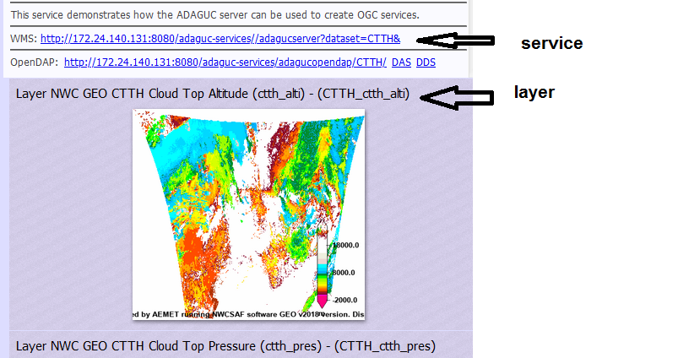

Figure 6: Where to find the service and the layer

# INCLUDING OTHER DATA SOURCES

To include other data sources you have to put them in a subdir of adaguc-autowms, for example /data/adaguc-autowms/OPERA/

Then include in adaguc-datasets a corresponding xml file, for example radar_prec.xml. Finally in TM.conf add the line:

& XML & OPERA = ['radar_prec.xml']

This change can be done with the TM running and without stopping the cron. You can add more than one external data source.

# FURTHER INFORMATION:

For further information on ADAGUC visit the page <http://adaguc.knmi.nl/>, for further information on the NWCSAF visit the page [http://nwc-saf.eumetsat.int](http://nwc-saf.eumetsat.int/).

1.