**EE464 - Software Project 1**

**Ćuk Converter and Full-Bridge DC/DC Converter**

**Report**



**Team Members:**

*Cem Akıncı - 2093193*

*Ekin Alp Biçer -*

**QUESTIONS**

**Q1)**

**a)**

The requirements of our Ćuk converter are given as :

* Vd : 9 V
* Vo : -12 V
* Io : 3 A
* Fs : 100 kHz
* ΔVo : 2%

Circuit schematic of our design is given illustrated in Figure 1.

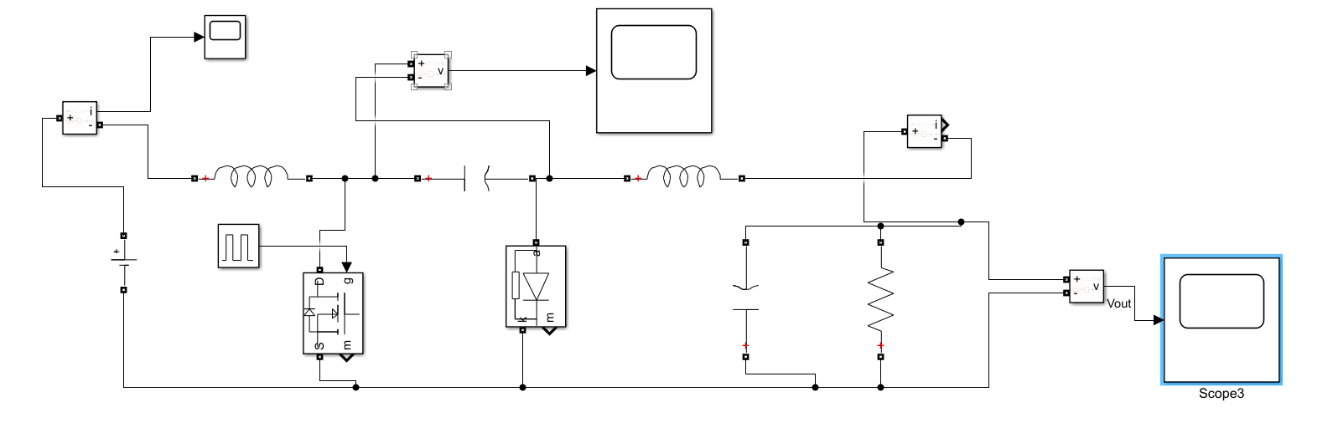

*Figure 1 – Circuit schematic of the Ćuk converter in Simulink.*

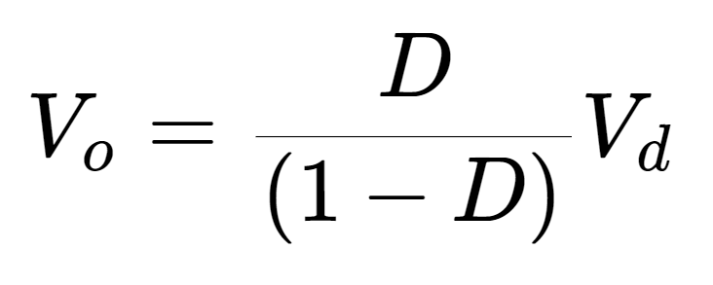[1]

Using Eq. 1 , D = 0.571.

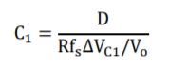[2]

Then by assuming that the maximum output voltage ripple is equal to the maximum voltage ripple of the C1 capacitor, the equation given in [2] is derived from the output current relation. Hence, it yields to C1 = 71.37 uF.

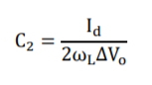[3]

The value of the C2 capacitor is given in the Eq. 3. When the parameters are put in the given equation, C2 = 10 uF.

For the inductor selection, we assumed L1 = L2 = 1 mH. However, we need to verify the selected values from the simulation results to see if they are consistent or not.

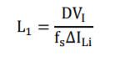[4]

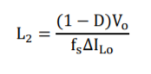[5]

As the L1 and L2 values are chosen equal, the ΔIo = ΔIi and calculated as to be 0.051.

In the simulation results, ΔIi = 0.04055 and ΔIo = 0.04065as illustrated in Figure 2 and Figure 3.

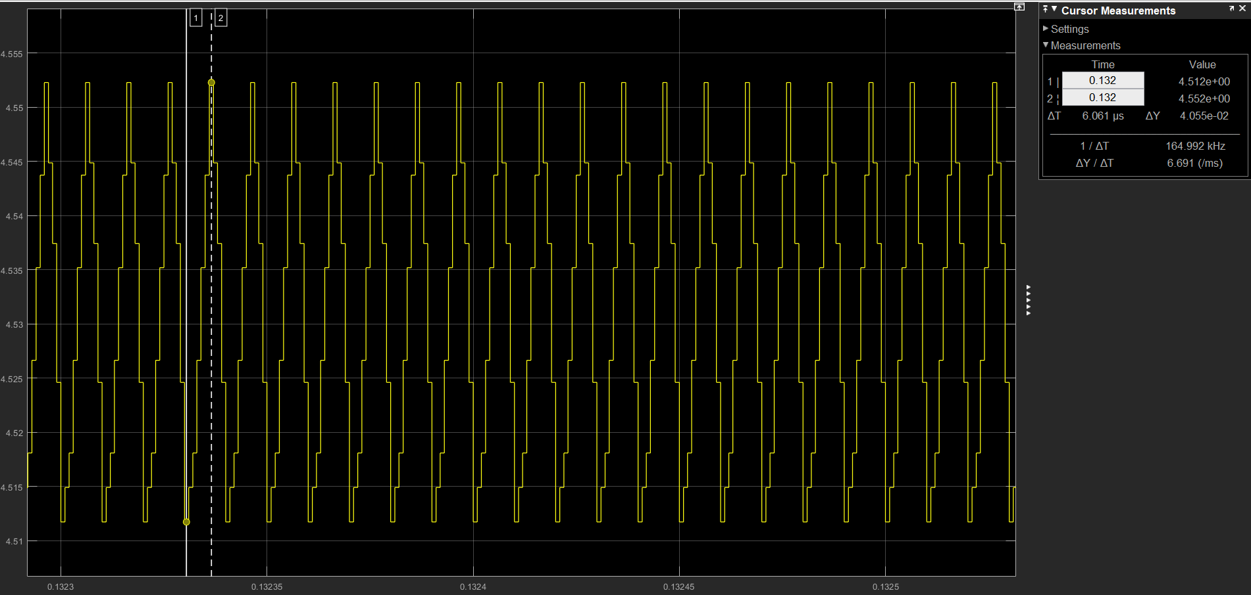

*Figure 2 – Steady state input current ripple.*

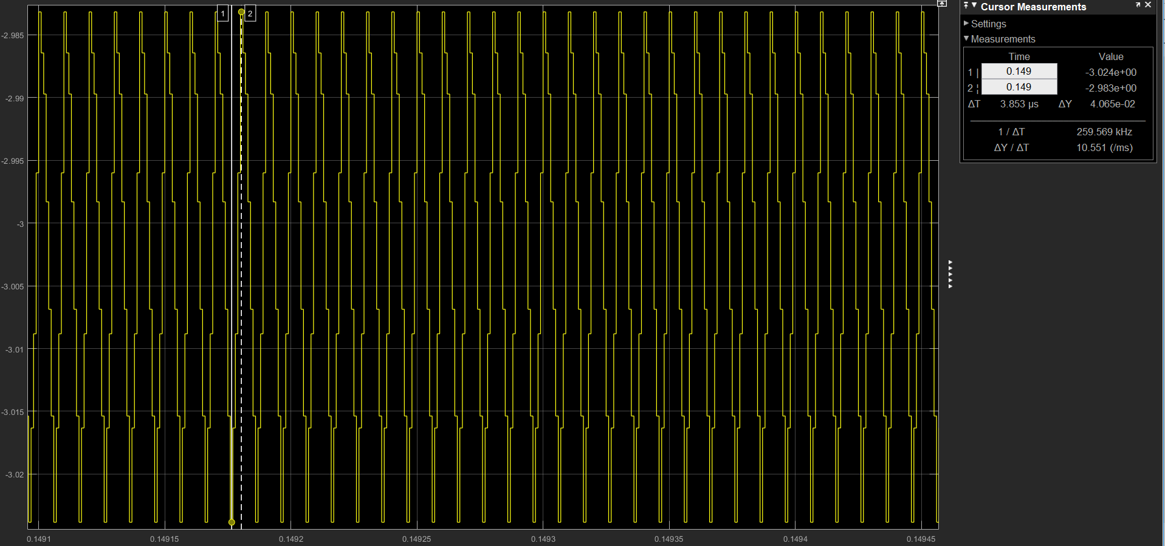

*Figure 3 – Steady state output current ripple.*

As a result, we can conclude that our chosen inductance values yields to some ΔIo ΔIi values, which has a little difference in the simulation results from the expected values. Thus, the chosen parameters are consistent with the design spesifications.

All of the required spesifications are satisfied in this design and it is shown in Figure 4 and Figure 5.

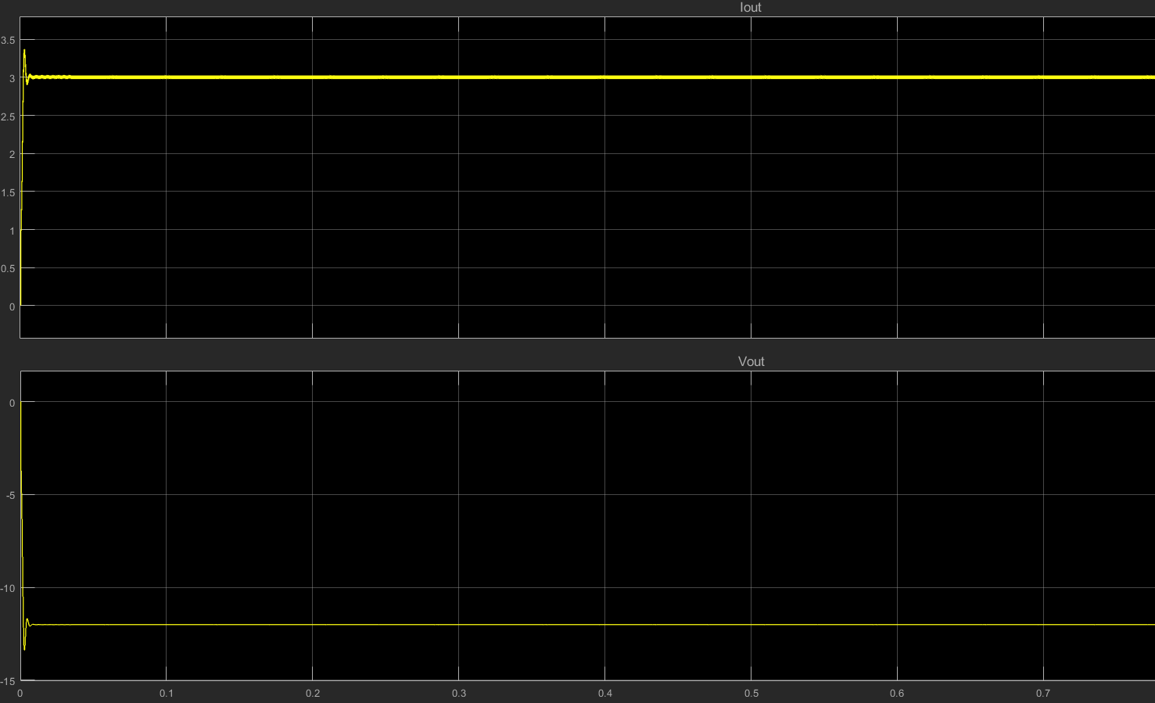

*Figure 4 – Output current and voltage waveforms at the steady state.*

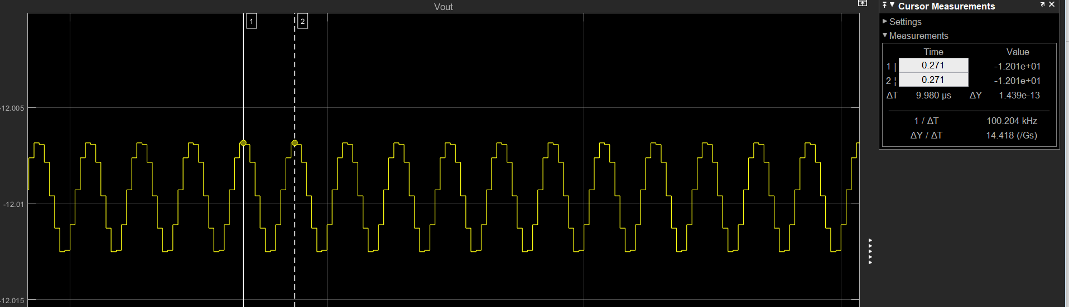

*Figure 5 – Output voltage ripple waveform at the steady state.*

We offer the following commercially available products for the components in our design:

**C1 Capacitor (72 uF) :** United Chemi-Con- EPAG451ELL720MM25S-ND

**Datasheet :** http://www.chemi-con.co.jp/cgi-bin/CAT_DB/SEARCH/cat_db_al.cgi?e=e&j=p&pdfname=pag

**C2 Capacitor (10 uF) :** Panasonic Electronic Components - ECA-1JM100I

**Datasheet :** https://media.digikey.com/pdf/Data%20Sheets/Panasonic%20Electronic%20Components/ECA-xxM%20Series,TypeA.pdf

**L1 and L2 inductors :** [Wurth Electronics - Inc.](https://www.digikey.com/en/supplier-centers/w/wurth-electronics)732-10759-2-ND

**Datasheet :** https://katalog.we-online.de/pbs/datasheet/74404043102A.pdf

**b)**

The input current waveform is plotted for the Ćuk converter and a similar sized buck-boost converter and the corresponding waveforms are illustrated in Figure 6-7-9.

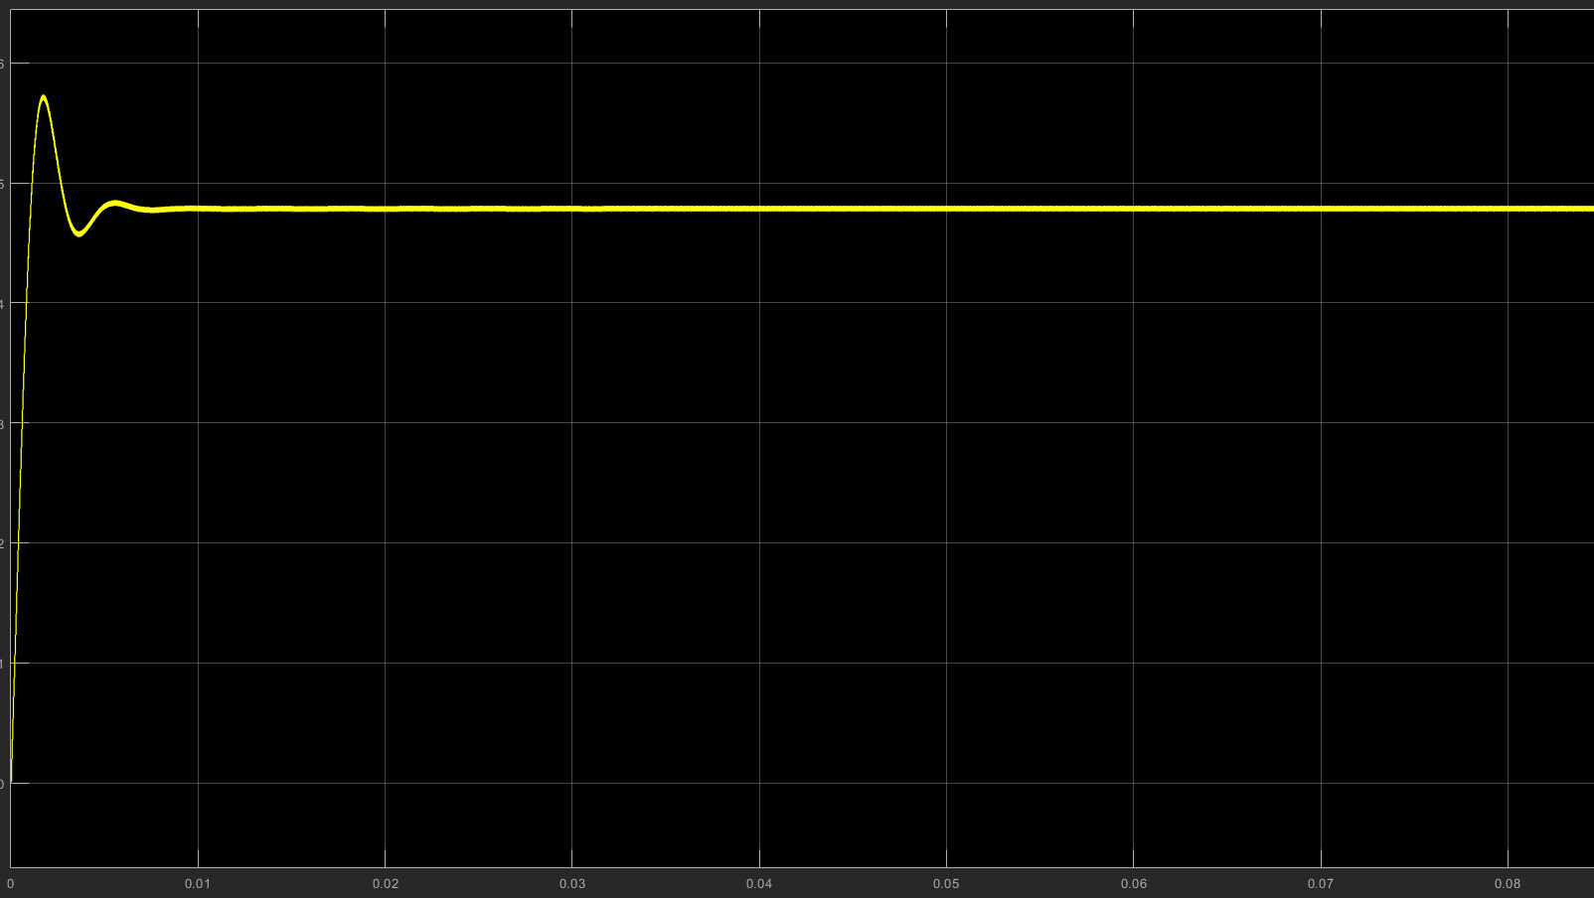

*Figure 6 – Input current waveform of the Cuk converter.*

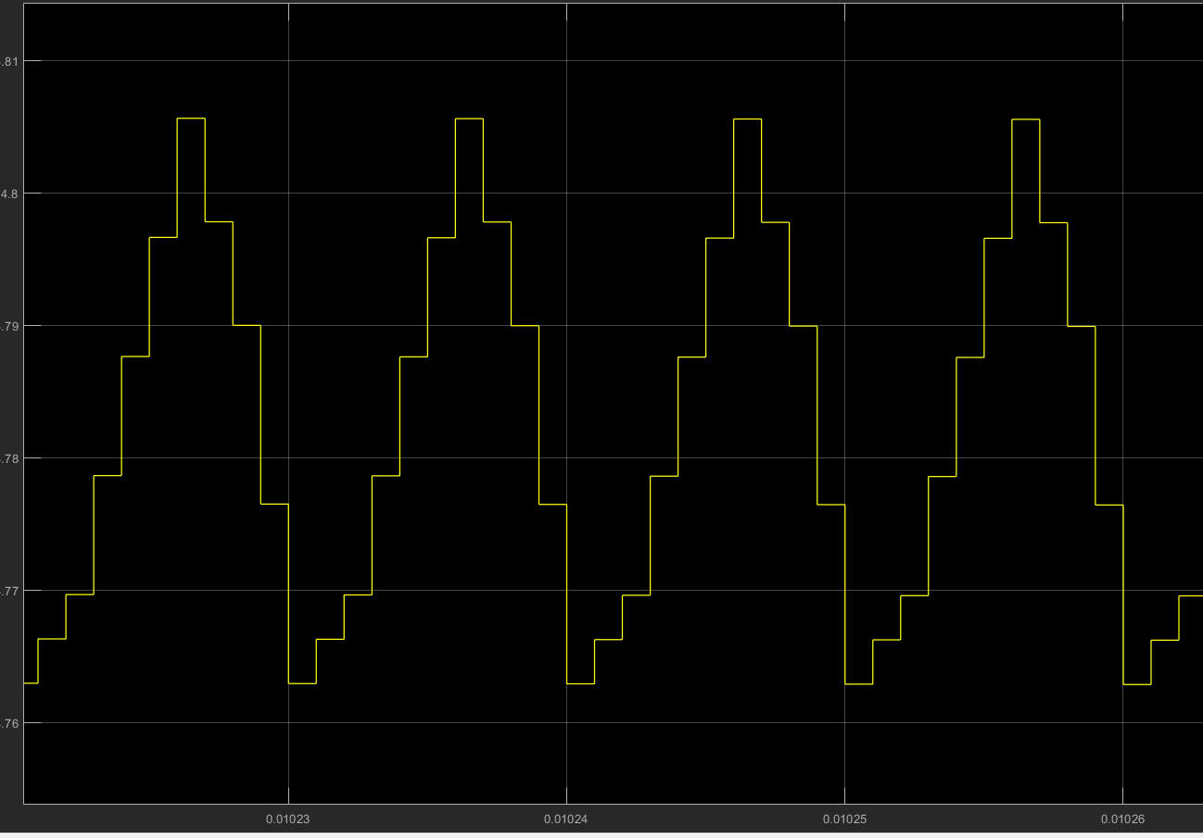

*Figure 7 – Ripple of the input current waveform at the steady state.*

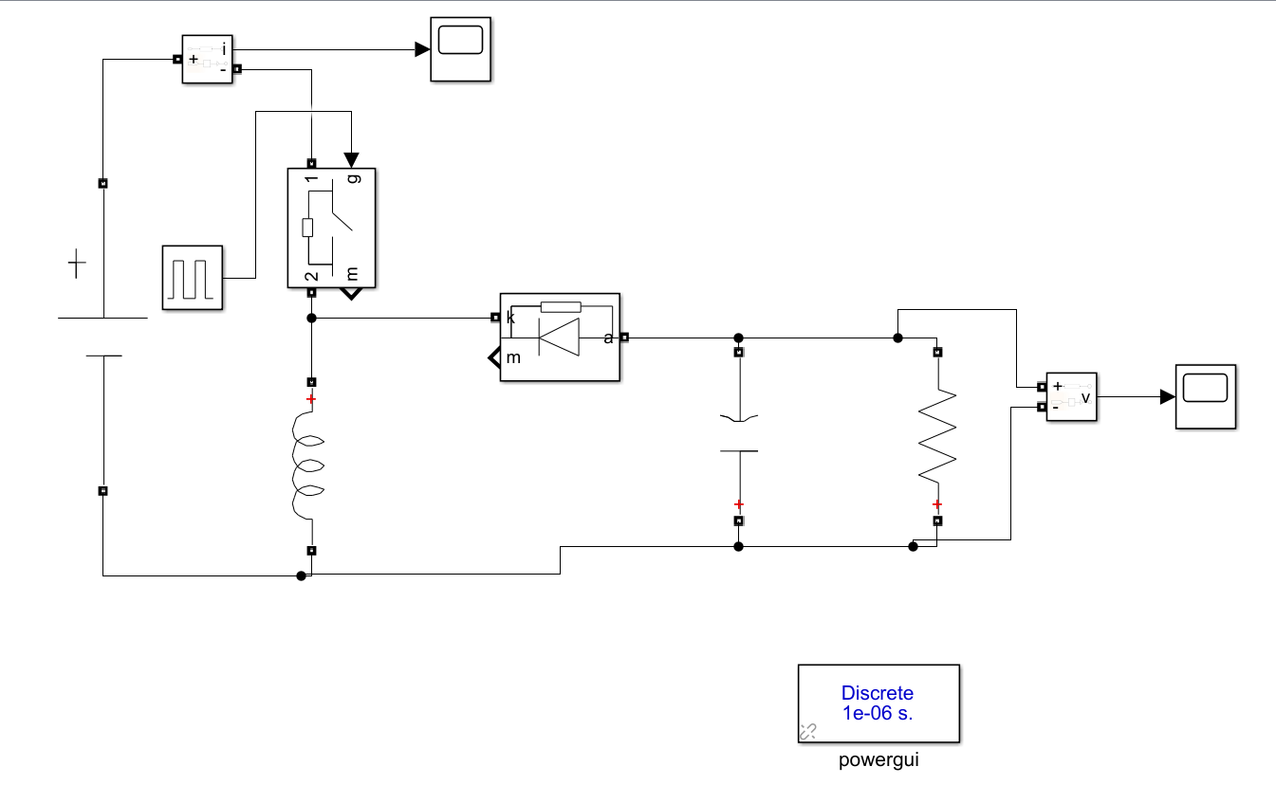

*Figure 8 – Circuit schematic for the buck boost converter topology.*

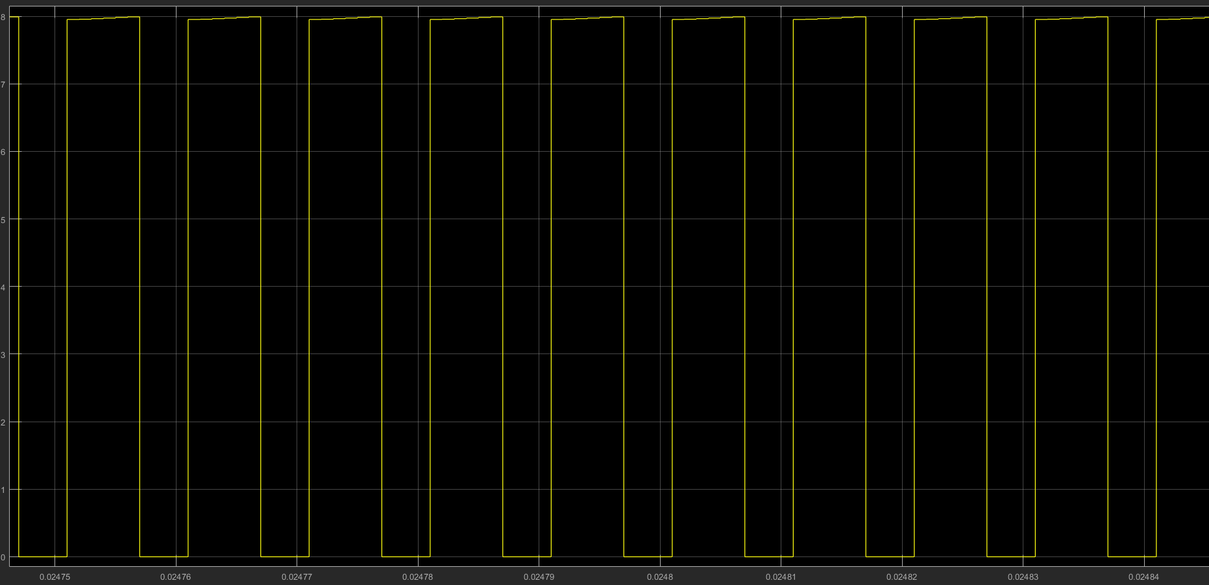

*Figure 9 – Input current waveform of the buck boost converter.*

The input current waveform of the buck boost converter and the Ćuk converter shows very different behaviour. The main difference is that the buck boost converter has a pulsed input current as can be observed in the Figure 9. The input current of the buck boost converter is discontinuous due to the power switch which pulses from zero to IL every cycle. However, such an input current requires filtering. The Ćuk converter has a continuous input current waveform, since the input current is not affected from the switching. In addition to that, in the Ćuk converter the input current is ripple free , since it is fed through the inductor. Hence, it requires lower filtering than the buck boost converter.

It can be deducted that, the Ćuk converter is more advantageous than the buck boost converter topology in terms of the input current.

**c)**

**d)**

**e)**