**EE464 - Software Project 1**

**Ćuk Converter and Full-Bridge DC/DC Converter**

**Report**



**Team Members:**

*Cem Akıncı - 2093193*

*Ekin Alp Biçer - 2030385*

**QUESTIONS**

**Q1)**

**a)**

The requirements of our Ćuk converter are given as :

* Vd : 9 V
* Vo : -12 V
* Io : 3 A
* Fs : 100 kHz
* ΔVo : 2%

Circuit schematic of our design is given illustrated in Figure 1.

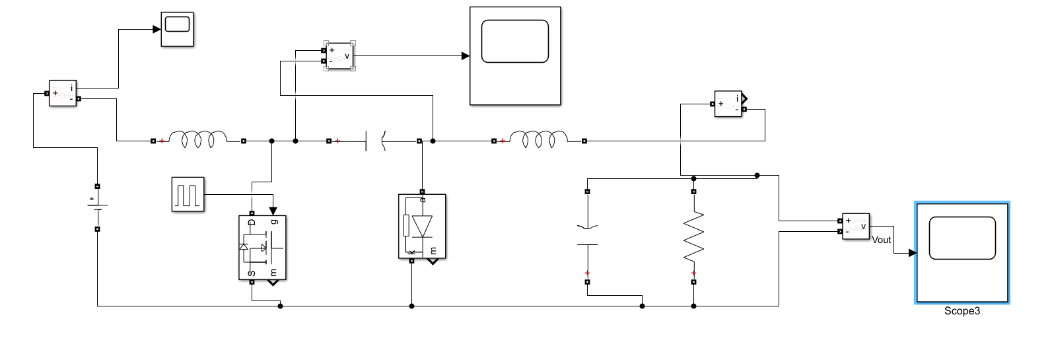

*Figure 1 – Circuit schematic of the Ćuk converter in Simulink.*

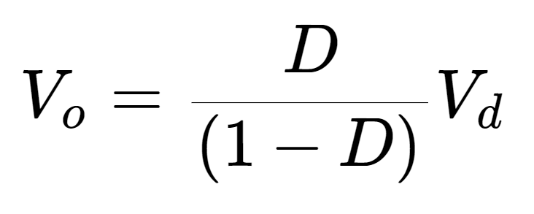[1]

Using Eq. 1 , D = 0.571.

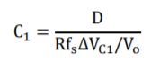[2]

Then by assuming that the maximum output voltage ripple is equal to the maximum voltage ripple of the C1 capacitor, the equation given in [2] is derived from the output current relation. Hence, it yields to C1 = 71.37 uF.

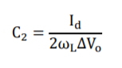[3]

The value of the C2 capacitor is given in the Eq. 3. When the parameters are put in the given equation, C2 = 10 uF. Steady State Output voltage ripple can be observed from below.

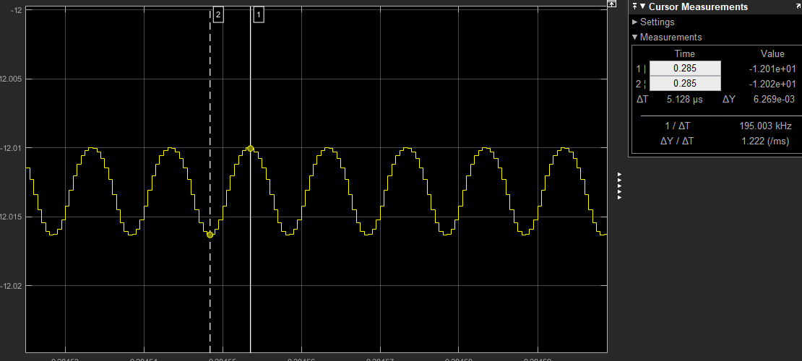

*Figure 2 – Steady state output voltage ripple.*

For the inductor selection, we assumed L1 = L2 = 1 mH. However, we need to verify the selected values from the simulation results to see if they are consistent or not.

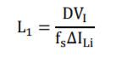[4]

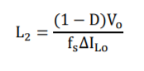[5]

As the L1 and L2 values are chosen equal, the ΔIo = ΔIi and calculated as to be 0.051.

In the simulation results, ΔIi = 0.04701 and ΔIo = 0.00158 as illustrated in Figure 2 and Figure 3.

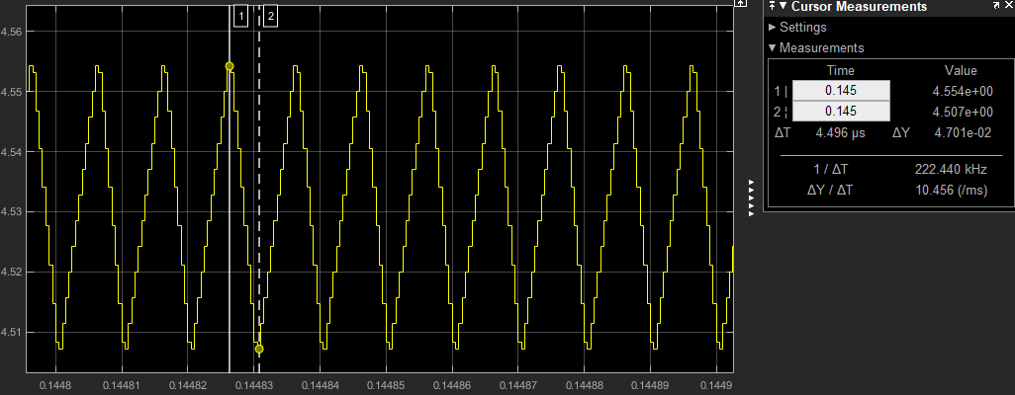

*Figure 3 – Steady state input current ripple.*

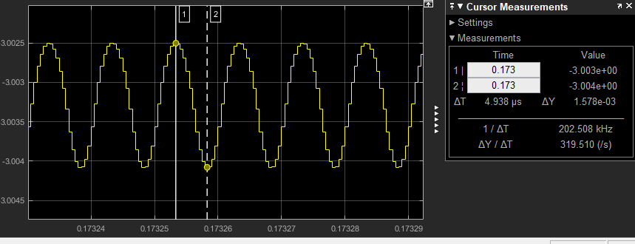

*Figure 4 – Steady state output current ripple.*

All of the required spesifications are satisfied in this design and it is shown in Figures 2,3,4,5.

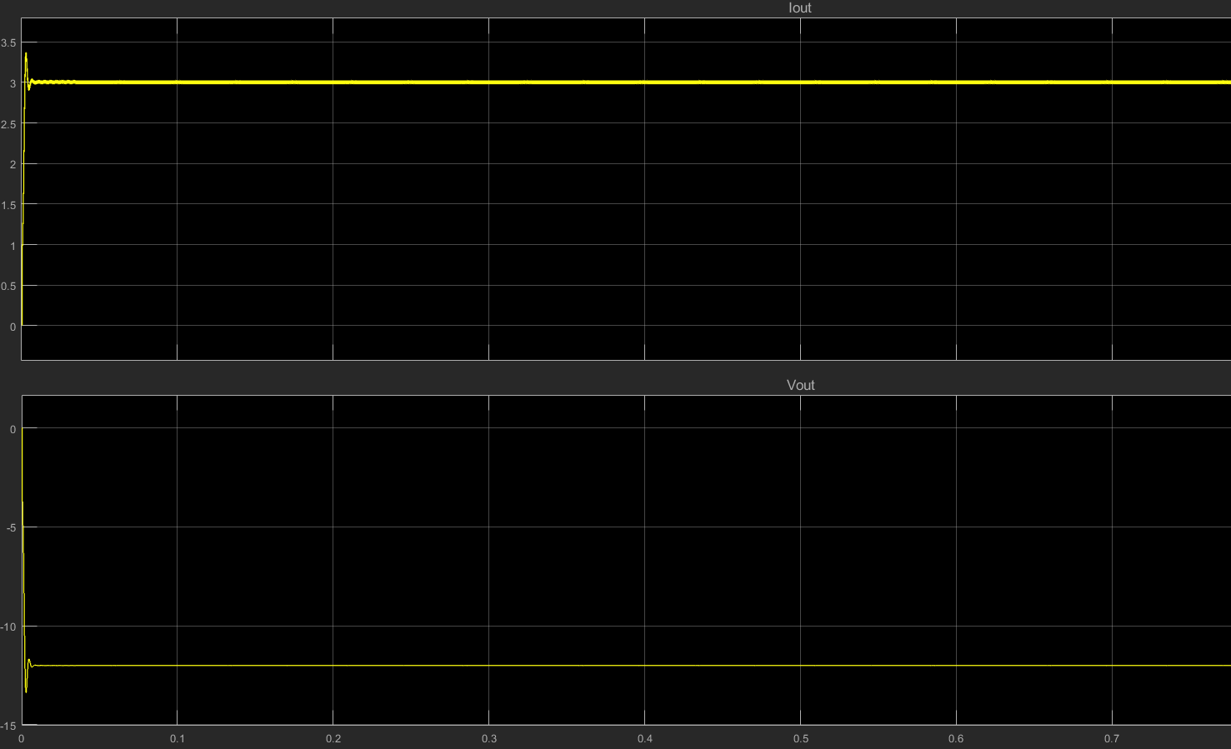

*Figure 5 – Output current and voltage waveforms at the steady state.*

We offer the following commercially available products for the components in our design:

**C1 Capacitor (72 uF) :** United Chemi-Con- EPAG451ELL720MM25S-ND

**Datasheet :** http://www.chemi-con.co.jp/cgi-bin/CAT_DB/SEARCH/cat_db_al.cgi?e=e&j=p&pdfname=pag

**C2 Capacitor (10 uF) :** Panasonic Electronic Components - ECA-1JM100I

**Datasheet :** https://media.digikey.com/pdf/Data%20Sheets/Panasonic%20Electronic%20Components/ECA-xxM%20Series,TypeA.pdf

**L1 and L2 inductors :** [Wurth Electronics - Inc.](https://www.digikey.com/en/supplier-centers/w/wurth-electronics)732-10759-2-ND

**Datasheet :** https://katalog.we-online.de/pbs/datasheet/74404043102A.pdf

**b)**

The input current waveform is plotted for the Ćuk converter and a similar sized buck-boost converter and the corresponding waveforms are illustrated in Figure 6-7-9.

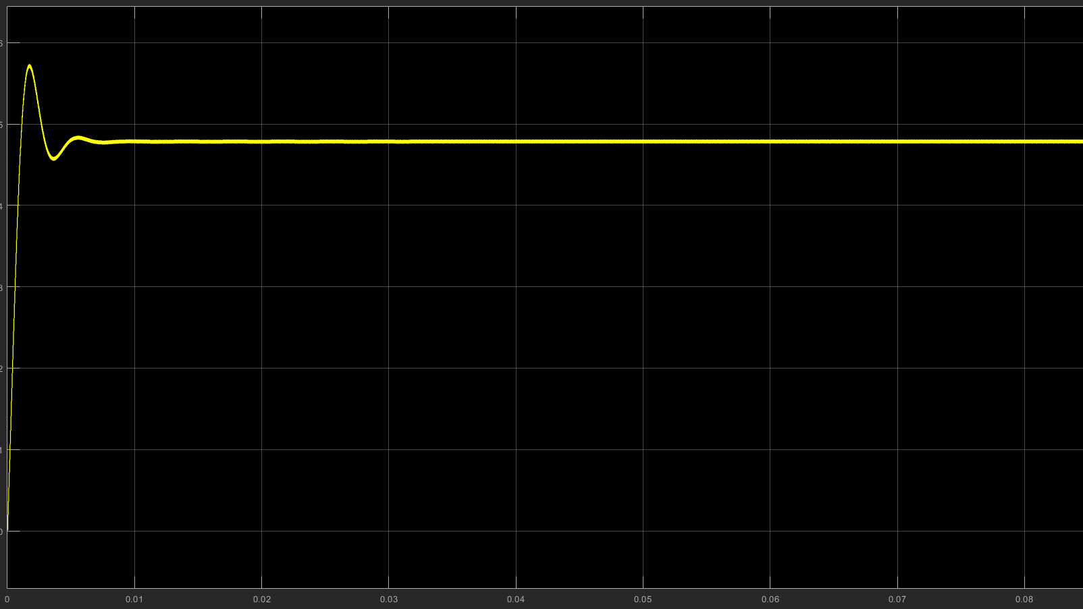

*Figure 6 – Input current waveform of the Cuk converter.*

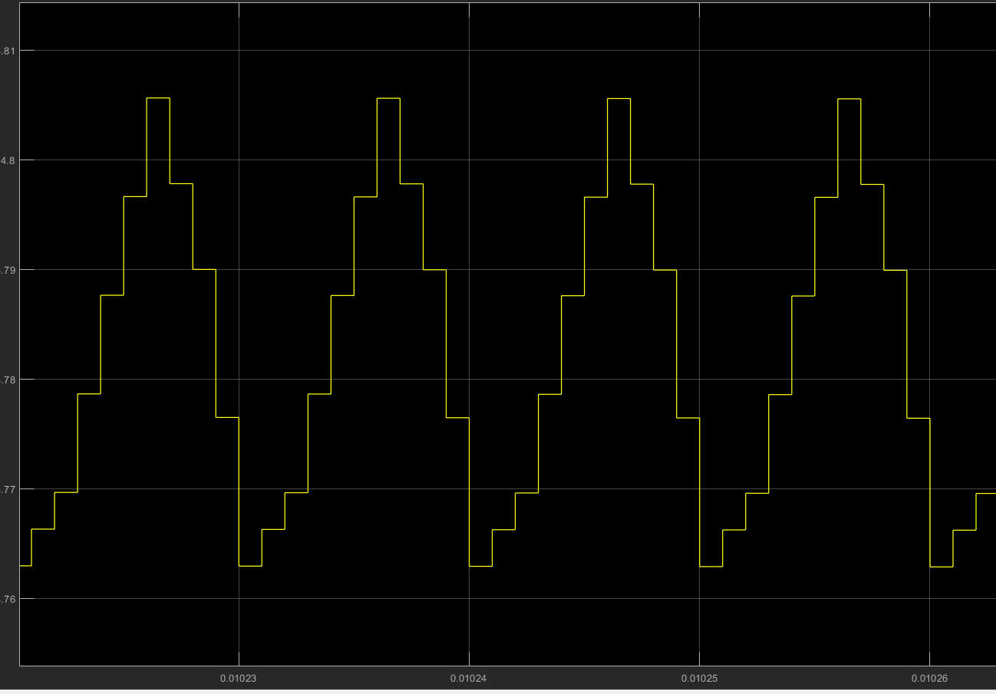

*Figure 7 – Ripple of the input current waveform at the steady state.*

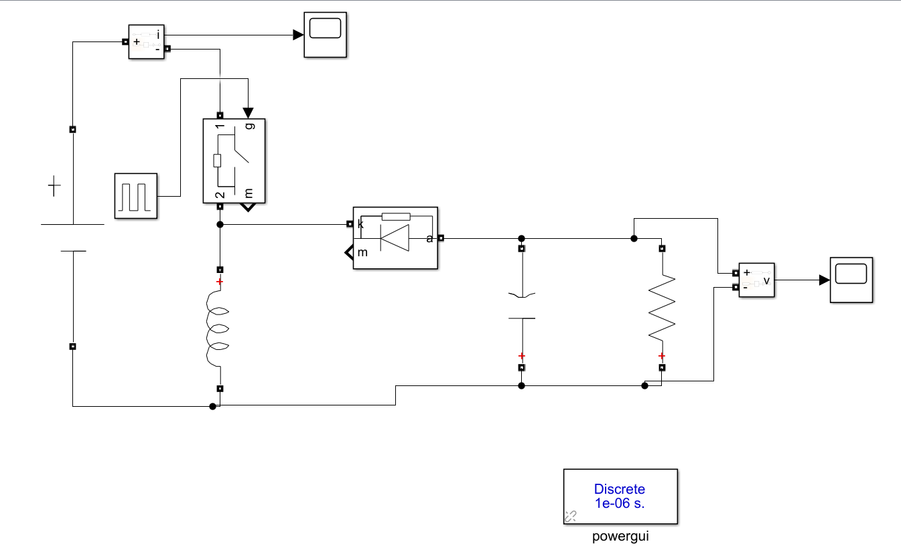

*Figure 8 – Circuit schematic for the buck boost converter topology.*

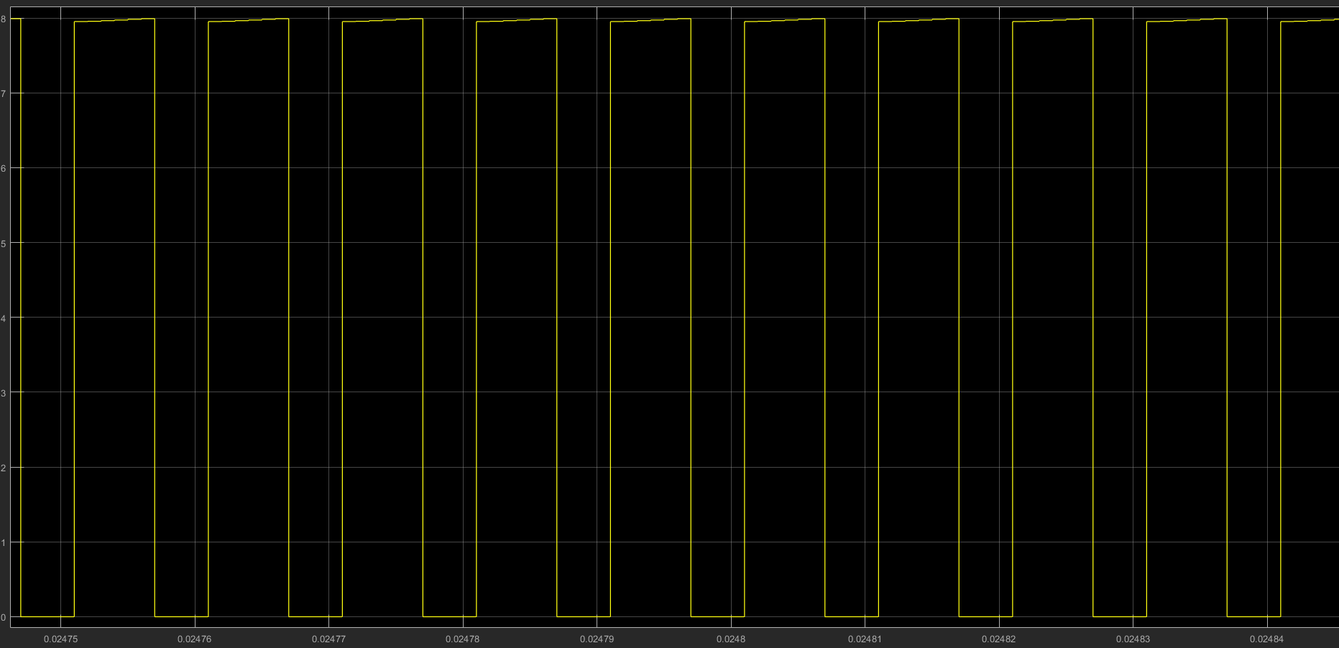

*Figure 9 – Input current waveform of the buck boost converter.*

The input current waveform of the buck boost converter and the Ćuk converter shows very different behaviour. The main difference is that the buck boost converter has a pulsed input current as can be observed in the Figure 9. The input current of the buck boost converter is discontinuous due to the power switch which pulses from zero to IL every cycle. However, such an input current requires filtering. The Ćuk converter has a continuous input current waveform, since the input current is not affected from the switching. In addition to that, in the Ćuk converter the input current is ripple free , since it is fed through the inductor. Hence, it requires lower filtering than the buck boost converter.

It can be deducted that, the Ćuk converter is more advantageous than the buck boost converter topology in terms of the input current.

**c)**

Assuming that the output current is constant, when we plug our capacitor, resistance, frequency values to equation [2], we see the expected output ripple as :

$$∆Vo=\frac{Io*D}{f*C1}=\frac{3*\frac{4}{7}}{100000*72*{10}^{-6}}=0.23 V=0.198 \%$$

However, when we look at the simulation results, we observe the output voltage ripple as 6.27 *10^-3 volts, which is much lower than what we expected.

Assuming Vo to be constant, when we plug our capacitor, resistance, frequency values to equation [5], we see the expected output ripple as :

$$∆Io=\frac{Vl2*\left(1-D\right)}{L2*F}=\frac{12*\left(1-\frac{4}{7}\right)}{{10}^{-3}*100000}=0.051 A=1.7 \%$$

However, when we inspect the simulation results, we observe the output current riple as 1.58 * 10^-3 A, which is much lower than expected.

Since the simulation result is much lower than expected, we are content with the results. We believe that the reason behind this happy discrepancy is our assumptions. When we are calculating the ripples, we assume constant voltage or constant current. Since they are also changing, this might have had an effect.

**d)**

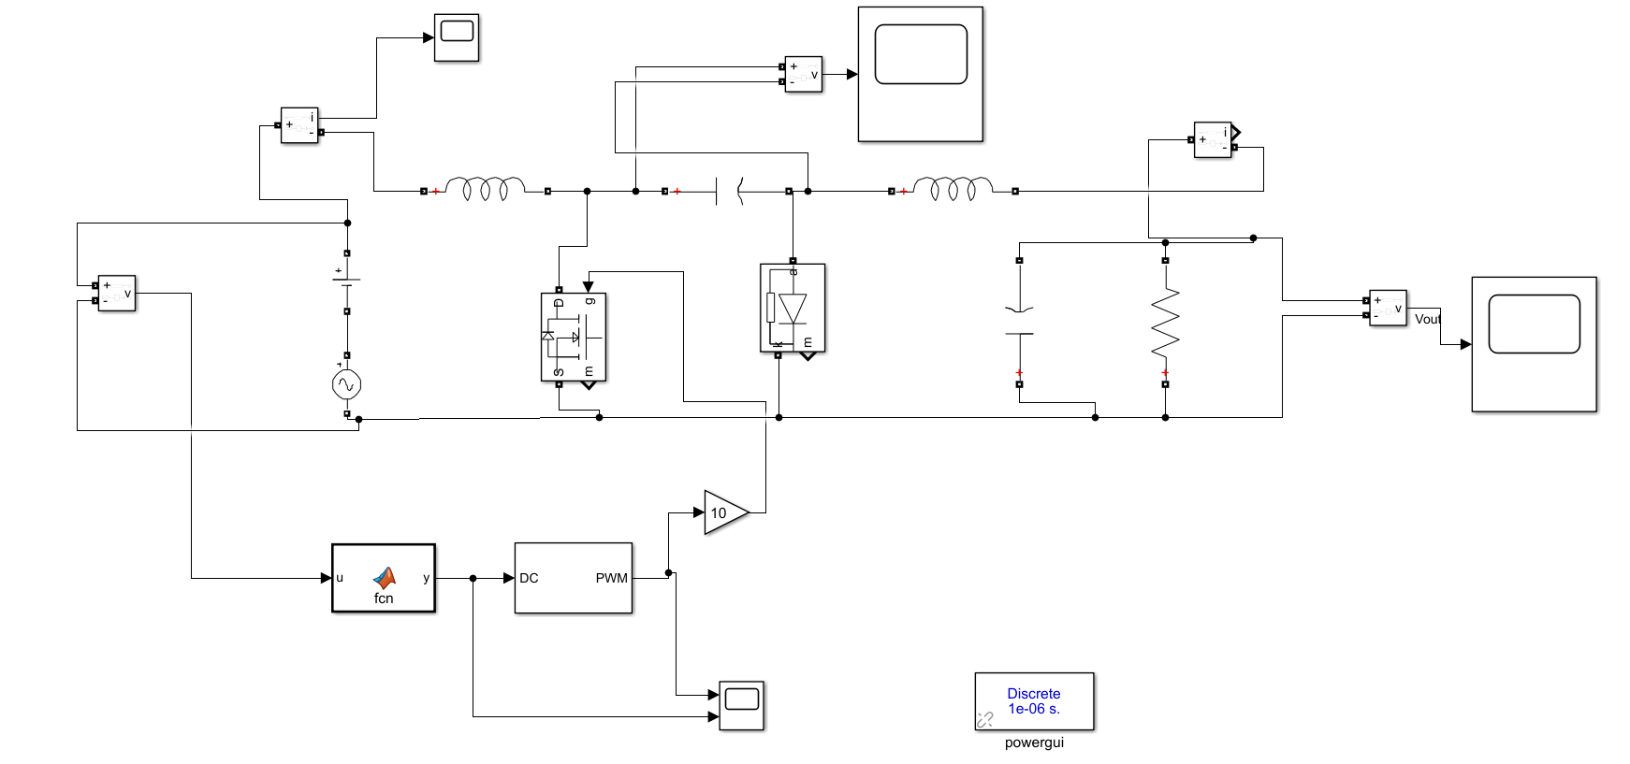

*Figure 10 – Circuit schematic of the Ćuk converter with the controller which keeps the output voltage constant.*

The controller is designed with a Matlab Function block in Simulink, which allows us to adjust the duty cycle as we wanted. The code written in the function block is as follows:

function y = fcn(u)

y = (12/(u+12))+0.05;

The duty cycle pin takes values between 0 and 1. We need a sinusoidal duty cycle which fluctuates between 0.54 and 0.6V in order to get a constant -12V output voltage with the changing input voltage. First, we used the formula above without the “+0.05”. However, the output voltage become -11V with this duty cycle. In order to fix the output voltage, 0.05 is added to the current duty cycle in order to get a fixed -12V output. Then, the gate of the MOSFET is driven with the generated PWM. The waveform of the DC and PWM is given in the Figure 11 and the output voltage waveform is illustrated in Figure 12.

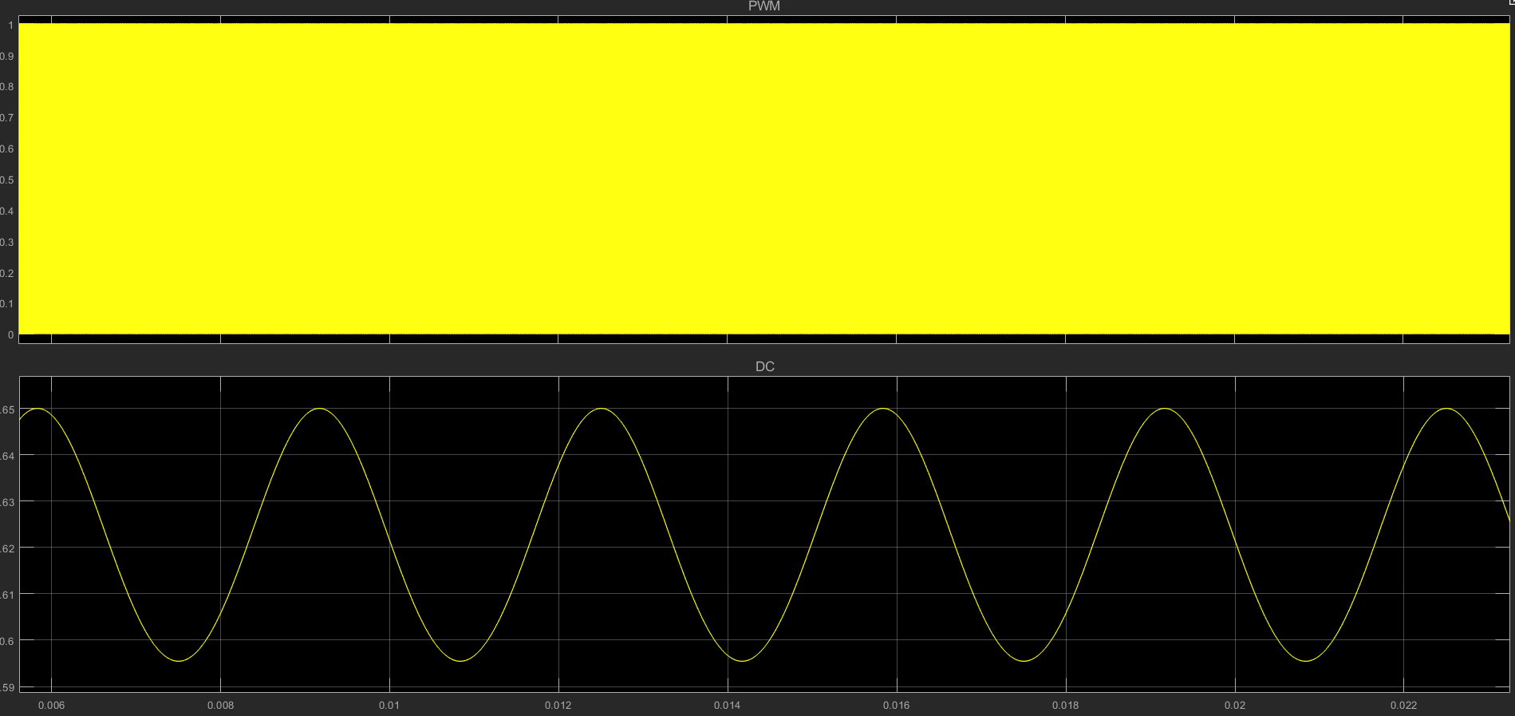

*Figure 11 – Variation of the duty cycle and the generated pwm at the controller.*

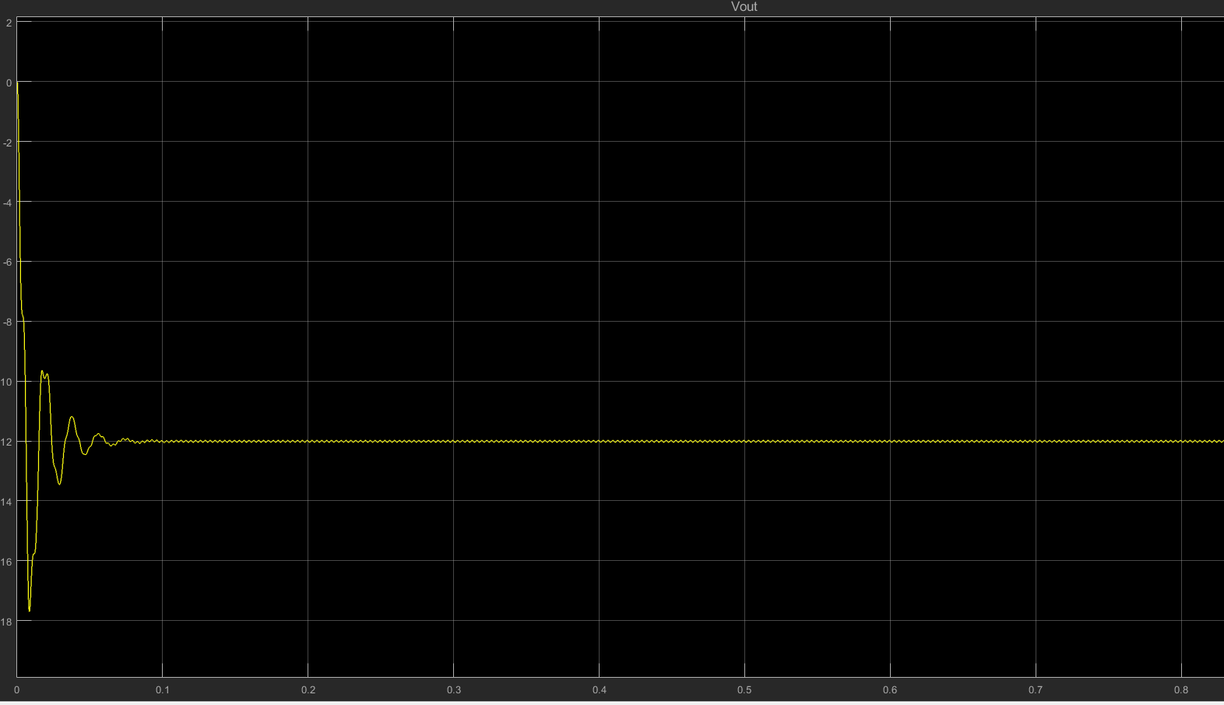

*Figure 12 – Output voltage waveform of the circuit with the controller.*

**e)**