# Q1

## 

## Assumptions

I have assumed all Ssn, DepartmentNumber and ProjectNumber attributes to be unique identifiers

### “Each project is managed by one professor (known as the project’s principal investigator)”

I have assumed that a professor may manage zero or many projects

## “Professors can manage and/or work on multiple projects”

I have assumed that a professor may not manage and/or work on any project.

### “Departments have a professor (known as the chairman) who runs the department. “

I have assumed that a professor may manage zero or many departments

### “Professors work in one or more departments and for each department that they work in, a time percentage is associated with their job”

I have assumed that a department must have at least one professor working

### “Graduate students have one major department in which they are working on their degree.”

I have assumed that a department may not have any graduate student

### “Each graduate student has another, more senior graduate student (known as a student advisor) who advises him or her on what courses to take.”

I have assumed that an advisor student can have one or more advisee students

# Q2

## Assumptions

-Instead of having an Artist attribute in ART_OBJECT I used the existing entity ARTIST and drawn a many-to-many relationship between them

“Information is kept on other COLLECTIONs (related to BORROWED_COLLECTION) with which the museum interacts, including Name (unique), Type (museum, personal, etc.), Description, Address, Phone, and current ContactPerson.”

-I have made an entity called “BORROWED_CONTACT_INFO” for BORROWED_COLLECTION to hold these data.

# Q3

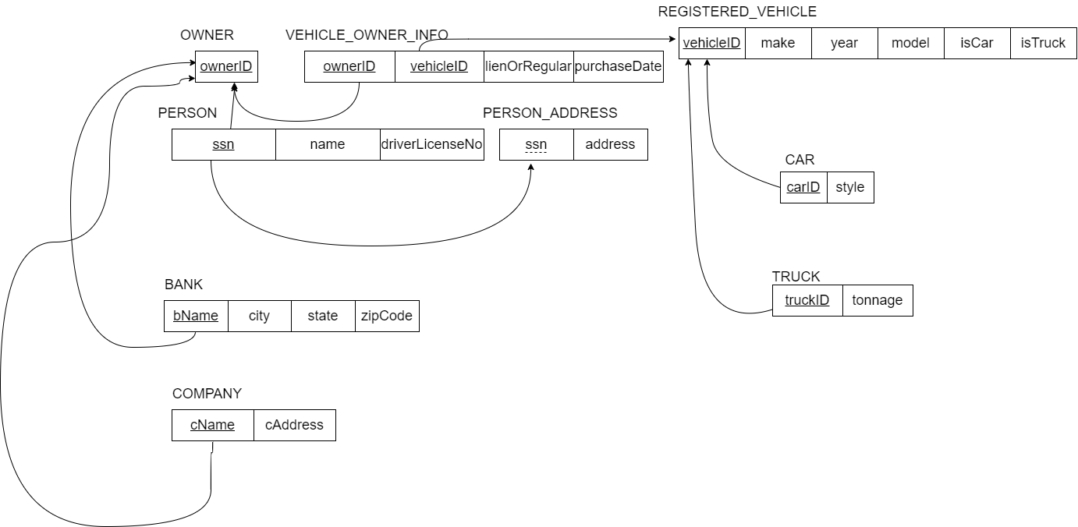

## Assumptions

-I did not include noOfEmployees in COMPANY because it was a derived attribute. I thought it should be calculated at runtime.

# Q4

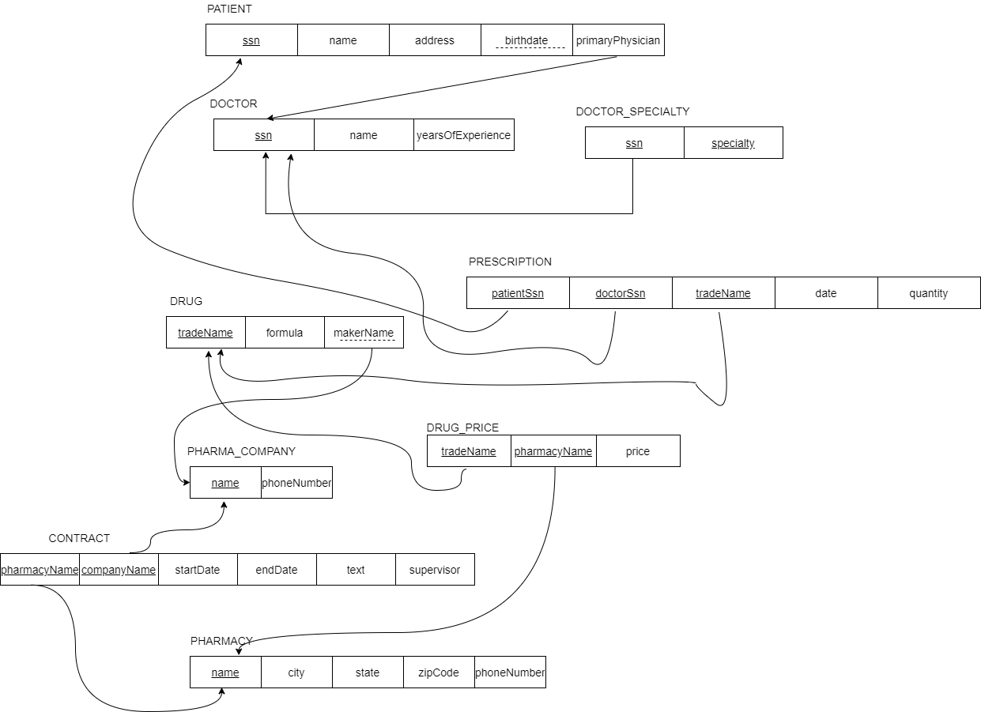

## Assumptions

-I did not include [age] in PATIENT because it should be calculated at runtime

-In PRESCRIPTION I have assumed that a patient can get the same drug with same doctor only once