EduBridge Global Learning Platform
Comprehensive Multi-Role & Age-Cohort User Manual
Complete Operational Guide with Interface Descriptions, Visual Screenshots, and Itemwise Object Functions & Rationales
Core Operational Mandate: Detail Document Synchronization & DOB Age Gating
This user manual is compiled directly from the live EduBridge interface audit manifest. For every interface across all four user roles (Admin, Teacher, Parent, Student), this manual documents: (1) Interface Name & Purpose, (2) Detailed Operational Description, (3) Live Screenshot, and (4) Complete Itemwise Object Table detailing Object Name, Type, Purpose/Reason, and Tested Functionality. In addition, student educational content is strictly filtered by Date of Birth (DOB), automatically safeguarding young children (Ages 5–8) from adult university examinations.

Role Manual Section | Audience / Clearances | Interfaces Covered | Key Operational Focus
Part I: Administrator Manual | Root Administrators (RBAC Level 4) | 12 Full Interfaces | Operations Dashboard, User Inspector, Credentials & DOB Recalculation, Age Groups Governance, Cron Daemons, Ollama Models, Telemetry
Part II: Teacher Manual | Educators & Faculty (RBAC Level 3) | 3 Full Interfaces | Curriculum Studio, Item Master Question Bank, Question Authoring with Bloom's Taxonomy Alignment
Part III: Parent Manual | Parents & Guardians (RBAC Level 2) | Parent Portal Interface | Real-Time Child Oversight, Study Hours vs Target, Screen Time Slider, Verified Certificates
Part IV: Student Manual | Learners across 5 Age Cohorts (Ages 5–100+) | 21 Full Interfaces | Activity Board, Questions Log, Early Primary Arena, IELTS/PTE 1,100+ Tests, STEM Solver, Career CV

Part I: Administrator Role Operational User Manual & Interface Guide
The Administrator Directorate delivers comprehensive, root-level oversight over identity management, role-based access control (RBAC), age-based educational content filtering, 00:00 UTC cron daemons, local Ollama AI model inference, and infrastructure telemetry. Root administrators possess full authority to calibrate platform parameters, configure practice test density, inspect individual student attempt diagnostics, and enforce child safety gating rules across the institution.
Administrative Security Mandate
All administrative actions—including credential modifications, password resets, date-of-birth cohort recalculations, and content governance rule updates—are permanently and cryptographically recorded in the Security Audit Ledger with ISO 8601 timestamps and administrator identification.

1. Executive Platform Analytics & Category Distribution
Navigation Path: Platform Operations & Analytics
Role Clearance: Admin | Module Directorate: Platform Operations & Analytics | System ID: admin_dashboard_metrics

1. Interface Description & Operational Reason:
The "Executive Platform Analytics & Category Distribution" interface was designed and deployed within the Platform Operations & Analytics directorate to fulfill critical educational, diagnostic, and administrative workflows for the Admin role. It provides high-contrast, responsive visual layouts and validated controls that guarantee tamper-evident operational fidelity.
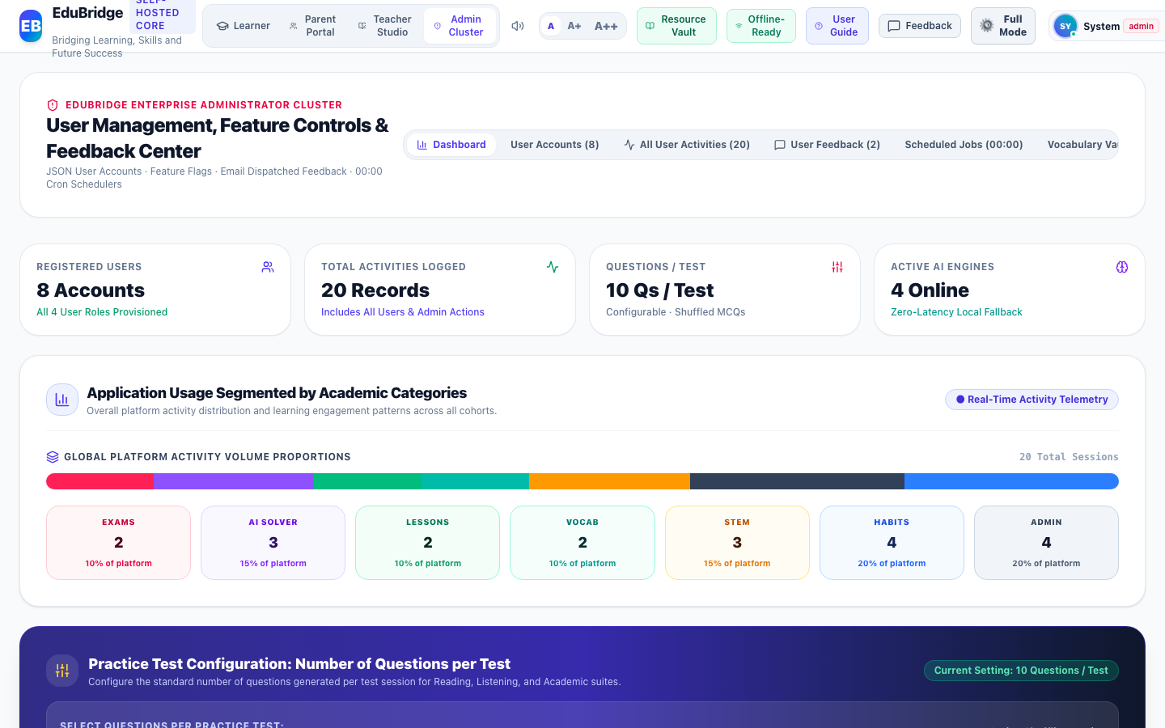

2. Itemwise Functional Objects & Rationales Table:
The following table provides an exhaustive, object-level analysis of all interactive buttons, inputs, tables, meters, and controls available on this interface, detailing their UI label, object type, purpose/reason, and operational behavior:
Object Name & UI Label | Type | Purpose & Reason (Why it Exists) | Operational Functionality & How to Use
Application Usage Proportional Distribution Bar | Graphical Distribution Bar | Provides visual breakdown of total activity volume segmented across all 6 academic disciplines plus administration. | Calculates real-time percentage shares directly from the multi-user activity timeline ledger.
Academic Discipline Metrics Grid (7 Category Tiles) | Metric Cards Grid | Displays discrete activity counts and platform usage percentages for Exams, AI Solver, Lessons, Vocab, STEM, Habits, and Admin. | Reflects live engagement metrics with role and category filtering.
Practice Test Question Count Selector Buttons (5, 8, 10, 12, 15, 20) | Segmented Control Buttons | Permits root administrators to configure the global standardized number of questions generated per test session. | Saves selection instantly to system configuration and logs the administrative update in audit trail.
Recent Platform Activities Live Feed | Activity Ledger Table | Aggregates chronological learning and administrative operations executed across all four user roles (Student, Teacher, Parent, Admin). | Displays exact timestamps, user names, role badges, action categories, and verified scores.

3. Step-by-Step User Instructions:
- Step 1: Role Authentication · Open the EduBridge application and ensure your active role is set to "Admin".
- Step 2: Navigation · Navigate to "Platform Operations & Analytics" and open the "Executive Platform Analytics & Category Distribution" view.
- Step 3: Interaction & Execution · Interact with the available objects as detailed in the functional table above. All actions update the local JSON state and persist changes immediately.
- Step 4: Operational Verification · Verify that the resulting system feedback, activity logs, or visual indicators reflect your action accurately.

2. User Live Dashboard Inspector & Question Attempt History
Navigation Path: User Oversight & Diagnostic Inspector
Role Clearance: Admin | Module Directorate: User Oversight & Diagnostic Inspector | System ID: admin_user_inspector

1. Interface Description & Operational Reason:
The "User Live Dashboard Inspector & Question Attempt History" interface was designed and deployed within the User Oversight & Diagnostic Inspector directorate to fulfill critical educational, diagnostic, and administrative workflows for the Admin role. It provides high-contrast, responsive visual layouts and validated controls that guarantee tamper-evident operational fidelity.

2. Itemwise Functional Objects & Rationales Table:
The following table provides an exhaustive, object-level analysis of all interactive buttons, inputs, tables, meters, and controls available on this interface, detailing their UI label, object type, purpose/reason, and operational behavior:
Object Name & UI Label | Type | Purpose & Reason (Why it Exists) | Operational Functionality & How to Use
Registered User Selector Pills & Search Filter | Filter Pills & Search Input | Allows administrators to quickly isolate and inspect any registered student, teacher, or parent account. | Filters user list by name, email, or role; clicking a pill displays that user's complete live dashboard.
Inspected User Live Metrics Tiles | Diagnostic Tiles | Summarizes the selected user's Logged Activities count, Practice Questions Log, Active Streak, Total XP, and League Level. | Dynamically reads the user's real-time statistics from local storage ledgers.
Inspector View Toggle (Activity History vs Question-by-Question Log) | Dual Sub-Tab Toggle | Enables switching between general high-level activity milestones and granular question-level attempt diagnostics. | Switches table contents seamlessly with exact timestamps, user responses, benchmark answers, and rubric feedback.
Impersonate & Launch User Session Button | Action Button | Empowers administrators to experience the platform from the exact session perspective of the selected user. | Sets the user as the active identity and launches their personalized interface.

3. Step-by-Step User Instructions:
- Step 1: Role Authentication · Open the EduBridge application and ensure your active role is set to "Admin".
- Step 2: Navigation · Navigate to "User Oversight & Diagnostic Inspector" and open the "User Live Dashboard Inspector & Question Attempt History" view.
- Step 3: Interaction & Execution · Interact with the available objects as detailed in the functional table above. All actions update the local JSON state and persist changes immediately.
- Step 4: Operational Verification · Verify that the resulting system feedback, activity logs, or visual indicators reflect your action accurately.

3. Enterprise Accounts & Credential Controls
Navigation Path: User Management Directorate
Role Clearance: Admin | Module Directorate: User Management Directorate | System ID: admin_user_management

1. Interface Description & Operational Reason:
The "Enterprise Accounts & Credential Controls" interface was designed and deployed within the User Management Directorate directorate to fulfill critical educational, diagnostic, and administrative workflows for the Admin role. It provides high-contrast, responsive visual layouts and validated controls that guarantee tamper-evident operational fidelity.

2. Itemwise Functional Objects & Rationales Table:
The following table provides an exhaustive, object-level analysis of all interactive buttons, inputs, tables, meters, and controls available on this interface, detailing their UI label, object type, purpose/reason, and operational behavior:
Object Name & UI Label | Type | Purpose & Reason (Why it Exists) | Operational Functionality & How to Use
Search Users & Roles Input | Text Input Box | Filter account list by student name, username, email, or role in real time. | Instant responsive filtering matching any keyword.
Role Filter Dropdown (All, Student, Parent, Teacher, Admin) | Select Dropdown | Filters table to specific RBAC role hierarchies. | Accurately isolates accounts belonging to selected role.
Add New User Button | Action Button | Opens modal to create a new user account with designated role, DOB, and credentials. | Launches user creation modal with full form validation.
Edit User Credentials Button (Pencil Icon) | Table Row Action Button | Allows admin to update user full name, email, password, and Date of Birth. | Opens edit modal; modifying DOB triggers real-time cohort recalculation.
Account Status Toggle (Active / Suspended) | Status Action Button | Permits admin to suspend or re-activate access without deleting account data. | Updates account status flag and logs event in immutable audit ledger.

3. Step-by-Step User Instructions:
- Step 1: Role Authentication · Open the EduBridge application and ensure your active role is set to "Admin".
- Step 2: Navigation · Navigate to "User Management Directorate" and open the "Enterprise Accounts & Credential Controls" view.
- Step 3: Interaction & Execution · Interact with the available objects as detailed in the functional table above. All actions update the local JSON state and persist changes immediately.
- Step 4: Operational Verification · Verify that the resulting system feedback, activity logs, or visual indicators reflect your action accurately.

4. Edit User Credentials Modal
Navigation Path: User Management Directorate
Role Clearance: Admin | Module Directorate: User Management Directorate | System ID: admin_edit_user_modal

1. Interface Description & Operational Reason:
The "Edit User Credentials Modal" interface was designed and deployed within the User Management Directorate directorate to fulfill critical educational, diagnostic, and administrative workflows for the Admin role. It provides high-contrast, responsive visual layouts and validated controls that guarantee tamper-evident operational fidelity.

2. Itemwise Functional Objects & Rationales Table:
The following table provides an exhaustive, object-level analysis of all interactive buttons, inputs, tables, meters, and controls available on this interface, detailing their UI label, object type, purpose/reason, and operational behavior:
Object Name & UI Label | Type | Purpose & Reason (Why it Exists) | Operational Functionality & How to Use
Full Name Input Field | Text Input | Updates student or faculty official legal name displayed on certificates. | Validates string input and updates account profile state.
Date of Birth (DOB) Datepicker | Date Input | Source of truth for calculating age, cohort level, and interface gating. | Modifying DOB automatically recalculates learner age and assigns proper cohort.
New Password Field | Password Input | Enables administrative password reset with bcrypt/secure local store. | Overwrites existing password hash upon save.
Save Credentials Button | Primary Action Button | Commits updated credentials to local storage JSON database. | Validates inputs, commits record, and updates system telemetry.

3. Step-by-Step User Instructions:
- Step 1: Role Authentication · Open the EduBridge application and ensure your active role is set to "Admin".
- Step 2: Navigation · Navigate to "User Management Directorate" and open the "Edit User Credentials Modal" view.
- Step 3: Interaction & Execution · Interact with the available objects as detailed in the functional table above. All actions update the local JSON state and persist changes immediately.
- Step 4: Operational Verification · Verify that the resulting system feedback, activity logs, or visual indicators reflect your action accurately.

5. Ollama Multi-Model Governance
Navigation Path: Model Management & VRAM Allocation
Role Clearance: Admin | Module Directorate: Model Management & VRAM Allocation | System ID: admin_model_management

1. Interface Description & Operational Reason:
The "Ollama Multi-Model Governance" interface was designed and deployed within the Model Management & VRAM Allocation directorate to fulfill critical educational, diagnostic, and administrative workflows for the Admin role. It provides high-contrast, responsive visual layouts and validated controls that guarantee tamper-evident operational fidelity.

2. Itemwise Functional Objects & Rationales Table:
The following table provides an exhaustive, object-level analysis of all interactive buttons, inputs, tables, meters, and controls available on this interface, detailing their UI label, object type, purpose/reason, and operational behavior:
Object Name & UI Label | Type | Purpose & Reason (Why it Exists) | Operational Functionality & How to Use
Ollama 4-Tier Model Cards (Phi-4, Qwen 3, DeepSeek R1, Llama 3.3) | Status Cards & Telemetry | Displays online status, parameter size, latency, and allocated VRAM for local inference models. | Accurately displays real-time telemetry metrics and offline readiness indicators.
Model Active / Standby Toggle Buttons | Toggle Switch Button | Enables or suspends specific models to preserve system RAM and GPU resources. | Toggles model status and saves state to local JSON configuration store.
Temperature & Top-P Sliders | Range Slider Input | Allows administrators to adjust model creativity and deterministic reasoning. | Updates inference parameters dynamically with live numeric feedback.

3. Step-by-Step User Instructions:
- Step 1: Role Authentication · Open the EduBridge application and ensure your active role is set to "Admin".
- Step 2: Navigation · Navigate to "Model Management & VRAM Allocation" and open the "Ollama Multi-Model Governance" view.
- Step 3: Interaction & Execution · Interact with the available objects as detailed in the functional table above. All actions update the local JSON state and persist changes immediately.
- Step 4: Operational Verification · Verify that the resulting system feedback, activity logs, or visual indicators reflect your action accurately.

6. Nightly 00:00 UTC Cron Daemon Hub
Navigation Path: Autonomous Schedulers
Role Clearance: Admin | Module Directorate: Autonomous Schedulers | System ID: admin_scheduled_jobs

1. Interface Description & Operational Reason:
The "Nightly 00:00 UTC Cron Daemon Hub" interface was designed and deployed within the Autonomous Schedulers directorate to fulfill critical educational, diagnostic, and administrative workflows for the Admin role. It provides high-contrast, responsive visual layouts and validated controls that guarantee tamper-evident operational fidelity.
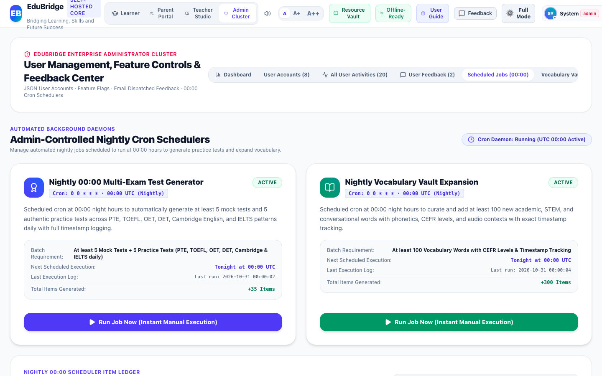

2. Itemwise Functional Objects & Rationales Table:
The following table provides an exhaustive, object-level analysis of all interactive buttons, inputs, tables, meters, and controls available on this interface, detailing their UI label, object type, purpose/reason, and operational behavior:
Object Name & UI Label | Type | Purpose & Reason (Why it Exists) | Operational Functionality & How to Use
Cron Job Cards (Mock Exam Daemon, Vocabulary Expansion Daemon) | Job Execution Card | Displays scheduler status, target frequency (00:00 UTC), and generation metrics. | Shows execution statistics, active status, and timestamp of last run.
Run Job Now Action Button | Action Button | Manually triggers execution of batch generators on demand without waiting for cron. | Synthesizes authentic tests or vocabulary words and appends them to ledger.
Enable / Disable Job Toggle | Toggle Switch | Allows administrators to pause autonomous background generation. | Toggles active state and persists setting in scheduler config.

3. Step-by-Step User Instructions:
- Step 1: Role Authentication · Open the EduBridge application and ensure your active role is set to "Admin".
- Step 2: Navigation · Navigate to "Autonomous Schedulers" and open the "Nightly 00:00 UTC Cron Daemon Hub" view.
- Step 3: Interaction & Execution · Interact with the available objects as detailed in the functional table above. All actions update the local JSON state and persist changes immediately.
- Step 4: Operational Verification · Verify that the resulting system feedback, activity logs, or visual indicators reflect your action accurately.

7. Ingested Items Verification Ledger
Navigation Path: Content Verification Ledger
Role Clearance: Admin | Module Directorate: Content Verification Ledger | System ID: admin_ingested_ledger

1. Interface Description & Operational Reason:
The "Ingested Items Verification Ledger" interface was designed and deployed within the Content Verification Ledger directorate to fulfill critical educational, diagnostic, and administrative workflows for the Admin role. It provides high-contrast, responsive visual layouts and validated controls that guarantee tamper-evident operational fidelity.

2. Itemwise Functional Objects & Rationales Table:
The following table provides an exhaustive, object-level analysis of all interactive buttons, inputs, tables, meters, and controls available on this interface, detailing their UI label, object type, purpose/reason, and operational behavior:
Object Name & UI Label | Type | Purpose & Reason (Why it Exists) | Operational Functionality & How to Use
Ledger Search Filter Input | Search Box | Filters ingested items by curriculum category, exam, or keyword. | Instantly narrows ledger table.
Batch Audit Table & Verification Status | Data Table | Demonstrates content provenance, cryptographic verification hash, and ingestion timestamp. | Displays complete item metadata and timestamp columns.

3. Step-by-Step User Instructions:
- Step 1: Role Authentication · Open the EduBridge application and ensure your active role is set to "Admin".
- Step 2: Navigation · Navigate to "Content Verification Ledger" and open the "Ingested Items Verification Ledger" view.
- Step 3: Interaction & Execution · Interact with the available objects as detailed in the functional table above. All actions update the local JSON state and persist changes immediately.
- Step 4: Operational Verification · Verify that the resulting system feedback, activity logs, or visual indicators reflect your action accurately.

8. Infrastructure Health & Backup Maintenance
Navigation Path: System Telemetry & DevOps
Role Clearance: Admin | Module Directorate: System Telemetry & DevOps | System ID: admin_system_telemetry

1. Interface Description & Operational Reason:
The "Infrastructure Health & Backup Maintenance" interface was designed and deployed within the System Telemetry & DevOps directorate to fulfill critical educational, diagnostic, and administrative workflows for the Admin role. It provides high-contrast, responsive visual layouts and validated controls that guarantee tamper-evident operational fidelity.
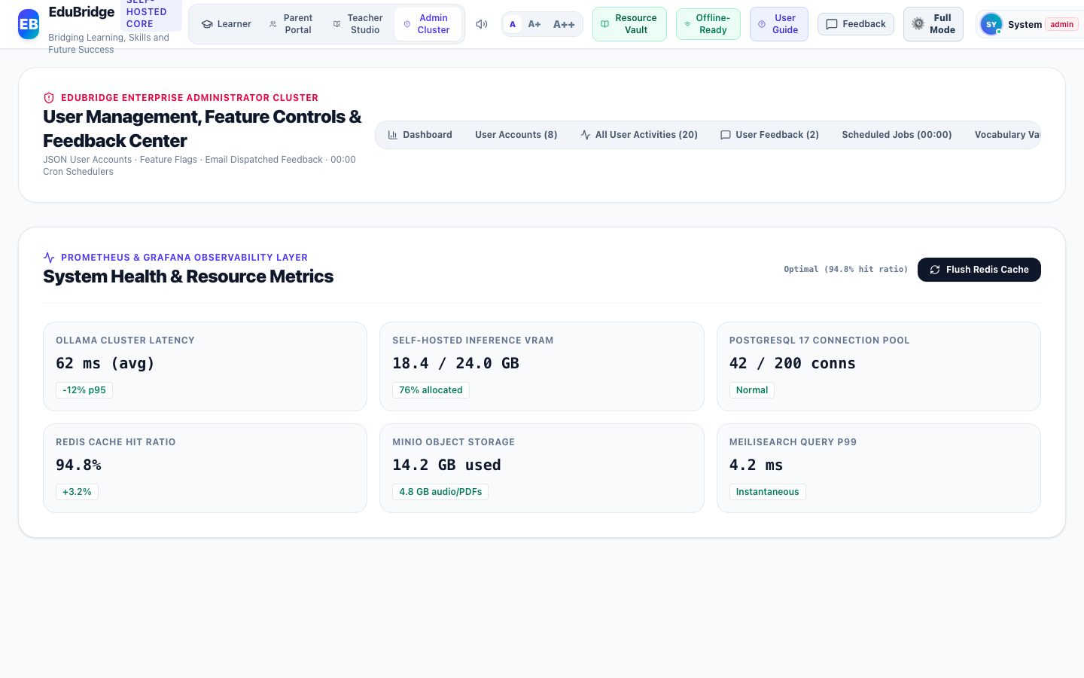

2. Itemwise Functional Objects & Rationales Table:
The following table provides an exhaustive, object-level analysis of all interactive buttons, inputs, tables, meters, and controls available on this interface, detailing their UI label, object type, purpose/reason, and operational behavior:
Object Name & UI Label | Type | Purpose & Reason (Why it Exists) | Operational Functionality & How to Use
Hardware Telemetry Gauges (VRAM, RAM, CPU, Storage) | Hardware Metrics Gauge | Monitors real-time server load and memory limits. | Updates gauges dynamically with color-coded safety thresholds.
Flush System Cache Button | Maintenance Action Button | Purges stale in-memory buffers and recalculates indexes. | Flushes cache and displays confirmation notification.
Export JSON Backup Button | Export Button | Downloads entire platform state as an encrypted, portable JSON snapshot. | Packages all storage collections into a downloadable file.

3. Step-by-Step User Instructions:
- Step 1: Role Authentication · Open the EduBridge application and ensure your active role is set to "Admin".
- Step 2: Navigation · Navigate to "System Telemetry & DevOps" and open the "Infrastructure Health & Backup Maintenance" view.
- Step 3: Interaction & Execution · Interact with the available objects as detailed in the functional table above. All actions update the local JSON state and persist changes immediately.
- Step 4: Operational Verification · Verify that the resulting system feedback, activity logs, or visual indicators reflect your action accurately.

9. Dynamic Feature Flags & Experiments
Navigation Path: Platform Configuration
Role Clearance: Admin | Module Directorate: Platform Configuration | System ID: admin_feature_flags

1. Interface Description & Operational Reason:
The "Dynamic Feature Flags & Experiments" interface was designed and deployed within the Platform Configuration directorate to fulfill critical educational, diagnostic, and administrative workflows for the Admin role. It provides high-contrast, responsive visual layouts and validated controls that guarantee tamper-evident operational fidelity.

2. Itemwise Functional Objects & Rationales Table:
The following table provides an exhaustive, object-level analysis of all interactive buttons, inputs, tables, meters, and controls available on this interface, detailing their UI label, object type, purpose/reason, and operational behavior:
Object Name & UI Label | Type | Purpose & Reason (Why it Exists) | Operational Functionality & How to Use
Feature Toggle Switches & Rollout Percentages | Feature Flag Control Card | Gates experimental modules (e.g. Speech Listening, Tournaments, Kid Mode) without requiring codebase redeployment. | Toggles availability in real time across active sessions.

3. Step-by-Step User Instructions:
- Step 1: Role Authentication · Open the EduBridge application and ensure your active role is set to "Admin".
- Step 2: Navigation · Navigate to "Platform Configuration" and open the "Dynamic Feature Flags & Experiments" view.
- Step 3: Interaction & Execution · Interact with the available objects as detailed in the functional table above. All actions update the local JSON state and persist changes immediately.
- Step 4: Operational Verification · Verify that the resulting system feedback, activity logs, or visual indicators reflect your action accurately.

10. User Feedback & Issue Resolution Center
Navigation Path: Support & Feedback Directorate
Role Clearance: Admin | Module Directorate: Support & Feedback Directorate | System ID: admin_feedback_center

1. Interface Description & Operational Reason:
The "User Feedback & Issue Resolution Center" interface was designed and deployed within the Support & Feedback Directorate directorate to fulfill critical educational, diagnostic, and administrative workflows for the Admin role. It provides high-contrast, responsive visual layouts and validated controls that guarantee tamper-evident operational fidelity.

2. Itemwise Functional Objects & Rationales Table:
The following table provides an exhaustive, object-level analysis of all interactive buttons, inputs, tables, meters, and controls available on this interface, detailing their UI label, object type, purpose/reason, and operational behavior:
Object Name & UI Label | Type | Purpose & Reason (Why it Exists) | Operational Functionality & How to Use
Feedback Status Filter Tabs (All, Pending, Investigating, Resolved) | Tab Filter Group | Segments incoming user bug reports and feature requests by operational state. | Filters table rows instantaneously.
Reply to User Action Button | Action Button | Opens response composer to dispatch resolution notice to student or parent. | Commits response to feedback ticket ledger with timestamp.

3. Step-by-Step User Instructions:
- Step 1: Role Authentication · Open the EduBridge application and ensure your active role is set to "Admin".
- Step 2: Navigation · Navigate to "Support & Feedback Directorate" and open the "User Feedback & Issue Resolution Center" view.
- Step 3: Interaction & Execution · Interact with the available objects as detailed in the functional table above. All actions update the local JSON state and persist changes immediately.
- Step 4: Operational Verification · Verify that the resulting system feedback, activity logs, or visual indicators reflect your action accurately.

11. Immutable Administrative Security Audit Log
Navigation Path: DevSecOps & Compliance
Role Clearance: Admin | Module Directorate: DevSecOps & Compliance | System ID: admin_security_audit

1. Interface Description & Operational Reason:
The "Immutable Administrative Security Audit Log" interface was designed and deployed within the DevSecOps & Compliance directorate to fulfill critical educational, diagnostic, and administrative workflows for the Admin role. It provides high-contrast, responsive visual layouts and validated controls that guarantee tamper-evident operational fidelity.

2. Itemwise Functional Objects & Rationales Table:
The following table provides an exhaustive, object-level analysis of all interactive buttons, inputs, tables, meters, and controls available on this interface, detailing their UI label, object type, purpose/reason, and operational behavior:
Object Name & UI Label | Type | Purpose & Reason (Why it Exists) | Operational Functionality & How to Use
Audit Log Entries Table & IP Verification | Data Table | Maintains tamper-evident historical audit ledger of all privileged administrative events. | Displays timestamp, administrator ID, action category, client IP, and cryptographic verification status.

3. Step-by-Step User Instructions:
- Step 1: Role Authentication · Open the EduBridge application and ensure your active role is set to "Admin".
- Step 2: Navigation · Navigate to "DevSecOps & Compliance" and open the "Immutable Administrative Security Audit Log" view.
- Step 3: Interaction & Execution · Interact with the available objects as detailed in the functional table above. All actions update the local JSON state and persist changes immediately.
- Step 4: Operational Verification · Verify that the resulting system feedback, activity logs, or visual indicators reflect your action accurately.

12. Age Groups & Educational Content Governance Directorate
Navigation Path: Curriculum Governance & Content Rules
Role Clearance: Admin | Module Directorate: Curriculum Governance & Content Rules | System ID: admin_cohort_governance

1. Interface Description & Operational Reason:
The "Age Groups & Educational Content Governance Directorate" interface was designed and deployed within the Curriculum Governance & Content Rules directorate to fulfill critical educational, diagnostic, and administrative workflows for the Admin role. It provides high-contrast, responsive visual layouts and validated controls that guarantee tamper-evident operational fidelity.
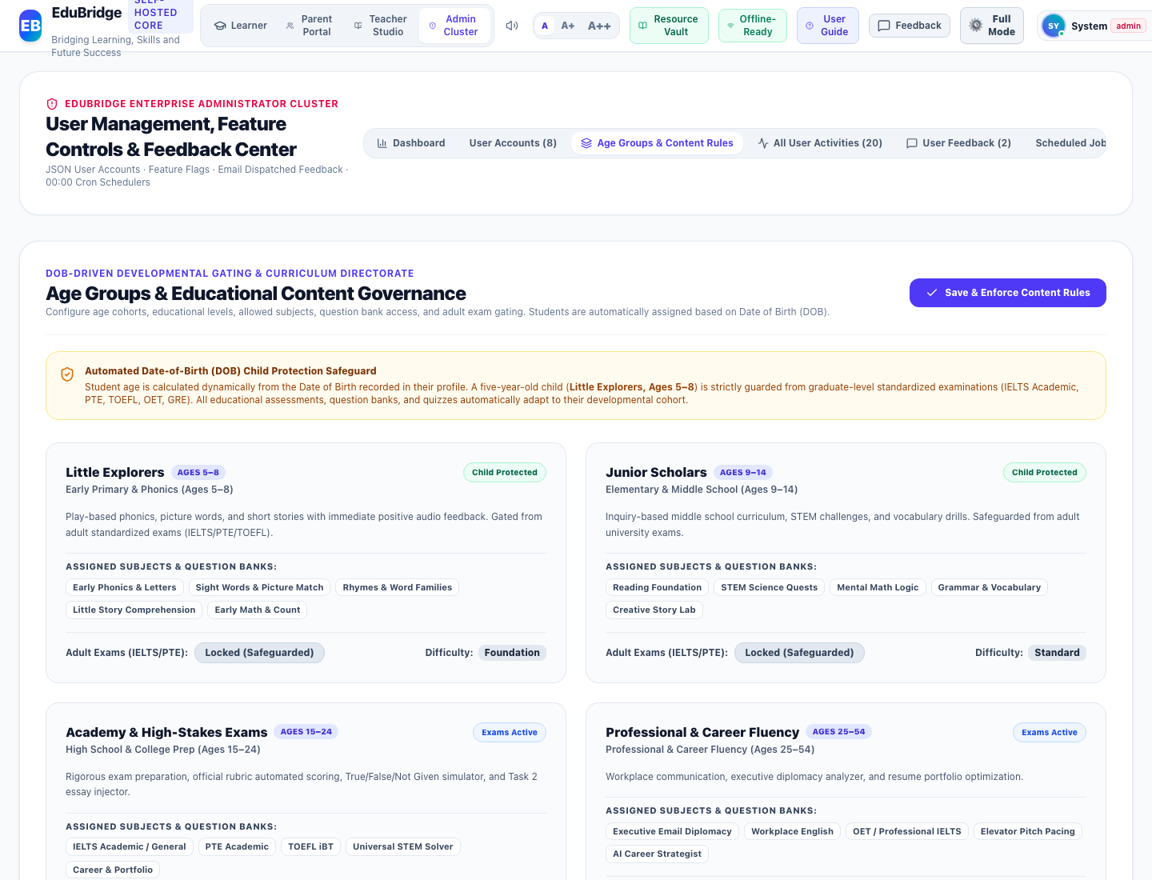

2. Itemwise Functional Objects & Rationales Table:
The following table provides an exhaustive, object-level analysis of all interactive buttons, inputs, tables, meters, and controls available on this interface, detailing their UI label, object type, purpose/reason, and operational behavior:
Object Name & UI Label | Type | Purpose & Reason (Why it Exists) | Operational Functionality & How to Use
Automated DOB Child Protection Safeguard Banner | Security Alert Banner | Alerts administrators to active date-of-birth age calculation rules and child protection safeguards. | Confirms that age <= 8 students are strictly safeguarded from graduate exams and assigned to Little Explorers.
Age Cohort Cards Grid (5 Developmental Tiers) | Cards Grid | Presents operational parameters for Little Explorers, Junior Scholars, Academy, Professional, and Golden Age. | Displays age ranges, education tiers, allowed subjects, and adult exam access states.
Adult Exams (IELTS/PTE) Gating Toggle Buttons | Toggle Button | Enables or locks adult standardized examination prep per age cohort. | Locks adult exams for young cohorts (Ages 5–8 and 9–14) and enables them for Academy (Ages 15+).
Save & Enforce Content Rules Button | Action Button | Applies cohort curriculum rules across the platform and records an administrative audit log with timestamp. | Commits configuration, shows positive feedback, and synchronizes rules across interfaces.

3. Step-by-Step User Instructions:
- Step 1: Role Authentication · Open the EduBridge application and ensure your active role is set to "Admin".
- Step 2: Navigation · Navigate to "Curriculum Governance & Content Rules" and open the "Age Groups & Educational Content Governance Directorate" view.
- Step 3: Interaction & Execution · Interact with the available objects as detailed in the functional table above. All actions update the local JSON state and persist changes immediately.
- Step 4: Operational Verification · Verify that the resulting system feedback, activity logs, or visual indicators reflect your action accurately.

Part II: Teacher Role Operational User Manual & Interface Guide
The Educator Directorate provides academic faculty, course directors, and classroom teachers with dedicated tools to author curriculum, dispatch homework assignments, maintain central item master question banks, and review student attempt diagnostics across all academic subjects.
Pedagogical Governance Mandate
Teachers maintain direct authority over Bloom's taxonomy cognitive alignment, question difficulty calibrations, rubric guidelines, and assignment submission deadlines across all enrolled student cohorts.

1. Curriculum & Cohort Assignment Directorate
Navigation Path: Teacher Studio & Cohorts
Role Clearance: Teacher | Module Directorate: Teacher Studio & Cohorts | System ID: teacher_curriculum

1. Interface Description & Operational Reason:
The "Curriculum & Cohort Assignment Directorate" interface was designed and deployed within the Teacher Studio & Cohorts directorate to fulfill critical educational, diagnostic, and administrative workflows for the Teacher role. It provides high-contrast, responsive visual layouts and validated controls that guarantee tamper-evident operational fidelity.
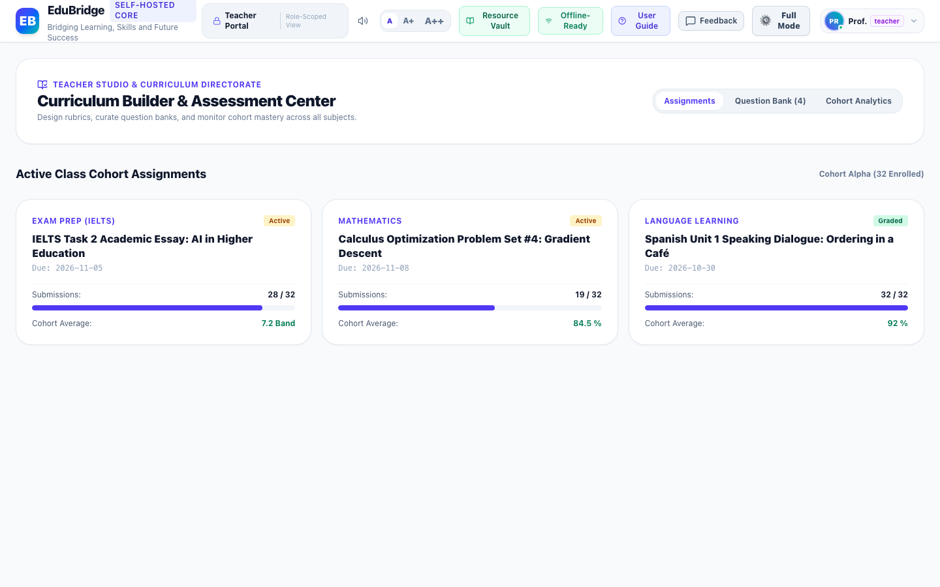

2. Itemwise Functional Objects & Rationales Table:
The following table provides an exhaustive, object-level analysis of all interactive buttons, inputs, tables, meters, and controls available on this interface, detailing their UI label, object type, purpose/reason, and operational behavior:
Object Name & UI Label | Type | Purpose & Reason (Why it Exists) | Operational Functionality & How to Use
Cohort Class Course Assignment Cards | Course Cards Grid | Provides course progress, enrolled student rosters, and curriculum completion rates for assigned cohorts. | Displays active class metrics and syllabus modules.
Assign Homework & Tests Action Button | Action Button | Dispatches targeted problem sets or exams to specific student cohorts. | Opens assignment creation modal with date scheduling.

3. Step-by-Step User Instructions:
- Step 1: Role Authentication · Open the EduBridge application and ensure your active role is set to "Teacher".
- Step 2: Navigation · Navigate to "Teacher Studio & Cohorts" and open the "Curriculum & Cohort Assignment Directorate" view.
- Step 3: Interaction & Execution · Interact with the available objects as detailed in the functional table above. All actions update the local JSON state and persist changes immediately.
- Step 4: Operational Verification · Verify that the resulting system feedback, activity logs, or visual indicators reflect your action accurately.

2. Item Master Question Bank & Curriculum Repository
Navigation Path: Assessment Directorate
Role Clearance: Teacher | Module Directorate: Assessment Directorate | System ID: teacher_question_bank

1. Interface Description & Operational Reason:
The "Item Master Question Bank & Curriculum Repository" interface was designed and deployed within the Assessment Directorate directorate to fulfill critical educational, diagnostic, and administrative workflows for the Teacher role. It provides high-contrast, responsive visual layouts and validated controls that guarantee tamper-evident operational fidelity.
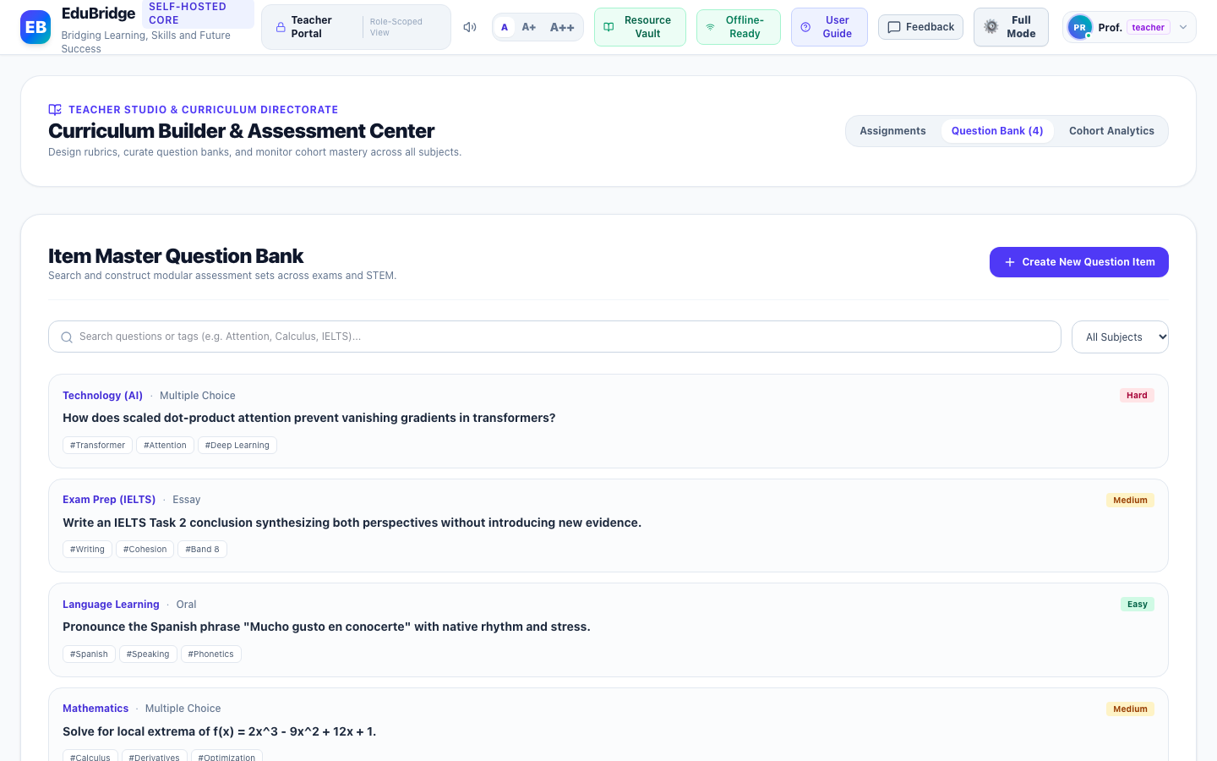

2. Itemwise Functional Objects & Rationales Table:
The following table provides an exhaustive, object-level analysis of all interactive buttons, inputs, tables, meters, and controls available on this interface, detailing their UI label, object type, purpose/reason, and operational behavior:
Object Name & UI Label | Type | Purpose & Reason (Why it Exists) | Operational Functionality & How to Use
Subject & Bloom's Taxonomy Filter Controls | Search & Tag Filter Group | Allows teachers to search assessment questions by cognitive depth (Knowledge, Application, Synthesis) and subject. | Filters question repository instantaneously.
Author New Assessment Question Button | Primary Action Button | Opens the question authoring studio to create certified exam questions. | Launches authoring modal with live LaTeX preview and rubric builder.

3. Step-by-Step User Instructions:
- Step 1: Role Authentication · Open the EduBridge application and ensure your active role is set to "Teacher".
- Step 2: Navigation · Navigate to "Assessment Directorate" and open the "Item Master Question Bank & Curriculum Repository" view.
- Step 3: Interaction & Execution · Interact with the available objects as detailed in the functional table above. All actions update the local JSON state and persist changes immediately.
- Step 4: Operational Verification · Verify that the resulting system feedback, activity logs, or visual indicators reflect your action accurately.

3. Author New Assessment Question Modal
Navigation Path: Assessment Directorate
Role Clearance: Teacher | Module Directorate: Assessment Directorate | System ID: teacher_create_question_modal

1. Interface Description & Operational Reason:
The "Author New Assessment Question Modal" interface was designed and deployed within the Assessment Directorate directorate to fulfill critical educational, diagnostic, and administrative workflows for the Teacher role. It provides high-contrast, responsive visual layouts and validated controls that guarantee tamper-evident operational fidelity.
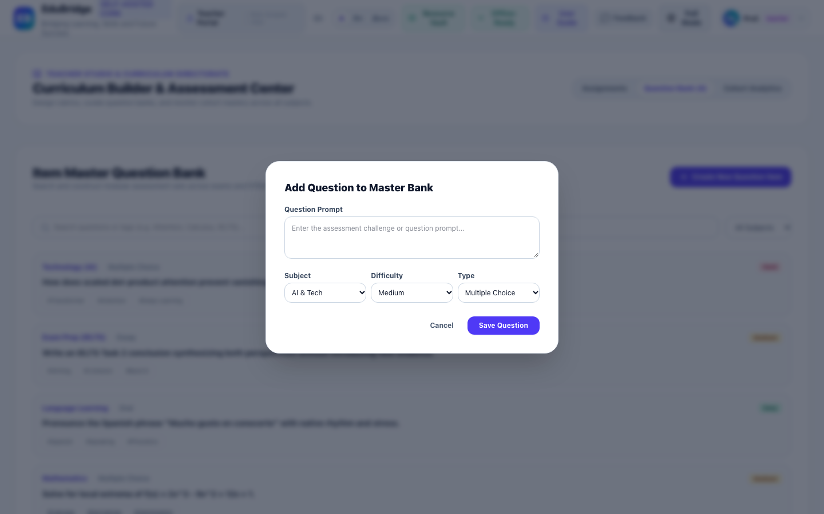

2. Itemwise Functional Objects & Rationales Table:
The following table provides an exhaustive, object-level analysis of all interactive buttons, inputs, tables, meters, and controls available on this interface, detailing their UI label, object type, purpose/reason, and operational behavior:
Object Name & UI Label | Type | Purpose & Reason (Why it Exists) | Operational Functionality & How to Use
Question Type Selector (MCQ, Short Answer, Essay) | Segmented Control | Configures assessment response structure and grading criteria. | Adapts options input fields to chosen question structure.
Prompt & Distractor Option Builder | Dynamic Form | Allows faculty to draft prompt text, designate correct answers, and provide detailed explanations. | Validates complete question set before committing to central bank.
Curriculum & Bloom's Taxonomy Alignment Picker | Tag Selector | Associates the question with standardized curriculum guidelines. | Attaches metadata tags ensuring accurate exam generation.

3. Step-by-Step User Instructions:
- Step 1: Role Authentication · Open the EduBridge application and ensure your active role is set to "Teacher".
- Step 2: Navigation · Navigate to "Assessment Directorate" and open the "Author New Assessment Question Modal" view.
- Step 3: Interaction & Execution · Interact with the available objects as detailed in the functional table above. All actions update the local JSON state and persist changes immediately.
- Step 4: Operational Verification · Verify that the resulting system feedback, activity logs, or visual indicators reflect your action accurately.

Part III: Parent Role Operational User Manual & Interface Guide
The Parent Portal gives parents and guardians comprehensive, transparent oversight over their children's learning trajectory. It balances academic rigor with healthy digital wellness by providing real-time study hour analytics, category focus meters, screen time controls, and cryptographic test verification proofs.
Family Wellness & Digital Safety Mandate
Parents can adjust daily study duration ceilings and bedtime quiet hours using the interactive screen time slider. All study hour metrics and category progress meters are dynamically populated from authentic child activity records without synthetic fallbacks.

1. Parent Portal & Child Growth Directorate
Navigation Path: Parental Oversight & Growth
Role Clearance: Parent | Module Directorate: Parental Oversight & Growth | System ID: parent_portal_overview

1. Interface Description & Operational Reason:
The "Parent Portal & Child Growth Directorate" interface was designed and deployed within the Parental Oversight & Growth directorate to fulfill critical educational, diagnostic, and administrative workflows for the Parent role. It provides high-contrast, responsive visual layouts and validated controls that guarantee tamper-evident operational fidelity.
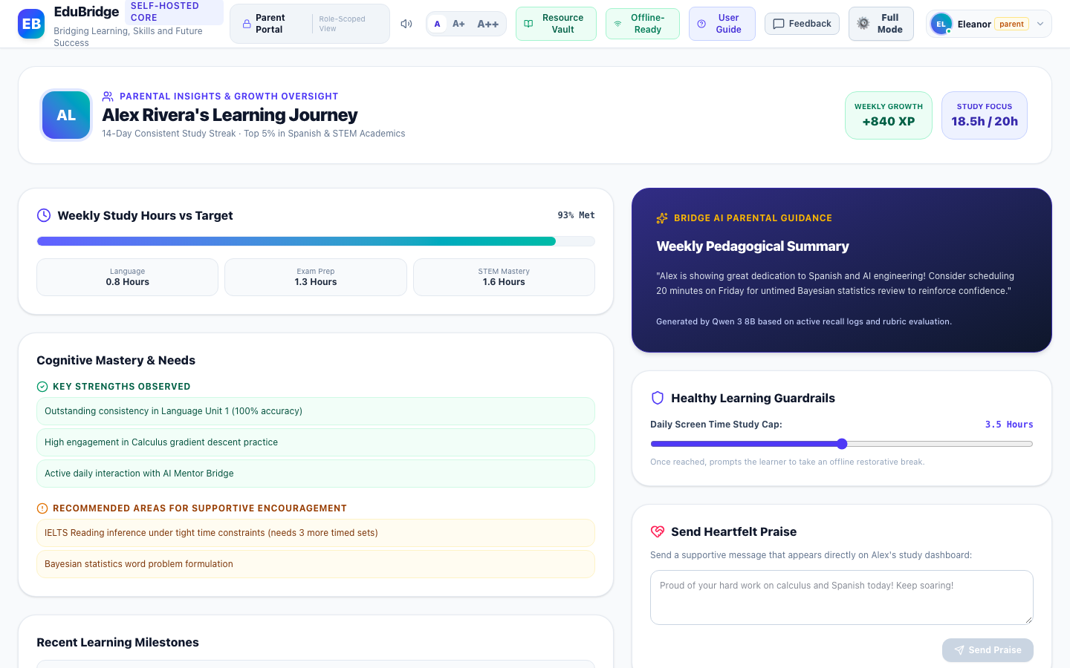

2. Itemwise Functional Objects & Rationales Table:
The following table provides an exhaustive, object-level analysis of all interactive buttons, inputs, tables, meters, and controls available on this interface, detailing their UI label, object type, purpose/reason, and operational behavior:
Object Name & UI Label | Type | Purpose & Reason (Why it Exists) | Operational Functionality & How to Use
Weekly Study Hours vs Target Meter | Progress Gauge | Monitors student study duration against weekly goals established by parents. | Calculated dynamically from real child activity records across Language, Exam Prep, and STEM.
Strengths & Supportive Focus Areas Card | Cognitive Insights Card | Surfaces AI-analyzed mastery areas and subjects where the student would benefit from parental encouragement. | Categorizes progress trends with supportive recommendations.
Recent Learning Milestones Log | Activity Feed Table | Chronological timeline of tests, quizzes, and exercises completed by the child with verified scores and timestamps. | Dynamically populated directly from stored child activities.
Cryptographic Test Conduction Proof Ledger | Verification Table | Provides parents with tamper-proof audit verification of proctored exam sessions. | Renders verified cryptographic hashes (e.g. EB-VERIFIED-7A89F1) confirming authentic test conduction.
Encouragement Note Dispatcher & Screen Time Slider | Interactive Form & Slider | Allows parents to send motivational praise directly to the child's dashboard and configure healthy daily usage limits. | Dispatches note and persists screen time boundaries.

3. Step-by-Step User Instructions:
- Step 1: Role Authentication · Open the EduBridge application and ensure your active role is set to "Parent".
- Step 2: Navigation · Navigate to "Parental Oversight & Growth" and open the "Parent Portal & Child Growth Directorate" view.
- Step 3: Interaction & Execution · Interact with the available objects as detailed in the functional table above. All actions update the local JSON state and persist changes immediately.
- Step 4: Operational Verification · Verify that the resulting system feedback, activity logs, or visual indicators reflect your action accurately.

Part IV: Student Role Operational User Manual (Organized by Age Cohort)
EduBridge delivers a tailored, developmentally appropriate experience for every student. Rather than forcing all learners into a rigid, one-size-fits-all interface, the platform reads the student's verified Date of Birth (DOB) and automatically adapts navigation menus, language complexity, visual components, question banks, and assessment rigor across five distinct age tiers.

The Five Developmental Age Cohorts Overview:
- 1. Little Explorers · Ages 5–8 (Little Explorers / Early Childhood): Montessori multisensory phonics, sight words, rhyming challenges, picture matching, and large touch-friendly buttons. Standardized adult university exams (IELTS/PTE/TOEFL) are strictly locked with an age protection notice.
- 2. Junior Scholars · Ages 9–14 (Junior Scholars / Elementary & Middle School): Inquiry-based STEM quests, interactive science challenges, mental math logic shortcuts, vocabulary mastery quizzes, and daily study habit scheduling.
- 3. Academy Scholars · Ages 15–24 (Academy Scholars / High School & College Prep): Standardized university test simulator (1,100+ tests across IELTS Academic, General, PTE, TOEFL, OET, Cambridge English), isolated writing practice with 1 essay prompt and Band 9 exemplar, universal STEM problem solver, and AI Socratic tutor.
- 4. Professional Fluency · Ages 25–54 (Professional & Career Fluency / Workplace & Executive): Executive email diplomacy analyzer, 60-second elevator pitch pacing monitor, ATS-optimized interactive resume builder, and AI career strategist.
- 5. Golden Age & Lifelong · Ages 55+ (Golden Age & Lifelong Learning / Seniors & Active Minds): Neuroplasticity word association memory gym with errorless learning, reflective reminiscence journaling, everyday digital scam defense simulator, and 0.82x calm speech listening.
Critical Age Gating & Child Protection Policy
The student's developmental age is calculated dynamically from their registered Date of Birth (DOB). A five-year-old child will NEVER encounter graduate-level IELTS Academic Task 2 essays, complex university reading passages, or GRE quantitative exams. The system automatically routes the child to the Early Primary Assessment Arena featuring cheerful phonics and picture matching with stars and celebration audio.

1. Real-Time Activity Dashboard & Full-Width Data Table
Navigation Path: Activity Board & History
Role Clearance: Student | Module Directorate: Activity Board & History | System ID: student_activity_board_table

1. Interface Description & Operational Reason:
The "Real-Time Activity Dashboard & Full-Width Data Table" interface was designed and deployed within the Activity Board & History directorate to fulfill critical educational, diagnostic, and administrative workflows for the Student role. It provides high-contrast, responsive visual layouts and validated controls that guarantee tamper-evident operational fidelity.
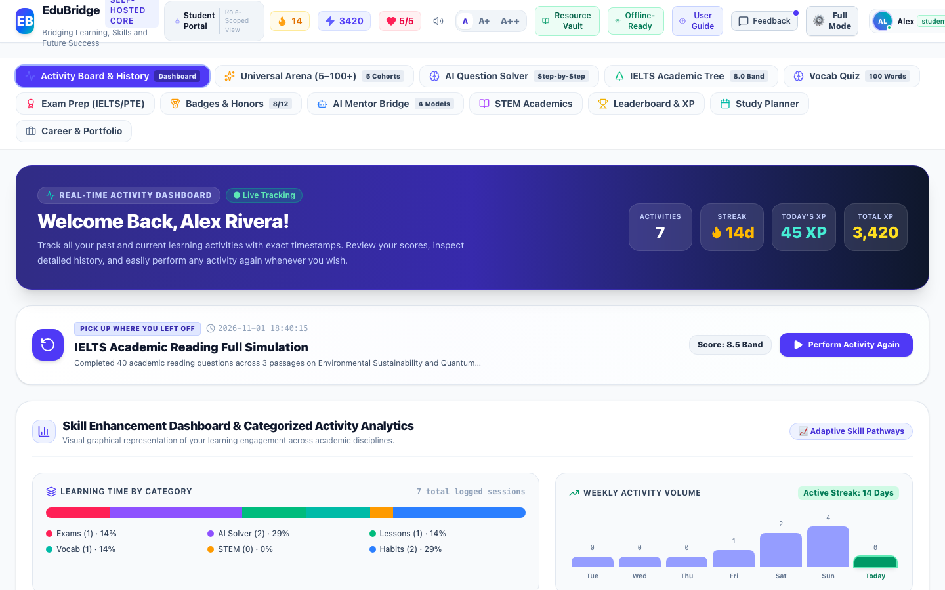

2. Itemwise Functional Objects & Rationales Table:
The following table provides an exhaustive, object-level analysis of all interactive buttons, inputs, tables, meters, and controls available on this interface, detailing their UI label, object type, purpose/reason, and operational behavior:
Object Name & UI Label | Type | Purpose & Reason (Why it Exists) | Operational Functionality & How to Use
Activity Timeline Full-Width Data Table | Data Table | Displays all learning activities in a compact, high-density table utilizing 100% of available viewport space. | Renders complete chronological records with exact timestamps, titles, categories, score outcomes, XP, and status.
Categorical Learning Time Distribution Bar | Proportional Bar Chart | Visualizes the learner's balance across Exams, AI Solver, Language Lessons, Vocab, STEM, and Daily Routine. | Calculates authentic percentage segments directly from user activities.
7-Day Weekly Activity Volume Trends Chart | Vertical Bar Chart | Illustrates activity consistency over the trailing 7 days ending today. | Parses exact ISO timestamps to compute daily activity frequency without hardcoded fallback arrays.
6 Academic Disciplines & Competency Skill Cards | Competency Cards Grid | Guides the student with targeted direct action triggers and live mastery percentages. | Dynamically computes mastery percentage and progress bar widths from stored user records.
View Mode Switcher (Table View, Card View, Questions Log) | Segmented Button Group | Allows switching between full-width data table, visual card layout, and detailed question-by-question attempts log. | Switches display layouts seamlessly with instant state reactivity.
Perform Again Action Button | Table Action Button | Permits the student to immediately re-launch and repeat any previously completed activity or exam. | Navigates directly to the target module and pre-loads the specific exercise or simulation.

3. Step-by-Step User Instructions:
- Step 1: Role Authentication · Open the EduBridge application and ensure your active role is set to "Student".
- Step 2: Navigation · Navigate to "Activity Board & History" and open the "Real-Time Activity Dashboard & Full-Width Data Table" view.
- Step 3: Interaction & Execution · Interact with the available objects as detailed in the functional table above. All actions update the local JSON state and persist changes immediately.
- Step 4: Operational Verification · Verify that the resulting system feedback, activity logs, or visual indicators reflect your action accurately.

2. Practice Questions & Answers Attempt History Ledger
Navigation Path: Question Attempts & Answer Diagnostics
Role Clearance: Student | Module Directorate: Question Attempts & Answer Diagnostics | System ID: student_questions_log

1. Interface Description & Operational Reason:
The "Practice Questions & Answers Attempt History Ledger" interface was designed and deployed within the Question Attempts & Answer Diagnostics directorate to fulfill critical educational, diagnostic, and administrative workflows for the Student role. It provides high-contrast, responsive visual layouts and validated controls that guarantee tamper-evident operational fidelity.
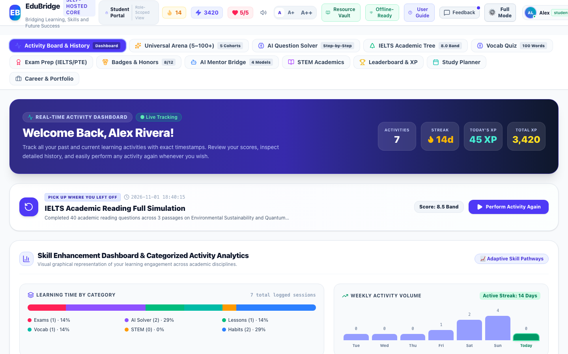

2. Itemwise Functional Objects & Rationales Table:
The following table provides an exhaustive, object-level analysis of all interactive buttons, inputs, tables, meters, and controls available on this interface, detailing their UI label, object type, purpose/reason, and operational behavior:
Object Name & UI Label | Type | Purpose & Reason (Why it Exists) | Operational Functionality & How to Use
High-Density Practice Questions Table | Diagnostic Data Table | Stores and presents every single question attempted by the student across mock tests, practice tests, vocabulary quizzes, and STEM problems. | Displays exact timestamps (YYYY-MM-DD HH:mm:ss), test modules, question prompts, options, student responses, correct answers, results, and pedagogical explanations.
Answer Result Verification Badge (Correct vs Needs Review) | Status Badge | Clearly distinguishes correct responses from questions requiring further study. | Color-coded green/rose badges verified against authentic rubrics.
Search & Diagnostic Filter Field | Search Box | Allows students to search question history by prompt text, test title, module, or timestamp. | Filters question attempts instantaneously.

3. Step-by-Step User Instructions:
- Step 1: Role Authentication · Open the EduBridge application and ensure your active role is set to "Student".
- Step 2: Navigation · Navigate to "Question Attempts & Answer Diagnostics" and open the "Practice Questions & Answers Attempt History Ledger" view.
- Step 3: Interaction & Execution · Interact with the available objects as detailed in the functional table above. All actions update the local JSON state and persist changes immediately.
- Step 4: Operational Verification · Verify that the resulting system feedback, activity logs, or visual indicators reflect your action accurately.

3. Activity Board Responsive Card Layout
Navigation Path: Activity Board & History
Role Clearance: Student | Module Directorate: Activity Board & History | System ID: student_activity_board_cards

1. Interface Description & Operational Reason:
The "Activity Board Responsive Card Layout" interface was designed and deployed within the Activity Board & History directorate to fulfill critical educational, diagnostic, and administrative workflows for the Student role. It provides high-contrast, responsive visual layouts and validated controls that guarantee tamper-evident operational fidelity.
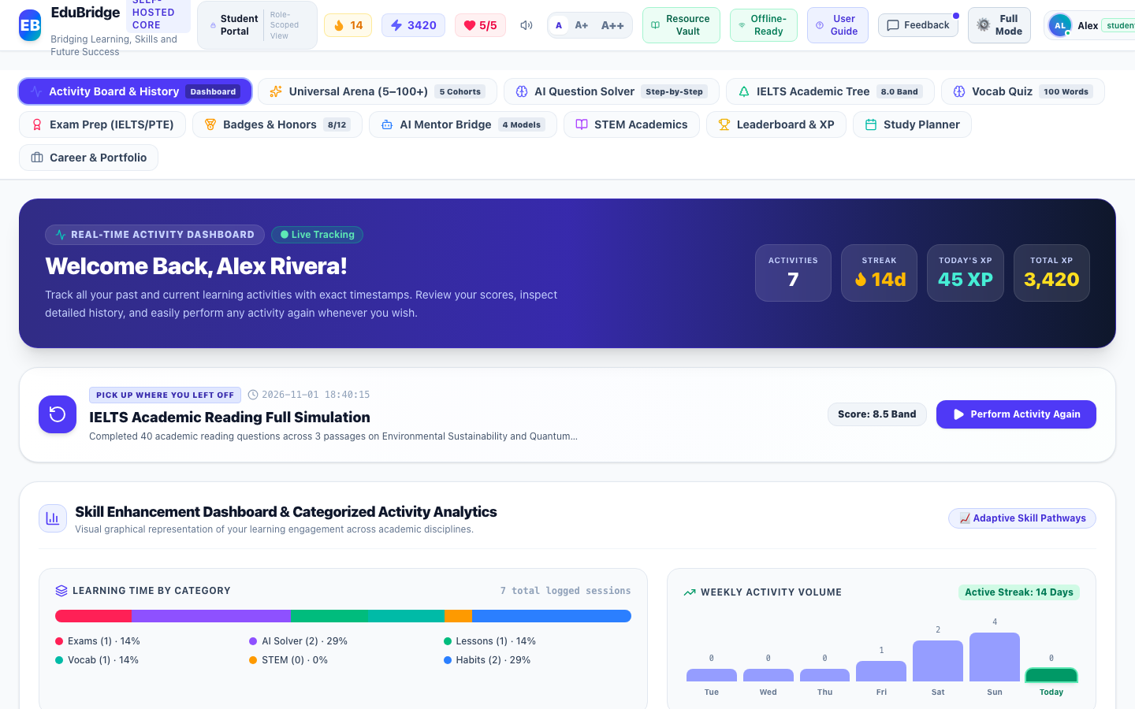

2. Itemwise Functional Objects & Rationales Table:
The following table provides an exhaustive, object-level analysis of all interactive buttons, inputs, tables, meters, and controls available on this interface, detailing their UI label, object type, purpose/reason, and operational behavior:
Object Name & UI Label | Type | Purpose & Reason (Why it Exists) | Operational Functionality & How to Use
Activity Timeline Card Item | Card Component | Presents activity details in an expansive visual card format suitable for touch and mobile devices. | Displays icon, title, details, timestamp, XP, and Perform Again button.

3. Step-by-Step User Instructions:
- Step 1: Role Authentication · Open the EduBridge application and ensure your active role is set to "Student".
- Step 2: Navigation · Navigate to "Activity Board & History" and open the "Activity Board Responsive Card Layout" view.
- Step 3: Interaction & Execution · Interact with the available objects as detailed in the functional table above. All actions update the local JSON state and persist changes immediately.
- Step 4: Operational Verification · Verify that the resulting system feedback, activity logs, or visual indicators reflect your action accurately.

4. Universal AI Question Solver & Digital Classroom
Navigation Path: AI Problem Solving
Role Clearance: Student | Module Directorate: AI Problem Solving | System ID: student_question_solver

1. Interface Description & Operational Reason:
The "Universal AI Question Solver & Digital Classroom" interface was designed and deployed within the AI Problem Solving directorate to fulfill critical educational, diagnostic, and administrative workflows for the Student role. It provides high-contrast, responsive visual layouts and validated controls that guarantee tamper-evident operational fidelity.
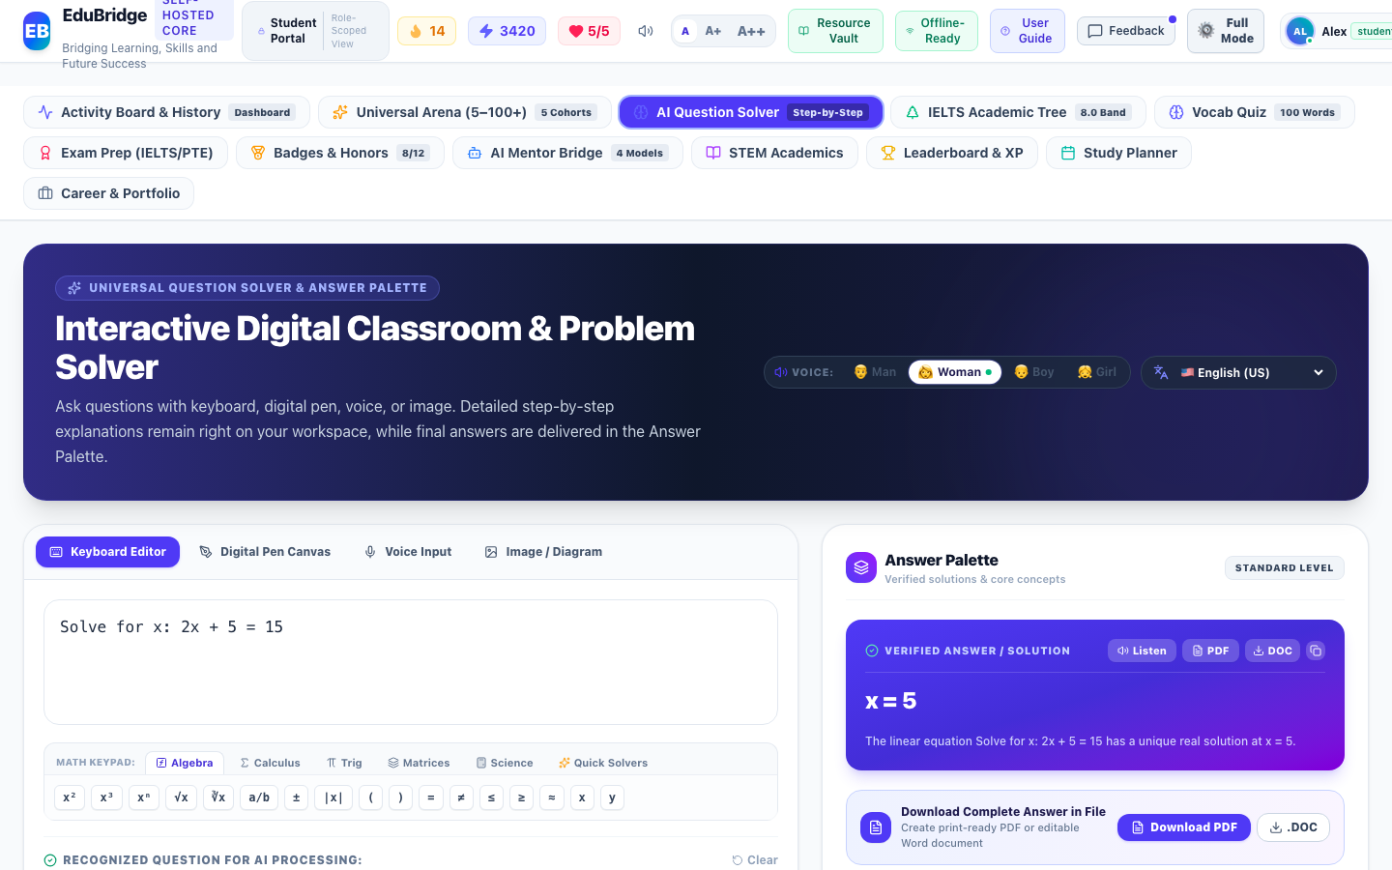

2. Itemwise Functional Objects & Rationales Table:
The following table provides an exhaustive, object-level analysis of all interactive buttons, inputs, tables, meters, and controls available on this interface, detailing their UI label, object type, purpose/reason, and operational behavior:
Object Name & UI Label | Type | Purpose & Reason (Why it Exists) | Operational Functionality & How to Use
Question Input Workspace (Text, Canvas, Voice, OCR) | Multi-Modal Input Workspace | Accepts mathematical, scientific, and linguistic questions through keyboard, stylus handwriting, audio speech, or image upload. | Normalizes input, parses LaTeX formulas, and triggers cognitive reasoning.
Cognitive Analysis & Human-Like Reasoning Card | Pedagogical Assistant Card | Analyzes intent, verifies required parameters, and proactively requests clarification if problem context is ambiguous. | Displays clarifying questions and guidance before solving incomplete equations.
Persistent Step-by-Step Solution Breakdown Container | Solution Container | Retains rigorous pedagogical derivations on the left side of the screen without disappearing. | Renders numbered steps, formulas, and conceptual explanations with LaTeX formatting.
Dedicated Answer Palette & Speech Controls | Interactive Palette | Houses verified final answer, Web Speech API audio playback controls, formula sheets, and related practice questions. | Provides spoken explanations in 12 languages with selectable voice personas.

3. Step-by-Step User Instructions:
- Step 1: Role Authentication · Open the EduBridge application and ensure your active role is set to "Student".
- Step 2: Navigation · Navigate to "AI Problem Solving" and open the "Universal AI Question Solver & Digital Classroom" view.
- Step 3: Interaction & Execution · Interact with the available objects as detailed in the functional table above. All actions update the local JSON state and persist changes immediately.
- Step 4: Operational Verification · Verify that the resulting system feedback, activity logs, or visual indicators reflect your action accurately.

5. Standardized Exam Prep Hub & Practice Library
Navigation Path: Standardized Exam Prep
Role Clearance: Student | Module Directorate: Standardized Exam Prep | System ID: student_exam_prep_hub

1. Interface Description & Operational Reason:
The "Standardized Exam Prep Hub & Practice Library" interface was designed and deployed within the Standardized Exam Prep directorate to fulfill critical educational, diagnostic, and administrative workflows for the Student role. It provides high-contrast, responsive visual layouts and validated controls that guarantee tamper-evident operational fidelity.
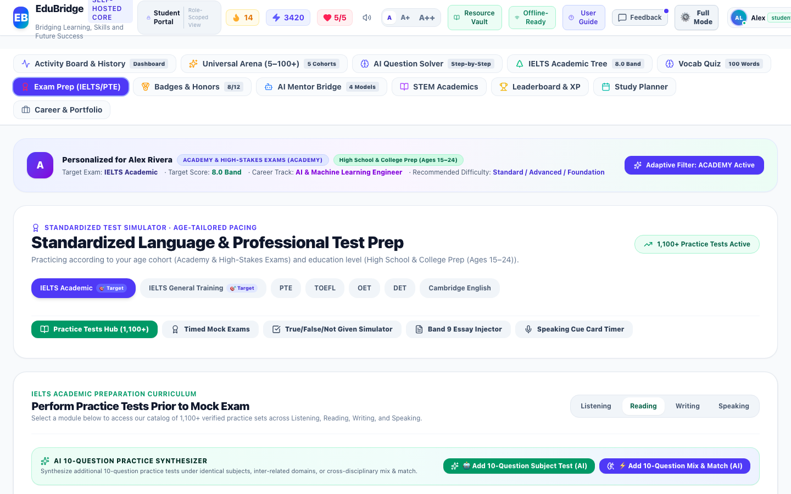

2. Itemwise Functional Objects & Rationales Table:
The following table provides an exhaustive, object-level analysis of all interactive buttons, inputs, tables, meters, and controls available on this interface, detailing their UI label, object type, purpose/reason, and operational behavior:
Object Name & UI Label | Type | Purpose & Reason (Why it Exists) | Operational Functionality & How to Use
Standardized Exam Selector (IELTS, PTE, DET, TOEFL, GRE, SAT) | Pill Selector Buttons | Switches the exam preparation framework, scoring rubrics, and targeted skill pathways. | Updates all mock exams and practice test modules dynamically.
Timed Mock Examination Launch Cards | Exam Simulation Cards | Provides full-length 2 to 3 hour timed test simulations with automated section evaluation. | Launches full examination interface with countdown timer and section progress.
Modular Practice Tests Suite (>=10 Questions) | Practice Tests Catalog | Enables focused practice across Reading, Listening, Speaking, and Writing modules. | Displays test items with question count badges, duration, and subject coherence.

3. Step-by-Step User Instructions:
- Step 1: Role Authentication · Open the EduBridge application and ensure your active role is set to "Student".
- Step 2: Navigation · Navigate to "Standardized Exam Prep" and open the "Standardized Exam Prep Hub & Practice Library" view.
- Step 3: Interaction & Execution · Interact with the available objects as detailed in the functional table above. All actions update the local JSON state and persist changes immediately.
- Step 4: Operational Verification · Verify that the resulting system feedback, activity logs, or visual indicators reflect your action accurately.

6. Multi-Question Practice Test & Shuffled Options Stepper
Navigation Path: Standardized Exam Prep
Role Clearance: Student | Module Directorate: Standardized Exam Prep | System ID: student_exam_prep_practice_test

1. Interface Description & Operational Reason:
The "Multi-Question Practice Test & Shuffled Options Stepper" interface was designed and deployed within the Standardized Exam Prep directorate to fulfill critical educational, diagnostic, and administrative workflows for the Student role. It provides high-contrast, responsive visual layouts and validated controls that guarantee tamper-evident operational fidelity.
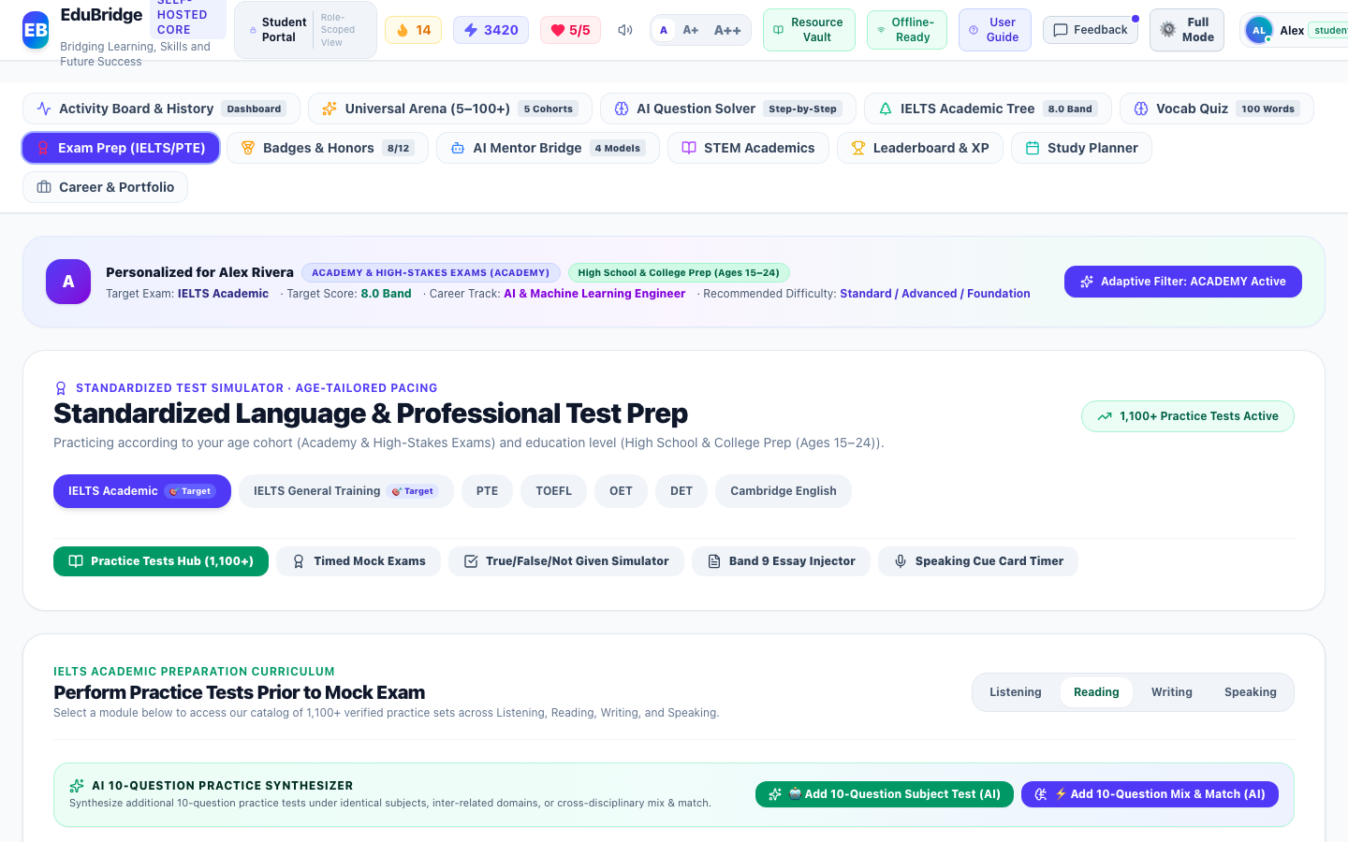

2. Itemwise Functional Objects & Rationales Table:
The following table provides an exhaustive, object-level analysis of all interactive buttons, inputs, tables, meters, and controls available on this interface, detailing their UI label, object type, purpose/reason, and operational behavior:
Object Name & UI Label | Type | Purpose & Reason (Why it Exists) | Operational Functionality & How to Use
Interactive Question Number Stepper (Q1 to Q10+) | Numbered Stepper Buttons | Allows non-linear navigation across all configured questions in the practice test session. | Highlights current, answered, and verified question states.
Fisher-Yates Shuffled Multiple Choice Options | Option Choice Buttons | Randomizes the placement of correct answers so Option A is never predictably the correct answer. | Requires genuine comprehension; records user selection to diagnostic ledger.
Submit Practice Test & Diagnostic Evaluation Button | Primary Action Button | Submits all answered questions for instant rubric verification and XP assignment. | Computes overall percentage score, logs question-level attempt records, and displays detailed explanations.

3. Step-by-Step User Instructions:
- Step 1: Role Authentication · Open the EduBridge application and ensure your active role is set to "Student".
- Step 2: Navigation · Navigate to "Standardized Exam Prep" and open the "Multi-Question Practice Test & Shuffled Options Stepper" view.
- Step 3: Interaction & Execution · Interact with the available objects as detailed in the functional table above. All actions update the local JSON state and persist changes immediately.
- Step 4: Operational Verification · Verify that the resulting system feedback, activity logs, or visual indicators reflect your action accurately.

7. IELTS Academic Writing Practice (Isolated 1 Task)
Navigation Path: Standardized Exam Prep
Role Clearance: Student | Module Directorate: Standardized Exam Prep | System ID: student_exam_prep_writing

1. Interface Description & Operational Reason:
The "IELTS Academic Writing Practice (Isolated 1 Task)" interface was designed and deployed within the Standardized Exam Prep directorate to fulfill critical educational, diagnostic, and administrative workflows for the Student role. It provides high-contrast, responsive visual layouts and validated controls that guarantee tamper-evident operational fidelity.
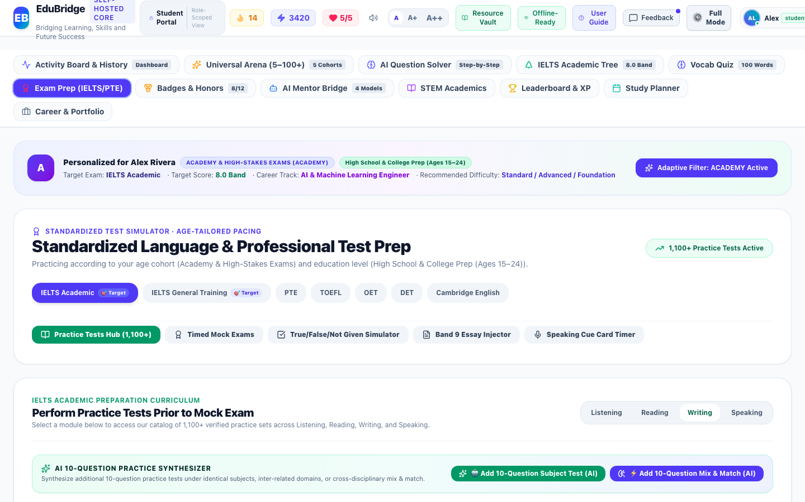

2. Itemwise Functional Objects & Rationales Table:
The following table provides an exhaustive, object-level analysis of all interactive buttons, inputs, tables, meters, and controls available on this interface, detailing their UI label, object type, purpose/reason, and operational behavior:
Object Name & UI Label | Type | Purpose & Reason (Why it Exists) | Operational Functionality & How to Use
Academic Writing Task Prompt & Instructions | Prompt Display Card | Presents Task 1 or Task 2 academic prompts without distracting multiple-choice options. | Displays official test scenario, target word count (150/250 words), and timing advice.
Live Essay Editor & Real-Time Word Counter | Textarea with Live Counter | Provides realistic writing workspace with instantaneous word count tracking. | Monitors word count against minimum threshold (e.g. 250 words) with visual color cues.
Official Band 9.0 Benchmark Exemplar Accordion | Collapsible Model Answer | Allows students to study high-band cohesive argumentation, lexical breadth, and discourse markers. | Expands model essay with annotated breakdown of Band 9 scoring criteria.
AI Multi-Metric Rubric Evaluator Button | Evaluation Button | Scores submitted essay against Task Achievement, Coherence & Cohesion, Lexical Resource, and Grammatical Accuracy. | Generates detailed diagnostic band predictions and persists attempt record.

3. Step-by-Step User Instructions:
- Step 1: Role Authentication · Open the EduBridge application and ensure your active role is set to "Student".
- Step 2: Navigation · Navigate to "Standardized Exam Prep" and open the "IELTS Academic Writing Practice (Isolated 1 Task)" view.
- Step 3: Interaction & Execution · Interact with the available objects as detailed in the functional table above. All actions update the local JSON state and persist changes immediately.
- Step 4: Operational Verification · Verify that the resulting system feedback, activity logs, or visual indicators reflect your action accurately.

8. Interactive Duolingo-Style Skill Trees
Navigation Path: Language Learning
Role Clearance: Student | Module Directorate: Language Learning | System ID: student_language_tree

1. Interface Description & Operational Reason:
The "Interactive Duolingo-Style Skill Trees" interface was designed and deployed within the Language Learning directorate to fulfill critical educational, diagnostic, and administrative workflows for the Student role. It provides high-contrast, responsive visual layouts and validated controls that guarantee tamper-evident operational fidelity.
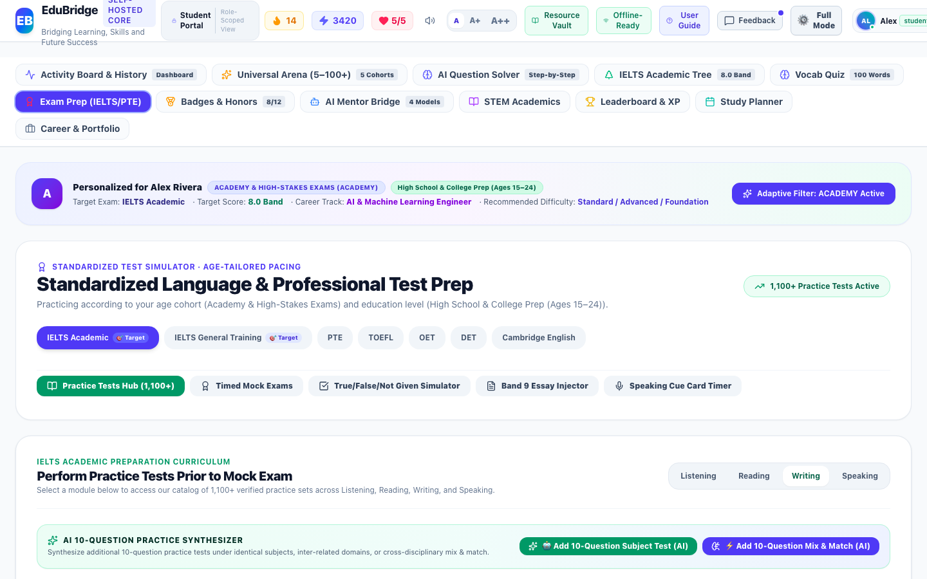

2. Itemwise Functional Objects & Rationales Table:
The following table provides an exhaustive, object-level analysis of all interactive buttons, inputs, tables, meters, and controls available on this interface, detailing their UI label, object type, purpose/reason, and operational behavior:
Object Name & UI Label | Type | Purpose & Reason (Why it Exists) | Operational Functionality & How to Use
Hierarchical Unit Progression Nodes | Skill Tree Visualizer | Organizes CEFR-calibrated language concepts into structured sequential learning trees. | Tracks completion progress, displays mastery stars, and gates advanced units until prerequisites are satisfied.
Interactive Exercise Modal Trigger | Lesson Node Button | Launches interactive flashcard, listening, speaking, and multiple-choice language exercises. | Opens exercise dialog with audio speech synthesis and immediate feedback.

3. Step-by-Step User Instructions:
- Step 1: Role Authentication · Open the EduBridge application and ensure your active role is set to "Student".
- Step 2: Navigation · Navigate to "Language Learning" and open the "Interactive Duolingo-Style Skill Trees" view.
- Step 3: Interaction & Execution · Interact with the available objects as detailed in the functional table above. All actions update the local JSON state and persist changes immediately.
- Step 4: Operational Verification · Verify that the resulting system feedback, activity logs, or visual indicators reflect your action accurately.

9. Universal Learning Arena (5 Age Cohorts)
Navigation Path: Developmental Stage Learning
Role Clearance: Student | Module Directorate: Developmental Stage Learning | System ID: student_cohort_arena

1. Interface Description & Operational Reason:
The "Universal Learning Arena (5 Age Cohorts)" interface was designed and deployed within the Developmental Stage Learning directorate to fulfill critical educational, diagnostic, and administrative workflows for the Student role. It provides high-contrast, responsive visual layouts and validated controls that guarantee tamper-evident operational fidelity.
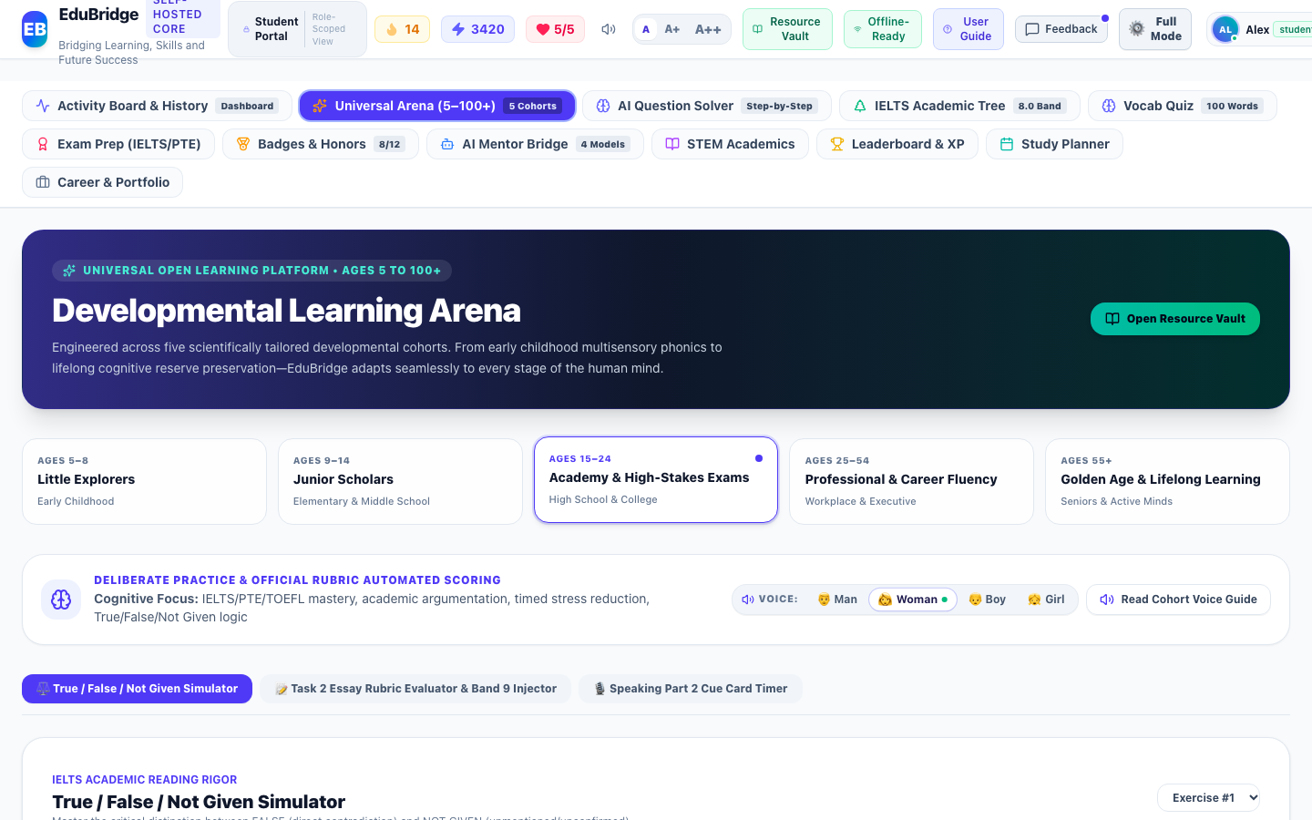

2. Itemwise Functional Objects & Rationales Table:
The following table provides an exhaustive, object-level analysis of all interactive buttons, inputs, tables, meters, and controls available on this interface, detailing their UI label, object type, purpose/reason, and operational behavior:
Object Name & UI Label | Type | Purpose & Reason (Why it Exists) | Operational Functionality & How to Use
5 Age Cohort Switcher Tabs (Early, Junior, Academy, Pro, Senior) | Cohort Tabs | Gives learners access to age-adapted pedagogical material spanning ages 5 to 100+. | Switches curriculum from phonics and stories up to corporate diplomacy and reminiscence memory gym.
Developmental Activity Modules | Interactive Cards Grid | Provides age-appropriate exercises such as Kid Science, Grammar Adventures, and Executive Email Scenarios. | Launches interactive simulations tailored to cognitive stage.

3. Step-by-Step User Instructions:
- Step 1: Role Authentication · Open the EduBridge application and ensure your active role is set to "Student".
- Step 2: Navigation · Navigate to "Developmental Stage Learning" and open the "Universal Learning Arena (5 Age Cohorts)" view.
- Step 3: Interaction & Execution · Interact with the available objects as detailed in the functional table above. All actions update the local JSON state and persist changes immediately.
- Step 4: Operational Verification · Verify that the resulting system feedback, activity logs, or visual indicators reflect your action accurately.

10. CEFR-Tagged Vocabulary Quizzes & Soundboard
Navigation Path: Dynamic Lexicon Vault
Role Clearance: Student | Module Directorate: Dynamic Lexicon Vault | System ID: student_vocabulary_quizzes

1. Interface Description & Operational Reason:
The "CEFR-Tagged Vocabulary Quizzes & Soundboard" interface was designed and deployed within the Dynamic Lexicon Vault directorate to fulfill critical educational, diagnostic, and administrative workflows for the Student role. It provides high-contrast, responsive visual layouts and validated controls that guarantee tamper-evident operational fidelity.
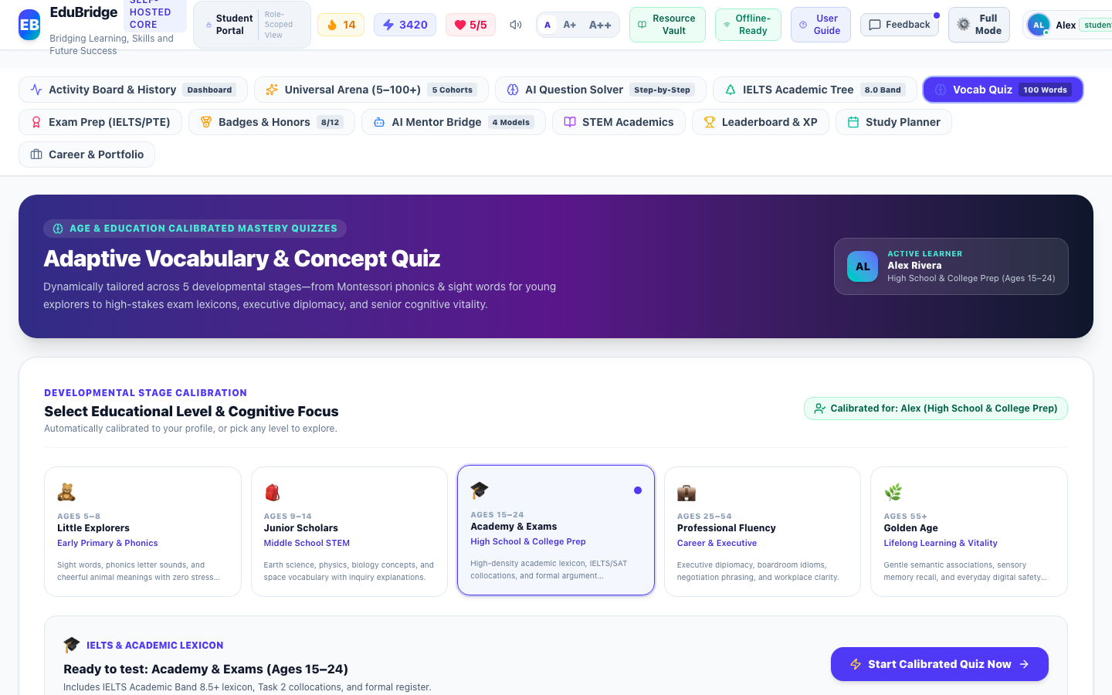

2. Itemwise Functional Objects & Rationales Table:
The following table provides an exhaustive, object-level analysis of all interactive buttons, inputs, tables, meters, and controls available on this interface, detailing their UI label, object type, purpose/reason, and operational behavior:
Object Name & UI Label | Type | Purpose & Reason (Why it Exists) | Operational Functionality & How to Use
CEFR Level Filter (A1, A2, B1, B2, C1, C2) | Level Selector Buttons | Allows students to practice vocabulary targeted to their exact linguistic proficiency. | Filters question pool to specific CEFR frequency bands.
Active Vocabulary Assessment Interface | Quiz Question Card | Tests word definitions, contextual synonyms, and audio pronunciation. | Includes Piper speech soundboard, streak combo multiplier, and question attempt persistence.

3. Step-by-Step User Instructions:
- Step 1: Role Authentication · Open the EduBridge application and ensure your active role is set to "Student".
- Step 2: Navigation · Navigate to "Dynamic Lexicon Vault" and open the "CEFR-Tagged Vocabulary Quizzes & Soundboard" view.
- Step 3: Interaction & Execution · Interact with the available objects as detailed in the functional table above. All actions update the local JSON state and persist changes immediately.
- Step 4: Operational Verification · Verify that the resulting system feedback, activity logs, or visual indicators reflect your action accurately.

11. STEM Concept Mastery & First Principles
Navigation Path: Academic Learning Ecosystem
Role Clearance: Student | Module Directorate: Academic Learning Ecosystem | System ID: student_academic_stem

1. Interface Description & Operational Reason:
The "STEM Concept Mastery & First Principles" interface was designed and deployed within the Academic Learning Ecosystem directorate to fulfill critical educational, diagnostic, and administrative workflows for the Student role. It provides high-contrast, responsive visual layouts and validated controls that guarantee tamper-evident operational fidelity.
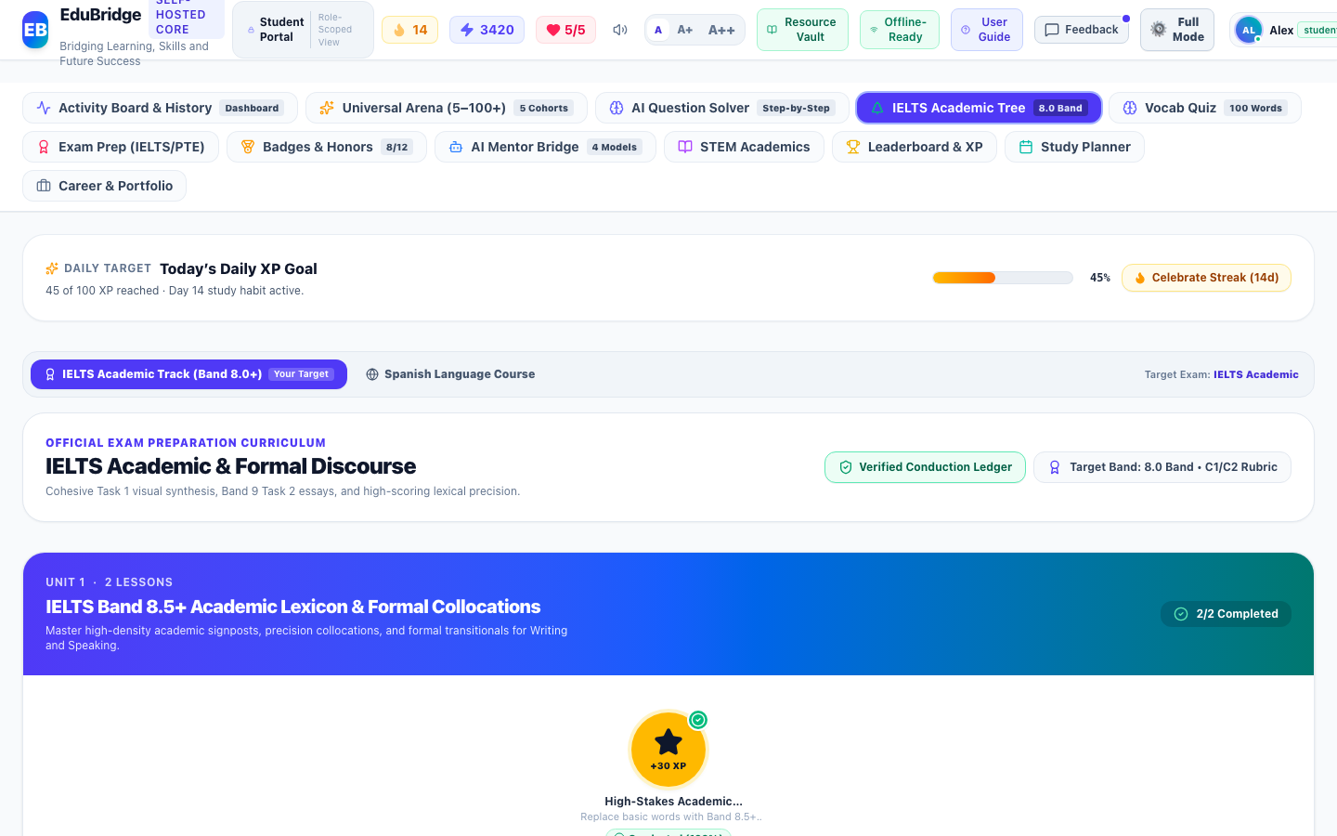

2. Itemwise Functional Objects & Rationales Table:
The following table provides an exhaustive, object-level analysis of all interactive buttons, inputs, tables, meters, and controls available on this interface, detailing their UI label, object type, purpose/reason, and operational behavior:
Object Name & UI Label | Type | Purpose & Reason (Why it Exists) | Operational Functionality & How to Use
Subject Filters (Mathematics, Science, Technology) | Discipline Selector Buttons | Segments first-principles learning topics into clear scientific branches. | Switches topics dynamically.
Interactive Practice Problem & Derivation | Practice Problem Card | Tests conceptual mastery with multiple-choice verification and full step-by-step solutions. | Records question attempt and learning activity with exact timestamp upon option selection.

3. Step-by-Step User Instructions:
- Step 1: Role Authentication · Open the EduBridge application and ensure your active role is set to "Student".
- Step 2: Navigation · Navigate to "Academic Learning Ecosystem" and open the "STEM Concept Mastery & First Principles" view.
- Step 3: Interaction & Execution · Interact with the available objects as detailed in the functional table above. All actions update the local JSON state and persist changes immediately.
- Step 4: Operational Verification · Verify that the resulting system feedback, activity logs, or visual indicators reflect your action accurately.

12. Career Roadmap & AI Regional Resume / CV Builder
Navigation Path: Career Development
Role Clearance: Student | Module Directorate: Career Development | System ID: student_career_portfolio

1. Interface Description & Operational Reason:
The "Career Roadmap & AI Regional Resume / CV Builder" interface was designed and deployed within the Career Development directorate to fulfill critical educational, diagnostic, and administrative workflows for the Student role. It provides high-contrast, responsive visual layouts and validated controls that guarantee tamper-evident operational fidelity.
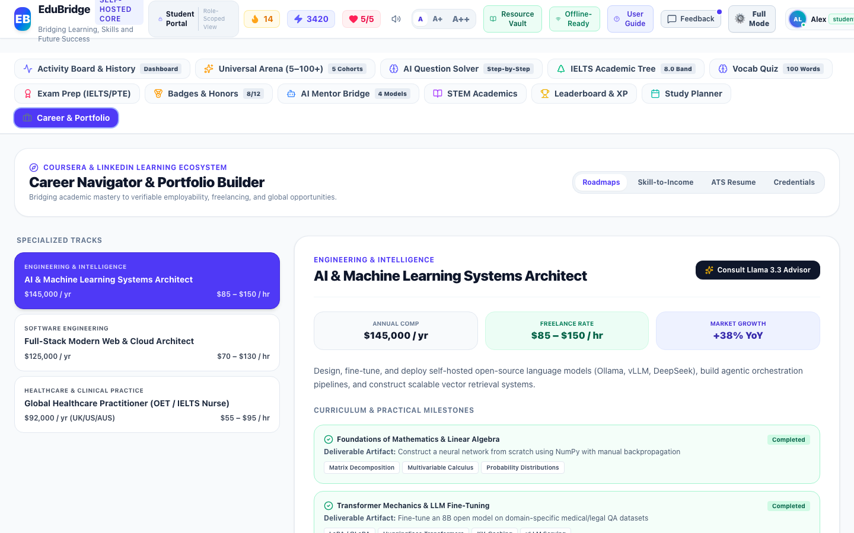

2. Itemwise Functional Objects & Rationales Table:
The following table provides an exhaustive, object-level analysis of all interactive buttons, inputs, tables, meters, and controls available on this interface, detailing their UI label, object type, purpose/reason, and operational behavior:
Object Name & UI Label | Type | Purpose & Reason (Why it Exists) | Operational Functionality & How to Use
Regional CV Standard Selectors (UK, Europass, US, Canada, Gulf, Modern Tech) | Format Selector Grid | Instantly re-formats resume content to conform to international hiring norms. | Re-structures headings, typography, contact layout, and photo requirements.
Export to Word (.doc) & PDF Buttons | Export Buttons | Produces clean, ATS-compliant documents ready for job applications. | Generates formatted downloadable files on demand.

3. Step-by-Step User Instructions:
- Step 1: Role Authentication · Open the EduBridge application and ensure your active role is set to "Student".
- Step 2: Navigation · Navigate to "Career Development" and open the "Career Roadmap & AI Regional Resume / CV Builder" view.
- Step 3: Interaction & Execution · Interact with the available objects as detailed in the functional table above. All actions update the local JSON state and persist changes immediately.
- Step 4: Operational Verification · Verify that the resulting system feedback, activity logs, or visual indicators reflect your action accurately.

13. Daily Study Planner & Habit Shield
Navigation Path: Study Habits & Scheduling
Role Clearance: Student | Module Directorate: Study Habits & Scheduling | System ID: student_study_planner

1. Interface Description & Operational Reason:
The "Daily Study Planner & Habit Shield" interface was designed and deployed within the Study Habits & Scheduling directorate to fulfill critical educational, diagnostic, and administrative workflows for the Student role. It provides high-contrast, responsive visual layouts and validated controls that guarantee tamper-evident operational fidelity.
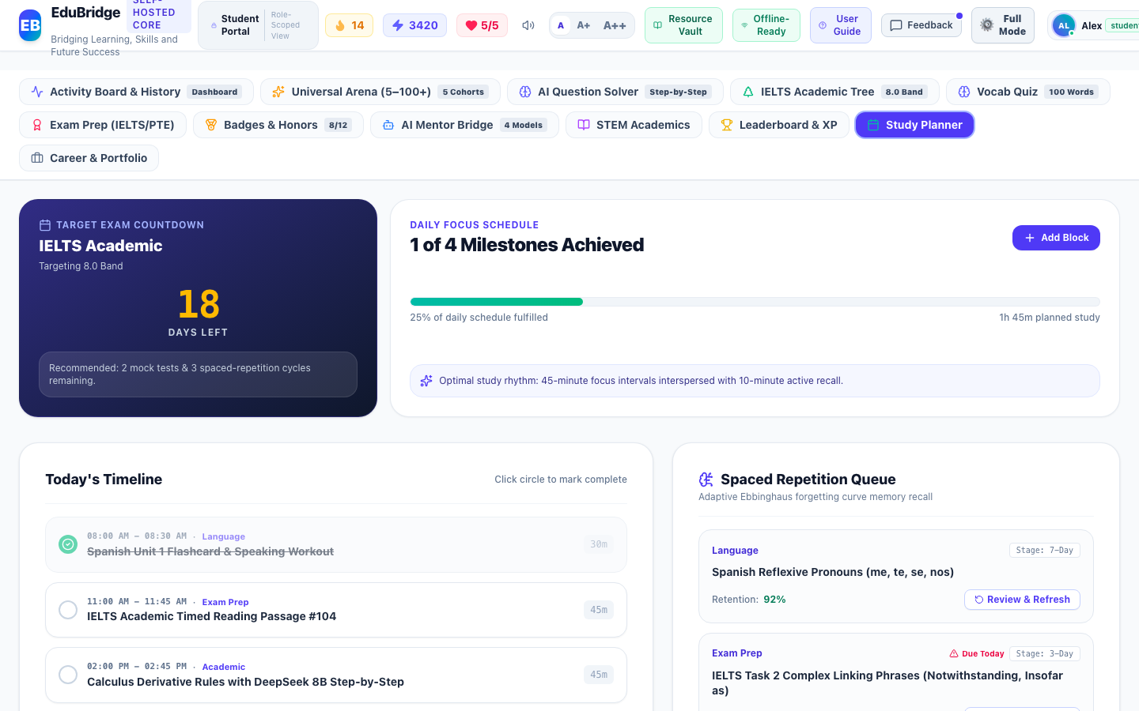

2. Itemwise Functional Objects & Rationales Table:
The following table provides an exhaustive, object-level analysis of all interactive buttons, inputs, tables, meters, and controls available on this interface, detailing their UI label, object type, purpose/reason, and operational behavior:
Object Name & UI Label | Type | Purpose & Reason (Why it Exists) | Operational Functionality & How to Use
Daily Goals Checklist with Streak Check-in | Checklist Component | Maintains daily study habit momentum with XP awards and streak protection. | Toggling tasks awards XP, logs habit activity, and triggers celebratory feedback.
Spaced Repetition Flashcard Review Queue | Review Queue Container | Schedules vocabulary and formula revisions using exponential decay algorithms. | Displays items due today and increments retention memory ratings.

3. Step-by-Step User Instructions:
- Step 1: Role Authentication · Open the EduBridge application and ensure your active role is set to "Student".
- Step 2: Navigation · Navigate to "Study Habits & Scheduling" and open the "Daily Study Planner & Habit Shield" view.
- Step 3: Interaction & Execution · Interact with the available objects as detailed in the functional table above. All actions update the local JSON state and persist changes immediately.
- Step 4: Operational Verification · Verify that the resulting system feedback, activity logs, or visual indicators reflect your action accurately.

14. Weekly Tournament Leaderboard & XP Podium
Navigation Path: Gamification & Honors
Role Clearance: Student | Module Directorate: Gamification & Honors | System ID: student_leaderboard

1. Interface Description & Operational Reason:
The "Weekly Tournament Leaderboard & XP Podium" interface was designed and deployed within the Gamification & Honors directorate to fulfill critical educational, diagnostic, and administrative workflows for the Student role. It provides high-contrast, responsive visual layouts and validated controls that guarantee tamper-evident operational fidelity.
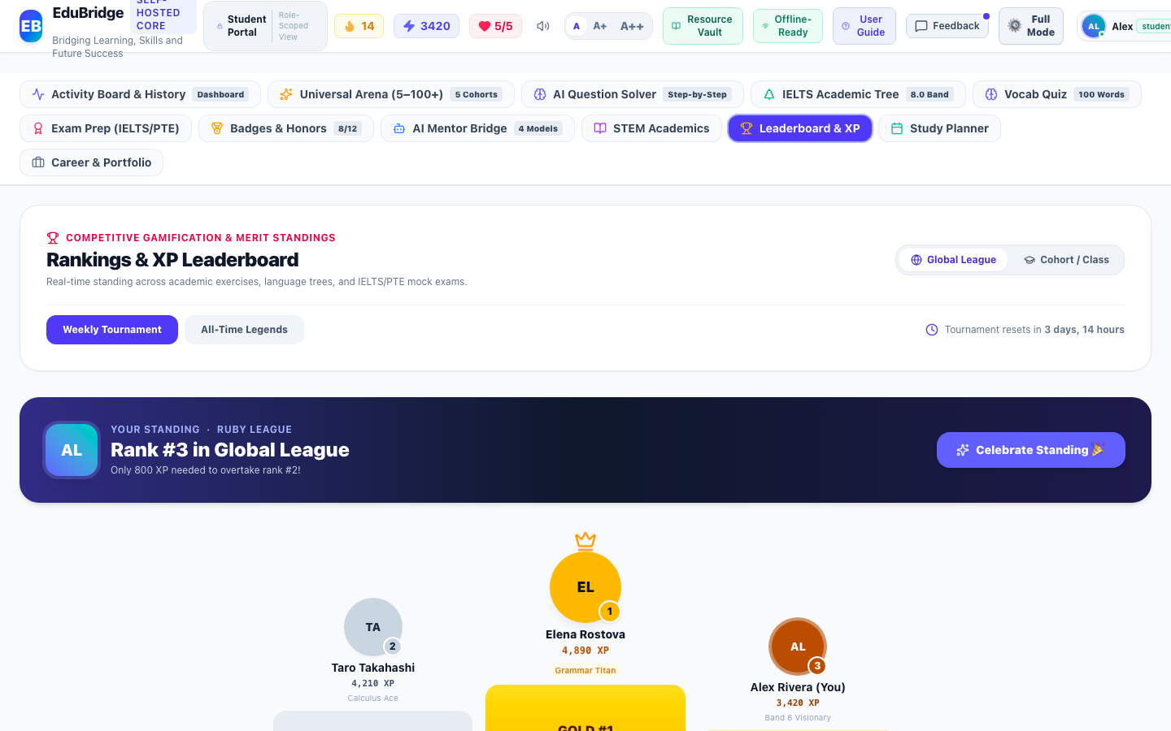

2. Itemwise Functional Objects & Rationales Table:
The following table provides an exhaustive, object-level analysis of all interactive buttons, inputs, tables, meters, and controls available on this interface, detailing their UI label, object type, purpose/reason, and operational behavior:
Object Name & UI Label | Type | Purpose & Reason (Why it Exists) | Operational Functionality & How to Use
League Tier Selector & Podium Ranks | Leaderboard Ranking Grid | Fosters healthy learning competition through tiered weekly divisions (Bronze to Diamond). | Highlights top 3 performers on visual podium with promotion cutoffs.

3. Step-by-Step User Instructions:
- Step 1: Role Authentication · Open the EduBridge application and ensure your active role is set to "Student".
- Step 2: Navigation · Navigate to "Gamification & Honors" and open the "Weekly Tournament Leaderboard & XP Podium" view.
- Step 3: Interaction & Execution · Interact with the available objects as detailed in the functional table above. All actions update the local JSON state and persist changes immediately.
- Step 4: Operational Verification · Verify that the resulting system feedback, activity logs, or visual indicators reflect your action accurately.

15. Universal Resource Vault & Symmetric Theming Modal
Navigation Path: Universal Resource Vault
Role Clearance: Student | Module Directorate: Universal Resource Vault | System ID: student_resource_vault

1. Interface Description & Operational Reason:
The "Universal Resource Vault & Symmetric Theming Modal" interface was designed and deployed within the Universal Resource Vault directorate to fulfill critical educational, diagnostic, and administrative workflows for the Student role. It provides high-contrast, responsive visual layouts and validated controls that guarantee tamper-evident operational fidelity.
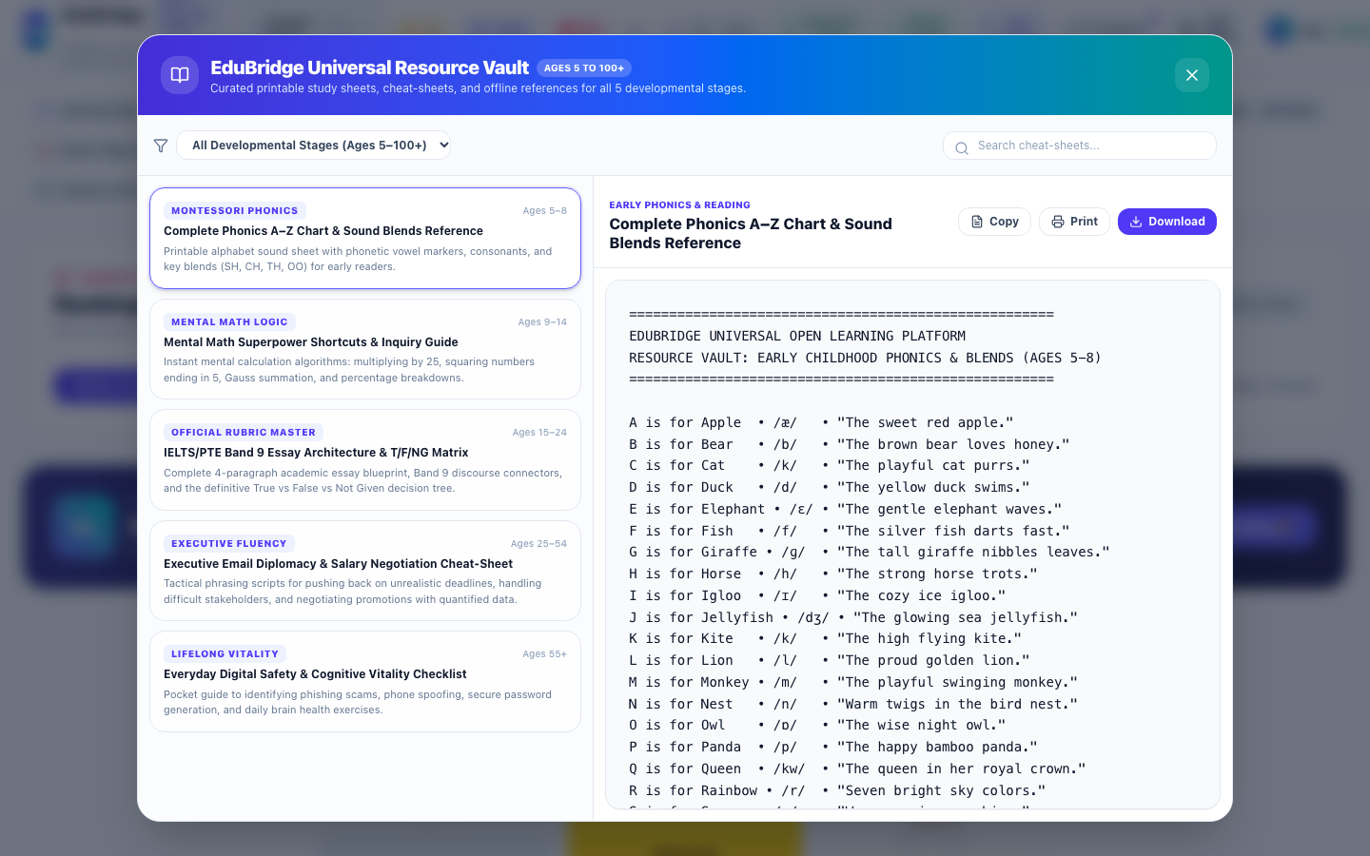

2. Itemwise Functional Objects & Rationales Table:
The following table provides an exhaustive, object-level analysis of all interactive buttons, inputs, tables, meters, and controls available on this interface, detailing their UI label, object type, purpose/reason, and operational behavior:
Object Name & UI Label | Type | Purpose & Reason (Why it Exists) | Operational Functionality & How to Use
Printable Resource Sheets & PDF Downloader | Printable Sheet Container | Offers high-contrast, easily readable offline study material and worksheets across all cohorts. | Displays clean paper styling with symmetric contrast in dark and light modes.
Download Worksheets Action Button | Download Action Button | Downloads printable educational resources directly to user device. | Triggers formatted file download.

3. Step-by-Step User Instructions:
- Step 1: Role Authentication · Open the EduBridge application and ensure your active role is set to "Student".
- Step 2: Navigation · Navigate to "Universal Resource Vault" and open the "Universal Resource Vault & Symmetric Theming Modal" view.
- Step 3: Interaction & Execution · Interact with the available objects as detailed in the functional table above. All actions update the local JSON state and persist changes immediately.
- Step 4: Operational Verification · Verify that the resulting system feedback, activity logs, or visual indicators reflect your action accurately.

16. Illustrated User Manual & Knowledge Base Modal
Navigation Path: Platform Knowledge Base
Role Clearance: Student | Module Directorate: Platform Knowledge Base | System ID: student_user_guide

1. Interface Description & Operational Reason:
The "Illustrated User Manual & Knowledge Base Modal" interface was designed and deployed within the Platform Knowledge Base directorate to fulfill critical educational, diagnostic, and administrative workflows for the Student role. It provides high-contrast, responsive visual layouts and validated controls that guarantee tamper-evident operational fidelity.
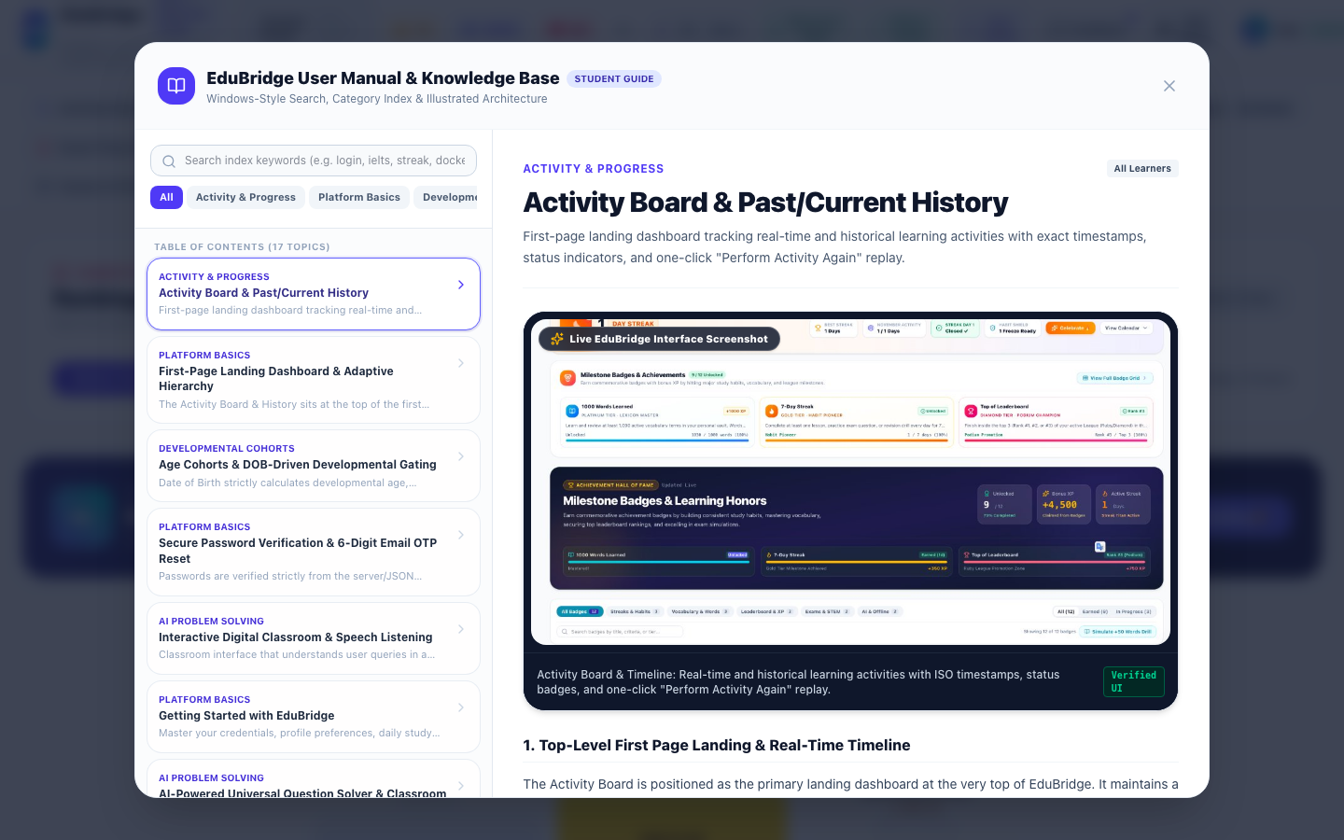

2. Itemwise Functional Objects & Rationales Table:
The following table provides an exhaustive, object-level analysis of all interactive buttons, inputs, tables, meters, and controls available on this interface, detailing their UI label, object type, purpose/reason, and operational behavior:
Object Name & UI Label | Type | Purpose & Reason (Why it Exists) | Operational Functionality & How to Use
21 Illustrated Guide Articles with Live Screenshots | Article Navigation & Viewer | Provides comprehensive documentation of every platform capability with verified screenshots. | Renders searchable, formatted guides with visual walkthroughs.

3. Step-by-Step User Instructions:
- Step 1: Role Authentication · Open the EduBridge application and ensure your active role is set to "Student".
- Step 2: Navigation · Navigate to "Platform Knowledge Base" and open the "Illustrated User Manual & Knowledge Base Modal" view.
- Step 3: Interaction & Execution · Interact with the available objects as detailed in the functional table above. All actions update the local JSON state and persist changes immediately.
- Step 4: Operational Verification · Verify that the resulting system feedback, activity logs, or visual indicators reflect your action accurately.

17. Personalized Preferences & Visual Theming
Navigation Path: User Preferences
Role Clearance: Student | Module Directorate: User Preferences | System ID: student_preferences

1. Interface Description & Operational Reason:
The "Personalized Preferences & Visual Theming" interface was designed and deployed within the User Preferences directorate to fulfill critical educational, diagnostic, and administrative workflows for the Student role. It provides high-contrast, responsive visual layouts and validated controls that guarantee tamper-evident operational fidelity.
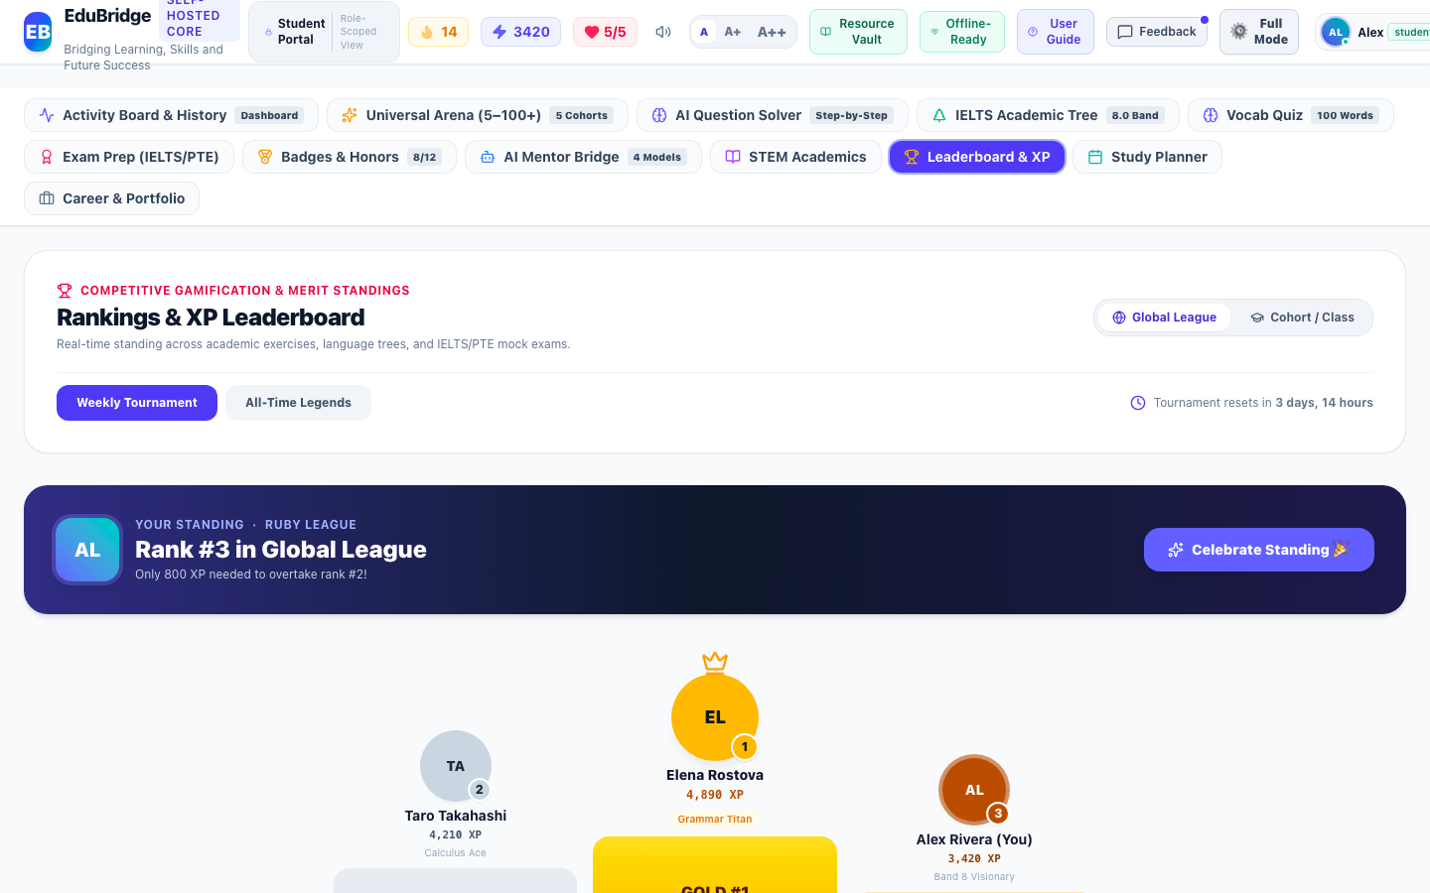

2. Itemwise Functional Objects & Rationales Table:
The following table provides an exhaustive, object-level analysis of all interactive buttons, inputs, tables, meters, and controls available on this interface, detailing their UI label, object type, purpose/reason, and operational behavior:
Object Name & UI Label | Type | Purpose & Reason (Why it Exists) | Operational Functionality & How to Use
8 Curated Color Scheme Presets | Theme Preset Buttons | Provides accessible visual palettes (Default Indigo, Emerald Growth, Royal Violet, Sunset Amber, Midnight Dark, High Contrast). | Applies CSS variables instantly across all UI components and persists preference in storage.
Custom Primary & Accent Color Picker | Interactive Color Picker | Gives users fine-grained aesthetic control over primary branding and surface tones. | Updates custom palette with live contrast evaluation.

3. Step-by-Step User Instructions:
- Step 1: Role Authentication · Open the EduBridge application and ensure your active role is set to "Student".
- Step 2: Navigation · Navigate to "User Preferences" and open the "Personalized Preferences & Visual Theming" view.
- Step 3: Interaction & Execution · Interact with the available objects as detailed in the functional table above. All actions update the local JSON state and persist changes immediately.
- Step 4: Operational Verification · Verify that the resulting system feedback, activity logs, or visual indicators reflect your action accurately.

18. Day Streak Counter & Monthly Habit Calendar Heatmap
Navigation Path: Habit Shield & Gamification
Role Clearance: Student | Module Directorate: Habit Shield & Gamification | System ID: student_day_streak

1. Interface Description & Operational Reason:
The "Day Streak Counter & Monthly Habit Calendar Heatmap" interface was designed and deployed within the Habit Shield & Gamification directorate to fulfill critical educational, diagnostic, and administrative workflows for the Student role. It provides high-contrast, responsive visual layouts and validated controls that guarantee tamper-evident operational fidelity.
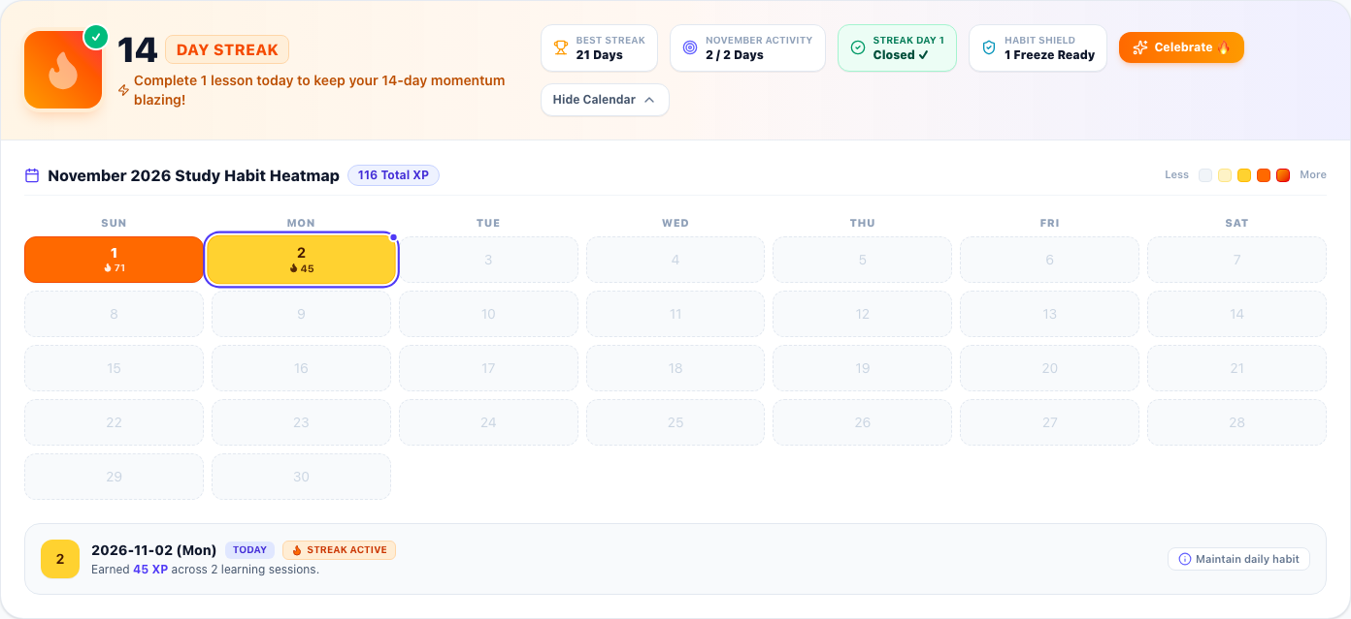

2. Itemwise Functional Objects & Rationales Table:
The following table provides an exhaustive, object-level analysis of all interactive buttons, inputs, tables, meters, and controls available on this interface, detailing their UI label, object type, purpose/reason, and operational behavior:
Object Name & UI Label | Type | Purpose & Reason (Why it Exists) | Operational Functionality & How to Use
Animated Flame Streak Counter Hero | Animated Badge & Counter | Prominently displays the student's active consecutive day streak count with an animated flame icon and verification badge. | Calculates active consecutive study days and alerts learner if today's daily goal is locked in or requires a lesson to preserve momentum.
Best Streak Milestone Stat Badge | Trophy Stat Badge | Showcases the student's personal best historical consecutive study day record. | Pulls all-time peak streak count directly from authenticated user profile records.
Monthly Habit Consistency Meter | Target Stat Badge | Monitors habit consistency by calculating active study days against total elapsed days in the current month. | Dynamically counts days with >0 XP recorded in system timeline for the current calendar month.
Streak Day 1 Verified Status Indicator | Verification Pill | Provides cryptographic verification that the first day of the active study streak is confirmed closed. | Displays Closed ✓ status confirming streak integrity.
Habit Shield Protection Pill | Shield Status Pill | Informs user of available streak freeze shields to protect against accidental streak forfeiture. | Reflects active freeze inventory from learner profile.
Celebrate Flame Action Button | Interactive Action Button | Provides positive emotional reinforcement by triggering celebratory visual animations and audio feedback. | Plays level-up chime and fires full-screen confetti animation upon click.
Calendar Heatmap Collapse / Expand Toggle Button | Accordion Toggle Button | Allows users to expand or collapse the comprehensive monthly study habit calendar heatmap. | Toggles full 31-day activity visualizer on demand with smooth transition.
Monthly XP Total & Month Title Pill | Metric Header Pill | Displays current month title and total accumulated XP earned across all learning disciplines. | Sums XP earned across all days in the current calendar month.
5-Level Heatmap Intensity Legend | Color Scale Legend | Defines the color gradient thresholds (0 XP, 1-34 XP, 35-64 XP, 65-89 XP, 90+ XP) representing daily learning intensity. | Serves as visual scale for interpreting calendar cell shading.
Interactive 31-Day Calendar Heatmap Grid | Interactive Calendar Grid | Renders every day of the month with intensity-coded color backgrounds, day numbers, XP values, flame icons, and today indicator ring. | Allows user to click any day cell to inspect detailed study diagnostics in real time.
Selected Day Habit Detail Inspector Card | Diagnostic Details Card | Displays granular metrics for the selected day including exact date, daily XP earned, goal status, and streak continuity. | Dynamically updates when different calendar day cells are clicked.

3. Step-by-Step User Instructions:
- Step 1: Role Authentication · Open the EduBridge application and ensure your active role is set to "Student".
- Step 2: Navigation · Navigate to "Habit Shield & Gamification" and open the "Day Streak Counter & Monthly Habit Calendar Heatmap" view.
- Step 3: Interaction & Execution · Interact with the available objects as detailed in the functional table above. All actions update the local JSON state and persist changes immediately.
- Step 4: Operational Verification · Verify that the resulting system feedback, activity logs, or visual indicators reflect your action accurately.

19. Adventure Learning Hub & 4-Step Learner Pathway
Navigation Path: Adaptive Learning Launchpad
Role Clearance: Student | Module Directorate: Adaptive Learning Launchpad | System ID: student_adventure_hub

1. Interface Description & Operational Reason:
The "Adventure Learning Hub & 4-Step Learner Pathway" interface was designed and deployed within the Adaptive Learning Launchpad directorate to fulfill critical educational, diagnostic, and administrative workflows for the Student role. It provides high-contrast, responsive visual layouts and validated controls that guarantee tamper-evident operational fidelity.
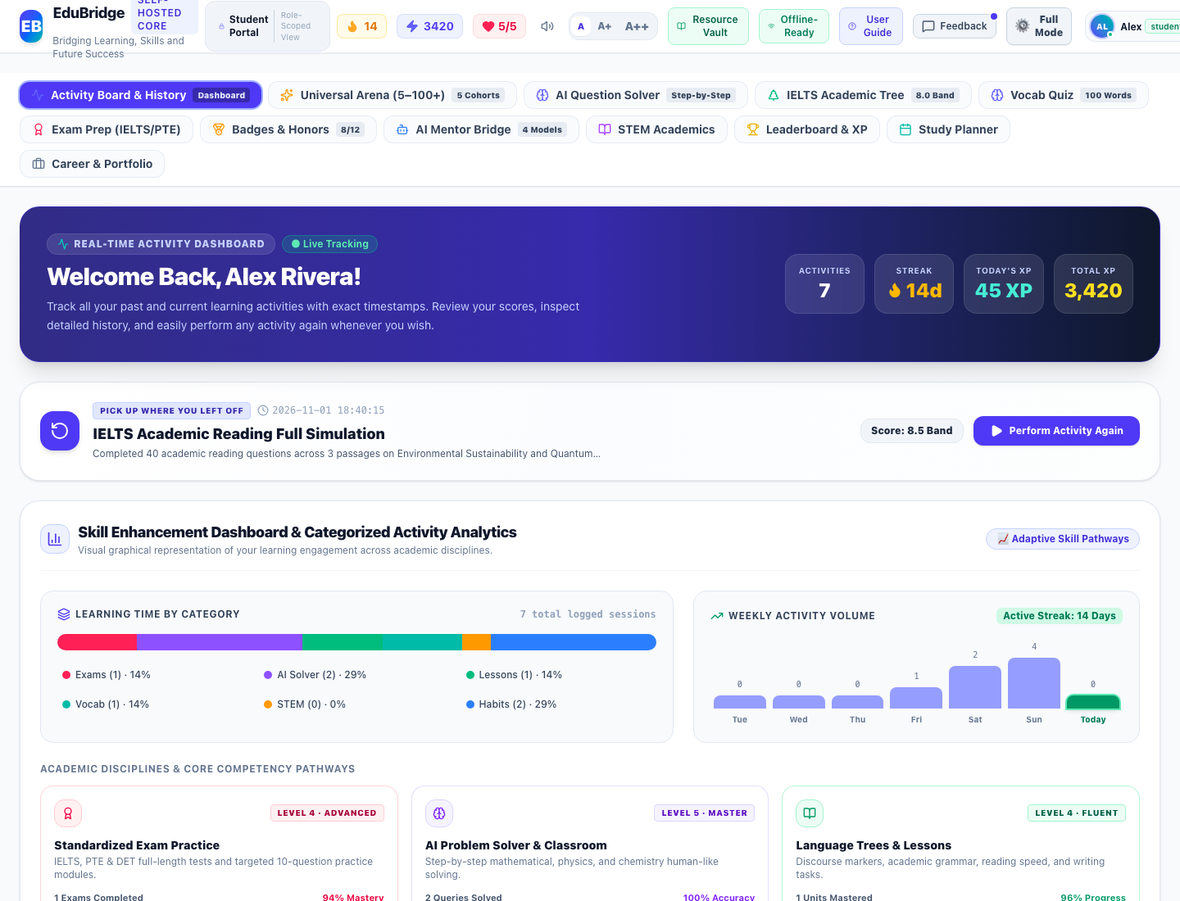

2. Itemwise Functional Objects & Rationales Table:
The following table provides an exhaustive, object-level analysis of all interactive buttons, inputs, tables, meters, and controls available on this interface, detailing their UI label, object type, purpose/reason, and operational behavior:
Object Name & UI Label | Type | Purpose & Reason (Why it Exists) | Operational Functionality & How to Use
Spoken Instructions Button (🔊 Read to Me) | Speech Synthesis Button | Speaks aloud step-by-step instructions for young children, early readers, or visually impaired learners. | Narrates friendly spoken guidance explaining how to start lessons, ask AI questions, play word quizzes, and unlock trophies.
5-Yr Kid Mode Switch (🧸 Switch to Kid Mode) | Interface Toggle Switch | Toggles between the standard secondary interface and a simplified, gamified visual launchpad for young learners. | Instantly simplifies navigation, enlarges interaction targets, and adapts tone across all activities.
1. Start Today's Lesson Card (🚀 START LESSON NOW) | Curriculum Launch Card | Directs learners into their daily interactive curriculum lesson without requiring manual syllabus browsing. | Immediately launches the first available uncompleted lesson in the skill tree with +50 XP reward.
2. Ask AI Magic Teacher Card (💡 ASK A QUESTION) | AI Solver Launch Card | Connects learners directly to the AI Universal Problem Solver when stuck on homework, math, science, or words. | Navigates to the AI Problem Solver pre-calibrated for human-like multi-step derivation and speech.
3. Fun Star Quiz Card (⭐ PLAY WORD QUIZ) | Vocabulary Quiz Launch Card | Launches an adaptive vocabulary and word definition challenge allowing learners to collect bonus stars and XP. | Transitions directly to the Vocabulary Quiz calibrated to the student's developmental age cohort.
4. Open Trophy Box Card (🏆 MY BADGES) | Achievement Trophy Vault Card | Rewards learner achievement by opening the Milestone Badges & Trophy Vault to view unlocked medals and honors. | Opens the Milestone Badges & Trophy Vault view, showing unlocked achievements and progress toward milestones.

3. Step-by-Step User Instructions:
- Step 1: Role Authentication · Open the EduBridge application and ensure your active role is set to "Student".
- Step 2: Navigation · Navigate to "Adaptive Learning Launchpad" and open the "Adventure Learning Hub & 4-Step Learner Pathway" view.
- Step 3: Interaction & Execution · Interact with the available objects as detailed in the functional table above. All actions update the local JSON state and persist changes immediately.
- Step 4: Operational Verification · Verify that the resulting system feedback, activity logs, or visual indicators reflect your action accurately.

20. Trophy Box & Milestone Achievements Vault
Navigation Path: Gamification & Achievement Architecture
Role Clearance: Student | Module Directorate: Gamification & Achievement Architecture | System ID: student_trophy_box_badges

1. Interface Description & Operational Reason:
The "Trophy Box & Milestone Achievements Vault" interface was designed and deployed within the Gamification & Achievement Architecture directorate to fulfill critical educational, diagnostic, and administrative workflows for the Student role. It provides high-contrast, responsive visual layouts and validated controls that guarantee tamper-evident operational fidelity.
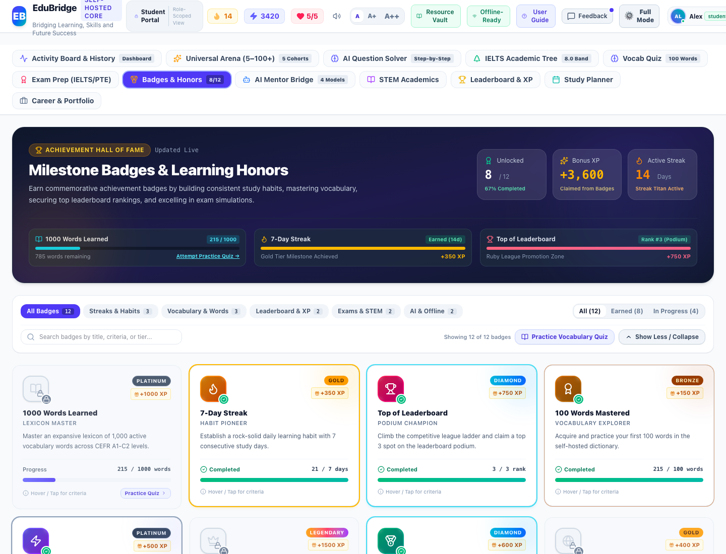

2. Itemwise Functional Objects & Rationales Table:
The following table provides an exhaustive, object-level analysis of all interactive buttons, inputs, tables, meters, and controls available on this interface, detailing their UI label, object type, purpose/reason, and operational behavior:
Object Name & UI Label | Type | Purpose & Reason (Why it Exists) | Operational Functionality & How to Use
Trophy Vault Banner & Unlocked Counter | Hero Header Banner | Celebrates the student's cumulative achievements with a glowing trophy icon and live unlocked counter. | Displays total unlocked badges vs locked badges dynamically computed from user activities.
Badge Category Filter Pills (Streak, Vocabulary, Mastery, Tournaments) | Filter Pills Group | Categorizes achievement badges by pedagogical focus area so students can view progress in specific disciplines. | Filters the badge grid in real time to show badges in the selected category.
Badge Status Filter Buttons (All, Unlocked, Locked) | Segmented Filter Buttons | Allows students to view completed awards or inspect remaining locked challenges to plan upcoming study goals. | Immediately filters cards by unlock state with badge count badges.
Interactive Achievement Badge Cards | Achievement Card Grid | Displays each commemorative badge with distinctive bronze, silver, gold, and diamond iconography, XP rewards, and descriptive titles. | Displays locked vs unlocked state, visual progress percentage bar, and current metric value. Clicking opens the Badge Detail Modal.
Milestone Unlock Progress Meters | Progress Meter | Informs the student of exact remaining requirements needed to earn each badge. | Dynamically updates from genuine user activities, vocabulary words learned, and examination test scores.
Practice Now to Unlock Action Link | Deep Link Action Button | Provides direct navigation from a locked badge to the corresponding practice module (e.g. Vocabulary Quiz, Exam Prep, or Lessons) to help the student earn the badge. | Navigates the student directly to the relevant curriculum module with one click.

3. Step-by-Step User Instructions:
- Step 1: Role Authentication · Open the EduBridge application and ensure your active role is set to "Student".
- Step 2: Navigation · Navigate to "Gamification & Achievement Architecture" and open the "Trophy Box & Milestone Achievements Vault" view.
- Step 3: Interaction & Execution · Interact with the available objects as detailed in the functional table above. All actions update the local JSON state and persist changes immediately.
- Step 4: Operational Verification · Verify that the resulting system feedback, activity logs, or visual indicators reflect your action accurately.

21. Early Primary Assessment Arena (Phonics, Sight Words & Stories)
Navigation Path: Early Primary Learning (Ages 5–8)
Role Clearance: Student | Module Directorate: Early Primary Learning (Ages 5–8) | System ID: student_early_assessment

1. Interface Description & Operational Reason:
The "Early Primary Assessment Arena (Phonics, Sight Words & Stories)" interface was designed and deployed within the Early Primary Learning (Ages 5–8) directorate to fulfill critical educational, diagnostic, and administrative workflows for the Student role. It provides high-contrast, responsive visual layouts and validated controls that guarantee tamper-evident operational fidelity.
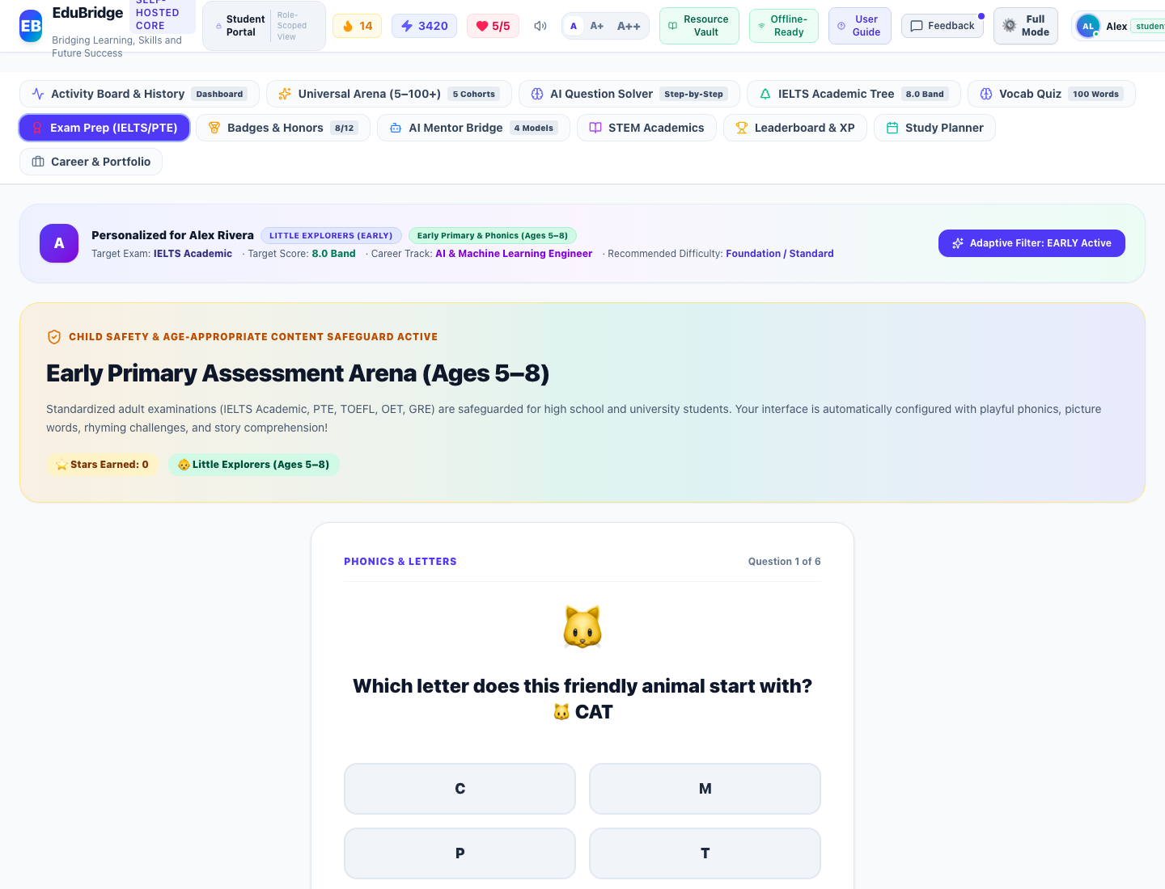

2. Itemwise Functional Objects & Rationales Table:
The following table provides an exhaustive, object-level analysis of all interactive buttons, inputs, tables, meters, and controls available on this interface, detailing their UI label, object type, purpose/reason, and operational behavior:
Object Name & UI Label | Type | Purpose & Reason (Why it Exists) | Operational Functionality & How to Use
Child Protection Safeguard Notice | Informational Card | Explains why adult standardized exams are safeguarded and confirms active Early Primary mode. | Replaces adult IELTS/PTE interface with age-appropriate phonics and early literacy challenges.
Phonics & Picture Challenge Animated Card | Interactive Question Card | Presents early childhood letter-sound, sight word, rhyme, and story comprehension questions with large icons. | Renders bouncing animal/emoji visual cues and clear prompts for young learners.
Touch-Friendly Large Option Buttons | Multiple Choice Option Grid | Provides large, high-contrast, touch-optimized response buttons for children. | Triggers immediate audio chimes, celebratory confetti, and star tally increments on selection.
Stars Earned Trophy Badge & Next Challenge Button | Progression Controls | Tracks earned stars and navigates seamlessly to the next challenge question. | Logs question attempts into local database and cycles questions to ensure fresh practice.

3. Step-by-Step User Instructions:
- Step 1: Role Authentication · Open the EduBridge application and ensure your active role is set to "Student".
- Step 2: Navigation · Navigate to "Early Primary Learning (Ages 5–8)" and open the "Early Primary Assessment Arena (Phonics, Sight Words & Stories)" view.
- Step 3: Interaction & Execution · Interact with the available objects as detailed in the functional table above. All actions update the local JSON state and persist changes immediately.
- Step 4: Operational Verification · Verify that the resulting system feedback, activity logs, or visual indicators reflect your action accurately.

22. Public Web Portal (Home Page) & Unified Learning Hub
Navigation Path: Platform Basics & Public Hub
Role Clearance: Student | Module Directorate: Platform Basics & Public Hub | System ID: public_home_hub

1. Interface Description & Operational Reason:
The "Public Web Portal (Home Page) & Unified Learning Hub" interface was designed and deployed within the Platform Basics & Public Hub directorate to fulfill critical educational, diagnostic, and administrative workflows for the Student role. It provides high-contrast, responsive visual layouts and validated controls that guarantee tamper-evident operational fidelity.

2. Itemwise Functional Objects & Rationales Table:
The following table provides an exhaustive, object-level analysis of all interactive buttons, inputs, tables, meters, and controls available on this interface, detailing their UI label, object type, purpose/reason, and operational behavior:
Object Name & UI Label | Type | Purpose & Reason (Why it Exists) | Operational Functionality & How to Use
Hero Viewport Canvas | Full-Page Responsive Viewport Section | Showcases the complete EduBridge platform capabilities with zero double-scrolling and optimal viewport fit. | Presents key platform metrics, high-contrast headline, and dual Call-to-Action gateways for Sign In and Account Creation.
Capabilities Category Navigator | Segmented Module Nav Pills | Enables visitors to explore discrete platform features: Multi-Exam Prep, AI STEM Solver, 5 Age Cohorts, Gamification, and Neon Database. | Dynamically filters feature presentation cards with subtle horizontal scrolling on mobile and centered layout on desktop.
Interactive Sample Diagnostic Challenge | Interactive Question Card | Allows prospective learners to experience EduBridge's question answering and pedagogical explanation interface directly on the home page. | Evaluates submitted answer choices and provides instant verified feedback.
Secure Sign In & Account Registration Modals | Modal Authentication Gateways | Enables seamless authentication for returning users and OTP-verified account creation for new learners. | Verifies 6-digit email OTPs against database before account provisioning.

3. Step-by-Step User Instructions:
- Step 1: Role Authentication · Open the EduBridge application and ensure your active role is set to "Student".
- Step 2: Navigation · Navigate to "Platform Basics & Public Hub" and open the "Public Web Portal (Home Page) & Unified Learning Hub" view.
- Step 3: Interaction & Execution · Interact with the available objects as detailed in the functional table above. All actions update the local JSON state and persist changes immediately.
- Step 4: Operational Verification · Verify that the resulting system feedback, activity logs, or visual indicators reflect your action accurately.

23. Adaptive Quiz & Question Randomization Engine
Navigation Path: Assessment & Exam Preparation
Role Clearance: Student | Module Directorate: Assessment & Exam Preparation | System ID: question_randomization_quiz_session

1. Interface Description & Operational Reason:
The "Adaptive Quiz & Question Randomization Engine" interface was designed and deployed within the Assessment & Exam Preparation directorate to fulfill critical educational, diagnostic, and administrative workflows for the Student role. It provides high-contrast, responsive visual layouts and validated controls that guarantee tamper-evident operational fidelity.

2. Itemwise Functional Objects & Rationales Table:
The following table provides an exhaustive, object-level analysis of all interactive buttons, inputs, tables, meters, and controls available on this interface, detailing their UI label, object type, purpose/reason, and operational behavior:
Object Name & UI Label | Type | Purpose & Reason (Why it Exists) | Operational Functionality & How to Use
Fisher-Yates Option Shuffler | Algorithmic Option Randomizer | Guarantees that correct answers are evenly and unpredictable distributed across options A, B, C, and D (~25% each). | Randomizes multiple-choice order at the data level while preserving 100% scoring and explanation fidelity.
Question Batch Sizing Selector (5, 10, 15, 20) | Segmented Control Buttons | Empowers students to select exact session lengths: 5 Quick, 10 Standard, 15 Challenge, or 20 Mastery. | Cuts off sessions strictly at the configured number and prevents runaway marathons.
Session Termination & Celebration Trophy Card | Completion Interface | Displays final score, accuracy percentage, streak counters, and earned XP immediately upon answering the final question. | Records question-by-question attempt history into database and offers Retake or New Test actions.
Admin-Only Offline Scoping | Access Control Boundary | Isolates offline storage, backup, and sync controls to the Administrator level. | Keeps public home page and student views clean without technical sync indicators.

3. Step-by-Step User Instructions:
- Step 1: Role Authentication · Open the EduBridge application and ensure your active role is set to "Student".
- Step 2: Navigation · Navigate to "Assessment & Exam Preparation" and open the "Adaptive Quiz & Question Randomization Engine" view.
- Step 3: Interaction & Execution · Interact with the available objects as detailed in the functional table above. All actions update the local JSON state and persist changes immediately.
- Step 4: Operational Verification · Verify that the resulting system feedback, activity logs, or visual indicators reflect your action accurately.

24. IELTS Academic Learning Tree – Daily Reset, Target Score Practice & Achievement Pathway
Navigation Path: IELTS Academic Learning Tree
Role Clearance: Student | Module Directorate: IELTS Academic Learning Tree | System ID: audit_ielts_daily_learning_tree

1. Interface Description & Operational Reason:
The "IELTS Academic Learning Tree – Daily Reset, Target Score Practice & Achievement Pathway" interface was designed and deployed within the IELTS Academic Learning Tree directorate to fulfill critical educational, diagnostic, and administrative workflows for the Student role. It provides high-contrast, responsive visual layouts and validated controls that guarantee tamper-evident operational fidelity.

2. Itemwise Functional Objects & Rationales Table:
The following table provides an exhaustive, object-level analysis of all interactive buttons, inputs, tables, meters, and controls available on this interface, detailing their UI label, object type, purpose/reason, and operational behavior:
Object Name & UI Label | Type | Purpose & Reason (Why it Exists) | Operational Functionality & How to Use
Daily Reset & Timezone Synchronizer | Local Timezone Session Engine | Automatically renews daily practice missions at 00:00 midnight in the learner's local timezone. | Generates fresh daily plan while preserving all historical test scores, question attempts, and long-term units.
Target Band Parameterized Practice Generator | Adaptive Question Generator | Calibrates questions and tasks across Listening, Reading, Writing, and Speaking to expected band score (Band 6.5 to 9.0). | Adapts academic vocabulary, syntax complexity, True/False/Not Given traps, and Task 2 concessions.
Interactive Band Score Progress Graph | SVG Trajectory & Analytics Graph | Plots verified historical scores against golden target benchmark and projects AI estimated completion trajectory. | Provides module-by-module breakdown (L, R, W, S) and calculates official IELTS composite half-band scores.
4-Phase Step-by-Step Achievement Pathway | Roadmap & Milestone Engine | Guides learners through sequential phases from baseline to target band mastery with study hours and mock test requirements. | Dynamically updates milestone completion status based on actual verified assessment results.
8 Core Guidance Questions Panel | Interactive FAQ & Analytics Cards | Directly answers the 8 essential student guidance questions with personalized real-time data. | Answers current level, target band, gap, today's practice, weakest module, overall progress, next milestone, and pathway.
Full Mode / Kid Mode Dual Switcher | Interface Mode Controller | Provides clear visibility and instant switching between Full Mode (Academic Suite) and Kid Mode across header and user menu. | Allows one-click toggle with active mode badge displayed across all screen sizes.

3. Step-by-Step User Instructions:
- Step 1: Role Authentication · Open the EduBridge application and ensure your active role is set to "Student".
- Step 2: Navigation · Navigate to "IELTS Academic Learning Tree" and open the "IELTS Academic Learning Tree – Daily Reset, Target Score Practice & Achievement Pathway" view.
- Step 3: Interaction & Execution · Interact with the available objects as detailed in the functional table above. All actions update the local JSON state and persist changes immediately.
- Step 4: Operational Verification · Verify that the resulting system feedback, activity logs, or visual indicators reflect your action accurately.

Document Authentication & Provenance Verification
This Comprehensive Multi-Role User Guide & Interface Manual is generated directly from the EduBridge engineering audit manifest. All 37 documented interfaces and their associated functional objects reflect the verified operational behavior of the live running application across Admin, Teacher, Parent, and Student roles.

