CME4456 Reconfigurable Computing – Homework 1
Due to: 22.03.2022
Write VHDL code to Design an arithmetic-logic circuit with 3-bit opcode variables P₂P₁P₀ and two 4-bits data inputs A and B by using full-adder blocks (FA). The circuit generates the following arithmetic, and logic operations. Draw the logic diagram with carry ( C_{OUT} ) and overflow ( OF ) outputs. Test your design with using Altera MuxPlus II or Quartus programme)

ALU

A

0

A

1

A

2

B

0

B

1

B

2

P

0

P

1

P

2

Q

0

Q

1

Q

2

C
OUT

OF

3
A
B
3
Q
3
 |  | P₂ |  | P₁ |  | P₀ |  | OPCODE |  | OPERATION
 | 0 |  | 0 |  | 0 |  | SUB |  | A - B
 | 0 |  | 0 |  | 1 |  | ADD |  | A + B
 | 0 |  | 1 |  | 0 |  | AND |  | A ∧ B
 | 0 |  | 1 |  | 1 |  | OR |  | A ∨ B
 | 1 |  | 0 |  | 0 |  | ASR |  | Arithmetic Shift Right A
 | 1 |  | 0 |  | 1 |  | ASL |  | Arithmetic Shift Left A
 | 1 |  | 1 |  | 0 |  | CSR |  | Circular Shift Right A
 | 1 |  | 1 |  | 1 |  | CSL |  | Circular Shift Left A

Example: MUX 4x1
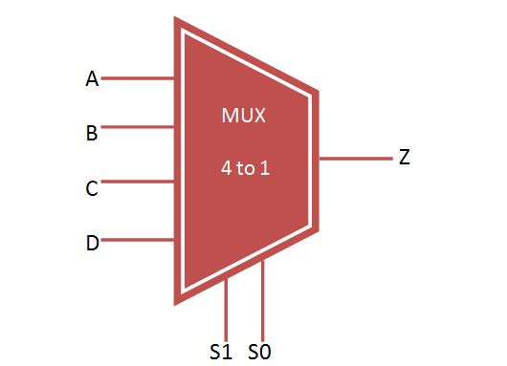
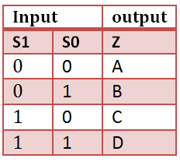

CODE:

library IEEE;
use IEEE.STD_LOGIC_1164.all;

entity mux4case is
port(
A,B,C,D : in bit;
Sel : in bit_vector(1 downto 0) :=("10");
Q: out bit
);
end mux4case ;

architecture mux4case_a of mux4case is
begin
PROCESS(sel, A, B, C, D)
BEGIN
CASE sel IS
WHEN "00" =>
Q <= A;
WHEN "01" =>
Q <= B;
WHEN "10" =>
Q <= C;
WHEN OTHERS =>
Q <= D;
END CASE;
END PROCESS;
end mux4case_a;

WAVEFORM:

