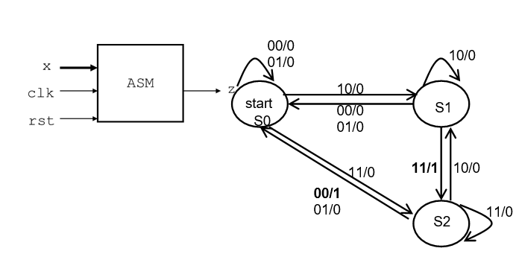
2
reset
CME4456 Reconfigurable Computing – Homework 2
Due to: 14.04.2022
Write VHDL code (entity and architecture) for following State Machine. Using waveform show that state transitions and outputs are correct. Test your design with using Altera MuxPlus II or Quartus programme). X is an input port with two bits ( X₁X₂), Z is an output port.

