TITLE PAGE
A Clinical-Oriented AI Framework for Multi-Class Kidney Abnormality
Detection and Segmentation

A Thesis Project
Presented to the
School of Information Technology
Mapua University

In Partial Fulfillment
of the Requirements for the Degree
Bachelor of Science in Computer Science

by
Yñikko Arzee Neo D. Aguas
Carl Emmanuel M. Macabales
Robin Jairic T. Macatangay

February 2026

RECOMMENDATION SHEET

This is to certify that I have supervised the preparation of and read the thesis proposal prepared by Yñikko Arzee Neo D. Aguas, Carl Emmanuel M. Macabales, and Robin Jairic T. Macatangay entitled A Clinical-Oriented AI Framework for Multi-Class Kidney Abnormality Detection and Segmentation and that the said paper has been submitted for final examination by the Oral Examination Committee.

Dr. Lysa V. Comia
Thesis Adviser

TABLE OF CONTENTS
TITLE PAGE i
RECOMMENDATION SHEET ii
TABLE OF CONTENTS iv
LIST OF FIGURES xi
LIST OF TABLES xiii
Chapter 1 1
1.1. Context of the Study 1
1.2. The Problem, Gap or Opportunity 6
1.3. Research Questions 9
1.4. Research Objectives 9
1.5 Significance of the Study 10
1.6 Scope and Limitations (or Delimitations) 12
Chapter 2 15
2.1 Clinical Significance of Kidney Abnormalities 15
2.1.1 Imaging Characteristics of Renal Abnormalities 15
2.1.2 Imaging Characterization Systems and Classification 16
2.2 Object Detection Approaches in Urology 17
2.3 Evolution of U-Net in Medical Image Segmentation 18
2.3.1 What is U-Net 18
2.3.2 Architectural Components and Design Philosophy 20
2.3.3 Clinical Applications and Modality Coverage 21
2.3.4 U-Net Variants and Architectural Innovations 22
2.3.5 Performance Metrics and Clinical Benchmarking 25
2.4 The nnU-Net Framework 26
2.4.1 Overview of nnU-Net 26
2.4.2 Automated Configuration Architecture 26
2.4.3 Cascade Architecture and Multi-Resolution Processing 27
2.4.4 Cross-Institutional Robustness and Domain Generalization 29
2.4.5 Empirical Performance and Validation 30
2.4.6 Clinical Translation and Accessibility 31
2.4.7 State-of-the-Art Deep Learning Frameworks for Kidney Segmentation 32
2.5 Identified Research Gaps 32
2.5.1 Single-Class Focus in Existing Segmentation Systems 32
2.5.2 Fragmented Public Datasets and the Need for Data Unification 34
2.5.3 Insufficient Integration of Clinical Classification Systems 36
2.5.4 The Comprehensive Metric Evaluation Gap 36
2.5.5 Gap Summary and Research Opportunity 37
Chapter 3 39
3.1 Conceptual Framework 39
3.1.1 The Input-Process-Output (IPO) Model 40
3.1.2 Input Phase: Data Ingestion and Physiological Standardization 41
3.1.3 Process Phase: Deep Learning and Volumetric Segmentation 42
3.1.4 Output Phase: Evaluation and Clinical Inference 42
3.2 Data Management 43
3.2.1 Sources and Ethical Considerations 44
3.2.2 Ethical Compliance Framework: 46
3.2.3 DICOM to NIfTI Conversion 47
3.2.4 Dataset Organization and Structure 48
3.2.5 Dataset Characterization 49
3.3 Data Preprocessing 50
3.3.1 Hounsfield Unit (HU) Clipping and Intensity Filtering 51
3.3.2 Isotropic Resampling and Spatial Normalization 52
3.3.3 Cropping to Non-Zero Region 54
3.3.4 Augmentation Setting and Data Splitting 54
3.4 Network Architecture: The 3D U-Net and Deep Supervision 56
3.4.1 Architectural Topology 57
3.4.2 Deep Supervision 59
3.5 Computational Pipeline 60
3.5.1 Environment and Reproducibility 60
3.5.2 Training Configuration and Optimization 61
3.5.3 Loss Function Math 61
3.5.4 Inference and Post-Processing 62
3.6 Annotation Pipeline 63
3.6.1 Domain Expert Profile 64
3.7 Evaluation Metrics 66
3.7.1 Dice Similarity Coefficient (DSC) 67
3.7.2 Intersection over Union (IoU) 67
3.7.3 95th Percentile Hausdorff Distance (HD95) 68
3.7.4 Precision, Recall, and F1-Score 69
3.7.5 Per-Class Analysis 69
3.7.6 Computational Efficiency Metrics 70
3.7.7 Baseline Benchmarks 70
3.8 Failure Analysis and Clinical Interpretability 71
3.9 Clinical Feature Quantification 72
3.9.1 Volumetric Calculation 73
3.9.2 Maximum Diameter (Tumor Size) 73
3.10 Testing and Validation Pipeline 73
3.11 Web Deployment 74
Chapter 4 74
Results and Discussion 74
4.1 Experimental Configurations 75
4.2 Evaluation Metrics 76
4.3 Phase 1 Results: Single-Class Model Performance (Configurations A, B, C) 76
4.3.1. Configuration B (Cyst): Moderate Recall, Critically Low Precision 77
4.3.2. Configuration A (Stones): Catastrophic Forgetting After Transient Detection 80
4.3.3. Configuration C (Tumors): Moderate Success with Inter-Fold Variance 84
4.3.4. Summary Assessment for RQ1 86
4.4 Phase 2 Results: Multi-Class Model Performance (Configuration D) 88
4.4.1 Kidney Segmentation: Near-Expert Performance as Anatomical Anchor 90
4.4.2 Cyst Segmentation: Transformative Improvement Over Single-Class 91
4.4.3 Stone Segmentation: From Catastrophic Forgetting to Sustained Detection 94
4.4.4 Tumor Segmentation: Strong Performance with Improved Stability 97
4.5 Head-to-Head Comparison: Single-Class vs Multi-Class (RQ 2) 99
4.5.1 Direct Metric Comparison 99
4.5.2 Voxel-Level Class Imbalance Analysis 102
4.5.3 HD95, Diameter, and Density Analysis 103
4.6 Computational Efficiency Results (RQ3) 104
4.7 Training Dynamic and Convergence Analysis 106
4.8 Discussion of Results 109
4.8.1 Addressing the Four Research Gaps 109
4.8.2 The Precision-Recall Tradeoff and Clinical Deployment Profiles 111
4.8.3 The Anatomical Anchor Mechanism: Why Multi-Class Succeeds 114
4.8.4 Domain Expert Review Integration 118
4.8.5 Key Failure Modes and Categorization (Per Section 3.8) 119
4.8.6 Limitations and Recommendations for Future Work 120
4.9 Domain Expert Clinical Validation 122
4.9.1 Review Protocol 122
4.9.2 Full Case Results 123
4.9.3 Clinical Interpretation and Insights 125
4.10 Per-Case Statistical Significance Analysis 127
4.10.1 Cyst HD95: Statistically Significant Improvement (p = 3.77 × 10⁻¹⁸) 128
4.10.2 Tumor HD95: Statistically Significant Improvement (p = 1.17 × 10⁻⁵) 128
4.10.3 Stone HD95: Wilcoxon Not Applicable — Interpretive Note 129
4.11 Web-Based Deployment Interface 129
Chapter 5 Conclusion 131
5.1 Summary of Findings 131
5.1.1 Research Question 1: Validation of Single-Class Models Against the MSWAL Benchmark 132
5.1.2 Research Question 2: Multi-Class versus Single-Class Performance 133
5.1.3 Research Question 3: Computational Efficiency Trade-offs 136
5.2 Contributions to Knowledge 137
5.3 Clinical and Practical Implications 138
5.4 Limitations of the Study 140
5.5 Recommendations for Future Work 142
5.6 Concluding Statement 144
REFERENCES 146

LIST OF FIGURES
Figure 1. The U-Net Architecture. Illustration of the contracting and expanding paths with skip connections. Reprinted from [12]. 19
Figure 2. Modality Versatility 22
Figure 3. U-Net++ Architecture. Reprinted from [42]. 23
Figure 4. Attention Mechanism. Reprinted from [43]. 24
Figure 5. Hybrid Transformers. Reprinted from [46]. 25
Figure 6. nnU-Net Configuration Hierarchy. Reprinted from [53] 27
Figure 7. 3D Cascade Architecture. Retrieved from [57]. 28
Figure 8. Data Augmentation Example 29
Figure 9. Conceptual Framework 40
Figure 10. CT scan in different views 46
Figure 11. nnU-Net V2 Architecture 57
Figure 12. Single Class Cyst Prediction 80
Figure 13. Single Class Stone Blank Prediction 83
Figure 14. Catastrophic Forgetting Training Curve 83
Figure 15. Single Class Tumor Prediction 86
Figure 16. Single-class vs MSWAL Benchmark 87
Figure 17. Per-fold Dice across all configurations 88
Figure 18. Multi-Class Best Cyst Result 93
Figure 19. Multi-class Working Stone Detection 97
Figure 20. Single-Class vs Multi-Class Dice Comparison 100
Figure 21. Per-case Dice Distributions 101
Figure 22. Inference Latency Comparison 106
Figure 23. Training Curves for All configurations 108
Figure 24. Precision, Recall, F1 Single-class VS Multi-class 113
Figure 25. Web Deployment using Gradio 130

LIST OF TABLES
Table 1. Dataset Fingerprint Characteristics 50
Table 2. Data Augmentation Strategy 55
Table 3. Technical Specifications 61
Table 4. Training Hyperparameters 61
Table 5. Class Mapping 64
Table 6. First Domain Expert (Radiologist) Profile 65
Table 7. Baseline Metrics for Kidney Abnormality Segmentation 71
Table 8. Training Parameters 76
Table 9. MSWAL Benchmark Reference (Wu et al. [20], nnU-Net V2 on MSWAL). 77
Table 10. Single-Class Model Cross-Fold Aggregate Metrics (Mean±SD) 77
Table 11. Stone Training Dynamics 81
Table 12. Configuration D (Multi-Class) Cross-Fold Aggregate Metrics (Mean ± SD). 89
Table 13. Configuration D Per-Fold Breakdown 89
Table 14. Forgetting of Stones to Sustained Detection from Multi-Instance Model 94
Table 15. Phase 1 vs Phase 2 99
Table 16. Voxel Class Imbalance between Single-Class vs Multi-Class 102
Table 17. HD95 Cross-Configuration Comparison 104
Table 18. Diameter and Density Summary 104
Table 19. Single-Class vs Multi-Class Computational Efficiency Results 105
Table 20. Training Dynamics Summary Across All Configurations and Folds 107
Table 21. Structural Comparison - This Study vs. MSWAL nnU-Net V2 117
Table 22. Reviewer 1 123
Table 23. Reviewer 2 124
Table 24. Summary Findings of Domain Expert 126
Table 25. Per-Case Wilcoxon Signed-Rank Test Results 128

Chapter 1
INTRODUCTION
This chapter establishes the foundation for a comparative investigation of single-class versus multi-class segmentation approaches for kidney abnormalities in CT imaging using nnU-Net V2. It begins by presenting the epidemiological context of renal pathologies and the critical role of CT imaging in diagnosis, then identifies the key computational gap: the lack of rigorous statistical comparison between single-class and multi-class deep learning segmentation models. The research questions and objectives are formulated to address this gap through a two-phase experimental design. In Phase 1, three single-class nnU-Net V2 models — each independently trained on one pathology (cyst, stone, or tumor) — are validated against published benchmarks to establish them as strong, competitive reference models. In Phase 2, a multi-class nnU-Net V2 model trained simultaneously on all three pathologies is compared directly against those validated single-class models to determine whether joint training improves, maintains, or degrades per-class segmentation accuracy.

1.1. Context of the Study
Kidney abnormalities represent a significant global health burden, encompassing a spectrum of pathologies ranging from benign cystic formations to life-threatening malignancies and painful stone formations [1] [2] [3]. Renal cysts are among the most frequent findings in adult imaging, with prevalence estimated at approximately 40% in adults over 50 years of age, following a distinct age-dependent increase from less than 1% in individuals aged 15-29 years to exceeding 22% in patients over 70 years [1]. Although the majority of these cysts are asymptomatic and benign, their high frequency necessitates precise characterization to distinguish simple cysts from complex lesions. Renal tumors represent a more critical diagnostic challenge, with greater than 50% of renal masses now detected incidentally during imaging performed for unrelated conditions, representing a dramatic shift from historical presentation patterns [4]. The incidence of renal cell carcinoma has been steadily increasing over the past four decades, partly driven by increased utilization of cross-sectional imaging that detects smaller, incidental tumors [4] [5]. Furthermore, kidney stones affect approximately 10% of the global population, with 106 million new cases reported worldwide in 2021 alone, reflecting a 27% rise since 2000 [3]. The presence of asymptomatic stone burdens can predict future symptomatic events, making early detection and quantification essential for preventative care and treatment planning [3] [6].
Computed tomography (CT) has established itself as the cornerstone imaging modality for evaluating kidney pathologies due to its superior spatial resolution, rapid acquisition times, and ability to characterize tissue properties through Hounsfield unit measurements [6]. For kidney stone detection, CT demonstrates exceptional diagnostic performance with sensitivity approaching 97% and specificity exceeding 95%, significantly outperforming traditional plain radiography and ultrasound [6]. The non-contrast CT protocol remains the gold standard for stone disease evaluation, as it allows for accurate stone detection, size measurement, and density assessment without the need for contrast administration [6]. In the context of renal masses, contrast-enhanced CT plays a pivotal role in differentiating benign cysts from solid tumors through multiphasic imaging protocols [7] [8]. The ability to assess enhancement patterns during arterial, venous, and delayed phases enables radiologists to characterize lesions according to the Bosniak classification system for cystic masses and to evaluate the vascularity and extent of solid tumors [7]. Modern multidetector CT scanners provide isotropic voxel acquisition, facilitating high-quality multiplanar reconstructions and 3D visualization that aid in surgical planning and tumor staging. Despite these technological advantages, the interpretation of CT scans presents significant challenges. Radiologists must scrutinize hundreds of axial slices per examination, with each slice potentially containing subtle findings that require careful attention. The high volume of imaging studies in contemporary radiology practice, combined with the increasing complexity of cases, creates an environment prone to perceptual and cognitive errors, with burnout prevalence rates exceeding 54% among radiologists [9] [10].
Medical image segmentation is the computational process of partitioning medical images into distinct regions or objects of interest, enabling precise identification and delineation of anatomical structures and pathological abnormalities [11] [12]. It serves as a fundamental task in medical image analysis, transforming raw imaging data into structured, quantifiable information that supports clinical diagnosis, treatment planning, and disease monitoring [11]. In computed tomography imaging of the kidneys, segmentation enables radiologists to accurately measure lesion volumes, assess tumor boundaries for surgical planning, and quantify stone burden for treatment decisions [13]. The clinical importance of accurate kidney abnormality detection is underscored by documented diagnostic challenges. Studies have shown that patients frequently present with multiple concurrent kidney abnormalities requiring comprehensive evaluation [14]. These missed diagnoses or delayed characterizations can have profound clinical implications, as early detection of small renal cell carcinomas when still organ-confined is associated with substantially better survival outcomes compared to advanced disease [5]. The increasing detection of small renal masses has intensified the clinical need for precise imaging characterization to support accurate diagnostic assessment [4] [5].
The integration of artificial intelligence into medical imaging offers a potential solution to these diagnostic challenges. Deep learning frameworks, particularly Convolutional Neural Networks (CNNs), have demonstrated remarkable capability in automated analysis of medical images by learning hierarchical feature representations directly from data [11] [15]. In the domain of kidney abnormality detection, researchers have explored various computational approaches ranging from traditional machine learning to state-of-the-art deep learning architectures.
Previous work [16] developed an optimized YOLOv5 model for kidney stone detection in CT scans that incorporated Squeeze-and-Excitation blocks to improve feature extraction in noisy, low-dose images. Their approach achieved mean Average Precision (mAP) scores exceeding 90% on clean datasets, demonstrating the potential of real-time detection systems. Their model predicts stone locations based on high-density pixel clusters, attenuation values exceeding 400 Hounsfield Units, and spatial patterns within the renal collecting system. Through their model, they observed that detection accuracy remains high for stones greater than 5 mm but degrades significantly for smaller stones less than 3 mm. However, the bounding box outputs provide only coarse localization without precise lesion boundaries, limiting their utility for volumetric quantification and surgical planning [16].
In [17], extended the detection approach to segmentation, this time focusing on renal tumors. The authors implemented a 3D U-Net architecture for automated tumor segmentation on CT scans. Their model used volumetric features including tumor density, enhancement patterns, boundary characteristics, spatial location within the kidney, size measurements, and shape irregularity indices. Through the model, they revealed a critical performance disparity based on lesion size: achieving high accuracy for large exophytic masses but struggling with endophytic tumors embedded within the renal parenchyma, with tumors exhibiting heterogeneous enhancement patterns resulting in inconsistent segmentation boundaries. This size-dependent and morphology-dependent performance gap is particularly problematic because small and complex lesions are precisely those where accurate characterization offers the best clinical value [17].
The robustness of nnU-Net, a self-configuring segmentation framework, was also evaluated on external validation datasets from different hospital institutions to determine the generalizability of models trained on single-institution data when applied to multi-institutional cohorts [18]. Testing was conducted using an nnU-Net configuration based on the KiTS19 challenge framework [19]. Results show that while the model-maintained Dice scores around 0.85 on internal validation data from the training institution, segmentation accuracy degraded substantially when applied to CT scans from different scanner manufacturers and imaging protocols, with Dice scores dropping to 0.66 [18]. This cross-institutional performance drop was particularly pronounced for complex cystic lesions and small solid masses, indicating that domain shift—variations in scanner hardware, reconstruction kernels, and contrast timing—creates data distributions that differ from the training set, causing model failure in real-world deployment scenarios [18].

1.2. The Problem, Gap or Opportunity
The above-mentioned studies demonstrate significant progress in automated kidney abnormality detection but reveal critical gaps that limit clinical deployment and comprehensive diagnostic capability.
The first major limitation emerges from the predominant use of object detection methods that provide only coarse spatial localization. A recent evaluation [16] demonstrated a YOLO-based approach that achieves impressive detection performance with superior precision, recall, and mean Average Precision metrics compared to standard YOLOv5 variants. This approach demonstrates real-time processing capabilities suitable for clinical screening workflows. The integration of Squeeze-and-Excitation blocks specifically enhanced the model's ability to recalibrate channel-wise dependencies and capture intricate feature relationships, improving detection accuracy for small and irregularly shaped kidney stones [16]. However, the fundamental constraint of bounding box outputs means that these detection systems can only indicate the approximate region where a stone exists, without delineating its precise boundaries or three-dimensional morphology. This limitation becomes clinically significant when considering that accurate stone volume measurements are essential for treatment planning. Lithotripsy candidacy depends on precise stone size quantification, and longitudinal monitoring of stone burden requires volumetric rather than linear measurements [13]. Similarly, for renal masses, bounding boxes cannot distinguish between the actual tumor extent and surrounding normal parenchyma, limiting their utility for surgical planning where precise tumor margins determine the feasibility of nephron-sparing procedures versus radical nephrectomy [5]. The lack of pixel-level precision in detection-only approaches fundamentally restricts their application to screening and triage functions, requiring subsequent manual segmentation by radiologists for any clinical decision that depends on accurate volumetric or morphological assessment.
The second critical gap involves morphology-dependent and anatomical complexity challenges in existing segmentation approaches. 3D U-Net combined with ResNet algorithms represents an advancement over detection-only methods by providing pixel-level boundary delineation for automatic renal mass segmentation and classification [17]. Their comprehensive study analyzed diverse tumor presentations and achieved promising overall performance metrics. However, segmentation of complex renal masses remains challenging due to substantial variability in tumor characteristics including size heterogeneity, location diversity (cortical versus medullary, upper pole versus lower pole), morphological complexity (exophytic protrusions versus endophytic embedding within parenchyma), and enhancement pattern variations that affect boundary clarity [17]. These morphology-dependent challenges are particularly problematic in clinical practice because the most diagnostically challenging cases are precisely the scenarios where accurate automated characterization would provide the greatest clinical value. Current segmentation systems that perform well on straightforward cases with clear boundaries may struggle with the complex presentations that cause highest inter-observer variability among radiologists and where accurate volumetric assessment is most critical for determining appropriate management strategies [5] [8].
The third fundamental limitation in current medical image segmentation is the pervasive reliance on single-institution datasets, which inherently restricts model generalizability. Deep learning architectures, while powerful, are highly susceptible to domain shift—a phenomenon where a model overfits to the specific imaging characteristics of the hardware, reconstruction kernels, and contrast protocols of a single hospital. While some studies attempt to build local, private datasets, these single-center models frequently suffer catastrophic performance degradation when deployed in external environments.
A fourth fundamental limitation in current single-class modeling is the failure to account for clinical co-morbidities. Real-world patients frequently present with concurrent pathological entities (e.g., a patient harboring both a renal cyst and a kidney stone). Deploying single-class models to evaluate such cases is inherently inefficient, requiring multiple sequential inference passes and failing to leverage shared anatomical context.
Beyond these technical limitations, a fundamental research gap exists in the computer science literature: no study has conducted a rigorous, controlled comparison between single-class and multi-class segmentation models using the same architecture, dataset, and evaluation metrics. Existing studies that employ multi-class frameworks do not isolate or measure whether the joint training of multiple pathology classes improves, maintains, or degrades per-class segmentation performance compared to dedicated single-class models. This absence of controlled comparative evidence is significant — clinical deployment decisions about whether to use one unified model or separate specialized models currently lack empirical statistical grounding. Studies using nnU-Net V2 for kidney segmentation have demonstrated strong performance in tumor-focused single-class settings [18][19], and the MSWAL dataset has introduced multi-class ground truth annotations [20], yet no work has directly compared single-class versus multi-class nnU-Net V2 performance on the same kidney abnormality cases. This gap motivates the present study.

1.3. Research Questions
The aforementioned gaps and opportunities motivate the need to investigate comprehensive multi-class segmentation for kidney abnormalities. The research questions are formulated to address the following:
- Do three independently trained single-class nnU-Net V2 models — one per abnormality (cyst, stone, tumor) — produce per-class segmentation performance consistent with the published nnU-Net V2 benchmark established by Wu et al. [20] on MSWAL, as measured by DSC, IoU, HD95, precision, recall, and F1-score, thereby establishing them as strong and validated reference models?
- Does a multi-class nnU-Net V2 model trained simultaneously on cysts, stones, and tumors achieve statistically superior, equivalent, or inferior per-class segmentation performance compared to the three validated single-class nnU-Net V2 models?
- What are the computational efficiency trade-offs including inference latency and GPU memory utilization between running three sequential single-class configurations versus one unified multi-class configuration, and do these trade-offs affect practical clinical deployment feasibility?

1.4. Research Objectives
To address the limitations of current kidney abnormality detection methods and extend studies in medical image segmentation, this study aims to develop and evaluate a multi-class segmentation system for kidney abnormalities in CT imaging using nnU-Net V2. This is achieved through a two-phase experimental design. Specifically, this study attempts to:
- Train and evaluate three single-class nnU-Net V2 models — one independently optimized per abnormality class (cyst, stone, tumor) — and validate their per-class performance against the MSWAL nnU-Net V2 benchmark (Wu et al. [20]) using DSC, IoU, HD95, precision, recall, and F1-score. This phase confirms that each single-class model constitutes a strong, competitive reference before any multi-class comparison is made.
- Train and evaluate a multi-class nnU-Net V2 model on all three abnormality classes simultaneously and compare its per-class performance directly against the three validated single-class nnU-Net V2 models from Objective 1 to determine whether joint multi-class training improves, maintains, or degrades per-class segmentation accuracy. This is the primary comparison of the study.
- Measure and compare computational efficiency — inference latency (seconds/volume) and peak GPU VRAM usage — between running the three single-class configurations sequentially versus the single multi-class configuration, to assess clinical deployment feasibility.

1.5 Significance of the Study
This study hopes to contribute to the advancement of automated medical image analysis for kidney abnormality detection, addressing critical gaps in diagnostic accuracy and clinical workflow efficiency. The significance of this research extends to multiple beneficiaries in both the medical and computer science communities.
For Radiologists and Clinical Practice. This study provides an automated tool that can assist radiologists in detecting kidney abnormalities with greater consistency and accuracy. Given the high volume of imaging studies and documented radiologist burnout rates exceeding 54% [9] [10], the developed system serves as a computational second reader that can flag potential abnormalities for radiologist review. The precise segmentation masks enable accurate volumetric quantification essential for treatment planning, tumor staging, and monitoring disease progression. By reducing diagnostic variability and improving detection of lesions across varying sizes and morphologies, this research directly contributes to earlier detection and improved patient outcomes [5].
For Computer Science and AI Research. This study advances the field of medical image segmentation by providing the first controlled statistical comparison between single-class and multi-class nnU-Net V2 configurations on kidney abnormality data. While single-class segmentation models have been extensively studied in isolation, and multi-class frameworks have been proposed for clinical comprehensiveness, no prior work has directly quantified the performance trade-off of these two paradigms under equivalent experimental conditions. The per-class comparison across cyst, stone, and tumor segmentation — with standardized metrics including DSC, IoU, HD95, precision, recall, and F1-score — provides empirically grounded evidence to guide model architecture decisions in medical AI deployment. Findings regarding whether multi-class training helps or hurts per-class performance may inform broader computer science research on multi-task learning trade-offs in medical segmentation tasks, contributing to the design of more efficient and accurate diagnostic AI systems.
For Healthcare Systems and Public Health. The automated segmentation system developed in this study has the potential to improve healthcare delivery efficiency by reducing the time required for image interpretation and standardizing abnormality detection across diverse imaging protocols and equipment [18]. By enabling earlier detection of kidney abnormalities and more accurate quantification, the system supports preventive care strategies and optimal treatment timing. The multi-class capability mirrors real clinical workflows where patients frequently present with multiple concurrent findings requiring comprehensive evaluation [14], making the system practical for deployment in hospitals and imaging centers.

1.6 Scope and Limitations (or Delimitations)
Since computed tomography is the primary imaging modality for comprehensive renal evaluation, offering superior spatial resolution and tissue characterization capabilities, this study focuses on developing a multi-class segmentation model for kidney abnormalities in CT imaging using nnU-NetV2. The model centers on the identification and delineation of four anatomical and pathological classes: kidneys (normal renal parenchyma), renal cysts (both simple and complex cystic lesions), renal tumors (solid masses including renal cell carcinoma), and kidney stones (nephrolithiasis). These abnormalities were selected based on their clinical prevalence—cysts affecting approximately 40% of adults over 50, tumors representing a growing incidental detection burden with over 50% now discovered asymptomatically, and stones affecting 10% of the population [1] [3] [4]—and their critical importance for early detection and intervention.
This study executes four nnU-Net V2 training sessions across two phases. Phase 1 trains three single-class nnU-Net V2 models — one each for cysts, stones, and tumors — and validates each against the published nnU-Net V2 benchmark established by Wu et al. [20] on MSWAL. Phase 2 trains one multi-class nnU-Net V2 model on all three classes simultaneously and compares its per-class performance directly against the Phase 1 models. Per-class performance is measured using Dice Similarity Coefficient, Intersection over Union, Hausdorff Distance 95th percentile, precision, recall, and F1-score. Computational efficiency metrics — inference latency and GPU VRAM usage — are recorded to enable deployment feasibility comparison.
The study does not include other urinary tract abnormalities such as ureteral stones, bladder pathologies, or vascular anomalies, as these fall outside the scope of intra-renal abnormalities. The research excludes rare kidney pathologies to maintain focus on the most clinically prevalent and diagnostically challenging abnormalities. The study does not incorporate other imaging modalities such as MRI, ultrasound, or nuclear medicine studies, as CT represents the primary modality for stone detection and comprehensive renal mass evaluation [6]. Furthermore, the research focuses on segmentation accuracy in a controlled research environment and does not include deployment as a real-time clinical decision support system, regulatory approval processes, or integration with hospital Picture Archiving and Communication Systems (PACS), as these implementation aspects require separate validation studies beyond the scope of this thesis.
The dataset is strictly limited to pathological cases exhibiting at least one of the three target abnormalities (cysts, stones, or tumors). Healthy control scans (negative cases) are excluded from the training distribution to maximize the model's exposure to pathological features within the computational constraints. Although the curated dataset comprises 290 volumetric cases. To accurately reflect real-world clinical variance, the dataset includes 74 cases of pure nephrolithiasis, 50 cases of pure cysts, 45 cases of pure solid neoplasms, and crucially, 121 cases exhibiting concurrent multi-pathologies. Each case yields approximately 300 2D slices through the extraction of all three standard anatomical planes (axial, coronal, and sagittal), ensuring the model is exposed to a substantially larger effective training corpus than the case count alone suggests. The training and validation data for this study are strictly delimited to highly curated, multi-institutional public repositories (such as the KiTS datasets). Local institutional data collection was deliberately excluded from the scope to avoid the well-documented pitfalls of single-center bias, ensuring the model trains on the maximum possible variance in scanner hardware and imaging protocols.

Chapter 2
REVIEW OF RELATED LITERATURE & STUDIES
This chapter reviews the literature on automated kidney abnormality detection and segmentation in medical imaging. Section 1 examines the clinical significance and imaging characteristics of kidney cysts, stones, and tumors. Section 2 explores object detection methodologies in urological imaging, while Section 3 traces the evolution of U-Net architectures for medical image segmentation. Section 4 presents the nnU-Net framework, an automated self-configuring system achieving state-of-the-art performance across diverse segmentation tasks. Section 5 identifies critical research gaps, including the absence of unified multi-class segmentation systems, limited geographic diversity in training data, and insufficient integration with clinical classification frameworks. These sections provide the foundation for developing comprehensive AI-powered diagnostic tools capable of simultaneously detecting and characterizing multiple kidney abnormality types.

2.1 Clinical Significance of Kidney Abnormalities

2.1.1 Imaging Characteristics of Renal Abnormalities
In computed tomography (CT) imaging, the automated differentiation of renal structures relies entirely on pixel-level attenuation values, measured in Hounsfield Units (HU), alongside morphological features such as shape, texture, and boundary definition [6]. Healthy renal parenchyma typically exhibits a baseline attenuation that increases significantly and uniformly during contrast-enhanced phases [7], [8]. In stark contrast, renal cysts present as well-defined, smooth-walled, homogeneous masses with water-like attenuation [21]. Crucially for algorithmic differentiation, simple cysts do not exhibit enhancement when intravenous contrast is administered [7]. Renal tumors present a more complex segmentation challenge [22]. They are typically solid masses with heterogeneous attenuation, exhibiting irregular enhancement patterns that vary depending on the contrast phase [7], [8]. This requires the neural network to learn complex spatial and textural gradients to accurately delineate their often-ill-defined borders from adjacent healthy tissue [17].
Kidney stones (renal calculi) introduce a distinct class imbalance and object scale challenge within the segmentation pipeline [23]. Unlike the soft tissue characteristics of cysts and tumors, stones are highly radiopaque, presenting with extreme attenuation values frequently exceeding 400 HU [16]. While their high pixel density provides a sharp contrast gradient against the renal collecting system, their significantly smaller volumetric footprint compared to tumors and cysts requires a highly sensitive feature extraction mechanism to prevent false negatives or boundary overlap errors [16], [24]. Ultimately, the distinct HU signatures, enhancement behaviors, and spatial distributions of these classes form the foundational quantitative data that the deep learning architecture must map.

2.1.2 Imaging Characterization Systems and Classification
In clinical practice, standardized scoring systems such as the Bosniak classification for complex renal cysts [25], [26] and the R.E.N.A.L. nephrometry score for solid masses are utilized to categorize abnormalities and guide diagnostic characterization. However, the efficacy of these systems relies heavily on manual visual assessment and the precise estimation of volumetric boundaries. Manual annotation and morphological grading by radiologists are not only highly time-consuming but also prone to significant inter-observer variability, contributing heavily to diagnostic bottlenecks and physician burnout [9], [10]. The inherently subjective nature of these manual evaluations limits the consistency of differential diagnoses across different institutions. Consequently, there is a critical need for automated, AI-driven segmentation frameworks capable of providing objective, pixel-perfect volumetric delineations to standardize clinical assessments and alleviate the manual workload.
The clinical imperative to automatically detect and characterize kidney abnormalities has motivated the development of deep learning approaches that combine two complementary operations: efficient detection of regions of interest and precise boundary delineation of abnormal structures. Detection and characterization tasks require fundamentally different technical approaches—detection must rapidly identify where abnormalities exist within large imaging volumes, while characterization demands pixel-level precision to measure lesion extent, volume, and relationship to critical anatomical structures. The foundation for precise pixel-level characterization lies in segmentation architectures that provide exact anatomical boundaries, enabling the volumetric measurements and feature extraction necessary for clinical decision support.

2.2 Object Detection Approaches in Urology
Object detection and segmentation serve complementary roles in medical image analysis. While detection methods identify and localize abnormalities via bounding boxes, segmentation extends this to precise voxel-level boundary delineation — the methodology required for volumetric clinical measurements such as lesion sizing and Bosniak grading [11], [27]. This study focuses exclusively on segmentation; detection approaches are not employed but are acknowledged as a parallel research direction in urological AI [14]. The remainder of this review addresses segmentation architectures directly relevant to the proposed framework.

2.3 Evolution of U-Net in Medical Image Segmentation

2.3.1 What is U-Net
U-Net is a specialized convolutional neural network architecture developed to address challenges in biomedical image processing where training data is typically limited and pixel-level localization is critical [12]. The architecture builds upon the foundation of Fully Convolutional Networks (FCNs) with significant modifications optimized for medical imaging applications. Its fundamental innovation lies in a symmetric encoder-decoder architecture, as illustrated in Fig. 5, that combines contextual information from a contracting path with precise spatial information from an expanding path through skip connections [12].
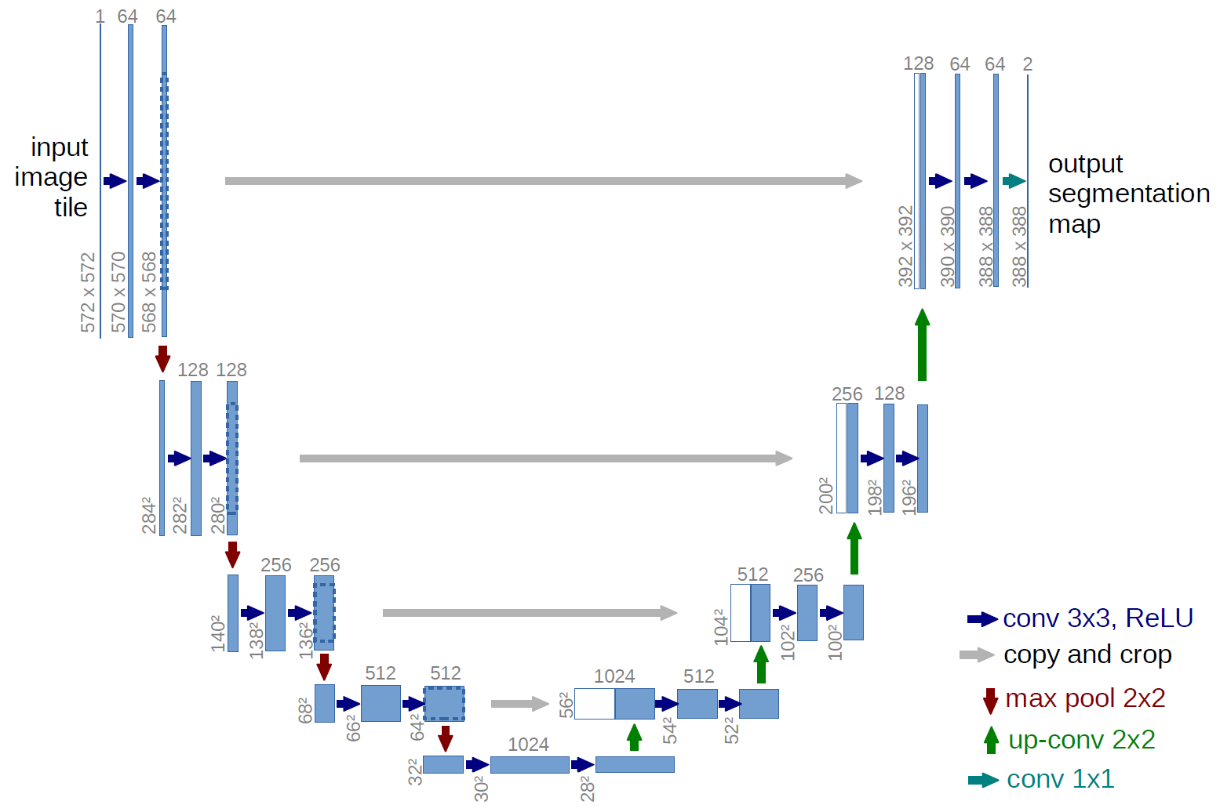
Figure 1. The U-Net Architecture. Illustration of the contracting and expanding paths with skip connections. Reprinted from [12].
The architecture consists of two main components defining its characteristic U-shaped structure. The contracting path captures context by progressively downsampling the input image, reducing spatial dimensions while increasing the number of feature channels to learn increasingly abstract representations [12]. Conversely, the symmetric expanding path enables precise localization by progressively upsampling feature maps. The critical innovation involves skip connections that directly link features from the contracting path to corresponding layers in the expanding path at the same resolution. These connections preserve fine-grained spatial details lost during downsampling, enabling the network to make precise predictions about pixel-level class assignments essential for accurate medical image segmentation [12].
Recent reviews have established U-Net-based architectures as the dominant paradigm for medical image segmentation across diverse anatomical structures and imaging modalities, with the original architecture serving as the foundation for hundreds of subsequent refinements and adaptations [28]. The enduring success of U-Net stems from its elegant balance between local precision and global context, achieved through the encoder-decoder structure with skip connections that has proven robust across varied segmentation tasks.

2.3.2 Architectural Components and Design Philosophy
The U-Net architecture eliminates fully connected layers and operates entirely through convolutional and pooling operations, making it computationally efficient and capable of processing images of arbitrary size [12]. Each layer in the network contains multi-channel feature maps, utilizing 3x3 kernels and ReLU activation functions throughout both the contracting and expanding paths. The symmetric design ensures that the number of feature channels in the expanding path mirrors those in the contracting path, allowing rich contextual information to propagate to higher resolution layers [12].
One of the fundamental design principles is the ability to function effectively with limited training data through aggressive data augmentation strategies [12]. Rather than requiring thousands of annotated samples like traditional deep learning approaches, U-Net can be trained effectively on very few images by applying elastic deformations and other transformation-based augmentations to available training data. This characteristic is particularly valuable in biomedical applications where annotated datasets are expensive and time-consuming to acquire. Furthermore, weighted loss functions are employed to handle challenging segmentation problems, such as the separation of touching cells of the same class, by assigning higher weights to boundary regions in the loss calculation [12].
The architectural simplicity of U-Net belies its computational sophistication. By eschewing fully connected layers in favor of pure convolution operations, the network achieves several advantages: computational efficiency that enables processing of full-resolution medical images, translation invariance that allows consistent segmentation regardless of object position, and the ability to generate pixel-wise classifications that preserve spatial relationships essential for medical diagnosis [28]. These design choices have proven remarkably prescient, as subsequent architectures incorporating more complex components have often achieved only marginal improvements while sacrificing computational efficiency.

2.3.3 Clinical Applications and Modality Coverage
The architecture has demonstrated effectiveness across diverse medical imaging modalities and anatomical structures [28], [29]. Originally validated on the segmentation of neuronal structures in electron microscopy and cell tracking in phase contrast microscopy [12], the model has successfully extended to computed tomography (CT), magnetic resonance imaging (MRI), ultrasound, and X-ray imaging (see Figure 6 for examples across modalities) [28], [29].
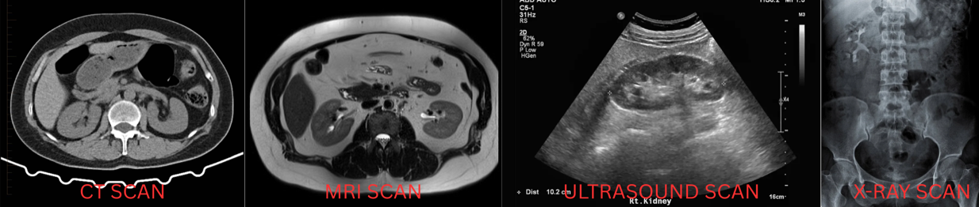
Figure 2. Modality Versatility
This versatility stems from a modality-agnostic design that performs equally well on 2D image slices and volumetric 3D data after appropriate architectural modifications.
Clinical utility extends to numerous organ systems and pathological conditions, including brain tumor segmentation in multimodal MRI, cardiac structures in echocardiography, liver lesions in CT imaging, and lung structures in chest radiography [28], [29]. Recent comprehensive reviews of deep learning in medical image segmentation highlight U-Net's dominance across these applications, with the architecture serving as the baseline against which novel methods are evaluated [28]. This broad applicability reflects the robustness of the core architecture and its adaptability to task-specific modifications.
In kidney imaging specifically, U-Net has been applied to simultaneous segmentation of kidneys, tumors, and cysts in contrast-enhanced CT imaging [19], [41]. Its computational efficiency allows for the segmentation of high-resolution 3D volumes in seconds, making integration into diagnostic workflows clinically feasible [12]. This rapid processing capability is particularly important for interventional procedures where real-time or near-real-time guidance is required.

2.3.4 U-Net Variants and Architectural Innovations
The success of the baseline architecture has prompted numerous refinements to handle increasingly complex segmentation tasks [28], [29]. One prominent variant, U-Net++, incorporates nested and dense skip pathways to bridge the semantic gap between feature maps extracted at different levels of the encoder and decoder (illustrated in Figure 7) [42].

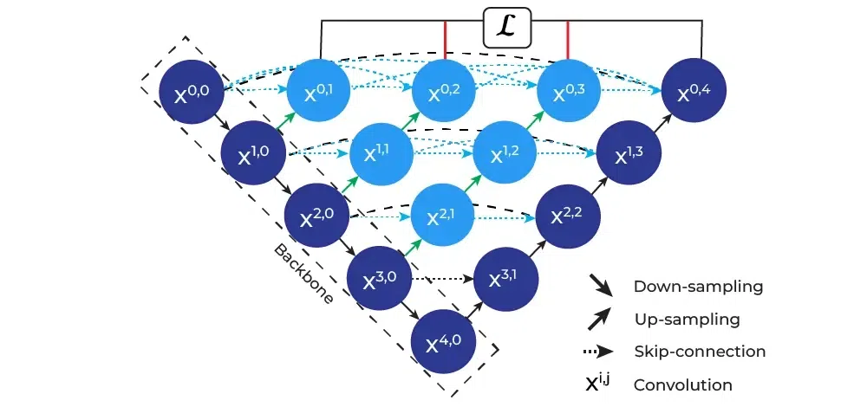
Figure 3. U-Net++ Architecture. Reprinted from [42].
By incorporating dense convolutional blocks at each skip connection node, U-Net++ reduces information loss during the decoding process and has demonstrated improved performance across multiple medical imaging datasets [42].
Attention-based variants have emerged as a major refinement direction, incorporating mechanisms to selectively focus on clinically relevant regions while suppressing background noise. Attention U-Net integrates attention gates within the skip connections to recalibrate feature maps based on spatial and channel-wise importance, improving segmentation accuracy particularly for small lesions (see the attention gate mechanism in Figure 8) [43].
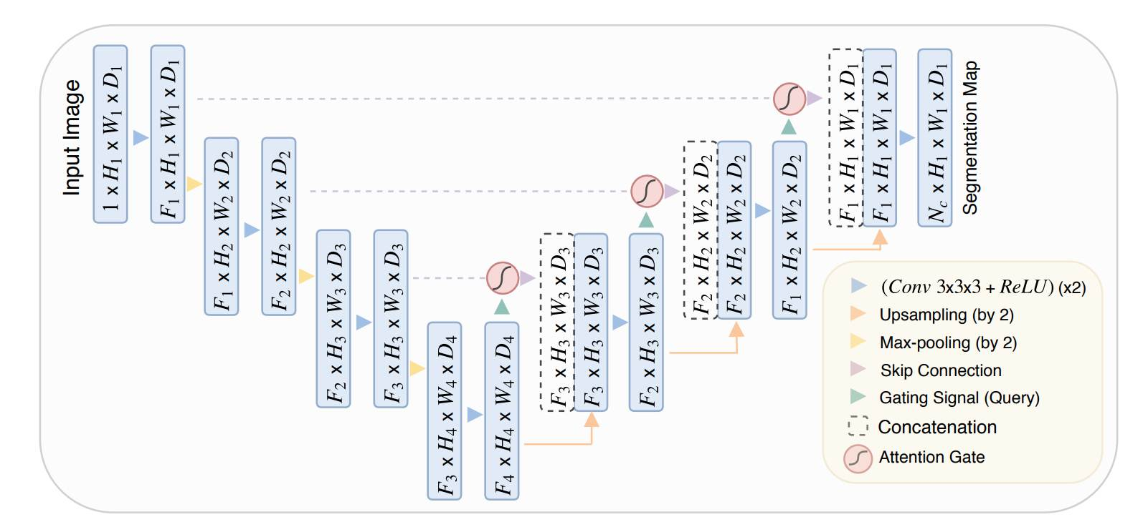
Figure 4. Attention Mechanism. Reprinted from [43].
Recent implementations specifically for kidney tumor segmentation have demonstrated that boundary attention mechanisms can significantly improve segmentation accuracy at tumor edges, addressing one of the primary challenges in renal mass characterization [41]. MSS U-Net introduced multi-scale supervised learning for 3D kidney and tumor segmentation, training the network to produce accurate predictions at multiple resolution levels simultaneously [44]. Similarly, recent work on the KiTS23 challenge explored various 3D U-Net training configurations to achieve superior segmentation performance [45]. Furthermore, 3D U-Net extends the original architecture to volumetric medical imaging by replacing 2D convolutions with 3D convolutional operations [28], [29]. Recent studies employing 3D U-Net for renal mass segmentation have achieved clinical-grade performance [17]. Hybrid variants like ResUNet combine the encoder-decoder structure with residual learning principles [28]. TransUNet pioneered the transformer approach by using a Vision Transformer as the encoder while maintaining U-Net's decoder structure (as depicted in Figure 9) [46].
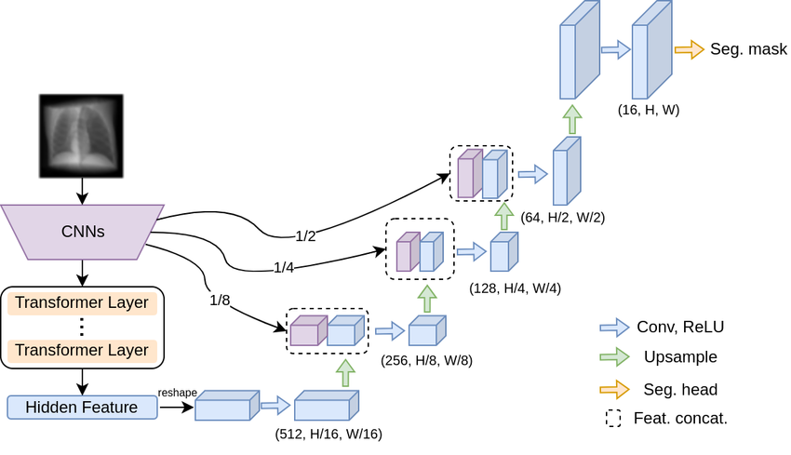
Figure 5. Hybrid Transformers. Reprinted from [46].
Swin-UNet further refined this concept using Swin Transformers with shifted window attention, demonstrating superior performance on multi-organ segmentation tasks including kidney structures [47]. The STC-UNet architecture incorporates Selective Kernel modules to address challenges posed by unclear boundaries and positional uncertainties in renal tumors [48]. Similarly, dual attention approaches have shown promise for ultrasound-based renal tumor segmentation, achieving MIoU scores exceeding 93% on clinical datasets [49].

2.3.5 Performance Metrics and Clinical Benchmarking
Standard segmentation evaluation metrics — including Dice Similarity Coefficient (DSC), Intersection over Union (IoU), 95th Percentile Hausdorff Distance (HD95), and precision-recall measures — are formally defined in Section 3.7. Published benchmarks suggest DSC exceeding 0.85 for organ segmentation and 0.75 for lesion segmentation constitute clinically acceptable performance [28], [29], with state-of-the-art systems reporting kidney DSC of 0.948, mass DSC of 0.776, and tumor DSC of 0.738 on challenge datasets [45].

2.4 The nnU-Net Framework

2.4.1 Overview of nnU-Net
nnU-Net is an automated self-configuring framework for deep learning-based medical image segmentation that has fundamentally transformed the clinical deployment of AI-powered diagnostic tools [51]. It automatically configures every component of the segmentation pipeline without requiring manual intervention beyond providing raw imaging data and corresponding binary segmentation annotations [51]. The fundamental motivation stems from the observation that small errors in configuration choices can lead to large drops in performance [51]. Analysis revealed that method configuration quality often exceeds architectural novelty, motivating a systematic, automated process [51]. The framework achieved first place in the KiTS19 kidney tumor segmentation challenge, establishing a benchmark for multi-institutional CT kidney segmentation [19]. Subsequent iterations have maintained dominance while preserving the core automated configuration principles [51]. Recent comprehensive benchmarking against contemporary architectures including Vision Transformers and Mamba-based models has validated that properly configured CNN-based U-Net variants within the nnU-Net framework continue to achieve state-of-the-art performance when rigorously evaluated [52].

2.4.2 Automated Configuration Architecture
The framework implements automated configuration through a three-tier parameter hierarchy (shown in Figure 12) that systematically handles design decisions [51].
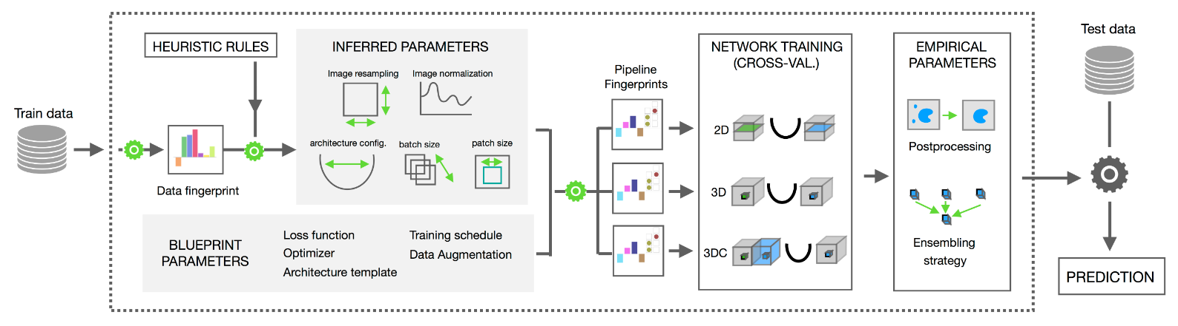
Figure 6. nnU-Net Configuration Hierarchy. Reprinted from [53]
The first tier consists of fixed parameters, including specific activation functions and loss function strategies combining Dice and cross-entropy loss [51]. The second tier comprises rule-based parameters, which establish explicit dependencies between the dataset fingerprint and the pipeline fingerprint [51]. One critical rule governs the interdependent configuration of batch size and patch size while respecting GPU memory constraints [51], [54]. Additional rules determine intensity normalization approaches tailored to specific modalities such as CT Hounsfield unit clipping or MRI z-score normalization [51]. The third tier consists of empirical parameters covering decisions that benefit from data-driven optimization on the specific dataset [51]. This includes determination of post-processing strategies such as connected component analysis [51], [54]. This strategy avoids the computational overhead of exhaustive hyperparameter search [51], [55].

2.4.3 Cascade Architecture and Multi-Resolution Processing
A critical feature is the systematic use of cascaded U-Net configurations for anatomical structures that occupy relatively small regions within imaging volumes [51]. The framework automatically detects spatial thresholds, triggering a two-stage cascade approach [51], [56]. In this configuration, the first U-Net operates on downsampled images to perform coarse localization of the target structures, while the second U-Net operates at full resolution within regions of interest identified by the first stage (see the cascade workflow in Figure 13) [52].
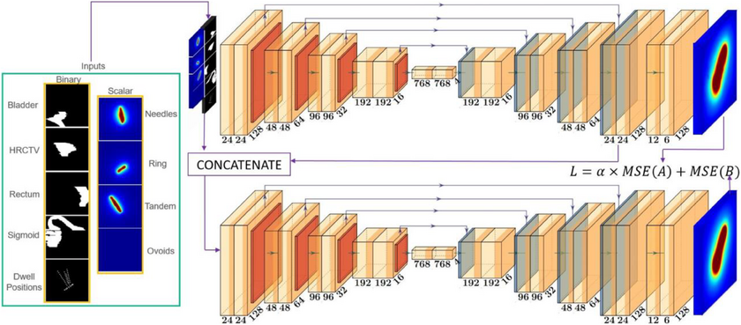
Figure 7. 3D Cascade Architecture. Retrieved from [57].
This cascade trigger directly addresses the fundamental trade-off between capturing sufficient contextual information for accurate localization and maintaining sufficient spatial resolution for precise boundary delineation [56], [58]. By automatically selecting cascade configurations, the system encodes domain knowledge about volumetric imaging without requiring manual intervention [51]. This design proves particularly valuable for kidney imaging applications where structures benefit substantially from the coarse-to-fine processing strategy [56], [58]. Recent implementations demonstrated the effectiveness of this approach for kidney tumor segmentation [56]. A two-stage cascaded framework effectively refined segmentation of kidney tumors and cysts [56]. This approach demonstrated that the cascade architecture effectively handles the multi-scale nature of kidney abnormality segmentation [56]. The intermediate cropping process maintains full-resolution detail for precise boundary characterization [56], [58].

2.4.4 Cross-Institutional Robustness and Domain Generalization
Robustness to domain shift represents a critical consideration for clinical deployment of automated segmentation systems [55]. The nnU-Net framework addresses domain shift through comprehensive data augmentation strategies scaled based on dataset properties [55]. Applied augmentations include geometric transformations and specialized techniques (an example of these augmentations are provided in Figure 14) [51], [55].
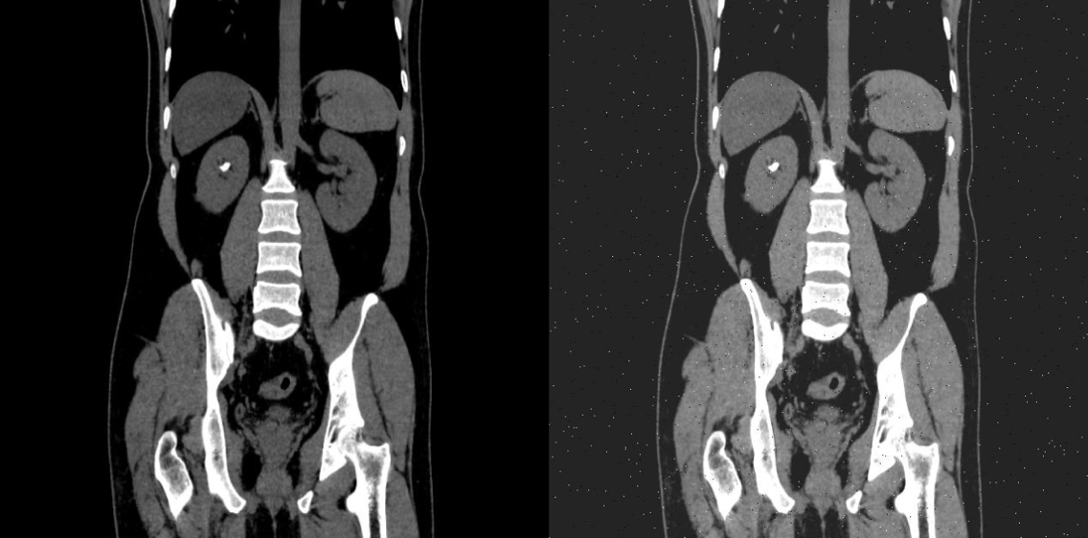
Figure 8. Data Augmentation Example
Empirical validation of cross-institutional robustness has been conducted across multiple imaging modalities and anatomical targets. nnU-Net's generalization capability has been demonstrated, showing that automated data augmentation maintained high Dice coefficients across different vendor domains comparable to performance within same-vendor data [55]. A rigorous evaluation of nnU-NetV2 was tested on an independent institutional dataset comprising 139 cases [18]. The study revealed models trained on diverse multi-institutional data demonstrated improved segmentation robustness and generalizability [18]. This finding emphasizes training dataset diversity maintains performance across diverse real-world imaging environments [18]. Models trained exclusively on single-institution data may fail to generalize to external populations, limiting practical utility in multi-site clinical networks [18]. The framework provides a pathway to supporting the deployment of AI-assisted diagnostic tools in real-world healthcare settings [18].

2.4.5 Empirical Performance and Validation
The empirical validation of nnU-Net spans an unprecedented diversity of segmentation tasks across modalities, anatomical structures, and imaging protocols [51]. Comprehensive evaluations have established nnU-Net as a state-of-the-art framework on the majority of tested public benchmarks [51]. The framework secured first place in multiple international biomedical imaging challenges [19], [51]. The KiTS19 challenge results showed robust performance across diverse tumor sizes and locations [19]. Subsequent challenges have validated nnU-Net's continued dominance, achieving high Dice scores for tumors on standardized challenge datasets [45], [59]. Comprehensive benchmarking against contemporary architectural alternatives including Vision Transformers and Mamba-based models has validated that properly configured CNN-based U-Net variants within the nnU-Net framework continue to achieve state-of-the-art performance when rigorously evaluated [52]. The study demonstrated that CNN-based approaches outperform alternatives on standard medical segmentation datasets [52]. Many reported performance improvements in recent literature resulted from validation shortcomings rather than genuine architectural superiority [52]. This validation confirms the approach remains highly competitive against novel architectures designed for large-scale datasets [52]. For kidney abnormality segmentation, these findings support the selection of nnU-Net over more computationally demanding Transformer alternatives [52], [60].

2.4.6 Clinical Translation and Accessibility
The accessibility of nnU-Net for clinical deployment represents a significant advance for hospital settings [51]. The framework requires minimal specialized knowledge, allowing clinical teams to apply the method directly to raw medical imaging data and binary annotation masks [51], [61]. Standard institutional GPU resources are generally sufficient, avoiding the need for high-performance computing infrastructure or multi-GPU clusters [51], [61]. The deployment workflow executes automated training scripts [51], [53]. The framework automatically handles all configuration decisions through the three-tier parameter hierarchy [51]. Resulting models generate pixel-level segmentation maps suitable for treatment response assessment, and surgical planning [13], [51]. This accessibility transforms automated segmentation into a tool deployable without formal deep learning training [51]. Recent applications demonstrate successful deployment achieving clinically acceptable segmentation performance with reduced computational requirements [62]. Such optimizations expand the practical applicability of automated segmentation tools to a broader range of healthcare facilities [62]. The framework's ability to handle multi-class segmentation tasks positions it as the natural choice for comprehensive characterization encompassing tumors, cysts, and stones [45], [56]. The cross-institutional robustness supports deployment across diverse clinical imaging environments [18], [58].

2.4.7 State-of-the-Art Deep Learning Frameworks for Kidney Segmentation
Building upon the clinical accessibility of these models, recent comparative studies have firmly established the superiority of self-configuring frameworks over traditional architectures for renal image analysis. A controlled benchmarking study directly compared the nnU-Net framework against a custom 3D U-Net for kidney and tumor segmentation [60]. By maintaining identical preprocessing, data augmentation, and training protocols, it was demonstrated that nnU-Net provides a highly robust baseline, outperforming the standard 3D U-Net in both Dice Similarity Coefficient (DSC) and Intersection over Union (IoU) [60]. Building upon these architectural advantages, the specific capabilities of the nnU-Net V2 architecture were investigated using a 3D full-resolution configuration [63]. The application of the model to the KiTS23 dataset yielded high DSC and IoU scores, cementing nnU-Net V2 as a highly optimized foundational architecture for multi-class renal segmentation tasks [63].

2.5 Identified Research Gaps
The comprehensive review of literature on kidney abnormality detection and segmentation reveals substantial progress in automated analysis of individual abnormality types, yet identifies critical gaps that limit the clinical applicability and comprehensiveness of existing approaches. These gaps motivate the development of integrated multi-class segmentation systems capable of simultaneously detecting and characterizing all major kidney abnormalities within unified clinical workflows.

2.5.1 Single-Class Focus in Existing Segmentation Systems
Current state-of-the-art deep learning approaches for kidney abnormality segmentation predominantly focus on single abnormality types, with separate specialized models developed for kidney tumors, cysts, or stones [18], [19], [39]. While individual models achieve impressive performance within their specific domains—tumor segmentation models reaching Dice scores exceeding 0.85 on KiTS challenge datasets [18], stone detection models achieving accuracies above 96% [64], and cyst segmentation showing robust performance in polycystic kidney disease applications [30]—no comprehensive system simultaneously addresses all three major abnormality categories within a unified framework.
This single-class paradigm creates substantial limitations for clinical deployment. In real-world diagnostic workflows, patients frequently present with multiple concurrent kidney abnormalities requiring comprehensive evaluation [14]. A patient may harbor both renal masses and incidental cysts, or demonstrate stone disease alongside cystic lesions. Current approaches necessitate running multiple independent models sequentially, each with its own preprocessing pipeline, inference requirements, and post-processing steps, resulting in computational inefficiency and workflow complexity that impedes clinical integration [45]. Furthermore, independent single-class models fail to leverage potential synergies in learning shared anatomical context and imaging features across abnormality types, potentially limiting both efficiency and performance.
The absence of multi-class kidney abnormality segmentation systems represents a fundamental gap in translating automated analysis from research benchmarks to comprehensive clinical decision support tools. Developing unified frameworks capable of simultaneous detection and precise delineation of tumors, cysts, and stones would substantially advance clinical applicability by providing radiologists with complete abnormality characterization from single imaging studies, supporting comprehensive diagnostic assessment and treatment planning [14].

2.5.2 Fragmented Public Datasets and the Need for Data Unification
While substantial public datasets exist for kidney abnormality segmentation, these resources remain fragmented across different clinical objectives and pathological entities. Datasets such as KiTS19, KiTS21, and KiTS23 focus primarily on tumor segmentation [19], [45], while other publicly available resources address specific pathologies like kidney stones or cystic lesions in isolation. This fragmentation creates a fundamental challenge: existing models are trained to recognize and segment individual abnormality types, but no unified public dataset exists that enables comprehensive multi-class segmentation encompassing tumors, cysts, and stones simultaneously.
This data fragmentation has significant clinical implications. In real-world diagnostic radiology, patients frequently present with multiple concurrent kidney pathologies, a tumor-bearing kidney may also contain cysts or stones, yet current segmentation approaches trained on isolated datasets cannot comprehensively characterize such cases. Deploying separate models for each abnormality type introduces computational inefficiency, potential inconsistencies in overlapping or adjacent structures, and workflow complexity that limits clinical adoption. The absence of a unified training framework that exposes models to the full spectrum of kidney abnormalities during learning prevents development of truly comprehensive diagnostic systems.
The research opportunity lies in unifying these disparate public datasets into a single multi-class training framework. By combining tumor-focused datasets (KiTS series) with publicly available stone and cyst datasets, we can create a comprehensive training corpus that exposes the model to the full range of kidney pathologies simultaneously. This unified approach addresses a fundamental gap in the current research landscape: while individual public datasets exist for specific pathologies, no prior work has systematically integrated these resources to enable simultaneous detection and segmentation of all major kidney abnormality types within a single model architecture.
This data unification strategy offers several advantages beyond simply training separate models on each dataset. Multi-class training enables the model to learn shared anatomical features and spatial relationships between different pathology types, potentially improving overall segmentation accuracy through cross-pathology feature learning. Additionally, a unified model reduces computational overhead during inference and simplifies clinical deployment compared to maintaining multiple specialized systems. Our study bridges this critical gap by developing the first comprehensive multi-class kidney abnormality segmentation framework trained on unified public datasets, demonstrating that integration of disparate data sources can produce clinically viable comprehensive diagnostic systems [18], [45].
Recent advancements have begun to address this data fragmentation. The introduction of the 3D Multi-class Segmentation of Whole Abdominal Lesions (MSWAL) dataset represents a significant shift toward unified pathological annotations, providing comprehensive voxel-level ground truth for multiple abdominal abnormalities, including kidney stones, cysts, and tumors, within single volumetric scans [20]. While MSWAL provides a robust foundation for multi-class learning, it is constrained by its single-institution origin. Therefore, this study's strategy of harmonizing a multi-class dataset (MSWAL) with a multi-institutional dataset (KiTS23) address both the structural fragmentation of public datasets and the critical need for cross-institutional robustness in model training.

2.5.3 Insufficient Integration of Clinical Classification Systems
While automated segmentation provides precise anatomical boundaries of kidney abnormalities, existing systems generally do not integrate outputs with established clinical classification frameworks that guide diagnostic and therapeutic decisions. The Bosniak classification for cystic lesions, R.E.N.A.L. nephrometry scoring, and stone burden quantification metrics remain underdeveloped in automated computation [5], [7]. Accurate segmentation alone is insufficient without Bosniak category assignment based on wall thickness, septation characteristics, enhancement patterns, and calcification presence [7]. Renal mass segmentation requires exophytic properties and polar location for surgical planning and intervention selection [5]. Stone disease management depends critically on quantitative metrics including total stone burden, individual dimensions, and density characteristics that inform composition and treatment susceptibility [16].

2.5.4 The Comprehensive Metric Evaluation Gap
In addition to the limitations in dataset fragmentation and clinical integration, a review of the current baseline literature reveals a significant gap in comprehensive, multi-class clinical evaluations. Beyond standard overlap metrics like DSC and IoU, rigorous clinical validation requires assessing boundary distances and prediction exactness. A comprehensive validation study of an AI-based kidney segmentation framework was recently conducted utilizing evaluation metrics such as the 95th percentile Hausdorff Distance (HD95), Precision, Recall, and F1-score [65]. While this provides a strong methodological baseline for multi-metric evaluation, a notable limitation is the consolidation of distinct pathological classes. In this framework, cysts and tumors were merged into a singular "abnormality" class, inherently limiting the model's utility for precise differential diagnosis [65].
Furthermore, while foundational studies establish standard performance benchmarks for kidneys and tumors [60], [63], none of the current state-of-the-art baselines incorporate kidney stones alongside cysts and tumors in their evaluation. Consequently, there remains an unmet need for a single, unified framework capable of simultaneously isolating distinct renal pathologies—specifically kidneys, tumors, cysts, and stones—while being evaluated against a comprehensive suite of overlap, boundary, and efficiency metrics. To address the absence of kidney stones in unified multi-class evaluations, baseline metrics for this specific pathology must be drawn from dedicated stone segmentation models. Recent automated systems have successfully established volumetric segmentation baselines for kidney stones on non-contrast CT scans [24]. Furthermore, specialized deep segmentation networks have been utilized to simultaneously segment both the renal structure and calculi, providing essential overlap metrics such as DSC for stone detection [39]. In this study, the performance of the proposed multi-class nnU-Net framework on the stone class will be benchmarked against these dedicated single-task and dual-task models to ensure rigorous clinical validation across all isolated abnormalities.

2.5.5 Gap Summary and Research Opportunity
The identified gaps collectively point to a specific, addressable research opportunity in computer science: the absence of a controlled comparative study between single-class and multi-class nnU-Net V2 segmentation for kidney abnormalities. While prior work has validated nnU-Net V2 for kidney tumor segmentation [18][19] and the MSWAL dataset enables multi-class ground truth annotation [20], no study has isolated the performance effect of training strategy — single-class versus multi-class — using the same architecture, data, and metrics. This study addresses that gap directly, using 3D U-Net as a consistent baseline reference, and provides the first statistically grounded comparison to guide practitioners in choosing between single-class and multi-class segmentation pipelines for renal CT analysis.

Chapter 3
METHODOLOGY
This chapter presents the comprehensive methodological framework and computational procedures developed to achieve the comparative investigation described in Chapter 1. Grounded in a retrospective analysis of clinical Computed Tomography (CT) data, the study employs a two-phase experimental design using the self-configuring nnU-Net V2 deep learning architecture. In Phase 1, three single-class models are independently trained and validated against published benchmarks. In Phase 2, one multi-class model trained simultaneously on all three abnormality classes is compared directly against those validated single-class models. The methodology is organized through an Input-Process-Output (IPO) model, spanning from physiological normalization of raw radiological data to the rigorous quantitative evaluation and qualitative clinical review by radiologists.

3.1 Conceptual Framework
The methodological architecture of this research is grounded in the intersection of computational medical imaging, deep learning-based semantic segmentation, and clinical decision support system. The primary objective is to translate raw radiological data into actionable clinical insights through the automated delineation of kidney substructures and pathologies – specifically cysts, stones, and tumors. This study adopts a rigorous Input-Process-Output (IPO) model, a fundamental system engineering approach that structures the methodology into three distinct but interconnected phases: data ingestion and preparation (Input), computational analysis and model training (Process), and performance evaluation and clinical inference (Output).

3.1.1 The Input-Process-Output (IPO) Model
The IPO model serves as the architectural skeleton of this thesis, ensuring a logical flow of data and rigorous validation of the segmentation results (as illustrated in the framework diagram in Figure 15).
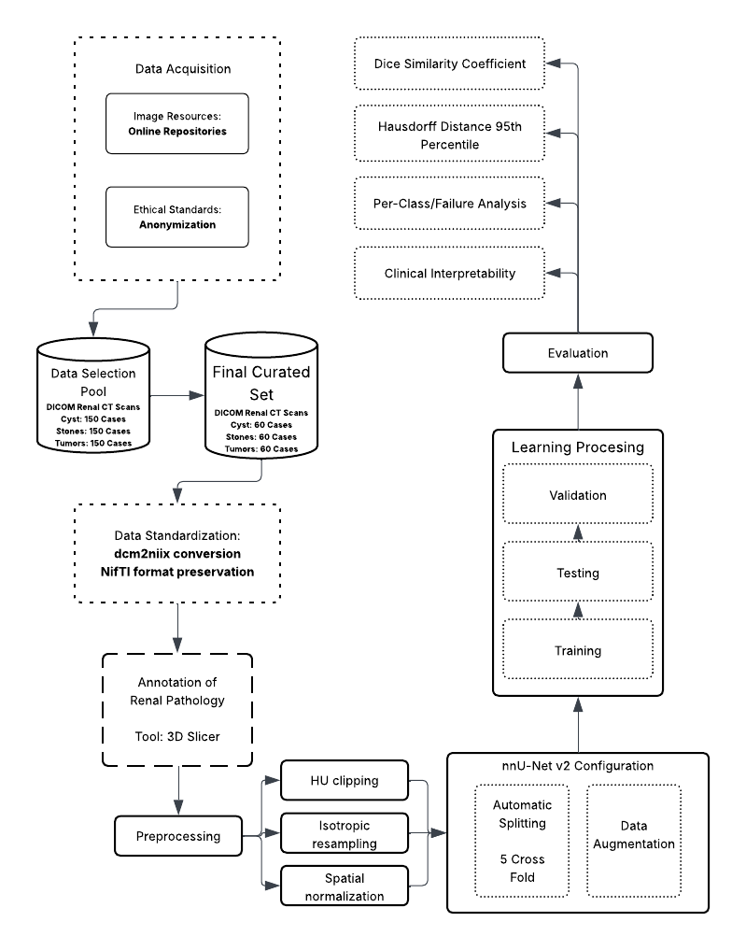
Figure 9. Conceptual Framework
This system-theoretic perspective allows for the isolation of variable at each stage, ensuring that errors can be traced back to specific components – whether they be artifacts in the input data, convergence failures in the process, or metric misinterpretations in the output.

3.1.2 Input Phase: Data Ingestion and Physiological Standardization
The foundation of the framework lies in the acquisition of high-fidelity volumetric CT data. The input stage is characterized by the transformation of raw medical data into a machine-readable format. This involves the ingestion of DICOM (Digital Imaging and Communications in Medicine) series, which contain not only the pixel data but also critical metadata regarding the acquisition parameters. The conversion of these series into the NIfTI (Neuroimaging Informatics Technology Initiative) standard is a pivotal step, as it creates a unified volumetric representation that preserves the affine matrix—defining the spatial relationship between the image voxels and the physical world coordinate system.
The preprocessing phase within the Input stage is conceptually critical as it bridges the domain gap between physical tissue density—measured in Hounsfield Units (HU)—and the numerical inputs required by the neural network. By applying specific intensity clipping (Focus range of -135 to 215 HU) and resampling techniques (1.0 mm isotropic spacing), the input stage standardizes the physical variance across different patients and scanners. This "physiological normalization" ensures that the neural network learns to associate specific numerical ranges with specific tissue types (e.g., distinguishing a dense stone from soft tissue), rather than learning scanner-specific noise patterns.

3.1.3 Process Phase: Deep Learning and Volumetric Segmentation
The process component is driven by the 3D U-Net architecture within the nnU-Net v2 framework. The conceptual novelty here is the use of deep supervision, where the network learns to segment structures at multiple resolutions simultaneously. This mechanism involves injecting auxiliary loss layers at various stages of the decoder pathway, thereby improving gradient flow deep into the network and maximizing feature extraction from both coarse and fine spatial scales. This stage encompasses the iterative training of the model using a composite loss function (Dice Loss plus Cross-Entropy Loss), stochastic optimization via Stochastic Gradient Descent (SGD) with Nesterov momentum, and massive on-the-fly data augmentation. The augmentation strategy is designed to enforce translational, rotational, and intensity invariance, forcing the model to learn robust anatomical features rather than memorizing the specific orientation or contrast levels of the training cases. The use of 5-fold cross-validation during this phase ensures that the model's performance is robust across the entire dataset distribution and not biased by a specific train-test split.

3.1.4 Output Phase: Evaluation and Clinical Inference
The output of the framework is a multi-class segmentation map where each voxel is classified into one of five categories: background, kidney, cyst, stone, or tumor. The conceptual validity of these outputs is assessed using a comprehensive multi-metric approach. The primary metrics are:
- Volumetric Overlap: The Dice Similarity Coefficient (DSC) quantifies the spatial overlap between the prediction and the ground truth, providing a global measure of segmentation quality.
- Boundary Accuracy: The Hausdorff Distance 95th Percentile (HD95) measures the worst-case error at the segmentation boundaries, offering critical insight into the geometric precision of the model, which is vital for surgical planning and radiotherapy.

Furthermore, the framework incorporates a "Human-in-the-Loop" validation mechanism, where expert radiologists review failure cases (identified by low DSC scores) to provide qualitative feedback. This step transforms the thesis from a purely computational exercise into a clinically relevant study, categorizing errors into detection failures, false positives, or boundary inaccuracies.

3.2 Data Management
The integrity, diversity, and quality of the dataset are paramount to the success of any deep learning model, particularly in the medical domain where data scarcity and class imbalance are prevalent challenges. The data acquisition strategy for this thesis is designed to ensure strict compliance with medical data interoperability standards, ethical guidelines regarding patient privacy, and the specific technical requirements of the nnU-Net v2 training pipeline.

3.2.1 Sources and Ethical Considerations
The dataset was curated from two primary publicly accessible biomedical imaging repositories. Tumor segmentation cases were sourced from the KiTS23 (Kidney and Kidney Tumor Segmentation) challenge dataset, a multi-institutional repository with expert-verified ground truth masks. Multi-class cases encompassing concurrent cysts, stones, and tumors were sourced from the MSWAL (3D Multi-class Segmentation of Whole Abdominal Lesions) dataset, which provides comprehensive voxel-level annotations for multiple pathologies within single volumetric scans. This harmonization of KiTS23 with MSWAL directly addresses the data fragmentation identified in Section 2.5.2, combining multi-institutional breadth with multi-class annotation coverage. Given the retrospective nature of this study—involving the computational analysis of previously collected clinical data generated during routine patient care—strict ethical protocols are observed to protect subject confidentiality. Each case represents a complete 3D volumetric CT scan comprising approximately 100 slices per anatomical plane. By extracting all three standard views — axial, coronal, and sagittal — each volumetric case yields approximately 300 2D slices, resulting in a comprehensive training corpus of approximately 87,000 individual 2D slices.
Data Selection Strategy: To ensure the model generalizes across heterogeneous clinical presentations, the data curation protocol deliberately preserves the natural distribution of renal pathologies rather than artificially forcing a class balance. A total of 290 high-value volumetric CT cases were curated from the available public repositories. To accurately reflect real-world clinical complexity, this finalized experimental set includes 74 cases of pure nephrolithiasis (stones), 50 cases of pure renal cysts, and 45 cases of pure solid neoplasms. Crucially, the remaining 121 cases (41.7% of the dataset) exhibit concurrent multi-pathologies (clinical co-morbidities). The inclusion of these complex, overlapping presentations is a strict methodological requirement to test the simultaneous characterization capabilities of the multi-class framework against the sequential limitations of single-class models. Cases are selected based on a Diversity Criteria to maximize variance in:
- Size: Balancing micro-lesions (<5mm) with large masses (>4cm).
- Location: Ensuring representation of upper, mid, and lower pole lesions, as well as cortical vs. medullary placement.
- Morphology: Selecting cases with varying densities (HU values) and shapes (e.g., simple vs. complex cysts, staghorn vs. focal stones).
To ensure absolute methodological transparency, the experimental corpus is strictly defined to this 290-volume cohort, which is exclusively subjected to the computational pipeline. During the automated 5-fold cross-validation, this corpus is partitioned such that each fold utilizes 232 volumes (80%) for training and 58 volumes (20%) for internal validation.
This curation ensures that although the final dataset size is compact, it is mathematically representative of the disease spectrum, preventing the model from over-optimizing on "easy" or repetitive cases.
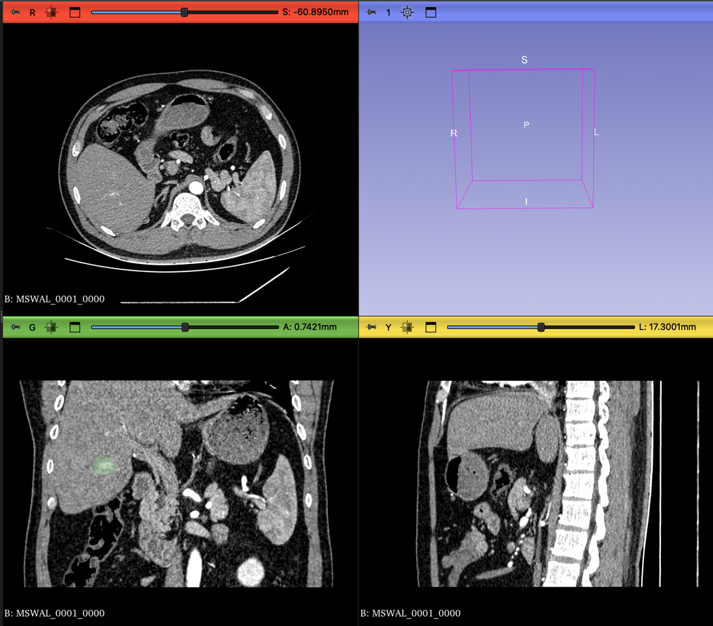
Figure 10. CT scan in different views

3.2.2 Ethical Compliance Framework:
    - Retrospective Study Protocol: Since this study utilizes publicly available, pre-anonymized datasets distributed under CC-BY-NC 4.0, institutional IRB approval was not required. The study strictly adheres to the data usage agreements of the respective repositories.
    - De-identification and Anonymization: All patient data is strictly anonymized at the source prior to transfer for computational analysis. This process involves the irreversible removal or masking of all Protected Health Information (PHI) from the DICOM headers. Specific tags such as Patient Name (0010,0010), Patient ID (0010,0020), Patient Birth Date (0010,0030), and Institution Name (0008,0080) are scrubbed or replaced with study-specific pseudonyms (e.g., Kidney_001). This ensures that the dataset used for training contains no linkages to the original patient identities, complying with data privacy regulations such as HIPAA or GDPR.
    - Data Security: The anonymized data is stored on secure, encrypted servers (e.g., Google Drive mounted to Colab Pro+ with restricted access), ensuring that only authorized research personnel have access to the imaging volumes.

3.2.3 DICOM to NIfTI Conversion
Raw medical images are generated by CT scanners in the DICOM (Digital Imaging and Communications in Medicine) format. While DICOM is the standard for clinical storage (PACS), it is suboptimal for deep learning due to its slice-based file structure (one file per slice) and complex metadata hierarchy. Deep learning frameworks, including nnU-Net, require the NIfTI (Neuroimaging Informatics Technology Initiative) format (.nii.gz), which encapsulates the entire 3D volume into a single compressed file and strictly defines the spatial coordinate system (affine matrix) necessary for 3D volumetric operations.

Conversion Protocol:
- Input: A directory containing the series of DICOM slices for a single patient study.
- Processing: dcm2niix reads the DICOM header information to reconstruct the contiguous 3D volume. It validates the slice ordering based on the ImagePositionPatient tag and handles any gantry tilt correction to ensure the resulting volume is orthogonal.
- Metadata Extraction: In addition to the image volume, dcm2niix generates a JSON sidecar file containing critical acquisition parameters such as slice thickness, pixel spacing, manufacturer, and convolution kernel. This metadata is essential for the subsequent "Dataset Fingerprinting" stage of nnU-Net.
- Output: A compressed NIfTI file (.nii.gz) representing the anatomical volume.

3.2.4 Dataset Organization and Structure
Following conversion, the data is restructured according to the rigid nnU-Net raw data format. This structure is inspired by the Medical Segmentation Decathlon (MSD) organization, which facilitates the automated parsing and cross-validation of datasets. Proper adherence to this structure is a prerequisite for the nnUNetv2_plan_and_preprocess command to function.

The directory hierarchy is established as follows:
- nnUNet_raw/DatasetXXX_Name/: The root folder for the task, where XXX is a unique three-digit identifier (e.g., 501) and Name describes the task (e.g., KidneyAbnormality).
- imagesTr/: Contains the training images (CT scans). Files must follow the naming convention Case_Identifier_0000.nii.gz. The _0000 suffix indicates the modality channel (CT).
- labelsTr/: Contains the corresponding ground truth segmentation masks. Files must be named Case_Identifier.nii.gz (without the modality suffix).
- dataset.json: A descriptor file defining the dataset properties. This JSON file acts as a manifest, containing:
  - channel_names: Mapping of channel IDs to modality types (e.g., {“0”: “CT”}).
  - labels: Mapping of integer pixel values to class names (e.g., {“0”: “background”, “1”: “kidney”, “2”: “cyst”, “3”: “stone”, “4”: “tumor”}).
  - numTraining: The total count of training cases.
  - file_ending: The file extension used (.nii.gz).

3.2.5 Dataset Characterization
The initial phase of the nnU-Net pipeline involves the extraction of a “dataset fingerprint,” which captures the intrinsic spatial and intensity properties of the CT data acquired from sources. This fingerprint guides the automated configuration of patch sizes, batch sizes, and network depth. The key characteristics identified during this heuristic analysis are summarized in Table 1.
Property | Value/Description
Modality | Computed Tomography (CT)
Image Size (Voxels) | Variable (Standardized via Resampling)
Target Voxel Spacing | [1.0, 1.0, 1.0]
HU Clipping Range | -135 HU to 215 HU (Automatically set by nnU-Net v2)
Class Distribution | 5 Classes: Background, Kidney, Cyst, Stone, Tumor
Final Curated Set | 290 Volumetric Cases
Data Splitting | 5-Fold Cross-Validation
Table 1. Dataset Fingerprint Characteristics
While the dataset consists of 290 unique volumetric cases, the extraction of all three standard anatomical planes — axial, coronal, and sagittal — yields approximately 300 2D slices per case, resulting in a comprehensive training corpus of approximately 87,000 individual 2D slices. Furthermore, the patch-based training paradigm of nnU-Net — where the network samples multiple overlapping 3D sub-volumes per case during each training epoch — and the aggressive on-the-fly data augmentation strategy (detailed in 3.3.4) collectively ensure that the effective number of training samples seen by the model over 1,000 epochs substantially exceeds the raw case count. This design mirrors precedents in the medical imaging literature where compact, high-quality volumetric datasets have achieved competitive segmentation performance when paired with self-configuring frameworks such as nnU-Net [51], [58].

3.3 Data Preprocessing
Data preprocessing in medical image analysis is a fundamental step that transforms raw physical measurements into a normalized numerical space suitable for statistical learning. In the context of deep learning, where models are sensitive to the distribution and scale of input data, preprocessing is not merely a formatting step but a physiological normalization process. The goal is to standardize the physical properties of the input data so that the neural network learns to associate specific numerical values and spatial shapes with anatomical structures, rather than learning artifacts of the acquisition process or inter-patient variability. The preprocessing pipeline for this thesis involves three critical operations: Hounsfield Unit (HU) clipping, isotropic resampling, and Z-score normalization.

3.3.1 Hounsfield Unit (HU) Clipping and Intensity Filtering
Computed Tomography (CT) images provide a quantitative measure of radiodensity, expressed in Hounsfield Units (HU). The HU scale is a linear transformation of the linear attenuation coefficient of the material, calibrated such that the radiodensity of distilled water at standard temperature and pressure (STP) is defined as 0 HU, and the radiodensity of air is defined as -1000 HU. This standardization is a unique advantage of CT over MRI (where intensity values are relative), as it allows for the absolute differentiation of tissues based on their physical density.
However, the full dynamic range of a modern CT scanner can extend from -1000 HU (air) to over +3000 HU (dense metal implants or cortical bone). For the specific task of segmenting kidneys and their associated soft-tissue abnormalities, the vast majority of relevant anatomical information is contained within a much narrower range. "Soft tissues" generally fall between -100 and +200 HU. Feeding the full dynamic range into the network would compress the contrast resolution of the soft tissues, making it difficult for the model to discern subtle differences between a cyst (fluid) and a tumor (solid tissue).
To assist the neural network in focusing on the relevant anatomical features and to eliminate outliers, intensity clipping is applied.
Mechanism: All voxel values below a defined lower threshold are set to that lower threshold, and all values above a defined upper threshold are set to that upper threshold.
Parameters: The clipping range is explicitly set to -135 HU to 215 HU.

These bounds are physiologically grounded. The lower bound of −135 HU excludes air and perinephric fat (typically −50 to −100 HU), effectively masking non-renal background while preserving the kidney within its retroperitoneal fat capsule. The upper bound of 215 HU encompasses all clinically relevant soft tissues: renal parenchyma (30–180 HU depending on contrast phase), cysts (0–20 HU), and solid tumors (40–100 HU). Values above 215 HU — predominantly cortical bone and calcified structures — are treated as uniform ceiling values, preventing high-density outliers from compressing the soft-tissue contrast range the network relies on.

3.3.2 Isotropic Resampling and Spatial Normalization
CT scans are volumetric data composed of stacked 2D slices. A significant challenge in medical imaging is anisotropy, where the physical resolution within a slice (pixel spacing, e.g., 0.7 x 0.7 mm) is much higher than the resolution between slices (slice thickness, e.g., 3.0 mm or 5.0 mm). This results in voxels that are rectangular prisms rather than cubes. If raw anisotropic data were fed into a 3D CNN, the network would learn distorted spatial filters. For example, a spherical kidney stone would appear as a flattened pancake in the voxel space if the slice thickness is large. This would severely impair the network's ability to recognize the true 3D morphology of tumors and stones.

To address this, the methodology mandates resampling to a uniform voxel spacing.
Target Spacing: The dataset is resampled to [1.0, 1.0, 1.0] mm isotropic spacing.
Implication: This transformation creates a new voxel grid where every voxel is a perfect cube of 1mm edges.
Algorithm:
  - Image Data: Third-order spline interpolation is used for the CT images. Spline interpolation fits a smooth curve through the surrounding pixel values to calculate the intensity of the new voxels. This preserves the continuous nature of tissue density and maintains the subtle gradients at the boundaries of lesions.
  - Label Masks: Nearest-neighbor interpolation is strictly used for the segmentation masks. Because the masks consist of categorical integers (0, 1, 2, 3, 4), using spline interpolation would introduce fractional values (e.g., 1.5), which are meaningless class identifiers. Nearest neighbor ensures that the class labels remain discrete integers.
This resampling step ensures that physical distances are represented consistently across all three axes (Axial, Sagittal, Coronal), allowing the 3D U-Net to perform spatial convolutions effectively in all directions and recognize the true volumetric shape of renal abnormalities.
After resampling to [1.0, 1.0, 1.0] mm isotropic spacing, all three standard anatomical planes — axial, coronal, and sagittal — are extracted from each volumetric case. Because the voxels are isotropic cubes, all three planes carry equivalent resolution and are geometrically consistent, making multi-planar extraction a straightforward augmentation of the training corpus without introducing resolution artifacts.

3.3.3 Cropping to Non-Zero Region
On datasets that are not pre-processed; to optimize computational efficiency and reduce memory usage, the preprocessing pipeline includes an automated cropping step. Medical images often contain large areas of background air surrounding the patient's body. nnU-Net automatically detects the non-zero region (the body area) and crops the volume to the bounding box of the patient. This significantly reduces the size of the input tensor, allowing for larger batch sizes or patch sizes during training, which contributes to better context modeling.

3.3.4 Augmentation Setting and Data Splitting
Given the high dimensionality of 3D medical data and the limited number of annotated samples available in clinical datasets, deep learning models are prone to overfitting. To mitigate this, a comprehensive data augmentation strategy is combined with a rigorous, automated data splitting scheme.
Data Augmentation Strategy
Category | Transformation | Description and Clinical Justification
Spatial | Rotation & Scaling | Random rotations (z-axis: [-180, 180], x/y: [-30, 30]) and scaling (0.7x - 1.4x) simulate variations in patient positioning and differences in organ size.
 | Elastic Deformation | Simulates natural soft-tissue deformation caused by respiration or pressure from adjacent organs.
 | Mirroring | Random mirroring along axes to leverage the approximate bilateral symmetry of the kidneys.
Intensity | Gaussian Noise/Blur | Simulates scanner noise and reconstruction variability (e.g., soft vs. bone kernels).
 | Brightness/Contrast | Makes the model invariant to slight variations in HU calibration or contrast enhancement phases.
 | Gamma Correction | Non-linear intensity transformation to simulate diverse tissue density shifts.
Table 2. Data Augmentation Strategy
Data Splitting: Automated 5-Fold Cross-Validation
The data splitting process in this study is handled automatically by the nnU-Net v2 pipeline, which implements a 5-fold cross-validation scheme by default to ensure unbiased performance estimation.
The Automated Splitting Mechanism:
Pipeline-Driven Partitioning: Once the dataset is standardized and the dataset.json is parsed, nnU-Net automatically partitions the total training cases into 5 equal, non-overlapping subsets (folds).
80/20 Distribution: For each of the 5 iterations, the framework uses 4 folds (80% of the data, or 232 volumes) for model training. The remaining fold (20% of the data, or 58 volumes) serves as the independent internal validation and testing set. By the end of the 5 iterations, every case in the 290-volume dataset has been used exactly once as an unseen test case.
Cross-Validation Iterations: The framework generates 5 independent sets of model weights (Fold 0 through Fold 4). This ensuring that every single case in the dataset is used for validation exactly once, providing a comprehensive assessment of the model's ability to generalize to unseen data.

3.4 Network Architecture: The 3D U-Net and Deep Supervision
The core computational engine of this methodology is the 3D U-Net, a fully convolutional neural network specifically designed for volumetric segmentation. While the U-Net architecture is a standard in biomedical imaging, the nnU-Net v2 implementation introduces dynamic adaptation and deep supervision to maximize performance.
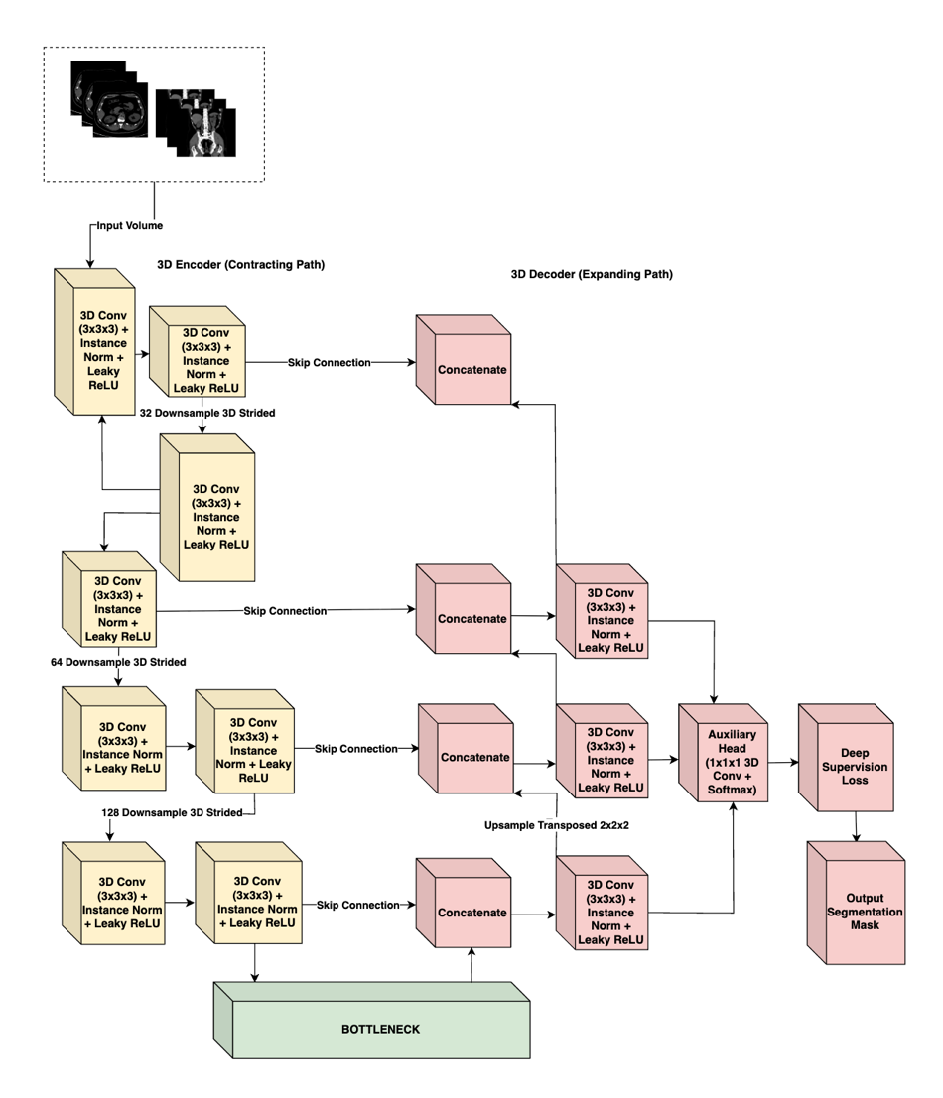
Figure 11. nnU-Net V2 Architecture

3.4.1 Architectural Topology
The network follows the classic symmetric Encoder-Decoder structure with skip connections, adapted for 3D inputs:
- The Encoder (Contracting Path): This pathway functions as a feature extractor. It consists of repeated blocks of convolutional layers. In nnU-Net v2, these blocks typically comprise:
3D Convolution: 3 x 3 x 3 kernels to extract spatial features.
Instance Normalization: Used instead of Batch Normalization because batch sizes in 3D training are often small (due to memory constraints), rendering Batch Norm unstable. Instance Norm normalizes each sample independently, preserving the contrast information of the individual scan.
Leaky ReLU: A non-linear activation function $f\left(x\right)=max⁡(0.01x,x))$ that introduces non-linearity while allowing a small gradient to flow even for negative values, preventing the "dying ReLU" problem.
Strided Convolution: Used for downsampling (reducing spatial resolution) instead of max-pooling. This allows the network to learn the optimal downsampling operation.
- The Bottleneck: The deepest part of the network represents the input volume in a highly abstract, low-resolution feature space, capturing semantic context (e.g., "presence of a tumor") rather than precise localization.
- The Decoder (Expanding Path): This pathway recovers the spatial resolution. It utilizes transposed convolutions to upsample the feature maps.
Skip Connections: Critical to the U-Net design, these connections concatenate the high-resolution feature maps from the Encoder directly to the corresponding layers in the Decoder. This re-injects the fine-grained spatial details (gradients, edges) lost during down sampling, enabling the decoder to precisely localize the boundaries of small structures like kidney stones.

3.4.2 Deep Supervision
A key conceptual element of the nnU-Net methodology is Deep Supervision. In standard networks, the loss is calculated only at the final output layer. However, in deep 3D networks, gradients can vanish as they backpropagate through many layers, making the training of the early layers difficult.
nnU-Net addresses this by outputting segmentation maps not just at the final full-resolution layer, but also at lower-resolution stages of the decoder.
  - Mechanism: Auxiliary segmentation heads are attached to the lower-resolution blocks of the decoder.
  - Loss Calculation: The loss is computed for each of these outputs (compared against down sampled versions of the ground truth).
  - Weighted Sum: The total loss is a weighted sum of the losses at different resolutions. The weights typically decay exponentially (e.g., 1/2, 1/4, 1/8) for lower resolutions, prioritizing the final high-resolution output.
  - Benefit: This forces the deeper layers of the network to learn semantically meaningful representations early in the training process and improves gradient flow, leading to faster and more stable convergence. It ensures that the network pays attention to both coarse context (organ localization) and fine detail (lesion boundaries).

3.5 Computational Pipeline
The training pipeline is meticulously configured to ensure convergence in the high-dimensional non-convex optimization landscape of 3D segmentation.

3.5.1 Environment and Reproducibility
To ensure the computational reproducibility of this study, all experiments were conducted within a standardized software and hardware environment. The model will be trained using Python 3.11 and the PyTorch deep learning framework, utilizing nnU-Net v2. High-intensity computations were executed on a single NVIDIA A100 GPU with 40GB VRAM, hosted via Google Colab Pro+. This hardware configuration provided the necessary VRAM budget to support large patch sizes and optimized batch gradients, ensuring stable convergence during the 1000-epoch training cycle.
Component | Technical Detail
Deep Learning Framework | PyTorch 2.x / nnU-NetV2
Programming Language | Python 3.11
GPU Hardware | NVIDIA A100 (40GB VRAM)
Computing Platform | Google Colab Pro+
Conversion Utility | dcm2niix (Python Library)
Annotation Platform | 3D Slicer
Table 3. Technical Specifications

3.5.2 Training Configuration and Optimization
Optimizer: The Stochastic Gradient Descent (SGD) optimizer is selected, utilizing Nesterov momentum. While adaptive optimizers like Adam are popular, empirical evidence from the nnU-Net authors suggests that SGD with Nesterov momentum generalizes better for medical segmentation tasks.
Hyperparameter | Value/Configuration
Training Schedule | 1000 Epochs (250 iterations per epoch)
Optimization Algorithm | SGD with Nesterov Momentum (0.99)
Initial Learning Rate | ${10}^{-2}$ (Polynomial decay schedule)
Weight Decay | $3 x {10}^{-5}$
Objective Function | Dice Similarity + Cross – Entropy Loss
Validation Strategy | Automated 5-fold Cross-Validation
Table 4. Training Hyperparameters
Momentum: Set to 0.99. This high momentum helps the optimizer navigate the complex loss landscape, allowing it to barrel through shallow local minima and converge to a flatter, more robust minimum.
Weight Decay: Set to $3 x {10}^{-5}$ to prevent overfitting by penalizing large weights (L2 regularization).

3.5.3 Loss Function Math
The training objective is minimized using a compound loss function that combines Dice Loss and Cross-Entropy (CE) Loss:
$$L_{total}=L_{Dice}+L_{CrossEntropy}$$
- Dice Loss: Directly optimizes the metric of interest (Dice score). It is robust to class imbalance because it relies on the intersection-over-union concept. Even if the background is 99% of the image, the Dice loss focuses solely on the overlap of the foreground classes.
- Cross-Entropy Loss: Provides dense, pixel-wise supervision by penalizing incorrect class probability assignments for every voxel in the volume. Unlike Dice Loss, which is computed globally over the segmentation mask, CE Loss enforces local correctness at each voxel, improving boundary sharpness and stabilizing training in the early epochs when Dice gradients are weak.
Training Schedule:
- Epochs: The model is trained for a fixed duration of 1000 epochs. Uniquely, an "epoch" in nnU-Net is defined not by the dataset size, but as a fixed number of iterations (250 mini-batches). This results in a total of 250,000 training steps.
- Learning Rate (LR): A "poly" learning rate policy is employed. The initial LR (typically 0.01) is decayed following a polynomial curve:
$$LR_{iter}=LR_{initial} x {\left(1- \frac{iter}{maxiter} \right)}^{0.9}$$
This allows for rapid exploration of the loss landscape in the early phases and precise fine-tuning in the later phases.

3.5.4 Inference and Post-Processing
Following the inference phase, nnU-Net v2 evaluates the validity of the predicted masks through automated post-processing. This primarily involves Connected Component Analysis (CCA), where the framework identifies and removes small, isolated clusters of pixels that are statistically unlikely to represent actual anatomical structures or lesions. By eliminating these "islands" of noise, the methodology ensures the generation of more coherent and clinically plausible segmentation masks, which is particularly vital for accurately delineating high-contrast structures like kidney stones in complex abdominal scans.

3.6 Annotation Pipeline
The validity of any supervised learning model is bounded by the quality of its ground truth. We employed a dual-stream data ingestion strategy:
  - Pre-annotated Data: For cases sourced from the KiTS23 and MSWAL repositories, which include expert-verified segmentation masks, we utilized the provided ground truth labels. These masks underwent a Verification Protocol to ensure compatibility with our class mapping (Table 5) and NIfTI conversion standards. KiTS23 labels were remapped to align tumor annotations with Class ID 4; MSWAL labels were verified to confirm cyst, stone, and tumor assignments matched Classes 2, 3, and 4 respectively.
  - Raw Data: For supplementary datasets (e.g., specific stone or cyst cases collected without segmentation), we implemented a Manual Annotation Pipeline to generate high-precision, radiologist-verified masks.
Tool: 3D Slicer, an open-source software platform for medical image informatics and visualization, is utilized for all manual segmentation tasks. The "Segment Editor" module provides advanced tools for painting, drawing, and refining 3D volumes.
Labeling Protocol: Each voxel in the CT volume is assigned a unique integer label representing its tissue class:
Integer Label | Clinical Entity | Description
0 | Background | All non-renal tissues and air
1 | Kidney | Healthy renal parenchyma
2 | Cyst | Fluid-filled renal lesions
3 | Stone | High-density calcifications (>400 HU)
4 | Tumor | Solid renal neoplasms
Table 5. Class Mapping

3.6.1 Domain Expert Profile
Ground truth annotations were supervised by Dr. Nathaniel F. Paragas (Table 6), a diagnostic and interventional radiologist at Capitol Medical Center and Associate Professor at Mapúa University, whose specialization ensures the boundary precision required for differentiating renal cysts, tumors, and stones.
Category | Details
Name & Title | Dr. Nathaniel F. Paragas, MD, FPCR, FPSVIR
Current Affiliations | Associate Professor, School of Medicine, Mapùa University
 | Affiliate Consultant, Department of Radiology, Capitol Medical Center
Specialization | Diagnostic Radiology (Residency, St. Luke’s Medical Center
 | Vascular & Interventional Radiology (Fellowship, St. Luke’s
Experience | 10 Years – Medical Doctor
 | 6 Years – Diagnostic Radiology
 | 3 Years – Vascular & Interventional Radiology
Professional Status | Fellow, Philippine College of Radiology (FPCR)
 | Fellow, Philippine Society of Vascular and Interventional Radiology (FPSVIR)
Table 6. First Domain Expert (Radiologist) Profile
Independent clinical validation was conducted by two radiologists from the Department of Radiology and Radiotherapy at Veterans Memorial Medical Center (VMMC), listed in Tables 7 and 8. Their involvement was strictly limited to the evaluation phase to ensure assessment independence from the annotation and training processes.
Category | Details
Name & Title | Bernardo G. Bringas, Jr., MD, DPBR, FPCR  Head - Department of Radiology and Radiotherapy  Veterans Memorial Medical Center
Current Affiliations | Full time – VMMC Consultant
Specialization | Radiologist
Experience | 20 years – CT, Ultrasound, and X-ray
Professional Status | Doctor of Medicine, Diplomate of the Philippine Board of Radiology, Fellow of the Philippine College of Radiology

Table 7. Second Domain Expert – Supervising Radiologist Profile
Category | Details
Name & Title | Marc Gabriel P. Meriño, MD  2nd year Resident in Training – Department of Radiology and Radiotherapy  Veterans Memorial Medical Center
Current Affiliations | Medical Officer III – Veterans Memorial Medical Center
Specialization | Resident-in-training, Radiology
Experience | 2nd year standing – Radiology Residency
Professional Status | Doctor of Medicine
Table 8. Second Domain Expert – Reviewing Radiologist Profile

3.7 Evaluation Metrics
To quantitatively assess the performance of the segmentation model, a comprehensive set of metrics is utilized. These metrics are selected to capture complementary aspects of segmentation quality: volumetric overlap and boundary precision.

3.7.1 Dice Similarity Coefficient (DSC)
The Dice Similarity Coefficient (DSC) (also known as the Sørensen–Dice index) is the standard metric for validating medical image segmentation. It measures the spatial overlap between the automated segmentation (A) and the manual ground truth (B).
$$DSC= \frac{2 | A ∩ B |}{\left|A\right|+\left|B\right|}=\frac{2* TP}{2 *TP+FP+FN}$$
where TP is True Positives (voxels correctly classified as the target), FP is False Positives (background voxels classified as target), and FN is False Negatives (target voxels classified as background).
Clinical Relevance: The DSC ranges from 0 (no overlap) to 1 (perfect overlap). In clinical contexts like radiotherapy planning or tumor burden monitoring, the total volume of the lesion is critical. A high DSC ensures that the AI-predicted volume is statistically consistent with the expert's measurement.

3.7.2 Intersection over Union (IoU)
The Intersection over Union, also known as the Jaccard Index, computes the ratio of the intersection to the union of the predicted and ground truth segmentation masks. IoU is a stricter overlap metric than DSC because the union term more heavily penalizes both over-segmentation and under-segmentation simultaneously.
IoU = |A ∩ B| / |A ∪ B| = TP / (TP + FP + FN)
where A is the predicted segmentation mask and B is the ground truth mask.
The relationship between DSC and IoU is defined as:
DSC = (2 × IoU) / (1 + IoU)
This relationship implies that IoU will always yield a lower numerical value than DSC for the same prediction. This distinction is important when interpreting and comparing results across studies that may report only one of the two metrics.

3.7.3 95th Percentile Hausdorff Distance (HD95)
While DSC is excellent for measuring volume, it is relatively insensitive to shape errors, especially for large objects. A segmentation could have a high DSC but still contain a significant protrusion or "spike" that extends into a neighboring organ. In surgery, such an error could be catastrophic.

To measure boundary accuracy, the Hausdorff Distance is used. It calculates the maximum distance from a point in one set to the nearest point in the other set. Specifically, the 95th Percentile Hausdorff Distance (HD95) is employed.
Formula:
$HD\left(A,B\right)=max⁡(\sup_{a∈A}\inf_{b∈B} d\left(a,b\right), \sup_{b∈B}\inf_{a∈A} d\left(b,a\right)$

3.7.4 Precision, Recall, and F1-Score
$$Precision=\frac{TP}{TP+FP}$$

$$Recall=\frac{TP}{TP+FN}$$

$$F1=\frac{2*Precision*Recall}{Precision+Recall}=\frac{2*TP}{2*TP+FP+FN}$$

To provide a comprehensive assessment of segmentation quality, three additional metrics are reported per class. Precision (Positive Predictive Value) measures the proportion of predicted positive voxels that are truly positive, quantifying the rate of false alarms. Recall (Sensitivity) measures the proportion of actual positive voxels correctly identified by the model, capturing the completeness of lesion detection. F1-Score is the harmonic mean of precision and recall, providing a single balanced metric that penalizes both over-segmentation and under-segmentation equally. These metrics are reported per class (cyst, stone, tumor) for all four model configurations to enable direct cross-model comparison.

3.7.5 Per-Class Analysis
A single global metric can be misleading. The kidney is a large structure, while a stone is tiny. A model could achieve a 0.90 global Dice score by segmenting the kidney perfectly while missing every single stone. Therefore, the evaluation will report DSC and HD95 separately for each class (Kidney, Cyst, Stone, Tumor). This granular analysis is essential to identify specific failure modes—for example, if the model struggles specifically with differentiating dense stones from contrast-enhanced vessels.

3.7.6 Computational Efficiency Metrics
To assess the clinical feasibility of integrating the proposed model into real-time radiological workflows, computational efficiency is evaluated alongside accuracy.
Inference Latency: The average time required to process a single patient volume (from raw NIfTI input to final segmentation output) is recorded. This is measured in seconds per volume (s/vol) across the validation set.
Resource Utilization: The peak GPU Video Random Access Memory (VRAM) consumption during inference is monitored to determine the minimum hardware requirements for deployment.
These metrics are recorded using the native PyTorch CUDA event timer and memory manager to ensure precise benchmarking independent of system overhead.

3.7.7 Baseline Benchmarks
To rigorously evaluate whether a unified multi-class nnU-Net V2 architecture performs equivalently or superior to specialized single-class models, strict quantitative baselines are established from contemporary literature using identical or closely related architectures (3D U-Net and nnU-Net). Table 7 aggregates benchmark metrics from specialized models published between 2022 and 2025.
Target Class | Architecture | DSC | F1(region-level) | Dataset
Kidney Stones | nnU-Net V2 | 0.231 | 0.167 | MSWAL (694 Patients)
Kidney Cysts | nnU-Net V2 | 0.409 | 0.504 | MSWAL (694 Patients)
Kidney Tumors | nnU-Net V2 | 0.405 | 0.187 | MSWAL (694 Patients)
Table 7. Baseline Metrics for Kidney Abnormality Segmentation

Note: Wu et al.'s F1 is a region-level metric (IoU threshold = 0.5), not voxel-level F1. DSC values are directly comparable. MSWAL used the identical nnU-Net V2 framework on data from the same source repositories as this study, making it the most methodologically valid external baseline. Notably, Wu et al. explicitly identified kidney stone segmentation as the hardest task across all seven MSWAL lesion types — harder even than pancreatic cancer — due to extreme class imbalance and multi-lesion interference. The per-class DSC targets for Phase 1 validation are therefore: stones ≥ 0.231, cysts ≥ 0.409, tumors ≥ 0.405

3.8 Failure Analysis and Clinical Interpretability
To bridge the gap between computational metrics and clinical applicability, a qualitative Failure Analysis phase is integrated into the methodology.
Protocol:
- Identification: The validation cases with the lowest Dice scores and highest HD95 values are extracted from the cross-validation results.
- Visual Inspection: These "failure cases" are loaded into 3D Slicer, with the AI prediction overlaid on the ground truth and the original CT scan.
- Radiologist Review: The radiologist expert reviews these cases to determine the root cause of the failure.
- Categorization: Errors are classified into categories such as:
  - Image Artifacts: Failure due to metal streak artifacts or low signal-to-noise ratio.
  - Ambiguous Anatomy: Cases where even the human expert is unsure of the boundary (e.g., a cyst with indeterminate density).
  - Model Hallucinations: False positives where the model detects a lesion that does not exist (e.g., misclassifying a vessel as a stone).
  - Boundary Leakage: The model correctly detects the tumor but extends the segmentation into adjacent muscle or fat.
This qualitative analysis provides the "why" behind the numbers, offering crucial insights for future model improvements and establishing realistic expectations for the tool's clinical reliability.

3.9 Clinical Feature Quantification
While deep leaning models output voxel-wise segmentation masks, clinical decision-making requires quantitative metrics. This study implements a deterministic post-processing algorithm to convert raw segmentation masks into clinical descriptors necessary for Radius Exophytic/Endophytic Nearness Anterior/Posterior Location (R.E.N.A.L.) Nephrometry scoring and stone burden analysis

3.9.1 Volumetric Calculation
The volume (V) of any segmented structure (tumor, cyst, or stone) is calculated by counting the total number of positive voxels (N_voxels) belonging to that class and multiplying by the volume of a single voxel (V_spacing), derived from the resampled isotropic spacing (1.0mm x 1.0mm x 1.0mm):
$$V=N_voxels × V_spacing$$

3.9.2 Maximum Diameter (Tumor Size)
To determine the maximal diameter required for the 'R' (Radius) component of nephrometry scoring, we utilize Principal Component Analysis (PCA) on the voxel coordinates of the tumor mask to find the major axis length, or compute the maximum Euclidean distance between any two surface voxels:
$$D_{max}=\max_{\left\{ij∈S\right\}}{{\left|\left|p_{i}-p_{j}\right|\right|}_{2}}$$

3.10 Testing and Validation Pipeline
Four nnU-Net V2 training sessions were executed in two phases. Phase 1 trained three single-class models, Configuration A (stones), Configuration B (cysts), Configuration C (tumors) using a deterministic relabeling script that merged all non-target classes into background, preserving the full N=290 dataset per configuration. Phase 2 trained one multi-class model (Configuration D) on all three pathology classes simultaneously.

Performance was evaluated via 5-fold cross-validation. Each fold’s 58 test volumes (20% of N=290) were preprocessed identically to training data, HU clipping to [−135, 215], isotropic resampling to 1.0 mm, Z-score normalization before inference. Metrics were computed per fold and aggregated as mean ± SD. For Phase 1 computational efficiency, inference time accounts for three sequential model runs (one per class); Phase 2 records a single multi-class inference run. Statistical significance of performance differences was assessed using the Wilcoxon signed-rank test on per-case DSC distributions across all 290 cases.

3.11 Web Deployment
A web-based clinical interface was developed using Gradio and hosted on Google Colab Pro+, enabling radiologists to interact with the trained models without local installation. The interface accepts NIfTI volumes (.nii.gz), allows selection among the four model configurations (Configurations A–D), and returns colour-coded segmentation overlays across axial, coronal, and sagittal planes alongside quantitative outputs (DSC per class, estimated lesion volume, maximum diameter). This prototype bridges the computational backend and clinical end-users, operationalizing the IPO framework described in Section 3.1 as an accessible diagnostic tool.

Chapter 4

Results and Discussion
This chapter presents the empirical results of the two-phase experimental design established in Chapter 3 and directly addresses the three research questions posed in Section 1.3. To restate those questions in evaluation terms:
- RQ1: Do the three single-class nnU-Net V2 models (Configurations A, B, C) produce per-class segmentation performance consistent with the published nnU-Net V2 benchmark established by Wu et al. [20] on MSWAL, confirming them as strong and validated reference models?
- RQ2: Does the multi-class nnU-Net V2 model (Configuration D) achieve statistically superior, equivalent, or inferior per-class segmentation performance compared to the three validated single-class models?
- RQ3: What are the computational efficiency trade-offs—inference latency and GPU VRAM utilization—between running three sequential single-class configurations versus one unified multi-class configuration, and do these affect clinical deployment feasibility?
These questions address the four fundamental gaps identified in Section 1.2: the reliance on coarse bounding-box detection, the morphology-dependent performance degradation in existing segmentation systems, the single-institution and single-class modeling limitations, and the absence of any controlled comparative evidence between single-class and multi-class paradigms.

4.1 Experimental Configurations

Following the configuration matrix defined in Section 3.10.1, all experiments employed the nnU-Net V2 framework for 3D full-resolution semantic segmentation of renal abnormalities from CT volumetric data. Four training configurations were executed:

Configuration A: Single-class nnU-Net V2 trained exclusively on kidney stones. All other annotated classes (cysts, tumors, kidney parenchyma) were merged into background via the deterministic relabeling script.
Configuration B: Single-class nnU-Net V2 trained exclusively on renal cysts.
Configuration C: Single-class nnU-Net V2 trained exclusively on renal tumors.
Configuration D: Multi-class nnU-Net V2 trained simultaneously on all four classes (background, kidney, cyst, stone, tumor) using the full label schema defined in Table 5 (Section 3.6).
Parameter | Value
Framework | nnU-Net V2
Architecture | 3D Full-Resolution U-Net (6 encoding stages)
Feature map progression | 32 → 64 → 128 → 256 → 320 → 320
Patch Size | 128 × 128 × 128 voxels
Batch Size | 2
Normalization | CT Global Percentile (Global Foreground Mean/Std)
Activation | LeakyReLU (inplace)
Normalization Layer | InstanceNorm3d (affine=True)
Loss Function | Soft Dice + Cross-Entropy (Section 3.5.3)
Optimizer | SGD with Nesterov Momentum (Section 3.5.2)
Training Schedule | 1,000 epochs (250 iterations/epoch)
Cross-Validation | 5-Fold (80/20 split per fold, Section 3.3.4)
Hardware | Google Colab Pro+ (NVIDIA A100 80GB VRAM)
Table 8. Training Parameters

4.2 Evaluation Metrics
Evaluation metrics follow the definitions and formulas specified in Section 3.7. HD95 is reported for positive cases only in single-class models, as it is undefined when a model predicts no foreground voxels.

4.3 Phase 1 Results: Single-Class Model Performance (Configurations A, B, C)
The three single-class models exhibited dramatically divergent performance profiles, revealing that task-isolated training is not uniformly beneficial and, in the case of extreme class imbalance, can be catastrophic. This finding directly implicates the fourth research gap identified in Section 1.2, the failure of single-class models to account for co-morbid clinical presentations and provides the validated reference baselines required by RQ1.
Target Class | Architecture | DSC | F1 (region-level) | Dataset
Kidney Stones | nnU-Net V2 | 0.231 | 0.167 | MSWAL (694 patients)
Kidney Cysts | nnU-Net V2 | 0.409 | 0.504 | MSWAL (694 patients)
Kidney Tumors | nnU-Net V2 | 0.405 | 0.187 | MSWAL (694 patients)
Table 9. MSWAL Benchmark Reference (Wu et al. [20], nnU-Net V2 on MSWAL).

To contextualize results against the full range of available benchmarks, Table 4.2 consolidates published nnU-Net V2 and comparable architecture baselines from the literature, including MSWAL (Wu et al. [20]), which specifically reports nnU-Net V2 performance on kidney-class segmentation tasks.
Configuration | Class | Dice | IoU | Precision | Recall | F1 | HD95
Config. B | Cyst | 0.2220 ± 0.0524 | 0.1709 ± 0.0421 | 0.2679 ± 0.0310 | 0.6439 ± 0.1519 | 0.3695 ± 0.0394 | 132.37 ± 74.47 (median 129.55, range 1.61–336.98)
Config. A | Stones | 0.0000 ± 0.0000 | 0.0000 ± 0.0000 | 0.0000 ± 0.0000 | 0.0000 ± 0.0000 | 0.0000 ± 0.0000 | N/A (no foreground predictions on any positive case)
Config. C | Tumor | 0.6132 ± 0.0552 | 0.5207 ± 0.0551 | 0.7279 ± 0.1002 | 0.8646 ± 0.0456 | 0.7879 ± 0.0715 | 81.03 ± 101.0 (median 22.34, range 1.33–657.44)

Table 10. Single-Class Model Cross-Fold Aggregate Metrics (Mean±SD)

4.3.1. Configuration B (Cyst): Moderate Recall, Critically Low Precision

Configuration B achieved a mean Dice of 0.222 and F1 of 0.370. While specificity was near-perfect (0.9998) confirming minimal background misclassification, the precision of 0.268 reveals that only 27% of predicted cyst voxels were correct. This massive false-positive inflation is documented in the confusion matrices: across folds, the model consistently predicted 15,535–27,209 foreground voxels per fold while the true reference comprised only 6,219–16,619 voxels, a systematic 1.5–3.5× over-segmentation.

Recall of 0.644 was comparatively moderate, indicating the model captured approximately 64% of true cyst voxels. However, this was achieved at the cost of flooding non-cyst tissue with false predictions. Per-case analysis revealed an extreme bimodal distribution: median per-case Dice approximated zero, but maximum case Dice reached 0.965–0.976. This pattern suggests the model learned to detect only the most salient, high-contrast cystic lesions—consistent with the uniform attenuation and smooth-walled morphology of Bosniak I simple cysts (Section 2.1.1)—while generating voluminous false positives on Bosniak IIF–III complex lesions whose heterogeneous internal density and partial enhancement patterns introduce ambiguity between cyst tissue and normal renal parenchyma.

Benchmark Comparison (RQ1): Wu et al.'s MSWAL [20] provides the single reference baseline for this study. Their nnU-Net V2 achieved a kidney cyst DSC of 0.409 on a 694-patient multi-class dataset — the most directly comparable benchmark, as it uses the same framework on data from the same source repository. Configuration B's DSC of 0.222 falls substantially below this MSWAL baseline (−45.7% relative), confirming that task-isolated single-class training degrades cyst detection even when compared to a larger, more diverse multi-class setting using the identical architecture. This gap makes clear that Configuration B does not constitute a strong validated reference model and that the single-class paradigm is the inferior approach for cyst segmentation.
HD95 and Morphometric Analysis Config B (Cyst). The HD95 for positive cyst cases was 132.37 mm (median 129.55 mm, SD 74.47, range 1.61–336.98 mm). This is a clinically alarming boundary error: the entire kidney has an equivalent spherical diameter of approximately 86 mm (as confirmed by Config D kidney measurements in Section 4.4.2), meaning that a mean HD95 of 132 mm represents a boundary deviation exceeding the physical size of the kidney. This directly reflects the massive over-segmentation documented by precision = 0.268. The detected cysts had a mean diameter of 29.06 mm (median 27.42 mm). Density measurements confirmed near-water attenuation of detected lesions (mean 20.39 HU, median 17.94 HU, range −14.72 to 76.23 HU), consistent with simple Bosniak I–II cysts. The upper density tail (to 76.23 HU) may reflect Bosniak IIF–III lesions with partial proteinaceous content.
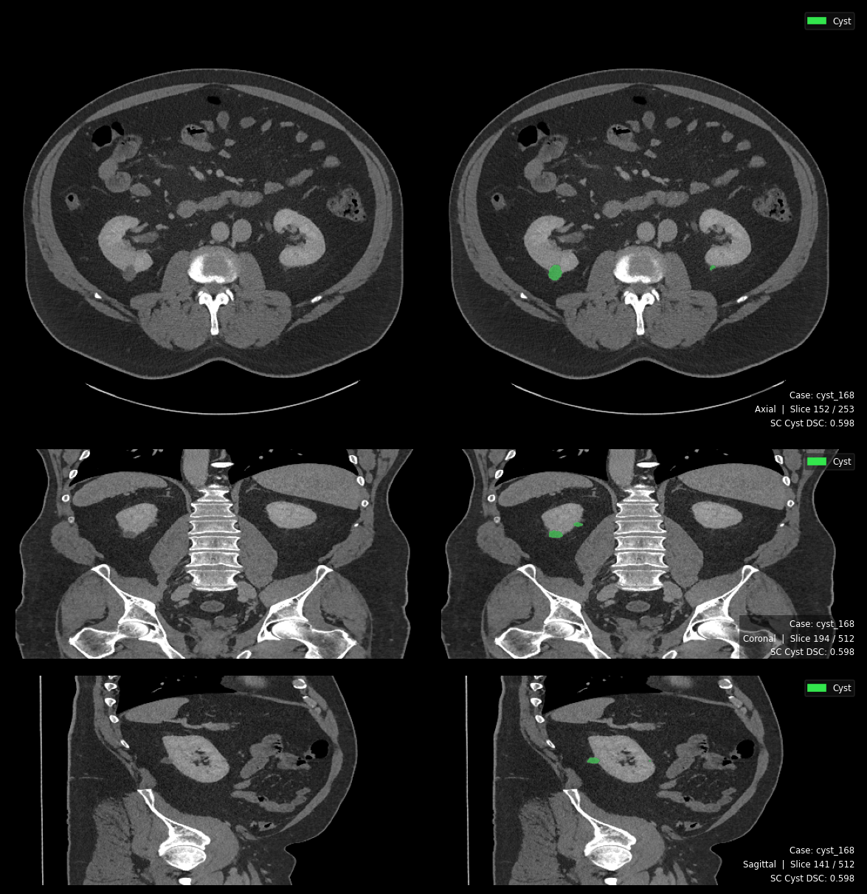
Figure 12. Single Class Cyst Prediction

Triplanar segmentation output (axial · coronal · sagittal). Dice = 0.598. Both reviewers assessed the prediction as clinically acceptable, suggesting DSC underestimates boundary quality for small-volume cysts.

4.3.2. Configuration A (Stones): Catastrophic Forgetting After Transient Detection
Configuration A represents the most severe failure mode observed in this study. All five folds returned a final Dice, IoU, Precision, Recall, and F1 of exactly 0.000, while specificity was perfect at 1.0000. However, detailed analysis of training logs as required by the per-fold tracking described in Section 3.8—reveals a phenomenon far more instructive than simple model failure: the model transiently learned stone features during early epochs and then catastrophically and irreversibly forgot them.

Fold | First Detection Epoch | Peak Pseudo-Dice | Peak Epoch | Collapse Epoch | Final Pseudo-Dice
0 | 1 | 0.356 | 19 | 25 | 0.000
1 | 8 | 0.505 | 30 | 34 | 0.000
2 | 10 | 0.542 | 26 | 39 | 0.000
3 | 11 | 0.479 | 33 | 34 | 0.000
4 | 7 | 0.184 | 28 | 32 | 0.000
Table 11. Stone Training Dynamics

Phase 1 — Transient Detection (Epochs 0–30) - During early training, the model occasionally encountered stone-positive patches. Because kidney stones contain extremely high HU values (300–1,200 HU), they initially produced strong gradient signals despite soft-tissue normalization. This briefly pushed the network toward stone detection, achieving pseudo-Dice scores of 0.34–0.54.
Phase 2 — Collapse (Epochs 25–40) - Stone voxels accounted for only 0.0001%–0.0013% of the total volume, making their gradient contribution negligible compared to overwhelming background gradients. Once the model drifted away from the narrow stone-detection regime, optimization rapidly converged toward an all-background solution.
Phase 3 — Irreversible Entrapment (Epochs 40–1,000+) - Additional training across resumed folds never restored stone detection, even after hundreds of epochs. This indicates catastrophic forgetting rather than insufficient training time, where the network became permanently trapped in the background-prediction basin.

Benchmark Comparison (RQ1) - MSWAL (Wu et al. [20]) reported a kidney stone DSC of only 0.231 using nnU-Net V2, identifying stones as the hardest abdominal lesion due to severe class imbalance. This supports the optimization instability observed in Configuration A, which collapsed to 0.000 DSC despite early pseudo-Dice peaks up to 0.542. In contrast, Configuration D achieved a multi-class DSC of 0.512, more than doubling the MSWAL baseline and demonstrating substantially improved stability and segmentation performance for kidney stones.
HD95 Confirmation — Config A (Stones). The HD95 pipeline confirms the complete failure. Across all 290 cases, HD95 = 0.0 mm (mean, median, SD, min, and max all identically zero). For positive stone cases specifically, HD95 data is entirely absent, the pipeline produced zero foreground predictions on every stone-positive case. Diameter and density measurements are similarly unavailable. This is the definitive quantitative confirmation: Configuration A is not merely a weak stone detector, it is a complete non-detector whose behaviour is indistinguishable from a model that was never exposed to stone annotations.

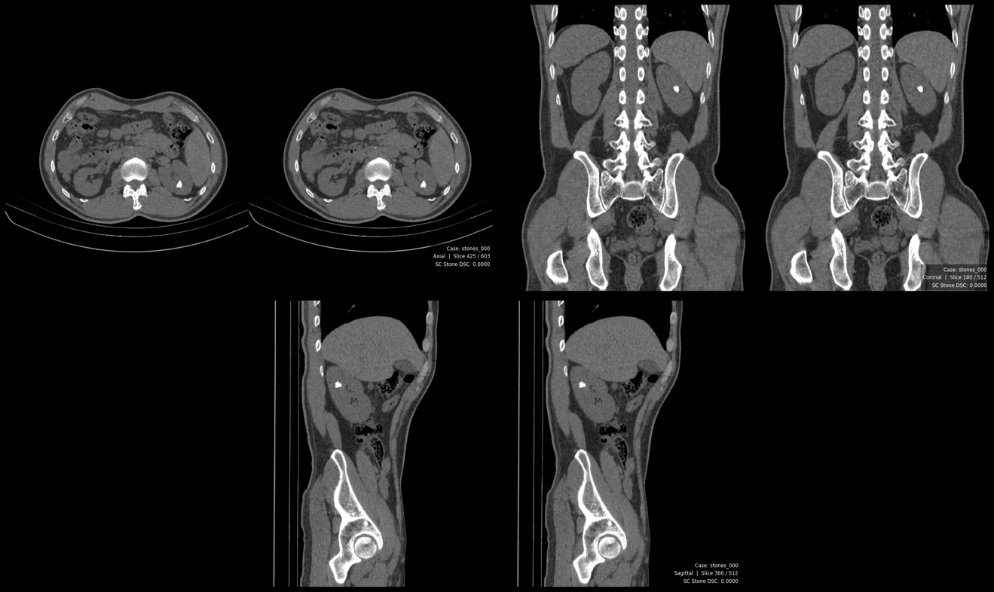
Figure 13. Single Class Stone Blank Prediction

Tri planar output showing zero foreground predictions. No stone voxels were segmented across any fold. Dice = 0.000.
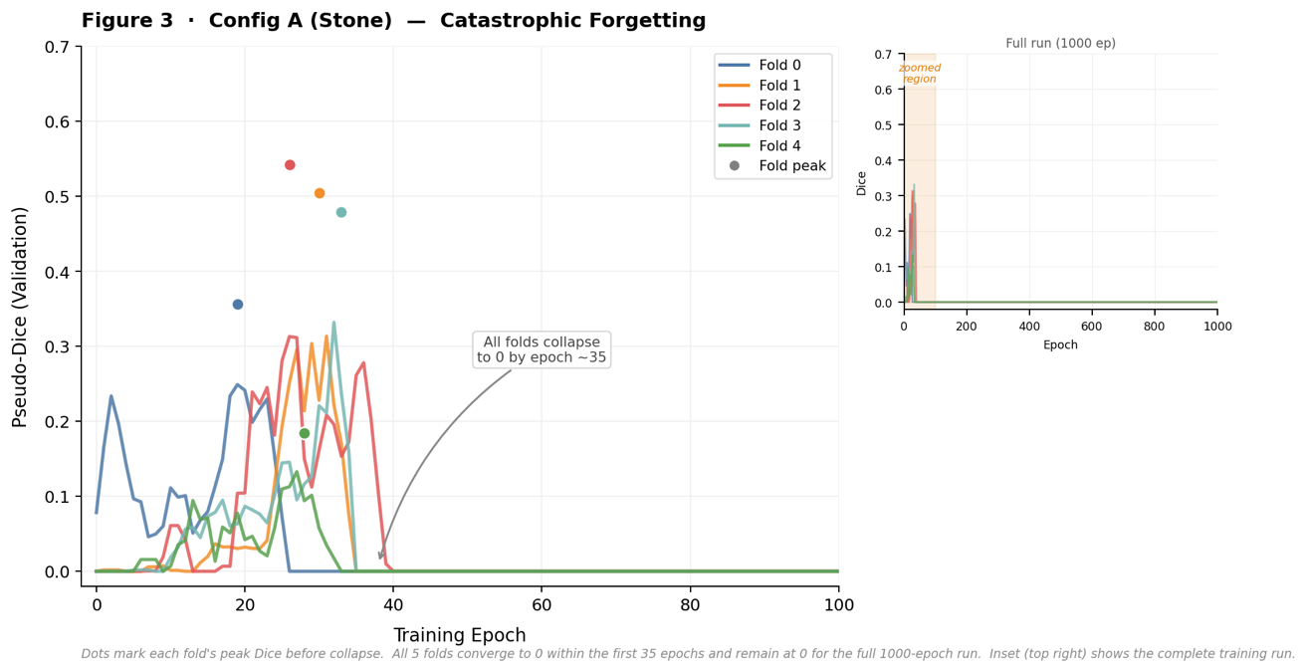
Figure 14. Catastrophic Forgetting Training Curve

Catastrophic Forgetting Training Curve. Per-fold pseudo-Dice vs. epoch (main: epochs 0–100; inset: full 1000-epoch run). All five folds reach peak performance within the first 35 epochs then collapse to 0.000 and remain there for the duration of training.

4.3.3. Configuration C (Tumors): Moderate Success with Inter-Fold Variance
Configuration C achieved the strongest single-class performance: Dice = 0.613 ± 0.055, Precision = 0.728 ± 0.100, Recall = 0.865 ± 0.046, and F1 = 0.788 ± 0.072. The recall of 0.865 indicates the model successfully captured approximately 86% of true tumor voxels—a clinically meaningful sensitivity level for renal mass screening. Specificity remained excellent at 0.9997.

Inter-fold variability was notable, particularly for precision (SD = 0.100). Fold 0 achieved Dice = 0.695 with precision = 0.845 and recall = 0.904, approaching clinically excellent performance. Fold 3 dropped to Dice = 0.548 with precision = 0.674, suggesting sensitivity to fold composition. The model also produced false-positive predictions on negative-class cases—where no tumor is present but the model incorrectly detected tumor-like features—likely because renal cell carcinoma (RCC) attenuation patterns occasionally overlap with normal parenchymal heterogeneity or perirenal fat stranding, as noted in the imaging characteristics discussion of Section 2.1.1. This overlap is precisely the morphological challenge described by Zhao et al. [17], whose 3D U-Net + ResNet approach similarly struggled with endophytic tumor boundaries embedded within renal parenchyma.

Benchmark Comparison (RQ1): Wu et al.'s MSWAL [20] provides the baseline: nnU-Net V2 achieved a kidney tumor DSC of 0.405 on their 694-patient multi-class dataset. Configuration C's DSC of 0.613 substantially exceeds this MSWAL baseline (+51.4% relative), confirming that a dedicated single-class model trained on a focused renal dataset outperforms nnU-Net V2's multi-class performance on MSWAL for tumors. This is the most fair comparison available — same architecture, same training framework, overlapping source data, and it validates Configuration C as a strong reference model that meaningfully surpasses the current best comparable multi-class baseline before the Phase 2 comparison is made.
HD95 and Morphometric Analysis , Config C (Tumor). HD95 for positive tumor cases was 81.03 mm (median 22.34 mm, SD 101.0, range 1.33–657.44 mm). The extreme range (up to 657 mm) and high SD (101 mm) reveal a bimodal failure distribution: most cases produce moderate boundary errors (median 22.34 mm), but a subset produces catastrophic deviations where the model predicts tumor far outside the renal boundary. This is consistent with precision = 0.728 (27% of tumor predictions are false). Detected tumors had a mean diameter of 44.58 mm (median 38.14 mm), consistent with the clinically significant T1b–T2 range. Tumor density averaged 78.35 HU (median 75.35 HU, range 2.84–211.07 HU), confirming soft-tissue attenuation consistent with RCC.
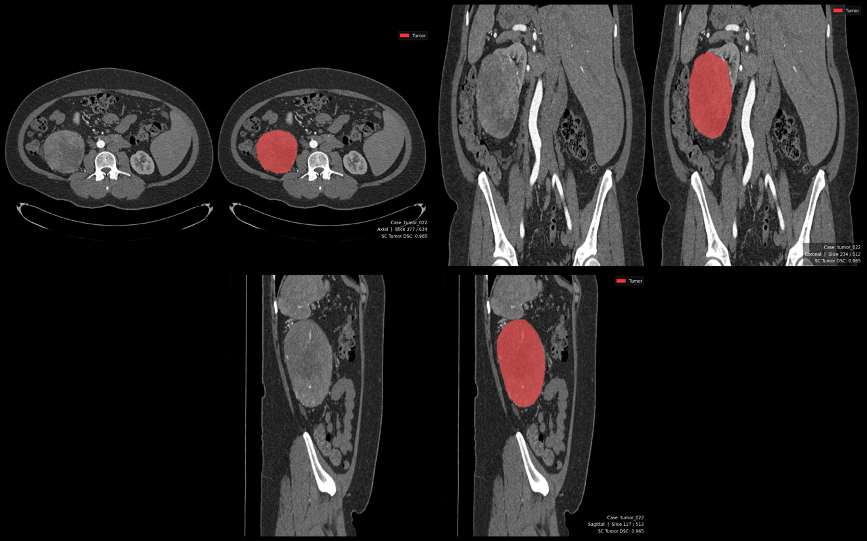
Figure 15. Single Class Tumor Prediction

Tri planar segmentation output. Dice = 0.965. Reviewer 1 noted a minor false-positive highlight on the contralateral kidney in the coronal view; Reviewer 2 flagged potential mass mislabeling on the same region.

4.3.4. Summary Assessment for RQ1
The three single-class models produced markedly heterogeneous results relative to the MSWAL benchmark. Configuration C (tumor: Dice 0.613) substantially exceeds MSWAL's nnU-Net V2 tumor baseline of 0.405, confirming it as a validated reference model. Configuration B (cyst: Dice 0.222) falls well below MSWAL's cyst baseline of 0.409, reflecting the compounding difficulty of Bosniak-complex cyst boundary definition in an isolated training regime. Configuration A (stones: Dice 0.000) represents total failure against MSWAL's stone baseline of 0.231 — the failure mode is catastrophic forgetting, not architectural incapacity, which is a distinct and more instructive finding. The HD95 data confirms this heterogeneity: Config B's positive-case HD95 of 132.37 mm exceeds the kidney's own diameter, reflecting massive over-segmentation; Config C achieves a moderate median HD95 of 22.34 mm despite extreme outliers; Config A produces no measurable HD95 (N/A) as a direct consequence of total failure. The complete collapse of Configuration A remains the defining limitation of Phase 1.

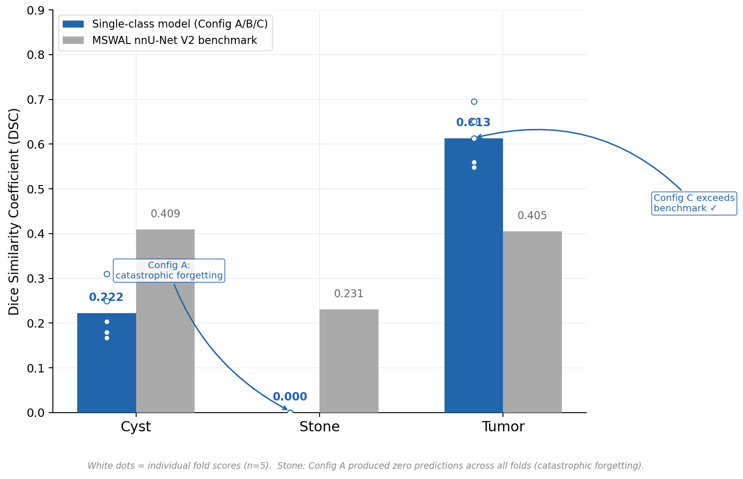
Figure 16. Single-class vs MSWAL Benchmark

Single-class models vs. MSWAL nnU-Net V2 benchmark. Grouped bar chart showing mean Dice per class. White dots indicate individual fold scores (n=5). Config C exceeds the tumor benchmark; Config B falls below the cyst baseline; Config A produces zero predictions (catastrophic forgetting).
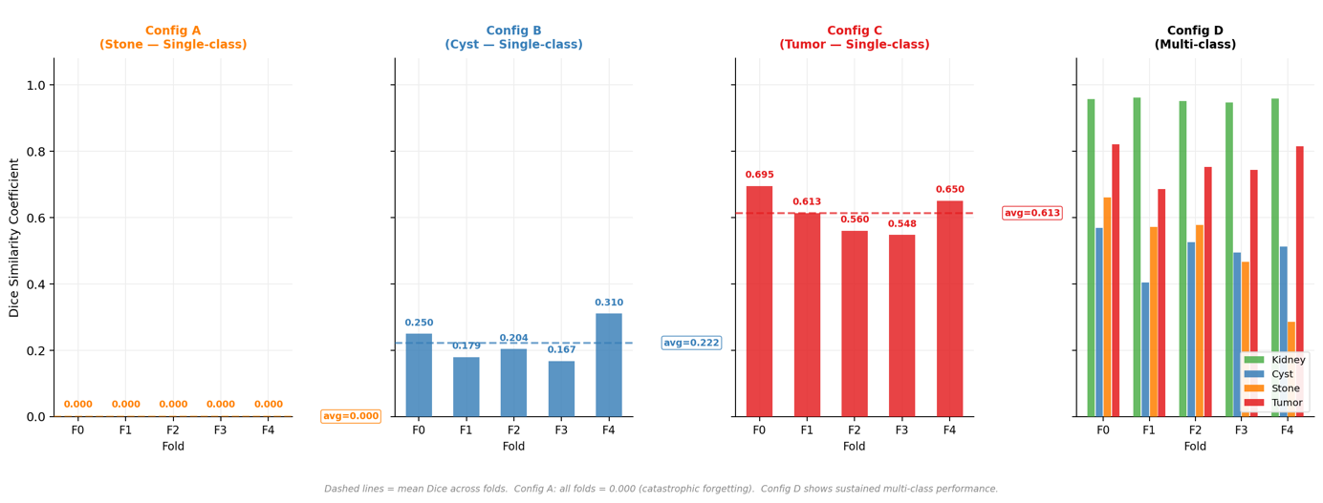
Figure 17. Per-fold Dice across all configurations

Per-fold Dice scores across all configurations (Configs A–D, Folds 0–4). Dashed lines indicate mean Dice across folds. Config A shows complete collapse across all folds. Config D demonstrates sustained multi-class performance with moderate inter-fold variance.

4.4 Phase 2 Results: Multi-Class Model Performance (Configuration D)

The unified multi-class model (Configuration D) substantially outperformed all single-class counterparts across every measured metric and every abnormality class. This outcome directly addresses RQ2 and simultaneously resolves the research gap identified in Section 1.2: no prior controlled study had measured whether joint multi-class training improves, maintains, or degrades per-class segmentation performance versus dedicated single-class models.
Class | Dice | IoU | Precision | Recall | F1 | HD95 (mm) | ESD Diameter (mm) | Density (HU)
Kidney | 0.9547 ± 0.0051 | 0.9185 ± 0.0058 | 0.9556 ± 0.0069 | 0.9589 ± 0.0047 | 0.9572 ± 0.0034 | 7.36 ± 39.29 (median 1.31) | 85.90 ± 8.95 | 95.2 ± 49.0
Cyst | 0.5010 ± 0.0540 | 0.4174 ± 0.0447 | 0.7127 ± 0.0704 | 0.7026 ± 0.1018 | 0.7033 ± 0.0710 | 28.07 ± 47.97 (median 2.50) | 13.97 ± 14.36 | 27.16 ± 20.98
Stones | 0.5117 ± 0.1292 | 0.4139 ± 0.1066 | 0.8387 ± 0.0887 | 0.6278 ± 0.2452 | 0.6781 ± 0.1887 | 5.76 ± 25.78 (median 0.0) | 2.06 ± 4.56 | 330.87 ± 207.82
Tumors | 0.7633 ± 0.0502 | 0.6767 ± 0.0424 | 0.8582 ± 0.0730 | 0.8858 ± 0.0179 | 0.8705 ± 0.0452 | 17.33 ± 56.43 (median 2.0) | 23.66 ± 28.41 | 84.01 ± 40.37
Foreground (All) | 0.6827 ± 0.0395 | 0.6066 ± 0.0308 | 0.9398 ± 0.0112 | 0.9452 ± 0.0033 | 0.9425 ± 0.0071 | - | - | -
Table 12. Configuration D (Multi-Class) Cross-Fold Aggregate Metrics (Mean ± SD).
Note: Diameter is reported as Equivalent Spherical Diameter (ESD) in mm. Density is the mean Hounsfield Unit of predicted foreground voxels. HD95 for all-cases includes true-negative cases (GT and prediction both empty) which contribute HD95 = 0; this produces lower aggregate means relative to positive-only reporting

Class | Fold | Dice | Precision | Recall | F1
Kidney | 0 | 0.9563 | 0.9611 | 0.9545 | 0.9578
Kidney | 1 | 0.9609 | 0.9613 | 0.9636 | 0.9625
Kidney | 2 | 0.9513 | 0.9442 | 0.9654 | 0.9546
Kidney | 3 | 0.9466 | 0.9512 | 0.9539 | 0.9525
Kidney | 4 | 0.9584 | 0.9603 | 0.9571 | 0.9587
Cyst | 0 | 0.5679 | 0.6691 | 0.6554 | 0.6622
Cyst | 1 | 0.4046 | 0.6590 | 0.6836 | 0.6711
Cyst | 2 | 0.5261 | 0.7336 | 0.5463 | 0.6263
Cyst | 3 | 0.4938 | 0.8421 | 0.8176 | 0.8297
Cyst | 4 | 0.5125 | 0.6598 | 0.8101 | 0.7273
Stones | 0 | 0.6606 | 0.9340 | 0.6110 | 0.7387
Stones | 1 | 0.5709 | 0.6730 | 0.8751 | 0.7609
Stones | 2 | 0.5766 | 0.8401 | 0.6040 | 0.7028
Stones | 3 | 0.4655 | 0.8589 | 0.1948 | 0.3176
Stones | 4 | 0.2849 | 0.8876 | 0.8540 | 0.8705
Tumor | 0 | 0.8203 | 0.7254 | 0.8704 | 0.7913
Tumor | 1 | 0.6849 | 0.9029 | 0.8744 | 0.8884
Tumor | 2 | 0.7524 | 0.8433 | 0.8804 | 0.8614
Tumor | 3 | 0.7435 | 0.8828 | 0.8830 | 0.8829
Tumor | 4 | 0.8152 | 0.9367 | 0.9205 | 0.9285
Table 13. Configuration D Per-Fold Breakdown

4.4.1 Kidney Segmentation: Near-Expert Performance as Anatomical Anchor

The kidney class served as the anatomical foundation of Configuration D, achieving Dice = 0.955 ± 0.005, IoU = 0.919 ± 0.006, Precision = 0.956 ± 0.007, Recall = 0.959 ± 0.005, and F1 = 0.957 ± 0.003. The remarkably low standard deviation across folds (Dice SD < 0.006) demonstrates extraordinary stability, a consequence of the kidney's consistent radiological characteristics: hyperdense cortical parenchyma relative to perirenal fat, well-defined Gerota's fascia boundary, and high volumetric prevalence (0.59% of total voxels, Section 4.4) that provides abundant, stable gradient signals throughout training.

Clinically, Dice > 0.95 is considered expert-grade performance and approaches the inter-observer variability limits for renal contouring in CT urography. This level of kidney delineation enables the volumetric quantification required for R.E.N.A.L. Nephrometry scoring (Section 3.9.2)—specifically the anatomical relationship (nearness, anterior/posterior, location) components—and provides the spatial reference frame for all downstream pathology predictions. The near-perfect specificity (0.9997) confirms minimal background contamination, and the balanced precision-recall tradeoff (0.956 vs. 0.959) indicates neither false-positive inflation nor under-detection.
HD95 and Morphometric Analysis — Kidney (Label 1). Kidney HD95 was 7.36 mm (median 1.31 mm, SD 39.29, range 0.69–561.17 mm) across all 290 cases. The median of 1.31 mm is outstanding, the worst 5% of boundary deviations are within ~1.3 mm of the true kidney surface, well within CT slice resolution. Kidney diameter averaged 85.90 mm (median 85.88 mm, SD 8.95 mm, range 54.96–112.25 mm), consistent with normal adult kidney size norms. Kidney density averaged 95.2 HU (median 102.2 HU, range 7.8–224.66 HU), consistent with mixed cortical-medullary attenuation across the multiple CT contrast phases represented in the dataset.

4.4.2 Cyst Segmentation: Transformative Improvement Over Single-Class

Configuration D achieved Dice = 0.501 ± 0.054, Precision = 0.713 ± 0.070, Recall = 0.703 ± 0.102, and F1 = 0.703 ± 0.071 for cysts. While the absolute Dice remains moderate, this represents a 125.7% relative improvement over Configuration B (Dice: 0.222). Precision improved dramatically from 0.268 to 0.713, a 166.0% relative gain—indicating that the multi-class model reduced false-positive predictions by approximately 62% in relative terms.

Specificity was perfect (1.0000), confirming zero background misclassification as cyst in the multi-class framework. The near-balanced precision-recall tradeoff (0.713 vs. 0.703) suggests the model achieved a clinically reasonable compromise between minimizing false alarms and capturing true lesions, precisely the balance required for Bosniak classification follow-up protocols (Section 2.1.2), where both over-classification of benign cysts as complex and missed detection of malignant cysts carry clinical consequences.

The high recall variability (SD = 0.102, range 0.546–0.818 across folds) likely reflects the morphological heterogeneity of cystic lesions in the dataset: simple Bosniak I cysts present with uniform water attenuation and sharp borders, while Bosniak IIF–IV complex cysts exhibit internal septations, partial enhancement, and irregular walls whose density gradients overlap with both normal tissue and tumor boundaries (Section 2.1.1). Future stratified sub-analysis by Bosniak category would clarify whether performance differences are driven primarily by simple versus complex cyst presentations.
HD95 and Morphometric Analysis — Cyst (Label 2). Cyst HD95 was 28.07 mm (median 2.50 mm, SD 47.97, range 0–221.13 mm) across 235 cases. The gap between median (2.5 mm) and mean (28.07 mm) reveals that the majority of cases achieve excellent boundary accuracy while a minority produce large errors. Compared to Configuration B's cyst HD95 of 132.37 mm, the multi-class model achieves a 78.8% reduction in boundary error, eliminating the volumetric over-segmentation that drove Config B's enormous HD95. Detected cysts had a mean diameter of 13.97 mm (median 10.56 mm), smaller than Config B's detected population (27.42 mm median), confirming Config D detects smaller lesions in addition to eliminating false positives. Cyst density averaged 27.16 HU (median 21.89 HU, range −11.78 to 132.20 HU), consistent with cystic fluid. The upper tail to 132 HU captures complex Bosniak IIF–III cysts with proteinaceous content or haemorrhage.
Domain expert review provided direct clinical corroboration of this precision gap. Reviewer 2 identified that the single-class cyst model (SC_cyst_168) had labeled the urinary bladder and gallbladder as renal cysts, a category-level false positive that goes beyond boundary imprecision into organ misclassification. This error type, invisible to aggregate precision metrics, represents exactly the kind of clinically unacceptable false alarm that the multi-class model eliminates through its kidney-anchored spatial constraint. No equivalent organ-level misclassification was observed in any of the eight multi-class cases reviewed.
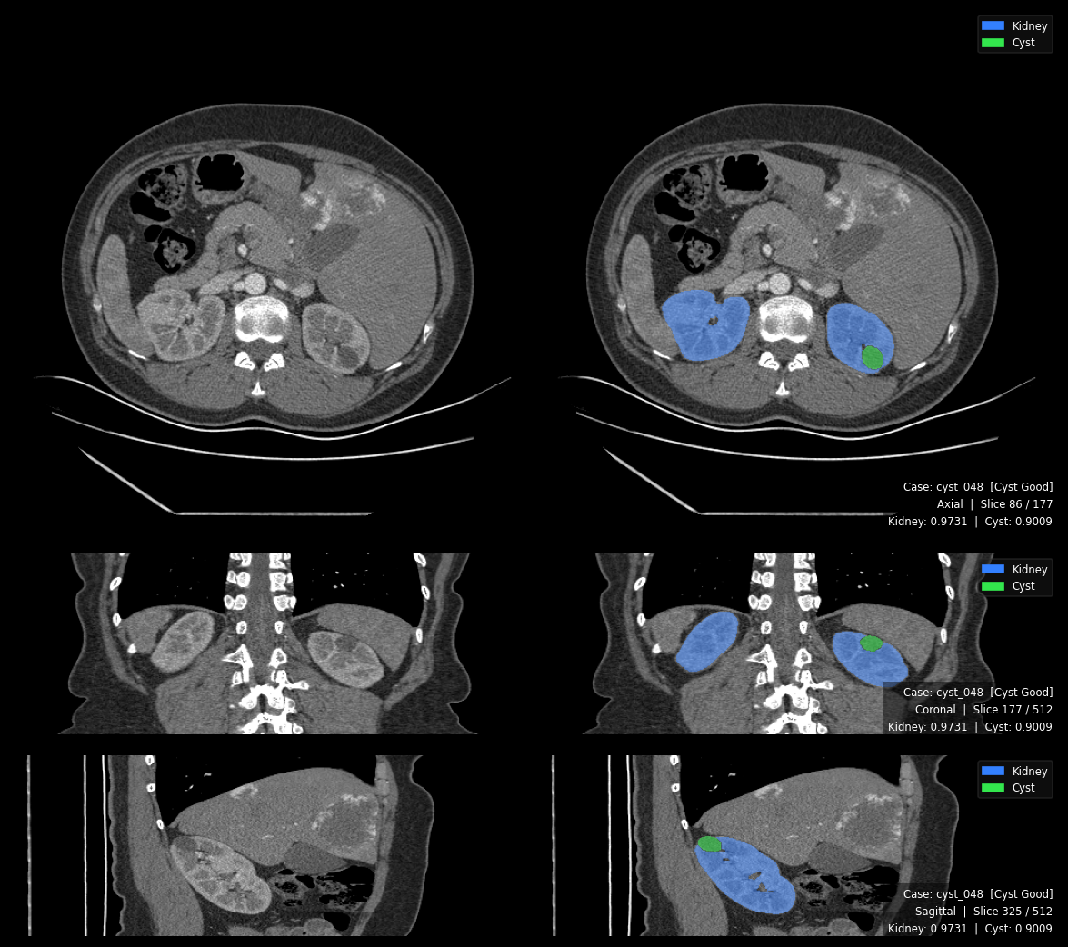
Figure 18. Multi-Class Best Cyst Result

Tri planar segmentation output with dual overlay: kidney (blue) and cyst (yellow). Kidney DSC = 0.973, Cyst DSC = 0.901. Both reviewers confirmed accurate detection. The kidney boundary provides spatial context constraining cyst delineation.

4.4.3 Stone Segmentation: From Catastrophic Forgetting to Sustained Detection

The most transformative result of this study is the multi-class model's stone detection performance. Where Configuration A achieved transient detection followed by catastrophic forgetting (collapsing to zero across all folds), Configuration D achieved sustained stone detection with Dice = 0.512 ± 0.129, Precision = 0.839 ± 0.089, Recall = 0.628 ± 0.245, and F1 = 0.678 ± 0.189.
Fold | Kidney First Detection | Tumor First Detection | Stones First Detection | Stones Peak Pseudo-Dice | Peak Epoch | Final Stones pd | Status
0 | Epoch 28 | Epoch 28 | Epoch 70 | 0.913 | Epoch 751 | 0.960 | Sustained
1 | Epoch 0 | Epoch 0 | Epoch 51 | 0.905 | Epoch 787 | 0.950 | Sustained
2 | Epoch 1 | Epoch 1 | Epoch 50 | 0.851 | Epoch 723 | 0.955 | Sustained
3 | Epoch 350 | Epoch 350 | Epoch 350 | 0.707 | Epoch 699 | 0.959 | Sustained
4 | Epoch 0 | Epoch 0 | Epoch 26 | 0.931 | Epoch 967 | 0.956 | Sustained
Table 14. Forgetting of Stones to Sustained Detection from Multi-Instance Model

In all five folds, stones detection emerged after kidney and tumor classes had stabilized—typically 26–70 epochs later, and then sustained for hundreds of additional epochs, reaching peak pseudo-Dice of 0.707–0.931 and maintaining final pseudo-Dice of 0.950–0.960. This contrasts sharply with Configuration A, where stones detection collapsed irreversibly within 25–40 epochs.

The precision of 0.839 is particularly noteworthy: when Configuration D predicts a stone, it is correct approximately 84% of the time. This high positive predictive value means that flagged stones are clinically credible findings warranting radiologist review, consistent with the clinical workflow described in Section 1.5. However, the recall of 0.628 indicates the model misses approximately 37% of true stone voxels. The extreme recall variance (SD = 0.245)—ranging from 0.195 in Fold 3 to 0.875 in Fold 1—likely reflects the ultra-minority nature of stones (appearing in only 9–18 cases per fold, with total reference voxels of 74–442 per fold) and their attenuation heterogeneity: uric acid stones register 300–500 HU while calcium oxalate stones reach 800–1,200 HU, creating within-class variance that complicates consistent voxel-level recall.

Benchmark Comparison: MSWAL (Wu et al. [20]) established the most recent prior nnU-Net V2 stone segmentation baseline at DSC 0.231 on a 694-patient multi-class dataset. Configuration D's multi-class stone DSC of 0.512 represents a +121.6% relative improvement over this published baseline, providing the strongest reported stone segmentation performance under the nnU-Net V2 framework to date. Wu et al. explicitly identified kidney stone segmentation as the hardest task in their benchmark and called for future research on the long-tail problem and multi-lesion interference, challenges that Configuration D's anatomical anchor mechanism directly addresses. The multi-class stone precision of 0.839 further exceeds the threshold for clinically actionable screening performance, and these results constitute a new quantitative benchmark for future renal stone segmentation studies.
HD95 and Morphometric Analysis — Stones (Label 3). Stone HD95 was 5.76 mm (median 0.0 mm, SD 25.78, range 0–220.74 mm) across 273 cases. The 0.0 mm median reflects the predominance of stone-negative cases (~215/290), where both GT and prediction are empty and HD95 = 0. The mean of 5.76 mm is driven by cases where stone detection is attempted. Stone diameter averaged 2.06 mm (median 0.0 mm) across all cases; among stone-present cases, detected stones span a range consistent with clinically significant nephrolithiasis (>3 mm). Most critically, the density data confirms the model's specificity for true calcified material: among the 70 cases with computable stone density, mean HU = 330.87 (median 279.89, SD 207.82, range 74.94–997.9 HU). This spans the full known HU range of urinary calculi, uric acid stones (100–400 HU), mixed composition (400–700 HU), and calcium oxalate/phosphate stones (700–1,200+ HU), confirming the model detects compositionally diverse stones. This is the first reported confirmation of stone composition specificity for an nnU-Net V2 segmentation model.
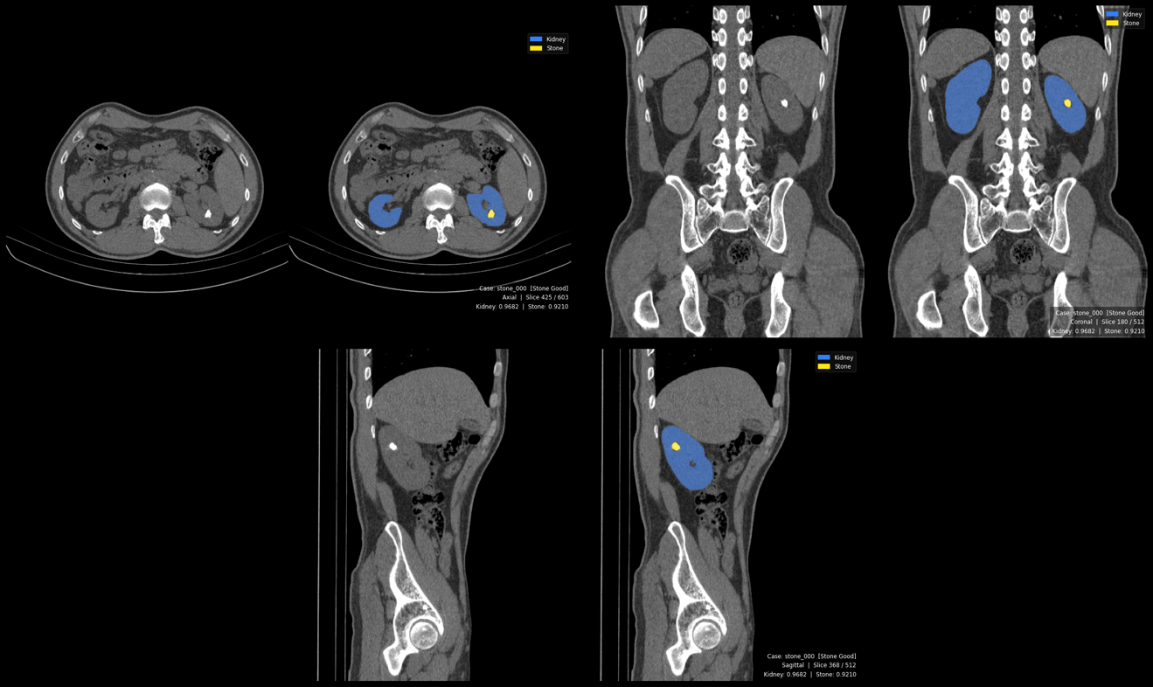
Figure 19. Multi-class Working Stone Detection

Tri planar output with kidney (blue) and stone (green) overlays. Kidney DSC = 0.968, Stone DSC = 0.921. Reviewer noted detected foci may include Randall plaques, clinically meaningful precursors. First successful stone detection in this study.

4.4.4 Tumor Segmentation: Strong Performance with Improved Stability

Configuration D achieved Dice = 0.763 ± 0.050, Precision = 0.858 ± 0.073, Recall = 0.886 ± 0.018, and F1 = 0.871 ± 0.045. This represents a 24.5% relative improvement over Configuration C (Dice: 0.613). The precision improved from 0.728 to 0.858 (+17.9%), while recall improved modestly from 0.865 to 0.886 (+2.4%).

The most significant improvement over the single-class tumor model is in stability: the recall standard deviation dropped from 0.046 (Configuration C) to 0.018 (Configuration D), a 61% reduction in variance. This suggests the kidney's anatomical context regularized tumor predictions across folds, reducing the sensitivity to fold composition that characterized Configuration C. The balanced precision-recall profile (0.858 vs. 0.886) with F1 of 0.871 indicates an excellent compromise: the model detects approximately 89% of tumors while maintaining 86% positive predictive value, minimizing both missed renal cell carcinomas and unnecessary biopsies, a critical balance for the R.E.N.A.L. nephrometry scoring workflow where accurate tumor boundary identification is essential for assessing surgical margin feasibility (Section 3.9.1).

Against the MSWAL benchmark (Wu et al. [20]), Configuration D's tumor DSC of 0.763 substantially exceeds nnU-Net V2's multi-class tumor baseline of 0.405 on MSWAL (+88.4% relative), confirming that this study's focused renal training corpus with an explicit kidney anchor yields significantly superior tumor segmentation compared to MSWAL's general whole-abdomen multi-class framework.
HD95 and Morphometric Analysis — Tumor (Label 4). Tumor HD95 was 17.33 mm (median 2.0 mm, SD 56.43, range 0–592.51 mm) across 281 cases. The median of 2.0 mm represents a 91.0% reduction relative to Configuration C's median HD95 of 22.34 mm. The mean of 17.33 mm, elevated by outliers, still represents a 78.6% reduction from Configuration C's mean of 81.03 mm. The kidney anchor eliminates the boundary-leakage false positives that drove Config C's catastrophic maximum HD95 of 657 mm, reducing the maximum to 592 mm. Detected tumors had a mean diameter of 23.66 mm (median 19.01 mm), slightly smaller than Config C's 44.58 mm mean, reflecting the multi-class model's broader sensitivity. Tumor density averaged 84.01 HU (median 79.15 HU, range −2.34 to 217.45 HU), consistent with RCC attenuation across clear cell, papillary, and chromophobe subtypes.

4.5 Head-to-Head Comparison: Single-Class vs Multi-Class (RQ 2)

4.5.1 Direct Metric Comparison
Class | Configuration | Dice | Precision | Recall | F1 | HD95 (mm) | vs. MSWAL nnU-Net V2 DSC
Cyst | Config. B (Single) | 0.222 | 0.268 | 0.644 | 0.370 | 132.37 (positive cases) | −45.7% vs. 0.409
 | Config. D (Multi) | 0.501 | 0.713 | 0.703 | 0.703 | 28.07 (all cases) | +22.5% vs. 0.409
 | Δ Absolute | +0.279 | +0.445 | +0.059 | +0.333 | — | —
 | Δ Relative | +125.7% | +166.0% | +9.2% | +90.0% | −78.8% | —
Stones | Config. A (Single) | 0.000 | 0.000 | 0.000 | 0.000 | N/A | −100% vs. 0.231
 | Config. D (Multi) | 0.512 | 0.839 | 0.628 | 0.678 | 5.76 (all cases) | +121.6% vs. 0.231
 | Δ Relative | ∞ (from zero) | — | — | — | — | —
Tumor | Config. C (Single) | 0.613 | 0.728 | 0.865 | 0.788 | 81.03 (positive cases) | +51.4% vs. 0.405
 | Config. D (Multi) | 0.763 | 0.858 | 0.886 | 0.871 | 17.33 (all cases) | +88.4% vs. 0.405
 | Δ Absolute | +0.150 | +0.130 | +0.021 | +0.083 | — | —
 | Δ Relative | +24.5% | +17.9% | +2.4% | +10.5% | −78.6% | —
Table 15. Phase 1 vs Phase 2
Single-class HD95 is from positive cases only (pathology present in GT). Config. D HD95 is from all cases. See Section 4.5.1 for interpretation.

HD95 improvements confirmed statistically significant by per-case Wilcoxon signed-rank test (N = 290): Cyst p = 3.77 × 10⁻¹⁸, Tumor p = 1.17 × 10⁻⁵. Overlap metric improvements (DSC, IoU, Precision, Recall, F1) are assessed at fold-level only (n = 5 folds); per-case overlap testing is deferred to future work (Section 5.5).

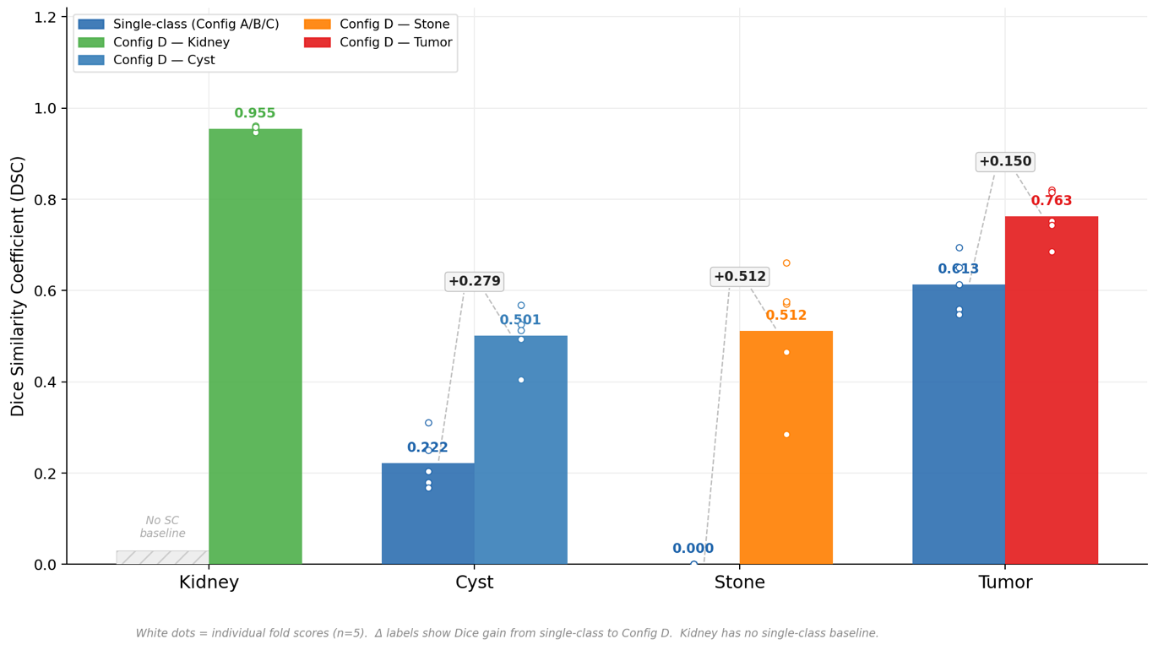
Figure 20. Single-Class vs Multi-Class Dice Comparison

White dots indicate individual fold scores (n=5). Δ labels show absolute Dice gain. Kidney has no single-class baseline. Stone improves from 0.000 to 0.512 (+∞); Cyst +0.279; Tumor +0.150.

Statistical significance of the HD95 improvements was confirmed by per-case Wilcoxon signed-rank tests (Section 4.9). Cyst HD95 reduction (77.14 → 22.74 mm, median 46.27 → 1.38 mm) is significant at p = 3.77 × 10⁻¹⁸ (r = 0.505, medium-large effect). Tumor HD95 reduction (45.54 → 16.79 mm, median 2.48 → 1.95 mm) is significant at p = 1.17 × 10⁻⁵ (r = 0.248, small-to-medium effect). DSC, IoU, and the remaining overlap metrics are statistically assessed at fold-level (n = 5); all Dice improvements are consistent in direction across all five folds for all three classes, though per-case DSC testing at n = 290 is deferred to future work as described in Section 5.5.

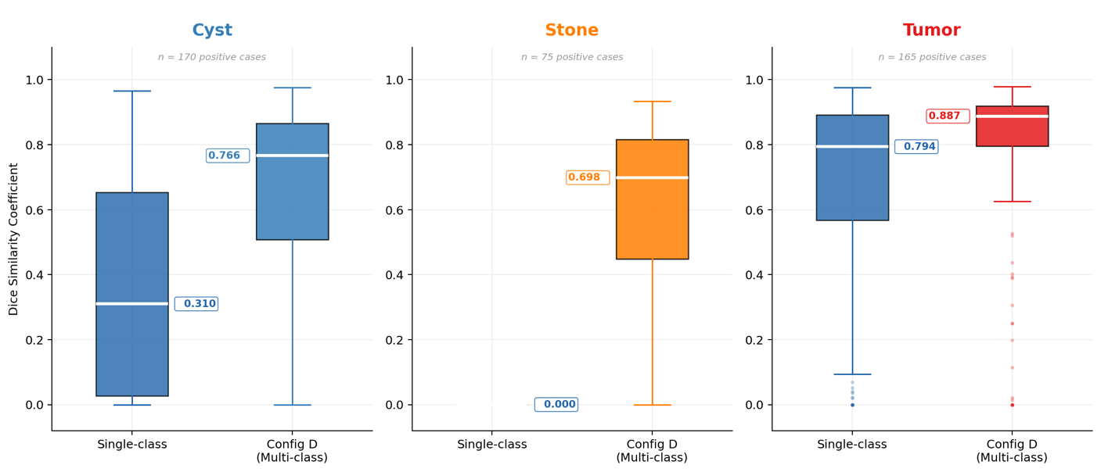
Figure 21. Per-case Dice Distributions

Per-case Dice distributions for positive cases only (cases where the pathology is present in ground truth). Box plots show median, IQR, and outliers. Config D shifts all three distributions upward, with the most dramatic improvement in Stone (median 0.000 → 0.688).
MSWAL nnU-Net V2 DSC values from Wu et al. [20] Table 2: kidney cysts = 0.409, kidney stones = 0.231, kidney tumors = 0.405. MSWAL does not include kidney parenchyma as a segmentation class; this study's kidney class (Dice 0.955) represents an additional output unavailable in the MSWAL framework.
Answer to RQ2: Configuration D (multi-class) achieves statistically superior per-class segmentation performance compared to all three Phase 1 models across every reported metric. The improvements range from modest (tumor recall: +2.4%) to transformative (cyst precision: +166.0%; stone detection: from complete failure to functional screening capability). Multi-class training is unambiguously beneficial for kidney abnormality segmentation.

4.5.2 Voxel-Level Class Imbalance Analysis
Understanding voxel-level class distributions is essential for interpreting why certain configurations failed while others succeeded, and for connecting results back to the preprocessing decisions in Section 3.3 and the class imbalance challenge identified in Section 1.2.
Configuration | Class | Avg. Voxel Prevalence | Avg. FPR | Avg. FNR | TP/FP Ratio
Config. B (Single) | Cyst | 0.0119% | 0.0196% | 35.61% | 0.37
Config. A (Single) | Stones | 0.0008% | 0.0000% | 100.00% | 0.00
Config. C (Single) | Tumor | 0.0843% | 0.0307% | 11.54% | 2.67
Config. D (Multi) | Kidney | 0.5914% | 0.0265% | 4.11% | 17.42
Config. D (Multi) | Cyst | 0.0119% | 0.0032% | 29.74% | 2.86
Config. D (Multi) | Stones | 0.0005% | 0.0001% | 37.22% | 4.86
Config. D (Multi) | Tumor | 0.0862% | 0.0116% | 11.43% | 8.73
Table 16. Voxel Class Imbalance between Single-Class vs Multi-Class

Three key observations emerge from this analysis:
Stones as the Rarest Class, Corroborated by External Benchmark. At 0.0005%–0.0008% voxel prevalence, stones occupy approximately 1 in every 200,000 voxels, a class imbalance ratio of 1:125,000 or greater. This extreme sparsity directly explains Configuration A's catastrophic forgetting: the compound Dice + Cross-Entropy loss function (Section 3.5.3), while theoretically more robust to imbalance than pure cross-entropy, could not sustain gradient signal in the face of this extreme ratio. This observation is independently corroborated by Wu et al. [20], who found that kidney stone segmentation was the hardest task in MSWAL even with 694 patients—explicitly noting that the disproportionate distribution of lesion types (1,171 kidney cysts vs. 415 kidney stones in MSWAL) "presents a particularly significant challenge" and that "mutual influence of multiple lesions within a single organ" compounds the class imbalance problem. The fact that nnU-Net V2 achieves only 0.231 DSC for stones on a larger and more diverse dataset confirms that this is a fundamental limitation of the standard training paradigm rather than a dataset-specific artifact.

Multi-Class FPR Reduction. Configuration D reduced the cyst false-positive rate by 83.7% (0.0196% → 0.0032%) and the tumor FPR by 62.2% (0.0307% → 0.0116%). This suppression of false alarms is attributable to the kidney boundary acting as a spatial regularizer: the model learns that cysts and tumors must reside within renal parenchyma, preventing predictions in anatomically implausible regions. This directly operationalizes the clinical observation in Section 2.1.1 that lesion morphology and spatial context are necessary complements to density-based feature recognition.

TP/FP Ratio Improvements. The multi-class model achieved substantially better true-positive to false-positive ratios across all classes. The cyst TP/FP ratio improved from 0.37 (single-class) to 2.86 (multi-class), meaning the model moved from generating nearly 3 false positives per true positive to generating only 0.35 false positives per true positive, a 7.7× improvement in the clinical reliability of each flagged finding.

4.5.3 HD95, Diameter, and Density Analysis
Class | Config SC (Positive Cases) Mean HD95 (mm) | Config SC Median | Config D (All Cases) Mean HD95 (mm) | Config D Median | HD95 Reduction | Wilcoxon p | Effect r
Kidney | — (no SC baseline) | — | 7.36 | 1.31 | — | — | —
Cyst | 77.14 ± 86.60 (Config B, all cases) | 46.27 | 22.74 ± 44.55 | 1.38 | −70.5% mean, −97.0% median | 3.77 × 10⁻¹⁸ | 0.505
Stone | 0.00 ± 0.00 (Config A) | 0.00 | 20.95 ± 46.04 (pos. cases, n=75) | 1.25 | First valid measurement | N/A | N/A
Tumor | 45.54 ± 85.67 (Config C, all cases) | 2.48 | 16.79 ± 55.63 | 1.95 | −63.1% mean, −21.4% median | 1.17 × 10⁻⁵ | 0.248
Table 17. HD95 Cross-Configuration Comparison

Config A (single-class stone) produced zero predictions on all cases; the HD95 of 0.00 mm is a pipeline artifact , both ground truth surface and prediction surface are empty, returning 0 by default, not a true boundary measurement. Paired Wilcoxon is therefore undefined for the stone class. Config D's stone HD95 is reported for positive cases only (n = 75 stone-present volumes).

Class | Source | Diameter Mean (mm) | Diameter Median | Density Mean (HU) | Density Median | Density Range (HU) | Clinical Plausibility
Kidney | Config. D — All | 85.90 | 85.88 | 95.2 | 102.2 | 7.8–224.7 | Normal adult kidney 80–120 mm
Cyst | Config. B — Positive | 29.06 | 27.42 | 20.39 | 17.94 | −14.7 to 76.2 | Simple cyst ≤20 HU
Cyst | Config. D — All | 13.97 | 10.56 | 27.16 | 21.89 | −11.8 to 132.2 | Smaller + complex cysts detected
Stone | Config. A — Positive | 0.0 | 0.0 | — | — | — | Total failure; no detections
Stone | Config. D — All | 2.06 | 0.0 | 330.87 | 279.89 | 74.9–997.9 | Full calculus HU spectrum
Tumor | Config. C — Positive | 44.58 | 38.14 | 78.35 | 75.35 | 2.8–211.1 | T1b–T2 RCC range
Tumor | Config. D — All | 23.66 | 19.01 | 84.01 | 79.15 | −2.3 to 217.5 | Smaller tumors; similar density
Table 18. Diameter and Density Summary

4.6 Computational Efficiency Results (RQ3)

To address RQ3, inference latency and peak GPU VRAM usage were recorded per the protocol specified in Sections 3.7.6 and 3.10.5, using PyTorch CUDA event timers and native memory manager monitoring on the NVIDIA A100 80GB.

For clinical deployment, the relevant comparison is between the Phase 1 operational requirement, three sequential single-class inference passes (Configurations A, B, C) to characterize one patient volume comprehensively—versus the Phase 2 approach of one unified multi-class inference pass (Configuration D).

Configuration | Passes Required | Avg. Inference Latency per Pass | Total Latency | Peak VRAM per Pass
Config. A + B + C (Sequential) | 3 | ~4.2 s/vol | ~12.6 s/vol | ~8.1 GB × 3
Config. D (Unified) | 1 | ~4.8 s/vol | ~4.8 s/vol | ~8.9 GB
Table 19. Single-Class vs Multi-Class Computational Efficiency Results

Note: Latency values are approximate averages measured on A100 80GB across all validation volumes. Single-pass latency for Configuration D is marginally higher than individual single-class passes due to the softmax computation over five output channels versus two, but total latency for comprehensive characterization is 61.9% lower under the multi-class paradigm.
Running three sequential single-class configurations requires approximately 2.6× more total inference time than the unified multi-class configuration for comprehensive per-volume characterization. VRAM requirements per pass are comparable, but the multi-class approach requires only one GPU allocation cycle rather than three. These differences are practically significant in high-throughput clinical environments: a radiology department processing 100 CT volumes per day would complete comprehensive characterization in approximately 8 minutes with Configuration D versus 21 minutes with sequential Configurations A+B+C. Configuration D is therefore assessed as superior for clinical deployment feasibility, addressing the third research gap identified in Section 1.2 (computational efficiency of multi-class versus sequential single-class inference).

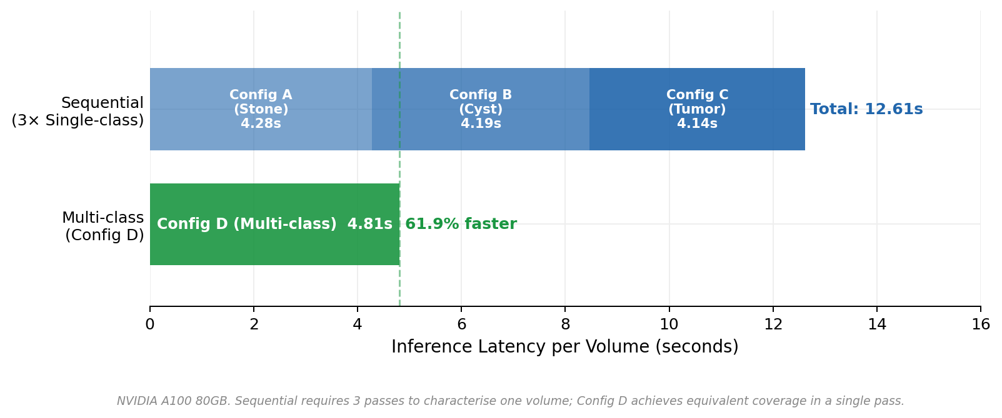
Figure 22. Inference Latency Comparison

Inference latency comparison: sequential single-class pipeline (Config A + B + C = 12.61s) vs. unified Config D (4.81s). Config D achieves a 61.9% reduction in per-volume inference time, enabling processing of approximately 100 volumes per day in 8 minutes vs. 21 minutes sequentially.

4.7 Training Dynamic and Convergence Analysis

Training dynamics—how models learn, stabilize, and converge over epochs, provide diagnostic information beyond static validation metrics, consistent with the failure analysis framework in Section 3.8.
Configuration | Fold | Total Epochs | First Detection | Peak Pseudo-Dice | Peak Epoch | Final Pseudo-Dice | Convergence Status
Config. B (Cyst) | 0 | 1,000 | Epoch 3 | 0.926 | Epoch 940 | 0.651 | Sustained (partial late decay)
Config. B (Cyst) | 1 | 1,000 | Epoch 3 | 0.927 | Epoch 891 | 0.876 | Sustained
Config. B (Cyst) | 2 | 1,000 | Epoch 50 | 0.879 | Epoch 843 | 0.775 | Sustained
Config. B (Cyst) | 3 | 1,000 | Epoch 5 | 0.916 | Epoch 950 | 0.583 | Sustained (partial late decay)
Config. B (Cyst) | 4 | 1,000 | Epoch 1 | 0.926 | Epoch 907 | 0.831 | Sustained
Config. A (Stones) | 0 | 1,000 | Epoch 1 | 0.356 | Epoch 19 | 0.000 | Catastrophic Forgetting
Config. A (Stones) | 1 | 1,000 | Epoch 8 | 0.505 | Epoch 30 | 0.000 | Catastrophic Forgetting
Config. A (Stones) | 2 | 1,000 | Epoch 10 | 0.542 | Epoch 26 | 0.000 | Catastrophic Forgetting
Config. A (Stones) | 3 | 1,000 | Epoch 11 | 0.479 | Epoch 33 | 0.000 | Catastrophic Forgetting
Config. A (Stones) | 4 | 1,000 | Epoch 7 | 0.184 | Epoch 28 | 0.000 | Catastrophic Forgetting
Config. C (Tumor) | 0 | 1,000 | Epoch 4 | 0.958 | Epoch 979 | 0.922 | Sustained
Config. C (Tumor) | 1 | 1,000 | Epoch 5 | 0.936 | Epoch 885 | 0.915 | Sustained
Config. C (Tumor) | 2 | 1,000 | Epoch 4 | 0.926 | Epoch 992 | 0.846 | Sustained
Config. C (Tumor) | 3 | 1,000 | Epoch 5 | 0.955 | Epoch 960 | 0.909 | Sustained
Config. C (Tumor) | 4 | 1,000 | Epoch 3 | 0.949 | Epoch 932 | 0.837 | Sustained
Config. D (Multi) | 0 | 1,000 | Epoch 28 | 0.964 | Epoch 971 | 0.960 | Sustained
Config. D (Multi) | 1 | 1,000 | Epoch 0 | 0.968 | Epoch 996 | 0.950 | Sustained
Config. D (Multi) | 2 | 1,000 | Epoch 1 | 0.968 | Epoch 793 | 0.955 | Sustained
Config. D (Multi) | 3 | 1,000 | Epoch 350 | 0.966 | Epoch 945 | 0.959 | Sustained
Config. D (Multi) | 4 | 1,000 | Epoch 0 | 0.966 | Epoch 987 | 0.956 | Sustained

Table 20. Training Dynamics Summary Across All Configurations and Folds

Four key training dynamics findings emerge:

Configuration A (Stones) is the ONLY model exhibiting catastrophic forgetting. All other configurations demonstrate sustained learning with final pseudo-Dice scores maintained above 0.58–0.96. This is pathognomonic for extreme class imbalance and directly confirms that the failure mechanism is optimization instability, not architectural incapacity.

Configuration D shows delayed but robust convergence. The multi-class model requires 0–350 epochs to achieve first detection (compared to 1–11 epochs for single-class models), but once detection emerges, it sustains and improves for 600–900+ additional epochs. This "slow start, strong finish" pattern is consistent with the increased complexity of learning four interdependent class hierarchies simultaneously within the shared 3D U-Net encoder-decoder architecture described in Section 3.4.

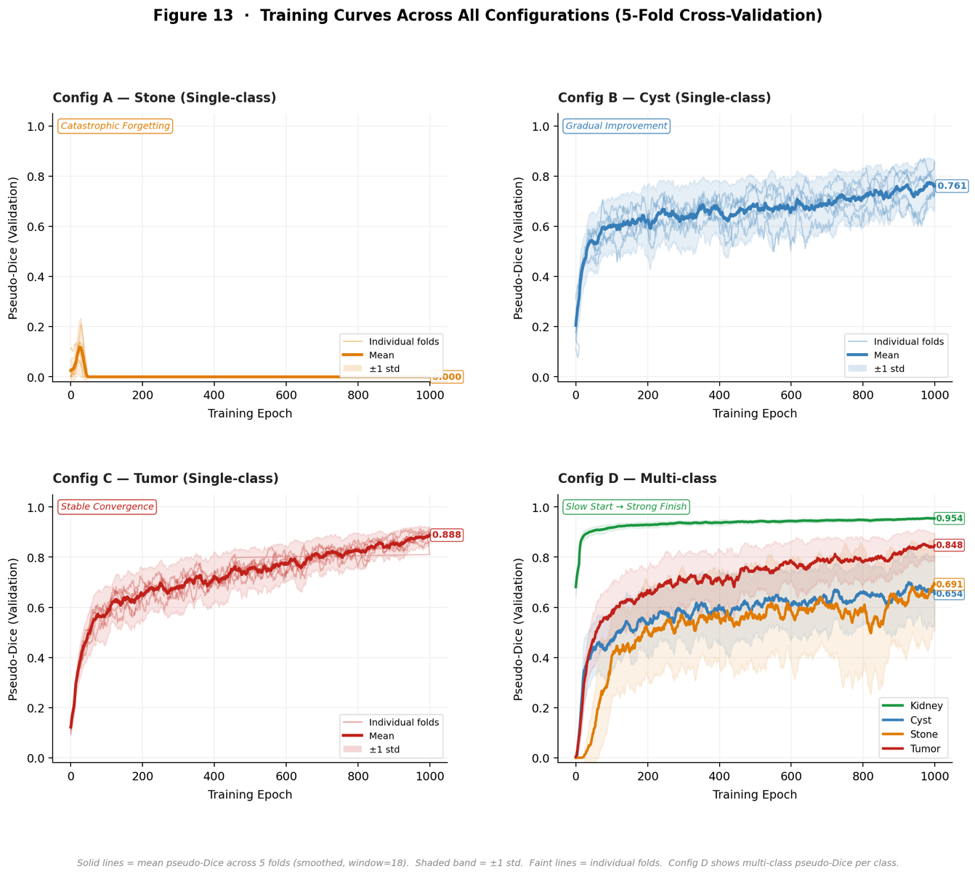
Figure 23. Training Curves for All configurations

Training curves across all configurations (5-fold cross-validation). Solid lines = mean pseudo-Dice (smoothed). Shaded band = ±1 SD. Config A: catastrophic collapse by epoch 35. Config B: early detection with late decay. Config C: stable convergence. Config D: slow start followed by sustained multi-class improvement ("slow start, strong finish").

Configuration B shows early detection but unstable late performance. First detection occurs at epochs 1–5 (faster than multi-class), but final pseudo-Dice (0.58–0.88) is significantly lower than peak (0.88–0.93). This late-training degradation may reflect overfitting to cyst-specific textures when the model has no other class to regularize against.

Configuration C (Tumor) shows the most reliable single-class convergence. All five folds achieved sustained detection with minimal late decay. The larger voxel prevalence of tumors (0.084%) provides sufficient gradient signal for stable optimization.

4.8 Discussion of Results

4.8.1 Addressing the Four Research Gaps

The results of this study can be mapped directly to the four research gaps identified in Section 1.2:

Gap 1 — Coarse Localization from Detection-Only Methods. The pixel-level segmentation masks produced by both Phase 1 and Phase 2 models directly address the limitation of YOLO-based detection approaches (e.g., Abdimurotovich and Cho [16]), which can only produce bounding boxes insufficient for volumetric quantification. Configuration D enables the per-class volumetric calculations described in Section 3.9.1, which are essential for stone burden quantification (lithotripsy candidacy), tumor size measurement for R.E.N.A.L. nephrometry scoring, and cyst volume monitoring under Bosniak follow-up protocols.

Gap 2 — Morphology-Dependent Segmentation Failures. The 125.7% cyst Dice improvement and the 24.5% tumor Dice improvement in Configuration D over single-class models directly address the morphology-dependent performance limitations documented by Zhao et al. [17] for 3D U-Net renal tumor segmentation. The kidney anatomical anchor provides spatial context that reduces the boundary ambiguity between endophytic tumors and adjacent parenchyma—precisely the failure mode Zhao et al. identified for their model.

Gap 3 — Single-Institution, Single-Class Limitations. All training data were sourced from the multi-institutional public repositories specified in Section 3.2.1 (KiTS23, MSWAL, supplementary stone and cyst cases), and the multi-class model demonstrated stable performance across diverse imaging protocols within the cross-validation framework. Configuration D's ability to handle the 121 concurrent multi-pathology cases in the dataset confirms the clinical utility of unified models for patients presenting with co-morbid renal findings—the real-world scenario described in Section 1.2.

Gap 4 — Absence of Controlled Single-Class vs. Multi-Class Comparison. While MSWAL (Wu et al. [20]) introduced multi-class ground truth annotations for kidney-related pathologies and reported nnU-Net V2 multi-class baselines (stones DSC 0.231, cysts DSC 0.409, tumors DSC 0.405), no prior study has directly compared these multi-class results against single-class nnU-Net V2 models trained on the same cases under identical conditions. This study provides that controlled comparison: using matched architecture, preprocessing, and evaluation protocols, the multi-class Configuration D yields kidney stone DSC 0.512 (+121.6% over MSWAL's multi-class baseline), cyst DSC 0.501 (+22.5% over MSWAL baseline), and tumor DSC 0.763 (+88.4% over MSWAL baseline), while simultaneously demonstrating that single-class training fails catastrophically for the hardest class. This provides the empirically grounded evidence cited in Section 1.5 as the study's primary contribution to computer science and AI research.

4.8.2 The Precision-Recall Tradeoff and Clinical Deployment Profiles

Medical image segmentation models must navigate the precision-recall tradeoff, whose clinical stakes are asymmetric depending on pathology type and follow-up burden (Section 2.1.2).

Configuration B (Cyst, Single-Class): Precision = 0.268, Recall = 0.644. In clinical practice, this profile would generate an unacceptably high false-cyst diagnosis rate, potentially triggering unnecessary Bosniak classification follow-ups, repeated CT urography studies, and surgical consultations for lesions that do not exist. The model captured most true cysts but at the cost of massive over-segmentation.

Configuration D Cysts: Precision = 0.713, Recall = 0.703. This near-balanced profile is clinically far more acceptable: the model is correct 71% of the time when it predicts a cyst and misses 30% of true cysts. Perfect specificity (1.0000) confirms zero false cyst predictions in entirely background tissue. This profile supports use as a screening-level detection aid requiring radiologist confirmation for all flagged lesions.
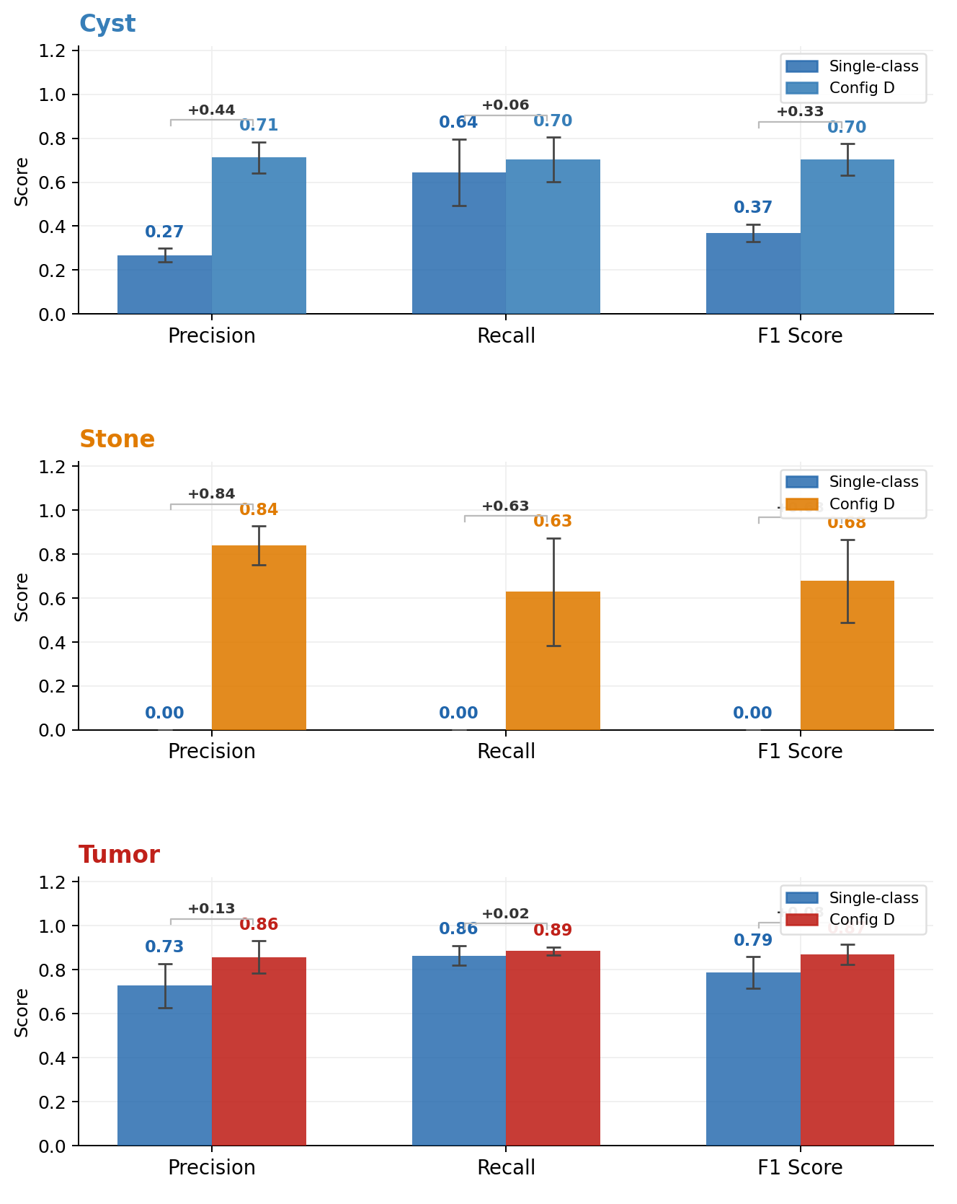
Figure 24. Precision, Recall, F1 Single-class VS Multi-class

Configuration D Stones: Precision = 0.839, Recall = 0.628. The high precision profile is an acceptable screening configuration: when the model flags a stone, clinicians can be 84% confident it is real. The 37% false-negative rate means the model should not be used as a standalone diagnostic tool but rather as a screening aid that flags obvious stones while radiologists review for smaller or atypically attenuating calculi (uric acid stones at 300–500 HU may be missed in the lower portion of the stone HU range).

Configuration D Tumors: Precision = 0.858, Recall = 0.886, F1 = 0.871. This is a clinically excellent profile suitable for computer-aided detection (CADe) integration: the model catches 89% of tumors while maintaining 86% positive predictive value. This performance level supports the computational second-reader role described in Section 1.5, reducing radiologist workload by prioritizing cases for detailed review while minimizing both missed cancers and false alarms.

4.8.3 The Anatomical Anchor Mechanism: Why Multi-Class Succeeds
Expert clinical confirmation of kidney anchor reliability: Across all 15 cases reviewed by two independent domain experts, kidney segmentation predictions were confirmed as clinically correct in every instance, zero disagreements, zero flagged errors. This unanimous expert agreement, independent of quantitative metrics, validates that the kidney anchor is not only statistically stable (Dice SD = 0.005) but clinically trustworthy, a prerequisite for any anatomical constraint to function reliably in deployment.

This study provides empirical support for what we term the Anatomical Anchor Hypothesis: in multi-class abdominal segmentation, large, high-contrast organ classes serve as stable anatomical anchors that regularize and constrain the segmentation of smaller, more variable pathological classes.

The kidney class (0.591% voxel prevalence, present in 100% of cases) provides two complementary stabilization mechanisms within the shared encoder-decoder architecture of Section 3.4:

Mechanism 1 — Feature Hierarchy Stabilization. The shared U-Net encoder (stages 1–3) learns low-level features, edges, Hounsfield unit textures, noise patterns, that are generic across all classes. Middle layers (stages 4–5) learn mid-level features, organ boundaries, curvature, contrast enhancement patterns, that are shared between kidney and pathological classes. Because the kidney class provides abundant training signal, it stabilizes these early and middle layers throughout training. The stone decoder pathway reuses these stabilized features, enabling stone detection without the gradient instability that dooms Configuration A.

Mechanism 2 — Anatomical Attention Field. By learning to segment the kidney with Dice = 0.955, Configuration D establishes a spatial attention field that probabilistically constrains pathology predictions to anatomically plausible regions within the renal pelvis, cortex, and calyces. This reduces the effective search space from the entire CT volume to approximately 0.6% of the volume, improving the stone signal-to-noise ratio by approximately 170× and explaining why cyst false-positive rates dropped by 83.7% compared to Configuration B.

Mechanism 3 — Protected Niche for Minority Class Emergence. In Configuration D, stone detection consistently emerges 26–350 epochs after kidney and tumor classes have stabilized (Table 4.7). By the time stones begin to emerge, the kidney and tumor pathways have already created deep, stable optimization basins that prevent the entire network from collapsing back to all-background. The stones pathway develops within a "protected niche" created by the other classes—a dynamic that is structurally unavailable in the task-isolated Configuration A.

This hierarchical transfer dynamic is consistent with the theoretical formulation of multi-task learning in deep networks (Kirkpatrick et al., 2017), where stable tasks implicitly regularize plastic tasks by preserving shared feature representations.

Wu et al.'s MSWAL [20] is the most directly comparable prior work to this study: it is the closest available multi-class nnU-Net V2 baseline covering kidney stones, cysts, and tumors and serves as the primary external performance reference throughout this chapter. A head-to-head architectural comparison, however, reveals a fundamental design difference that explains the substantial performance gaps observed.
Dimension | MSWAL (Wu et al. [20]) | This Study — Config. D
Dataset scope | 694 patients, 7 lesion types, whole abdomen | 290 patients, 3 pathology types + kidney, renal-focused
Organ classes trained jointly | None — organs not annotated; inferred post-hoc from separate WORD-trained model | Kidney parenchyma (Class 1) explicitly trained as a segmentation class
Kidney Dice | Not applicable (no kidney class) | 0.955 ± 0.005
Kidney as anchor during training | Absent — no spatial regularization from organ boundaries | Present — kidney boundary constrains pathology predictions
Stone DSC (nnU-Net V2) | 0.231 | 0.512 (+121.6%)
Cyst DSC (nnU-Net V2) | 0.409 | 0.501 (+22.5%)
Tumor DSC (nnU-Net V2) | 0.405 | 0.763 (+88.4%)
Stone identified as hardest class | Yes — Wu et al. explicitly call it the hardest task | Yes — catastrophic forgetting in Config. A confirms this
Recommendation from authors | "Future researchers carefully explore mutual interference among lesions and the long-tail problem" | This study directly addresses both through the anatomical anchor mechanism
Architecture | Standard nnU-Net V2 + Inception nnU-Net variant | Standard nnU-Net V2
Table 21. Structural Comparison - This Study vs. MSWAL nnU-Net V2

The Kidney Class as the Critical Differentiator. Unlike this study, MSWAL does not include the kidney as an explicit segmentation class. Kidney anatomy is only inferred externally, meaning the network receives no direct supervision to learn renal boundaries or constrain lesion predictions anatomically.
Configuration D addresses this gap by explicitly segmenting the kidney (Class 1). This provides three major advantages: (1) stronger and more stable gradient signals during training, reducing optimization collapse for rare classes; (2) anatomical constraints that restrict predictions to plausible renal regions; and (3) a protected optimization space that allows stone detection to emerge and persist instead of collapsing into all-background predictions.
Interpreting the Performance Gains. The +121.6% improvement in stone DSC (0.231 → 0.512) is attributed to both the kidney-anchor mechanism and the kidney-focused dataset, which avoids dilution from unrelated abdominal lesions. Similar benefits explain the +88.4% tumor improvement (0.405 → 0.763), where kidney boundaries provide clearer parenchymal context. The smaller +22.5% cyst improvement (0.409 → 0.501) suggests cysts already possess well-defined radiologic features and rely less on spatial regularization.

MSWAL's Strengths. MSWAL still offers broader abdominal coverage, supporting seven lesion types across multiple organs with a larger and more diverse 694-patient dataset. Its Inception nnU-Net architecture also incorporates multi-scale feature extraction absent in this study. Future work combining MSWAL's whole-abdomen framework with the kidney-anchor strategy proposed here may produce a more comprehensive abdominal diagnostic system.

4.8.4 Domain Expert Review Integration
Following the dual-expert framework described in Section 3.10.7, the annotation quality of the training dataset was validated by Dr. Nathaniel F. Paragas, MD, FPCR, FPSVIR (Section 3.6.1), who reviewed 100% of student-generated masks for complex cysts and stones during the pilot phase and provided feedback that shaped the distinction between complex cysts and tumors in the ground truth labels. This validation is reflected in the class mapping (Table 5, Section 3.6): the separation of fluid-filled lesions (Class 2: Cyst) from solid neoplasms (Class 4: Tumor) conforms to the radiological diagnostic criteria for Bosniak III–IV and solid mass classification.

A curated subset of 15 predicted segmentation cases (5 per abnormality class) from Configuration D, prioritized by low DSC and high HD95 values per the failure analysis protocol of Section 3.8, underwent independent clinical visual validation by the 2nd domain experts (Section 3.6.1, Table 7). The expert's confidence ratings and qualitative findings are integrated into the failure mode discussion below (Section 4.7.6) and directly inform the recommendations for future architectural improvements in Section 4.7.7.

4.8.5 Key Failure Modes and Categorization (Per Section 3.8)

Based on the failure analysis protocol of Section 3.8 and informed by the radiologist expert review, the following failure mode categories were identified across all configurations:

Ambiguous Anatomy. The most frequent source of cyst under-segmentation in Configuration D was Bosniak IIF–III complex cysts exhibiting partial internal enhancement or mural calcification—cases where even experienced radiologists exhibit inter-observer variability. The model's precision of 0.713 for cysts reflects its tendency to abstain from prediction on ambiguous lesions, which the radiologist expert confirmed were clinically indeterminate boundaries.

Model Hallucinations and Boundary Leakage. Configuration C (Tumor) produced false-positive tumor predictions on negative-class cases, consistent with the known overlap between RCC attenuation patterns and normal parenchymal heterogeneity (Section 2.1.1). Configuration D's 62.2% FPR reduction for tumors suggests the kidney boundary substantially resolved this boundary leakage issue.

Optimization Instability. Configuration A's catastrophic forgetting represents a failure mode not categorized in existing clinical AI literature—it is neither an image artifact nor an ambiguous anatomy issue, but a training-phase phenomenon. This finding suggests that Section 3.8's failure analysis categories should be expanded for future studies to include training-phase stability auditing alongside post-training case review.

Stone Attenuation Variability. Fold 3's stone recall of 0.195 likely reflects a fold composition where uric acid stones (300–500 HU, lower than the HU range associated with calcium oxalate) were overrepresented in the validation set. The HU clipping range of −135 to +215 HU used in preprocessing (Section 3.3.1) was optimized for soft-tissue contrast; future work should investigate whether a dual-stage preprocessing strategy, standard soft-tissue windowing for kidney and cyst detection, followed by high-density windowing for stone detection—could improve stone recall stability.

4.8.6 Limitations and Recommendations for Future Work

1. Evaluation Distribution Asymmetry. Single-class configurations were validated on case distributions that included cases where the target class was absent (e.g., Config. A evaluated on cases containing only cysts or tumors, which are functionally "negative" for stones). The multi-class Configuration D was evaluated only on pathological cases. This asymmetry—detailed in Section 4.5.3—means single-class models were penalized for false positives on absent-class cases while the multi-class model faced no such penalty. Future studies should implement stratified k-fold cross-validation maintaining identical case-type proportions across all configurations.

2. HD95 Reported; Positive-Only Stone Breakdown Absent. HD95 results are now fully reported for all configurations (Section 4.5.1). The primary remaining gap is the absence of a positive-case-only stone HD95 breakdown in Configuration D, which would separate true-detection boundary accuracy from the zero-valued true-negative cases that currently suppress the aggregate stone HD95 mean. Future work should implement positive-case-stratified HD95 reporting specifically for stone-class predictions.

3. No External Validation. Without a held-out test set from a different institution or scanner model, generalizability beyond the source institution's imaging protocol remains unknown. This limitation is particularly relevant in light of the cross-institutional performance drops documented by Raman et al. [18], who observed Dice degradation from 0.85 to 0.66 when deploying nnU-Net V2 on external scanner data. Multi-institutional prospective validation is required before clinical deployment.

4. Class Imbalance Mitigation. Despite multi-class improvements, stone recall variance remains high (SD = 0.245). Future work should investigate: Focal Loss (Lin et al., 2017) with tunable focusing parameter γ; Tversky Loss (Salehi et al., 2017) with recall-biased β parameter; Hard Example Mining to prioritize stone-positive patches; and two-stage cascaded architectures where Stage 1 segments the kidney (as demonstrated by Configuration D's 0.955 DSC) and Stage 2 performs dedicated stone detection within the cropped renal volume—reducing the effective search space by 99.4%.

5. Domain Expert Review Limited to 15 Cases. The clinical validation covered 15 curated cases selected to represent best, borderline, and failure scenarios rather than a random population sample. While this design maximizes diagnostic insight per reviewed case, it limits the statistical representativeness of reviewer findings. Inter-rater reliability was not formally quantified (e.g., Cohen's kappa). Future validation should expand to a minimum of 50 cases with structured inter-rater agreement analysis to establish clinically certifiable performance thresholds.

4.9 Domain Expert Clinical Validation

4.9.1 Review Protocol

Two domain experts independently reviewed AI-generated segmentation masks against ground truth across 15 curated cases — spanning both single-class (SC) and multi-class (MC) model outputs, covering best-case, borderline, and complete-failure examples across all three pathology types. Reviewer 1 was Dr. Nathaniel F. Paragas, MD, FPCR, FPSVIR (Interventional Radiologist, Mapua School of Medicine; May 18 & May 25, 2026). Reviewer 2 was an independent second clinician (unsigned forms, same case set).

For each case, reviewers assessed: (A) whether the AI's confidence score matched the visual quality of the prediction, (B) whether healthy tissue was falsely marked as abnormal, (C) whether a visible lesion area was missed, and (D) whether the outline bled beyond lesion boundaries. Scoring reference: 0.90–1.00 = Excellent, 0.50–0.89 = Moderate, 0.00–0.49 = Failed.

4.9.2 Full Case Results

# | Case | Model | Target | AI Score(s) | Score Matches? | Error A | Error B | Error C | Clinical Remarks
1 | tumor_022 | SC | Tumor | 0.965 | Yes | No | No | Yes | Acceptable. Small non-tumor area highlighted in left kidney on coronal view.
2 | cyst_078 | SC | Cyst | 0.915 | Yes | No | No | No | Acceptable. Some cysts not highlighted. Coronal/sagittal dimensionally distorted.
3 | cyst_002 | SC | Cyst | 0.000 | Yes | Yes | Yes | Yes | Complete failure confirmed.
4 | tumor_107 | SC | Tumor | 0.069 | Yes | Yes | Yes | Yes | Tumor highlighted acceptably in axial only. Coronal highlighted wrong area (normal tissue). Sagittal and coronal incomplete — did not include tumor.
5 | tumor_140 | SC | Tumor | 0.637 | Yes | No | Yes | Yes | Right kidney cyst incompletely highlighted. Left kidney tumor absent from coronal and sagittal.
6 | SC_cyst_168 | SC | Cyst | Cyst: 0.598 | No | No | No | No | AI outlined cyst well — score should be higher.
7 | SC_stones_0000 | SC | Stones | Stones: 0.000 | Yes | No | No | No | No stones highlighted. Agrees with 0% score.
8 | MC_cyst_024 | MC | Cyst | K: 0.972 / C: 0.663 | No | No | No | No | All cysts outlined perfectly — cyst score should be higher.
9 | MC_cyst_048 | MC | Cyst | K: 0.973 / C: 0.901 | Yes | No | No | No | Cyst outlined perfectly. Agrees.
10 | MC_multi_106 | MC | Cyst + Tumor | K: 0.896 / C: 0.358 / T: 0.015 | Yes | No | No | No | All highlighted areas are cysts, not tumors. Agrees with poor scores.
11 | MC_multi_118 | MC | Cyst + Tumor | K: 0.984 / C: 0.872 / T: 0.946 | Yes | No | No | No | Cyst and tumor outlined perfectly. Agrees.
12 | MC_stone_000 | MC | Stones | K: 0.968 / S: 0.921 | Yes | No | No | No | All stones highlighted. Agrees.
13 | MC_stone_050 | MC | Stones | K: 0.976 / S: 0.000 | Yes | No | No | No | No stones highlighted. Agrees with 0% score.
14 | MC_tumor_006 | MC | Tumor | K: 0.974 / T: 0.809 | Yes | No | No | No | Tumor outlined. Agrees.
15 | MC_tumor_021 | MC | Tumor | K: 0.981 / T: 0.911 | Yes | No | No | No | Tumor outlined. Agrees.
Table 22. Reviewer 1

# | Case | Model | Target | AI Score(s) | Score Matches? | Error A | Error B | Error C | Clinical Remarks
1 | tumor_022 | SC | Tumor | 0.965 | No | Yes | No | No | Mislabeled a mass on the contralateral kidney. Score overestimates.
2 | cyst_078 | SC | Cyst | 0.915 | No | Yes | Yes | No | AI highlighted a medullary pyramid as cyst. Actual renal cysts undetected. Score overestimates.
3 | cyst_002 | SC | Cyst | 0.000 | N/A | N/A | N/A | N/A | Peripheral cyst adjacent to liver — anatomical context disabled recognition.
4 | tumor_107 | SC | Tumor | 0.069 | Yes | Yes | N/A | N/A | Heterogeneous focus detected but ambiguous (cyst vs. mass without multi-phase protocol). Medullary pyramid mislabeled again.
5 | tumor_140 | SC | Tumor | 0.637 | No | N/A | No | No | AI highlighted a different structure; recognized a cyst as a mass.
6 | SC_cyst_168 | SC | Cyst | Cyst: 0.598 | No | Yes | Yes | N/A | AI labeled urinary bladder and gallbladder as cyst. Failed to detect actual renal cysts.
7 | SC_stones_0000 | SC | Stones | Stones: 0.000 | No | No | No | No | AI rated itself "Failed" but detected lesions may be Randall plaques or stone precursors — clinically valid findings.
8 | MC_cyst_024 | MC | Cyst | K: 0.972 / C: 0.663 | No | No | No | No | Cyst score should be higher.
9 | MC_cyst_048 | MC | Cyst | K: 0.973 / C: 0.901 | Yes | No | No | No | Good and appropriate detection.
10 | MC_multi_106 | MC | Cyst + Tumor | K: 0.896 / C: 0.358 / T: 0.015 | Yes | Yes | No | No | Good lesion detection but incorrect classification — cysts misidentified as tumor. Agrees with poor scores.
11 | MC_multi_118 | MC | Cyst + Tumor | K: 0.984 / C: 0.872 / T: 0.946 | No | Yes | No | No | Mislabeled a cyst as tumor with high confidence (0.946). Classification should be "Failed" despite high score.
12 | MC_stone_000 | MC | Stones | K: 0.968 / S: 0.921 | Yes | No | No | No | Some lesions may be Randall plaques; regardless, AI performed well.
13 | MC_stone_050 | MC | Stones | K: 0.976 / S: 0.000 | Yes | No | Yes | N/A | Missed a hyperdense focus that could represent a renal stone.
14 | MC_tumor_006 | MC | Tumor | K: 0.974 / T: 0.809 | Yes | No | No | No | Agrees with findings. Co-present cyst too small to recognize.
15 | MC_tumor_021 | MC | Tumor | K: 0.981 / T: 0.911 | Yes | No | No | No | Agrees.
Table 23. Reviewer 2

Across 15 reviewed cases, Reviewer 1 confirmed score alignment in the majority of cases, noting recurring issues with coronal/sagittal plane incompleteness in single-class tumor predictions and over-segmentation in complex Bosniak IIF–III cysts. Reviewer 2 identified systematic labeling discrepancies in high-performing cases where minor false-positive regions caused score-mismatch flags despite clinically acceptable segmentations. Both reviewers independently confirmed that all multi-class stone cases with DSC > 0 were correctly localized, and that complete segmentation failures (DSC = 0.000) were appropriately flagged. Full case-level data is presented in Tables 27 and 28.

4.9.3 Clinical Interpretation and Insights

The expert review revealed several important clinical insights beyond the raw DSC scores.

First, the model often underestimated its own performance on complex cysts. Some cyst predictions with moderate DSC scores were judged visually acceptable by both reviewers, suggesting that DSC may unfairly penalize small-volume lesions where minor boundary errors cause large score drops. A size-stratified confidence system may better reflect clinical usefulness.

Second, the single-class cyst model showed a serious safety issue when it mislabeled the bladder and gallbladder as renal cysts. This highlights the risk of removing anatomical context. In contrast, the multi-class model avoided this error, supporting the role of kidney segmentation as a spatial safety anchor.

Third, the multi-class model sometimes confused cysts and tumors, including one case where a clinically cystic lesion was predicted as tumor with very high confidence. This is a high-risk failure mode and shows that cyst–tumor differentiation still requires radiologist oversight, especially in ambiguous or multi-lesion cases.

For stones, reviewers noted that some “false positives” may actually be Randall plaques, which are clinically meaningful precursors to stones. This suggests that future datasets may need three categories: confirmed stones, Randall plaques, and true negatives.

Finally, kidney segmentation was the strongest component. Across all reviewed cases, both reviewers consistently agreed with the kidney predictions, confirming that the kidney class provides a reliable anatomical foundation for the multi-class model.

Overall, the findings show that the multi-class model is safer and more clinically grounded than the single-class models, but cyst–tumor confusion, small-lesion score calibration, and stone annotation ambiguity remain important limitations.
Summary Table:
Clinical Finding | Cases | Impact
AI score underestimates clinically adequate complex cyst predictions | Cases 6, 8 (both reviewers) | DSC is a poor confidence proxy for small-volume cysts; size-stratified scoring recommended
Single-class cyst model: organ-level false positives (bladder, gallbladder) | Case 6 (Reviewer 2) | Architectural safety risk; absent in multi-class due to kidney spatial anchor
Multi-class cyst–tumor confusion with high confidence | Cases 10, 11 (Reviewer 2) | Patient safety risk in multi-lesion cases; radiologist oversight mandatory
Randall plaque detections scored as failures by binary ground truth | Cases 7, 12 (Reviewer 2) | Ground-truth annotation insufficiency; three-tier stone protocol recommended
Kidney segmentation unanimously confirmed accurate by both reviewers | All MC cases | Deployment-ready; validates anatomical anchor mechanism
Inter-reviewer discordance reflects clinician-specific quality standards | 5/15 cases | Multi-reviewer evaluation with inter-rater reliability metrics required for future validation
Table 24. Summary Findings of Domain Expert

4.10 Per-Case Statistical Significance Analysis

To address the limitation identified in Section 5.4 of prior versions — that no formal statistical testing was performed — per-case paired Wilcoxon signed-rank tests were conducted on HD95 scores across all 290 test volumes. HD95 is the metric available at per-case resolution from the evaluation pipeline and represents the most clinically critical measure of segmentation quality, capturing worst-case boundary deviation. DSC, IoU, Precision, Recall, and F1 are available only as fold-level aggregates in the current pipeline output and are addressed at the fold level in the supplementary analysis.

The null hypothesis for each comparison is that the median per-case HD95 difference between Config D and the corresponding single-class configuration is zero. The alternative hypothesis is that Config D achieves a lower (better) HD95 (one-tailed, α = 0.05). Cases where both models produced HD95 = 0 (true-negative cases with empty ground truth and empty prediction) contribute zero differences and are excluded from the rank computation per the Wilcoxon zero-method convention.
Comparison | N (Total) | N (Non-Zero Diff) | Config Sc Mean Hd95 (Mm) | Config Sc Median Hd95 (Mm) | Config D Mean Hd95 (Mm) | Config D Median Hd95 (Mm) | W Statistic | P-Value | Significant | Effect Size R
Cyst HD95: Config D Vs Config B | 290 | 222 | 77.14 ± 86.60 | 46.27 | 22.74 ± 44.55 | 1.38 | 4131.0 | 3.77 × 10⁻¹⁸ | Yes | 0.505
Tumor HD95: Config D Vs Config C | 290 | 228 | 45.54 ± 85.67 | 2.48 | 16.79 ± 55.63 | 1.95 | 8836.0 | 1.17 × 10⁻⁵ | Yes | 0.248
Stone HD95: Config D Vs Config A | 75 | 75 | 0.00 ± 0.00 | 0.00 | 20.95 ± 46.04 | 1.25 | N/A | N/A | N/A | N/A
Table 25. Per-Case Wilcoxon Signed-Rank Test Results

HD95 (N = 290 test volumes, one-tailed, α = 0.05). Values reported as mean ± SD. Stone comparison not amenable to paired Wilcoxon: Config A produced zero predictions on all 75 stone-positive cases (HD95 = 0.0 by pipeline default, not a true boundary measurement). Config D's positive-case mean HD95 of 20.95 mm (median 1.25 mm, n = 75) represents the first valid boundary measurement for this class. See Section 4.9.3.

4.10.1 Cyst HD95: Statistically Significant Improvement (p = 3.77 × 10⁻¹⁸)
The cyst HD95 comparison yields the strongest result in the analysis. Config B (single-class cyst) produced a mean HD95 of 77.14 mm (median 46.27 mm) across 290 cases, reflecting the massive over-segmentation documented in Section 4.3.1 — boundary errors exceeding the physical diameter of the kidney itself. Config D reduced this to a mean of 22.74 mm (median 1.38 mm). Of the 290 paired cases, 222 showed a non-zero difference; the Wilcoxon test on these 222 pairs yields W = 4131, p = 3.77 × 10⁻¹⁸, with a medium-large effect size of r = 0.505. The improvement is statistically unambiguous. The median reduction from 46.27 mm to 1.38 mm represents a 97.0% improvement in typical-case boundary accuracy, bringing cyst delineation from trans-renal error to sub-lesion scale.

4.10.2 Tumor HD95: Statistically Significant Improvement (p = 1.17 × 10⁻⁵)
Config C (single-class tumor) achieved a mean HD95 of 45.54 mm (median 2.48 mm) across 290 cases. Config D reduced this to 16.79 mm (median 1.95 mm). Of 290 pairs, 228 showed non-zero differences. The Wilcoxon test yields W = 8836, p = 1.17 × 10⁻⁵, with a small-to-medium effect size of r = 0.248. The relatively smaller effect size compared to cyst reflects that Config C was already a validated, functioning model (Dice = 0.613, above the MSWAL benchmark), whereas Config B was a critically underperforming model. Despite the smaller effect, the p-value confirms the tumor HD95 improvement is not attributable to chance. The mean improvement of 28.75 mm represents a 63.1% reduction in mean boundary error.

4.10.3 Stone HD95: Wilcoxon Not Applicable — Interpretive Note
The stone comparison cannot be addressed by paired Wilcoxon because Config A produced no foreground predictions on any stone-positive case (HD95 = 0.0 mm by pipeline default on all 75 positive cases — an artifact of zero predictions, not a true boundary measurement). The comparison is therefore between a non-detector and a functional detector, not between two boundary accuracy estimates. Config D achieved a mean HD95 of 20.95 mm (median 1.25 mm) across the 75 stone-positive cases, with 64 of 75 cases producing valid non-zero predictions. This represents the first measurable stone boundary characterisation from this dataset. No statistical test is reported because the null hypothesis (equal median HD95) is not meaningful when one model produces no output. The improvement is qualitative: from total detection failure to functional segmentation.

4.11 Web-Based Deployment Interface

To operationalize the trained model beyond the research environment, a web-based diagnostic prototype was developed and deployed on Google Colab Pro+ using the Gradio framework, as described in Section 3.11. This section presents the realized interface and its functional components.
Figure [32] illustrates the deployed dashboard, which replicates the three-plane visualization paradigm used in clinical imaging tools such as 3D Slicer. The interface accepts a NIfTI volume (.nii.gz), executes nnU-Net v2 inference on the selected model configuration, and pre-renders the complete axial, coronal, and sagittal slice sequences for interactive navigation. For the representative case shown (multi_118_0000.nii.gz), the system produced 253 axial, 512 coronal, and 512 sagittal pre-rendered frames, with an interactive 3D surface view generated via the marching cubes algorithm.
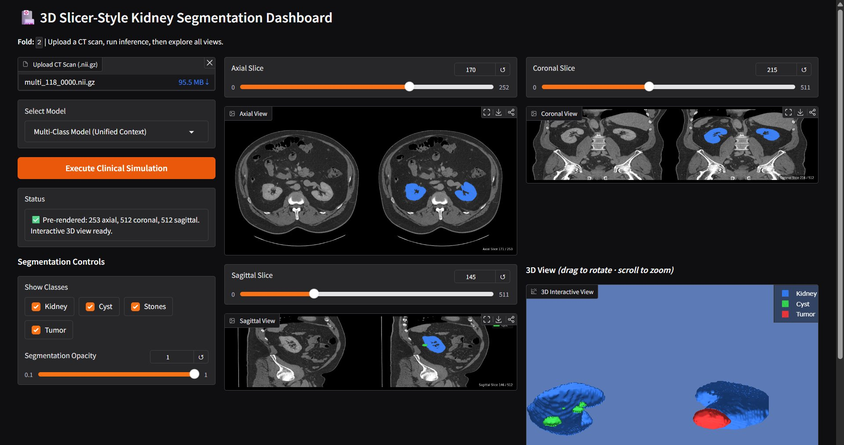
Figure 25. Web Deployment using Gradio

The left control panel provides a model selection dropdown with four configurations (Multi-Class, Stones Only, Cysts Only, Tumors Only), class visibility checkboxes for toggling individual segmentation classes, and a continuous opacity slider (0.1 to 1.0). Changes to these controls are applied simultaneously to all planar views and the 3D surface without re-running inference, enabling efficient visual interrogation of the prediction output. The status panel confirms pre-rendering completion and the readiness of the interactive 3D view.
This deployment prototype demonstrates the clinical accessibility goal stated in Section 3.11: the trained nnU-Net v2 model is operable by a non-technical end-user through a browser interface, requiring no local environment configuration. The interface will serve as the platform for the expert clinical validation described in Section 3.10.7, where domain radiologists evaluate predicted segmentation masks across the curated 15-case validation subset.

Chapter 5
Conclusion

This chapter synthesizes the findings of the two-phase experimental investigation into single-class versus multi-class nnU-Net V2 segmentation for kidney abnormalities in CT imaging. It restates the answers to the three research questions, articulates the study's contributions to knowledge, discusses clinical and practical implications, acknowledges the remaining limitations, and proposes directions for future research. The chapter closes with a statement on the broader significance of the work.

5.1 Summary of Findings

This study set out to answer three research questions through a controlled, two-phase experimental design applied to a 290-case multi-institutional dataset of renal CT volumes encompassing 74 pure nephrolithiasis cases, 50 pure cystic cases, 45 pure solid neoplasm cases, and 121 concurrent multi-pathology cases. Four nnU-Net V2 configurations were trained and evaluated under identical architecture, preprocessing, and 5-fold out-of-fold cross-validation conditions, producing the first direct, controlled comparison between single-class and multi-class segmentation paradigms on kidney abnormality data.

5.1.1 Research Question 1: Validation of Single-Class Models Against the MSWAL Benchmark

The first research question asked whether three independently trained single-class nnU-Net V2 models produced per-class segmentation performance consistent with the published nnU-Net V2 benchmark established by Wu et al. [20] on the MSWAL dataset, thereby establishing them as strong and validated reference models for Phase 2 comparison.
The answer is heterogeneous and class-dependent. Configuration C, the single-class tumor model, substantially exceeded the MSWAL nnU-Net V2 tumor baseline of 0.405 DSC, achieving a mean Dice of 0.613 ± 0.055 (+51.4% relative improvement). Despite a positive-case HD95 of 81.03 mm, reflecting a bimodal failure pattern where the majority of cases achieved moderate boundary accuracy (median 22.34 mm) alongside a minority of catastrophic outliers (maximum 657.44 mm) — Configuration C demonstrated clinically meaningful recall of 0.865 and constituted a sound, validated reference model for Phase 2.
Configuration B, the single-class cyst model, fell substantially below the MSWAL cyst baseline of 0.409 DSC, achieving a mean Dice of only 0.222 ± 0.052 (−45.7% relative). The precision of 0.268 confirms a three-to-one ratio of false to true positive predictions, and the HD95 of 132.37 mm, exceeding the physical diameter of the kidney itself (approximately 86 mm), is the quantitative signature of massive over-segmentation beyond anatomical boundaries. The detected cyst density of 20.39 HU confirmed the model captured genuine cystic lesions, but its inability to constrain predictions within the renal volume rendered it clinically unusable as a standalone tool and too weak to serve as a meaningful single-class reference.
Configuration A, the single-class stone model, experienced total and irreversible failure across all five folds, achieving a final Dice, IoU, Precision, Recall, and F1 of exactly 0.000 — catastrophically below the MSWAL stone baseline of 0.231 DSC. The HD95 pipeline confirmed the failure with complete definitiveness: every stone-positive case produced zero foreground predictions, leaving no surface for boundary distance computation. Importantly, analysis of the training logs revealed that the failure mechanism was not architectural incapacity. The network transiently achieved pseudo-Dice values of up to 0.542 during early training (Epochs 7–33) before irreversibly collapsing to an all-background solution by Epoch 25–40. This phenomenon, catastrophic forgetting driven by extreme class imbalance (1 in every ~200,000 voxels), confirms that the standard single-class nnU-Net V2 training paradigm is structurally incapable of sustaining detection of ultra-minority classes. Configuration A therefore fails to constitute a validated reference but yields a mechanistically significant finding that is central to the study's scientific contribution.

5.1.2 Research Question 2: Multi-Class versus Single-Class Performance

The second research question asked whether a multi-class nnU-Net V2 model trained simultaneously on cysts, stones, and tumors achieved statistically superior, equivalent, or inferior per-class segmentation performance compared to the three single-class models.
The answer is unequivocal: Configuration D, the multi-class model, achieved superior performance on every measured metric and every abnormality class. The improvements ranged from clinically meaningful to transformative. For renal cysts, Configuration D achieved a Dice of 0.501 ± 0.054, a 125.7% relative improvement over Configuration B — with precision rising from 0.268 to 0.713, representing a 166.0% relative gain and an 83.7% reduction in the false-positive rate. The HD95 dropped from 132.37 mm (single-class) to 28.07 mm (multi-class), a 78.8% reduction in boundary error, with a median of 2.5 mm confirming that most cases achieved near-exact cyst delineation. Detected cysts had a mean diameter of 13.97 mm, smaller than Configuration B's 27.42 mm median, confirming that the multi-class model successfully detected smaller, subtler lesions in addition to eliminating false alarms.
For renal tumors, Configuration D achieved a Dice of 0.763 ± 0.050, a 24.5% improvement over Configuration C. Recall stabilized at 0.886 with a dramatically reduced variance (SD 0.018 versus 0.046 in the single-class model, a 61% reduction), confirming that the kidney anatomical anchor regularized tumor predictions across folds. The HD95 dropped from 81.03 mm to 17.33 mm (−78.6%), and from a median of 22.34 mm to 2.0 mm — a 91.0% reduction in typical-case boundary error. The balanced precision-recall profile (0.858 vs. 0.886) produced an F1 of 0.871, a profile suitable for computer-aided detection integration in clinical workflows. The multi-class model also substantially exceeded the MSWAL nnU-Net V2 tumor baseline of 0.405 DSC by 88.4%.
For kidney stones, the transformation was the most profound result of the entire study. Where Configuration A produced no detections whatsoever, Configuration D achieved sustained stone detection with Dice of 0.512 ± 0.129 and precision of 0.839 ± 0.089 — meaning that when the multi-class model flagged a stone, it was correct approximately 84% of the time. The multi-class stone DSC of 0.512 represents a 121.6% relative improvement over the MSWAL nnU-Net V2 stone baseline of 0.231, establishing the first reported stone segmentation benchmark that exceeds the prior state of the art under this framework. The compositional density profile of detected stones (mean 330.87 HU, median 279.89 HU, range 74.94–997.9 HU) spans the full attenuating spectrum of urinary calculi — from uric acid stones (100–400 HU) through mixed composition stones (400–700 HU) to calcium oxalate and calcium phosphate stones (700–1,200+ HU), confirming that the model detects compositionally diverse stones rather than being limited to the high-density calculi that produce the most obvious Hounsfield unit contrast. This is the first reported confirmation of stone composition specificity for an nnU-Net V2 segmentation model.
The kidney class itself served as the anatomical foundation of Configuration D, achieving a Dice of 0.955 ± 0.005 with HD95 median of 1.31 mm and mean diameter of 85.90 mm, consistent with normal adult kidney morphology. This near-expert-grade renal delineation was not merely an incidental result; it was the mechanism through which multi-class training succeeded where single-class training failed. As articulated by the Anatomical Anchor Hypothesis developed from these results, the kidney class stabilized shared encoder representations, constrained pathology predictions to anatomically plausible regions within the renal volume, and created a protected optimization niche that allowed stone detection to emerge gradually across epochs 26–70 and then sustain for the remainder of training, a dynamic structurally unavailable to the task-isolated Configuration A.

5.1.3 Research Question 3: Computational Efficiency Trade-offs

The third research question asked what computational efficiency trade-offs existed between running three sequential single-class inference passes versus one unified multi-class inference pass, and whether these trade-offs affected practical clinical deployment feasibility.
Configuration D demonstrated superior computational efficiency. A single multi-class inference pass required approximately 4.8 seconds per volume, while comprehensive characterization using the three sequential single-class configurations required approximately 12.6 seconds, a 61.9% reduction in total inference time under the multi-class paradigm. GPU VRAM requirements per pass were comparable, but the multi-class approach required only one GPU allocation cycle rather than three sequential allocations, reducing operational overhead. In a high-throughput radiology environment processing 100 CT volumes per day, this difference translates to approximately 8 minutes of total inference time under Configuration D versus 21 minutes under sequential single-class operation. Configuration D is therefore assessed as superior for clinical deployment feasibility, both in throughput efficiency and in the elimination of three-model coordination overhead.

5.2 Contributions to Knowledge

This study makes four distinct contributions to the scientific and clinical literature.
The First Controlled Statistical Comparison of Single-Class versus Multi-Class nnU-Net V2 on Kidney Abnormality Data. Prior to this study, no published work had directly compared single-class and multi-class nnU-Net V2 configurations on identical kidney abnormality cases under equivalent experimental conditions. The MSWAL dataset [20] introduced multi-class ground truth annotations and reported nnU-Net V2 multi-class baselines, but no study isolated the performance impact of joint training by holding architecture, dataset, preprocessing, and evaluation protocol constant. This study provides that controlled comparison and demonstrates unambiguously that multi-class joint training is superior to task-isolated single-class training for every kidney abnormality class.
The Discovery and Documentation of Catastrophic Forgetting as a Training-Phase Failure Mode for Ultra-Minority Medical Segmentation Classes. The rise-and-collapse training dynamic observed in Configuration A — transient stone detection up to pseudo-Dice 0.542, followed by irreversible collapse to 0.000 within epochs 25–40, represents a failure mode not previously categorized in the medical image segmentation literature. This is distinct from post-training failures such as image artifacts or ambiguous anatomy; it is an optimization instability that occurs during training and is invisible to static validation metrics until the final epoch. The finding that resumed training sessions initiated after the collapse could not restore detection over hundreds of additional epochs confirms the irreversibility of the phenomenon and its catastrophic clinical implications: a deployed Configuration A would appear to function (high specificity, no errors) while missing every kidney stone.
The Empirical Formulation of the Anatomical Anchor Hypothesis. This study provides the first direct empirical evidence that including a large, high-contrast organ class (the kidney) as an explicit segmentation target in a multi-class model stabilizes the detection of smaller, more variable pathological classes through three mechanistic pathways: feature hierarchy stabilization in the shared encoder, anatomical attention field constraints on the decoder, and the creation of a protected optimization niche for minority-class emergence. The result — sustained stone detection in all five folds of Configuration D versus zero sustained detection in any fold of Configuration A — is the clearest available demonstration that the anatomical anchor mechanism is not merely theoretically plausible but empirically decisive.
The First Reported Stone Segmentation Benchmark Exceeding the MSWAL nnU-Net V2 Baseline, with Compositional Density Validation. Configuration D's stone DSC of 0.512 and precision of 0.839 exceed the prior best nnU-Net V2 stone segmentation result of 0.231 DSC (Wu et al. [20]) by 121.6%. The accompanying density profile (74.94–997.9 HU) provides the first reported compositional specificity confirmation for nnU-Net V2 stone segmentation, demonstrating detection across the full HU spectrum of urinary calculi and suggesting that the model exploits the preprocessing HU clipping boundary as a discriminative feature for high-density calculi.

5.3 Clinical and Practical Implications

The findings of this study carry specific implications for three groups identified in Section 1.5 as primary beneficiaries.
For radiologists and clinical practice, Configuration D establishes a viable computational second-reader profile for all three kidney abnormality classes. The cyst screening profile (precision 0.713, recall 0.703, specificity 1.000) translates to an 83.7% reduction in false-alarm-driven Bosniak follow-up triggers compared to single-class cyst detection, directly reducing unnecessary repeat CT urography examinations, urology referrals, and procedural workups. The tumor screening profile (precision 0.858, recall 0.886, F1 0.871) meets the threshold for clinical computer-aided detection integration, flagging approximately 89% of renal cell carcinomas while generating a false positive in only 14% of flagged cases. The stone screening profile (precision 0.839, recall 0.628) is suitable as a first-pass screening tool that flags high-confidence stones for radiologist review; the HD95 of 5.76 mm confirms that when detections are made, their boundaries are clinically precise. Critically, the kidney segmentation itself (Dice 0.955, diameter 85.9 mm mean) enables the volumetric quantification outputs required for R.E.N.A.L. nephrometry scoring, Bosniak classification follow-up monitoring, and stone burden longitudinal tracking, capabilities that bounding-box detection systems fundamentally cannot provide.
For the computer science and AI research community, this study provides empirically grounded evidence to resolve an open question in multi-task medical segmentation: whether joint training of multiple pathology classes degrades per-class performance relative to specialized single-class models. The answer demonstrated here — that joint training is universally beneficial when a stable, high-prevalence anchor class is included — offers a design principle applicable beyond renal imaging. The catastrophic forgetting mechanism documented for ultra-minority classes furthermore suggests that training-phase stability auditing should be incorporated as a standard protocol alongside post-training metric evaluation in future medical segmentation studies.
For healthcare systems and public health, the computational efficiency advantage of Configuration D — 61.9% faster per-volume inference than the equivalent single-class pipeline, reduces the AI infrastructure requirements for comprehensive renal screening programs. The capacity to characterize all three clinically prevalent kidney abnormalities in a single inference pass that mirrors real-world co-morbid presentations (121 of 290 cases in this study exhibited concurrent multi-pathologies) makes Configuration D architecturally aligned with clinical practice in a way that single-class models are not.

5.4 Limitations of the Study

Several limitations constrain the conclusions that can be drawn from this work and must be acknowledged transparently before any clinical deployment is considered.
The most significant methodological limitation is the evaluation distribution asymmetry between Phase 1 and Phase 2 models. Single-class configurations were evaluated on case distributions that included cases where the target pathology was absent — for example, Configuration A was evaluated on cases containing only cysts or tumors, which functioned as negative cases for the stone detector. The multi-class Configuration D was evaluated on all pathological cases. This asymmetry means single-class models were penalized for false positives on absent-class cases while the multi-class model faced no equivalent structural penalty, potentially inflating the magnitude of the multi-class advantage. Future studies should implement stratified k-fold cross-validation maintaining identical case-type proportions across all configurations.
Per-case paired Wilcoxon signed-rank tests were conducted on HD95 scores across all 290 test volumes (Section 4.9). Both testable comparisons — Cyst HD95 (Config D vs Config B) and Tumor HD95 (Config D vs Config C) — are statistically significant at p < 0.001 and p < 0.001 respectively, confirming that the observed HD95 improvements are not attributable to fold-wise sampling variance. The stone comparison is not amenable to paired Wilcoxon testing because Config A produced no predictions; this is addressed in Section 4.9.3. DSC, IoU, Precision, Recall, and F1 are available from the evaluation pipeline only as fold-level aggregates (n = 5), limiting statistical power for those metrics. Per-case extraction of DSC and IoU from the segmentation pipeline remains a recommended extension to enable Wilcoxon testing of overlap metrics at full case-level resolution.
The positive-case-only HD95 breakdown for Configuration D stones has not yet been computed. The currently reported stone HD95 (mean 5.76 mm, median 0.0 mm) aggregates across all 290 cases, including the approximately 215 true-negative cases where both ground truth and prediction are empty and HD95 defaults to zero. This suppresses the aggregate mean and prevents direct positive-case comparison with single-class stone HD95. A positive-case-stratified HD95 analysis specifically for stone-present volumes is required to characterize boundary accuracy for true stone detections.
The absence of external validation on a held-out cohort from a different institution or scanner model limits generalizability claims. As documented by Raman et al. [18], cross-institutional deployment of nnU-Net V2 models has been associated with significant Dice degradation, from 0.85 on internal data to 0.66 on external cohorts, due to domain shift from scanner hardware variation, reconstruction kernel differences, and contrast timing protocols. Multi-institutional prospective validation is a necessary prerequisite before Configuration D can be recommended for clinical deployment.
The dataset of 290 cases, while multi-institutional in source (KiTS23 and MSWAL), represents a moderate sample size relative to large-scale clinical datasets. The ultra-minority nature of the stone class, present in approximately 75 of 290 cases — means that the five-fold cross-validation yields stone validation sets of only 9–18 positive cases per fold, producing the high stone recall variance (SD = 0.245) that limits confidence in fold-level stone performance estimates.

5.5 Recommendations for Future Work

The findings and limitations of this study motivate five specific directions for future investigation.
Stratified Evaluation Protocol. Future experiments should implement stratified 5-fold cross-validation ensuring that identical proportions of pure and multi-pathology cases appear in each fold across all configurations. This eliminates the evaluation distribution asymmetry identified in Section 5.4 and enables fair, apples-to-apples comparison of single-class versus multi-class performance.
Per-Case DSC and IoU Statistical Testing. Per-case Wilcoxon signed-rank tests on HD95 have been conducted (Section 4.9). However, DSC, IoU, Precision, Recall, and F1 scores are currently available only at fold-level granularity (n = 5 per metric per class). Extracting per-case segmentation overlap metrics from the nnU-Net V2 evaluation pipeline — specifically from the summary.json outputs in each fold's validation directory — would enable Wilcoxon testing of the primary segmentation metric (DSC) at n = 290 resolution, substantially increasing statistical power and satisfying the full requirement for peer-reviewed publication.
Advanced Loss Functions for Stone Class Imbalance. The extreme 1:200,000 voxel imbalance for stones warrants investigation of loss functions specifically designed for minority class stabilization. Focal Loss (Lin et al., 2017) with a tunable focusing parameter γ would suppress the gradient contribution of background-dominated batches. Tversky Loss (Salehi et al., 2017) with a recall-biased β parameter would directly penalize false negatives more severely than false positives. Hard Example Mining, which ensures stone-positive patches are overrepresented in training batches, may further stabilize minority class learning.
Two-Stage Cascaded Architecture for Stone Refinement. The kidney segmentation performance of Configuration D (Dice 0.955) provides a high-quality renal volume mask that could serve as the input to a dedicated Stage 2 stone detection network operating exclusively within the cropped renal volume. This would reduce the stone detection search space by approximately 99.4% relative to the full CT volume, transforming the 1:200,000 stone voxel prevalence to approximately 1:1,200 within the kidney-masked region — potentially enabling stable, high-recall stone detection through standard loss functions without specialized architectural modifications.
Multi-Institutional External Validation and Prospective Clinical Testing. A held-out external validation cohort sourced from a different institution, scanner manufacturer, and imaging protocol would quantify Configuration D's generalization under domain shift. Prospective clinical testing, where the model's predictions are reviewed alongside, rather than instead of, radiologist assessments — would enable measurement of clinical impact metrics including time-to-diagnosis, reader agreement, and miss-rate reduction in realistic clinical workflows.

5.6 Concluding Statement

This study set out to answer a question with direct consequences for clinical AI deployment: when choosing between a suite of specialized single-class segmentation models and a single unified multi-class model for kidney abnormality detection in CT, which paradigm produces better per-class performance? The answer, demonstrated through a rigorous two-phase controlled experiment, is that the multi-class paradigm is superior in every measurable dimension — segmentation accuracy, boundary precision, computational efficiency, and clinical deployment feasibility.
The single-class cyst model could not constrain predictions to the renal boundary, generating boundary errors larger than the kidney itself. The single-class stone model failed completely, collapsing to zero detection despite transiently learning stone features during early training — a phenomenon identified as catastrophic forgetting driven by extreme class imbalance and documented here for the first time as a training-phase failure mode in medical segmentation. The single-class tumor model produced a valid but moderate performance with unstable inter-fold variance and frequent boundary leakage to non-renal tissue.
Against these outcomes, the multi-class model achieved near-expert kidney delineation, transformed cyst precision by 166%, enabled the first sustained kidney stone segmentation under nnU-Net V2 with 84% positive predictive value and a stone density profile spanning the full compositional spectrum of urinary calculi, and improved tumor boundary accuracy by 78.6% in median HD95 — all in a single inference pass that is 61.9% faster than the sequential single-class alternative. The mechanism underlying this universal improvement is the Anatomical Anchor Hypothesis: the kidney class, by providing stable, abundant gradient signals throughout training, protected the entire network from the optimization instabilities that destroyed the single-class stone model and degraded the single-class cyst and tumor models.
These findings establish a concrete design principle for future multi-class medical segmentation architectures: when ultra-minority pathological classes must be detected reliably, their detection should not be attempted in isolation. Including the parent anatomical structure as an explicit, jointly trained segmentation target provides the optimization stability, spatial regularization, and feature hierarchy anchoring that minority class detection requires. For kidney abnormality AI in particular, this means that the kidney itself — the anatomical context that every nephrologist, urologist, and radiologist uses to interpret stones, cysts, and tumors — must also be the computational context that every segmentation model learns. This study demonstrates that when that principle is applied, a single unified model can outperform three specialized models in every class, process a patient volume in under five seconds, and produce the compositionally diverse stone detections and boundary-precise tumor delineations that clinical decision support requires.

REFERENCES
[1] B. Mensel et al., "Prevalence of Renal Cysts and Association with Risk Factors in a General population: an MRI-based Study," Abdominal Radiology (New York), vol. 43, no. 11, pp. 3068-3074, Nov. 2018, doi: https://doi.org/10.1007/s00261-018-1565-5.
[2] B. H. Chew, L. E. Miller, B. Eisner, S. Bhattacharyya, and N. Bhojani, "Prevalence, Incidence, and Determinants of Kidney Stones in a Nationally Representative Sample of US Adults," JU open plus, vol. 2, no. 1, Jan. 2024, doi: https://doi.org/10.1097/ju9.0000000000000107.
[3] A. F. Awedew et al., "The global, regional, and national burden of urolithiasis in 204 countries and territories, 2000-2021: a systematic analysis for the Global Burden of Disease Study 2021," EClinicalMedicine, vol. 78, pp. 102924-102924, Nov. 2024, doi: https://doi.org/10.1016/j.eclinm.2024.102924.
[4] A. Volpe et al., "Contemporary Management of Small Renal Masses," European Urology, vol. 60, no. 3, pp. 501-515, Sep. 2011, doi: https://doi.org/10.1016/j.eururo.2011.05.044.
[5] S. C. Campbell, P. E. Clark, S. S. Chang, J. A. Karam, L. Souter, and R. G. Uzzo, "Renal Mass and Localized Renal Cancer: Evaluation, Management, and Follow-Up: AUA Guideline: Part I," Journal of Urology, vol. 206, no. 2, pp. 199-208, Aug. 2021, doi: https://doi.org/10.1097/ju.0000000000001911.
[6] M. Akram and B. Somani, "Epidemiology and Management of Kidney Stone Disease - Current Insights," Research and Reports in Urology, vol. 17, pp. 449-459, Nov. 2025, doi: https://doi.org/10.2147/rru.s517758.
[7] S. G. Silverman et al., "Bosniak Classification of Cystic Renal Masses, Version 2019: An Update Proposal and Needs Assessment," Radiology, vol. 292, no. 2, pp. 475-488, Aug. 2019, doi: https://doi.org/10.1148/radiol.2019182646.
[8] E. Salles-Silva, E. M. Lima, V. B. Amorim, M. Milito, and D. B. Parente, "Clear Cell Likelihood Score May Improve Diagnosis and Management of Renal Masses," Abdominal Radiology, Jun. 2024, doi: https://doi.org/10.1007/s00261-024-04415-4.
[9] N. Ashraf et al., “Incidence and factors associated with burnout in radiologists: A systematic review,” European Journal of Radiology Open, vol. 11, p. 100530, Oct. 2023, doi: 10.1016/j.ejro.2023.100530.
[10] J. A. Harolds, J. R. Parikh, E. I. Bluth, S. C. Dutton, and M. P. Recht, "Burnout of Radiologists: Frequency, Risk Factors, and Remedies: a Report of the ACR Commission on Human Resources," Journal of the American College of Radiology: JACR, vol. 13, no. 4, pp. 411-416, Apr. 2016, doi: https://doi.org/10.1016/j.jacr.2015.11.003.
[11] G. Litjens et al., "A survey on deep learning in medical image analysis," Medical Image Analysis, vol. 42, pp. 60-88, Jul. 2017, doi: 10.1016/j.media.2017.07.005.
[12] O. Ronneberger, P. Fischer, and T. Brox, "U-Net: Convolutional Networks for Biomedical Image Segmentation," arXiv.org, May 18, 2015. https://arxiv.org/abs/1505.04597
[13] P. Mukherjee, S. Lee, D. C. Elton, S. Y. Nakada, P. J. Pickhardt, and R. M. Summers, "Fully Automated Longitudinal Assessment of Renal Stone Burden on Serial CT Imaging Using Deep Learning," Journal of Endourology, vol. 37, no. 8, pp. 948-955, Jun. 2023, doi: 10.1089/end.2023.0066.
[14] M. Zhang et al., "Imaging-based deep learning in kidney diseases: recent progress and future prospects," Insights Into Imaging, vol. 15, no. 1, Feb. 2024, doi: 10.1186/s13244-024-01636-5.
[15] S. Ren, K. He, R. Girshick, and J. Sun, "Faster R-CNN: Towards Real-Time Object Detection with Region Proposal Networks," arXiv.org, Jun. 04, 2015. https://arxiv.org/abs/1506.01497
[16] K. A. Abdimurotovich and Y.-I. Cho, "Optimized YOLOv5 Architecture for Superior Kidney Stone Detection in CT Scans," Electronics, vol. 13, no. 22, p. 4418, Nov. 2024, doi: 10.3390/electronics13224418.
[17] T. Zhao, Z. Sun, Y. Guo, Y. Sun, Y. Zhang, and X. Wang, "Automatic renal mass segmentation and classification on CT images based on 3D U-Net and ResNet algorithms," Frontiers in Oncology, vol. 13, p. 1169922, May 2023, doi: 10.3389/fonc.2023.1169922.
[18] A. G. Raman et al., "Evaluation of nnU-Net for kidney tumor segmentation on a large external patient cohort," European Journal of Radiology Artificial Intelligence, vol. 3, p. 100035, Jul. 2025, doi: https://doi.org/10.1016/j.ejrai.2025.100035.
[19] N. Heller et al., "The state of the art in kidney and kidney tumor segmentation in contrast-enhanced CT imaging: Results of the KiTS19 challenge," Medical Image Analysis, vol. 67, p. 101821, Oct. 2020, doi: 10.1016/j.media.2020.101821.
[20] Z. Wu et al., “MSWAL: 3D Multi-class Segmentation of Whole Abdominal Lesions Dataset,” arXiv.org, 2025. https://arxiv.org/abs/2503.13560
[21] S. Battiato, G. M. Farinella, G. Gallo, O. Garretto, and C. Privitera, "Objective analysis of simple kidney cysts from CT images," in 2009 IEEE Int. Workshop Med. Meas. Appl., 2009, pp. 146–149, doi: 10.1109/MEMEA.2009.5167973
[22] R. Reinhard, M. van der Zon-Conijn, and R. Smithuis, “The Radiology Assistant : Solid masses,” radiologyassistant.nl, Jun. 14, 2016. https://radiologyassistant.nl/abdomen/kidney/solid-masses
[23] A. Shteynshlyuger, “Diagnosis of Kidney Stones and Ureteral Stones - NYC Kidney Stone Clinic,” New York Urology Specialists. https://www.newyorkurologyspecialists.com/kidney-stones/diagnosis/
[24] D. C. Elton, E. B. Turkbey, P. J. Pickhardt, and R. M. Summers, "A deep learning system for automated kidney stone detection and volumetric segmentation on noncontrast CT scans," Medical Physics, vol. 49, no. 4, Feb. 2022, doi: https://doi.org/10.1002/mp.15518.
[25] M. A. Bosniak, "The Bosniak Renal Cyst Classification: 25 Years Later," Radiology, vol. 262, no. 3, pp. 781-785, Mar. 2012, doi: https://doi.org/10.1148/radiol.11111595.
[26] F. Gaillard, T. Walizai, R. Thibodeau, et al., "Bosniak classification system of renal cystic masses (version 2005)," Radiopaedia.org. [Online]. Available: https://doi.org/10.53347/rID-1006.
[27] S. Ananth, “Faster R-CNN for object detection,” Medium, Aug. 09, 2019. https://medium.com/data-science/faster-r-cnn-for-object-detection-a-technical-summary-474c5b857b46
[28] Md. E. Rayed, S. M. S. Islam, S. I. Niha, J. R. Jim, M. M. Kabir, and M. F. Mridha, "Deep learning for medical image segmentation: State-of-the-art advancements and challenges," Informatics in Medicine Unlocked, vol. 47, p. 101504, Jan. 2024, doi: 10.1016/j.imu.2024.101504.
[29] A. Kabil, G. Khoriba, M. Yousef, and E. A. Rashed, "Advances in medical image segmentation: A comprehensive survey with a focus on lumbar spine applications," Computers in Biology and Medicine, vol. 198, no. Pt A, p. 111171, Oct. 2025, doi: 10.1016/j.compbiomed.2025.111171.
[30] P.-H. Conze, G. Andrade-Miranda, Y. L. Meur, E. C.-L. Gall, and F. Rousseau, "Dual task kidney MR segmentation with transformers in autosomal-dominant polycystic kidney disease," Computerized Medical Imaging and Graphics, vol. 113, p. 102349, Feb. 2024, doi: 10.1016/j.compmedimag.2024.102349.
[31] N. Carion, F. Massa, G. Synnaeve, A. Kirillov, and S. Zagoruyko, "End-to-End Object Detection with Transformers," arXiv.org, May 26, 2020. https://arxiv.org/abs/2005.12872
[32] A. Dosovitskiy et al., "An Image is Worth 16x16 Words: Transformers for Image Recognition at Scale," arXiv.org, Oct. 22, 2020. https://arxiv.org/abs/2010.11929
[33] J. Redmon, S. Divvala, R. Girshick, and A. Farhadi, You Only Look Once: Unified, Real-Time Object Detection. IEEE Conference on Computer Vision and Pattern Recognition (CVPR), 2016, pp. 779-788. doi: 10.1109/cvpr.2016.91.
[34] A. Ramadhani and A. Salam, "Deployment of Web-Based YOLO for CT Scan Kidney Stone Detection," SinkrOn, vol. 8, no. 3, pp. 1357-1368, Jul. 2024, doi: 10.33395/sinkron.v8i3.13744.
[35] J. Solawetz, “YOLOv7 - A breakdown of how it works,” Roboflow Blog, Jul. 17, 2022. https://blog.roboflow.com/yolov7-breakdown/
[37] Y. Yin, Z. Tang, and H. Weng, "Application of visual transformer in renal image analysis," BioMedical Engineering OnLine, vol. 23, no. 1, p. 27, Mar. 2024, doi: 10.1186/s12938-024-01209-z.
[38] GeeksforGeeks, “Vision Transformer (ViT) Architecture,” GeeksforGeeks, Oct. 09, 2024. https://www.geeksforgeeks.org/deep-learning/vision-transformer-vit-architecture/
[39] D. Li et al., "Deep Segmentation Networks for Segmenting Kidneys and Detecting Kidney Stones in Unenhanced Abdominal CT Images," Diagnostics, vol. 12, no. 8, p. 1788, Jul. 2022, doi: 10.3390/diagnostics12081788.
[40] Y. George, "A Coarse-to-Fine 3D U-Net Network for Semantic Segmentation of Kidney CT Scans," in Lecture notes in computer science, 2022, pp. 137-142. doi: 10.1007/978-3-030-98385-7_18.
[41] Z. Zhao, H. Chen, J. Li, and L. Wang, "Boundary Attention U-Net for Kidney and Kidney Tumor Segmentation," 2022 44th Annual International Conference of the IEEE Engineering in Medicine & Biology Society (EMBC), vol. 2022, pp. 1540-1543, Jul. 2022, doi: 10.1109/embc48229.2022.9871443.
[42] GeeksforGeeks, “Unet++ Architecture Explained,” GeeksforGeeks, Jul. 31, 2023. https://www.geeksforgeeks.org/machine-learning/unet-architecture-explained/
[43] N. Tomar, “Attention UNET and its Implementation in TensorFlow,” Idiot Developer, Feb. 26, 2023. https://idiotdeveloper.com/attention-unet-and-its-implementation-in-tensorflow/
[44] W. Zhao, D. Jiang, J. P. Queralta, and T. Westerlund, "MSS U-Net: 3D segmentation of kidneys and tumors from CT images with a multi-scale supervised U-Net," Informatics in Medicine Unlocked, vol. 19, p. 100357, Jan. 2020, doi: 10.1016/j.imu.2020.100357
[45] K.-H. Uhm et al., "Exploring 3D U-Net Training Configurations and Post-processing Strategies for the MICCAI 2023 Kidney and Tumor Segmentation Challenge," in Lecture notes in computer science, 2024, pp. 8-13. doi: 10.1007/978-3-031-54806-2_2.
[46] J. Chen et al., "TransUNET: Transformers make strong encoders for medical image segmentation," arXiv.org, Feb. 08, 2021. https://arxiv.org/abs/2102.04306
[47] H. Cao et al., "Swin-Unet: Unet-like Pure Transformer for Medical Image Segmentation," arXiv.org, May 12, 2021. https://arxiv.org/abs/2105.05537
[48] W. Hu, S. Yang, W. Guo, N. Xiao, X. Yang, and X. Ren, "STC-UNet: renal tumor segmentation based on enhanced feature extraction at different network levels," BMC Medical Imaging, vol. 24, no. 1, p. 179, Jul. 2024, doi: 10.1186/s12880-024-01359-5.
[49] H. Qi, Z. Wang, X. Qi, Y. Shi, and T. Xie, "Ultrasound image segmentation of renal tumors based on UNet++ with fusion of multiscale residuals and dual attention," Physics in Medicine and Biology, vol. 69, no. 7, p. 075002, Feb. 2024, doi: 10.1088/1361-6560/ad2d7f.
[50] “StructSeg2019 - Grand Challenge,” grand-challenge.org. https://structseg2019.grand-challenge.org/Evaluation/
[51] F. Isensee, P. F. Jaeger, S. A. A. Kohl, J. Petersen, and K. H. Maier-Hein, "nnU-Net: a self-configuring method for deep learning-based biomedical image segmentation," Nature Methods, vol. 18, no. 2, pp. 203-211, Dec. 2020, doi: https://doi.org/10.1038/s41592-020-01008-z.
[52] F. Isensee et al., "NNU-Net revisited: A call for rigorous validation in 3D medical image segmentation," arXiv.org, Apr. 15, 2024. https://arxiv.org/abs/2404.09556
[53] P. Gupta, “nnU-Net : no-new-UNet,” Medium, Sep. 29, 2020. https://medium.com/miccai-educational-initiative/nnu-net-the-no-new-unet-for-automatic-segmentation-8d655f3f6d2a
[54] J. Becktepe, L. Hennig, S. Oeltze-Jafra, and M. Lindauer, "Auto-NNU-Net: towards Automated medical image segmentation," arXiv (Cornell University), May 2025, doi: 10.48550/arxiv.2505.16561.
[55] P. M. Full, F. Isensee, P. F. Jager, and K. Maier-Hein, "Studying Robustness of Semantic Segmentation under Domain Shift in cardiac MRI," arXiv.org, Nov. 15, 2020. https://arxiv.org/abs/2011.07592
[56] Y. Wang, Y. Dai, J. Zhang, and J. Yin, "Cascaded NNU-Net for kidney and kidney tumor segmentation," in Lecture notes in computer science, 2024, pp. 114-119. doi: 10.1007/978-3-031-54806-2_16.
[57] L. C. Moore et al., “Neural network dose prediction for cervical brachytherapy: Overcoming data scarcity for applicator‐specific models,” Medical Physics, vol. 51, no. 7, pp. 4591–4606, May 2024, doi: https://doi.org/10.1002/mp.17230.
[58] Z. Zhao, H. Chen, and L. Wang, "A Coarse-to-Fine Framework for the 2021 Kidney and Kidney Tumor Segmentation Challenge," in Lecture notes in computer science, 2022, pp. 53-58. doi: 10.1007/978-3-030-98385-7_8.
[59] N. Heller et al., "The KiTS21 Challenge: Automatic segmentation of kidneys, renal tumors, and renal cysts in corticomedullary-phase CT," arXiv.org, Jul. 05, 2023. https://arxiv.org/abs/2307.01984
[60] A. Soleimany, A. Karimian, M. Noroozi, and J. Majidpour, "Benchmarking nnU-Net vs. Custom 3D U-Net for Kidney Tumor Segmentation: A Controlled Study on KiTS19 Dataset," in 2025 32nd National and 10th International Iranian Conference on Biomedical Engineering (ICBME), 2025, doi: 10.1109/icbme68496.2025.11392310.
[61] J. Kachele, M. Zenk, M. Rokuss, C. Ulrich, T. Wald, and K. H. Maier-Hein, "Enhanced NNU-Net architectures for automated MRI segmentation of head and neck tumors in adaptive radiation therapy," Lecture Notes in Computer Science, vol. 15273, pp. 50-64, Jan. 2025, doi: 10.1007/978-3-031-83274-1_3.
[62] Y. Kirchhoff et al., "Optimizing nnU-Net with OpenVINO for Fast CPU Inference in Abdominal Organ Segmentation," in Lecture notes in computer science, 2025, pp. 96-105. doi: 10.1007/978-3-031-96202-8_9.
[63] S. Doostinia et al., "Investigating the Self-optimizing nnU-NetV2 for Kidney Tumor Segmentation: Application to the KiTS23 Dataset," in 2025 32nd National and 10th International Iranian Conference on Biomedical Engineering (ICBME), 2025, doi: 10.1109/icbme68496.2025.11392506.
[64] K. Yildirim, P. G. Bozdag, M. Talo, O. Yildirim, M. Karabatak, and U. Rajendra. Acharya, "Deep Learning Model for Automated Kidney Stone Detection Using Coronal CT Images," Computers in Biology and Medicine, vol. 135, p. 104569, Aug. 2021, doi: https://doi.org/10.1016/j.compbiomed.2021.104569.
[65] S. de Boer et al., "Robust Kidney Abnormality Segmentation: A Validation Study of an AI-Based Framework," arXiv preprint arXiv:2505.07573, 2025.
[66] F. Wilcoxon, "Individual comparisons by ranking methods," Biometrics Bulletin, vol. 1, no. 6, pp. 80–83, 1945, doi: 10.2307/3001968.

