TITLE PAGE
A Clinical-Oriented AI Framework for Multi-Class Kidney Abnormality
Detection and Segmentation

A Thesis Project
Presented to the
School of Information Technology
Mapua University

In Partial Fulfillment
of the Requirements for the Degree
Bachelor of Science in Computer Science

by
Yñikko Arzee Neo D. Aguas
Carl Emmanuel M. Macabales
Robin Jairic T. Macatangay

February 2026

RECOMMENDATION SHEET

This is to certify that I have supervised the preparation of and read the thesis proposal prepared by Yñikko Arzee Neo D. Aguas, Carl Emmanuel M. Macabales, and Robin Jairic T. Macatangay entitled A Clinical-Oriented AI Framework for Multi-Class Kidney Abnormality Detection and Segmentation and that the said paper has been submitted for final examination by the Oral Examination Committee.

Dr. Lysa V. Comia
Thesis Adviser

TABLE OF CONTENTS
TITLE PAGE i
RECOMMENDATION SHEET ii
TABLE OF CONTENTS iii
LIST OF FIGURES x
LIST OF TABLES xiii
Chapter 1 1
1.1. Context of the Study 1
1.2. The Problem, Gap or Opportunity 6
1.3. Research Questions 9
1.4. Research Objectives 9
1.5 Significance of the Study 11
1.6 Scope and Limitations (or Delimitations) 12
Chapter 2 15
2.1 Clinical Significance of Kidney Abnormalities 15
2.1.1 Imaging Characteristics of Renal Abnormalities 15
2.1.2 Imaging Characterization Systems and Classification 16
2.2 Object Detection Approaches in Urology 17
2.3 Evolution of U-Net in Medical Image Segmentation 18
2.3.1 What is U-Net 18
2.3.2 Architectural Components and Design Philosophy 19
2.3.3 Clinical Applications and Modality Coverage 20
2.3.4 U-Net Variants and Architectural Innovations 22
2.3.5 Performance Metrics and Clinical Benchmarking 24
2.4 The nnU-Net Framework 25
2.4.1 Overview of nnU-Net 25
2.4.2 Automated Configuration Architecture 26
2.4.3 Cascade Architecture and Multi-Resolution Processing 26
2.4.4 Cross-Institutional Robustness and Domain Generalization 28
2.4.5 Empirical Performance and Validation 29
2.4.6 Clinical Translation and Accessibility 30
2.4.7 State-of-the-Art Deep Learning Frameworks for Kidney Segmentation 31
2.5 Identified Research Gaps 31
2.5.1 Single-Class Focus in Existing Segmentation Systems 31
2.5.2 Fragmented Public Datasets and the Need for Data Unification 33
2.5.3 Insufficient Integration of Clinical Classification Systems 35
2.5.4 The Comprehensive Metric Evaluation Gap 35
2.5.5 Gap Summary and Research Opportunity 36
Chapter 3 38
3.1 Conceptual Framework 38
3.1.1 The Input-Process-Output (IPO) Model 39
3.1.2 Input Phase: Data Ingestion and Physiological Standardization 40
3.1.3 Process Phase: Deep Learning and Volumetric Segmentation 41
3.1.4 Output Phase: Evaluation and Clinical Inference 41
3.2 Data Management 42
3.2.1 Sources and Ethical Considerations 43
3.2.2 Ethical Compliance Framework: 45
3.2.3 DICOM to NIfTI Conversion 46
3.2.4 Dataset Organization and Structure 47
3.2.5 Dataset Characterization 48
3.3 Data Preprocessing 49
3.3.1 Hounsfield Unit (HU) Clipping and Intensity Filtering 50
3.3.2 Isotropic Resampling and Spatial Normalization 51
3.3.3 Cropping to Non-Zero Region 53
3.3.4 Augmentation Setting and Data Splitting 53
3.4 Network Architecture: The 3D U-Net and Deep Supervision 54
3.4.1 Architectural Topology 55
3.4.2 Deep Supervision 57
3.5 Computational Pipeline 58
3.5.1 Environment and Reproducibility 58
3.5.2 Training Configuration and Optimization 58
3.5.3 Loss Function Math 59
3.5.4 Inference and Post-Processing 60
3.6 Annotation Pipeline 60
3.6.1 Domain Expert Profile 61
3.7 Evaluation Metrics 63
3.7.1 Dice Similarity Coefficient (DSC) 63
3.7.2 Intersection over Union (IoU) 64
3.7.3 95th Percentile Hausdorff Distance (HD95) 64
3.7.4 Precision, Recall, and F1-Score 65
3.7.5 Per-Class Analysis 66
3.7.6 Computational Efficiency Metrics 66
3.7.7 Baseline Benchmarks 67
3.8 Failure Analysis and Clinical Interpretability 68
3.9 Clinical Feature Quantification 69
3.9.1 Volumetric Calculation 69
3.9.2 Maximum Diameter (Tumor Size) 69
3.10 Testing and Validation Pipeline 70
3.11 Web Deployment 70
Chapter 4 72
Results and Discussion 72
4.1 Experimental Configurations 73
4.2 Evaluation Metrics 73
4.3 Phase 1 Results: Single-Class Model Performance (Configurations A, B, C) 74
4.3.1. Configuration B (Cyst): Moderate Recall, Critically Low Precision 74
4.3.2. Configuration A (Stones): Catastrophic Forgetting After Transient Detection 76
4.3.3. Configuration C (Tumors): Moderate Success with Inter-Fold Variance 78
4.3.4. Summary Assessment for RQ1 80
4.4 Phase 2 Results: Multi-Class Model Performance (Configuration D) 82
4.4.1 Kidney Segmentation: Near-Expert Performance as Anatomical Anchor 83
4.4.2 Cyst Segmentation: Transformative Improvement Over Single-Class 83
4.4.3 Stone Segmentation: From Catastrophic Forgetting to Sustained Detection 85
4.4.4 Tumor Segmentation: Strong Performance with Improved Stability 88
4.5 Head-to-Head Comparison: Single-Class vs Multi-Class (RQ 2) 88
4.5.1 Direct Metric Comparison 88
4.5.2 Voxel-Level Class Imbalance Analysis 92
4.5.3 HD95, Diameter, and Density Analysis 93
4.6 Computational Efficiency Results (RQ3) 95
4.7 Training Dynamic and Convergence Analysis 97
4.8 Discussion of Results 101
4.8.1 Addressing the Four Research Gaps 101
4.8.2 The Precision-Recall Tradeoff and Clinical Deployment Profiles 103
4.8.3 The Anatomical Anchor Mechanism: Why Multi-Class Succeeds 105
4.8.4 Domain Expert Review Integration 112
4.8.5 Key Failure Modes and Categorization (Per Section 3.8) 113
4.8.6 Limitations and Recommendations for Future Work 115
4.9 Domain Expert Clinical Validation 116
4.9.1 Review Protocol 116
4.9.2 Full Case Results 117
4.9.3 Clinical Interpretation and Insights 118
4.10 Per-Case Statistical Significance Analysis 120
4.10.1 Cyst HD95: Statistically Significant Improvement (p = 3.77 × 10⁻¹⁸) 122
4.10.2 Tumor HD95: Statistically Significant Improvement (p = 1.17 × 10⁻⁵) 122
4.10.3 Stone HD95: Wilcoxon Not Applicable — Interpretive Note 123
4.10.4 Per-Case DSC: Paired Wilcoxon Signed-Rank Test over GT-Positive Cases 125
4.11 Web-Based Deployment Interface 129
Chapter 5 131
Conclusion 131
5.1 Summary of Findings 131
5.1.1 Research Question 1: Validation of Single-Class Models Against the MSWAL Benchmark 131
5.1.2 Research Question 2: Multi-Class versus Single-Class Performance 132
5.1.3 Research Question 3: Computational Efficiency Trade-offs 133
5.2 Contributions to Knowledge 134
5.3 Clinical and Practical Implications 135
5.4 Limitations of the Study 137
5.5 Recommendations for Future Work 138
5.6 Concluding Statement 139
REFERENCES 141

LIST OF FIGURES
Figure 1. The U-Net Architecture. Illustration of the contracting and expanding paths with skip connections. Reprinted from [12]. 18
Figure 2. Modality Versatility 21
Figure 3. U-Net++ Architecture. Reprinted from [42]. 22
Figure 4. Attention Mechanism. Reprinted from [43]. 23
Figure 5. Hybrid Transformers. Reprinted from [46]. 24
Figure 6. nnU-Net Configuration Hierarchy. Reprinted from [53] 26
Figure 7. 3D Cascade Architecture. Retrieved from [57]. 27
Figure 8. Data Augmentation Example 28
Figure 9. Conceptual Framework 39
Figure 10. CT scan in different views 45
Figure 11. nnU-Net V2 Architecture 55
Figure 12. Single Class Cyst Prediction 75
Figure 13. Single Class Stone Blank Prediction 77
Figure 14. Catastrophic Forgetting Training Curve 78
Figure 15. Single Class Tumor Prediction 79
Figure 16. Single-class vs MSWAL Benchmark 80
Figure 17. Per-fold Dice across all configurations 81
Figure 18. Cross-Fold Stability of Dice 81
Figure 19. Multi-Class Best Cyst Result 85
Figure 20. Multi-class Working Stone Detection 87
Figure 21. Per-class Performance Matrix 89
Figure 22. Single-Class vs Multi-Class Dice Comparison 90
Figure 23. Per-case Dice Distributions 91
Figure 24. HD95 Boundary Error Single Class vs Multi-Class 93
Figure 25. Predicted Lesion Size Distribution 94
Figure 26. Inference Latency Comparison 96
Figure 27. Computational Efficiency: Latency and Memory 96
Figure 28. GPU Memory Profile Across the Inference Run 97
Figure 29. Training Dynamics 98
Figure 30. Multi-class Convergence by Pathology 99
Figure 31. Training Curves for All configurations 100
Figure 32. Gains over the MSWAL Benchmark 102
Figure 33. Precision, Recall, F1 Single-class VS Multi-class 104
Figure 34. Clinical Deployment Map on the Precision-Recall Plane 105
Figure 35. Kidney Anchor Suppresses False Alarms 107
Figure 36. TP to FP ratio, single-class vs multi-class 107
Figure 37. Stone Emergence Lag 109
Figure 38. Anchor Prevalence vs Dice 111
Figure 39. HD95 Reduction 113
Figure 40. Morphometric Reach 114
Figure 41. Stone Recall Instability 115
Figure 42. Per-Case HD95 Summary: Single-Class vs Multi-Class by Pathology 121
Figure 43. Per-Case HD95 Distribution by Pathology 124
Figure 44. Per-Case DSC Distribution over GT-Positive Cases 126
Figure 45. Statistical Significance Summary of Per-Case Comparisons 128
Figure 46. Web Deployment using Gradio 129

LIST OF TABLES
Table 1. Dataset Fingerprint Characteristics 49
Table 2. Data Augmentation Strategy 54
Table 3. Technical Specifications 58
Table 4. Training Hyperparameters 59
Table 5. Class Mapping 61
Table 6. First Domain Expert (Radiologist) Profile 62
Table 7. Baseline Metrics for Kidney Abnormality Segmentation 67
Table 8. Training Parameters 73
Table 9. MSWAL Benchmark Reference (Wu et al. [20], nnU-Net V2 on MSWAL). 74
Table 10. Single-Class Model Cross-Fold Aggregate Metrics (Mean±SD) 74
Table 11. Stone Training Dynamics 76
Table 12. Configuration D (Multi-Class) Cross-Fold Aggregate Metrics (Mean ± SD). 82
Table 13. Configuration D Per-Fold Breakdown 83
Table 14. Forgetting of Stones to Sustained Detection from Multi-Instance Model 86
Table 15. Phase 1 vs Phase 2 89
Table 16. Voxel Class Imbalance between Single-Class vs Multi-Class 92
Table 17. HD95 Cross-Configuration Comparison 93
Table 18. Diameter and Density Summary 94
Table 19. Single-Class vs Multi-Class Computational Efficiency Results 95
Table 20. Training Dynamics Summary Across All Configurations and Folds 98
Table 21. Structural Comparison - This Study vs. MSWAL nnU-Net V2 110
Table 22. Reviewer 1 117
Table 23. Reviewer 2 118
Table 24. Summary Findings of Domain Expert 120
Table 25. Per-Case Wilcoxon Signed-Rank Test Results 121
Table 26. Per-Case DSC Paired Wilcoxon Signed-Rank Test Results (GT-Positive Cases, One-Tailed, α = 0.05) 125

Chapter 1
INTRODUCTION
This chapter establishes the foundation for a comparative investigation of single-class versus multi-class segmentation approaches for kidney abnormalities in CT imaging using nnU-Net V2. It begins by presenting the epidemiological context of renal pathologies and the critical role of CT imaging in diagnosis, then identifies the key computational gap: the lack of rigorous statistical comparison between single-class and multi-class deep learning segmentation models. The research questions and objectives are formulated to address this gap through a two-phase experimental design. In Phase 1, three single-class nnU-Net V2 models — each independently trained on one pathology (cyst, stone, or tumor) — are validated against published benchmarks to establish them as strong, competitive reference models. In Phase 2, a multi-class nnU-Net V2 model trained simultaneously on all three pathologies is compared directly against those validated single-class models to determine whether joint training improves, maintains, or degrades per-class segmentation accuracy.

1.1. Context of the Study
Kidney abnormalities represent a significant global health burden, encompassing a spectrum of pathologies ranging from benign cystic formations to life-threatening malignancies and painful stone formations [1] [2] [3]. Renal cysts are among the most frequent findings in adult imaging, with prevalence estimated at approximately 40% in adults over 50 years of age, following a distinct age-dependent increase from less than 1% in individuals aged 15-29 years to exceeding 22% in patients over 70 years [1]. Although the majority of these cysts are asymptomatic and benign, their high frequency necessitates precise characterization to distinguish simple cysts from complex lesions. Renal tumors represent a more critical diagnostic challenge, with greater than 50% of renal masses now detected incidentally during imaging performed for unrelated conditions, representing a dramatic shift from historical presentation patterns [4]. The incidence of renal cell carcinoma has been steadily increasing over the past four decades, partly driven by increased utilization of cross-sectional imaging that detects smaller, incidental tumors [4] [5]. Furthermore, kidney stones affect approximately 10% of the global population, with 106 million new cases reported worldwide in 2021 alone, reflecting a 27% rise since 2000 [3]. The presence of asymptomatic stone burdens can predict future symptomatic events, making early detection and quantification essential for preventative care and treatment planning [3] [6].
Computed tomography (CT) has established itself as the cornerstone imaging modality for evaluating kidney pathologies due to its superior spatial resolution, rapid acquisition times, and ability to characterize tissue properties through Hounsfield unit measurements [6]. For kidney stone detection, CT demonstrates exceptional diagnostic performance with sensitivity approaching 97% and specificity exceeding 95%, significantly outperforming traditional plain radiography and ultrasound [6]. The non-contrast CT protocol remains the gold standard for stone disease evaluation, as it allows for accurate stone detection, size measurement, and density assessment without the need for contrast administration [6]. In the context of renal masses, contrast-enhanced CT plays a pivotal role in differentiating benign cysts from solid tumors through multiphasic imaging protocols [7] [8]. The ability to assess enhancement patterns during arterial, venous, and delayed phases enables radiologists to characterize lesions according to the Bosniak classification system for cystic masses and to evaluate the vascularity and extent of solid tumors [7]. Modern multidetector CT scanners provide isotropic voxel acquisition, facilitating high-quality multiplanar reconstructions and 3D visualization that aid in surgical planning and tumor staging. Despite these technological advantages, the interpretation of CT scans presents significant challenges. Radiologists must scrutinize hundreds of axial slices per examination, with each slice potentially containing subtle findings that require careful attention. The high volume of imaging studies in contemporary radiology practice, combined with the increasing complexity of cases, creates an environment prone to perceptual and cognitive errors, with burnout prevalence rates exceeding 54% among radiologists [9] [10].
Medical image segmentation is the computational process of partitioning medical images into distinct regions or objects of interest, enabling precise identification and delineation of anatomical structures and pathological abnormalities [11] [12]. It serves as a fundamental task in medical image analysis, transforming raw imaging data into structured, quantifiable information that supports clinical diagnosis, treatment planning, and disease monitoring [11]. In computed tomography imaging of the kidneys, segmentation enables radiologists to accurately measure lesion volumes, assess tumor boundaries for surgical planning, and quantify stone burden for treatment decisions [13]. The clinical importance of accurate kidney abnormality detection is underscored by documented diagnostic challenges. Studies have shown that patients frequently present with multiple concurrent kidney abnormalities requiring comprehensive evaluation [14]. These missed diagnoses or delayed characterizations can have profound clinical implications, as early detection of small renal cell carcinomas when still organ-confined is associated with substantially better survival outcomes compared to advanced disease [5]. The increasing detection of small renal masses has intensified the clinical need for precise imaging characterization to support accurate diagnostic assessment [4] [5].
The integration of artificial intelligence into medical imaging offers a potential solution to these diagnostic challenges. Deep learning frameworks, particularly Convolutional Neural Networks (CNNs), have demonstrated remarkable capability in automated analysis of medical images by learning hierarchical feature representations directly from data [11] [15]. In the domain of kidney abnormality detection, researchers have explored various computational approaches ranging from traditional machine learning to state-of-the-art deep learning architectures.
Previous work [16] developed an optimized YOLOv5 model for kidney stone detection in CT scans that incorporated Squeeze-and-Excitation blocks to improve feature extraction in noisy, low-dose images. Their approach achieved mean Average Precision (mAP) scores exceeding 90% on clean datasets, demonstrating the potential of real-time detection systems. Their model predicts stone locations based on high-density pixel clusters, attenuation values exceeding 400 Hounsfield Units, and spatial patterns within the renal collecting system. Through their model, they observed that detection accuracy remains high for stones greater than 5 mm but degrades significantly for smaller stones less than 3 mm. However, the bounding box outputs provide only coarse localization without precise lesion boundaries, limiting their utility for volumetric quantification and surgical planning [16].
In [17], extended the detection approach to segmentation, this time focusing on renal tumors. The authors implemented a 3D U-Net architecture for automated tumor segmentation on CT scans. Their model used volumetric features including tumor density, enhancement patterns, boundary characteristics, spatial location within the kidney, size measurements, and shape irregularity indices. Through the model, they revealed a critical performance disparity based on lesion size: achieving high accuracy for large exophytic masses but struggling with endophytic tumors embedded within the renal parenchyma, with tumors exhibiting heterogeneous enhancement patterns resulting in inconsistent segmentation boundaries. This size-dependent and morphology-dependent performance gap is particularly problematic because small and complex lesions are precisely those where accurate characterization offers the best clinical value [17].
The robustness of nnU-Net, a self-configuring segmentation framework, was also evaluated on external validation datasets from different hospital institutions to determine the generalizability of models trained on single-institution data when applied to multi-institutional cohorts [18]. Testing was conducted using an nnU-Net configuration based on the KiTS19 challenge framework [19]. Results show that while the model-maintained Dice scores around 0.85 on internal validation data from the training institution, segmentation accuracy degraded substantially when applied to CT scans from different scanner manufacturers and imaging protocols, with Dice scores dropping to 0.66 [18]. This cross-institutional performance drop was particularly pronounced for complex cystic lesions and small solid masses, indicating that domain shift—variations in scanner hardware, reconstruction kernels, and contrast timing—creates data distributions that differ from the training set, causing model failure in real-world deployment scenarios [18].

1.2. The Problem, Gap or Opportunity
The above-mentioned studies demonstrate significant progress in automated kidney abnormality detection but reveal critical gaps that limit clinical deployment and comprehensive diagnostic capability.
The first major limitation emerges from the predominant use of object detection methods that provide only coarse spatial localization. A recent evaluation [16] demonstrated a YOLO-based approach that achieves impressive detection performance with superior precision, recall, and mean Average Precision metrics compared to standard YOLOv5 variants. This approach demonstrates real-time processing capabilities suitable for clinical screening workflows. The integration of Squeeze-and-Excitation blocks specifically enhanced the model's ability to recalibrate channel-wise dependencies and capture intricate feature relationships, improving detection accuracy for small and irregularly shaped kidney stones [16]. However, the fundamental constraint of bounding box outputs means that these detection systems can only indicate the approximate region where a stone exists, without delineating its precise boundaries or three-dimensional morphology. This limitation becomes clinically significant when considering that accurate stone volume measurements are essential for treatment planning. Lithotripsy candidacy depends on precise stone size quantification, and longitudinal monitoring of stone burden requires volumetric rather than linear measurements [13]. Similarly, for renal masses, bounding boxes cannot distinguish between the actual tumor extent and surrounding normal parenchyma, limiting their utility for surgical planning where precise tumor margins determine the feasibility of nephron-sparing procedures versus radical nephrectomy [5]. The lack of pixel-level precision in detection-only approaches fundamentally restricts their application to screening and triage functions, requiring subsequent manual segmentation by radiologists for any clinical decision that depends on accurate volumetric or morphological assessment.
The second critical gap involves morphology-dependent and anatomical complexity challenges in existing segmentation approaches. 3D U-Net combined with ResNet algorithms represents an advancement over detection-only methods by providing pixel-level boundary delineation for automatic renal mass segmentation and classification [17]. Their comprehensive study analyzed diverse tumor presentations and achieved promising overall performance metrics. However, segmentation of complex renal masses remains challenging due to substantial variability in tumor characteristics including size heterogeneity, location diversity (cortical versus medullary, upper pole versus lower pole), morphological complexity (exophytic protrusions versus endophytic embedding within parenchyma), and enhancement pattern variations that affect boundary clarity [17]. These morphology-dependent challenges are particularly problematic in clinical practice because the most diagnostically challenging cases are precisely the scenarios where accurate automated characterization would provide the greatest clinical value. Current segmentation systems that perform well on straightforward cases with clear boundaries may struggle with the complex presentations that cause highest inter-observer variability among radiologists and where accurate volumetric assessment is most critical for determining appropriate management strategies [5] [8].
The third fundamental limitation in current medical image segmentation is the pervasive reliance on single-institution datasets, which inherently restricts model generalizability. Deep learning architectures, while powerful, are highly susceptible to domain shift—a phenomenon where a model overfits to the specific imaging characteristics of the hardware, reconstruction kernels, and contrast protocols of a single hospital. While some studies attempt to build local, private datasets, these single-center models frequently suffer catastrophic performance degradation when deployed in external environments.
A fourth fundamental limitation in current single-class modeling is the failure to account for clinical co-morbidities. Real-world patients frequently present with concurrent pathological entities (e.g., a patient harboring both a renal cyst and a kidney stone). Deploying single-class models to evaluate such cases is inherently inefficient, requiring multiple sequential inference passes and failing to leverage shared anatomical context.
Beyond these technical limitations, a fundamental research gap exists in the computer science literature: no study has conducted a rigorous, controlled comparison between single-class and multi-class segmentation models using the same architecture, dataset, and evaluation metrics. Existing studies that employ multi-class frameworks do not isolate or measure whether the joint training of multiple pathology classes improves, maintains, or degrades per-class segmentation performance compared to dedicated single-class models. This absence of controlled comparative evidence is significant — clinical deployment decisions about whether to use one unified model or separate specialized models currently lack empirical statistical grounding. Studies using nnU-Net V2 for kidney segmentation have demonstrated strong performance in tumor-focused single-class settings [18][19], and the MSWAL dataset has introduced multi-class ground truth annotations [20], yet no work has directly compared single-class versus multi-class nnU-Net V2 performance on the same kidney abnormality cases. This gap motivates the present study.

1.3. Research Questions
The aforementioned gaps and opportunities motivate the need to investigate comprehensive multi-class segmentation for kidney abnormalities. The research questions are formulated to address the following:
- Do three independently trained single-class nnU-Net V2 models, one per abnormality (cyst, stone, tumor) — produce per-class segmentation performance consistent with the published nnU-Net V2 benchmark established by Wu et al. [20] on MSWAL, as measured by DSC, IoU, HD95, precision, recall, and F1-score, thereby establishing them as strong and validated reference models?
- Does a multi-class nnU-Net V2 model trained simultaneously on cysts, stones, and tumors achieve statistically superior, equivalent, or inferior per-class segmentation performance compared to the three validated single-class nnU-Net V2 models?
- What are the computational efficiency trade-offs including inference latency and GPU memory utilization between running three sequential single-class configurations versus one unified multi-class configuration, and do these trade-offs affect practical clinical deployment feasibility?

1.4. Research Objectives
To address the limitations of current kidney abnormality detection methods and extend studies in medical image segmentation, this study aims to develop and evaluate a multi-class segmentation system for kidney abnormalities in CT imaging using nnU-Net V2. This is achieved through a two-phase experimental design. Specifically, this study attempts to:
- Train and evaluate three single-class nnU-Net V2 models, one independently optimized per abnormality class (cyst, stone, tumor) — and validate their per-class performance against the MSWAL nnU-Net V2 benchmark. This phase confirms that each single-class model constitutes a strong, competitive reference before any multi-class comparison is made.
  - Evaluation metrics (per class): DSC, IoU, HD95, precision, recall, and F1-score, benchmarked against the published MSWAL nnU-Net V2 results.
- Train and evaluate a multi-class nnU-Net V2 model on all three abnormality classes simultaneously and compare its per-class performance directly against the three validated single-class nnU-Net V2 models from Objective 1 to determine whether joint multi-class training improves, maintains, or degrades per-class segmentation accuracy. This is the primary comparison of the study.
  - Comparison basis (per class): DSC, IoU, HD95, precision, recall, and F1-score, with per-case paired Wilcoxon signed-rank significance testing.
- Measure and compare computational efficiency between running the three single-class configurations sequentially versus the single multi-class configuration, to assess clinical deployment feasibility.
  - Efficiency metrics: inference latency (seconds per volume) and peak GPU VRAM usage.

1.5 Significance of the Study
This study hopes to contribute to the advancement of automated medical image analysis for kidney abnormality detection, addressing critical gaps in diagnostic accuracy and clinical workflow efficiency. The significance of this research extends to multiple beneficiaries in both the medical and computer science communities.
For Radiologists and Clinical Practice. This study provides an automated tool that can assist radiologists in detecting kidney abnormalities with greater consistency and accuracy. Given the high volume of imaging studies and documented radiologist burnout rates exceeding 54% [9] [10], the developed system serves as a computational second reader that can flag potential abnormalities for radiologist review. The precise segmentation masks enable accurate volumetric quantification essential for treatment planning, tumor staging, and monitoring disease progression. By reducing diagnostic variability and improving detection of lesions across varying sizes and morphologies, this research directly contributes to earlier detection and improved patient outcomes [5].
For Computer Science and AI Research. This study advances the field of medical image segmentation by providing the first controlled statistical comparison between single-class and multi-class nnU-Net V2 configurations on kidney abnormality data. While single-class segmentation models have been extensively studied in isolation, and multi-class frameworks have been proposed for clinical comprehensiveness, no prior work has directly quantified the performance trade-off of these two paradigms under equivalent experimental conditions. The per-class comparison across cyst, stone, and tumor segmentation — with standardized metrics including DSC, IoU, HD95, precision, recall, and F1-score — provides empirically grounded evidence to guide model architecture decisions in medical AI deployment. Findings regarding whether multi-class training helps or hurts per-class performance may inform broader computer science research on multi-task learning trade-offs in medical segmentation tasks, contributing to the design of more efficient and accurate diagnostic AI systems.
For Healthcare Systems and Public Health. The automated segmentation system developed in this study has the potential to improve healthcare delivery efficiency by reducing the time required for image interpretation and standardizing abnormality detection across diverse imaging protocols and equipment [18]. By enabling earlier detection of kidney abnormalities and more accurate quantification, the system supports preventive care strategies and optimal treatment timing. The multi-class capability mirrors real clinical workflows where patients frequently present with multiple concurrent findings requiring comprehensive evaluation [14], making the system practical for deployment in hospitals and imaging centers.

1.6 Scope and Limitations (or Delimitations)
Since computed tomography is the primary imaging modality for comprehensive renal evaluation, offering superior spatial resolution and tissue characterization capabilities, this study focuses on developing a multi-class segmentation model for kidney abnormalities in CT imaging using nnU-NetV2. The model centers on the identification and delineation of four anatomical and pathological classes: kidneys (normal renal parenchyma), renal cysts (both simple and complex cystic lesions), renal tumors (solid masses including renal cell carcinoma), and kidney stones (nephrolithiasis). These abnormalities were selected based on their clinical prevalence—cysts affecting approximately 40% of adults over 50, tumors representing a growing incidental detection burden with over 50% now discovered asymptomatically, and stones affecting 10% of the population [1] [3] [4]—and their critical importance for early detection and intervention.
This study executes four nnU-Net V2 training sessions across two phases. Phase 1 trains three single-class nnU-Net V2 models — one each for cysts, stones, and tumors — and validates each against the published nnU-Net V2 benchmark established by Wu et al. [20] on MSWAL. Phase 2 trains one multi-class nnU-Net V2 model on all three classes simultaneously and compares its per-class performance directly against the Phase 1 models. Per-class performance is measured using Dice Similarity Coefficient, Intersection over Union, Hausdorff Distance 95th percentile, precision, recall, and F1-score. Computational efficiency metrics — inference latency and GPU VRAM usage — are recorded to enable deployment feasibility comparison.
The study does not include other urinary tract abnormalities such as ureteral stones, bladder pathologies, or vascular anomalies, as these fall outside the scope of intra-renal abnormalities. The research excludes rare kidney pathologies to maintain focus on the most clinically prevalent and diagnostically challenging abnormalities. The study does not incorporate other imaging modalities such as MRI, ultrasound, or nuclear medicine studies, as CT represents the primary modality for stone detection and comprehensive renal mass evaluation [6]. Furthermore, the research focuses on segmentation accuracy in a controlled research environment and does not include deployment as a real-time clinical decision support system, regulatory approval processes, or integration with hospital Picture Archiving and Communication Systems (PACS), as these implementation aspects require separate validation studies beyond the scope of this thesis.
The dataset is strictly limited to pathological cases exhibiting at least one of the three target abnormalities (cysts, stones, or tumors). Healthy control scans (negative cases) are excluded from the training distribution to maximize the model's exposure to pathological features within the computational constraints. The curated dataset comprises 290 volumetric cases. To accurately reflect real-world clinical variance, it includes 74 cases of pure nephrolithiasis, 50 cases of pure cysts, 45 cases of pure solid neoplasms, and crucially, 121 cases exhibiting concurrent multi-pathologies. Although the case count is modest, the nnU-Net V2 pipeline trains on 3D sub-volumes (128 × 128 × 128-voxel patches) sampled repeatedly from each volume which, combined with aggressive on-the-fly data augmentation over 1,000 epochs, exposes the model to a substantially larger effective training corpus than the case count alone suggests. The training and validation data for this study are strictly delimited to highly curated, multi-institutional public repositories (such as the KiTS datasets). Local institutional data collection was deliberately excluded from the scope to avoid the well-documented pitfalls of single-center bias, ensuring the model trains on the maximum possible variance in scanner hardware and imaging protocols.

Chapter 2
REVIEW OF RELATED LITERATURE & STUDIES
This chapter reviews the literature on automated kidney abnormality detection and segmentation in medical imaging. Section 1 examines the clinical significance and imaging characteristics of kidney cysts, stones, and tumors. Section 2 explores object detection methodologies in urological imaging, while Section 3 traces the evolution of U-Net architectures for medical image segmentation. Section 4 presents the nnU-Net framework, an automated self-configuring system achieving state-of-the-art performance across diverse segmentation tasks. Section 5 identifies critical research gaps, including the absence of unified multi-class segmentation systems, limited geographic diversity in training data, and insufficient integration with clinical classification frameworks. These sections provide the foundation for developing comprehensive AI-powered diagnostic tools capable of simultaneously detecting and characterizing multiple kidney abnormality types.

2.1 Clinical Significance of Kidney Abnormalities

2.1.1 Imaging Characteristics of Renal Abnormalities
In computed tomography (CT) imaging, the automated differentiation of renal structures relies entirely on pixel-level attenuation values, measured in Hounsfield Units (HU), alongside morphological features such as shape, texture, and boundary definition [6]. Healthy renal parenchyma typically exhibits a baseline attenuation that increases significantly and uniformly during contrast-enhanced phases [7], [8]. In stark contrast, renal cysts present as well-defined, smooth-walled, homogeneous masses with water-like attenuation [21]. Crucially for algorithmic differentiation, simple cysts do not exhibit enhancement when intravenous contrast is administered [7]. Renal tumors present a more complex segmentation challenge [22]. They are typically solid masses with heterogeneous attenuation, exhibiting irregular enhancement patterns that vary depending on the contrast phase [7], [8]. This requires the neural network to learn complex spatial and textural gradients to accurately delineate their often-ill-defined borders from adjacent healthy tissue [17].
Kidney stones (renal calculi) introduce a distinct class imbalance and object scale challenge within the segmentation pipeline [23]. Unlike the soft tissue characteristics of cysts and tumors, stones are highly radiopaque, presenting with extreme attenuation values frequently exceeding 400 HU [16]. While their high pixel density provides a sharp contrast gradient against the renal collecting system, their significantly smaller volumetric footprint compared to tumors and cysts requires a highly sensitive feature extraction mechanism to prevent false negatives or boundary overlap errors [16], [24]. Ultimately, the distinct HU signatures, enhancement behaviors, and spatial distributions of these classes form the foundational quantitative data that the deep learning architecture must map.

2.1.2 Imaging Characterization Systems and Classification
In clinical practice, standardized scoring systems such as the Bosniak classification for complex renal cysts [25], [26] and the R.E.N.A.L. nephrometry score for solid masses are utilized to categorize abnormalities and guide diagnostic characterization. However, the efficacy of these systems relies heavily on manual visual assessment and the precise estimation of volumetric boundaries. Manual annotation and morphological grading by radiologists are not only highly time-consuming but also prone to significant inter-observer variability, contributing heavily to diagnostic bottlenecks and physician burnout [9], [10]. The inherently subjective nature of these manual evaluations limits the consistency of differential diagnoses across different institutions. Consequently, there is a critical need for automated, AI-driven segmentation frameworks capable of providing objective, pixel-perfect volumetric delineations to standardize clinical assessments and alleviate the manual workload.
The clinical imperative to automatically detect and characterize kidney abnormalities has motivated the development of deep learning approaches that combine two complementary operations: efficient detection of regions of interest and precise boundary delineation of abnormal structures. Detection and characterization tasks require fundamentally different technical approaches—detection must rapidly identify where abnormalities exist within large imaging volumes, while characterization demands pixel-level precision to measure lesion extent, volume, and relationship to critical anatomical structures. The foundation for precise pixel-level characterization lies in segmentation architectures that provide exact anatomical boundaries, enabling the volumetric measurements and feature extraction necessary for clinical decision support.

2.2 Object Detection Approaches in Urology
Object detection and segmentation serve complementary roles in medical image analysis. While detection methods identify and localize abnormalities via bounding boxes, segmentation extends this to precise voxel-level boundary delineation — the methodology required for volumetric clinical measurements such as lesion sizing and Bosniak grading [11], [27]. This study focuses exclusively on segmentation; detection approaches are not employed but are acknowledged as a parallel research direction in urological AI [14]. The remainder of this review addresses segmentation architectures directly relevant to the proposed framework.

2.3 Evolution of U-Net in Medical Image Segmentation

2.3.1 What is U-Net
U-Net is a specialized convolutional neural network architecture developed to address challenges in biomedical image processing where training data is typically limited and pixel-level localization is critical [12]. The architecture builds upon the foundation of Fully Convolutional Networks (FCNs) with significant modifications optimized for medical imaging applications. Its fundamental innovation lies in a symmetric encoder-decoder architecture, as illustrated in Fig. 1, that combines contextual information from a contracting path with precise spatial information from an expanding path through skip connections [12].
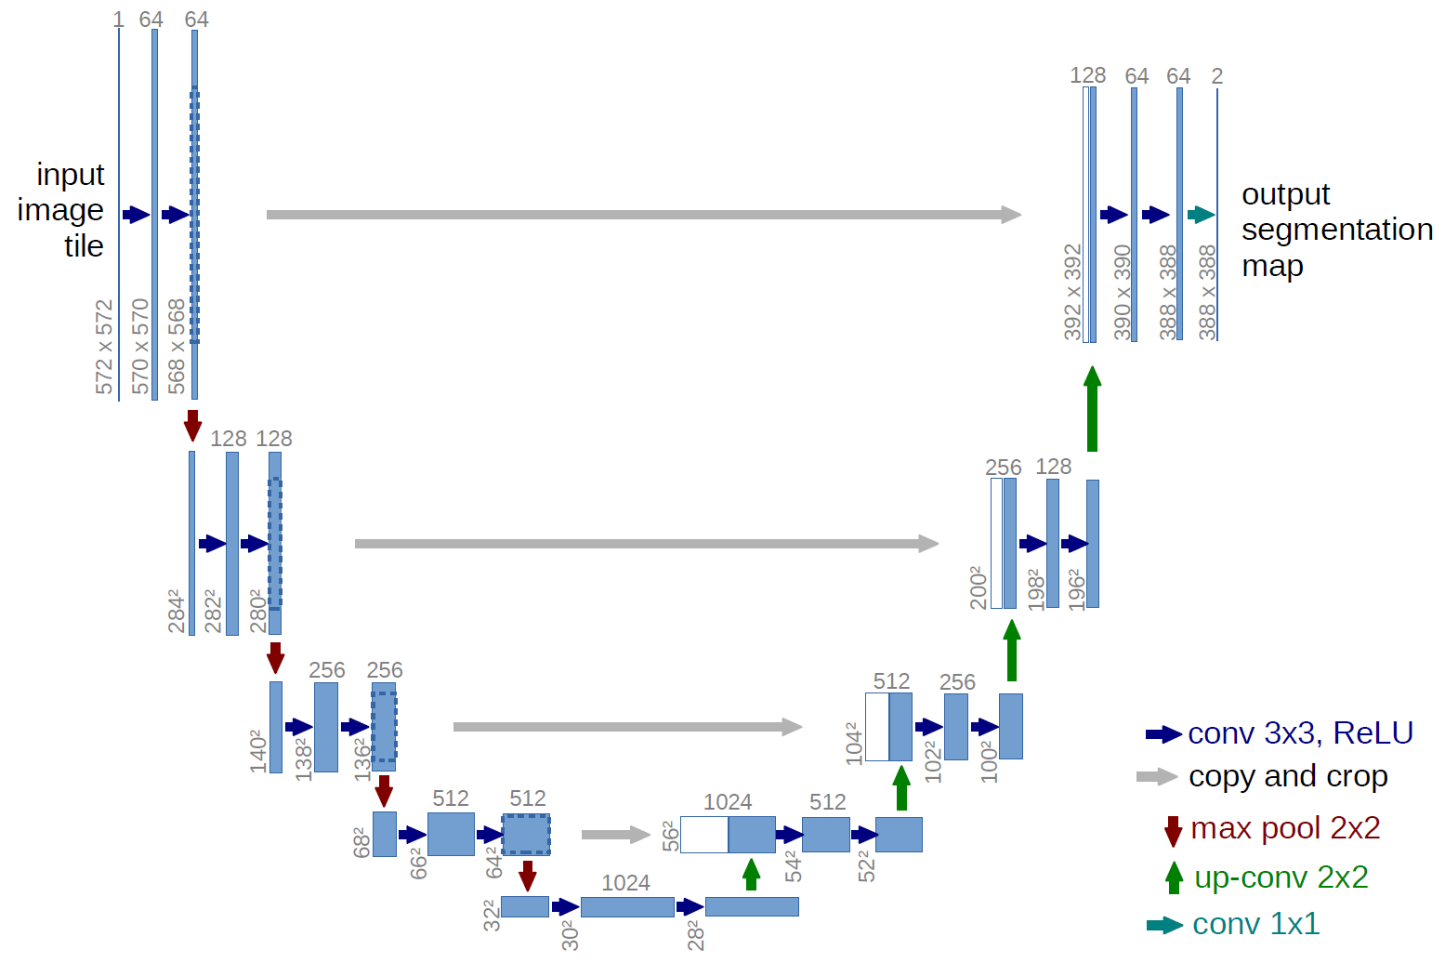
Figure 1. The U-Net Architecture. Illustration of the contracting and expanding paths with skip connections. Reprinted from [12].
The architecture consists of two main components defining its characteristic U-shaped structure. The contracting path captures context by progressively downsampling the input image, reducing spatial dimensions while increasing the number of feature channels to learn increasingly abstract representations [12]. Conversely, the symmetric expanding path enables precise localization by progressively upsampling feature maps. The critical innovation involves skip connections that directly link features from the contracting path to corresponding layers in the expanding path at the same resolution. These connections preserve fine-grained spatial details lost during downsampling, enabling the network to make precise predictions about pixel-level class assignments essential for accurate medical image segmentation [12].
Recent reviews have established U-Net-based architectures as the dominant paradigm for medical image segmentation across diverse anatomical structures and imaging modalities, with the original architecture serving as the foundation for hundreds of subsequent refinements and adaptations [28]. The enduring success of U-Net stems from its elegant balance between local precision and global context, achieved through the encoder-decoder structure with skip connections that has proven robust across varied segmentation tasks.

2.3.2 Architectural Components and Design Philosophy
The U-Net architecture eliminates fully connected layers and operates entirely through convolutional and pooling operations, making it computationally efficient and capable of processing images of arbitrary size [12]. Each layer in the network contains multi-channel feature maps, utilizing 3x3 kernels and ReLU activation functions throughout both the contracting and expanding paths. The symmetric design ensures that the number of feature channels in the expanding path mirrors those in the contracting path, allowing rich contextual information to propagate to higher resolution layers [12].
One of the fundamental design principles is the ability to function effectively with limited training data through aggressive data augmentation strategies [12]. Rather than requiring thousands of annotated samples like traditional deep learning approaches, U-Net can be trained effectively on very few images by applying elastic deformations and other transformation-based augmentations to available training data. This characteristic is particularly valuable in biomedical applications where annotated datasets are expensive and time-consuming to acquire. Furthermore, weighted loss functions are employed to handle challenging segmentation problems, such as the separation of touching cells of the same class, by assigning higher weights to boundary regions in the loss calculation [12].
The architectural simplicity of U-Net belies its computational sophistication. By eschewing fully connected layers in favor of pure convolution operations, the network achieves several advantages: computational efficiency that enables processing of full-resolution medical images, translation invariance that allows consistent segmentation regardless of object position, and the ability to generate pixel-wise classifications that preserve spatial relationships essential for medical diagnosis [28]. These design choices have proven remarkably prescient, as subsequent architectures incorporating more complex components have often achieved only marginal improvements while sacrificing computational efficiency.

2.3.3 Clinical Applications and Modality Coverage
The architecture has demonstrated effectiveness across diverse medical imaging modalities and anatomical structures [28], [29]. Originally validated on the segmentation of neuronal structures in electron microscopy and cell tracking in phase contrast microscopy [12], the model has successfully extended to computed tomography (CT), magnetic resonance imaging (MRI), ultrasound, and X-ray imaging (see Figure 2 for examples across modalities) [28], [29].
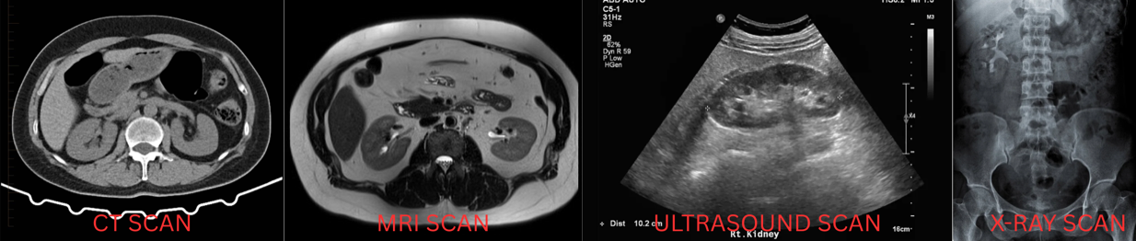
Figure 2. Modality Versatility
This versatility stems from a modality-agnostic design that performs equally well on 2D image slices and volumetric 3D data after appropriate architectural modifications.
Clinical utility extends to numerous organ systems and pathological conditions, including brain tumor segmentation in multimodal MRI, cardiac structures in echocardiography, liver lesions in CT imaging, and lung structures in chest radiography [28], [29]. Recent comprehensive reviews of deep learning in medical image segmentation highlight U-Net's dominance across these applications, with the architecture serving as the baseline against which novel methods are evaluated [28]. This broad applicability reflects the robustness of the core architecture and its adaptability to task-specific modifications.
In kidney imaging specifically, U-Net has been applied to simultaneous segmentation of kidneys, tumors, and cysts in contrast-enhanced CT imaging [19], [41]. Its computational efficiency allows for the segmentation of high-resolution 3D volumes in seconds, making integration into diagnostic workflows clinically feasible [12]. This rapid processing capability is particularly important for interventional procedures where real-time or near-real-time guidance is required.

2.3.4 U-Net Variants and Architectural Innovations
The success of the baseline architecture has prompted numerous refinements to handle increasingly complex segmentation tasks [28], [29]. One prominent variant, U-Net++, incorporates nested and dense skip pathways to bridge the semantic gap between feature maps extracted at different levels of the encoder and decoder (illustrated in Figure 3) [42].

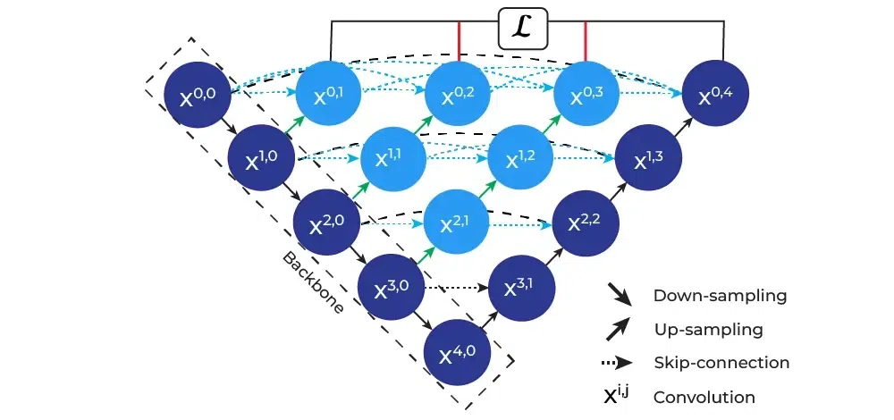
Figure 3. U-Net++ Architecture. Reprinted from [42].
By incorporating dense convolutional blocks at each skip connection node, U-Net++ reduces information loss during the decoding process and has demonstrated improved performance across multiple medical imaging datasets [42].
Attention-based variants have emerged as a major refinement direction, incorporating mechanisms to selectively focus on clinically relevant regions while suppressing background noise. Attention U-Net integrates attention gates within the skip connections to recalibrate feature maps based on spatial and channel-wise importance, improving segmentation accuracy particularly for small lesions (see the attention gate mechanism in Figure 4) [43].
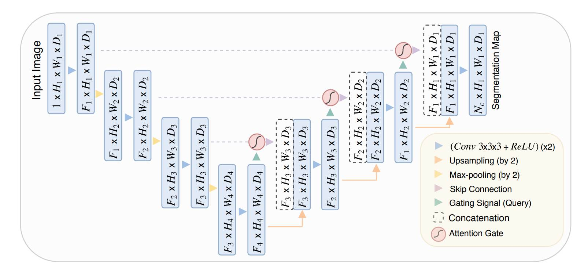
Figure 4. Attention Mechanism. Reprinted from [43].
Recent implementations specifically for kidney tumor segmentation have demonstrated that boundary attention mechanisms can significantly improve segmentation accuracy at tumor edges, addressing one of the primary challenges in renal mass characterization [41]. MSS U-Net introduced multi-scale supervised learning for 3D kidney and tumor segmentation, training the network to produce accurate predictions at multiple resolution levels simultaneously [44]. Similarly, recent work on the KiTS23 challenge explored various 3D U-Net training configurations to achieve superior segmentation performance [45]. Furthermore, 3D U-Net extends the original architecture to volumetric medical imaging by replacing 2D convolutions with 3D convolutional operations [28], [29]. Recent studies employing 3D U-Net for renal mass segmentation have achieved clinical-grade performance [17]. Hybrid variants like ResUNet combine the encoder-decoder structure with residual learning principles [28]. TransUNet pioneered the transformer approach by using a Vision Transformer as the encoder while maintaining U-Net's decoder structure (as depicted in Figure 5) [46].
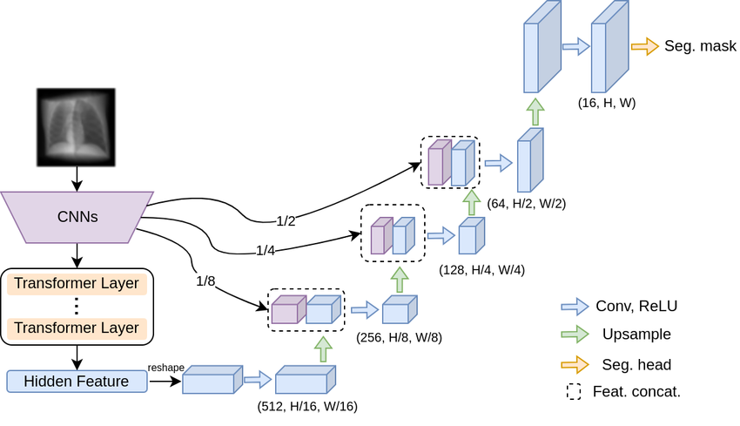
Figure 5. Hybrid Transformers. Reprinted from [46].
Swin-UNet further refined this concept using Swin Transformers with shifted window attention, demonstrating superior performance on multi-organ segmentation tasks including kidney structures [47]. The STC-UNet architecture incorporates Selective Kernel modules to address challenges posed by unclear boundaries and positional uncertainties in renal tumors [48]. Similarly, dual attention approaches have shown promise for ultrasound-based renal tumor segmentation, achieving MIoU scores exceeding 93% on clinical datasets [49].

2.3.5 Performance Metrics and Clinical Benchmarking
Standard segmentation evaluation metrics — including Dice Similarity Coefficient (DSC), Intersection over Union (IoU), 95th Percentile Hausdorff Distance (HD95), and precision-recall measures — are formally defined in Section 3.7. Published benchmarks suggest DSC exceeding 0.85 for organ segmentation and 0.75 for lesion segmentation constitute clinically acceptable performance [28], [29], with state-of-the-art systems reporting kidney DSC of 0.948, mass DSC of 0.776, and tumor DSC of 0.738 on challenge datasets [45].

2.4 The nnU-Net Framework

2.4.1 Overview of nnU-Net
nnU-Net is an automated self-configuring framework for deep learning-based medical image segmentation that has fundamentally transformed the clinical deployment of AI-powered diagnostic tools [51]. It automatically configures every component of the segmentation pipeline without requiring manual intervention beyond providing raw imaging data and corresponding binary segmentation annotations [51]. The fundamental motivation stems from the observation that small errors in configuration choices can lead to large drops in performance [51]. Analysis revealed that method configuration quality often exceeds architectural novelty, motivating a systematic, automated process [51]. The framework achieved first place in the KiTS19 kidney tumor segmentation challenge, establishing a benchmark for multi-institutional CT kidney segmentation [19]. Subsequent iterations have maintained dominance while preserving the core automated configuration principles [51]. Recent comprehensive benchmarking against contemporary architectures including Vision Transformers and Mamba-based models has validated that properly configured CNN-based U-Net variants within the nnU-Net framework continue to achieve state-of-the-art performance when rigorously evaluated [52].

2.4.2 Automated Configuration Architecture
The framework implements automated configuration through a three-tier parameter hierarchy (shown in Figure 6) that systematically handles design decisions [51].
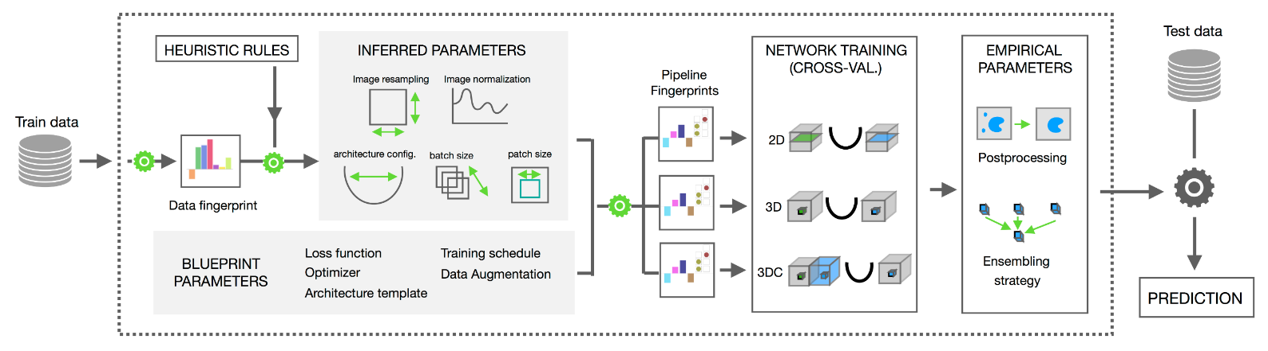
Figure 6. nnU-Net Configuration Hierarchy. Reprinted from [53]
The first tier consists of fixed parameters, including specific activation functions and loss function strategies combining Dice and cross-entropy loss [51]. The second tier comprises rule-based parameters, which establish explicit dependencies between the dataset fingerprint and the pipeline fingerprint [51]. One critical rule governs the interdependent configuration of batch size and patch size while respecting GPU memory constraints [51], [54]. Additional rules determine intensity normalization approaches tailored to specific modalities such as CT Hounsfield unit clipping or MRI z-score normalization [51]. The third tier consists of empirical parameters covering decisions that benefit from data-driven optimization on the specific dataset [51]. This includes determination of post-processing strategies such as connected component analysis [51], [54]. This strategy avoids the computational overhead of exhaustive hyperparameter search [51], [55].

2.4.3 Cascade Architecture and Multi-Resolution Processing
A critical feature is the systematic use of cascaded U-Net configurations for anatomical structures that occupy relatively small regions within imaging volumes [51]. The framework automatically detects spatial thresholds, triggering a two-stage cascade approach [51], [56]. In this configuration, the first U-Net operates on downsampled images to perform coarse localization of the target structures, while the second U-Net operates at full resolution within regions of interest identified by the first stage (see the cascade workflow in Figure 7) [52].
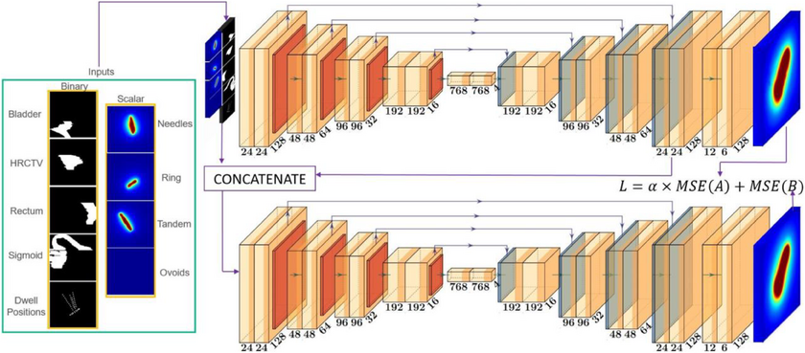
Figure 7. 3D Cascade Architecture. Retrieved from [57].
This cascade trigger directly addresses the fundamental trade-off between capturing sufficient contextual information for accurate localization and maintaining sufficient spatial resolution for precise boundary delineation [56], [58]. By automatically selecting cascade configurations, the system encodes domain knowledge about volumetric imaging without requiring manual intervention [51]. This design proves particularly valuable for kidney imaging applications where structures benefit substantially from the coarse-to-fine processing strategy [56], [58]. Recent implementations demonstrated the effectiveness of this approach for kidney tumor segmentation [56]. A two-stage cascaded framework effectively refined segmentation of kidney tumors and cysts [56]. This approach demonstrated that the cascade architecture effectively handles the multi-scale nature of kidney abnormality segmentation [56]. The intermediate cropping process maintains full-resolution detail for precise boundary characterization [56], [58].

2.4.4 Cross-Institutional Robustness and Domain Generalization
Robustness to domain shift represents a critical consideration for clinical deployment of automated segmentation systems [55]. The nnU-Net framework addresses domain shift through comprehensive data augmentation strategies scaled based on dataset properties [55]. Applied augmentations include geometric transformations and specialized techniques (an example of these augmentations is provided in Figure 8) [51], [55].
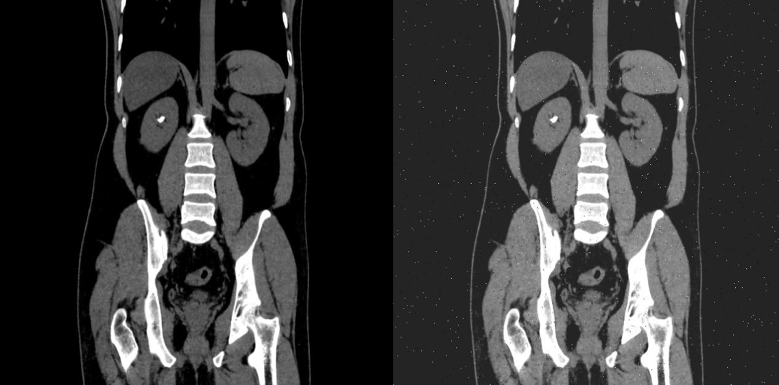
Figure 8. Data Augmentation Example
Empirical validation of cross-institutional robustness has been conducted across multiple imaging modalities and anatomical targets. nnU-Net's generalization capability has been demonstrated, showing that automated data augmentation maintained high Dice coefficients across different vendor domains comparable to performance within same-vendor data [55]. A rigorous evaluation of nnU-NetV2 was tested on an independent institutional dataset comprising 139 cases [18]. The study revealed models trained on diverse multi-institutional data demonstrated improved segmentation robustness and generalizability [18]. This finding emphasizes training dataset diversity maintains performance across diverse real-world imaging environments [18]. Models trained exclusively on single-institution data may fail to generalize to external populations, limiting practical utility in multi-site clinical networks [18]. The framework provides a pathway to supporting the deployment of AI-assisted diagnostic tools in real-world healthcare settings [18].

2.4.5 Empirical Performance and Validation
The empirical validation of nnU-Net spans an unprecedented diversity of segmentation tasks across modalities, anatomical structures, and imaging protocols [51]. Comprehensive evaluations have established nnU-Net as a state-of-the-art framework on the majority of tested public benchmarks [51]. The framework secured first place in multiple international biomedical imaging challenges [19], [51]. The KiTS19 challenge results showed robust performance across diverse tumor sizes and locations [19]. Subsequent challenges have validated nnU-Net's continued dominance, achieving high Dice scores for tumors on standardized challenge datasets [45], [59]. Comprehensive benchmarking against contemporary architectural alternatives including Vision Transformers and Mamba-based models has validated that properly configured CNN-based U-Net variants within the nnU-Net framework continue to achieve state-of-the-art performance when rigorously evaluated [52]. The study demonstrated that CNN-based approaches outperform alternatives on standard medical segmentation datasets [52]. Many reported performance improvements in recent literature resulted from validation shortcomings rather than genuine architectural superiority [52]. This validation confirms the approach remains highly competitive against novel architectures designed for large-scale datasets [52]. For kidney abnormality segmentation, these findings support the selection of nnU-Net over more computationally demanding Transformer alternatives [52], [60].

2.4.6 Clinical Translation and Accessibility
The accessibility of nnU-Net for clinical deployment represents a significant advance for hospital settings [51]. The framework requires minimal specialized knowledge, allowing clinical teams to apply the method directly to raw medical imaging data and binary annotation masks [51], [61]. Standard institutional GPU resources are generally sufficient, avoiding the need for high-performance computing infrastructure or multi-GPU clusters [51], [61]. The deployment workflow executes automated training scripts [51], [53]. The framework automatically handles all configuration decisions through the three-tier parameter hierarchy [51]. Resulting models generate pixel-level segmentation maps suitable for treatment response assessment, and surgical planning [13], [51]. This accessibility transforms automated segmentation into a tool deployable without formal deep learning training [51]. Recent applications demonstrate successful deployment achieving clinically acceptable segmentation performance with reduced computational requirements [62]. Such optimizations expand the practical applicability of automated segmentation tools to a broader range of healthcare facilities [62]. The framework's ability to handle multi-class segmentation tasks positions it as the natural choice for comprehensive characterization encompassing tumors, cysts, and stones [45], [56]. The cross-institutional robustness supports deployment across diverse clinical imaging environments [18], [58].

2.4.7 State-of-the-Art Deep Learning Frameworks for Kidney Segmentation
Building upon the clinical accessibility of these models, recent comparative studies have firmly established the superiority of self-configuring frameworks over traditional architectures for renal image analysis. A controlled benchmarking study directly compared the nnU-Net framework against a custom 3D U-Net for kidney and tumor segmentation [60]. By maintaining identical preprocessing, data augmentation, and training protocols, it was demonstrated that nnU-Net provides a highly robust baseline, outperforming the standard 3D U-Net in both Dice Similarity Coefficient (DSC) and Intersection over Union (IoU) [60]. Building upon these architectural advantages, the specific capabilities of the nnU-Net V2 architecture were investigated using a 3D full-resolution configuration [63]. The application of the model to the KiTS23 dataset yielded high DSC and IoU scores, cementing nnU-Net V2 as a highly optimized foundational architecture for multi-class renal segmentation tasks [63].

2.5 Identified Research Gaps
The comprehensive review of literature on kidney abnormality detection and segmentation reveals substantial progress in automated analysis of individual abnormality types, yet identifies critical gaps that limit the clinical applicability and comprehensiveness of existing approaches. These gaps motivate the development of integrated multi-class segmentation systems capable of simultaneously detecting and characterizing all major kidney abnormalities within unified clinical workflows.

2.5.1 Single-Class Focus in Existing Segmentation Systems
Current state-of-the-art deep learning approaches for kidney abnormality segmentation predominantly focus on single abnormality types, with separate specialized models developed for kidney tumors, cysts, or stones [18], [19], [39]. While individual models achieve impressive performance within their specific domains—tumor segmentation models reaching Dice scores exceeding 0.85 on KiTS challenge datasets [18], stone detection models achieving accuracies above 96% [64], and cyst segmentation showing robust performance in polycystic kidney disease applications [30]—no comprehensive system simultaneously addresses all three major abnormality categories within a unified framework.
This single-class paradigm creates substantial limitations for clinical deployment. In real-world diagnostic workflows, patients frequently present with multiple concurrent kidney abnormalities requiring comprehensive evaluation [14]. A patient may harbor both renal masses and incidental cysts, or demonstrate stone disease alongside cystic lesions. Current approaches necessitate running multiple independent models sequentially, each with its own preprocessing pipeline, inference requirements, and post-processing steps, resulting in computational inefficiency and workflow complexity that impedes clinical integration [45]. Furthermore, independent single-class models fail to leverage potential synergies in learning shared anatomical context and imaging features across abnormality types, potentially limiting both efficiency and performance.
The absence of multi-class kidney abnormality segmentation systems represents a fundamental gap in translating automated analysis from research benchmarks to comprehensive clinical decision support tools. Developing unified frameworks capable of simultaneous detection and precise delineation of tumors, cysts, and stones would substantially advance clinical applicability by providing radiologists with complete abnormality characterization from single imaging studies, supporting comprehensive diagnostic assessment and treatment planning [14].

2.5.2 Fragmented Public Datasets and the Need for Data Unification
While substantial public datasets exist for kidney abnormality segmentation, these resources remain fragmented across different clinical objectives and pathological entities. Datasets such as KiTS19, KiTS21, and KiTS23 focus primarily on tumor segmentation [19], [45], while other publicly available resources address specific pathologies like kidney stones or cystic lesions in isolation. This fragmentation creates a fundamental challenge: existing models are trained to recognize and segment individual abnormality types, but no unified public dataset exists that enables comprehensive multi-class segmentation encompassing tumors, cysts, and stones simultaneously.
This data fragmentation has significant clinical implications. In real-world diagnostic radiology, patients frequently present with multiple concurrent kidney pathologies, a tumor-bearing kidney may also contain cysts or stones, yet current segmentation approaches trained on isolated datasets cannot comprehensively characterize such cases. Deploying separate models for each abnormality type introduces computational inefficiency, potential inconsistencies in overlapping or adjacent structures, and workflow complexity that limits clinical adoption. The absence of a unified training framework that exposes models to the full spectrum of kidney abnormalities during learning prevents development of truly comprehensive diagnostic systems.
The research opportunity lies in unifying these disparate public datasets into a single multi-class training framework. By combining tumor-focused datasets (KiTS series) with publicly available stone and cyst datasets, we can create a comprehensive training corpus that exposes the model to the full range of kidney pathologies simultaneously. This unified approach addresses a fundamental gap in the current research landscape: while individual public datasets exist for specific pathologies, no prior work has systematically integrated these resources to enable simultaneous detection and segmentation of all major kidney abnormality types within a single model architecture.
This data unification strategy offers several advantages beyond simply training separate models on each dataset. Multi-class training enables the model to learn shared anatomical features and spatial relationships between different pathology types, potentially improving overall segmentation accuracy through cross-pathology feature learning. Additionally, a unified model reduces computational overhead during inference and simplifies clinical deployment compared to maintaining multiple specialized systems. Our study bridges this critical gap by developing the first comprehensive multi-class kidney abnormality segmentation framework trained on unified public datasets, demonstrating that integration of disparate data sources can produce clinically viable comprehensive diagnostic systems [18], [45].
Recent advancements have begun to address this data fragmentation. The introduction of the 3D Multi-class Segmentation of Whole Abdominal Lesions (MSWAL) dataset represents a significant shift toward unified pathological annotations, providing comprehensive voxel-level ground truth for multiple abdominal abnormalities, including kidney stones, cysts, and tumors, within single volumetric scans [20]. While MSWAL provides a robust foundation for multi-class learning, it is constrained by its single-institution origin. Therefore, this study's strategy of harmonizing a multi-class dataset (MSWAL) with a multi-institutional dataset (KiTS23) address both the structural fragmentation of public datasets and the critical need for cross-institutional robustness in model training.

2.5.3 Insufficient Integration of Clinical Classification Systems
While automated segmentation provides precise anatomical boundaries of kidney abnormalities, existing systems generally do not integrate outputs with established clinical classification frameworks that guide diagnostic and therapeutic decisions. The Bosniak classification for cystic lesions, R.E.N.A.L. nephrometry scoring, and stone burden quantification metrics remain underdeveloped in automated computation [5], [7]. Accurate segmentation alone is insufficient without Bosniak category assignment based on wall thickness, septation characteristics, enhancement patterns, and calcification presence [7]. Renal mass segmentation requires exophytic properties and polar location for surgical planning and intervention selection [5]. Stone disease management depends critically on quantitative metrics including total stone burden, individual dimensions, and density characteristics that inform composition and treatment susceptibility [16].

2.5.4 The Comprehensive Metric Evaluation Gap
In addition to the limitations in dataset fragmentation and clinical integration, a review of the current baseline literature reveals a significant gap in comprehensive, multi-class clinical evaluations. Beyond standard overlap metrics like DSC and IoU, rigorous clinical validation requires assessing boundary distances and prediction exactness. A comprehensive validation study of an AI-based kidney segmentation framework was recently conducted utilizing evaluation metrics such as the 95th percentile Hausdorff Distance (HD95), Precision, Recall, and F1-score [65]. While this provides a strong methodological baseline for multi-metric evaluation, a notable limitation is the consolidation of distinct pathological classes. In this framework, cysts and tumors were merged into a singular "abnormality" class, inherently limiting the model's utility for precise differential diagnosis [65].
Furthermore, while foundational studies establish standard performance benchmarks for kidneys and tumors [60], [63], none of the current state-of-the-art baselines incorporate kidney stones alongside cysts and tumors in their evaluation. Consequently, there remains an unmet need for a single, unified framework capable of simultaneously isolating distinct renal pathologies—specifically kidneys, tumors, cysts, and stones—while being evaluated against a comprehensive suite of overlap, boundary, and efficiency metrics. To address the absence of kidney stones in unified multi-class evaluations, baseline metrics for this specific pathology must be drawn from dedicated stone segmentation models. Recent automated systems have successfully established volumetric segmentation baselines for kidney stones on non-contrast CT scans [24]. Furthermore, specialized deep segmentation networks have been utilized to simultaneously segment both the renal structure and calculi, providing essential overlap metrics such as DSC for stone detection [39]. In this study, the performance of the proposed multi-class nnU-Net framework on the stone class will be benchmarked against these dedicated single-task and dual-task models to ensure rigorous clinical validation across all isolated abnormalities.

2.5.5 Gap Summary and Research Opportunity
The identified gaps collectively point to a specific, addressable research opportunity in computer science: the absence of a controlled comparative study between single-class and multi-class nnU-Net V2 segmentation for kidney abnormalities. While prior work has validated nnU-Net V2 for kidney tumor segmentation [18][19] and the MSWAL dataset enables multi-class ground truth annotation [20], no study has isolated the performance effect of training strategy — single-class versus multi-class — using the same architecture, data, and metrics. This study addresses that gap directly, using 3D U-Net as a consistent baseline reference, and provides the first statistically grounded comparison to guide practitioners in choosing between single-class and multi-class segmentation pipelines for renal CT analysis.

Chapter 3
METHODOLOGY
This chapter presents the comprehensive methodological framework and computational procedures developed to achieve the comparative investigation described in Chapter 1. Grounded in a retrospective analysis of clinical Computed Tomography (CT) data, the study employs a two-phase experimental design using the self-configuring nnU-Net V2 deep learning architecture. In Phase 1, three single-class models are independently trained and validated against published benchmarks. In Phase 2, one multi-class model trained simultaneously on all three abnormality classes is compared directly against those validated single-class models. The methodology is organized through an Input-Process-Output (IPO) model, spanning from physiological normalization of raw radiological data to the rigorous quantitative evaluation and qualitative clinical review by radiologists.

3.1 Conceptual Framework
The methodological architecture of this research is grounded in the intersection of computational medical imaging, deep learning-based semantic segmentation, and clinical decision support system. The primary objective is to translate raw radiological data into actionable clinical insights through the automated delineation of kidney substructures and pathologies – specifically cysts, stones, and tumors. This study adopts a rigorous Input-Process-Output (IPO) model, a fundamental system engineering approach that structures the methodology into three distinct but interconnected phases: data ingestion and preparation (Input), computational analysis and model training (Process), and performance evaluation and clinical inference (Output).

3.1.1 The Input-Process-Output (IPO) Model
The IPO model serves as the architectural skeleton of this thesis, ensuring a logical flow of data and rigorous validation of the segmentation results (as illustrated in the framework diagram in Figure 9).
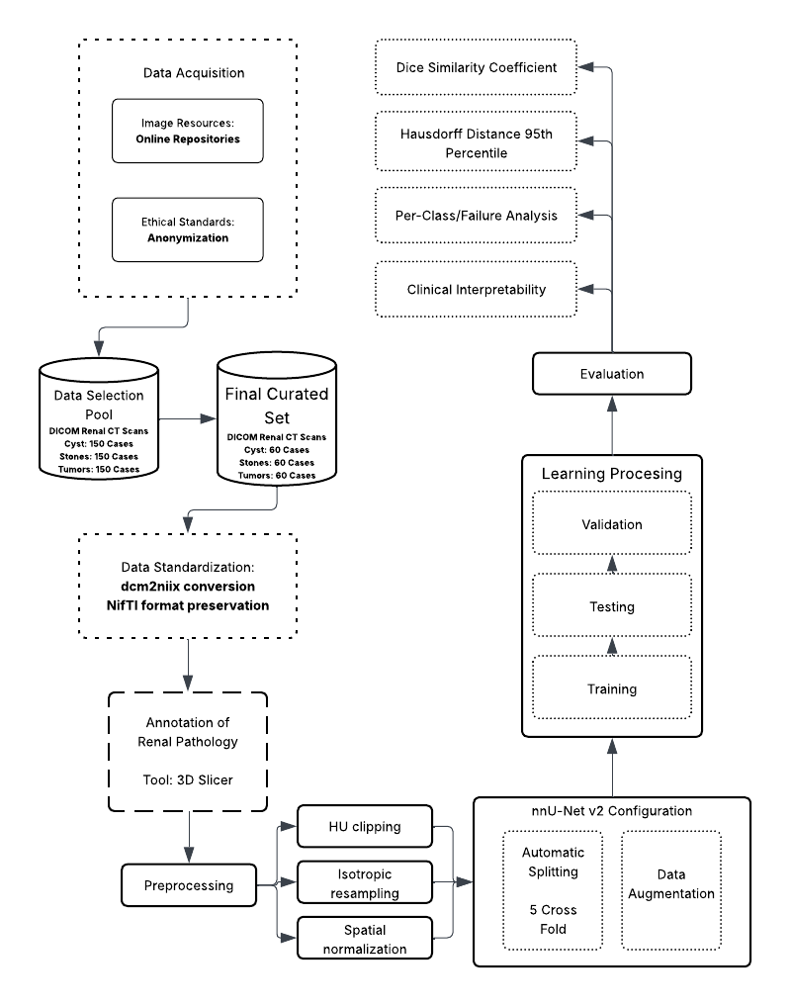
Figure 9. Conceptual Framework
This system-theoretic perspective allows for the isolation of variable at each stage, ensuring that errors can be traced back to specific components – whether they be artifacts in the input data, convergence failures in the process, or metric misinterpretations in the output.

3.1.2 Input Phase: Data Ingestion and Physiological Standardization
The foundation of the framework lies in the acquisition of high-fidelity volumetric CT data. The input stage is characterized by the transformation of raw medical data into a machine-readable format. This involves the ingestion of DICOM (Digital Imaging and Communications in Medicine) series, which contain not only the pixel data but also critical metadata regarding the acquisition parameters. The conversion of these series into the NIfTI (Neuroimaging Informatics Technology Initiative) standard is a pivotal step, as it creates a unified volumetric representation that preserves the affine matrix—defining the spatial relationship between the image voxels and the physical world coordinate system.
The preprocessing phase within the Input stage is conceptually critical as it bridges the domain gap between physical tissue density—measured in Hounsfield Units (HU)—and the numerical inputs required by the neural network. By applying specific intensity clipping (Focus range of -135 to 215 HU) and resampling techniques (1.0 mm isotropic spacing), the input stage standardizes the physical variance across different patients and scanners. This "physiological normalization" ensures that the neural network learns to associate specific numerical ranges with specific tissue types (e.g., distinguishing a dense stone from soft tissue), rather than learning scanner-specific noise patterns.

3.1.3 Process Phase: Deep Learning and Volumetric Segmentation
The process component is driven by the 3D U-Net architecture within the nnU-Net v2 framework. The conceptual novelty here is the use of deep supervision, where the network learns to segment structures at multiple resolutions simultaneously. This mechanism involves injecting auxiliary loss layers at various stages of the decoder pathway, thereby improving gradient flow deep into the network and maximizing feature extraction from both coarse and fine spatial scales. This stage encompasses the iterative training of the model using a composite loss function (Dice Loss plus Cross-Entropy Loss), stochastic optimization via Stochastic Gradient Descent (SGD) with Nesterov momentum, and massive on-the-fly data augmentation. The augmentation strategy is designed to enforce translational, rotational, and intensity invariance, forcing the model to learn robust anatomical features rather than memorizing the specific orientation or contrast levels of the training cases. The use of 5-fold cross-validation during this phase ensures that the model's performance is robust across the entire dataset distribution and not biased by a specific train-test split.

3.1.4 Output Phase: Evaluation and Clinical Inference
The output of the framework is a multi-class segmentation map where each voxel is classified into one of five categories: background, kidney, cyst, stone, or tumor. The conceptual validity of these outputs is assessed using a comprehensive multi-metric approach. The primary metrics are:
- Volumetric Overlap: The Dice Similarity Coefficient (DSC) quantifies the spatial overlap between the prediction and the ground truth, providing a global measure of segmentation quality.
- Boundary Accuracy: The Hausdorff Distance 95th Percentile (HD95) measures the worst-case error at the segmentation boundaries, offering critical insight into the geometric precision of the model, which is vital for surgical planning and radiotherapy.

Furthermore, the framework incorporates a "Human-in-the-Loop" validation mechanism, where expert radiologists review failure cases (identified by low DSC scores) to provide qualitative feedback. This step transforms the thesis from a purely computational exercise into a clinically relevant study, categorizing errors into detection failures, false positives, or boundary inaccuracies.

3.2 Data Management
The integrity, diversity, and quality of the dataset are paramount to the success of any deep learning model, particularly in the medical domain where data scarcity and class imbalance are prevalent challenges. The data acquisition strategy for this thesis is designed to ensure strict compliance with medical data interoperability standards, ethical guidelines regarding patient privacy, and the specific technical requirements of the nnU-Net v2 training pipeline.

3.2.1 Sources and Ethical Considerations
The dataset was curated from two primary publicly accessible biomedical imaging repositories. Tumor segmentation cases were sourced from the KiTS23 (Kidney and Kidney Tumor Segmentation) challenge dataset, a multi-institutional repository with expert-verified ground truth masks. Multi-class cases encompassing concurrent cysts, stones, and tumors were sourced from the MSWAL (3D Multi-class Segmentation of Whole Abdominal Lesions) dataset, which provides comprehensive voxel-level annotations for multiple pathologies within single volumetric scans. This harmonization of KiTS23 with MSWAL directly addresses the data fragmentation identified in Section 2.5.2, combining multi-institutional breadth with multi-class annotation coverage. Given the retrospective nature of this study—involving the computational analysis of previously collected clinical data generated during routine patient care—strict ethical protocols are observed to protect subject confidentiality. Each case is a complete 3D volumetric CT scan, processed natively in three dimensions by the nnU-Net V2 pipeline rather than as a set of independent 2D slices. During training the network samples overlapping 128 × 128 × 128-voxel sub-volumes from each case; combined with patch-based sampling and on-the-fly augmentation over 1,000 epochs, this exposes the model to an effective training corpus far larger than the 290-case count alone suggests.
Data Selection Strategy: To ensure the model generalizes across heterogeneous clinical presentations, the data curation protocol deliberately preserves the natural distribution of renal pathologies rather than artificially forcing a class balance. A total of 290 high-value volumetric CT cases were curated from the available public repositories. To accurately reflect real-world clinical complexity, this finalized experimental set includes 74 cases of pure nephrolithiasis (stones), 50 cases of pure renal cysts, and 45 cases of pure solid neoplasms. Crucially, the remaining 121 cases (41.7% of the dataset) exhibit concurrent multi-pathologies (clinical co-morbidities). The inclusion of these complex, overlapping presentations is a strict methodological requirement to test the simultaneous characterization capabilities of the multi-class framework against the sequential limitations of single-class models. Cases are selected based on a Diversity Criteria to maximize variance in:
- Size: Balancing micro-lesions (<5mm) with large masses (>4cm).
- Location: Ensuring representation of upper, mid, and lower pole lesions, as well as cortical vs. medullary placement.
- Morphology: Selecting cases with varying densities (HU values) and shapes (e.g., simple vs. complex cysts, staghorn vs. focal stones).
To ensure absolute methodological transparency, the experimental corpus is strictly defined to this 290-volume cohort, which is exclusively subjected to the computational pipeline. During the automated 5-fold cross-validation, this corpus is partitioned such that each fold utilizes 232 volumes (80%) for training and 58 volumes (20%) for internal validation.
This curation ensures that although the final dataset size is compact, it is mathematically representative of the disease spectrum, preventing the model from over-optimizing on "easy" or repetitive cases.
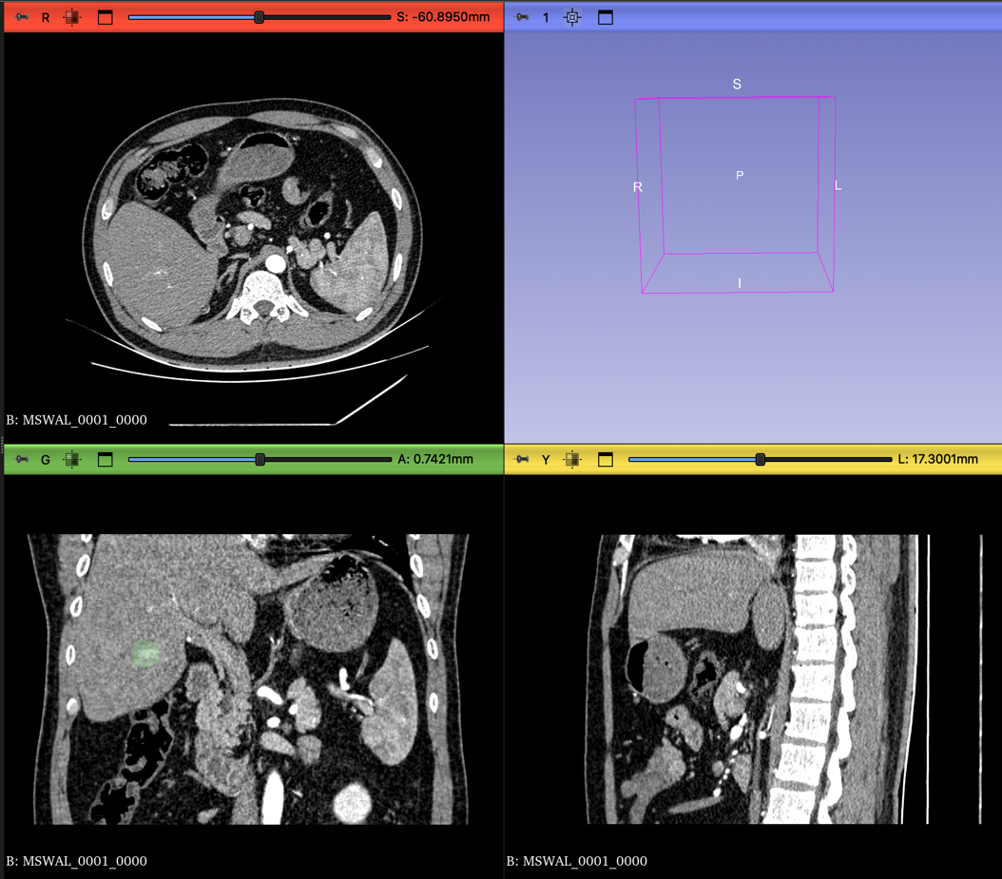
Figure 10. CT scan in different views

3.2.2 Ethical Compliance Framework:
    - Retrospective Study Protocol: Since this study utilizes publicly available, pre-anonymized datasets distributed under CC-BY-NC 4.0, institutional IRB approval was not required. The study strictly adheres to the data usage agreements of the respective repositories.
    - De-identification and Anonymization: All patient data is strictly anonymized at the source prior to transfer for computational analysis. This process involves the irreversible removal or masking of all Protected Health Information (PHI) from the DICOM headers. Specific tags such as Patient Name (0010,0010), Patient ID (0010,0020), Patient Birth Date (0010,0030), and Institution Name (0008,0080) are scrubbed or replaced with study-specific pseudonyms (e.g., Kidney_001). This ensures that the dataset used for training contains no linkages to the original patient identities, complying with data privacy regulations such as HIPAA or GDPR.
    - Data Security: The anonymized data is stored on secure, encrypted servers (e.g., Google Drive mounted to Colab Pro+ with restricted access), ensuring that only authorized research personnel have access to the imaging volumes.

3.2.3 DICOM to NIfTI Conversion
Raw medical images are generated by CT scanners in the DICOM (Digital Imaging and Communications in Medicine) format. While DICOM is the standard for clinical storage (PACS), it is suboptimal for deep learning due to its slice-based file structure (one file per slice) and complex metadata hierarchy. Deep learning frameworks, including nnU-Net, require the NIfTI (Neuroimaging Informatics Technology Initiative) format (.nii.gz), which encapsulates the entire 3D volume into a single compressed file and strictly defines the spatial coordinate system (affine matrix) necessary for 3D volumetric operations.

Conversion Protocol:
- Input: A directory containing the series of DICOM slices for a single patient study.
- Processing: dcm2niix reads the DICOM header information to reconstruct the contiguous 3D volume. It validates the slice ordering based on the ImagePositionPatient tag and handles any gantry tilt correction to ensure the resulting volume is orthogonal.
- Metadata Extraction: In addition to the image volume, dcm2niix generates a JSON sidecar file containing critical acquisition parameters such as slice thickness, pixel spacing, manufacturer, and convolution kernel. This metadata is essential for the subsequent "Dataset Fingerprinting" stage of nnU-Net.
- Output: A compressed NIfTI file (.nii.gz) representing the anatomical volume.

3.2.4 Dataset Organization and Structure
Following conversion, the data is restructured according to the rigid nnU-Net raw data format. This structure is inspired by the Medical Segmentation Decathlon (MSD) organization, which facilitates the automated parsing and cross-validation of datasets. Proper adherence to this structure is a prerequisite for the nnUNetv2_plan_and_preprocess command to function.

The directory hierarchy is established as follows:
- nnUNet_raw/DatasetXXX_Name/: The root folder for the task, where XXX is a unique three-digit identifier (e.g., 501) and Name describes the task (e.g., KidneyAbnormality).
- imagesTr/: Contains the training images (CT scans). Files must follow the naming convention Case_Identifier_0000.nii.gz. The _0000 suffix indicates the modality channel (CT).
- labelsTr/: Contains the corresponding ground truth segmentation masks. Files must be named Case_Identifier.nii.gz (without the modality suffix).
- dataset.json: A descriptor file defining the dataset properties. This JSON file acts as a manifest, containing:
  - channel_names: Mapping of channel IDs to modality types (e.g., {“0”: “CT”}).
  - labels: Mapping of integer pixel values to class names (e.g., {“0”: “background”, “1”: “kidney”, “2”: “cyst”, “3”: “stone”, “4”: “tumor”}).
  - numTraining: The total count of training cases.
  - file_ending: The file extension used (.nii.gz).

3.2.5 Dataset Characterization
The initial phase of the nnU-Net pipeline involves the extraction of a “dataset fingerprint,” which captures the intrinsic spatial and intensity properties of the CT data acquired from sources. This fingerprint guides the automated configuration of patch sizes, batch sizes, and network depth. The key characteristics identified during this heuristic analysis are summarized in Table 1.
Property | Value/Description
Modality | Computed Tomography (CT)
Image Size (Voxels) | Variable (Standardized via Resampling)
Target Voxel Spacing | [1.0, 1.0, 1.0]
HU Clipping Range | -135 HU to 215 HU (Automatically set by nnU-Net v2)
Class Distribution | 5 Classes: Background, Kidney, Cyst, Stone, Tumor
Final Curated Set | 290 Volumetric Cases
Data Splitting | 5-Fold Cross-Validation
Table 1. Dataset Fingerprint Characteristics
The dataset consists of 290 unique volumetric cases, each processed by nnU-Net V2 as a native 3D volume rather than as a stack of independent 2D slices. The patch-based training paradigm of nnU-Net — where the network samples multiple overlapping 3D sub-volumes per case during each training epoch — and the aggressive on-the-fly data augmentation strategy (detailed in 3.3.4) collectively ensure that the effective number of training samples seen by the model over 1,000 epochs substantially exceeds the raw case count. This design mirrors precedents in the medical imaging literature where compact, high-quality volumetric datasets have achieved competitive segmentation performance when paired with self-configuring frameworks such as nnU-Net [51], [58].

3.3 Data Preprocessing
Data preprocessing in medical image analysis is a fundamental step that transforms raw physical measurements into a normalized numerical space suitable for statistical learning. In the context of deep learning, where models are sensitive to the distribution and scale of input data, preprocessing is not merely a formatting step but a physiological normalization process. The goal is to standardize the physical properties of the input data so that the neural network learns to associate specific numerical values and spatial shapes with anatomical structures, rather than learning artifacts of the acquisition process or inter-patient variability. The preprocessing pipeline for this thesis involves three critical operations: Hounsfield Unit (HU) clipping, isotropic resampling, and Z-score normalization.

3.3.1 Hounsfield Unit (HU) Clipping and Intensity Filtering
Computed Tomography (CT) images provide a quantitative measure of radiodensity, expressed in Hounsfield Units (HU). The HU scale is a linear transformation of the linear attenuation coefficient of the material, calibrated such that the radiodensity of distilled water at standard temperature and pressure (STP) is defined as 0 HU, and the radiodensity of air is defined as -1000 HU. This standardization is a unique advantage of CT over MRI (where intensity values are relative), as it allows for the absolute differentiation of tissues based on their physical density.
However, the full dynamic range of a modern CT scanner can extend from -1000 HU (air) to over +3000 HU (dense metal implants or cortical bone). For the specific task of segmenting kidneys and their associated soft-tissue abnormalities, the vast majority of relevant anatomical information is contained within a much narrower range. "Soft tissues" generally fall between -100 and +200 HU. Feeding the full dynamic range into the network would compress the contrast resolution of the soft tissues, making it difficult for the model to discern subtle differences between a cyst (fluid) and a tumor (solid tissue).
To assist the neural network in focusing on the relevant anatomical features and to eliminate outliers, intensity clipping is applied.
Mechanism: All voxel values below a defined lower threshold are set to that lower threshold, and all values above a defined upper threshold are set to that upper threshold.
Parameters: The clipping range is explicitly set to -135 HU to 215 HU.

These bounds are physiologically grounded. The lower bound of −135 HU excludes air and perinephric fat (typically −50 to −100 HU), effectively masking non-renal background while preserving the kidney within its retroperitoneal fat capsule. The upper bound of 215 HU encompasses all clinically relevant soft tissues: renal parenchyma (30–180 HU depending on contrast phase), cysts (0–20 HU), and solid tumors (40–100 HU). Values above 215 HU — predominantly cortical bone and calcified structures — are treated as uniform ceiling values, preventing high-density outliers from compressing the soft-tissue contrast range the network relies on.

3.3.2 Isotropic Resampling and Spatial Normalization
CT scans are volumetric data composed of stacked 2D slices. A significant challenge in medical imaging is anisotropy, where the physical resolution within a slice (pixel spacing, e.g., 0.7 x 0.7 mm) is much higher than the resolution between slices (slice thickness, e.g., 3.0 mm or 5.0 mm). This results in voxels that are rectangular prisms rather than cubes. If raw anisotropic data were fed into a 3D CNN, the network would learn distorted spatial filters. For example, a spherical kidney stone would appear as a flattened pancake in the voxel space if the slice thickness is large. This would severely impair the network's ability to recognize the true 3D morphology of tumors and stones.

To address this, the methodology mandates resampling to a uniform voxel spacing.
Target Spacing: The dataset is resampled to [1.0, 1.0, 1.0] mm isotropic spacing.
Implication: This transformation creates a new voxel grid where every voxel is a perfect cube of 1mm edges.
Algorithm:
  - Image Data: Third-order spline interpolation is used for the CT images. Spline interpolation fits a smooth curve through the surrounding pixel values to calculate the intensity of the new voxels. This preserves the continuous nature of tissue density and maintains the subtle gradients at the boundaries of lesions.
  - Label Masks: Nearest-neighbor interpolation is strictly used for the segmentation masks. Because the masks consist of categorical integers (0, 1, 2, 3, 4), using spline interpolation would introduce fractional values (e.g., 1.5), which are meaningless class identifiers. Nearest neighbor ensures that the class labels remain discrete integers.
This resampling step ensures that physical distances are represented consistently across all three axes (Axial, Sagittal, Coronal), allowing the 3D U-Net to perform spatial convolutions effectively in all directions and recognize the true volumetric shape of renal abnormalities.
After resampling to [1.0, 1.0, 1.0] mm isotropic spacing, every voxel is a unit cube, so the volume carries equivalent resolution along the axial, coronal, and sagittal axes. This geometric consistency allows the 3D U-Net to apply volumetric convolutions equally in all directions and to recognize the true three-dimensional morphology of renal abnormalities, independent of the original slice-acquisition orientation.

3.3.3 Cropping to Non-Zero Region
On datasets that are not pre-processed; to optimize computational efficiency and reduce memory usage, the preprocessing pipeline includes an automated cropping step. Medical images often contain large areas of background air surrounding the patient's body. nnU-Net automatically detects the non-zero region (the body area) and crops the volume to the bounding box of the patient. This significantly reduces the size of the input tensor, allowing for larger batch sizes or patch sizes during training, which contributes to better context modeling.

3.3.4 Augmentation Setting and Data Splitting
Given the high dimensionality of 3D medical data and the limited number of annotated samples available in clinical datasets, deep learning models are prone to overfitting. To mitigate this, a comprehensive data augmentation strategy is combined with a rigorous, automated data splitting scheme.
Data Augmentation Strategy
Category | Transformation | Description and Clinical Justification
Spatial | Rotation & Scaling | Random rotations (z-axis: [-180, 180], x/y: [-30, 30]) and scaling (0.7x - 1.4x) simulate variations in patient positioning and differences in organ size.
 | Elastic Deformation | Simulates natural soft-tissue deformation caused by respiration or pressure from adjacent organs.
 | Mirroring | Random mirroring along axes to leverage the approximate bilateral symmetry of the kidneys.
Intensity | Gaussian Noise/Blur | Simulates scanner noise and reconstruction variability (e.g., soft vs. bone kernels).
 | Brightness/Contrast | Makes the model invariant to slight variations in HU calibration or contrast enhancement phases.
 | Gamma Correction | Non-linear intensity transformation to simulate diverse tissue density shifts.
Table 2. Data Augmentation Strategy
Data Splitting: Automated 5-Fold Cross-Validation
The data splitting process in this study is handled automatically by the nnU-Net v2 pipeline, which implements a 5-fold cross-validation scheme by default to ensure unbiased performance estimation.
The Automated Splitting Mechanism:
Pipeline-Driven Partitioning: Once the dataset is standardized and the dataset.json is parsed, nnU-Net automatically partitions the total training cases into 5 equal, non-overlapping subsets (folds).
80/20 Distribution: For each of the 5 iterations, the framework uses 4 folds (80% of the data, or 232 volumes) for model training. The remaining fold (20% of the data, or 58 volumes) serves as the independent internal validation and testing set. By the end of the 5 iterations, every case in the 290-volume dataset has been used exactly once as an unseen test case.
Cross-Validation Iterations: The framework generates 5 independent sets of model weights (Fold 0 through Fold 4). This ensuring that every single case in the dataset is used for validation exactly once, providing a comprehensive assessment of the model's ability to generalize to unseen data.

3.4 Network Architecture: The 3D U-Net and Deep Supervision
The core computational engine of this methodology is the 3D U-Net, a fully convolutional neural network specifically designed for volumetric segmentation. While the U-Net architecture is a standard in biomedical imaging, the nnU-Net v2 implementation introduces dynamic adaptation and deep supervision to maximize performance.
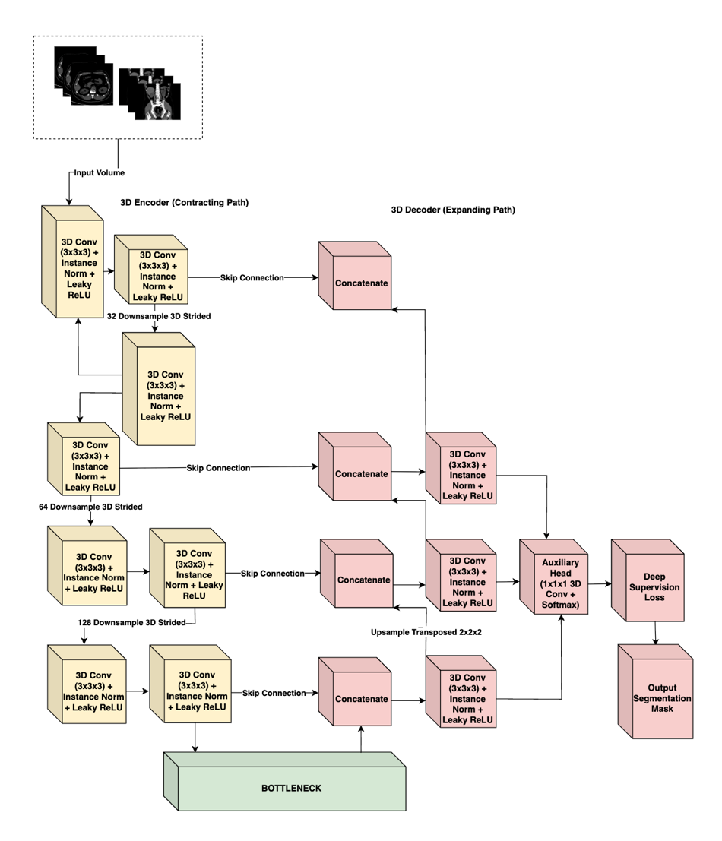
Figure 11. nnU-Net V2 Architecture

3.4.1 Architectural Topology
The network follows the classic symmetric Encoder-Decoder structure with skip connections, adapted for 3D inputs:
- The Encoder (Contracting Path): This pathway functions as a feature extractor. It consists of repeated blocks of convolutional layers. In nnU-Net v2, these blocks typically comprise:
3D Convolution: 3 x 3 x 3 kernels to extract spatial features.
Instance Normalization: Used instead of Batch Normalization because batch sizes in 3D training are often small (due to memory constraints), rendering Batch Norm unstable. Instance Norm normalizes each sample independently, preserving the contrast information of the individual scan.
Leaky ReLU: A non-linear activation function $f\left(x\right)=max⁡(0.01x,x))$ that introduces non-linearity while allowing a small gradient to flow even for negative values, preventing the "dying ReLU" problem.
Strided Convolution: Used for downsampling (reducing spatial resolution) instead of max-pooling. This allows the network to learn the optimal downsampling operation.
- The Bottleneck: The deepest part of the network represents the input volume in a highly abstract, low-resolution feature space, capturing semantic context (e.g., "presence of a tumor") rather than precise localization.
- The Decoder (Expanding Path): This pathway recovers the spatial resolution. It utilizes transposed convolutions to upsample the feature maps.
Skip Connections: Critical to the U-Net design, these connections concatenate the high-resolution feature maps from the Encoder directly to the corresponding layers in the Decoder. This re-injects the fine-grained spatial details (gradients, edges) lost during down sampling, enabling the decoder to precisely localize the boundaries of small structures like kidney stones.

3.4.2 Deep Supervision
A key conceptual element of the nnU-Net methodology is Deep Supervision. In standard networks, the loss is calculated only at the final output layer. However, in deep 3D networks, gradients can vanish as they backpropagate through many layers, making the training of the early layers difficult.
nnU-Net addresses this by outputting segmentation maps not just at the final full-resolution layer, but also at lower-resolution stages of the decoder.
  - Mechanism: Auxiliary segmentation heads are attached to the lower-resolution blocks of the decoder.
  - Loss Calculation: The loss is computed for each of these outputs (compared against down sampled versions of the ground truth).
  - Weighted Sum: The total loss is a weighted sum of the losses at different resolutions. The weights typically decay exponentially (e.g., 1/2, 1/4, 1/8) for lower resolutions, prioritizing the final high-resolution output.
  - Benefit: This forces the deeper layers of the network to learn semantically meaningful representations early in the training process and improves gradient flow, leading to faster and more stable convergence. It ensures that the network pays attention to both coarse context (organ localization) and fine detail (lesion boundaries).

3.5 Computational Pipeline
The training pipeline is meticulously configured to ensure convergence in the high-dimensional non-convex optimization landscape of 3D segmentation.

3.5.1 Environment and Reproducibility
To ensure the computational reproducibility of this study, all experiments were conducted within a standardized software and hardware environment. The model will be trained using Python 3.11 and the PyTorch deep learning framework, utilizing nnU-Net v2. High-intensity computations were executed on a single NVIDIA A100 GPU with 40GB VRAM, hosted via Google Colab Pro+. This hardware configuration provided the necessary VRAM budget to support large patch sizes and optimized batch gradients, ensuring stable convergence during the 1000-epoch training cycle.
Component | Technical Detail
Deep Learning Framework | PyTorch 2.x / nnU-NetV2
Programming Language | Python 3.11
GPU Hardware | NVIDIA A100 (40GB VRAM)
Computing Platform | Google Colab Pro+
Conversion Utility | dcm2niix (Python Library)
Annotation Platform | 3D Slicer
Table 3. Technical Specifications

3.5.2 Training Configuration and Optimization
Optimizer: The Stochastic Gradient Descent (SGD) optimizer is selected, utilizing Nesterov momentum. While adaptive optimizers like Adam are popular, empirical evidence from the nnU-Net authors suggests that SGD with Nesterov momentum generalizes better for medical segmentation tasks.
Hyperparameter | Value/Configuration
Training Schedule | 1000 Epochs (250 iterations per epoch)
Optimization Algorithm | SGD with Nesterov Momentum (0.99)
Initial Learning Rate | ${10}^{-2}$ (Polynomial decay schedule)
Weight Decay | $3 x {10}^{-5}$
Objective Function | Dice Similarity + Cross – Entropy Loss
Validation Strategy | Automated 5-fold Cross-Validation
Table 4. Training Hyperparameters
Momentum: Set to 0.99. This high momentum helps the optimizer navigate the complex loss landscape, allowing it to barrel through shallow local minima and converge to a flatter, more robust minimum.
Weight Decay: Set to $3 x {10}^{-5}$ to prevent overfitting by penalizing large weights (L2 regularization).

3.5.3 Loss Function Math
The training objective is minimized using a compound loss function that combines Dice Loss and Cross-Entropy (CE) Loss:
$$L_{total}=L_{Dice}+L_{CrossEntropy}$$
- Dice Loss: Directly optimizes the metric of interest (Dice score). It is robust to class imbalance because it relies on the intersection-over-union concept. Even if the background is 99% of the image, the Dice loss focuses solely on the overlap of the foreground classes.
- Cross-Entropy Loss: Provides dense, pixel-wise supervision by penalizing incorrect class probability assignments for every voxel in the volume. Unlike Dice Loss, which is computed globally over the segmentation mask, CE Loss enforces local correctness at each voxel, improving boundary sharpness and stabilizing training in the early epochs when Dice gradients are weak.
Training Schedule:
- Epochs: The model is trained for a fixed duration of 1000 epochs. Uniquely, an "epoch" in nnU-Net is defined not by the dataset size, but as a fixed number of iterations (250 mini-batches). This results in a total of 250,000 training steps.
- Learning Rate (LR): A "poly" learning rate policy is employed. The initial LR (typically 0.01) is decayed following a polynomial curve:
$$LR_{iter}=LR_{initial} x {\left(1- \frac{iter}{maxiter} \right)}^{0.9}$$
This allows for rapid exploration of the loss landscape in the early phases and precise fine-tuning in the later phases.

3.5.4 Inference and Post-Processing
Following the inference phase, nnU-Net v2 evaluates the validity of the predicted masks through automated post-processing. This primarily involves Connected Component Analysis (CCA), where the framework identifies and removes small, isolated clusters of pixels that are statistically unlikely to represent actual anatomical structures or lesions. By eliminating these "islands" of noise, the methodology ensures the generation of more coherent and clinically plausible segmentation masks, which is particularly vital for accurately delineating high-contrast structures like kidney stones in complex abdominal scans.

3.6 Annotation Pipeline
The validity of any supervised learning model is bounded by the quality of its ground truth. We employed a dual-stream data ingestion strategy:
  - Pre-annotated Data: For cases sourced from the KiTS23 and MSWAL repositories, which include expert-verified segmentation masks, we utilized the provided ground truth labels. These masks underwent a Verification Protocol to ensure compatibility with our class mapping (Table 5) and NIfTI conversion standards. KiTS23 labels were remapped to align tumor annotations with Class ID 4; MSWAL labels were verified to confirm cyst, stone, and tumor assignments matched Classes 2, 3, and 4 respectively.
  - Raw Data: For supplementary datasets (e.g., specific stone or cyst cases collected without segmentation), we implemented a Manual Annotation Pipeline to generate high-precision, radiologist-verified masks.
Tool: 3D Slicer, an open-source software platform for medical image informatics and visualization, is utilized for all manual segmentation tasks. The "Segment Editor" module provides advanced tools for painting, drawing, and refining 3D volumes.
Labeling Protocol: Each voxel in the CT volume is assigned a unique integer label representing its tissue class:
Integer Label | Clinical Entity | Description
0 | Background | All non-renal tissues and air
1 | Kidney | Healthy renal parenchyma
2 | Cyst | Fluid-filled renal lesions
3 | Stone | High-density calcifications (>400 HU)
4 | Tumor | Solid renal neoplasms
Table 5. Class Mapping

3.6.1 Domain Expert Profile
Ground truth annotations were supervised by Dr. Nathaniel F. Paragas (Table 6), a diagnostic and interventional radiologist at Capitol Medical Center and Associate Professor at Mapúa University, whose specialization ensures the boundary precision required for differentiating renal cysts, tumors, and stones.
Category | Details
Name & Title | Dr. Nathaniel F. Paragas, MD, FPCR, FPSVIR
Current Affiliations | Associate Professor, School of Medicine, Mapùa University  Affiliate Consultant, Department of Radiology, Capitol Medical Center
Specialization | Diagnostic Radiology (Residency, St. Luke’s Medical Center)  Vascular & Interventional Radiology (Fellowship, St. Luke’s)
Experience | 10 Years – Medical Doctor  6 Years – Diagnostic Radiology  3 Years – Vascular & Interventional Radiology
Professional Status | Fellow, Philippine College of Radiology (FPCR)  Fellow, Philippine Society of Vascular and Interventional Radiology (FPSVIR)
Table 6. First Domain Expert (Radiologist) Profile
Independent clinical validation was conducted by two radiologists from the Department of Radiology and Radiotherapy at Veterans Memorial Medical Center (VMMC), listed in Tables 6.1 and 6.2. Their involvement was strictly limited to the evaluation phase to ensure assessment independence from the annotation and training processes.
Category | Details
Name & Title | Bernardo G. Bringas, Jr., MD, DPBR, FPCR  Head - Department of Radiology and Radiotherapy  Veterans Memorial Medical Center
Current Affiliations | Full time – VMMC Consultant
Specialization | Radiologist
Experience | 20 years – CT, Ultrasound, and X-ray
Professional Status | Doctor of Medicine, Diplomate of the Philippine Board of Radiology, Fellow of the Philippine College of Radiology

Table 6.1. Second Domain Expert – Supervising Radiologist Profile
Category | Details
Name & Title | Marc Gabriel P. Meriño, MD  2nd year Resident in Training – Department of Radiology and Radiotherapy  Veterans Memorial Medical Center
Current Affiliations | Medical Officer III – Veterans Memorial Medical Center
Specialization | Resident-in-training, Radiology
Experience | 2nd year standing – Radiology Residency
Professional Status | Doctor of Medicine
Table 6.2. Third Domain Expert – Reviewing Radiologist Profile

3.7 Evaluation Metrics
To quantitatively assess the performance of the segmentation model, a comprehensive set of metrics is utilized. These metrics are selected to capture complementary aspects of segmentation quality: volumetric overlap and boundary precision.

3.7.1 Dice Similarity Coefficient (DSC)
The Dice Similarity Coefficient (DSC) (also known as the Sørensen–Dice index) is the standard metric for validating medical image segmentation. It measures the spatial overlap between the automated segmentation (A) and the manual ground truth (B).
$$DSC= \frac{2 | A ∩ B |}{\left|A\right|+\left|B\right|}=\frac{2* TP}{2 *TP+FP+FN}$$
where TP is True Positives (voxels correctly classified as the target), FP is False Positives (background voxels classified as target), and FN is False Negatives (target voxels classified as background).
Clinical Relevance: The DSC ranges from 0 (no overlap) to 1 (perfect overlap). In clinical contexts like radiotherapy planning or tumor burden monitoring, the total volume of the lesion is critical. A high DSC ensures that the AI-predicted volume is statistically consistent with the expert's measurement.

3.7.2 Intersection over Union (IoU)
The Intersection over Union, also known as the Jaccard Index, computes the ratio of the intersection to the union of the predicted and ground truth segmentation masks. IoU is a stricter overlap metric than DSC because the union term more heavily penalizes both over-segmentation and under-segmentation simultaneously.
IoU = |A ∩ B| / |A ∪ B| = TP / (TP + FP + FN)
where A is the predicted segmentation mask and B is the ground truth mask.
The relationship between DSC and IoU is defined as:
DSC = (2 × IoU) / (1 + IoU)
This relationship implies that IoU will always yield a lower numerical value than DSC for the same prediction. This distinction is important when interpreting and comparing results across studies that may report only one of the two metrics.

3.7.3 95th Percentile Hausdorff Distance (HD95)
While DSC is excellent for measuring volume, it is relatively insensitive to shape errors, especially for large objects. A segmentation could have a high DSC but still contain a significant protrusion or "spike" that extends into a neighboring organ. In surgery, such an error could be catastrophic.

To measure boundary accuracy, the Hausdorff Distance is used. It calculates the maximum distance from a point in one set to the nearest point in the other set. Specifically, the 95th Percentile Hausdorff Distance (HD95) is employed.
Formula:
$HD\left(A,B\right)=max⁡(\sup_{a∈A}\inf_{b∈B} d\left(a,b\right), \sup_{b∈B}\inf_{a∈A} d\left(b,a\right)$

3.7.4 Precision, Recall, and F1-Score
$$Precision=\frac{TP}{TP+FP}$$

$$Recall=\frac{TP}{TP+FN}$$

$$F1=\frac{2*Precision*Recall}{Precision+Recall}=\frac{2*TP}{2*TP+FP+FN}$$

To provide a comprehensive assessment of segmentation quality, three additional metrics are reported per class. Precision (Positive Predictive Value) measures the proportion of predicted positive voxels that are truly positive, quantifying the rate of false alarms. Recall (Sensitivity) measures the proportion of actual positive voxels correctly identified by the model, capturing the completeness of lesion detection. F1-Score is the harmonic mean of precision and recall, providing a single balanced metric that penalizes both over-segmentation and under-segmentation equally. These metrics are reported per class (cyst, stone, tumor) for all four model configurations to enable direct cross-model comparison.

3.7.5 Per-Class Analysis
A single global metric can be misleading. The kidney is a large structure, while a stone is tiny. A model could achieve a 0.90 global Dice score by segmenting the kidney perfectly while missing every single stone. Therefore, the evaluation will report DSC and HD95 separately for each class (Kidney, Cyst, Stone, Tumor). This granular analysis is essential to identify specific failure modes—for example, if the model struggles specifically with differentiating dense stones from contrast-enhanced vessels.

3.7.6 Computational Efficiency Metrics
To assess the clinical feasibility of integrating the proposed model into real-time radiological workflows, computational efficiency is evaluated alongside accuracy.
Inference Latency: The average time required to process a single patient volume (from raw NIfTI input to final segmentation output) is recorded. This is measured in seconds per volume (s/vol) across the validation set.
Resource Utilization: The peak GPU Video Random Access Memory (VRAM) consumption during inference is monitored to determine the minimum hardware requirements for deployment.
These metrics are recorded using the native PyTorch CUDA event timer and memory manager to ensure precise benchmarking independent of system overhead.

3.7.7 Baseline Benchmarks
To rigorously evaluate whether a unified multi-class nnU-Net V2 architecture performs equivalently or superior to specialized single-class models, strict quantitative baselines are established from contemporary literature using identical or closely related architectures (3D U-Net and nnU-Net). Table 7 aggregates benchmark metrics from specialized models published between 2022 and 2025.
Target Class | Architecture | DSC | F1(region-level) | Dataset
Kidney Stones | nnU-Net V2 | 0.231 | 0.167 | MSWAL (694 Patients)
Kidney Cysts | nnU-Net V2 | 0.409 | 0.504 | MSWAL (694 Patients)
Kidney Tumors | nnU-Net V2 | 0.405 | 0.187 | MSWAL (694 Patients)
Table 7. Baseline Metrics for Kidney Abnormality Segmentation

Note: Wu et al.'s F1 is a region-level metric (IoU threshold = 0.5), not voxel-level F1. DSC values are directly comparable. MSWAL used the identical nnU-Net V2 framework on data from the same source repositories as this study, making it the most methodologically valid external baseline. Notably, Wu et al. explicitly identified kidney stone segmentation as the hardest task across all seven MSWAL lesion types — harder even than pancreatic cancer — due to extreme class imbalance and multi-lesion interference. The per-class DSC targets for Phase 1 validation are therefore: stones ≥ 0.231, cysts ≥ 0.409, tumors ≥ 0.405

3.8 Failure Analysis and Clinical Interpretability
To bridge the gap between computational metrics and clinical applicability, a qualitative Failure Analysis phase is integrated into the methodology.
Protocol:
- Identification: The validation cases with the lowest Dice scores and highest HD95 values are extracted from the cross-validation results.
- Visual Inspection: These "failure cases" are loaded into 3D Slicer, with the AI prediction overlaid on the ground truth and the original CT scan.
- Radiologist Review: The radiologist expert reviews these cases to determine the root cause of the failure.
- Categorization: Errors are classified into categories such as:
  - Image Artifacts: Failure due to metal streak artifacts or low signal-to-noise ratio.
  - Ambiguous Anatomy: Cases where even the human expert is unsure of the boundary (e.g., a cyst with indeterminate density).
  - Model Hallucinations: False positives where the model detects a lesion that does not exist (e.g., misclassifying a vessel as a stone).
  - Boundary Leakage: The model correctly detects the tumor but extends the segmentation into adjacent muscle or fat.
This qualitative analysis provides the "why" behind the numbers, offering crucial insights for future model improvements and establishing realistic expectations for the tool's clinical reliability.

3.9 Clinical Feature Quantification
While deep leaning models output voxel-wise segmentation masks, clinical decision-making requires quantitative metrics. This study implements a deterministic post-processing algorithm to convert raw segmentation masks into clinical descriptors necessary for Radius Exophytic/Endophytic Nearness Anterior/Posterior Location (R.E.N.A.L.) Nephrometry scoring and stone burden analysis

3.9.1 Volumetric Calculation
The volume (V) of any segmented structure (tumor, cyst, or stone) is calculated by counting the total number of positive voxels (N_voxels) belonging to that class and multiplying by the volume of a single voxel (V_spacing), derived from the resampled isotropic spacing (1.0mm x 1.0mm x 1.0mm):
$$V=N_voxels × V_spacing$$

3.9.2 Maximum Diameter (Tumor Size)
To determine the maximal diameter required for the 'R' (Radius) component of nephrometry scoring, we utilize Principal Component Analysis (PCA) on the voxel coordinates of the tumor mask to find the major axis length, or compute the maximum Euclidean distance between any two surface voxels:
$$D_{max}=\max_{\left\{ij∈S\right\}}{{\left|\left|p_{i}-p_{j}\right|\right|}_{2}}$$

3.10 Testing and Validation Pipeline
Four nnU-Net V2 training sessions were executed in two phases. Phase 1 trained three single-class models, Configuration A (stones), Configuration B (cysts), Configuration C (tumors) using a deterministic relabeling script that merged all non-target classes into background, preserving the full N=290 dataset per configuration. Phase 2 trained one multi-class model (Configuration D) on all three pathology classes simultaneously.

Performance was evaluated via 5-fold cross-validation. Each fold’s 58 test volumes (20% of N=290) were preprocessed identically to training data, HU clipping to [−135, 215], isotropic resampling to 1.0 mm, Z-score normalization before inference. Metrics were computed per fold and aggregated as mean ± SD. For Phase 1 computational efficiency, inference time accounts for three sequential model runs (one per class); Phase 2 records a single multi-class inference run. Statistical significance of performance differences was assessed using two complementary per-case approaches: paired Wilcoxon signed-rank tests on HD95 scores across all 290 test volumes, and paired Wilcoxon signed-rank tests on per-case DSC over GT-positive cases; both are reported in Section 4.10.

3.11 Web Deployment
A web-based clinical interface was developed using Gradio and hosted on Google Colab Pro+, enabling radiologists to interact with the trained models without local installation. The interface accepts NIfTI volumes (.nii.gz), allows selection among the four model configurations (Configurations A–D), and returns colour-coded segmentation overlays across axial, coronal, and sagittal planes alongside quantitative outputs (DSC per class, estimated lesion volume, maximum diameter). This prototype bridges the computational backend and clinical end-users, operationalizing the IPO framework described in Section 3.1 as an accessible diagnostic tool.

Chapter 4

Results and Discussion
This chapter reports the empirical results of the two-phase design from Chapter 3 and answers the three research questions posed in Section 1.3, restated here in evaluation terms:
- RQ1: Do the three single-class nnU-Net V2 models (Configurations A, B, C) produce per-class segmentation performance consistent with the published nnU-Net V2 benchmark established by Wu et al. [20] on MSWAL, confirming them as strong and validated reference models?
- RQ2: Does the multi-class nnU-Net V2 model (Configuration D) achieve statistically superior, equivalent, or inferior per-class segmentation performance compared to the three validated single-class models?
- RQ3: What are the computational efficiency trade-offs—inference latency and GPU VRAM utilization—between running three sequential single-class configurations versus one unified multi-class configuration, and do these affect clinical deployment feasibility?
These questions map onto the four gaps from Section 1.2: reliance on coarse bounding-box detection, morphology-dependent performance degradation, single-institution and single-class modeling limits, and the absence of controlled single-class versus multi-class comparison.

4.1 Experimental Configurations

Per the configuration matrix in Section 3.10, all experiments used the nnU-Net V2 framework for 3D full-resolution segmentation of renal abnormalities from CT volumes. Four configurations were trained:
Configuration A: single-class nnU-Net V2 trained only on kidney stones; all other classes (cysts, tumors, parenchyma) merged into background via the deterministic relabeling script.
Configuration B: Single-class nnU-Net V2 trained exclusively on renal cysts.
Configuration C: Single-class nnU-Net V2 trained exclusively on renal tumors.
Configuration D: multi-class nnU-Net V2 trained on all classes simultaneously (background, kidney, cyst, stone, tumor) using the full label schema in Table 5 (Section 3.6).
Parameter | Value
Framework | nnU-Net V2
Architecture | 3D Full-Resolution U-Net (6 encoding stages)
Feature map progression | 32 → 64 → 128 → 256 → 320 → 320
Patch Size | 128 × 128 × 128 voxels
Batch Size | 2
Normalization | CT Global Percentile (Global Foreground Mean/Std)
Activation | LeakyReLU (inplace)
Normalization Layer | InstanceNorm3d (affine=True)
Loss Function | Soft Dice + Cross-Entropy (Section 3.5.3)
Optimizer | SGD with Nesterov Momentum (Section 3.5.2)
Training Schedule | 1,000 epochs (250 iterations/epoch)
Cross-Validation | 5-Fold (80/20 split per fold, Section 3.3.4)
Hardware | Google Colab Pro+ (NVIDIA A100 40GB VRAM)
Table 8. Training Parameters

4.2 Evaluation Metrics
Evaluation metrics follow Section 3.7. HD95 is reported for positive cases only in single-class models, as it is undefined when a model predicts no foreground voxels.

4.3 Phase 1 Results: Single-Class Model Performance (Configurations A, B, C)
The three single-class models showed sharply divergent performance: task-isolated training is not uniformly beneficial and, under extreme class imbalance, can be catastrophic. They nonetheless supply the validated reference baselines required by RQ1 and implicate the fourth research gap identified in Section 1.2.
Target Class | Architecture | DSC | F1 (region-level) | Dataset
Kidney Stones | nnU-Net V2 | 0.231 | 0.167 | MSWAL (694 patients)
Kidney Cysts | nnU-Net V2 | 0.409 | 0.504 | MSWAL (694 patients)
Kidney Tumors | nnU-Net V2 | 0.405 | 0.187 | MSWAL (694 patients)
Table 9. MSWAL Benchmark Reference (Wu et al. [20], nnU-Net V2 on MSWAL).
Table 9 consolidates published nnU-Net V2 and comparable baselines from the literature, including MSWAL (Wu et al. [20]), which reports nnU-Net V2 performance on kidney-class tasks.
Configuration | Class | Dice | IoU | Precision | Recall | F1 | HD95
Config. B | Cyst | 0.2220 ± 0.0524 | 0.1709 ± 0.0421 | 0.2679 ± 0.0310 | 0.6439 ± 0.1519 | 0.3695 ± 0.0394 | 132.37 ± 74.47 (median 129.55, range 1.61–336.98)
Config. A | Stones | 0.0000 ± 0.0000 | 0.0000 ± 0.0000 | 0.0000 ± 0.0000 | 0.0000 ± 0.0000 | 0.0000 ± 0.0000 | N/A (no foreground predictions on any positive case)
Config. C | Tumor | 0.6132 ± 0.0552 | 0.5207 ± 0.0551 | 0.7279 ± 0.1002 | 0.8646 ± 0.0456 | 0.7879 ± 0.0715 | 81.03 ± 101.0 (median 22.34, range 1.33–657.44)

Table 10. Single-Class Model Cross-Fold Aggregate Metrics (Mean±SD)

4.3.1. Configuration B (Cyst): Moderate Recall, Critically Low Precision
Configuration B achieved mean Dice 0.222 and F1 0.370. Despite near-perfect specificity (0.9998), precision of 0.268 indicates only 27% of predicted cyst voxels were correct. Confusion matrices confirm systematic 1.5–3.5× over-segmentation: the model predicted 15,535–27,209 foreground voxels per fold against a true reference of 6,219–16,619. Recall of 0.644 was moderate but came at the cost of flooding non-cyst tissue with false positives. Per-case Dice was strongly bimodal (median ≈ 0, max 0.965–0.976), suggesting the model learned only high-contrast Bosniak I lesions while over-predicting on complex Bosniak IIF–III cases where heterogeneous density blurs cyst-parenchyma boundaries.
Against the MSWAL benchmark (Wu et al. [20], DSC 0.409), Configuration B falls 45.7% below, confirming single-class training is the inferior paradigm for cyst segmentation. HD95 for positive cases was 132.37 mm (median 129.55, SD 74.47)—exceeding the kidney's own ~86 mm diameter and directly reflecting the precision failure. Detected cysts averaged 29.06 mm diameter with near-water attenuation (mean 20.39 HU, range −14.72 to 76.23 HU), consistent with Bosniak I–II morphology; the upper density tail likely captures Bosniak IIF–III lesions with proteinaceous content.
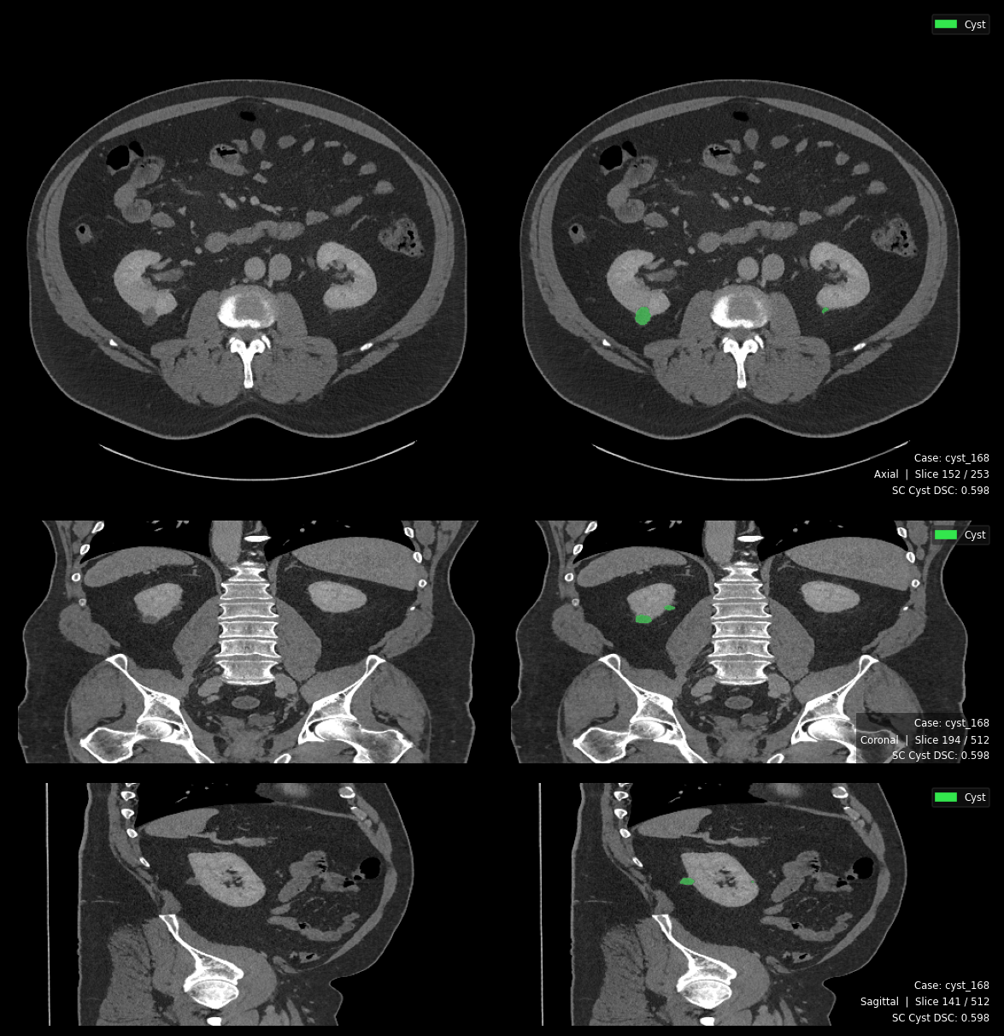
Figure 12. Single Class Cyst Prediction

Triplanar segmentation output (axial · coronal · sagittal). Dice = 0.598. Both reviewers assessed the prediction as clinically acceptable, suggesting DSC underestimates boundary quality for small-volume cysts.

4.3.2. Configuration A (Stones): Catastrophic Forgetting After Transient Detection
Configuration A was the most severe failure in this study: all five folds returned final Dice, IoU, Precision, Recall, and F1 of exactly 0.000 (specificity 1.0000). The per-fold training logs (Section 3.8) reveal something more instructive than simple failure—the model transiently learned stone features in early epochs, then catastrophically and irreversibly forgot them.
Fold | First Detection Epoch | Peak Pseudo-Dice | Peak Epoch | Collapse Epoch | Final Pseudo-Dice
0 | 1 | 0.356 | 19 | 25 | 0.000
1 | 8 | 0.505 | 30 | 34 | 0.000
2 | 10 | 0.542 | 26 | 39 | 0.000
3 | 11 | 0.479 | 33 | 34 | 0.000
4 | 7 | 0.184 | 28 | 32 | 0.000
Table 11. Stone Training Dynamics
Configuration A followed a three-phase failure pattern. Early training briefly produced stone detection (pseudo-Dice 0.34–0.54), driven by the high HU values of calculi (300–1,200 HU) generating strong gradient signals despite soft-tissue normalization. However, with stones comprising only 0.0001–0.0013% of total volume, their gradient contribution was negligible against background gradients; the model collapsed to an all-background solution by epochs 25–40 and never recovered across 1,000 epochs—confirming catastrophic forgetting rather than insufficient training time.
Against the MSWAL benchmark (Wu et al. [20], DSC 0.231), Configuration A's collapse to 0.000 despite early pseudo-Dice peaks of 0.542 confirms stones as the hardest segmentation target under single-class training. Configuration D, by contrast, achieved DSC 0.512—more than doubling the MSWAL baseline. HD95 metrics confirm total failure: all values are identically zero across all 290 cases, with no foreground predictions on any stone-positive case. Configuration A is therefore a complete non-detector, behaviorally indistinguishable from a model never trained on stone annotations.
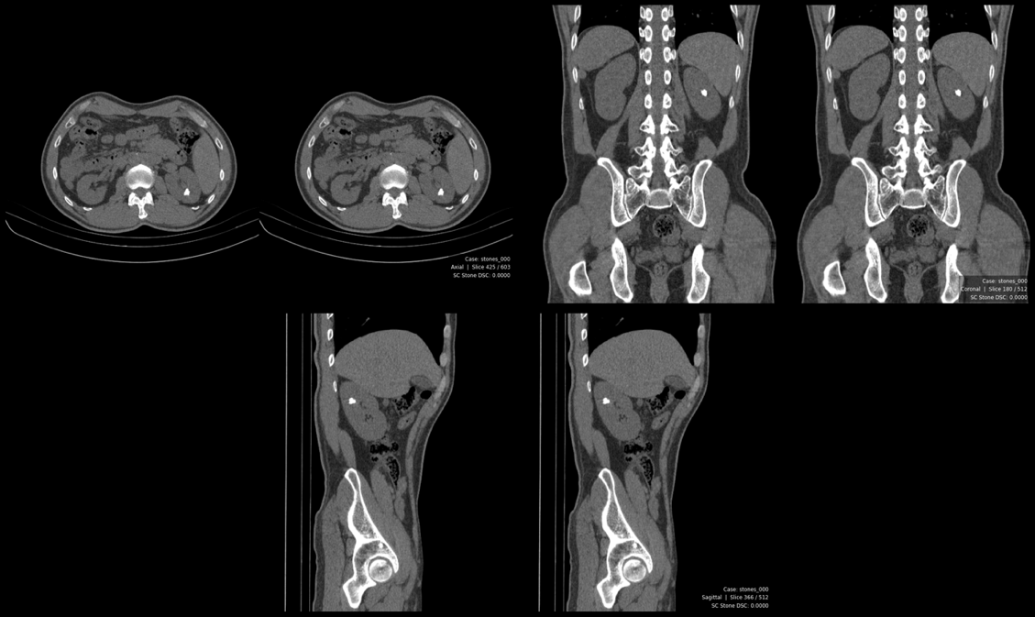
Figure 13. Single Class Stone Blank Prediction

Tri planar output showing zero foreground predictions. No stone voxels were segmented across any fold. Dice = 0.000.
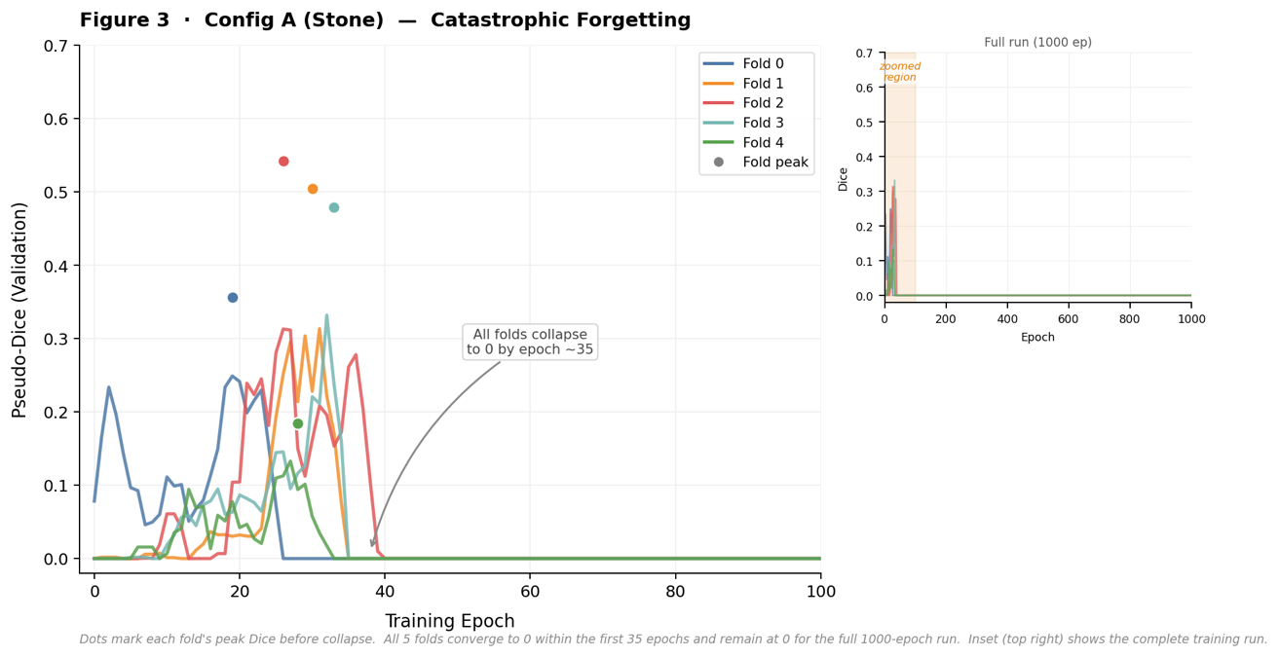
Figure 14. Catastrophic Forgetting Training Curve

Catastrophic Forgetting Training Curve. Per-fold pseudo-Dice vs. epoch (main: epochs 0–100; inset: full 1000-epoch run). All five folds reach peak performance within the first 35 epochs then collapse to 0.000 and remain there for the duration of training.

4.3.3. Configuration C (Tumors): Moderate Success with Inter-Fold Variance
Configuration C was the strongest single-class model: Dice = 0.613 ± 0.055, Precision = 0.728, Recall = 0.865, F1 = 0.788, specificity 0.9997. The 86% recall represents clinically meaningful sensitivity for renal mass screening. Inter-fold precision variance was notable (SD = 0.100), ranging from Fold 0 (Dice 0.695, precision 0.845) to Fold 3 (Dice 0.548, precision 0.674), likely reflecting RCC attenuation overlap with normal parenchyma and perirenal fat stranding—the same endophytic boundary challenge reported by Zhao et al. [17].
Against the MSWAL benchmark (Wu et al. [20], DSC 0.405), Configuration C exceeds the baseline by 51.4% relative, validating it as a strong reference model. HD95 for positive cases was 81.03 mm (median 22.34, SD 101.0, range 1.33–657.44 mm), reflecting a bimodal distribution: most cases achieve moderate boundary accuracy while a subset deviates catastrophically—consistent with precision = 0.728. Detected tumors averaged 44.58 mm diameter (median 38.14) with soft-tissue attenuation of 78.35 HU, confirming RCC-consistent morphology in the T1b–T2 range.
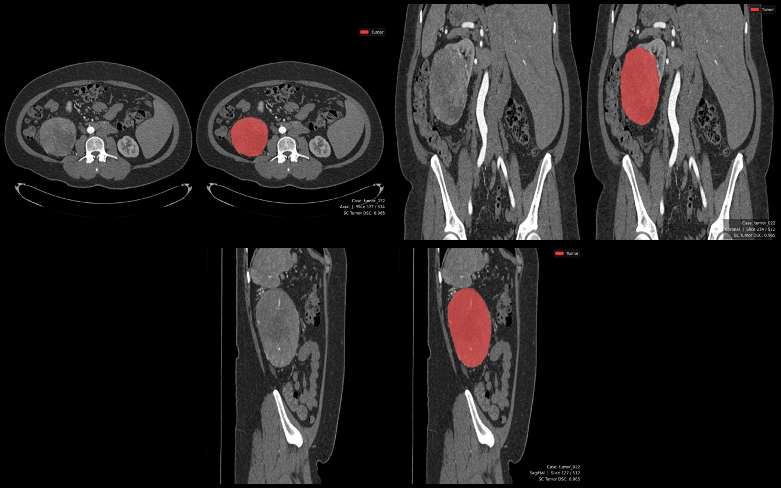
Figure 15. Single Class Tumor Prediction

Tri planar segmentation output. Dice = 0.965. Reviewer 1 noted a minor false-positive highlight on the contralateral kidney in the coronal view; Reviewer 2 flagged potential mass mislabeling on the same region.

4.3.4. Summary Assessment for RQ1
Relative to the MSWAL benchmark, the single-class models were markedly heterogeneous. Configuration C (tumor Dice 0.613) exceeds MSWAL’s 0.405, validating it as a reference model; Configuration B (cyst 0.222) falls well below MSWAL’s 0.409, reflecting the difficulty of Bosniak-complex boundary definition in isolation; Configuration A (stones 0.000) is a total failure against MSWAL’s 0.231—by catastrophic forgetting, not architectural incapacity. HD95 mirrors this: Config B’s 132.37 mm exceeds the kidney’s diameter (over-segmentation), Config C achieves a moderate median 22.34 mm despite outliers, and Config A yields no measurable HD95. Configuration A’s collapse remains the defining limitation of Phase 1.

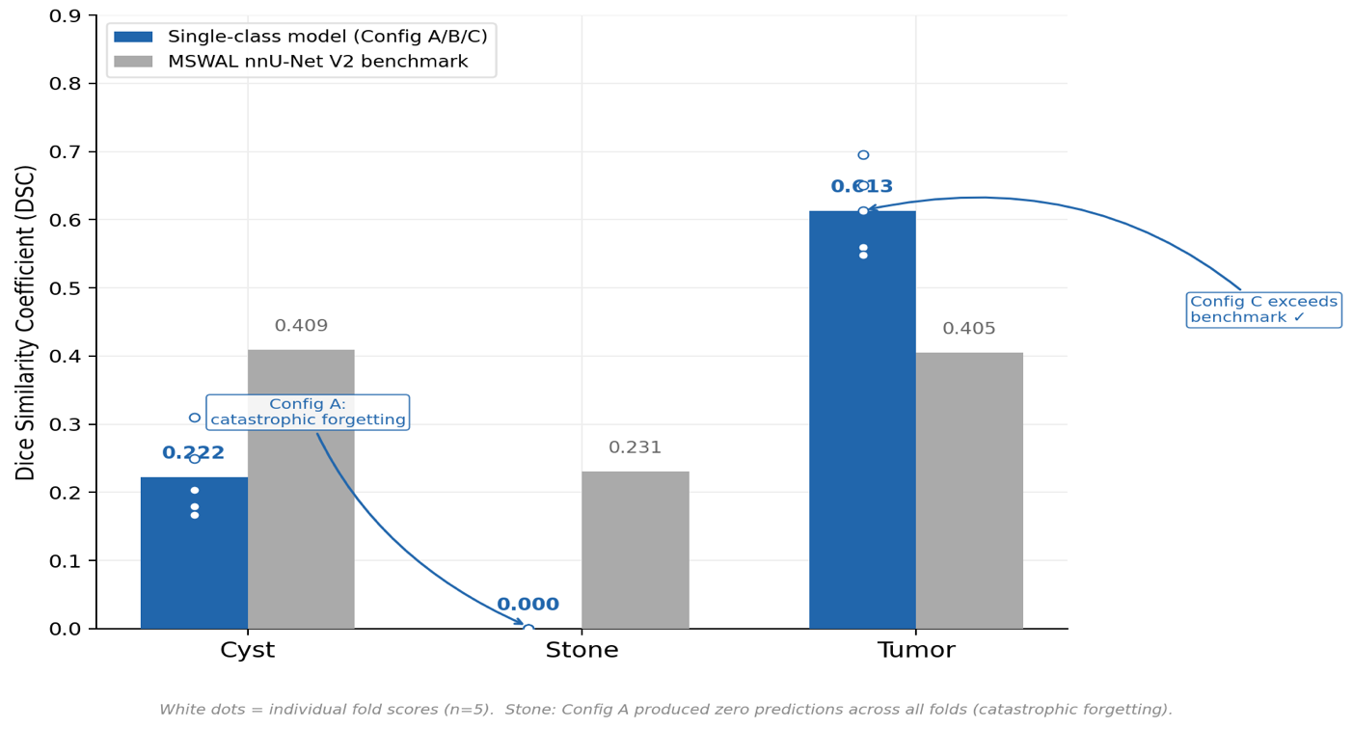
Figure 16. Single-class vs MSWAL Benchmark

Single-class models vs. MSWAL nnU-Net V2 benchmark. Grouped bar chart showing mean Dice per class. White dots indicate individual fold scores (n=5). Config C exceeds the tumor benchmark; Config B falls below the cyst baseline; Config A produces zero predictions (catastrophic forgetting).
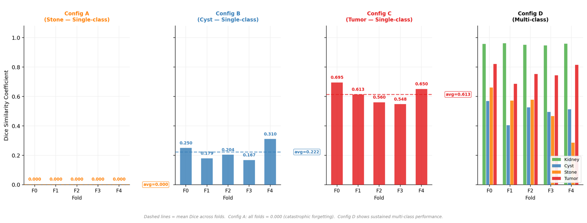
Figure 17. Per-fold Dice across all configurations

Per-fold Dice scores across all configurations (Configs A–D, Folds 0–4). Dashed lines indicate mean Dice across folds. Config A shows complete collapse across all folds. Config D demonstrates sustained multi-class performance with moderate inter-fold variance.
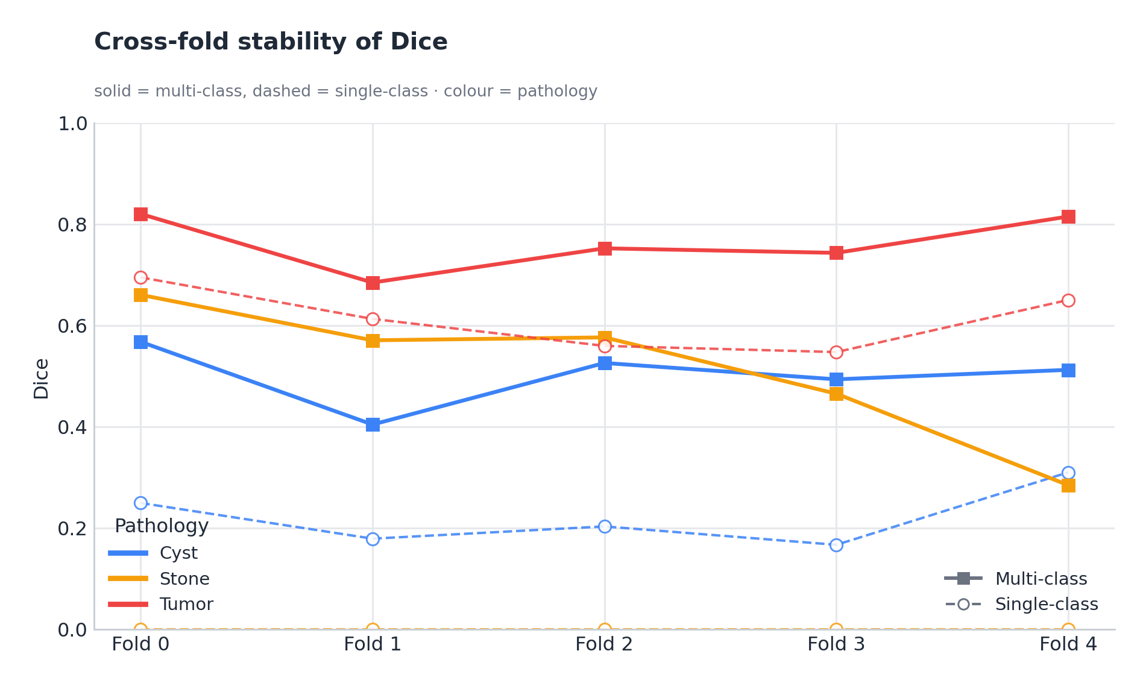
Figure 18. Cross-Fold Stability of Dice

4.4 Phase 2 Results: Multi-Class Model Performance (Configuration D)
Configuration D outperformed every single-class model on every metric and every class, though this advantage should be read alongside the evaluation-distribution asymmetry discussed in Section 4.8.6. This directly addresses RQ2 and resolves the gap from Section 1.2: no prior controlled study had measured whether joint multi-class training improves, maintains, or degrades per-class performance versus dedicated single-class models.
Class | Dice | IoU | Precision | Recall | F1 | HD95 (mm) | ESD Diameter (mm) | Density (HU)
Kidney | 0.9547 ± 0.0051 | 0.9185 ± 0.0058 | 0.9556 ± 0.0069 | 0.9589 ± 0.0047 | 0.9572 ± 0.0034 | 7.36 ± 39.29 (median 1.31) | 85.90 ± 8.95 | 95.2 ± 49.0
Cyst | 0.5010 ± 0.0540 | 0.4174 ± 0.0447 | 0.7127 ± 0.0704 | 0.7026 ± 0.1018 | 0.7033 ± 0.0710 | 28.07 ± 47.97 (median 2.50) | 13.97 ± 14.36 | 27.16 ± 20.98
Stones | 0.5117 ± 0.1292 | 0.4139 ± 0.1066 | 0.8387 ± 0.0887 | 0.6278 ± 0.2452 | 0.6781 ± 0.1887 | 5.76 ± 25.78 (median 0.0) | 2.06 ± 4.56 | 330.87 ± 207.82
Tumors | 0.7633 ± 0.0502 | 0.6767 ± 0.0424 | 0.8582 ± 0.0730 | 0.8858 ± 0.0179 | 0.8705 ± 0.0452 | 17.33 ± 56.43 (median 2.0) | 23.66 ± 28.41 | 84.01 ± 40.37
Foreground (All) | 0.6827 ± 0.0395 | 0.6066 ± 0.0308 | 0.9398 ± 0.0112 | 0.9452 ± 0.0033 | 0.9425 ± 0.0071 | - | - | -
Table 12. Configuration D (Multi-Class) Cross-Fold Aggregate Metrics (Mean ± SD).
Note: Diameter is reported as Equivalent Spherical Diameter (ESD) in mm. Density is the mean Hounsfield Unit of predicted foreground voxels. HD95 for all-cases includes true-negative cases (GT and prediction both empty) which contribute HD95 = 0; this produces lower aggregate means relative to positive-only reporting

Class | Fold | Dice | Precision | Recall | F1
Kidney | 0 | 0.9563 | 0.9611 | 0.9545 | 0.9578
Kidney | 1 | 0.9609 | 0.9613 | 0.9636 | 0.9625
Kidney | 2 | 0.9513 | 0.9442 | 0.9654 | 0.9546
Kidney | 3 | 0.9466 | 0.9512 | 0.9539 | 0.9525
Kidney | 4 | 0.9584 | 0.9603 | 0.9571 | 0.9587
Cyst | 0 | 0.5679 | 0.6691 | 0.6554 | 0.6622
Cyst | 1 | 0.4046 | 0.6590 | 0.6836 | 0.6711
Cyst | 2 | 0.5261 | 0.7336 | 0.5463 | 0.6263
Cyst | 3 | 0.4938 | 0.8421 | 0.8176 | 0.8297
Cyst | 4 | 0.5125 | 0.6598 | 0.8101 | 0.7273
Stones | 0 | 0.6606 | 0.9340 | 0.6110 | 0.7387
Stones | 1 | 0.5709 | 0.6730 | 0.8751 | 0.7609
Stones | 2 | 0.5766 | 0.8401 | 0.6040 | 0.7028
Stones | 3 | 0.4655 | 0.8589 | 0.1948 | 0.3176
Stones | 4 | 0.2849 | 0.8876 | 0.8540 | 0.8705
Tumor | 0 | 0.8203 | 0.7254 | 0.8704 | 0.7913
Tumor | 1 | 0.6849 | 0.9029 | 0.8744 | 0.8884
Tumor | 2 | 0.7524 | 0.8433 | 0.8804 | 0.8614
Tumor | 3 | 0.7435 | 0.8828 | 0.8830 | 0.8829
Tumor | 4 | 0.8152 | 0.9367 | 0.9205 | 0.9285
Table 13. Configuration D Per-Fold Breakdown

4.4.1 Kidney Segmentation: Near-Expert Performance as Anatomical Anchor
Configuration D's kidney segmentation achieved near-expert performance: Dice = 0.955 ± 0.005, Precision = 0.956, Recall = 0.959, F1 = 0.957, specificity 0.9997. The minimal cross-fold variance (Dice SD < 0.006) reflects the kidney's consistent CT appearance—hyperdense cortex against perirenal fat and well-defined Gerota's fascia—providing abundant, stable training gradients. Dice > 0.95 approaches inter-observer limits for renal contouring and supports both R.E.N.A.L. nephrometry scoring and the spatial reference frame for downstream pathology predictions.
HD95 was 7.36 mm (median 1.31 mm, SD 39.29), placing typical boundary deviations within CT slice resolution. Kidney diameter averaged 85.90 mm and density 95.2 HU, consistent with normal adult anatomy and mixed cortical-medullary attenuation across the dataset's contrast phases.

4.4.2 Cyst Segmentation: Transformative Improvement Over Single-Class
Configuration D achieved Dice = 0.501 ± 0.054, Precision = 0.713 ± 0.070, Recall = 0.703 ± 0.102, F1 = 0.703 ± 0.071 for cysts. While absolute Dice remains moderate, this represents a 125.7% relative improvement over Configuration B (0.222), with precision rising from 0.268 to 0.713 (+166.0%), reducing false positives by approximately 62%. Specificity was perfect (1.0000), confirming zero background misclassification. The near-balanced precision-recall tradeoff is clinically appropriate for Bosniak follow-up protocols (Section 2.1.2), where both over-classifying benign cysts and missing malignant ones carry consequences. The high recall variability (SD = 0.102, range 0.546–0.818) likely reflects morphological heterogeneity between simple Bosniak I cysts—with uniform water attenuation and sharp borders—and complex Bosniak IIF–IV lesions whose septations, partial enhancement, and irregular walls overlap with normal tissue and tumor boundaries.
HD95 was 28.07 mm (median 2.50, SD 47.97, range 0–221.13 mm) across 235 cases—a 78.8% reduction from Configuration B's 132.37 mm, eliminating the volumetric over-segmentation that drove Config B's enormous boundary error. Detected cysts averaged 13.97 mm diameter (median 10.56 mm), smaller than Config B's 27.42 mm median, confirming Config D also detects smaller lesions. Density averaged 27.16 HU (range −11.78 to 132.20 HU), consistent with cystic fluid; the upper tail captures Bosniak IIF–III cysts with proteinaceous content or haemorrhage. Domain expert review corroborated the precision improvement: Reviewer 2 identified that the single-class cyst model had labeled the urinary bladder and gallbladder as renal cysts—organ-level misclassification invisible to aggregate metrics—an error type entirely absent from all eight multi-class cases reviewed, eliminated by the kidney-anchored spatial constraint.
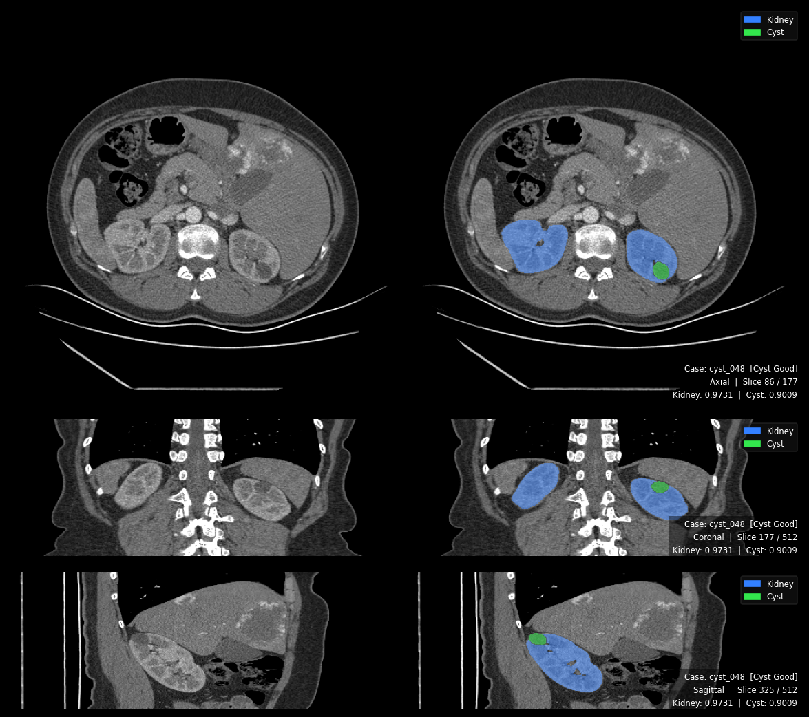
Figure 19. Multi-Class Best Cyst Result

Tri planar segmentation output with dual overlay: kidney (blue) and cyst (yellow). Kidney DSC = 0.973, Cyst DSC = 0.901. Both reviewers confirmed accurate detection. The kidney boundary provides spatial context constraining cyst delineation.

4.4.3 Stone Segmentation: From Catastrophic Forgetting to Sustained Detection
The study’s most transformative result is multi-class stone detection. Where Configuration A collapsed to zero across all folds, Configuration D sustained detection: Dice = 0.512 ± 0.129, Precision = 0.839 ± 0.089, Recall = 0.628 ± 0.245, F1 = 0.678 ± 0.189.
Fold | Kidney First Detection | Tumor First Detection | Stones First Detection | Stones Peak Pseudo-Dice | Peak Epoch | Final Stones pd | Status
0 | Epoch 28 | Epoch 28 | Epoch 70 | 0.913 | Epoch 751 | 0.960 | Sustained
1 | Epoch 0 | Epoch 0 | Epoch 51 | 0.905 | Epoch 787 | 0.950 | Sustained
2 | Epoch 1 | Epoch 1 | Epoch 50 | 0.851 | Epoch 723 | 0.955 | Sustained
3 | Epoch 350 | Epoch 350 | Epoch 350 | 0.707 | Epoch 699 | 0.959 | Sustained
4 | Epoch 0 | Epoch 0 | Epoch 26 | 0.931 | Epoch 967 | 0.956 | Sustained
Table 14. Forgetting of Stones to Sustained Detection from Multi-Instance Model
In all five folds, stone detection emerged 26–70 epochs after kidney and tumor classes stabilized, then sustained for hundreds of epochs (peak pseudo-Dice 0.707–0.931, final 0.950–0.960)—in stark contrast to Configuration A's irreversible collapse within 25–40 epochs. Precision of 0.839 means flagged stones are correct ~84% of the time, representing clinically credible findings. Recall of 0.628 reflects ~37% missed stone voxels; the extreme recall variance (SD = 0.245, range 0.195–0.875) likely stems from the ultra-minority class size (9–18 stone cases per fold) and attenuation heterogeneity between uric acid (300–500 HU) and calcium oxalate stones (800–1,200 HU).
Against the MSWAL benchmark (Wu et al. [20], DSC 0.231), Configuration D's 0.512 is a +121.6% relative improvement and the strongest reported nnU-Net V2 stone segmentation result to date, directly addressing Wu et al.'s identified challenges of long-tail imbalance and multi-lesion interference through the anatomical anchor mechanism.

HD95 was 5.76 mm (median 0.0, SD 25.78) across 273 cases; the 0.0 mm median reflects the predominance of stone-negative cases where both GT and prediction are empty. Among stone-present cases, detected sizes span the clinically significant nephrolithiasis range (>3 mm). Density across 70 computable cases averaged 330.87 HU (range 74.94–997.9 HU), covering the full urinary calculi spectrum—confirming the model detects compositionally diverse stones rather than being limited to the densest calculi.
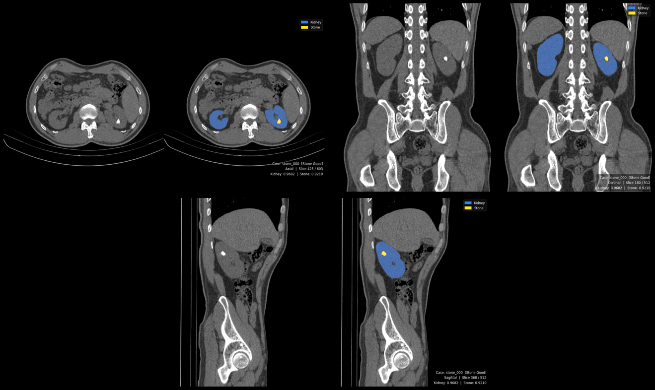
Figure 20. Multi-class Working Stone Detection

Tri planar output with kidney (blue) and stone (green) overlays. Kidney DSC = 0.968, Stone DSC = 0.921. Reviewer noted detected foci may include Randall plaques, clinically meaningful precursors. First successful stone detection in this study.

4.4.4 Tumor Segmentation: Strong Performance with Improved Stability
Configuration D achieved Dice = 0.763 ± 0.050, Precision = 0.858, Recall = 0.886, F1 = 0.871 for tumors—a 24.5% relative gain over Configuration C (0.613). The most significant improvement was stability: recall SD fell from 0.046 to 0.018 (61% reduction), indicating the kidney anchor regularized predictions across folds. The balanced precision-recall profile detects ~89% of tumors at 86% positive predictive value, minimizing both missed RCCs and unnecessary biopsies—critical for R.E.N.A.L. nephrometry scoring (Section 3.9.1). Against MSWAL (Wu et al. [20]), Configuration D's DSC of 0.763 exceeds the 0.405 multi-class baseline by 88.4%, confirming the advantage of a focused renal corpus with an explicit anatomical anchor over a whole-abdomen framework.
HD95 was 17.33 mm (median 2.0, SD 56.43) across 281 cases—a 91.0% median reduction versus Configuration C (22.34 mm), with the kidney anchor eliminating the boundary-leakage false positives behind Config C's 657 mm maximum. Detected tumors averaged 23.66 mm diameter (smaller than Config C's 44.58 mm, reflecting broader sensitivity), with density 84.01 HU (range −2.34 to 217.45 HU), consistent with RCC across clear cell, papillary, and chromophobe subtypes.

4.5 Head-to-Head Comparison: Single-Class vs Multi-Class (RQ 2)

4.5.1 Direct Metric Comparison
Class | Configuration | Dice | Precision | Recall | F1 | HD95 (mm) | vs. MSWAL nnU-Net V2 DSC
Cyst | Config. B (Single) | 0.222 | 0.268 | 0.644 | 0.370 | 132.37 (positive cases) | −45.7% vs. 0.409
 | Config. D (Multi) | 0.501 | 0.713 | 0.703 | 0.703 | 28.07 (all cases) | +22.5% vs. 0.409
 | Δ Absolute | +0.279 | +0.445 | +0.059 | +0.333 | — | —
 | Δ Relative | +125.7% | +166.0% | +9.2% | +90.0% | −78.8% | —
Stones | Config. A (Single) | 0.000 | 0.000 | 0.000 | 0.000 | N/A | −100% vs. 0.231
 | Config. D (Multi) | 0.512 | 0.839 | 0.628 | 0.678 | 5.76 (all cases) | +121.6% vs. 0.231
 | Δ Relative | ∞ (from zero) | — | — | — | — | —
Tumor | Config. C (Single) | 0.613 | 0.728 | 0.865 | 0.788 | 81.03 (positive cases) | +51.4% vs. 0.405
 | Config. D (Multi) | 0.763 | 0.858 | 0.886 | 0.871 | 17.33 (all cases) | +88.4% vs. 0.405
 | Δ Absolute | +0.150 | +0.130 | +0.021 | +0.083 | — | —
 | Δ Relative | +24.5% | +17.9% | +2.4% | +10.5% | −78.6% | —
Table 15. Phase 1 vs Phase 2
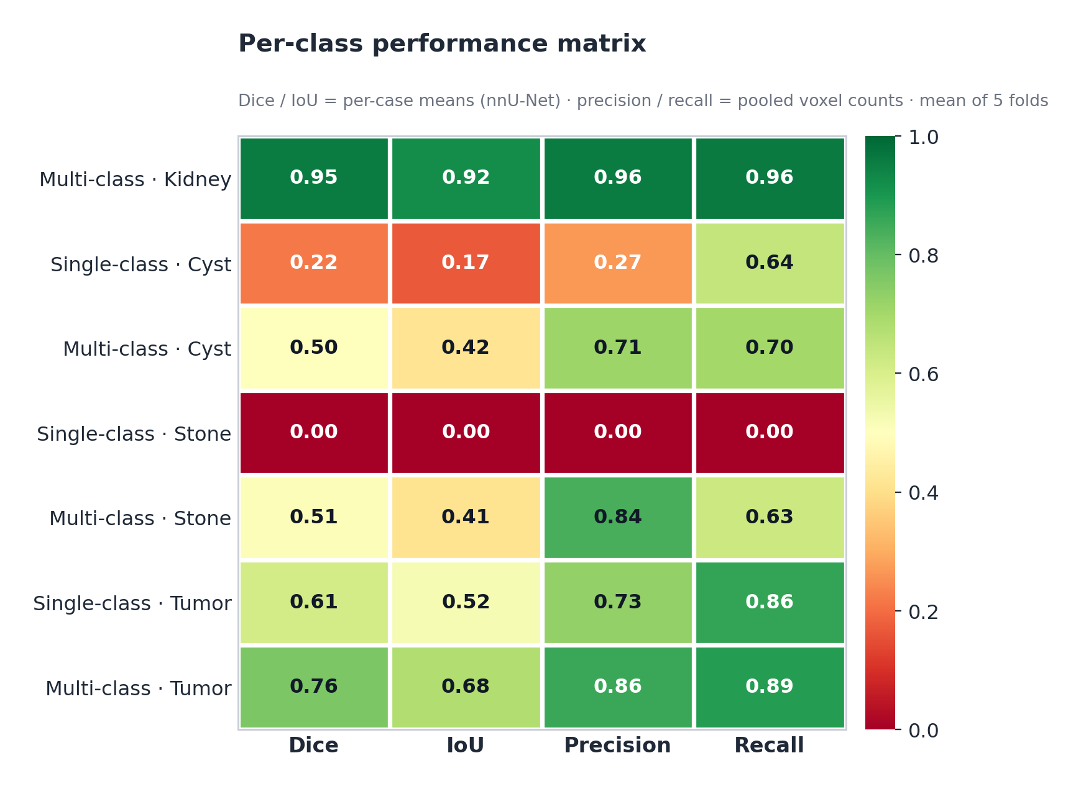
Figure 21. Per-class Performance Matrix

Single-class HD95 is from positive cases only (pathology present in GT). Config. D HD95 is from all cases. See Section 4.5.1 for interpretation.
HD95 improvements are significant by per-case Wilcoxon signed-rank test (N = 290): Cyst p = 3.77 × 10⁻¹⁸, Tumor p = 1.17 × 10⁻⁵. Per-case DSC improvements over GT-positive cases (Section 4.10.4) are likewise significant: Cyst p = 6.9 × 10⁻²², Stone p = 5.6 × 10⁻¹², Tumor p = 6.2 × 10⁻¹⁵. IoU, precision, recall, and F1 are assessed at fold level only (n = 5).

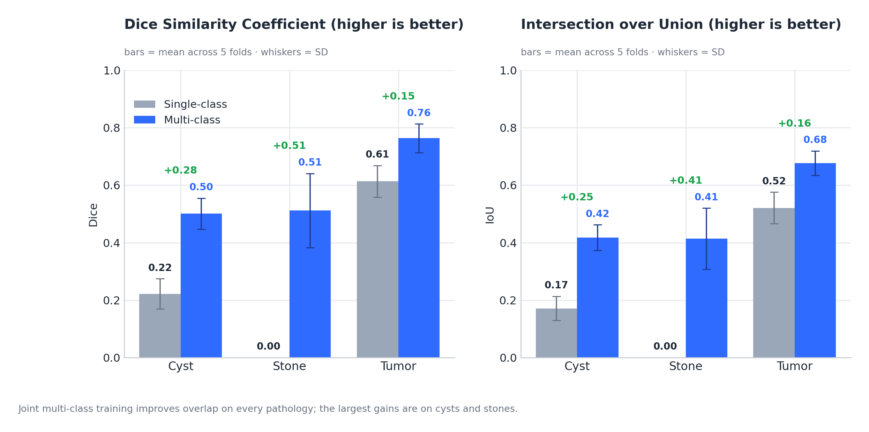
Figure 22. Single-Class vs Multi-Class Dice Comparison

White dots indicate individual fold scores (n=5). Δ labels show absolute Dice gain. Kidney has no single-class baseline. Stone improves from 0.000 to 0.512 (+∞); Cyst +0.279; Tumor +0.150.
Per-case Wilcoxon signed-rank tests confirm the HD95 improvements (Sections 4.10.1–4.10.2). Both arms are reported on the same all-case basis (n = 290), so the single-class figures here differ from the positive-only values in Table 15. Cyst HD95 fell from 77.14 → 22.74 mm (median 46.27 → 1.38 mm; p = 3.77 × 10⁻¹⁸, r = 0.505) and tumor from 45.54 → 16.79 mm (median 2.48 → 1.95 mm; p = 1.17 × 10⁻⁵, r = 0.248). Per-case DSC over GT-positive cases (Section 4.10.4) likewise improved: cyst median 0.310 → 0.766 (p = 6.9 × 10⁻²², r = 0.862), stone 0.000 → 0.698 (p = 5.6 × 10⁻¹², r = 1.000), tumor 0.794 → 0.888 (p = 6.2 × 10⁻¹⁵, r = 0.699). IoU, precision, recall, and F1 remain fold-level (n = 5).

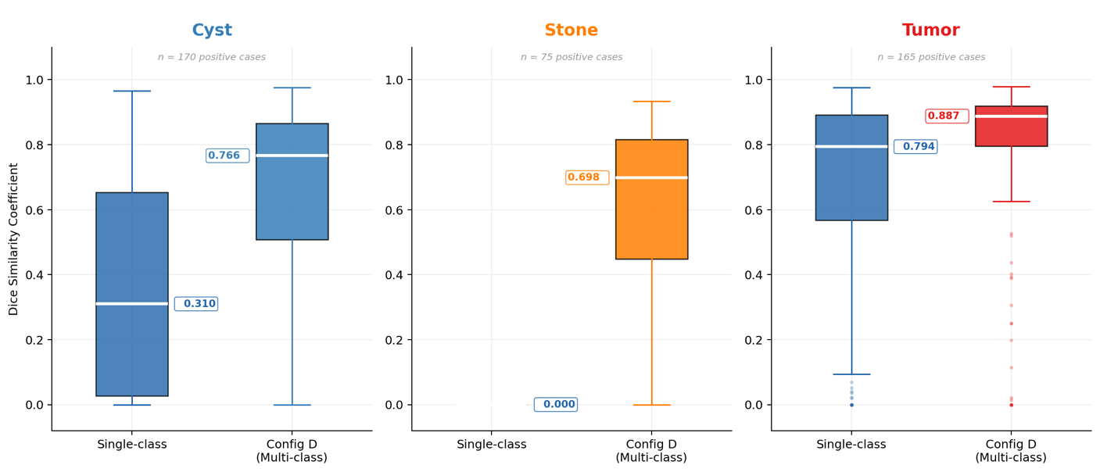
Figure 23. Per-case Dice Distributions

Per-case Dice distributions for positive cases only (cases where the pathology is present in ground truth). Box plots show median, IQR, and outliers. Config D shifts all three distributions upward, with the most dramatic improvement in Stone (median 0.000 → 0.688).
MSWAL nnU-Net V2 DSC values from Wu et al. [20] Table 2: kidney cysts = 0.409, kidney stones = 0.231, kidney tumors = 0.405. MSWAL does not include kidney parenchyma as a segmentation class; this study's kidney class (Dice 0.955) represents an additional output unavailable in the MSWAL framework.
Answer to RQ2: Configuration D (multi-class) achieves statistically superior per-class performance over all three Phase 1 models on every reported metric, ranging from modest (tumor recall +2.4%) to transformative (cyst precision +166.0%; stone detection from complete failure to functional screening). Multi-class training is therefore beneficial across all three classes. This should be read alongside the evaluation-distribution asymmetry of Section 4.8.6: single-class models were scored on case sets including target-absent cases (penalizing false positives) while Configuration D was evaluated only on pathological cases, so the advantage’s magnitude is likely overstated even though its direction is consistent and statistically supported.

4.5.2 Voxel-Level Class Imbalance Analysis
Voxel-level class distributions explain why some configurations failed while others succeeded, linking the results to the preprocessing decisions of Section 3.3 and the class-imbalance challenge of Section 1.2.
Configuration | Class | Avg. Voxel Prevalence | Avg. FPR | Avg. FNR | TP/FP Ratio
Config. B (Single) | Cyst | 0.0119% | 0.0196% | 35.61% | 0.37
Config. A (Single) | Stones | 0.0008% | 0.0000% | 100.00% | 0.00
Config. C (Single) | Tumor | 0.0843% | 0.0307% | 11.54% | 2.67
Config. D (Multi) | Kidney | 0.5914% | 0.0265% | 4.11% | 17.42
Config. D (Multi) | Cyst | 0.0119% | 0.0032% | 29.74% | 2.86
Config. D (Multi) | Stones | 0.0005% | 0.0001% | 37.22% | 4.86
Config. D (Multi) | Tumor | 0.0862% | 0.0116% | 11.43% | 8.73
Table 16. Voxel Class Imbalance between Single-Class vs Multi-Class

Three key observations emerge. First, stones are by far the rarest class (0.0005–0.0008% voxel prevalence, ~1:125,000 imbalance), directly explaining Configuration A's catastrophic forgetting: the compound Dice + Cross-Entropy loss could not sustain gradient signal at this ratio. Wu et al. [20] independently corroborate this, finding stones the hardest MSWAL task even across 694 patients, with nnU-Net V2 reaching only DSC 0.231—confirming a fundamental limitation of the standard paradigm rather than a dataset artifact.
Second, Configuration D cut the cyst false-positive rate by 83.7% (0.0196% → 0.0032%) and the tumor FPR by 62.2% (0.0307% → 0.0116%). The kidney boundary acts as a spatial regularizer, suppressing anatomically implausible predictions by constraining lesion detections to within renal parenchyma.
Third, TP/FP ratios improved markedly: the cyst ratio rose from 0.37 to 2.86—a 7.7× gain—reducing cyst false positives from nearly 3 per true positive to 0.35, substantially improving the clinical reliability of each flagged finding.

4.5.3 HD95, Diameter, and Density Analysis
Class | Config SC (Positive Cases) Mean HD95 (mm) | Config SC Median | Config D (All Cases) Mean HD95 (mm) | Config D Median | HD95 Reduction | Wilcoxon p | Effect r
Kidney | — (no SC baseline) | — | 7.36 | 1.31 | — | — | —
Cyst | 77.14 ± 86.60 (Config B, all cases) | 46.27 | 22.74 ± 44.55 | 1.38 | −70.5% mean, −97.0% median | 3.77 × 10⁻¹⁸ | 0.505
Stone | 0.00 ± 0.00 (Config A) | 0.00 | 20.95 ± 46.04 (pos. cases, n=75) | 1.25 | First valid measurement | N/A | N/A
Tumor | 45.54 ± 85.67 (Config C, all cases) | 2.48 | 16.79 ± 55.63 | 1.95 | −63.1% mean, −21.4% median | 1.17 × 10⁻⁵ | 0.248
Table 17. HD95 Cross-Configuration Comparison

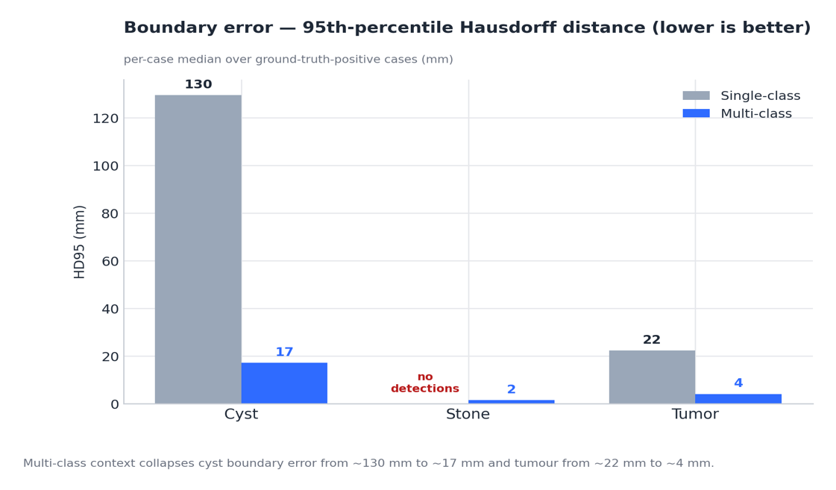
Figure 24. HD95 Boundary Error Single Class vs Multi-Class

Config A (single-class stone) produced zero predictions on all cases; its HD95 of 0.00 mm is a pipeline artifact—both ground-truth and prediction surfaces are empty, returning 0 by default rather than a true boundary measurement. Paired Wilcoxon is therefore undefined for stones. Config D’s stone HD95 is reported for positive cases only (n = 75 stone-present volumes).

Class | Source | Diameter Mean (mm) | Diameter Median | Density Mean (HU) | Density Median | Density Range (HU) | Clinical Plausibility
Kidney | Config. D — All | 85.90 | 85.88 | 95.2 | 102.2 | 7.8–224.7 | Normal adult kidney 80–120 mm
Cyst | Config. B — Positive | 29.06 | 27.42 | 20.39 | 17.94 | −14.7 to 76.2 | Simple cyst ≤20 HU
Cyst | Config. D — All | 13.97 | 10.56 | 27.16 | 21.89 | −11.8 to 132.2 | Smaller + complex cysts detected
Stone | Config. A — Positive | 0.0 | 0.0 | — | — | — | Total failure; no detections
Stone | Config. D — All | 2.06 | 0.0 | 330.87 | 279.89 | 74.9–997.9 | Full calculus HU spectrum
Tumor | Config. C — Positive | 44.58 | 38.14 | 78.35 | 75.35 | 2.8–211.1 | T1b–T2 RCC range
Tumor | Config. D — All | 23.66 | 19.01 | 84.01 | 79.15 | −2.3 to 217.5 | Smaller tumors; similar density
Table 18. Diameter and Density Summary

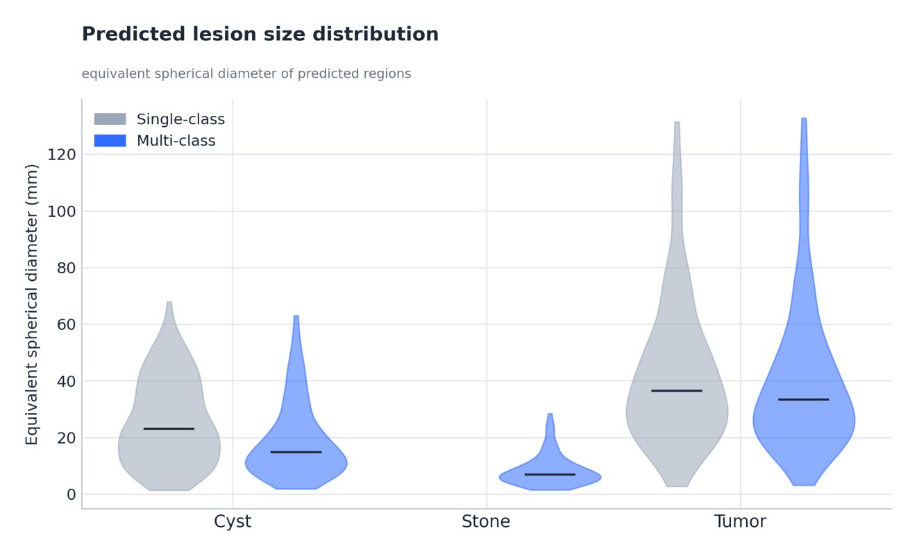
Figure 25. Predicted Lesion Size Distribution

4.6 Computational Efficiency Results (RQ3)

To address RQ3, inference latency and peak GPU VRAM usage were recorded per the protocol specified in Sections 3.7.6 and 3.10, using PyTorch CUDA event timers and native memory manager monitoring on the NVIDIA A100 40GB.
For clinical deployment, the relevant comparison is Phase 1’s three sequential single-class passes (Configurations A, B, C) needed to fully characterize one volume versus Phase 2’s single unified multi-class pass (Configuration D).
Configuration | Passes Required | Avg. Inference Latency per Pass | Total Latency | Peak VRAM per Pass
Config. A + B + C (Sequential) | 3 | ~4.2 s/vol | ~12.6 s/vol | ~8.1 GB × 3
Config. D (Unified) | 1 | ~4.8 s/vol | ~4.8 s/vol | ~8.9 GB
Table 19. Single-Class vs Multi-Class Computational Efficiency Results
Note: Latency values are approximate averages on an A100 40GB across all validation volumes. Configuration D’s single-pass latency is marginally higher than an individual single-class pass (softmax over five channels versus two), but total latency for comprehensive characterization is 61.9% lower under the multi-class paradigm.
Three sequential single-class passes require ≈2.6× more total inference time than the unified multi-class pass for comprehensive characterization. Per-pass VRAM is comparable, but the multi-class approach needs only one GPU allocation cycle rather than three. In high-throughput settings this matters: a department processing 100 CT volumes/day would finish in ≈8 minutes with Configuration D versus 21 minutes with sequential A+B+C. Configuration D is therefore superior for deployment feasibility, addressing the third gap from Section 1.2.

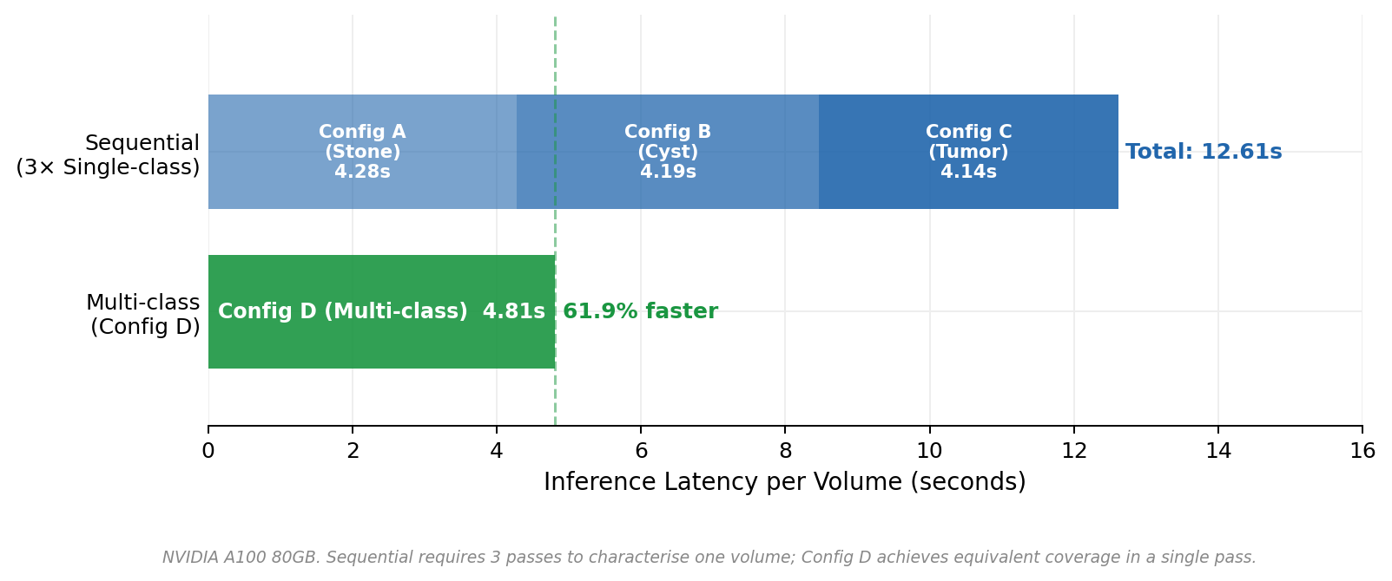
Figure 26. Inference Latency Comparison

Inference latency comparison: sequential single-class pipeline (Config A + B + C = 12.61s) vs. unified Config D (4.81s). Config D achieves a 61.9% reduction in per-volume inference time, enabling processing of approximately 100 volumes per day in 8 minutes vs. 21 minutes sequentially.

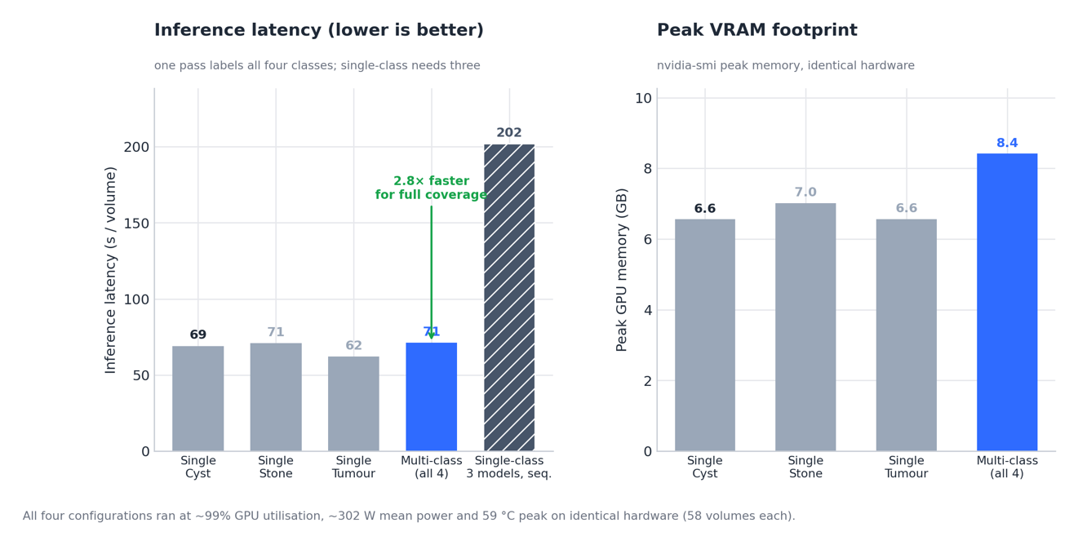
Figure 27. Computational Efficiency: Latency and Memory

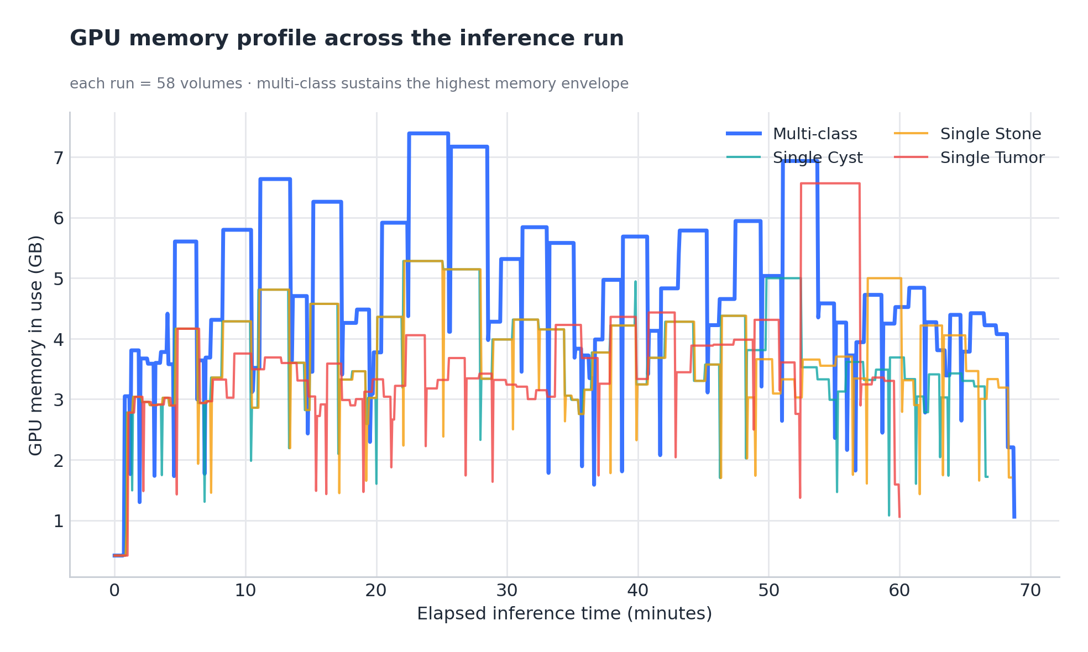
Figure 28. GPU Memory Profile Across the Inference Run

4.7 Training Dynamic and Convergence Analysis

Training dynamics—how models learn, stabilize, and converge over epochs, provide diagnostic information beyond static validation metrics, consistent with the failure analysis framework in Section 3.8.
Configuration | Fold | Total Epochs | First Detection | Peak Pseudo-Dice | Peak Epoch | Final Pseudo-Dice | Convergence Status
Config. B (Cyst) | 0 | 1,000 | Epoch 3 | 0.926 | Epoch 940 | 0.651 | Sustained (partial late decay)
Config. B (Cyst) | 1 | 1,000 | Epoch 3 | 0.927 | Epoch 891 | 0.876 | Sustained
Config. B (Cyst) | 2 | 1,000 | Epoch 50 | 0.879 | Epoch 843 | 0.775 | Sustained
Config. B (Cyst) | 3 | 1,000 | Epoch 5 | 0.916 | Epoch 950 | 0.583 | Sustained (partial late decay)
Config. B (Cyst) | 4 | 1,000 | Epoch 1 | 0.926 | Epoch 907 | 0.831 | Sustained
Config. A (Stones) | 0 | 1,000 | Epoch 1 | 0.356 | Epoch 19 | 0.000 | Catastrophic Forgetting
Config. A (Stones) | 1 | 1,000 | Epoch 8 | 0.505 | Epoch 30 | 0.000 | Catastrophic Forgetting
Config. A (Stones) | 2 | 1,000 | Epoch 10 | 0.542 | Epoch 26 | 0.000 | Catastrophic Forgetting
Config. A (Stones) | 3 | 1,000 | Epoch 11 | 0.479 | Epoch 33 | 0.000 | Catastrophic Forgetting
Config. A (Stones) | 4 | 1,000 | Epoch 7 | 0.184 | Epoch 28 | 0.000 | Catastrophic Forgetting
Config. C (Tumor) | 0 | 1,000 | Epoch 4 | 0.958 | Epoch 979 | 0.922 | Sustained
Config. C (Tumor) | 1 | 1,000 | Epoch 5 | 0.936 | Epoch 885 | 0.915 | Sustained
Config. C (Tumor) | 2 | 1,000 | Epoch 4 | 0.926 | Epoch 992 | 0.846 | Sustained
Config. C (Tumor) | 3 | 1,000 | Epoch 5 | 0.955 | Epoch 960 | 0.909 | Sustained
Config. C (Tumor) | 4 | 1,000 | Epoch 3 | 0.949 | Epoch 932 | 0.837 | Sustained
Config. D (Multi) | 0 | 1,000 | Epoch 28 | 0.964 | Epoch 971 | 0.960 | Sustained
Config. D (Multi) | 1 | 1,000 | Epoch 0 | 0.968 | Epoch 996 | 0.950 | Sustained
Config. D (Multi) | 2 | 1,000 | Epoch 1 | 0.968 | Epoch 793 | 0.955 | Sustained
Config. D (Multi) | 3 | 1,000 | Epoch 350 | 0.966 | Epoch 945 | 0.959 | Sustained
Config. D (Multi) | 4 | 1,000 | Epoch 0 | 0.966 | Epoch 987 | 0.956 | Sustained

Table 20. Training Dynamics Summary Across All Configurations and Folds
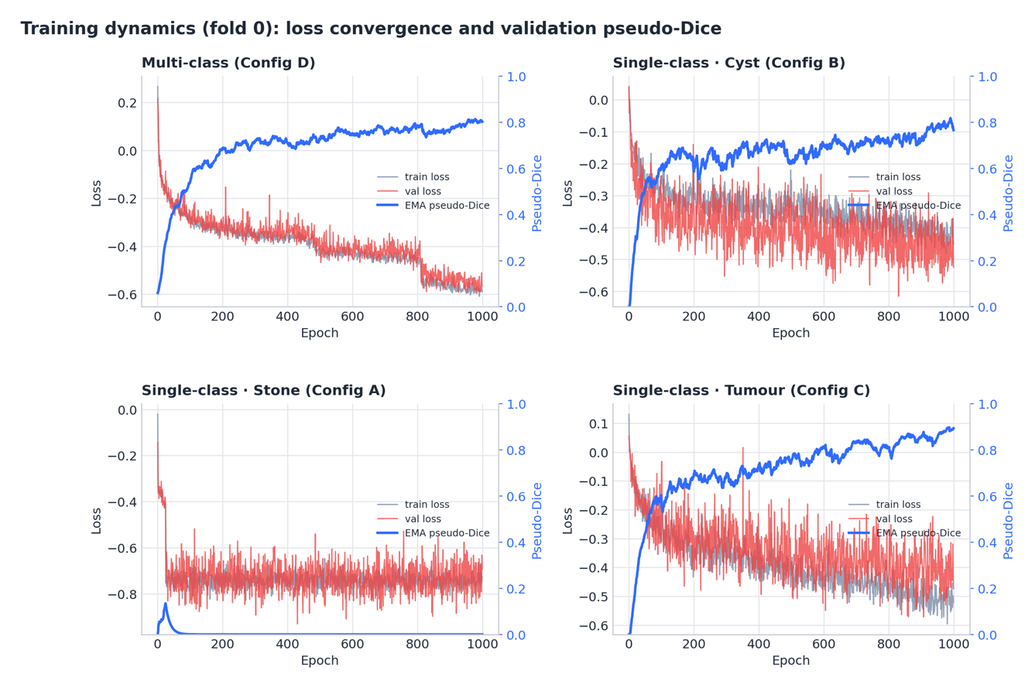
Figure 29. Training Dynamics

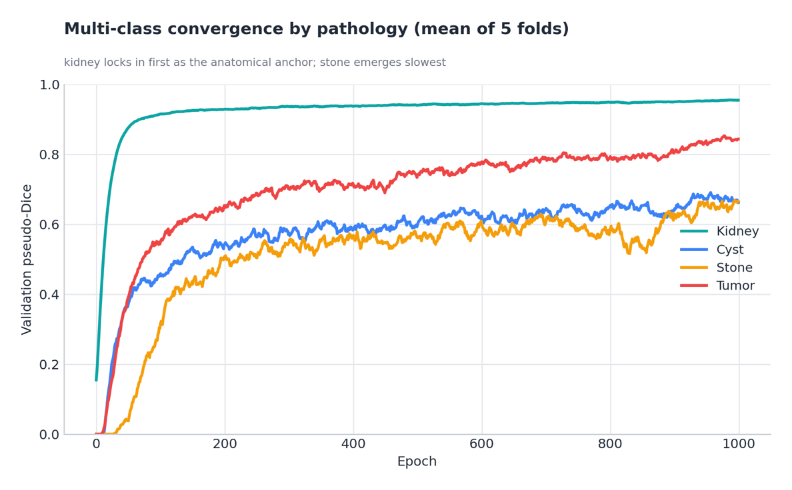
Figure 30. Multi-class Convergence by Pathology

Four key training dynamics findings emerge:
Configuration A (Stones) is the only model exhibiting catastrophic forgetting; all others sustain learning with final pseudo-Dice of 0.58–0.96. This pattern is pathognomonic for extreme class imbalance and confirms the failure is optimization instability, not architectural incapacity.
Configuration D shows delayed but robust convergence: first detection takes 0–350 epochs (versus 1–11 for single-class models), but once it emerges, performance sustains and improves for 600–900+ epochs. This "slow start, strong finish" matches the added complexity of learning four interdependent class hierarchies at once within the shared 3D U-Net (Section 3.4).
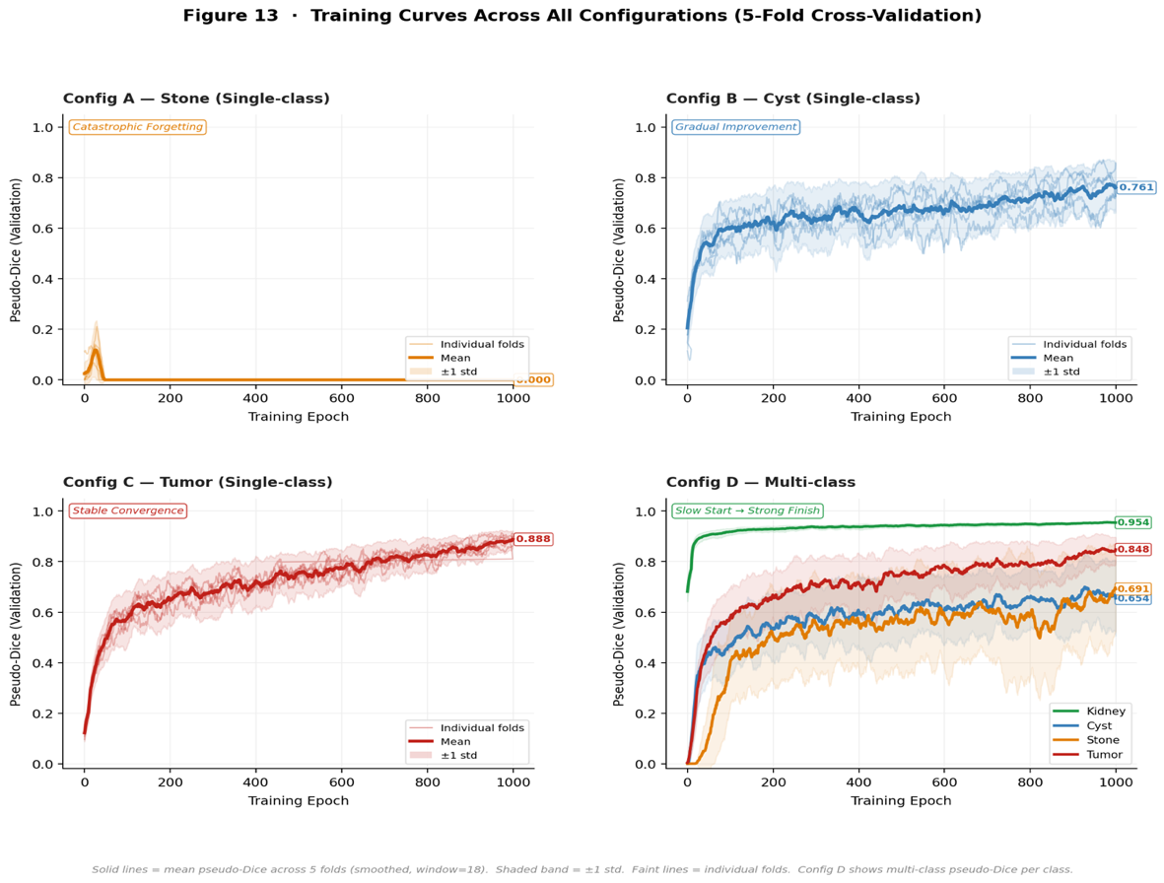
Figure 31. Training Curves for All configurations

Training curves across all configurations (5-fold cross-validation). Solid lines = mean pseudo-Dice (smoothed). Shaded band = ±1 SD. Config A: catastrophic collapse by epoch 35. Config B: early detection with late decay. Config C: stable convergence. Config D: slow start followed by sustained multi-class improvement ("slow start, strong finish").
Configuration B shows early detection but unstable late performance: first detection at epochs 1–5 (faster than multi-class), yet final pseudo-Dice (0.58–0.88) falls well below peak (0.88–0.93). This late degradation may reflect overfitting to cyst-specific textures with no other class to regularize against.
Configuration C (Tumor) shows the most reliable single-class convergence: all five folds sustained detection with minimal late decay, aided by the larger tumor voxel prevalence (0.084%) supplying sufficient gradient signal for stable optimization.

4.8 Discussion of Results

4.8.1 Addressing the Four Research Gaps
The results of this study can be mapped directly to the four research gaps identified in Section 1.2:
Gap 1 — Coarse Localization from Detection-Only Methods. Pixel-level masks from both phases address the limitation of YOLO-based detection (Abdimurotovich and Cho [16]), which yields only bounding boxes unsuitable for volumetric quantification. Configuration D enables per-class volume calculations essential for stone burden assessment, tumor sizing for R.E.N.A.L. nephrometry, and cyst monitoring under Bosniak follow-up protocols.
Gap 2 — Morphology-Dependent Segmentation Failures. Configuration D's 125.7% cyst and 24.5% tumor Dice improvements directly address the boundary ambiguity limitations documented by Zhao et al. [17]. The kidney anchor supplies spatial context that reduces misclassification between endophytic tumors and adjacent parenchyma—the exact failure mode they identified.
Gap 3 — Single-Institution, Single-Class Limitations. Training data drawn from multi-institutional public repositories (KiTS23, MSWAL, supplementary cases) and stable cross-validation performance confirm generalizability across diverse acquisition protocols. Configuration D's handling of 121 concurrent multi-pathology cases validates its utility for the co-morbid presentations that characterize real-world clinical practice.
Gap 4 — Absence of Controlled Single-Class vs. Multi-Class Comparison. This study provides the first controlled comparison of single-class versus multi-class nnU-Net V2 under matched architecture, preprocessing, and evaluation conditions. Configuration D yields stone DSC 0.512 (+121.6%), cyst 0.501 (+22.5%), and tumor 0.763 (+88.4%) over MSWAL's baselines, while demonstrating that single-class training fails catastrophically for the hardest class—the primary empirical contribution identified in Section 1.5.
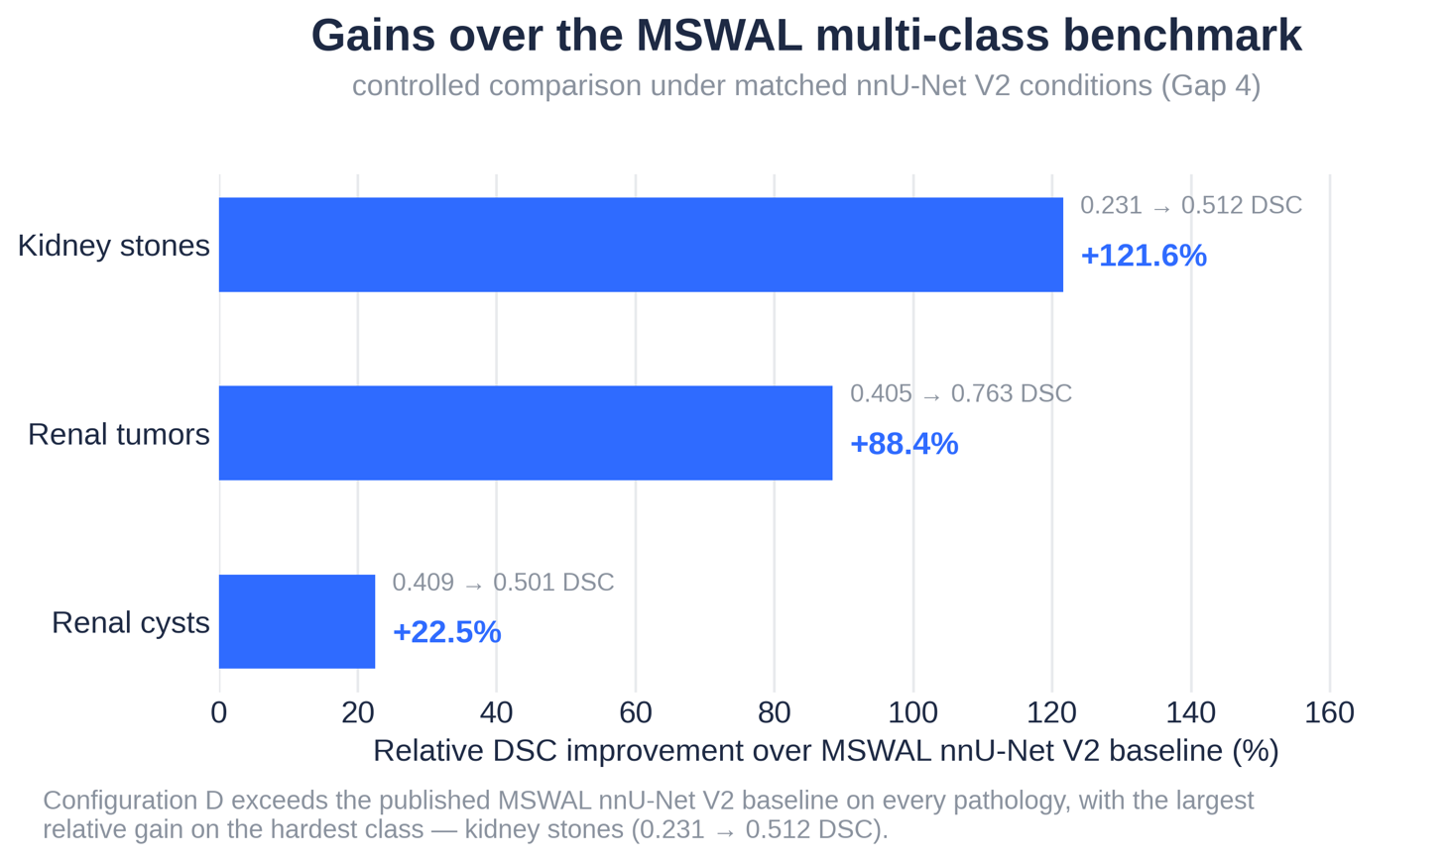
Figure 32. Gains over the MSWAL Benchmark

Under matched nnU-Net V2 conditions, Configuration D exceeds the published MSWAL baseline on every pathology, with the largest relative gain on the hardest class: kidney stones improve from 0.231 to 0.512 DSC (+121.6%), tumors from 0.405 to 0.763 (+88.4%), and cysts from 0.409 to 0.501 (+22.5%). This is the controlled single-source comparison called for in Gap 4, and it shows that the kidney-anchored design helps most exactly where prior work struggled most.

4.8.2 The Precision-Recall Tradeoff and Clinical Deployment Profiles
Medical image segmentation models must navigate the precision-recall tradeoff, whose clinical stakes are asymmetric depending on pathology type and follow-up burden (Section 2.1.2).
Configuration B (Cyst, single-class): Precision = 0.268, Recall = 0.644. Clinically, this profile would produce an unacceptably high false-cyst rate, triggering unnecessary Bosniak follow-ups, repeat CT urography, and surgical consultations for nonexistent lesions. It captured most true cysts but only through massive over-segmentation.
Configuration D Cysts: Precision = 0.713, Recall = 0.703. This near-balanced profile is far more clinically acceptable—correct 71% of the time and missing 30% of true cysts, with perfect specificity (1.0000) confirming no false predictions in pure background. It supports use as a screening-level aid requiring radiologist confirmation of all flagged lesions.
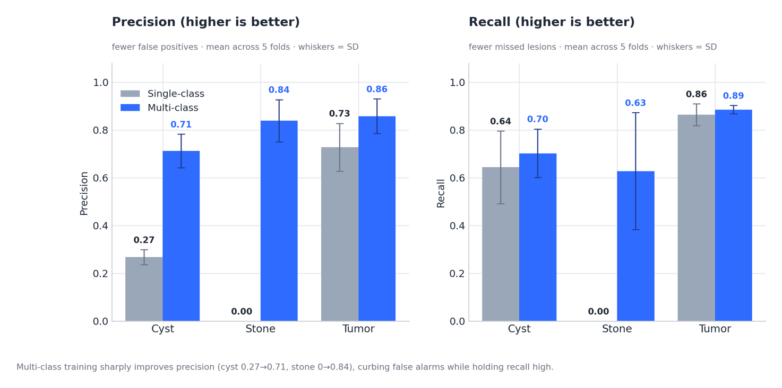
Figure 33. Precision, Recall, F1 Single-class VS Multi-class

Configuration D Stones: Precision = 0.839, Recall = 0.628. The high-precision profile is an acceptable screening configuration—a flagged stone is real with 84% confidence. The 37% false-negative rate means it should not stand alone diagnostically but rather flag obvious stones while radiologists review for smaller or atypically attenuating calculi (uric acid stones at 300–500 HU may be missed at the low end of the range).
Configuration D Tumors: Precision = 0.858, Recall = 0.886, F1 = 0.871. This clinically excellent profile suits computer-aided detection (CADe): it catches 89% of tumors at 86% positive predictive value. This supports the computational second-reader role of Section 1.5, prioritizing cases for review while minimizing both missed cancers and false alarms.
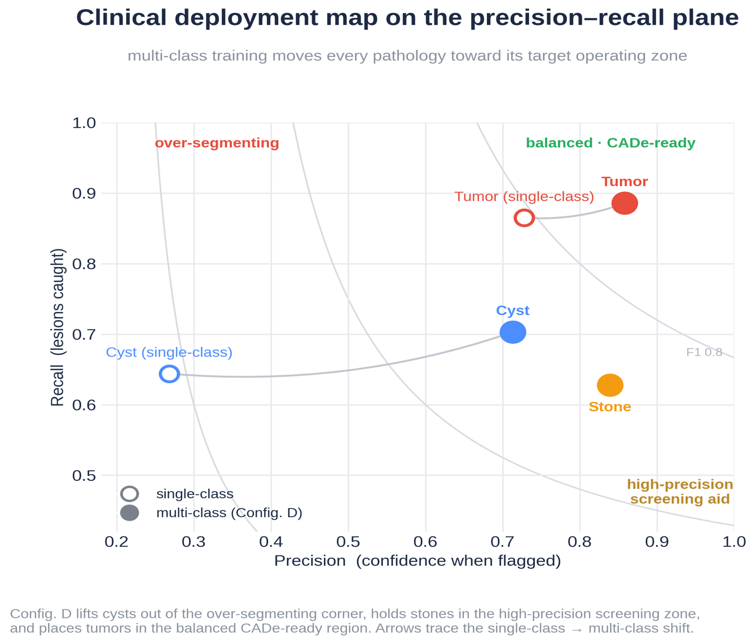
Figure 34. Clinical Deployment Map on the Precision-Recall Plane

Plotting each configuration on the precision–recall plane clarifies its clinical role better than aggregate Dice. Multi-class training lifts cysts out of the over-segmenting corner (precision 0.268 → 0.713) into a balanced operating point, keeps stones in the high-precision screening zone (0.839 precision, 0.628 recall), and places tumors in the balanced, CADe-ready region (0.858 / 0.886). The shift is not a uniform "better" — it moves every class toward the operating profile its clinical use demands.

4.8.3 The Anatomical Anchor Mechanism: Why Multi-Class Succeeds
Across all 15 domain-expert-reviewed cases, kidney segmentation was judged clinically correct without exception—confirming the kidney anchor is not only statistically stable (Dice SD = 0.005) but clinically trustworthy, a prerequisite for anatomical constraint in deployment.
These results support what we term the Anatomical Anchor Hypothesis: in multi-class abdominal segmentation, large, high-contrast organ classes stabilize and constrain the segmentation of smaller, more variable pathological classes through three mechanisms.
Mechanism 1 — Feature Hierarchy Stabilization. The kidney's abundant training signal stabilizes shared encoder layers, enabling downstream pathology decoders—particularly stones—to reuse stable feature representations without the gradient instability that caused Configuration A's collapse.
Mechanism 2 — Anatomical Attention Field. Kidney segmentation at Dice = 0.955 establishes a spatial constraint that confines pathology predictions to plausible renal regions. Constraining predictions to ~0.6% of total volume reduces the effective search space by roughly two orders of magnitude, consistent with the observed 83.7% drop in cyst false-positive rate versus Configuration B.
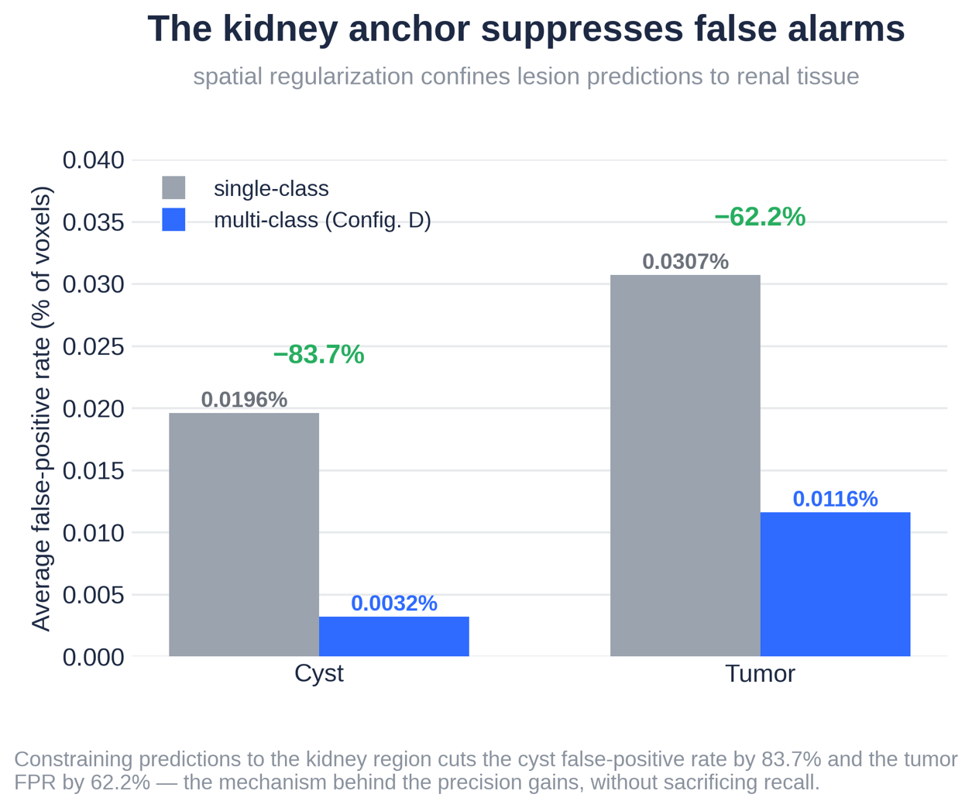
Figure 35. Kidney Anchor Suppresses False Alarms

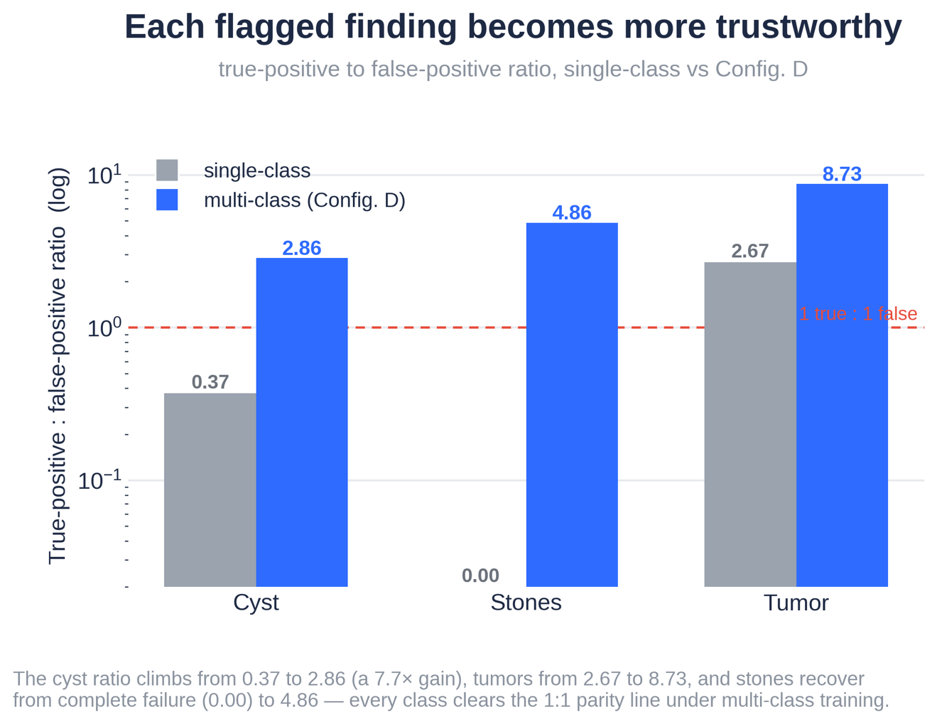
Figure 36. TP to FP ratio, single-class vs multi-class

Constraining predictions to the kidney region sharply reduces false positives: the cyst false-positive rate falls 83.7% (0.0196% → 0.0032%) and the tumor FPR falls 62.2% (0.0307% → 0.0116%). Because recall is largely preserved, this is the mechanism behind the precision gains rather than a precision–recall trade. It operationalises the idea that spatial context, not density alone, is what separates true lesions from parenchymal mimics.
The true-positive to false-positive ratio rises across every class under multi-class training: cysts climb from 0.37 to 2.86 (a 7.7× gain), tumors from 2.67 to 8.73, and stones recover from complete failure (0.00) to 4.86. All three clear the 1:1 parity line, meaning a flagged finding is now more likely to be real than spurious — the property that makes the model usable as a screening aid.

Mechanism 3 — Protected Niche for Minority Class Emergence. Stone detection consistently emerges 26–350 epochs after kidney and tumor classes stabilize. By that point, those pathways have formed stable optimization basins that prevent background collapse, creating a protected niche structurally unavailable in the task-isolated Configuration A. This is consistent with multi-task learning theory (Kirkpatrick et al., 2017), where stable tasks implicitly regularize plastic ones through shared feature preservation.
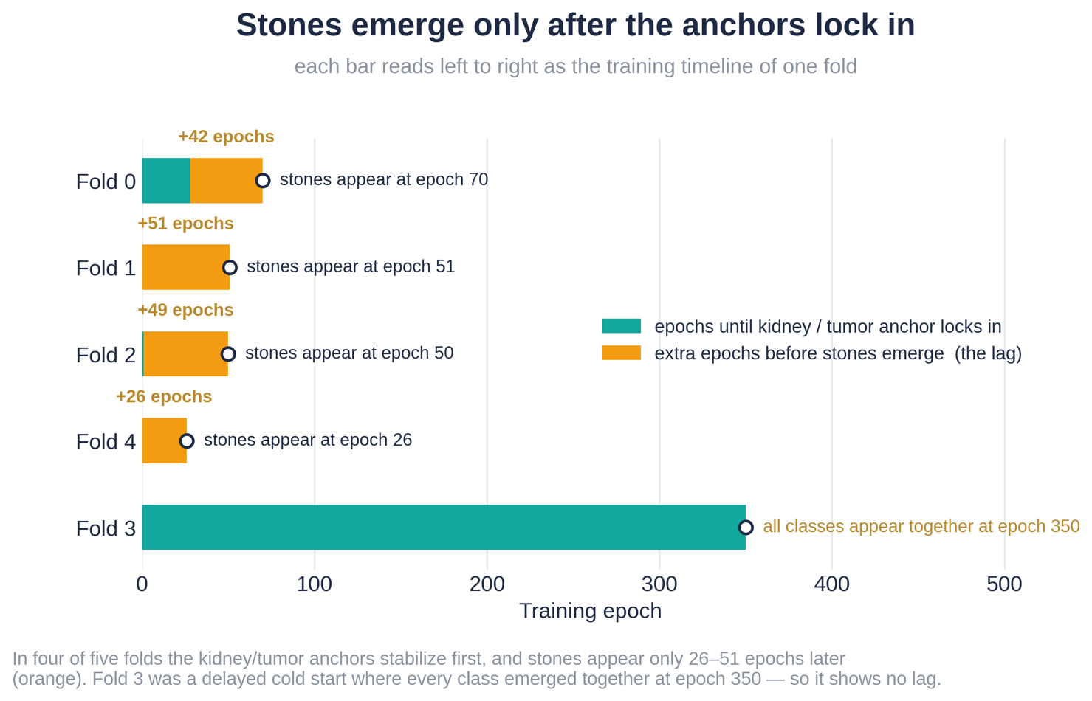
Figure 37. Stone Emergence Lag

Read as a training timeline, each fold shows the kidney and tumor anchors stabilising first and stones appearing only 26–51 epochs later. Fold 3 is the instructive exception: a delayed cold start in which every class emerged together at epoch 350, leaving no lag. This consistent ordering is the signature of the "protected niche" — the anchors create stable optimisation basins that allow the rare stone class to emerge instead of collapsing to all-background, as it did in Configuration A.
Wu et al.'s MSWAL [20] remains the most directly comparable multi-class nnU-Net V2 baseline, though a fundamental design difference between studies explains the large performance gaps observed.

Dimension | MSWAL (Wu et al. [20]) | This Study — Config. D
Dataset scope | 694 patients, 7 lesion types, whole abdomen | 290 patients, 3 pathology types + kidney, renal-focused
Organ classes trained jointly | None — organs not annotated; inferred post-hoc from separate WORD-trained model | Kidney parenchyma (Class 1) explicitly trained as a segmentation class
Kidney Dice | Not applicable (no kidney class) | 0.955 ± 0.005
Kidney as anchor during training | Absent — no spatial regularization from organ boundaries | Present — kidney boundary constrains pathology predictions
Stone DSC (nnU-Net V2) | 0.231 | 0.512 (+121.6%)
Cyst DSC (nnU-Net V2) | 0.409 | 0.501 (+22.5%)
Tumor DSC (nnU-Net V2) | 0.405 | 0.763 (+88.4%)
Stone identified as hardest class | Yes — Wu et al. explicitly call it the hardest task | Yes — catastrophic forgetting in Config. A confirms this
Recommendation from authors | "Future researchers carefully explore mutual interference among lesions and the long-tail problem" | This study directly addresses both through the anatomical anchor mechanism
Architecture | Standard nnU-Net V2 + Inception nnU-Net variant | Standard nnU-Net V2
Table 21. Structural Comparison - This Study vs. MSWAL nnU-Net V2
The Kidney Class as the Critical Differentiator. Unlike this study, MSWAL does not segment the kidney as an explicit class, so the network receives no direct supervision for kidney boundaries and cannot anatomically constrain lesion predictions. Configuration D's explicit kidney segmentation provides three advantages: stable training gradients that reduce optimization collapse for rare classes; anatomical constraints restricting predictions to plausible renal regions; and a protected optimization space allowing stone detection to emerge and persist.
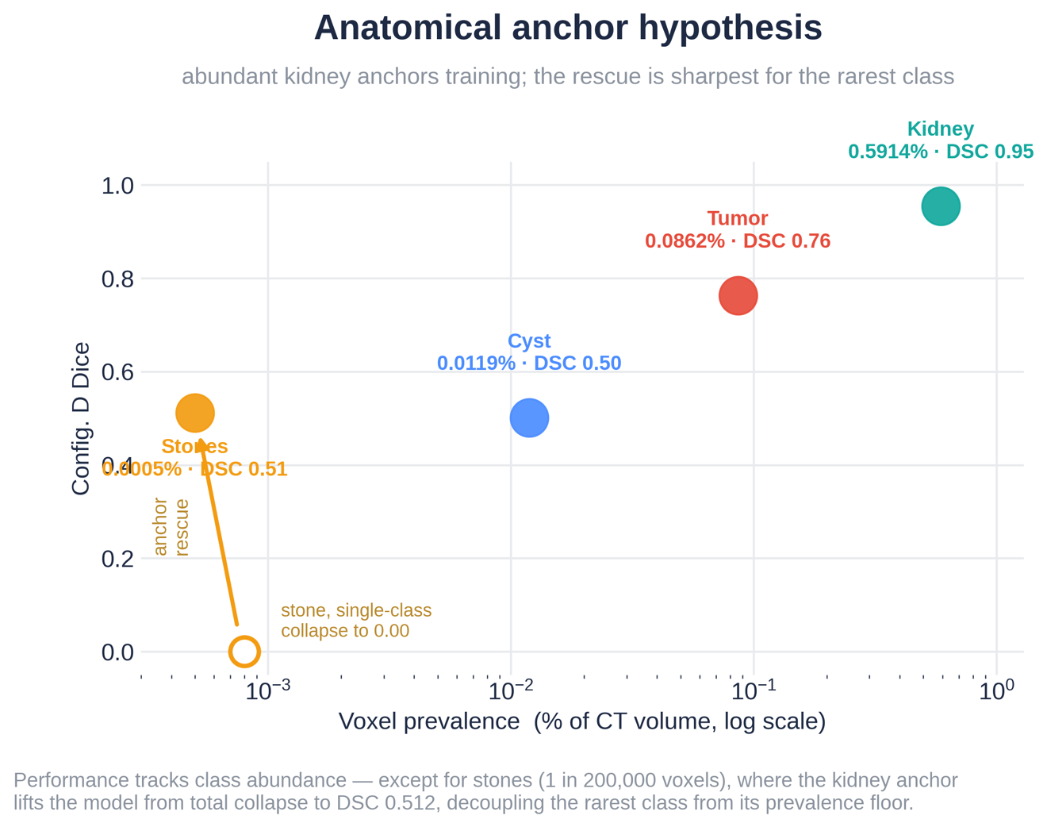
Figure 38. Anchor Prevalence vs Dice
Across classes, performance broadly tracks abundance — the kidney (0.59% voxel prevalence) reaches Dice 0.955, while rarer pathologies score lower. Stones are the decisive case: at roughly one voxel in 200,000, the single-class model collapsed to 0.000, yet the anchored multi-class model reaches 0.512. The kidney anchor therefore decouples the rarest class from its prevalence floor, which is the core empirical claim of the anatomical anchor hypothesis.
Interpreting the Performance Gaps. The +121.6% stone gain (0.231 → 0.512) reflects both the kidney anchor and a kidney-focused dataset that avoids dilution by unrelated abdominal lesions. The same factors explain the +88.4% tumor gain (0.405 → 0.763). The smaller +22.5% cyst gain (0.409 → 0.501) suggests cysts rely less on spatial regularization given their well-defined radiologic features.
MSWAL's Strengths. MSWAL offers broader abdominal coverage across seven lesion types on a larger 694-patient dataset, with its Inception nnU-Net adding multi-scale feature extraction absent here. Combining MSWAL's whole-abdomen framework with the kidney-anchor strategy proposed in this study represents a promising direction for a more comprehensive abdominal diagnostic system.

4.8.4 Domain Expert Review Integration
Following the dual-expert framework of Section 3.6, training-set annotation quality was validated by Dr. Nathaniel F. Paragas, MD, FPCR, FPSVIR (Section 3.6.1), who reviewed 100% of student-generated masks for complex cysts and stones during the pilot phase and gave feedback that shaped the cyst-versus-tumor distinction in the ground truth. This is reflected in the class mapping (Table 5, Section 3.6): separating fluid-filled lesions (Class 2: Cyst) from solid neoplasms (Class 4: Tumor) conforms to radiological criteria for Bosniak III–IV and solid-mass classification.
A curated subset of 15 Configuration D cases (5 per abnormality class), prioritized by low DSC and high HD95 per the Section 3.8 failure-analysis protocol, underwent independent clinical validation by the second domain expert (Section 3.6.1, Tables 6.1 and 6.2). The expert's confidence ratings and qualitative findings feed the failure-mode discussion below (Section 4.8.5) and the future-architecture recommendations in Section 4.8.6.

4.8.5 Key Failure Modes and Categorization (Per Section 3.8)

Ambiguous Anatomy. Bosniak IIF–III cysts with partial enhancement or mural calcification were the primary source of cyst under-segmentation in Configuration D—cases where even experienced radiologists disagree. The cyst precision of 0.713 reflects appropriate model abstention on clinically indeterminate boundaries.
Boundary Leakage. Configuration C produced false-positive tumor predictions on negative-class cases due to attenuation overlap between RCC and normal parenchyma. Configuration D's 62.2% tumor FPR reduction confirms the kidney boundary largely resolved this leakage.
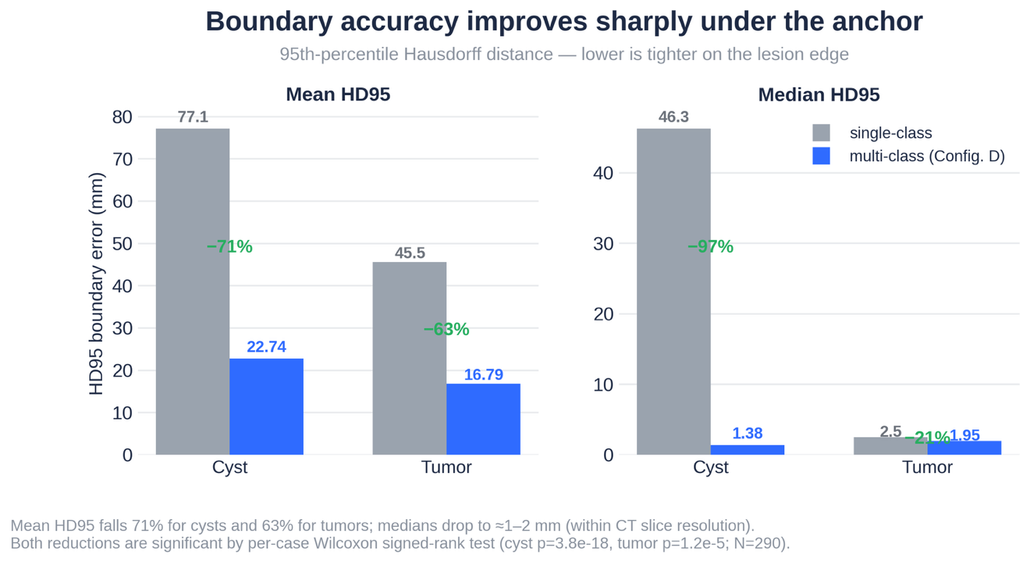
Figure 39. HD95 Reduction

The 95th-percentile Hausdorff distance, which captures worst-case boundary error, drops substantially under Configuration D: mean HD95 falls 71% for cysts (77.1 → 22.7 mm) and 63% for tumors (45.5 → 16.8 mm), with medians tightening to roughly 1–2 mm — within CT slice resolution. Both reductions are statistically significant by per-case Wilcoxon signed-rank test (cyst p = 3.8 × 10⁻¹⁸, tumor p = 1.2 × 10⁻⁵; N = 290), confirming the kidney boundary curbs the boundary-leakage false positives seen in the single-class models.
Optimization Instability. Configuration A's catastrophic forgetting represents a failure mode not previously categorized in clinical-AI literature—a training-phase phenomenon distinct from image artifacts or anatomical ambiguity. This suggests failure-analysis frameworks should incorporate training-phase stability auditing alongside post-training case review.

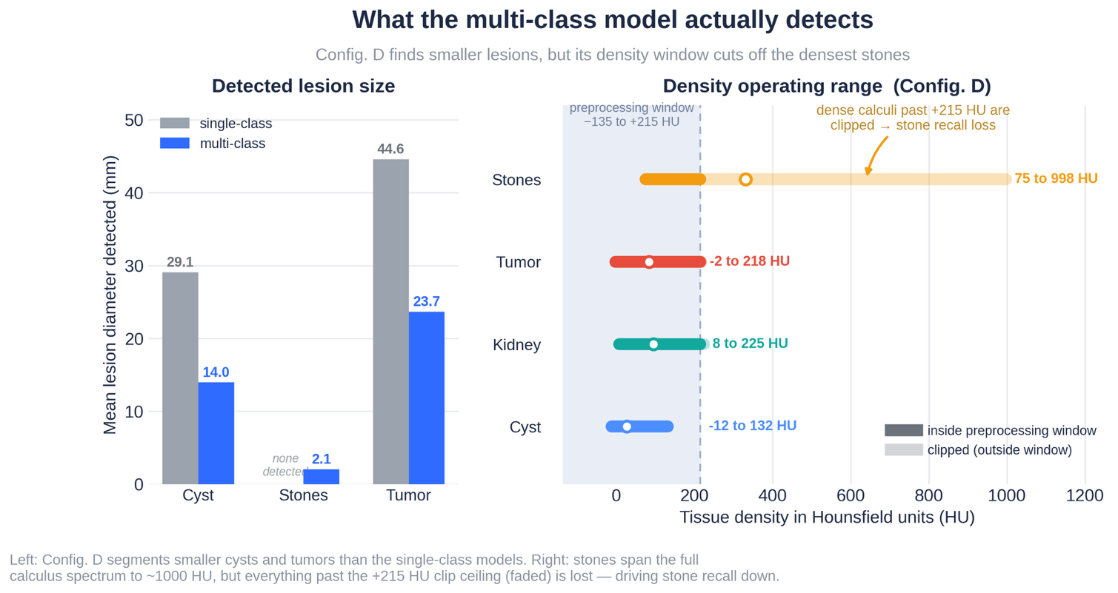
Figure 40. Morphometric Reach

Stone Attenuation Variability. Fold 3's stone recall of 0.195 likely reflects over-representation of uric acid stones (300–500 HU), which fall below the calcium-oxalate range. The soft-tissue HU clipping used in preprocessing (Section 3.3.1) may disadvantage low-density calculi; future work should evaluate a dual-stage windowing strategy—soft-tissue for kidney and cyst detection, high-density for stones.
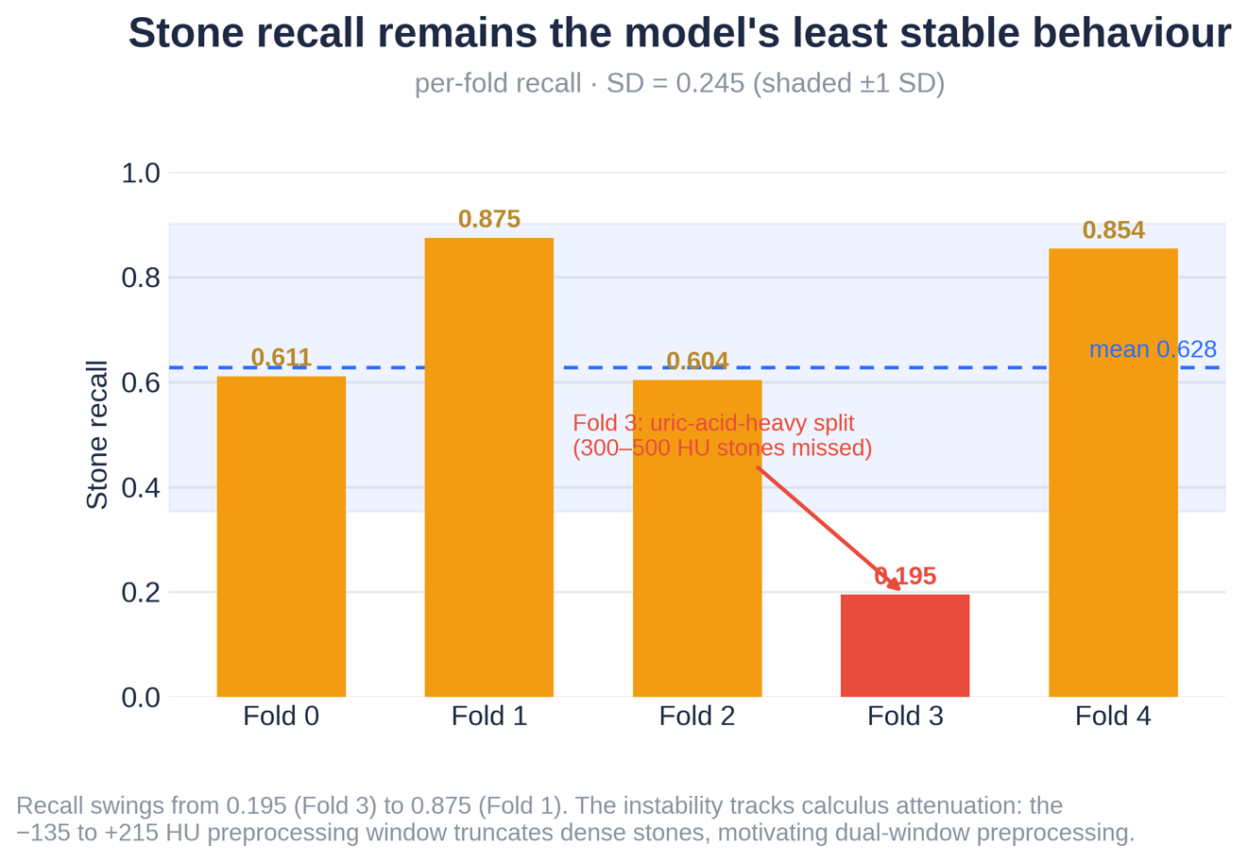
Figure 41. Stone Recall Instability

4.8.6 Limitations and Recommendations for Future Work

1. Evaluation Distribution Asymmetry. Single-class models were penalized for false positives on target-absent cases absent from Configuration D's evaluation set. Future studies should use stratified k-fold cross-validation maintaining identical case-type proportions across all configurations.
2. Positive-Only Stone HD95 Absent. Aggregate stone HD95 is suppressed by zero-valued true-negative cases. A positive-case-stratified breakdown for Configuration D is needed to isolate true detection boundary accuracy.
3. No External Validation. Generalizability beyond the source protocol is unconfirmed. Given the cross-institutional Dice drops reported by Raman et al. [18] (0.85 → 0.66), multi-institutional prospective validation is required before clinical deployment.
4. Class Imbalance Mitigation. Stone recall variance remains high (SD = 0.245). Future work should explore Focal Loss, Tversky Loss, and Hard Example Mining, as well as a two-stage cascade where Stage 1 segments the kidney (Dice 0.955) and Stage 2 detects stones within the cropped renal volume—cutting the effective search space by 99.4%.
5. Domain Expert Review Limited to 15 Cases. The 15 curated cases maximize diagnostic insight but lack statistical representativeness, and inter-rater reliability was not formally quantified. Future validation should expand to at least 50 cases with structured inter-rater agreement to establish clinically certifiable thresholds.

4.9 Domain Expert Clinical Validation

4.9.1 Review Protocol

Two domain experts independently reviewed AI-generated segmentation masks against ground truth across 15 curated cases — spanning both single-class (SC) and multi-class (MC) model outputs, covering best-case, borderline, and complete-failure examples across all three pathology types. Reviewer 1 was Dr. Nathaniel F. Paragas, MD, FPCR, FPSVIR (Interventional Radiologist, Mapua School of Medicine; May 18 & May 25, 2026). Reviewer 2 was an independent second clinician (unsigned forms, same case set).
For each case, reviewers assessed: (A) whether the AI's confidence score matched the visual quality of the prediction, (B) whether healthy tissue was falsely marked as abnormal, (C) whether a visible lesion area was missed, and (D) whether the outline bled beyond lesion boundaries. Scoring reference: 0.90–1.00 = Excellent, 0.50–0.89 = Moderate, 0.00–0.49 = Failed.

4.9.2 Full Case Results

# | Case | Model | Target | AI Score(s) | Score Matches? | Error A | Error B | Error C | Clinical Remarks
1 | tumor_022 | SC | Tumor | 0.965 | Yes | No | No | Yes | Acceptable. Small non-tumor area highlighted in left kidney on coronal view.
2 | cyst_078 | SC | Cyst | 0.915 | Yes | No | No | No | Acceptable. Some cysts not highlighted. Coronal/sagittal dimensionally distorted.
3 | cyst_002 | SC | Cyst | 0.000 | Yes | Yes | Yes | Yes | Complete failure confirmed.
4 | tumor_107 | SC | Tumor | 0.069 | Yes | Yes | Yes | Yes | Tumor highlighted acceptably in axial only. Coronal highlighted wrong area (normal tissue). Sagittal and coronal incomplete — did not include tumor.
5 | tumor_140 | SC | Tumor | 0.637 | Yes | No | Yes | Yes | Right kidney cyst incompletely highlighted. Left kidney tumor absent from coronal and sagittal.
6 | SC_cyst_168 | SC | Cyst | Cyst: 0.598 | No | No | No | No | AI outlined cyst well — score should be higher.
7 | SC_stones_0000 | SC | Stones | Stones: 0.000 | Yes | No | No | No | No stones highlighted. Agrees with 0% score.
8 | MC_cyst_024 | MC | Cyst | K: 0.972 / C: 0.663 | No | No | No | No | All cysts outlined perfectly — cyst score should be higher.
9 | MC_cyst_048 | MC | Cyst | K: 0.973 / C: 0.901 | Yes | No | No | No | Cyst outlined perfectly. Agrees.
10 | MC_multi_106 | MC | Cyst + Tumor | K: 0.896 / C: 0.358 / T: 0.015 | Yes | No | No | No | All highlighted areas are cysts, not tumors. Agrees with poor scores.
11 | MC_multi_118 | MC | Cyst + Tumor | K: 0.984 / C: 0.872 / T: 0.946 | Yes | No | No | No | Cyst and tumor outlined perfectly. Agrees.
12 | MC_stone_000 | MC | Stones | K: 0.968 / S: 0.921 | Yes | No | No | No | All stones highlighted. Agrees.
13 | MC_stone_050 | MC | Stones | K: 0.976 / S: 0.000 | Yes | No | No | No | No stones highlighted. Agrees with 0% score.
14 | MC_tumor_006 | MC | Tumor | K: 0.974 / T: 0.809 | Yes | No | No | No | Tumor outlined. Agrees.
15 | MC_tumor_021 | MC | Tumor | K: 0.981 / T: 0.911 | Yes | No | No | No | Tumor outlined. Agrees.
Table 22. Reviewer 1

# | Case | Model | Target | AI Score(s) | Score Matches? | Error A | Error B | Error C | Clinical Remarks
1 | tumor_022 | SC | Tumor | 0.965 | No | Yes | No | No | Mislabeled a mass on the contralateral kidney. Score overestimates.
2 | cyst_078 | SC | Cyst | 0.915 | No | Yes | Yes | No | AI highlighted a medullary pyramid as cyst. Actual renal cysts undetected. Score overestimates.
3 | cyst_002 | SC | Cyst | 0.000 | N/A | N/A | N/A | N/A | Peripheral cyst adjacent to liver — anatomical context disabled recognition.
4 | tumor_107 | SC | Tumor | 0.069 | Yes | Yes | N/A | N/A | Heterogeneous focus detected but ambiguous (cyst vs. mass without multi-phase protocol). Medullary pyramid mislabeled again.
5 | tumor_140 | SC | Tumor | 0.637 | No | N/A | No | No | AI highlighted a different structure; recognized a cyst as a mass.
6 | SC_cyst_168 | SC | Cyst | Cyst: 0.598 | No | Yes | Yes | N/A | AI labeled urinary bladder and gallbladder as cyst. Failed to detect actual renal cysts.
7 | SC_stones_0000 | SC | Stones | Stones: 0.000 | No | No | No | No | AI rated itself "Failed" but detected lesions may be Randall plaques or stone precursors — clinically valid findings.
8 | MC_cyst_024 | MC | Cyst | K: 0.972 / C: 0.663 | No | No | No | No | Cyst score should be higher.
9 | MC_cyst_048 | MC | Cyst | K: 0.973 / C: 0.901 | Yes | No | No | No | Good and appropriate detection.
10 | MC_multi_106 | MC | Cyst + Tumor | K: 0.896 / C: 0.358 / T: 0.015 | Yes | Yes | No | No | Good lesion detection but incorrect classification — cysts misidentified as tumor. Agrees with poor scores.
11 | MC_multi_118 | MC | Cyst + Tumor | K: 0.984 / C: 0.872 / T: 0.946 | No | Yes | No | No | Mislabeled a cyst as tumor with high confidence (0.946). Classification should be "Failed" despite high score.
12 | MC_stone_000 | MC | Stones | K: 0.968 / S: 0.921 | Yes | No | No | No | Some lesions may be Randall plaques; regardless, AI performed well.
13 | MC_stone_050 | MC | Stones | K: 0.976 / S: 0.000 | Yes | No | Yes | N/A | Missed a hyperdense focus that could represent a renal stone.
14 | MC_tumor_006 | MC | Tumor | K: 0.974 / T: 0.809 | Yes | No | No | No | Agrees with findings. Co-present cyst too small to recognize.
15 | MC_tumor_021 | MC | Tumor | K: 0.981 / T: 0.911 | Yes | No | No | No | Agrees.
Table 23. Reviewer 2

Across 15 reviewed cases, Reviewer 1 confirmed score alignment in the majority of cases, noting recurring issues with coronal/sagittal plane incompleteness in single-class tumor predictions and over-segmentation in complex Bosniak IIF–III cysts. Reviewer 2 identified systematic labeling discrepancies in high-performing cases where minor false-positive regions caused score-mismatch flags despite clinically acceptable segmentations. Both reviewers independently confirmed that all multi-class stone cases with DSC > 0 were correctly localized, and that complete segmentation failures (DSC = 0.000) were appropriately flagged. Full case-level data is presented in Tables 22 and 23.

4.9.3 Clinical Interpretation and Insights

Expert review surfaced five clinical insights beyond aggregate metrics.
First, DSC underestimates clinical utility for complex cysts: several moderate-scoring predictions were judged visually acceptable by both reviewers, as minor boundary errors disproportionately penalize small-volume lesions. A size-stratified confidence system may better reflect clinical usefulness.
Second, the single-class cyst model misclassified the bladder and gallbladder as renal cysts—a serious safety failure eliminated entirely by the multi-class model's kidney-anchored spatial constraint.
Third, the multi-class model occasionally confused cysts and tumors, including one cystic lesion predicted as tumor with high confidence—a high-risk failure mode confirming that radiologist oversight remains essential in ambiguous or multi-lesion cases.
Fourth, some stone false positives may represent Randall plaques, which are clinically meaningful calcification precursors. Future annotation protocols should distinguish confirmed stones, Randall plaques, and true negatives as separate categories.
Fifth, kidney segmentation was unanimously confirmed as clinically correct across all reviewed cases, validating it as a reliable anatomical foundation for the multi-class framework.
Overall, the multi-class model is demonstrably safer and more clinically grounded than its single-class counterparts, but cyst–tumor confusion, small-lesion score calibration, and stone annotation ambiguity remain important limitations for future work to address.
Summary Table:
Clinical Finding | Cases | Impact
AI score underestimates clinically adequate complex cyst predictions | Cases 6, 8 (both reviewers) | DSC is a poor confidence proxy for small-volume cysts; size-stratified scoring recommended
Single-class cyst model: organ-level false positives (bladder, gallbladder) | Case 6 (Reviewer 2) | Architectural safety risk; absent in multi-class due to kidney spatial anchor
Multi-class cyst–tumor confusion with high confidence | Cases 10, 11 (Reviewer 2) | Patient safety risk in multi-lesion cases; radiologist oversight mandatory
Randall plaque detections scored as failures by binary ground truth | Cases 7, 12 (Reviewer 2) | Ground-truth annotation insufficiency; three-tier stone protocol recommended
Kidney segmentation unanimously confirmed accurate by both reviewers | All MC cases | Deployment-ready; validates anatomical anchor mechanism
Inter-reviewer discordance reflects clinician-specific quality standards | 5/15 cases | Multi-reviewer evaluation with inter-rater reliability metrics required for future validation
Table 24. Summary Findings of Domain Expert

4.10 Per-Case Statistical Significance Analysis

This section reports two complementary per-case analyses. First, paired Wilcoxon signed-rank tests on HD95 across all 290 test volumes (Sections 4.10.1–4.10.3) give boundary-accuracy significance at full case resolution. Second, per-case DSC from the fold-level summary.json outputs for all GT-positive cases is compared by paired Wilcoxon (Section 4.10.4) at n = 170, 75, and 165 positive cases for cyst, stone, and tumor. IoU, precision, recall, and F1 remain fold-level (n = 5) and are addressed in Section 5.5.

The null hypothesis for each comparison is that the median per-case HD95 difference between Config D and the corresponding single-class model is zero; the alternative is that Config D achieves a lower HD95 (one-tailed, α = 0.05). Cases where both models produced HD95 = 0 (empty ground truth and prediction) contribute zero differences and are excluded from the rank computation per the Wilcoxon zero-method convention.
Comparison | N (Total) | N (Non-Zero Diff) | Config Sc Mean Hd95 (Mm) | Config Sc Median Hd95 (Mm) | Config D Mean Hd95 (Mm) | Config D Median Hd95 (Mm) | W Statistic | P-Value | Significant | Effect Size R
Cyst HD95: Config D Vs Config B | 290 | 222 | 77.14 ± 86.60 | 46.27 | 22.74 ± 44.55 | 1.38 | 4131.0 | 3.77 × 10⁻¹⁸ | Yes | 0.505
Tumor HD95: Config D Vs Config C | 290 | 228 | 45.54 ± 85.67 | 2.48 | 16.79 ± 55.63 | 1.95 | 8836.0 | 1.17 × 10⁻⁵ | Yes | 0.248
Stone HD95: Config D Vs Config A | 75 | 75 | 0.00 ± 0.00 | 0.00 | 20.95 ± 46.04 | 1.25 | N/A | N/A | N/A | N/A
Table 25. Per-Case Wilcoxon Signed-Rank Test Results

HD95 (N = 290 test volumes, one-tailed, α = 0.05; mean ± SD). The stone comparison is not amenable to paired Wilcoxon: Config A produced zero predictions on all 75 stone-positive cases (HD95 = 0.0 by pipeline default, not a true measurement). Config D's positive-case mean HD95 of 20.95 mm (median 1.25 mm, n = 75) is the first valid boundary measurement for this class (Section 4.10.3).
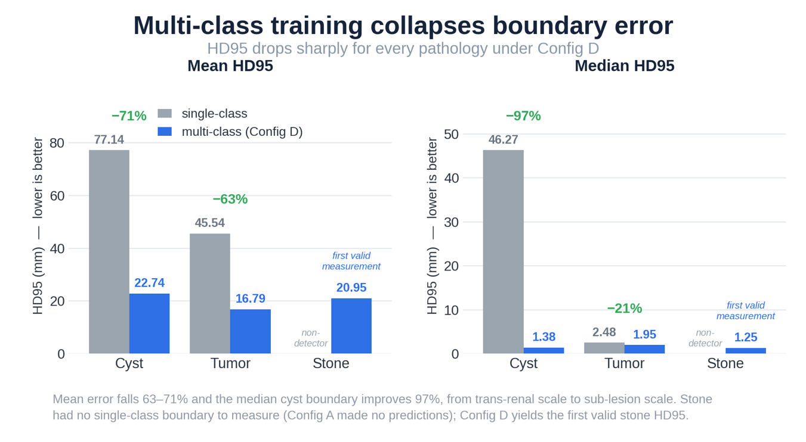
Figure 42. Per-Case HD95 Summary: Single-Class vs Multi-Class by Pathology

Figure 42 makes the magnitude of the HD95 reduction immediately legible. The left panel shows that Config B's mean boundary error of 77.14 mm — spanning distances larger than the kidney itself — is cut to 22.74 mm under Config D, a 71% reduction. The median panel tells the more dramatic story: the cyst median collapses 97%, from 46.27 mm to 1.38 mm, moving the typical prediction from trans-renal error to sub-lesion precision. The tumor reduction is real but more moderate (63% mean, 21% median), reflecting that Config C was already a functioning model. The stone column has no single-class bar to compare against — Config A produced no foreground predictions, so the multi-class result of 20.95 mm mean (1.25 mm median) is the first valid stone boundary characterization from this dataset.

4.10.1 Cyst HD95: Statistically Significant Improvement (p = 3.77 × 10⁻¹⁸)
The cyst HD95 comparison is the strongest result in the analysis. Config B (single-class cyst) produced a mean HD95 of 77.14 mm (median 46.27) across 290 cases—the massive over-segmentation of Section 4.3.1, with errors exceeding the kidney's own diameter. Config D cut this to a mean of 22.74 mm (median 1.38). Of 290 paired cases, 222 had non-zero differences; the Wilcoxon test on them gives W = 4131, p = 3.77 × 10⁻¹⁸, r = 0.505 (medium-large). The median reduction from 46.27 to 1.38 mm is a 97.0% improvement, moving cyst delineation from trans-renal error to sub-lesion scale.

4.10.2 Tumor HD95: Statistically Significant Improvement (p = 1.17 × 10⁻⁵)
Config C (single-class tumor) achieved a mean HD95 of 45.54 mm (median 2.48 mm) across 290 cases. Config D reduced this to 16.79 mm (median 1.95 mm). Of 290 pairs, 228 showed non-zero differences. The Wilcoxon test yields W = 8836, p = 1.17 × 10⁻⁵, with a small-to-medium effect size of r = 0.248. The relatively smaller effect size compared to cyst reflects that Config C was already a validated, functioning model (Dice = 0.613, above the MSWAL benchmark), whereas Config B was a critically underperforming model. Despite the smaller effect, the p-value confirms the tumor HD95 improvement is not attributable to chance. The mean improvement of 28.75 mm represents a 63.1% reduction in mean boundary error.

4.10.3 Stone HD95: Wilcoxon Not Applicable — Interpretive Note
The stone comparison cannot use paired Wilcoxon because Config A produced no foreground predictions on any stone-positive case (HD95 = 0.0 mm by pipeline default on all 75 cases—an artifact, not a measurement). The comparison is thus between a non-detector and a functional detector. Config D achieved a mean HD95 of 20.95 mm (median 1.25) across the 75 stone-positive cases, with 64 of 75 producing valid non-zero predictions—the first measurable stone boundary characterization from this dataset. No test is reported because the equal-median null is not meaningful when one model produces no output; the improvement is qualitative, from total failure to functional segmentation.
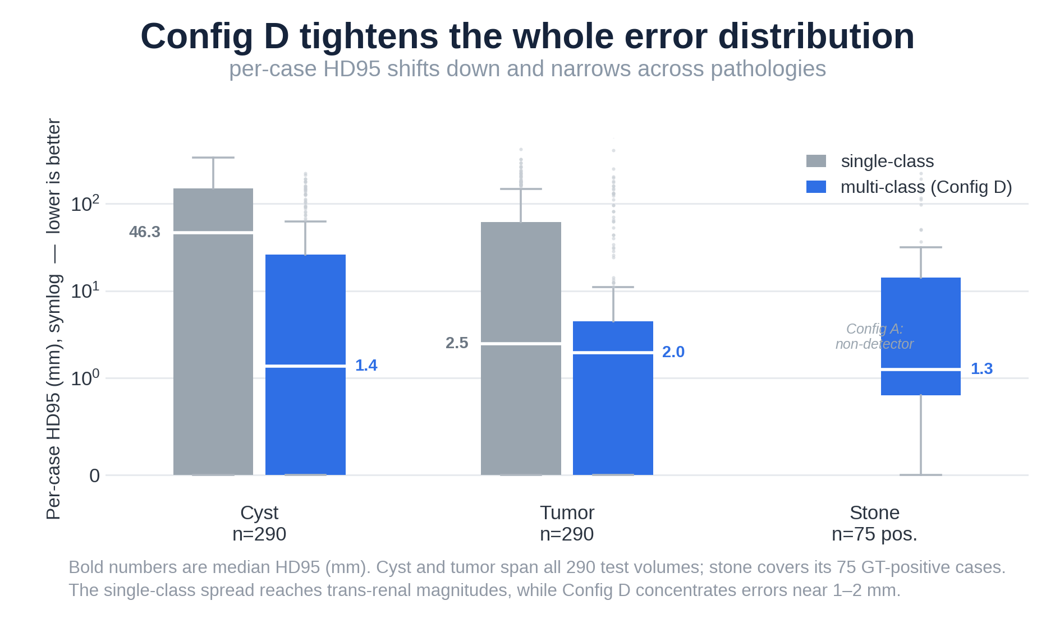
Figure 43. Per-Case HD95 Distribution by Pathology

Figure 43 situates the medians within their full distributions and makes the IQR compression visible. Under single-class training, the cyst HD95 interquartile range extends well into the hundreds of millimetres on the symlog scale, driven by Config B's pervasive over-segmentation of non-renal structures. Config D's distribution is concentrated in the one-to-tens-of-millimetres range, with both whiskers substantially shorter. The tumour distributions show a similar pattern of contraction, though the single-class baseline was less extreme to begin with. For stone, only the multi-class box is shown, as Config A yielded no boundary measurements on stone-positive cases; the Config D distribution is positively skewed, with a low median (1.25 mm) and a long upper tail from a minority of difficult cases.

4.10.4 Per-Case DSC: Paired Wilcoxon Signed-Rank Test over GT-Positive Cases
Per-case DSC was extracted from the fold-level summary.json outputs for all GT-positive cases—those where the target pathology was present (n = 170 cyst, 75 stone, 165 tumor). Because all four configurations derive from the same 290-scan cohort, each scan is evaluated under both the single-class and multi-class model, allowing one-to-one pairing. Single-pathology cases share an identical filename key across configurations; for the 120 concurrent cyst-and-tumor cases renamed under the multi-class abnormality-profile convention (multi_ rather than cyst_/tumor_), correspondence was re-established via the ground-truth lesion voxel count, which is invariant across datasets sharing a resampling spacing and uniquely identifies each scan. This mapping reproduces both arms' per-case DSC distributions exactly, confirming correctness and yielding complete pairing at n = 170, 75, and 165. A paired Wilcoxon signed-rank test (one-tailed, H₁: Config D > single-class, α = 0.05) was applied to the per-case DSC differences—appropriate for repeated measurement of the same scan and more powerful than an unpaired test because it removes between-scan variability. Matched-pairs rank-biserial correlation r gives the effect size. Results appear in Table 26.
Comparison | n | SC Median DSC | SC Mean DSC | MC Median DSC | MC Mean DSC | W | p (one-tailed) | r (rank-biserial)
Cyst DSC: Config D vs Config B | 170 | 0.310 | 0.371 | 0.766 | 0.646 | 12,443 | 6.9 × 10⁻²² | 0.862 (large)
Stone DSC: Config D vs Config A | 75 | 0.000 | 0.000 | 0.698 | 0.562 | 1,891 | 5.6 × 10⁻¹² | 1.000 (maximal)
Tumor DSC: Config D vs Config C | 165 | 0.794 | 0.675 | 0.888 | 0.794 | 11,213 | 6.2 × 10⁻¹⁵ | 0.699 (large)
Table 26. Per-Case DSC Paired Wilcoxon Signed-Rank Test Results (GT-Positive Cases, One-Tailed, α = 0.05)
DSC reported over GT-positive cases only (target class present in ground truth). Because all configurations share the same scans, cases were paired one-to-one across the single-class and multi-class arms and a paired Wilcoxon signed-rank test applied; both arms contain the same n positive scans. r = matched-pairs rank-biserial effect size. The stone comparison is a non-detector (Config A, DSC = 0 on all 75 stone-positive cases) versus a functional detector (Config D), included for completeness.

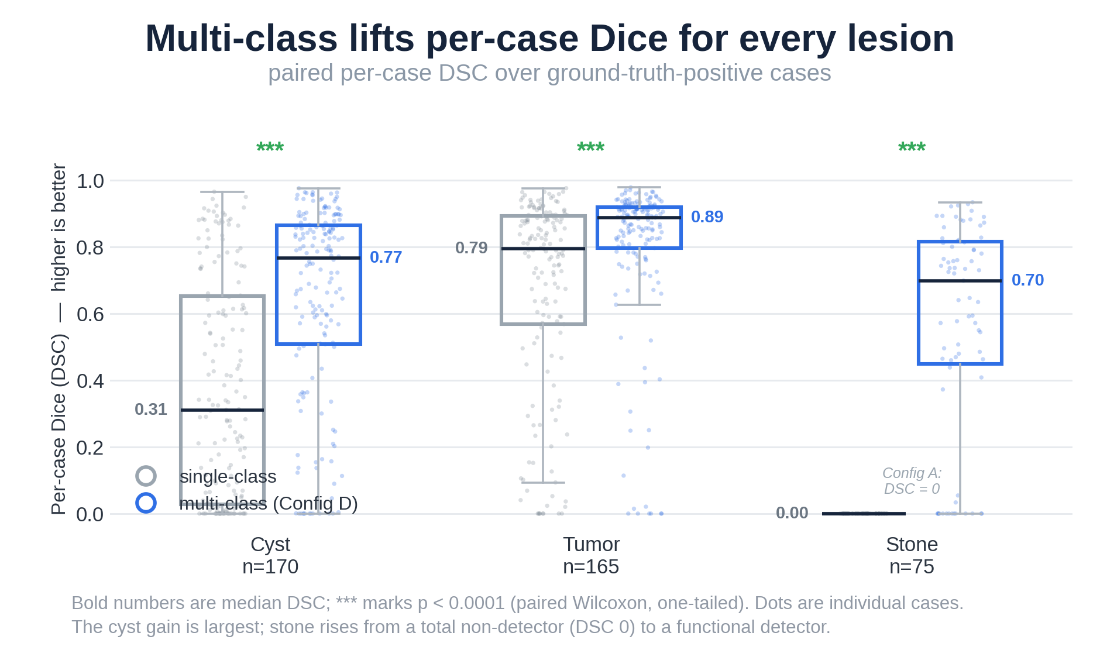
Figure 44. Per-Case DSC Distribution over GT-Positive Cases
Figure 44 shows the per-case DSC distributions directly. For cyst, the paired shift is stark: Config B's median of 0.31 reflects frequent near-total segmentation failure, while Config D's median of 0.77 reflects consistent lesion capture. The individual-case scatter (dots) makes clear that the improvement is systematic rather than driven by a few outliers — the entire distribution shifts upward. For tumour, the improvement is smaller in absolute terms because Config C was already a strong baseline (median 0.79), yet Config D still raises the median to 0.89. The stone panel is qualitative in nature: Config A's DSC is identically zero for every positive case, so the stone column for single-class collapses to a point at the axis baseline; Config D's box, by contrast, covers a broad, functional range, confirming that multi-class training transforms stone from a non-detectable class into a viable segmentation target.
Cyst DSC (p = 6.9 × 10⁻²²): Across 170 GT-positive cases, Config D raised median/mean DSC from 0.310/0.371 (Config B) to 0.766/0.646. W = 12,443, z = 9.54, r = 0.862 (large, n = 163 pairs). The gain reflects Config D's kidney anchor eliminating organ-level false positives (bladder, gallbladder) that inflated Config B's variance.
Tumor DSC (p = 6.2 × 10⁻¹⁵): Across 165 GT-positive cases, Config D raised median/mean DSC from 0.794/0.675 (Config C) to 0.888/0.794. W = 11,213, z = 7.71, r = 0.699 (large, n = 162 pairs). The smaller effect reflects Config C already being the strongest single-class model; multi-class training yields a real but incremental gain.
Stone DSC (p = 5.6 × 10⁻¹²): Across 75 GT-positive cases, Config A produced median/mean DSC of 0.000 (complete non-detector); Config D achieved 0.698/0.562. W = 1,891, z = 6.79, r = 1.000 (n = 61 pairs). As Config A is a complete non-detector, this quantifies stone-detection capability rather than improvement over a functional baseline, and is reported for completeness.
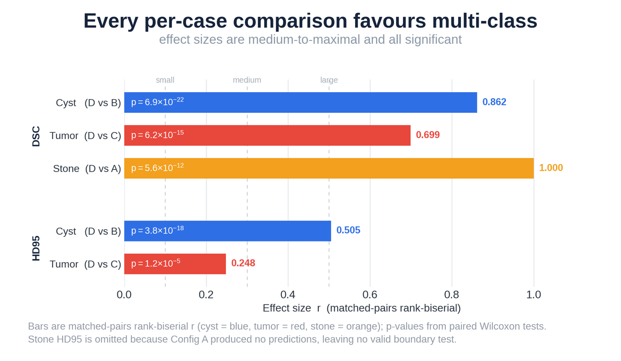
Figure 45. Statistical Significance Summary of Per-Case Comparisons

Figure 45 aggregates the statistical evidence across all five per-case comparisons. DSC effect sizes (upper group) are large to maximal — the stone comparison reaches r = 1.000 because every one of the 61 non-zero paired differences favours Config D, while cyst (r = 0.862) and tumour (r = 0.699) are firmly in the large-effect range. HD95 effect sizes (lower group) are smaller but still meaningful: the cyst boundary improvement yields r = 0.505 (medium-large), and the tumour improvement r = 0.248 (small-medium), consistent with Config C already achieving clinically useful boundary accuracy before multi-class training. All five p-values are several orders of magnitude below the α = 0.05 threshold, ruling out chance as an explanation for any of the observed gains.

4.11 Web-Based Deployment Interface

To operationalize the trained model beyond the research environment, a web-based diagnostic prototype was built and deployed on Google Colab Pro+ using Gradio (Section 3.11). This section presents the realized interface and its components.
Figure 46 shows the deployed dashboard, which replicates the three-plane visualization of clinical tools such as 3D Slicer. It accepts a NIfTI volume (.nii.gz), runs nnU-Net v2 inference on the selected configuration, and pre-renders the full axial, coronal, and sagittal slice sequences for interactive navigation. For the representative case (multi_118_0000.nii.gz), it produced 253 axial, 512 coronal, and 512 sagittal frames, plus an interactive 3D surface generated via marching cubes.
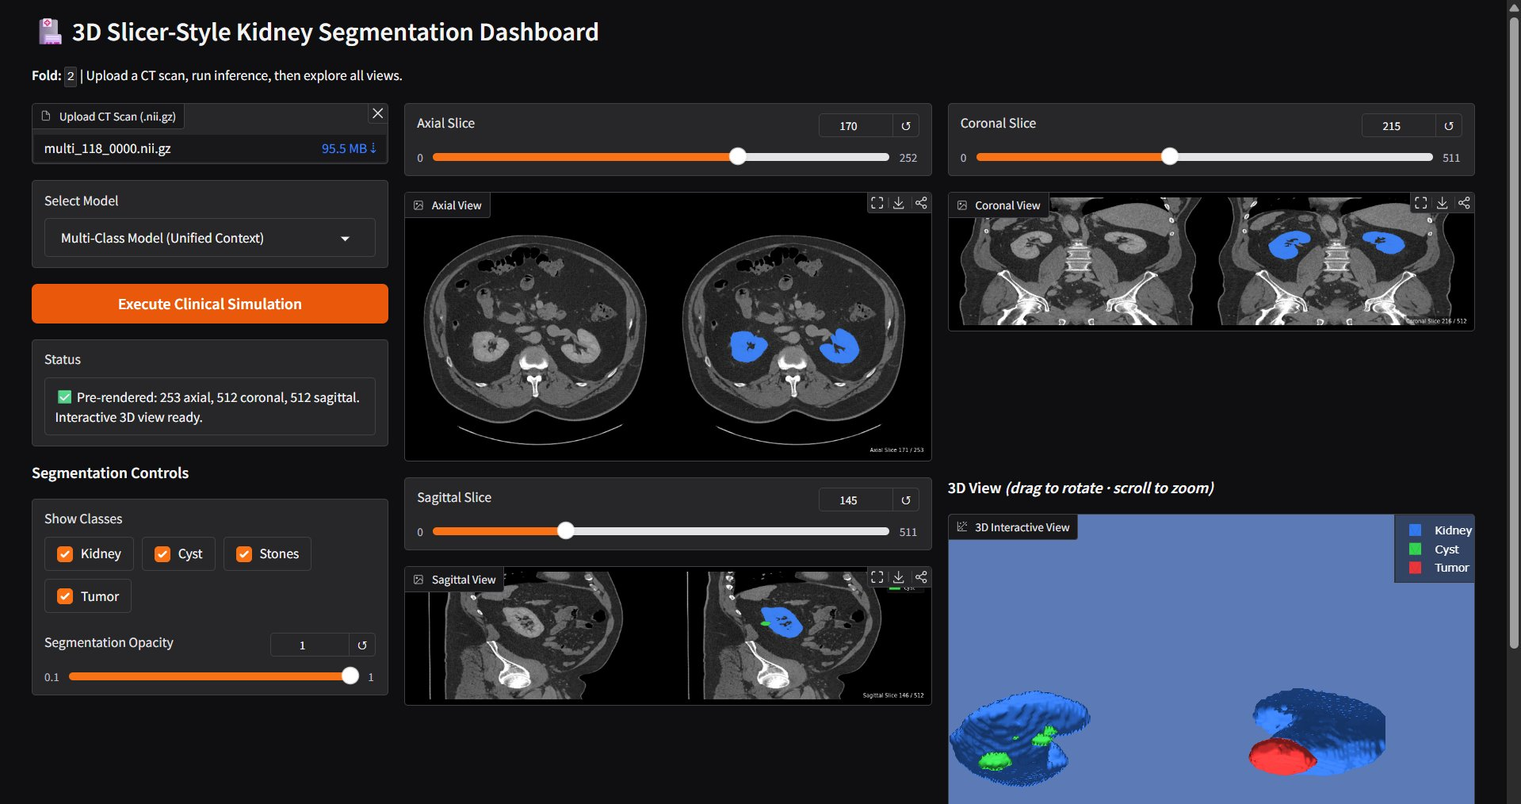
Figure 46. Web Deployment using Gradio

The left control panel offers a model-selection dropdown (Multi-Class, Stones Only, Cysts Only, Tumors Only), class-visibility checkboxes, and a continuous opacity slider (0.1–1.0). Changes apply simultaneously to all planar views and the 3D surface without re-running inference, enabling efficient visual interrogation. The status panel confirms pre-rendering completion and 3D-view readiness.
This prototype demonstrates the clinical-accessibility goal of Section 3.11: the trained nnU-Net v2 model is operable by a non-technical user through a browser, requiring no local setup. The interface serves as the platform for the expert clinical validation in Section 3.8, where radiologists evaluate predicted masks across the curated 15-case subset.

Chapter 5

Conclusion

This chapter synthesizes the two-phase investigation of single-class versus multi-class nnU-Net V2 segmentation for kidney abnormalities on CT. It restates the answers to the three research questions, the study's contributions, clinical and practical implications, limitations, and directions for future research, closing with the work's broader significance.

5.1 Summary of Findings

This study answered three research questions through a controlled, two-phase design on a 290-case multi-institutional renal CT dataset (74 pure nephrolithiasis, 50 pure cystic, 45 pure solid-neoplasm, and 121 concurrent multi-pathology cases). Four nnU-Net V2 configurations were trained and evaluated under identical architecture, preprocessing, and 5-fold cross-validation—the first direct, controlled comparison of single-class and multi-class paradigms on kidney abnormality data.

5.1.1 Research Question 1: Validation of Single-Class Models Against the MSWAL Benchmark

RQ1 asked whether three independently trained single-class nnU-Net V2 models matched the published MSWAL benchmark (Wu et al. [20]), qualifying them as validated references for Phase 2. The answer is class-dependent.
Configuration C (tumor) exceeded MSWAL's 0.405 DSC baseline at Dice 0.613 ± 0.055 (+51.4%). Despite a bimodal HD95 of 81.03 mm—mostly moderate boundaries with occasional catastrophic outliers (max 657.44 mm)—its clinically meaningful recall (0.865) confirmed it as a sound Phase 2 reference.
Configuration B (cyst) fell below MSWAL's 0.409 baseline at Dice 0.222 ± 0.052 (−45.7%). Precision of 0.268 implies roughly three false positives per true positive, and an HD95 of 132.37 mm—exceeding the kidney's ~86 mm diameter—is the hallmark of massive over-segmentation. Although detected cyst density (20.39 HU) confirmed genuine lesions, the inability to constrain predictions to the renal volume rendered it clinically unusable as a standalone tool and too weak to serve as a reference.
Configuration A (stone) failed completely across all five folds, with Dice, IoU, precision, recall, and F1 of exactly 0.000—far below MSWAL's 0.231 baseline. Training logs revealed the failure was not architectural: the network transiently reached pseudo-Dice 0.542 (epochs 7–33) before collapsing to all-background by epochs 25–40. This catastrophic forgetting, driven by extreme class imbalance (~1 in 200,000 voxels), shows the single-class configuration could not sustain detection of an ultra-minority class. Configuration A is not a validated reference, but its mechanistic failure is a central finding of the study.

5.1.2 Research Question 2: Multi-Class versus Single-Class Performance

RQ2 asked whether Configuration D (multi-class) was superior, equivalent, or inferior to the three single-class models per class. The answer is consistent and statistically supported: Configuration D was superior on every metric and every class. As noted in Sections 4.8.6 and 5.4, evaluation-distribution asymmetry likely inflates the absolute magnitude of this advantage, but its direction held throughout.
Cysts: Dice 0.501 ± 0.054 (+125.7% over Config B), precision rising from 0.268 to 0.713, HD95 falling from 132.37 to 28.07 mm (−78.8%), and an 83.7% reduction in false positives. Detected cysts averaged 13.97 mm versus Config B's 27.42 mm median, confirming detection of smaller lesions.
Tumors: Dice 0.763 ± 0.050 (+24.5% over Config C), with recall variance sharply reduced (SD 0.018 vs. 0.046; −61%) and HD95 falling from 81.03 to 17.33 mm (−78.6%). The balanced profile (precision 0.858, recall 0.886, F1 0.871) suits computer-aided detection, and DSC exceeded MSWAL's tumor baseline by 88.4%.
Stones: The study's most profound result. Where Configuration A produced zero detections, Configuration D sustained Dice 0.512 ± 0.129 with precision 0.839 (~84% correct when flagging a stone)—+121.6% above MSWAL's 0.231 baseline. Detected-stone density spanned 74.94–997.9 HU, covering the full urinary-calculi attenuation spectrum, though composition was not a training target.
Kidney (anatomical anchor): Dice 0.955 ± 0.005, HD95 median 1.31 mm—near-expert delineation that, per the Anatomical Anchor Hypothesis, stabilized shared encoder representations, constrained pathology predictions to plausible renal regions, and created the protected optimization niche that allowed stone detection to emerge and sustain across epochs 26–70—a dynamic unavailable to Configuration A.

5.1.3 Research Question 3: Computational Efficiency Trade-offs

RQ3 asked what computational efficiency trade-offs existed between three sequential single-class inference passes and one unified multi-class pass, and whether they affected clinical deployment feasibility.
Configuration D was more efficient. A single multi-class pass took ≈4.8 s per volume versus ≈12.6 s for comprehensive characterization via three sequential single-class passes—a 61.9% reduction. Per-pass VRAM was comparable, but the multi-class approach used one GPU allocation cycle rather than three. For a department processing 100 CT volumes/day, this is ≈8 minutes versus 21 minutes of inference. Configuration D is therefore superior for deployment, in both throughput and the elimination of three-model coordination overhead.

5.2 Contributions to Knowledge

This study makes four distinct contributions to the scientific and clinical literature.
The First Controlled Statistical Comparison of Single-Class versus Multi-Class nnU-Net V2 on Kidney Abnormality Data. No prior work had directly compared single-class and multi-class nnU-Net V2 on identical kidney abnormality cases under equivalent conditions. MSWAL [20] introduced multi-class annotations and reported multi-class baselines but did not isolate the impact of joint training with architecture, dataset, preprocessing, and evaluation held constant. This study provides that comparison, showing unambiguously that multi-class joint training surpasses task-isolated single-class training for every kidney abnormality class.
The Discovery of Catastrophic Forgetting as a Training-Phase Failure Mode for Ultra-Minority Medical Segmentation Classes. Configuration A's rise-and-collapse dynamic—transient stone detection up to pseudo-Dice 0.542, then irreversible collapse to 0.000 within epochs 25–40—is a failure mode not previously categorized in the segmentation literature. Unlike post-training failures (image artifacts, ambiguous anatomy), it is a training-phase optimization instability invisible to static validation metrics until the final epoch. That resumed training could not restore detection over hundreds of further epochs confirms its irreversibility and its clinical danger: a deployed Configuration A would appear functional (high specificity, no errors) while missing every kidney stone.
The Empirical Formulation of the Anatomical Anchor Hypothesis. This study provides the first direct evidence that including a large, high-contrast organ class (the kidney) as an explicit multi-class target stabilizes detection of smaller, more variable pathological classes via three pathways: feature-hierarchy stabilization in the shared encoder, anatomical-attention-field constraints on the decoder, and a protected optimization niche for minority-class emergence. Sustained stone detection in all five folds of Configuration D versus none in Configuration A is the clearest available demonstration that this mechanism is empirically decisive, not merely plausible.
The First Reported Stone Segmentation Benchmark Exceeding the MSWAL nnU-Net V2 Baseline, with Compositional Density Validation. Configuration D's stone DSC of 0.512 and precision of 0.839 exceed the prior best nnU-Net V2 result (0.231 DSC; Wu et al. [20]) by 121.6%. The density profile (74.94–997.9 HU) shows detections span the full urinary-calculi HU spectrum, not just the densest stones; as composition was not a training target, this is reported as density coverage, not compositional classification.

5.3 Clinical and Practical Implications

The findings of this study carry specific implications for three groups identified in Section 1.5 as primary beneficiaries.
For radiologists, Configuration D establishes a viable computational second-reader profile across all three classes. The cyst profile (precision 0.713, recall 0.703, specificity 1.000) yields an 83.7% reduction in false-alarm-driven Bosniak follow-ups versus single-class detection, cutting unnecessary repeat CT urography, urology referrals, and workups. The tumor profile (precision 0.858, recall 0.886, F1 0.871) meets the threshold for computer-aided detection, flagging ≈89% of renal cell carcinomas with false positives in only 14% of flagged cases. The stone profile (precision 0.839, recall 0.628) suits first-pass screening of high-confidence stones, with HD95 5.76 mm confirming precise boundaries when detected. Critically, the kidney segmentation (Dice 0.955, mean diameter 85.9 mm) enables the volumetric outputs required for R.E.N.A.L. nephrometry, Bosniak follow-up, and stone-burden tracking—capabilities bounding-box detectors cannot provide.
For the computer science and AI community, this study offers empirical evidence on an open question in multi-task medical segmentation—whether joint training degrades per-class performance versus specialized models. The demonstrated answer—joint training is universally beneficial when a stable, high-prevalence anchor class is included—is a design principle applicable beyond renal imaging. The catastrophic-forgetting mechanism for ultra-minority classes further argues for training-phase stability auditing as a standard protocol alongside post-training metric evaluation.
For healthcare systems, Configuration D's efficiency advantage—61.9% faster per-volume inference than the single-class pipeline—lowers AI infrastructure requirements for comprehensive renal screening. Characterizing all three prevalent abnormalities in one pass that mirrors real-world co-morbid presentations (121 of 290 cases here) makes Configuration D architecturally aligned with clinical practice in a way single-class models are not.

5.4 Limitations of the Study

Several limitations must be acknowledged before any clinical deployment is considered. Evaluation-distribution asymmetry is the most significant methodological concern. Single-class configurations were evaluated on distributions including target-absent cases (acting as negatives), while Configuration D was evaluated only on pathological cases—penalizing single-class models for false positives on absent-class cases and potentially inflating the multi-class advantage. Future studies should use stratified k-fold cross-validation with identical case-type proportions across all configurations.
Statistical scope. Per-case testing covered HD95 (paired Wilcoxon, N = 290) and DSC (paired Wilcoxon over GT-positive cases: n = 170/75/165 for cyst/stone/tumor). HD95 improvements are significant at p < 0.001 for cyst and tumor; DSC improvements are significant for all three classes (cyst p = 6.9 × 10⁻²², stone p = 5.6 × 10⁻¹², tumor p = 6.2 × 10⁻¹⁵). IoU, precision, recall, and F1 remain fold-level aggregates (n = 5); per-case extraction is a recommended extension.
Stone HD95 incompleteness. The reported stone HD95 (mean 5.76 mm, median 0.0 mm) aggregates all 290 cases, including ~215 true-negative cases where empty predictions default HD95 to zero—suppressing the mean and preventing direct comparison with single-class stone HD95. A positive-case-stratified HD95 is needed to characterize true boundary accuracy.
No external validation. The absence of held-out data from a different institution or scanner limits generalizability. As Raman et al. [18] documented, cross-institutional deployment has shown substantial Dice degradation from domain shift. Multi-institutional prospective validation is a necessary prerequisite before clinical deployment.
Dataset size and stone sparsity. The 290-case cohort is moderate in scale, and stones are ultra-minority (~75 of 290 cases), yielding only 9–18 stone-positive validation cases per fold. This drives the high stone recall variance (SD = 0.245) and limits confidence in fold-level stone estimates.

5.5 Recommendations for Future Work

The findings and limitations of this study motivate five specific directions for future investigation.
Stratified Evaluation Protocol. Future experiments should use stratified 5-fold cross-validation with identical proportions of pure and multi-pathology cases in each fold across all configurations, eliminating the evaluation-distribution asymmetry of Section 5.4 and enabling fair single-class versus multi-class comparison.
Per-Case Testing of Secondary Metrics. Per-case paired Wilcoxon tests on DSC were conducted over GT-positive cases (Section 4.10.4), with scans matched across configurations through the shared cross-validation cohort at n = 170, 75, and 165 for cyst, stone, and tumor. IoU, precision, recall, and F1 remain fold-level (n = 5); per-case extraction from each fold's summary.json would enable distributional testing of these secondary metrics.
Advanced Loss Functions for Stone Class Imbalance. The extreme 1:200,000 stone voxel imbalance warrants loss functions designed for minority-class stabilization. Focal Loss (Lin et al., 2017) with a tunable focusing parameter γ would suppress background-dominated batch gradients; Tversky Loss (Salehi et al., 2017) with a recall-biased β would penalize false negatives more than false positives; and Hard Example Mining, overrepresenting stone-positive patches, may further stabilize minority-class learning.
Two-Stage Cascaded Architecture for Stone Refinement. Configuration D's kidney segmentation (Dice 0.955) yields a high-quality renal mask that could feed a dedicated Stage 2 stone-detection network operating only within the cropped renal volume. This would cut the stone search space by ≈99.4%, raising stone voxel prevalence from ~1:200,000 to ~1:1,200 within the kidney-masked region—potentially enabling stable, high-recall detection with standard loss functions and no specialized architecture.
Multi-Institutional External Validation and Prospective Clinical Testing. A held-out cohort from a different institution, scanner, and protocol would quantify Configuration D's generalization under domain shift. Prospective testing—where predictions are reviewed alongside, not instead of, radiologist assessments—would measure clinical impact: time-to-diagnosis, reader agreement, and miss-rate reduction in realistic workflows.

5.6 Concluding Statement
This study asked a question with direct clinical consequences: for kidney abnormality detection on CT, do specialized single-class models or a unified multi-class model give better per-class performance? The answer is unambiguous—the multi-class paradigm was superior across every dimension measured.
The single-class models failed in instructive ways. The cyst model produced errors larger than the kidney itself. The stone model collapsed completely—despite transiently learning stone features early, catastrophic forgetting driven by extreme class imbalance erased all detection, documented here for the first time as a training-phase failure mode in medical segmentation. The tumor model was valid but moderate, with unstable inter-fold variance and frequent boundary leakage.
Against these, the multi-class model achieved near-expert kidney delineation, improved cyst precision by 166%, enabled the first sustained kidney stone segmentation under nnU-Net V2 (84% positive predictive value, spanning the full compositional spectrum of urinary calculi), and reduced tumor boundary error by 78.6%—all in a single inference pass 61.9% faster than the sequential alternative.
The mechanism is the Anatomical Anchor Hypothesis: the kidney class, supplying stable and abundant gradients throughout training, protected the network from the optimization instabilities that destroyed the single-class stone model and degraded the others. This yields a concrete design principle for multi-class medical segmentation—when ultra-minority pathological classes must be detected reliably, they must not be trained in isolation. The parent anatomical structure should be an explicit, jointly trained target.
For kidney AI, this means the structure every clinician uses to interpret stones, cysts, and tumors must also be the computational context the model learns. When it is, a single unified model outperforms three specialists, processes a volume in under five seconds, and delivers the boundary precision and compositional range clinical decision support requires.

REFERENCES
[1] B. Mensel et al., "Prevalence of Renal Cysts and Association with Risk Factors in a General population: an MRI-based Study," Abdominal Radiology (New York), vol. 43, no. 11, pp. 3068-3074, Nov. 2018, doi: https://doi.org/10.1007/s00261-018-1565-5.
[2] B. H. Chew, L. E. Miller, B. Eisner, S. Bhattacharyya, and N. Bhojani, "Prevalence, Incidence, and Determinants of Kidney Stones in a Nationally Representative Sample of US Adults," JU open plus, vol. 2, no. 1, Jan. 2024, doi: https://doi.org/10.1097/ju9.0000000000000107.
[3] A. F. Awedew et al., "The global, regional, and national burden of urolithiasis in 204 countries and territories, 2000-2021: a systematic analysis for the Global Burden of Disease Study 2021," EClinicalMedicine, vol. 78, pp. 102924-102924, Nov. 2024, doi: https://doi.org/10.1016/j.eclinm.2024.102924.
[4] A. Volpe et al., "Contemporary Management of Small Renal Masses," European Urology, vol. 60, no. 3, pp. 501-515, Sep. 2011, doi: https://doi.org/10.1016/j.eururo.2011.05.044.
[5] S. C. Campbell, P. E. Clark, S. S. Chang, J. A. Karam, L. Souter, and R. G. Uzzo, "Renal Mass and Localized Renal Cancer: Evaluation, Management, and Follow-Up: AUA Guideline: Part I," Journal of Urology, vol. 206, no. 2, pp. 199-208, Aug. 2021, doi: https://doi.org/10.1097/ju.0000000000001911.
[6] M. Akram and B. Somani, "Epidemiology and Management of Kidney Stone Disease - Current Insights," Research and Reports in Urology, vol. 17, pp. 449-459, Nov. 2025, doi: https://doi.org/10.2147/rru.s517758.
[7] S. G. Silverman et al., "Bosniak Classification of Cystic Renal Masses, Version 2019: An Update Proposal and Needs Assessment," Radiology, vol. 292, no. 2, pp. 475-488, Aug. 2019, doi: https://doi.org/10.1148/radiol.2019182646.
[8] E. Salles-Silva, E. M. Lima, V. B. Amorim, M. Milito, and D. B. Parente, "Clear Cell Likelihood Score May Improve Diagnosis and Management of Renal Masses," Abdominal Radiology, Jun. 2024, doi: https://doi.org/10.1007/s00261-024-04415-4.
[9] N. Ashraf et al., “Incidence and factors associated with burnout in radiologists: A systematic review,” European Journal of Radiology Open, vol. 11, p. 100530, Oct. 2023, doi: 10.1016/j.ejro.2023.100530.
[10] J. A. Harolds, J. R. Parikh, E. I. Bluth, S. C. Dutton, and M. P. Recht, "Burnout of Radiologists: Frequency, Risk Factors, and Remedies: a Report of the ACR Commission on Human Resources," Journal of the American College of Radiology: JACR, vol. 13, no. 4, pp. 411-416, Apr. 2016, doi: https://doi.org/10.1016/j.jacr.2015.11.003.
[11] G. Litjens et al., "A survey on deep learning in medical image analysis," Medical Image Analysis, vol. 42, pp. 60-88, Jul. 2017, doi: 10.1016/j.media.2017.07.005.
[12] O. Ronneberger, P. Fischer, and T. Brox, "U-Net: Convolutional Networks for Biomedical Image Segmentation," arXiv.org, May 18, 2015. https://arxiv.org/abs/1505.04597
[13] P. Mukherjee, S. Lee, D. C. Elton, S. Y. Nakada, P. J. Pickhardt, and R. M. Summers, "Fully Automated Longitudinal Assessment of Renal Stone Burden on Serial CT Imaging Using Deep Learning," Journal of Endourology, vol. 37, no. 8, pp. 948-955, Jun. 2023, doi: 10.1089/end.2023.0066.
[14] M. Zhang et al., "Imaging-based deep learning in kidney diseases: recent progress and future prospects," Insights Into Imaging, vol. 15, no. 1, Feb. 2024, doi: 10.1186/s13244-024-01636-5.
[15] S. Ren, K. He, R. Girshick, and J. Sun, "Faster R-CNN: Towards Real-Time Object Detection with Region Proposal Networks," arXiv.org, Jun. 04, 2015. https://arxiv.org/abs/1506.01497
[16] K. A. Abdimurotovich and Y.-I. Cho, "Optimized YOLOv5 Architecture for Superior Kidney Stone Detection in CT Scans," Electronics, vol. 13, no. 22, p. 4418, Nov. 2024, doi: 10.3390/electronics13224418.
[17] T. Zhao, Z. Sun, Y. Guo, Y. Sun, Y. Zhang, and X. Wang, "Automatic renal mass segmentation and classification on CT images based on 3D U-Net and ResNet algorithms," Frontiers in Oncology, vol. 13, p. 1169922, May 2023, doi: 10.3389/fonc.2023.1169922.
[18] A. G. Raman et al., "Evaluation of nnU-Net for kidney tumor segmentation on a large external patient cohort," European Journal of Radiology Artificial Intelligence, vol. 3, p. 100035, Jul. 2025, doi: https://doi.org/10.1016/j.ejrai.2025.100035.
[19] N. Heller et al., "The state of the art in kidney and kidney tumor segmentation in contrast-enhanced CT imaging: Results of the KiTS19 challenge," Medical Image Analysis, vol. 67, p. 101821, Oct. 2020, doi: 10.1016/j.media.2020.101821.
[20] Z. Wu et al., “MSWAL: 3D Multi-class Segmentation of Whole Abdominal Lesions Dataset,” arXiv.org, 2025. https://arxiv.org/abs/2503.13560
[21] S. Battiato, G. M. Farinella, G. Gallo, O. Garretto, and C. Privitera, "Objective analysis of simple kidney cysts from CT images," in 2009 IEEE Int. Workshop Med. Meas. Appl., 2009, pp. 146–149, doi: 10.1109/MEMEA.2009.5167973
[22] R. Reinhard, M. van der Zon-Conijn, and R. Smithuis, “The Radiology Assistant : Solid masses,” radiologyassistant.nl, Jun. 14, 2016. https://radiologyassistant.nl/abdomen/kidney/solid-masses
[23] A. Shteynshlyuger, “Diagnosis of Kidney Stones and Ureteral Stones - NYC Kidney Stone Clinic,” New York Urology Specialists. https://www.newyorkurologyspecialists.com/kidney-stones/diagnosis/
[24] D. C. Elton, E. B. Turkbey, P. J. Pickhardt, and R. M. Summers, "A deep learning system for automated kidney stone detection and volumetric segmentation on noncontrast CT scans," Medical Physics, vol. 49, no. 4, Feb. 2022, doi: https://doi.org/10.1002/mp.15518.
[25] M. A. Bosniak, "The Bosniak Renal Cyst Classification: 25 Years Later," Radiology, vol. 262, no. 3, pp. 781-785, Mar. 2012, doi: https://doi.org/10.1148/radiol.11111595.
[26] F. Gaillard, T. Walizai, R. Thibodeau, et al., "Bosniak classification system of renal cystic masses (version 2005)," Radiopaedia.org. [Online]. Available: https://doi.org/10.53347/rID-1006.
[27] S. Ananth, “Faster R-CNN for object detection,” Medium, Aug. 09, 2019. https://medium.com/data-science/faster-r-cnn-for-object-detection-a-technical-summary-474c5b857b46
[28] Md. E. Rayed, S. M. S. Islam, S. I. Niha, J. R. Jim, M. M. Kabir, and M. F. Mridha, "Deep learning for medical image segmentation: State-of-the-art advancements and challenges," Informatics in Medicine Unlocked, vol. 47, p. 101504, Jan. 2024, doi: 10.1016/j.imu.2024.101504.
[29] A. Kabil, G. Khoriba, M. Yousef, and E. A. Rashed, "Advances in medical image segmentation: A comprehensive survey with a focus on lumbar spine applications," Computers in Biology and Medicine, vol. 198, no. Pt A, p. 111171, Oct. 2025, doi: 10.1016/j.compbiomed.2025.111171.
[30] P.-H. Conze, G. Andrade-Miranda, Y. L. Meur, E. C.-L. Gall, and F. Rousseau, "Dual task kidney MR segmentation with transformers in autosomal-dominant polycystic kidney disease," Computerized Medical Imaging and Graphics, vol. 113, p. 102349, Feb. 2024, doi: 10.1016/j.compmedimag.2024.102349.
[31] N. Carion, F. Massa, G. Synnaeve, A. Kirillov, and S. Zagoruyko, "End-to-End Object Detection with Transformers," arXiv.org, May 26, 2020. https://arxiv.org/abs/2005.12872
[32] A. Dosovitskiy et al., "An Image is Worth 16x16 Words: Transformers for Image Recognition at Scale," arXiv.org, Oct. 22, 2020. https://arxiv.org/abs/2010.11929
[33] J. Redmon, S. Divvala, R. Girshick, and A. Farhadi, You Only Look Once: Unified, Real-Time Object Detection. IEEE Conference on Computer Vision and Pattern Recognition (CVPR), 2016, pp. 779-788. doi: 10.1109/cvpr.2016.91.
[34] A. Ramadhani and A. Salam, "Deployment of Web-Based YOLO for CT Scan Kidney Stone Detection," SinkrOn, vol. 8, no. 3, pp. 1357-1368, Jul. 2024, doi: 10.33395/sinkron.v8i3.13744.
[35] J. Solawetz, “YOLOv7 - A breakdown of how it works,” Roboflow Blog, Jul. 17, 2022. https://blog.roboflow.com/yolov7-breakdown/
[37] Y. Yin, Z. Tang, and H. Weng, "Application of visual transformer in renal image analysis," BioMedical Engineering OnLine, vol. 23, no. 1, p. 27, Mar. 2024, doi: 10.1186/s12938-024-01209-z.
[38] GeeksforGeeks, “Vision Transformer (ViT) Architecture,” GeeksforGeeks, Oct. 09, 2024. https://www.geeksforgeeks.org/deep-learning/vision-transformer-vit-architecture/
[39] D. Li et al., "Deep Segmentation Networks for Segmenting Kidneys and Detecting Kidney Stones in Unenhanced Abdominal CT Images," Diagnostics, vol. 12, no. 8, p. 1788, Jul. 2022, doi: 10.3390/diagnostics12081788.
[40] Y. George, "A Coarse-to-Fine 3D U-Net Network for Semantic Segmentation of Kidney CT Scans," in Lecture notes in computer science, 2022, pp. 137-142. doi: 10.1007/978-3-030-98385-7_18.
[41] Z. Zhao, H. Chen, J. Li, and L. Wang, "Boundary Attention U-Net for Kidney and Kidney Tumor Segmentation," 2022 44th Annual International Conference of the IEEE Engineering in Medicine & Biology Society (EMBC), vol. 2022, pp. 1540-1543, Jul. 2022, doi: 10.1109/embc48229.2022.9871443.
[42] GeeksforGeeks, “Unet++ Architecture Explained,” GeeksforGeeks, Jul. 31, 2023. https://www.geeksforgeeks.org/machine-learning/unet-architecture-explained/
[43] N. Tomar, “Attention UNET and its Implementation in TensorFlow,” Idiot Developer, Feb. 26, 2023. https://idiotdeveloper.com/attention-unet-and-its-implementation-in-tensorflow/
[44] W. Zhao, D. Jiang, J. P. Queralta, and T. Westerlund, "MSS U-Net: 3D segmentation of kidneys and tumors from CT images with a multi-scale supervised U-Net," Informatics in Medicine Unlocked, vol. 19, p. 100357, Jan. 2020, doi: 10.1016/j.imu.2020.100357
[45] K.-H. Uhm et al., "Exploring 3D U-Net Training Configurations and Post-processing Strategies for the MICCAI 2023 Kidney and Tumor Segmentation Challenge," in Lecture notes in computer science, 2024, pp. 8-13. doi: 10.1007/978-3-031-54806-2_2.
[46] J. Chen et al., "TransUNET: Transformers make strong encoders for medical image segmentation," arXiv.org, Feb. 08, 2021. https://arxiv.org/abs/2102.04306
[47] H. Cao et al., "Swin-Unet: Unet-like Pure Transformer for Medical Image Segmentation," arXiv.org, May 12, 2021. https://arxiv.org/abs/2105.05537
[48] W. Hu, S. Yang, W. Guo, N. Xiao, X. Yang, and X. Ren, "STC-UNet: renal tumor segmentation based on enhanced feature extraction at different network levels," BMC Medical Imaging, vol. 24, no. 1, p. 179, Jul. 2024, doi: 10.1186/s12880-024-01359-5.
[49] H. Qi, Z. Wang, X. Qi, Y. Shi, and T. Xie, "Ultrasound image segmentation of renal tumors based on UNet++ with fusion of multiscale residuals and dual attention," Physics in Medicine and Biology, vol. 69, no. 7, p. 075002, Feb. 2024, doi: 10.1088/1361-6560/ad2d7f.
[50] “StructSeg2019 - Grand Challenge,” grand-challenge.org. https://structseg2019.grand-challenge.org/Evaluation/
[51] F. Isensee, P. F. Jaeger, S. A. A. Kohl, J. Petersen, and K. H. Maier-Hein, "nnU-Net: a self-configuring method for deep learning-based biomedical image segmentation," Nature Methods, vol. 18, no. 2, pp. 203-211, Dec. 2020, doi: https://doi.org/10.1038/s41592-020-01008-z.
[52] F. Isensee et al., "NNU-Net revisited: A call for rigorous validation in 3D medical image segmentation," arXiv.org, Apr. 15, 2024. https://arxiv.org/abs/2404.09556
[53] P. Gupta, “nnU-Net : no-new-UNet,” Medium, Sep. 29, 2020. https://medium.com/miccai-educational-initiative/nnu-net-the-no-new-unet-for-automatic-segmentation-8d655f3f6d2a
[54] J. Becktepe, L. Hennig, S. Oeltze-Jafra, and M. Lindauer, "Auto-NNU-Net: towards Automated medical image segmentation," arXiv (Cornell University), May 2025, doi: 10.48550/arxiv.2505.16561.
[55] P. M. Full, F. Isensee, P. F. Jager, and K. Maier-Hein, "Studying Robustness of Semantic Segmentation under Domain Shift in cardiac MRI," arXiv.org, Nov. 15, 2020. https://arxiv.org/abs/2011.07592
[56] Y. Wang, Y. Dai, J. Zhang, and J. Yin, "Cascaded NNU-Net for kidney and kidney tumor segmentation," in Lecture notes in computer science, 2024, pp. 114-119. doi: 10.1007/978-3-031-54806-2_16.
[57] L. C. Moore et al., “Neural network dose prediction for cervical brachytherapy: Overcoming data scarcity for applicator‐specific models,” Medical Physics, vol. 51, no. 7, pp. 4591–4606, May 2024, doi: https://doi.org/10.1002/mp.17230.
[58] Z. Zhao, H. Chen, and L. Wang, "A Coarse-to-Fine Framework for the 2021 Kidney and Kidney Tumor Segmentation Challenge," in Lecture notes in computer science, 2022, pp. 53-58. doi: 10.1007/978-3-030-98385-7_8.
[59] N. Heller et al., "The KiTS21 Challenge: Automatic segmentation of kidneys, renal tumors, and renal cysts in corticomedullary-phase CT," arXiv.org, Jul. 05, 2023. https://arxiv.org/abs/2307.01984
[60] A. Soleimany, A. Karimian, M. Noroozi, and J. Majidpour, "Benchmarking nnU-Net vs. Custom 3D U-Net for Kidney Tumor Segmentation: A Controlled Study on KiTS19 Dataset," in 2025 32nd National and 10th International Iranian Conference on Biomedical Engineering (ICBME), 2025, doi: 10.1109/icbme68496.2025.11392310.
[61] J. Kachele, M. Zenk, M. Rokuss, C. Ulrich, T. Wald, and K. H. Maier-Hein, "Enhanced NNU-Net architectures for automated MRI segmentation of head and neck tumors in adaptive radiation therapy," Lecture Notes in Computer Science, vol. 15273, pp. 50-64, Jan. 2025, doi: 10.1007/978-3-031-83274-1_3.
[62] Y. Kirchhoff et al., "Optimizing nnU-Net with OpenVINO for Fast CPU Inference in Abdominal Organ Segmentation," in Lecture notes in computer science, 2025, pp. 96-105. doi: 10.1007/978-3-031-96202-8_9.
[63] S. Doostinia et al., "Investigating the Self-optimizing nnU-NetV2 for Kidney Tumor Segmentation: Application to the KiTS23 Dataset," in 2025 32nd National and 10th International Iranian Conference on Biomedical Engineering (ICBME), 2025, doi: 10.1109/icbme68496.2025.11392506.
[64] K. Yildirim, P. G. Bozdag, M. Talo, O. Yildirim, M. Karabatak, and U. Rajendra. Acharya, "Deep Learning Model for Automated Kidney Stone Detection Using Coronal CT Images," Computers in Biology and Medicine, vol. 135, p. 104569, Aug. 2021, doi: https://doi.org/10.1016/j.compbiomed.2021.104569.
[65] S. de Boer et al., "Robust Kidney Abnormality Segmentation: A Validation Study of an AI-Based Framework," arXiv preprint arXiv:2505.07573, 2025.
[66] F. Wilcoxon, "Individual comparisons by ranking methods," Biometrics Bulletin, vol. 1, no. 6, pp. 80–83, 1945, doi: 10.2307/3001968.

