TITLE PAGE
A Clinical-Oriented AI Framework for Multi-Class Kidney Abnormality
Detection and Segmentation

A Thesis Project
Presented to the
School of Information Technology
Mapua University

In Partial Fulfillment
of the Requirements for the Degree
Bachelor of Science in Computer Science

by
Yñikko Arzee Neo D. Aguas
Carl Emmanuel M. Macabales
Robin Jairic T. Macatangay

February 2026

RECOMMENDATION SHEET

This is to certify that I have supervised the preparation of and read the thesis proposal prepared by Yñikko Arzee Neo D. Aguas, Carl Emmanuel M. Macabales, and Robin Jairic T. Macatangay entitled A Clinical-Oriented AI Framework for Multi-Class Kidney Abnormality Detection and Segmentation and that the said paper has been submitted for final examination by the Oral Examination Committee.

Dr. Lysa V. Comia
Thesis Adviser

TABLE OF CONTENTS
TITLE PAGE i
RECOMMENDATION SHEET ii
TABLE OF CONTENTS iv
LIST OF FIGURES ix
LIST OF TABLES x
Chapter 1 1
1.1. Context of the Study 1
1.2. The Problem, Gap or Opportunity 6
1.3. Research Questions 9
1.4. Research Objectives 9
1.5 Significance of the Study 10
1.6 Scope and Limitations (or Delimitations) 12
Chapter 2 15
2.1 Clinical Significance of Kidney Abnormalities 15
2.1.1 Imaging Characteristics of Renal Abnormalities 15
2.1.2 Imaging Characterization Systems and Classification 16
2.2 Object Detection Approaches in Urology 17
2.2.1 Object Detection in Medical Imaging: Concepts and Approaches 17
2.2.2 Detection vs. Segmentation: Complementary Methodologies 18
2.2.3 Region-Based Deep Learning Detection Methods 20
2.2.4 Single-Shot and Real-Time Detection Architectures 22
2.2.5 Transformer and Advanced Detection Models 24
2.2.6 Detection and Segmentation Integration in Urological Clinical Workflows 26
2.3 Evolution of U-Net in Medical Image Segmentation 27
2.3.1 What is U-Net 27
2.3.2 Architectural Components and Design Philosophy 29
2.3.3 Clinical Applications and Modality Coverage 30
2.3.4 U-Net Variants and Architectural Innovations 31
2.3.5 Performance Metrics and Clinical Benchmarking 34
2.4 The nnU-Net Framework 38
2.4.1 Overview of nnU-Net 38
2.4.2 Automated Configuration Architecture 39
2.4.3 Cascade Architecture and Multi-Resolution Processing 40
2.4.4 Cross-Institutional Robustness and Domain Generalization 41
2.4.5 Empirical Performance and Validation 43
2.4.6 Clinical Translation and Accessibility 43
2.4.7 State-of-the-Art Deep Learning Frameworks for Kidney Segmentation 44
2.5 Identified Research Gaps 45
2.5.1 Single-Class Focus in Existing Segmentation Systems 45
2.5.2 Fragmented Public Datasets and the Need for Data Unification 46
2.5.3 Insufficient Integration of Clinical Classification Systems 48
2.5.4 The Comprehensive Metric Evaluation Gap 49
2.5.5 Gap Summary and Research Opportunity 50
Chapter 3 51
3.1 Conceptual Framework 51
3.1.1 The Input-Process-Output (IPO) Model 52
3.1.2 Input Phase: Data Ingestion and Physiological Standardization 53
3.1.3 Process Phase: Deep Learning and Volumetric Segmentation 54
3.1.4 Output Phase: Evaluation and Clinical Inference 54
3.2 Data Management 55
3.2.1 Sources and Ethical Considerations 56
3.2.2 Ethical Compliance Framework: 58
3.2.3 DICOM to NIfTI Conversion 59
3.2.4 Dataset Organization and Structure 60
3.2.5 Dataset Characterization 61
3.3 Data Preprocessing 62
3.3.1 Hounsfield Unit (HU) Clipping and Intensity Filtering 63
3.3.2 Physiological Justification for Clipping Range: 64
3.3.3 Isotropic Resampling and Spatial Normalization 65
3.3.4 Cropping to Non-Zero Region 67
3.3.5 Augmentation Setting and Data Splitting 67
3.4 Network Architecture: The 3D U-Net and Deep Supervision 70
3.4.1 Architectural Topology 71
3.4.2 Deep Supervision 73
3.5 Computational Pipeline 74
3.5.1 Environment and Reproducibility 74
3.5.2 Training Configuration and Optimization 75
3.5.3 Loss Function Math 75
3.5.4 Inference and Post-Processing 76
3.6 Annotation Pipeline 77
3.6.1 Domain Expert Profile 78
3.7 Evaluation Metrics 83
3.7.1 Dice Similarity Coefficient (DSC) 83
3.7.2 Intersection over Union (IoU) 84
3.7.3 95th Percentile Hausdorff Distance (HD95) 84
3.7.4 Precision, Recall, and F1-Score 85
3.7.5 Per-Class Analysis 86
3.7.6 Computational Efficiency Metrics 86
3.7.7 Baseline Benchmarks 87
3.8 Failure Analysis and Clinical Interpretability 88
3.9 Clinical Feature Quantification 89
3.9.1 Volumetric Calculation 90
3.9.2 Maximum Diameter (Tumor Size) 90
3.10 Testing and Validation Pipeline 90
3.10.1 Experimental Configuration Matrix 91
3.10.2 Held-Out Test Set Preparation 92
3.10.3 Inference & Post-Processing 93
3.10.4 Metric Computation 94
3.10.5 Computational Efficiency Recording 94
3.10.6 Cross Configuration Comparison 95
3.10.7 Domain Expert Review 95
3.11 Web Deployment 96
3.11.1 Framework Selection: Streamlit 96
3.11.2 Application Architecture 97
3.11.3 Clinical Reporting Features 98
REFERENCES 135

LIST OF FIGURES
Figure 1. Comparison of Object Detection versus Semantic Segmentation in Medical Imaging. Adapted from [28]. 19
Figure 2. Faster R-CNN Architecture. Reprinted from [15]. 21
Figure 3. YOLO Architecture. Reprinted from [34]. 22
Figure 4. Vision Transformers. Reprinted from [38]. 25
Figure 5. The U-Net Architecture. Illustration of the contracting and expanding paths with skip connections. Reprinted from [12]. 28
Figure 6. Modality Versatility 31
Figure 7. U-Net++ Architecture. Reprinted from [42]. 32
Figure 8. Attention Mechanism. Reprinted from [43]. 33
Figure 9. Hybrid Transformers. Reprinted from [46]. 34
Figure 10. Volumetric Overlap Metrics 35
Figure 11. Boundary Distance Metrics. Reprinted from [50]. 37
Figure 12. nnU-Net Configuration Hierarchy. Reprinted from [53] 39
Figure 13. 3D Cascade Architecture. Retrieved from [57]. 40
Figure 14. Data Augmentation Example 42
Figure 15. Conceptual Framework 52
Figure 16. CT scan in different views 58
Figure 17. nnU-Net V2 Architecture 71

LIST OF TABLES
Table 1. Dataset Fingerprint Characteristics 62
Table 2. Data Augmentation Strategy 69
Table 3. Technical Specifications 75
Table 4. Training Hyperparameters 75
Table 5. Class Mapping 78
Table 6. Domain Expert (Radiologist) Profile 79
Table 7. Baseline Metrics for Kidney Abnormality Segmentation 88
Table 8. Metric Computation 94
Table 9. Training Parameters 101
Table 10. Evaluation Metrics - Definition and Clinical Relevance 102
Table 11. MSWAL Benchmark Reference (Wu et al. [20], nnU-Net V2 on MSWAL). 102
Table 12. Single-Class Model Cross-Fold Aggregate Metrics (Mean+-SD) 103
Table 13. Single-Class Model Per-Fold Breakdown (Cyst) 103
Table 14. Single-Class Model Per-Fold Breakdown (Stone) 105
Table 15. Stone Training Dynamics 106
Table 16. Single-Class Model Per-Fold Breakdown (Tumor) 107
Table 17. Configuration D (Multi-Class) Cross-Fold Aggregate Metrics (Mean ± SD). 110
Table 18. Configuration D Per-Fold Breakdown 111
Table 19. Stone Segmentation Forgetting to Sustained Detection from Multi-Instance Model 113
Table 20. Phase 1 vs Phase 2 117
Table 21. Voxel Class Imbalance between Single-Class vs Multi-Class 118
Table 22. Single-Class vs Multi-Class Computational Efficiency Results 120
Table 23. Training Dynamics Summary Across All Configurations and Folds 122
Table 24. Structural Comparison - This Study vs. MSWAL nnU-Net V2 130

Chapter 1
INTRODUCTION
This chapter establishes the foundation for a comparative investigation of single-class versus multi-class segmentation approaches for kidney abnormalities in CT imaging using nnU-Net V2. It begins by presenting the epidemiological context of renal pathologies and the critical role of CT imaging in diagnosis, then identifies the key computational gap: the lack of rigorous statistical comparison between single-class and multi-class deep learning segmentation models. The research questions and objectives are formulated to address this gap through a two-phase experimental design. In Phase 1, three single-class nnU-Net V2 models — each independently trained on one pathology (cyst, stone, or tumor) — are validated against published benchmarks to establish them as strong, competitive reference models. In Phase 2, a multi-class nnU-Net V2 model trained simultaneously on all three pathologies is compared directly against those validated single-class models to determine whether joint training improves, maintains, or degrades per-class segmentation accuracy.

Context of the Study
Kidney abnormalities represent a significant global health burden, encompassing a spectrum of pathologies ranging from benign cystic formations to life-threatening malignancies and painful stone formations [1] [2] [3]. Renal cysts are among the most frequent findings in adult imaging, with prevalence estimated at approximately 40% in adults over 50 years of age, following a distinct age-dependent increase from less than 1% in individuals aged 15-29 years to exceeding 22% in patients over 70 years [1]. Although the majority of these cysts are asymptomatic and benign, their high frequency necessitates precise characterization to distinguish simple cysts from complex lesions. Renal tumors represent a more critical diagnostic challenge, with greater than 50% of renal masses now detected incidentally during imaging performed for unrelated conditions, representing a dramatic shift from historical presentation patterns [4]. The incidence of renal cell carcinoma has been steadily increasing over the past four decades, partly driven by increased utilization of cross-sectional imaging that detects smaller, incidental tumors [4] [5]. Furthermore, kidney stones affect approximately 10% of the global population, with 106 million new cases reported worldwide in 2021 alone, reflecting a 27% rise since 2000 [3]. The presence of asymptomatic stone burdens can predict future symptomatic events, making early detection and quantification essential for preventative care and treatment planning [3] [6].
Computed tomography (CT) has established itself as the cornerstone imaging modality for evaluating kidney pathologies due to its superior spatial resolution, rapid acquisition times, and ability to characterize tissue properties through Hounsfield unit measurements [6]. For kidney stone detection, CT demonstrates exceptional diagnostic performance with sensitivity approaching 97% and specificity exceeding 95%, significantly outperforming traditional plain radiography and ultrasound [6]. The non-contrast CT protocol remains the gold standard for stone disease evaluation, as it allows for accurate stone detection, size measurement, and density assessment without the need for contrast administration [6]. In the context of renal masses, contrast-enhanced CT plays a pivotal role in differentiating benign cysts from solid tumors through multiphasic imaging protocols [7] [8]. The ability to assess enhancement patterns during arterial, venous, and delayed phases enables radiologists to characterize lesions according to the Bosniak classification system for cystic masses and to evaluate the vascularity and extent of solid tumors [7]. Modern multidetector CT scanners provide isotropic voxel acquisition, facilitating high-quality multiplanar reconstructions and 3D visualization that aid in surgical planning and tumor staging. Despite these technological advantages, the interpretation of CT scans presents significant challenges. Radiologists must scrutinize hundreds of axial slices per examination, with each slice potentially containing subtle findings that require careful attention. The high volume of imaging studies in contemporary radiology practice, combined with the increasing complexity of cases, creates an environment prone to perceptual and cognitive errors, with burnout prevalence rates exceeding 54% among radiologists [9] [10].
Medical image segmentation is the computational process of partitioning medical images into distinct regions or objects of interest, enabling precise identification and delineation of anatomical structures and pathological abnormalities [11] [12]. It serves as a fundamental task in medical image analysis, transforming raw imaging data into structured, quantifiable information that supports clinical diagnosis, treatment planning, and disease monitoring [11]. In computed tomography imaging of the kidneys, segmentation enables radiologists to accurately measure lesion volumes, assess tumor boundaries for surgical planning, and quantify stone burden for treatment decisions [13]. The clinical importance of accurate kidney abnormality detection is underscored by documented diagnostic challenges. Studies have shown that patients frequently present with multiple concurrent kidney abnormalities requiring comprehensive evaluation [14]. These missed diagnoses or delayed characterizations can have profound clinical implications, as early detection of small renal cell carcinomas when still organ-confined is associated with substantially better survival outcomes compared to advanced disease [5]. The increasing detection of small renal masses has intensified the clinical need for precise imaging characterization to support accurate diagnostic assessment [4] [5].
The integration of artificial intelligence into medical imaging offers a potential solution to these diagnostic challenges. Deep learning frameworks, particularly Convolutional Neural Networks (CNNs), have demonstrated remarkable capability in automated analysis of medical images by learning hierarchical feature representations directly from data [11] [15]. In the domain of kidney abnormality detection, researchers have explored various computational approaches ranging from traditional machine learning to state-of-the-art deep learning architectures.
Previous work [16] developed an optimized YOLOv5 model for kidney stone detection in CT scans that incorporated Squeeze-and-Excitation blocks to improve feature extraction in noisy, low-dose images. Their approach achieved mean Average Precision (mAP) scores exceeding 90% on clean datasets, demonstrating the potential of real-time detection systems. Their model predicts stone locations based on high-density pixel clusters, attenuation values exceeding 400 Hounsfield Units, and spatial patterns within the renal collecting system. Through their model, they observed that detection accuracy remains high for stones greater than 5 mm but degrades significantly for smaller stones less than 3 mm. However, the bounding box outputs provide only coarse localization without precise lesion boundaries, limiting their utility for volumetric quantification and surgical planning [16].
In [17], extended the detection approach to segmentation, this time focusing on renal tumors. The authors implemented a 3D U-Net architecture for automated tumor segmentation on CT scans. Their model used volumetric features including tumor density, enhancement patterns, boundary characteristics, spatial location within the kidney, size measurements, and shape irregularity indices. Through the model, they revealed a critical performance disparity based on lesion size: achieving high accuracy for large exophytic masses but struggling with endophytic tumors embedded within the renal parenchyma, with tumors exhibiting heterogeneous enhancement patterns resulting in inconsistent segmentation boundaries. This size-dependent and morphology-dependent performance gap is particularly problematic because small and complex lesions are precisely those where accurate characterization offers the best clinical value [17].
The robustness of nnU-Net, a self-configuring segmentation framework, was also evaluated on external validation datasets from different hospital institutions to determine the generalizability of models trained on single-institution data when applied to multi-institutional cohorts [18]. Testing was conducted using an nnU-Net configuration based on the KiTS19 challenge framework [19]. Results show that while the model-maintained Dice scores around 0.85 on internal validation data from the training institution, segmentation accuracy degraded substantially when applied to CT scans from different scanner manufacturers and imaging protocols, with Dice scores dropping to 0.66 [18]. This cross-institutional performance drop was particularly pronounced for complex cystic lesions and small solid masses, indicating that domain shift—variations in scanner hardware, reconstruction kernels, and contrast timing—creates data distributions that differ from the training set, causing model failure in real-world deployment scenarios [18].

The Problem, Gap or Opportunity
The above-mentioned studies demonstrate significant progress in automated kidney abnormality detection but reveal critical gaps that limit clinical deployment and comprehensive diagnostic capability.
The first major limitation emerges from the predominant use of object detection methods that provide only coarse spatial localization. A recent evaluation [16] demonstrated a YOLO-based approach that achieves impressive detection performance with superior precision, recall, and mean Average Precision metrics compared to standard YOLOv5 variants. This approach demonstrates real-time processing capabilities suitable for clinical screening workflows. The integration of Squeeze-and-Excitation blocks specifically enhanced the model's ability to recalibrate channel-wise dependencies and capture intricate feature relationships, improving detection accuracy for small and irregularly shaped kidney stones [16]. However, the fundamental constraint of bounding box outputs means that these detection systems can only indicate the approximate region where a stone exists, without delineating its precise boundaries or three-dimensional morphology. This limitation becomes clinically significant when considering that accurate stone volume measurements are essential for treatment planning. Lithotripsy candidacy depends on precise stone size quantification, and longitudinal monitoring of stone burden requires volumetric rather than linear measurements [13]. Similarly, for renal masses, bounding boxes cannot distinguish between the actual tumor extent and surrounding normal parenchyma, limiting their utility for surgical planning where precise tumor margins determine the feasibility of nephron-sparing procedures versus radical nephrectomy [5]. The lack of pixel-level precision in detection-only approaches fundamentally restricts their application to screening and triage functions, requiring subsequent manual segmentation by radiologists for any clinical decision that depends on accurate volumetric or morphological assessment.
The second critical gap involves morphology-dependent and anatomical complexity challenges in existing segmentation approaches. 3D U-Net combined with ResNet algorithms represents an advancement over detection-only methods by providing pixel-level boundary delineation for automatic renal mass segmentation and classification [17]. Their comprehensive study analyzed diverse tumor presentations and achieved promising overall performance metrics. However, segmentation of complex renal masses remains challenging due to substantial variability in tumor characteristics including size heterogeneity, location diversity (cortical versus medullary, upper pole versus lower pole), morphological complexity (exophytic protrusions versus endophytic embedding within parenchyma), and enhancement pattern variations that affect boundary clarity [17]. These morphology-dependent challenges are particularly problematic in clinical practice because the most diagnostically challenging cases are precisely the scenarios where accurate automated characterization would provide the greatest clinical value. Current segmentation systems that perform well on straightforward cases with clear boundaries may struggle with the complex presentations that cause highest inter-observer variability among radiologists and where accurate volumetric assessment is most critical for determining appropriate management strategies [5] [8].
The third fundamental limitation in current medical image segmentation is the pervasive reliance on single-institution datasets, which inherently restricts model generalizability. Deep learning architectures, while powerful, are highly susceptible to domain shift—a phenomenon where a model overfits to the specific imaging characteristics of the hardware, reconstruction kernels, and contrast protocols of a single hospital. While some studies attempt to build local, private datasets, these single-center models frequently suffer catastrophic performance degradation when deployed in external environments.
A fourth fundamental limitation in current single-class modeling is the failure to account for clinical co-morbidities. Real-world patients frequently present with concurrent pathological entities (e.g., a patient harboring both a renal cyst and a kidney stone). Deploying single-class models to evaluate such cases is inherently inefficient, requiring multiple sequential inference passes and failing to leverage shared anatomical context.
Beyond these technical limitations, a fundamental research gap exists in the computer science literature: no study has conducted a rigorous, controlled comparison between single-class and multi-class segmentation models using the same architecture, dataset, and evaluation metrics. Existing studies that employ multi-class frameworks do not isolate or measure whether the joint training of multiple pathology classes improves, maintains, or degrades per-class segmentation performance compared to dedicated single-class models. This absence of controlled comparative evidence is significant — clinical deployment decisions about whether to use one unified model or separate specialized models currently lack empirical statistical grounding. Studies using nnU-Net V2 for kidney segmentation have demonstrated strong performance in tumor-focused single-class settings [18][19], and the MSWAL dataset has introduced multi-class ground truth annotations [20], yet no work has directly compared single-class versus multi-class nnU-Net V2 performance on the same kidney abnormality cases. This gap motivates the present study.

Research Questions
The aforementioned gaps and opportunities motivate the need to investigate comprehensive multi-class segmentation for kidney abnormalities. The research questions are formulated to address the following:
- Do three independently trained single-class nnU-Net V2 models — one per abnormality (cyst, stone, tumor) — produce per-class segmentation performance consistent with published state-of-the-art benchmarks [24][39][60][63][65], as measured by DSC, IoU, HD95, precision, recall, and F1-score, thereby establishing them as strong and validated reference models?
- Does a multi-class nnU-Net V2 model trained simultaneously on cysts, stones, and tumors achieve statistically superior, equivalent, or inferior per-class segmentation performance compared to the three validated single-class nnU-Net V2 models?
- What are the computational efficiency trade-offs including inference latency and GPU memory utilization between running three sequential single-class configurations versus one unified multi-class configuration, and do these trade-offs affect practical clinical deployment feasibility?

Research Objectives
To address the limitations of current kidney abnormality detection methods and extend studies in medical image segmentation, this study aims to develop and evaluate a multi-class segmentation system for kidney abnormalities in CT imaging using nnU-Net V2. This is achieved through a two-phase experimental design. Specifically, this study attempts to:
- Train and evaluate three single-class nnU-Net V2 models — one independently optimized per abnormality class (cyst, stone, tumor) — and validate their per-class performance against published benchmarks [24][39][60][63][65] using DSC, IoU, HD95, precision, recall, and F1-score. This phase confirms that each single-class model constitutes a strong, competitive reference before any multi-class comparison is made.
- Train and evaluate a multi-class nnU-Net V2 model on all three abnormality classes simultaneously and compare its per-class performance directly against the three validated single-class nnU-Net V2 models from Objective 1 to determine whether joint multi-class training improves, maintains, or degrades per-class segmentation accuracy. This is the primary comparison of the study.
- Measure and compare computational efficiency — inference latency (seconds/volume) and peak GPU VRAM usage — between running the three single-class configurations sequentially versus the single multi-class configuration, to assess clinical deployment feasibility.

1.5 Significance of the Study
This study hopes to contribute to the advancement of automated medical image analysis for kidney abnormality detection, addressing critical gaps in diagnostic accuracy and clinical workflow efficiency. The significance of this research extends to multiple beneficiaries in both the medical and computer science communities.
For Radiologists and Clinical Practice. This study provides an automated tool that can assist radiologists in detecting kidney abnormalities with greater consistency and accuracy. Given the high volume of imaging studies and documented radiologist burnout rates exceeding 54% [9] [10], the developed system serves as a computational second reader that can flag potential abnormalities for radiologist review. The precise segmentation masks enable accurate volumetric quantification essential for treatment planning, tumor staging, and monitoring disease progression. By reducing diagnostic variability and improving detection of lesions across varying sizes and morphologies, this research directly contributes to earlier detection and improved patient outcomes [5].
For Computer Science and AI Research. This study advances the field of medical image segmentation by providing the first controlled statistical comparison between single-class and multi-class nnU-Net V2 configurations on kidney abnormality data. While single-class segmentation models have been extensively studied in isolation, and multi-class frameworks have been proposed for clinical comprehensiveness, no prior work has directly quantified the performance trade-off of these two paradigms under equivalent experimental conditions. The per-class comparison across cyst, stone, and tumor segmentation — with standardized metrics including DSC, IoU, HD95, precision, recall, and F1-score — provides empirically grounded evidence to guide model architecture decisions in medical AI deployment. Findings regarding whether multi-class training helps or hurts per-class performance may inform broader computer science research on multi-task learning trade-offs in medical segmentation tasks, contributing to the design of more efficient and accurate diagnostic AI systems.
For Healthcare Systems and Public Health. The automated segmentation system developed in this study has the potential to improve healthcare delivery efficiency by reducing the time required for image interpretation and standardizing abnormality detection across diverse imaging protocols and equipment [18]. By enabling earlier detection of kidney abnormalities and more accurate quantification, the system supports preventive care strategies and optimal treatment timing. The multi-class capability mirrors real clinical workflows where patients frequently present with multiple concurrent findings requiring comprehensive evaluation [14], making the system practical for deployment in hospitals and imaging centers.

Scope and Limitations (or Delimitations)
Since computed tomography is the primary imaging modality for comprehensive renal evaluation, offering superior spatial resolution and tissue characterization capabilities, this study focuses on developing a multi-class segmentation model for kidney abnormalities in CT imaging using nnU-NetV2. The model centers on the identification and delineation of four anatomical and pathological classes: kidneys (normal renal parenchyma), renal cysts (both simple and complex cystic lesions), renal tumors (solid masses including renal cell carcinoma), and kidney stones (nephrolithiasis). These abnormalities were selected based on their clinical prevalence—cysts affecting approximately 40% of adults over 50, tumors representing a growing incidental detection burden with over 50% now discovered asymptomatically, and stones affecting 10% of the population [1] [3] [4]—and their critical importance for early detection and intervention.
This study executes four nnU-Net V2 training sessions across two phases. Phase 1 trains three single-class nnU-Net V2 models — one each for cysts, stones, and tumors — and validates each against published state-of-the-art benchmarks [24][39][60][63][65]. Phase 2 trains one multi-class nnU-Net V2 model on all three classes simultaneously and compares its per-class performance directly against the Phase 1 models. Per-class performance is measured using Dice Similarity Coefficient, Intersection over Union, Hausdorff Distance 95th percentile, precision, recall, and F1-score. Computational efficiency metrics — inference latency and GPU VRAM usage — are recorded to enable deployment feasibility comparison.
The study does not include other urinary tract abnormalities such as ureteral stones, bladder pathologies, or vascular anomalies, as these fall outside the scope of intra-renal abnormalities. The research excludes rare kidney pathologies to maintain focus on the most clinically prevalent and diagnostically challenging abnormalities. The study does not incorporate other imaging modalities such as MRI, ultrasound, or nuclear medicine studies, as CT represents the primary modality for stone detection and comprehensive renal mass evaluation [6]. Furthermore, the research focuses on segmentation accuracy in a controlled research environment and does not include deployment as a real-time clinical decision support system, regulatory approval processes, or integration with hospital Picture Archiving and Communication Systems (PACS), as these implementation aspects require separate validation studies beyond the scope of this thesis.
The dataset is strictly limited to pathological cases exhibiting at least one of the three target abnormalities (cysts, stones, or tumors). Healthy control scans (negative cases) are excluded from the training distribution to maximize the model's exposure to pathological features within the computational constraints. Although the curated dataset comprises 290 volumetric cases. To accurately reflect real-world clinical variance, the dataset includes 74 cases of pure nephrolithiasis, 50 cases of pure cysts, 45 cases of pure solid neoplasms, and crucially, 121 cases exhibiting concurrent multi-pathologies. Each case yields approximately 300 2D slices through the extraction of all three standard anatomical planes (axial, coronal, and sagittal), ensuring the model is exposed to a substantially larger effective training corpus than the case count alone suggests. The training and validation data for this study are strictly delimited to highly curated, multi-institutional public repositories (such as the KiTS datasets). Local institutional data collection was deliberately excluded from the scope to avoid the well-documented pitfalls of single-center bias, ensuring the model trains on the maximum possible variance in scanner hardware and imaging protocols.

Chapter 2
REVIEW OF RELATED LITERATURE & STUDIES
This chapter reviews the literature on automated kidney abnormality detection and segmentation in medical imaging. Section 1 examines the clinical significance and imaging characteristics of kidney cysts, stones, and tumors. Section 2 explores object detection methodologies in urological imaging, while Section 3 traces the evolution of U-Net architectures for medical image segmentation. Section 4 presents the nnU-Net framework, an automated self-configuring system achieving state-of-the-art performance across diverse segmentation tasks. Section 5 identifies critical research gaps, including the absence of unified multi-class segmentation systems, limited geographic diversity in training data, and insufficient integration with clinical classification frameworks. These sections provide the foundation for developing comprehensive AI-powered diagnostic tools capable of simultaneously detecting and characterizing multiple kidney abnormality types.

2.1 Clinical Significance of Kidney Abnormalities

2.1.1 Imaging Characteristics of Renal Abnormalities
In computed tomography (CT) imaging, the automated differentiation of renal structures relies entirely on pixel-level attenuation values, measured in Hounsfield Units (HU), alongside morphological features such as shape, texture, and boundary definition [6]. Healthy renal parenchyma typically exhibits a baseline attenuation that increases significantly and uniformly during contrast-enhanced phases [7], [8]. In stark contrast, renal cysts present as well-defined, smooth-walled, homogeneous masses with water-like attenuation [21]. Crucially for algorithmic differentiation, simple cysts do not exhibit enhancement when intravenous contrast is administered [7]. Renal tumors present a more complex segmentation challenge [22]. They are typically solid masses with heterogeneous attenuation, exhibiting irregular enhancement patterns that vary depending on the contrast phase [7], [8]. This requires the neural network to learn complex spatial and textural gradients to accurately delineate their often-ill-defined borders from adjacent healthy tissue [17].
Kidney stones (renal calculi) introduce a distinct class imbalance and object scale challenge within the segmentation pipeline [23]. Unlike the soft tissue characteristics of cysts and tumors, stones are highly radiopaque, presenting with extreme attenuation values frequently exceeding 400 HU [16]. While their high pixel density provides a sharp contrast gradient against the renal collecting system, their significantly smaller volumetric footprint compared to tumors and cysts requires a highly sensitive feature extraction mechanism to prevent false negatives or boundary overlap errors [16], [24]. Ultimately, the distinct HU signatures, enhancement behaviors, and spatial distributions of these classes form the foundational quantitative data that the deep learning architecture must map.

2.1.2 Imaging Characterization Systems and Classification
In clinical practice, standardized scoring systems such as the Bosniak classification for complex renal cysts [25], [26] and the R.E.N.A.L. nephrometry score for solid masses are utilized to categorize abnormalities and guide diagnostic characterization. However, the efficacy of these systems relies heavily on manual visual assessment and the precise estimation of volumetric boundaries. Manual annotation and morphological grading by radiologists are not only highly time-consuming but also prone to significant inter-observer variability, contributing heavily to diagnostic bottlenecks and physician burnout [9], [10]. The inherently subjective nature of these manual evaluations limits the consistency of differential diagnoses across different institutions. Consequently, there is a critical need for automated, AI-driven segmentation frameworks capable of providing objective, pixel-perfect volumetric delineations to standardize clinical assessments and alleviate the manual workload.
The clinical imperative to automatically detect and characterize kidney abnormalities has motivated the development of deep learning approaches that combine two complementary operations: efficient detection of regions of interest and precise boundary delineation of abnormal structures. Detection and characterization tasks require fundamentally different technical approaches—detection must rapidly identify where abnormalities exist within large imaging volumes, while characterization demands pixel-level precision to measure lesion extent, volume, and relationship to critical anatomical structures. The foundation for precise pixel-level characterization lies in segmentation architectures that provide exact anatomical boundaries, enabling the volumetric measurements and feature extraction necessary for clinical decision support.

2.2 Object Detection Approaches in Urology

2.2.1 Object Detection in Medical Imaging: Concepts and Approaches
Object detection represents a fundamental computer vision task that combines two critical operations: localizing objects within an image and classifying them into predefined categories. In the context of medical imaging, this capability enables automated systems to identify and locate anatomical structures, pathological findings, and abnormalities within diagnostic images without requiring manual annotation by clinicians [11]. Deep learning approaches have revolutionized object detection by learning hierarchical feature representations directly from data, enabling systems to identify subtle patterns that may indicate kidney abnormalities such as cysts, tumors, or structural anomalies [15]. Recent advances in imaging-based deep learning for kidney diseases have demonstrated broad applicability across clinical scenarios including organ segmentation, lesion detection, differential diagnosis, surgical planning, and prognosis prediction [14]. Contemporary applications extend beyond simple abnormality detection to encompass comprehensive analysis pipelines that support clinical decision-making through quantitative assessment and standardized reporting [13].

2.2.2 Detection vs. Segmentation: Complementary Methodologies
While object detection and segmentation are both essential components of medical image analysis, they serve distinct yet complementary purposes in the diagnostic pipeline. Object detection focuses on identifying the presence and location of abnormalities by generating bounding boxes that encompass regions of interest, providing spatial coordinates and class labels for detected objects [27]. In contrast, as illustrated in Figure 6, segmentation extends beyond simple localization to delineate precise pixel-level boundaries.
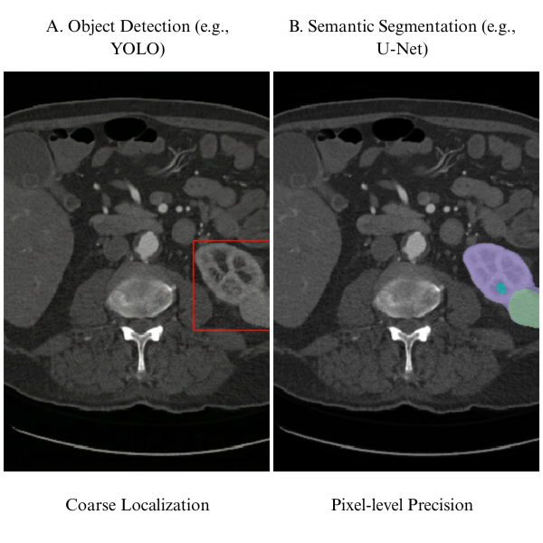
Figure 1. Comparison of Object Detection versus Semantic Segmentation in Medical Imaging. Adapted from [28].
These methodologies operate synergistically in urological imaging workflows, where detection algorithms first identify suspicious regions that may contain kidney abnormalities, subsequently guiding segmentation algorithms to perform detailed boundary delineation of the detected structures [11]. This complementary relationship proves particularly valuable in kidney abnormality analysis, where initial detection can rapidly screen entire imaging volumes to locate potential lesions, followed by precise segmentation that characterizes the abnormality's shape, size, and spatial relationship to surrounding tissues. Recent studies have demonstrated that this hierarchical approach significantly improves computational efficiency while maintaining diagnostic accuracy [29].
The detection-then-segmentation paradigm enhances computational efficiency by focusing detailed segmentation analysis only on regions flagged as potentially abnormal, rather than processing entire image volumes at the highest resolution, thereby optimizing both diagnostic accuracy and processing time in clinical settings. This approach is particularly critical when dealing with three-dimensional volumetric data from CT or MRI, where exhaustive pixel-level processing would be computationally prohibitive [30].

2.2.3 Region-Based Deep Learning Detection Methods
Region-based convolutional neural networks have established a robust framework for object detection by decomposing the task into sequential stages of region proposal generation and object classification. The seminal Faster R-CNN architecture introduced an integrated Region Proposal Network that learns to generate high-quality candidate regions directly from image features, creating an end-to-end trainable detection system (illustrated in Figure 2) that has become foundational in medical imaging applications [15].
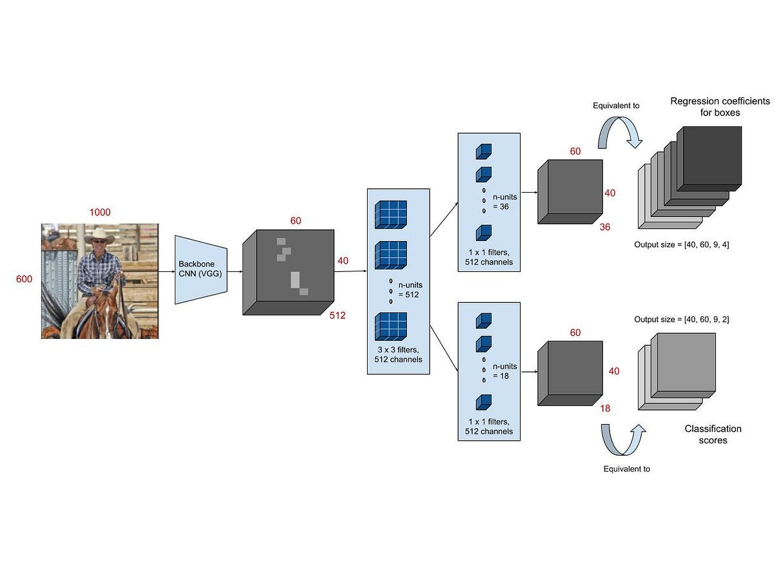
Figure 2. Faster R-CNN Architecture. Reprinted from [15].
Modern adaptations of region-based approaches incorporate attention mechanisms and feature pyramid networks to enhance multi-scale detection capabilities, enabling more effective identification of kidney abnormalities that vary substantially in size and appearance. These region-based approaches excel in medical imaging applications where detection accuracy takes precedence over processing speed, as the two-stage architecture allows for careful refinement of bounding box coordinates and classification decisions [31]. In urological imaging, region-based detectors demonstrate strength in identifying kidney abnormalities of varying sizes and morphologies, as the region proposal mechanism can adapt to detect both small focal lesions and larger masses within the same imaging study.
Recent implementations have integrated transformer-based feature extractors with region-based detection frameworks to capture long-range dependencies between anatomical structures, improving the discrimination of pathological findings from normal anatomical variations [32]. However, their computational requirements remain higher compared to single-shot alternatives, making them more suitable for offline analysis rather than real-time clinical applications.

2.2.4 Single-Shot and Real-Time Detection Architectures
Single-shot detection architectures emerged to address the computational limitations of region-based methods by reformulating object detection as a unified regression problem that simultaneously predicts bounding box coordinates and class probabilities. The You Only Look Once (YOLO) family of detectors has evolved through multiple iterations, with recent versions incorporating advanced backbone networks and sophisticated feature aggregation strategies that maintain real-time processing capabilities while substantially improving detection accuracy for medical imaging applications (see Figure 3 for a typical YOLO architecture) [33].
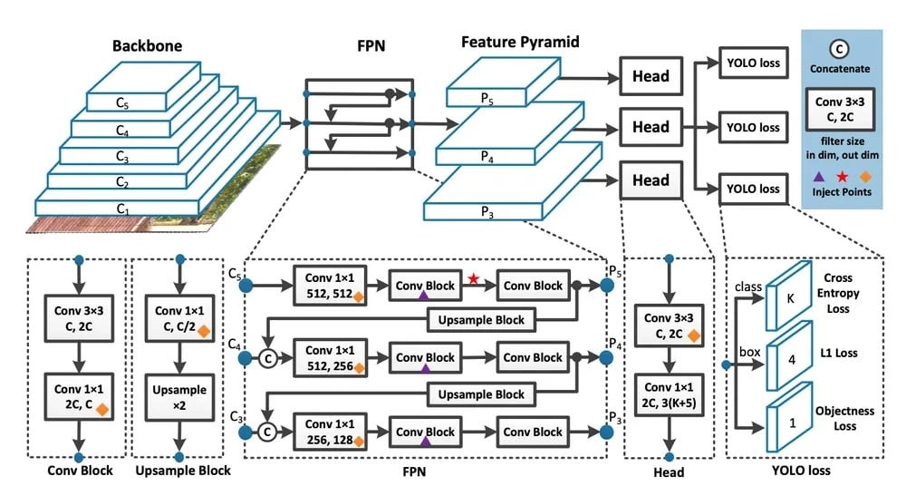
Figure 3. YOLO Architecture. Reprinted from [34].
Contemporary YOLO applications in urological imaging have demonstrated remarkable success in kidney stone detection and kidney parenchyma localization. Recent work presented an optimized YOLOv5 architecture specifically tailored for kidney stone detection in CT images, incorporating squeeze-and-excitation blocks within the C3 architecture to enhance channel-wise feature recalibration and achieve superior precision and recall metrics while maintaining real-time inference capabilities [16]. Similarly, YOLOv7 was applied to kidney detection in MRI, training on 878 patients with renal cell carcinoma and 206 with normal kidneys, demonstrating the architecture's adaptability to different imaging modalities and its capability to process medical image formats including DICOM and NIfTI [35]. While this study used MRI, the demonstrated capability to process both DICOM and NIfTI file formats validates YOLO's adaptability to diverse medical imaging modalities and preprocessing pipelines, directly relevant to CT-based workflows that similarly convert DICOM to NIfTI for volumetric processing.
Contemporary single-shot architectures employ feature pyramid networks and path aggregation mechanisms to enhance detection across multiple scales, improving the identification of kidney abnormalities with diverse sizes without sacrificing processing efficiency. Advanced focal loss mechanisms address class imbalance between foreground objects and background regions, a challenge particularly relevant in medical imaging where abnormalities constitute a small fraction of the total image area [36]. These single-shot architectures prove advantageous in clinical scenarios requiring rapid screening, such as intraoperative imaging or emergency radiology, where detection speed enables immediate clinical decision-making.
For urological applications, modern single-shot detectors facilitate efficient processing of multi-phase CT studies or large ultrasound video sequences, identifying kidney abnormalities across entire imaging series with minimal latency while achieving detection performance increasingly comparable to region-based methods for most clinical tasks. The lightweight nature of these architectures makes them particularly suitable for deployment in resource-constrained clinical environments or edge computing scenarios where computational resources are limited [36].

2.2.5 Transformer and Advanced Detection Models
The emergence of transformer architectures has introduced novel attention mechanisms to object detection, enabling models to capture global contextual relationships that traditional convolutional approaches may overlook. Vision Transformers apply self-attention mechanisms to image patches, allowing networks to model long-range dependencies between spatially distant regions, which proves valuable when kidney abnormalities exhibit subtle imaging characteristics that require contextual interpretation [37].
Detection frameworks incorporating transformer architectures, inspired by models such as Detection Transformer (DETR), eliminate the need for hand-crafted components such as anchor boxes or non-maximum suppression by directly predicting object locations and classes through learned queries that attend to relevant image features (as shown in Figure 4) [38].
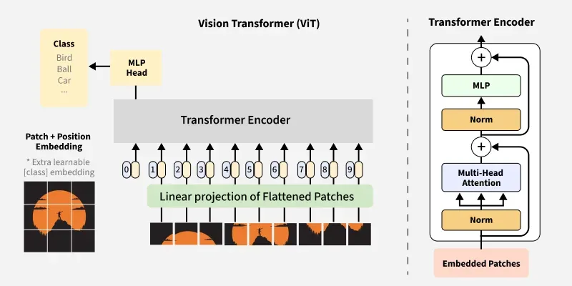
Figure 4. Vision Transformers. Reprinted from [38].
These transformer-based approaches demonstrate particular promise in medical imaging by leveraging attention mechanisms to focus computational resources on diagnostically relevant regions while maintaining awareness of broader anatomical context [31].

Recent applications in kidney imaging have explored dual-task approaches that combine detection with segmentation using transformer architectures. A transformer-based dual-task framework was presented for kidney MR segmentation in autosomal-dominant polycystic kidney disease, demonstrating the architecture's capacity to handle complex morphological variations while maintaining computational efficiency [30]. Transformers showed superior ability to capture global spatial relationships essential for distinguishing pathological from normal tissue in challenging cases where local appearance alone is insufficient.

The ability of transformers to integrate information across entire imaging volumes proves advantageous for detecting kidney abnormalities that may be characterized by subtle texture changes or relationships to surrounding structures rather than dramatic intensity differences. A comprehensive review of visual transformer applications in renal image analysis, emphasizing their effectiveness in capturing long-range dependencies critical for accurate delineation of complex renal structures and tumors that vary in location, shape, and appearance [37]. However, ongoing research continues to enhance their computational efficiency for clinical deployment, as transformer architectures typically require more computational resources than traditional CNN-based approaches.

2.2.6 Detection and Segmentation Integration in Urological Clinical Workflows
Detection algorithms serve as an efficient first-stage filter that rapidly scans urological imaging studies to identify regions containing potential abnormalities, generating bounding boxes that define areas requiring detailed analysis [39]. This hierarchical detection-to-segmentation pipeline optimizes computational efficiency by concentrating intensive segmentation processing only on clinically relevant regions rather than exhaustively analyzing entire imaging volumes [40]. Recent studies have demonstrated that automated longitudinal assessment systems employing this paradigm can effectively track stone burden progression and measure volumetric changes across serial CT imaging with minimal human intervention [13]. This standardization is particularly critical when developing models trained on multi-institutional datasets, as detection-based region proposal can help normalize variability in acquisition parameters and imaging protocols across different clinical sites [18]. While this detection-then-segmentation paradigm offers efficiency advantages in certain deployment contexts, the present study adopts a direct end-to-end segmentation approach using nnU-Net V2, which performs volumetric segmentation without a separate detection stage — a design choice motivated by nnU-Net's demonstrated ability to localize and delineate small structures such as kidney stones without requiring a region-proposal preprocessing step.

2.3 Evolution of U-Net in Medical Image Segmentation

2.3.1 What is U-Net
U-Net is a specialized convolutional neural network architecture developed to address challenges in biomedical image processing where training data is typically limited and pixel-level localization is critical [12]. The architecture builds upon the foundation of Fully Convolutional Networks (FCNs) with significant modifications optimized for medical imaging applications. Its fundamental innovation lies in a symmetric encoder-decoder architecture, as illustrated in Fig. 5, that combines contextual information from a contracting path with precise spatial information from an expanding path through skip connections [12].
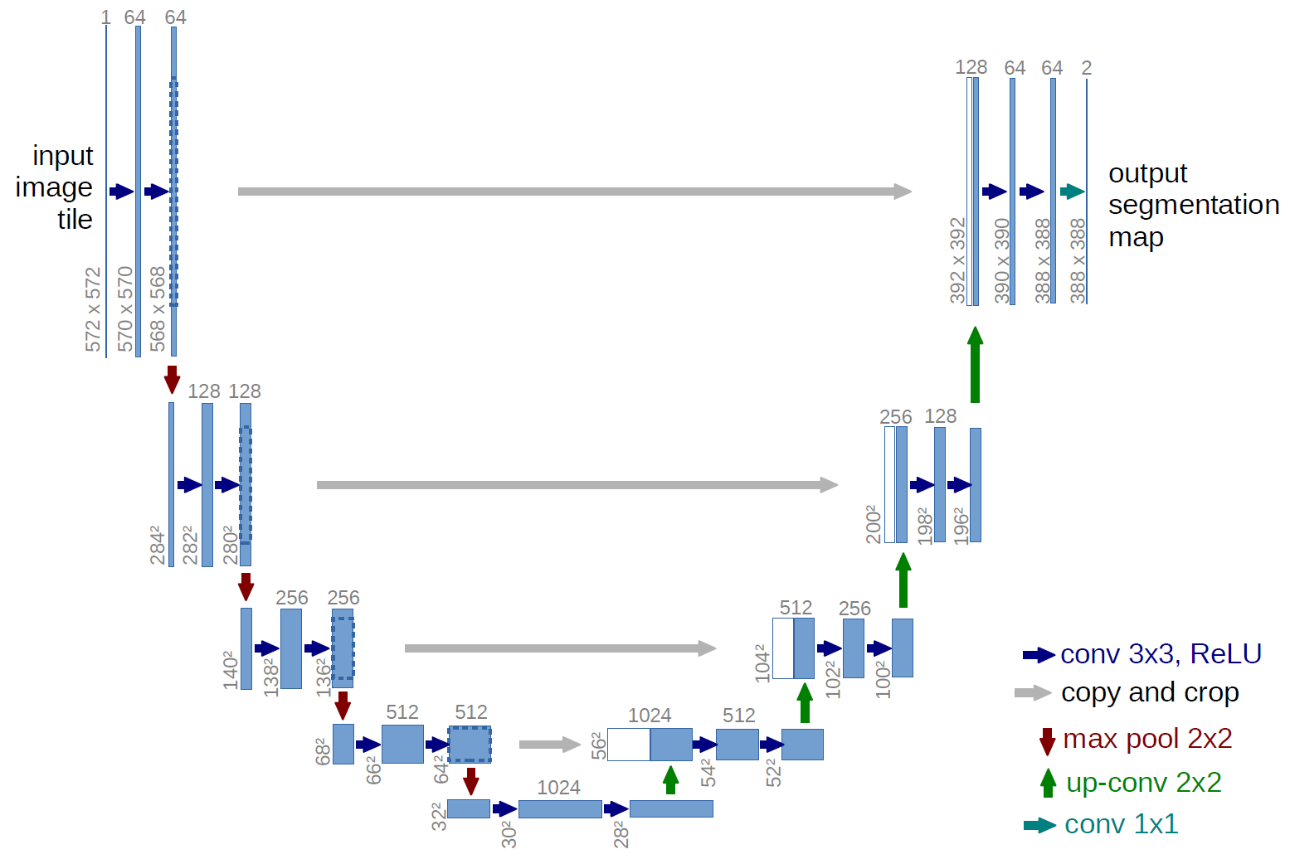
Figure 5. The U-Net Architecture. Illustration of the contracting and expanding paths with skip connections. Reprinted from [12].
The architecture consists of two main components defining its characteristic U-shaped structure. The contracting path captures context by progressively downsampling the input image, reducing spatial dimensions while increasing the number of feature channels to learn increasingly abstract representations [12]. Conversely, the symmetric expanding path enables precise localization by progressively upsampling feature maps. The critical innovation involves skip connections that directly link features from the contracting path to corresponding layers in the expanding path at the same resolution. These connections preserve fine-grained spatial details lost during downsampling, enabling the network to make precise predictions about pixel-level class assignments essential for accurate medical image segmentation [12].
Recent reviews have established U-Net-based architectures as the dominant paradigm for medical image segmentation across diverse anatomical structures and imaging modalities, with the original architecture serving as the foundation for hundreds of subsequent refinements and adaptations [28]. The enduring success of U-Net stems from its elegant balance between local precision and global context, achieved through the encoder-decoder structure with skip connections that has proven robust across varied segmentation tasks.

2.3.2 Architectural Components and Design Philosophy
The U-Net architecture eliminates fully connected layers and operates entirely through convolutional and pooling operations, making it computationally efficient and capable of processing images of arbitrary size [12]. Each layer in the network contains multi-channel feature maps, utilizing 3x3 kernels and ReLU activation functions throughout both the contracting and expanding paths. The symmetric design ensures that the number of feature channels in the expanding path mirrors those in the contracting path, allowing rich contextual information to propagate to higher resolution layers [12].
One of the fundamental design principles is the ability to function effectively with limited training data through aggressive data augmentation strategies [12]. Rather than requiring thousands of annotated samples like traditional deep learning approaches, U-Net can be trained effectively on very few images by applying elastic deformations and other transformation-based augmentations to available training data. This characteristic is particularly valuable in biomedical applications where annotated datasets are expensive and time-consuming to acquire. Furthermore, weighted loss functions are employed to handle challenging segmentation problems, such as the separation of touching cells of the same class, by assigning higher weights to boundary regions in the loss calculation [12].
The architectural simplicity of U-Net belies its computational sophistication. By eschewing fully connected layers in favor of pure convolution operations, the network achieves several advantages: computational efficiency that enables processing of full-resolution medical images, translation invariance that allows consistent segmentation regardless of object position, and the ability to generate pixel-wise classifications that preserve spatial relationships essential for medical diagnosis [28]. These design choices have proven remarkably prescient, as subsequent architectures incorporating more complex components have often achieved only marginal improvements while sacrificing computational efficiency.

2.3.3 Clinical Applications and Modality Coverage
The architecture has demonstrated effectiveness across diverse medical imaging modalities and anatomical structures [28], [29]. Originally validated on the segmentation of neuronal structures in electron microscopy and cell tracking in phase contrast microscopy [12], the model has successfully extended to computed tomography (CT), magnetic resonance imaging (MRI), ultrasound, and X-ray imaging (see Figure 6 for examples across modalities) [28], [29].
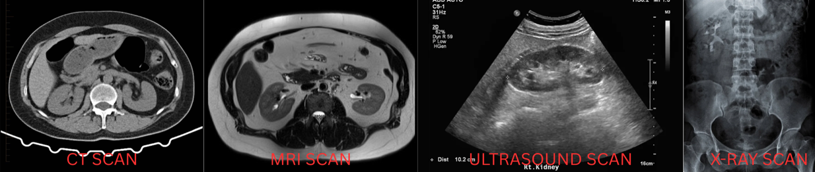
Figure 6. Modality Versatility
This versatility stems from a modality-agnostic design that performs equally well on 2D image slices and volumetric 3D data after appropriate architectural modifications.
Clinical utility extends to numerous organ systems and pathological conditions, including brain tumor segmentation in multimodal MRI, cardiac structures in echocardiography, liver lesions in CT imaging, and lung structures in chest radiography [28], [29]. Recent comprehensive reviews of deep learning in medical image segmentation highlight U-Net's dominance across these applications, with the architecture serving as the baseline against which novel methods are evaluated [28]. This broad applicability reflects the robustness of the core architecture and its adaptability to task-specific modifications.
In kidney imaging specifically, U-Net has been applied to simultaneous segmentation of kidneys, tumors, and cysts in contrast-enhanced CT imaging [19], [41]. Its computational efficiency allows for the segmentation of high-resolution 3D volumes in seconds, making integration into diagnostic workflows clinically feasible [12]. This rapid processing capability is particularly important for interventional procedures where real-time or near-real-time guidance is required.

2.3.4 U-Net Variants and Architectural Innovations
The success of the baseline architecture has prompted numerous refinements to handle increasingly complex segmentation tasks [28], [29]. One prominent variant, U-Net++, incorporates nested and dense skip pathways to bridge the semantic gap between feature maps extracted at different levels of the encoder and decoder (illustrated in Figure 7) [42].

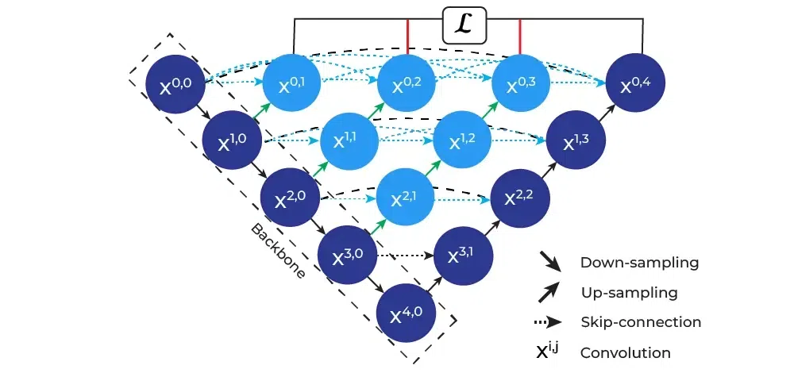
Figure 7. U-Net++ Architecture. Reprinted from [42].
By incorporating dense convolutional blocks at each skip connection node, U-Net++ reduces information loss during the decoding process and has demonstrated improved performance across multiple medical imaging datasets [42].
Attention-based variants have emerged as a major refinement direction, incorporating mechanisms to selectively focus on clinically relevant regions while suppressing background noise. Attention U-Net integrates attention gates within the skip connections to recalibrate feature maps based on spatial and channel-wise importance, improving segmentation accuracy particularly for small lesions (see the attention gate mechanism in Figure 8) [43].
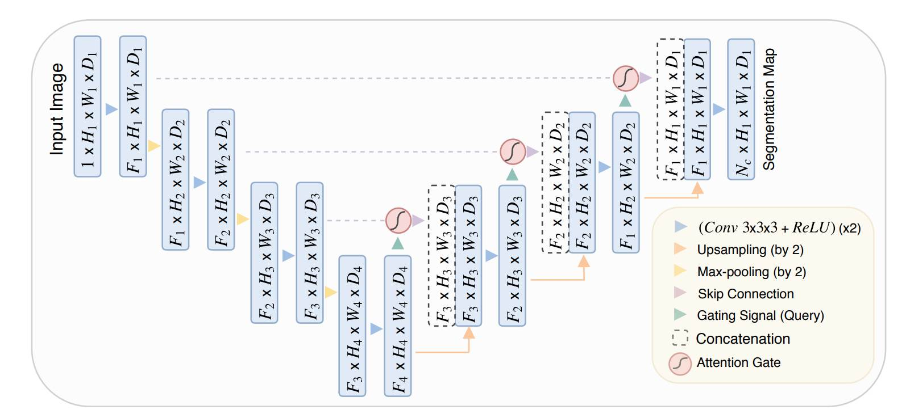
Figure 8. Attention Mechanism. Reprinted from [43].
Recent implementations specifically for kidney tumor segmentation have demonstrated that boundary attention mechanisms can significantly improve segmentation accuracy at tumor edges, addressing one of the primary challenges in renal mass characterization [41]. MSS U-Net introduced multi-scale supervised learning for 3D kidney and tumor segmentation, training the network to produce accurate predictions at multiple resolution levels simultaneously [44]. Similarly, recent work on the KiTS23 challenge explored various 3D U-Net training configurations to achieve superior segmentation performance [45]. Furthermore, 3D U-Net extends the original architecture to volumetric medical imaging by replacing 2D convolutions with 3D convolutional operations [28], [29]. Recent studies employing 3D U-Net for renal mass segmentation have achieved clinical-grade performance [17]. Hybrid variants like ResUNet combine the encoder-decoder structure with residual learning principles [28]. TransUNet pioneered the transformer approach by using a Vision Transformer as the encoder while maintaining U-Net's decoder structure (as depicted in Figure 9) [46].
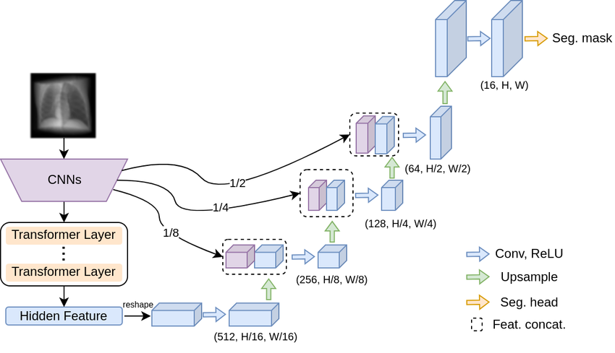
Figure 9. Hybrid Transformers. Reprinted from [46].
Swin-UNet further refined this concept using Swin Transformers with shifted window attention, demonstrating superior performance on multi-organ segmentation tasks including kidney structures [47]. The STC-UNet architecture incorporates Selective Kernel modules to address challenges posed by unclear boundaries and positional uncertainties in renal tumors [48]. Similarly, dual attention approaches have shown promise for ultrasound-based renal tumor segmentation, achieving MIoU scores exceeding 93% on clinical datasets [49].

2.3.5 Performance Metrics and Clinical Benchmarking
Medical image segmentation performance is evaluated using several complementary metrics that capture different aspects of segmentation quality [28]. The Dice Similarity Coefficient (DSC) measures the overlap between predicted and ground truth segmentation masks, providing a balanced measure that accounts for both false positives and false negatives. Intersection over Union (IoU), also known as the Jaccard index, computes the ratio of the intersection to the union of predicted and ground truth regions, offering a stricter assessment of segmentation accuracy (see the visual comparison of DSC and IoU in Figure 10).
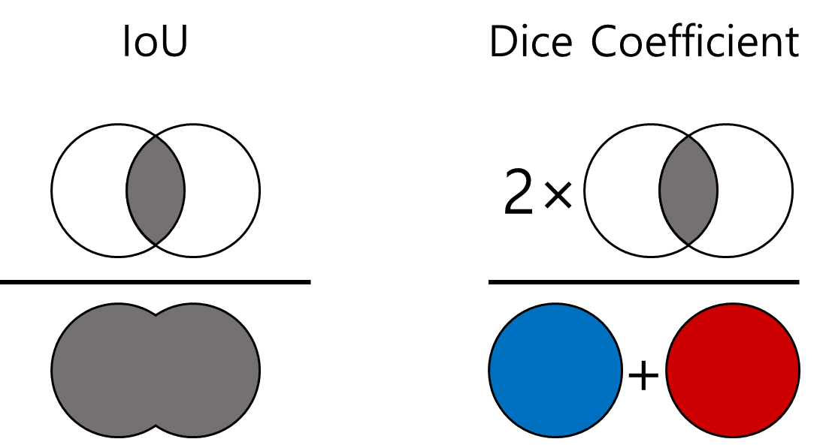
Figure 10. Volumetric Overlap Metrics
While these overlap-based metrics provide quantitative measures of volumetric accuracy, boundary precision is typically quantified using the Hausdorff distance and Average Symmetric Surface Distance [28].
Performance reporting typically includes sensitivity (recall), specificity, and precision to provide a comprehensive assessment of segmentation quality across different clinical requirements [28]. Sensitivity measures the proportion of actual positive pixels correctly identified, critical for ensuring complete lesion capture. Specificity quantifies the proportion of actual negative pixels correctly classified, important for minimizing false positive regions. Precision, or positive predictive value, indicates the proportion of predicted positive pixels that are actually positive, relevant for clinical confidence in segmented regions.
For clinical translation, published benchmarks suggest that Dice coefficients exceeding 0.85 for organ segmentation and 0.75 for lesion segmentation generally indicate clinically acceptable performance [28], [29]. However, mathematical accuracy metrics do not always correlate perfectly with clinical utility, necessitating a careful balance between metric optimization and the improvement of patient outcomes [28]. Recent studies on kidney and tumor segmentation have reported achieving these benchmarks, with state-of-the-art models attaining Dice scores of 0.948 for kidney segmentation, 0.776 for masses, and 0.738 for tumors on standardized challenge datasets [45].
Surface-based metrics have gained prominence for assessing boundary accuracy, particularly important in surgical planning where precise delineation of tumor margins is critical. The 95th percentile Hausdorff Distance (HD95) measures the maximum distance between predicted and ground truth boundaries while being robust to outliers, with lower values indicating better boundary alignment (illustrated in Figure 11).
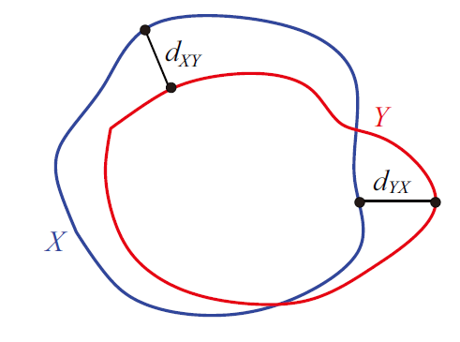
Figure 11. Boundary Distance Metrics. Reprinted from [50].
Recent kidney segmentation challenges have incorporated Surface Dice metrics that combine volumetric overlap with surface distance considerations, providing a more comprehensive assessment of segmentation quality for clinical applications [45].
The complementary relationship between detection and segmentation defines optimal clinical workflows for kidney abnormality analysis—detection serves as an efficient initial screening mechanism that identifies regions requiring detailed analysis, while segmentation provides the precise anatomical boundaries necessary for clinical measurement and characterization. Implementing this integrated pipeline in clinical practice, however, faces substantial challenges: manual configuration of detection and segmentation parameters is time-intensive and requires deep machine learning expertise; performance is highly dependent on dataset-specific parameter tuning and validation; cross-institutional robustness demands careful attention to diverse imaging protocols, scanner manufacturers, and image acquisition parameters; and reproducibility across clinical sites is compromised by the sensitivity of both detection and segmentation networks to variations in training and configuration.
The nnU-Net framework addresses these implementation challenges through fully automated configuration, eliminating the need for manual task-specific parameter tuning while achieving state-of-the-art performance across diverse segmentation tasks. By automatically configuring U-Net architectures for kidney-specific tasks and encoding domain knowledge about optimal detection-segmentation integration into systematic rules, nnU-Net transforms kidney abnormality segmentation from a specialized research capability requiring substantial machine learning expertise to a clinically deployable tool accessible to clinical researchers and radiologists without formal deep learning training. This transformation represents a critical advance toward clinical translation of automated kidney abnormality analysis. The following section examines the nnU-Net framework's architecture, configuration strategy, empirical validation, and implications for clinical deployment of kidney abnormality detection and characterization systems.

2.4 The nnU-Net Framework

2.4.1 Overview of nnU-Net
nnU-Net is an automated self-configuring framework for deep learning-based medical image segmentation that has fundamentally transformed the clinical deployment of AI-powered diagnostic tools [51]. It automatically configures every component of the segmentation pipeline without requiring manual intervention beyond providing raw imaging data and corresponding binary segmentation annotations [51]. The fundamental motivation stems from the observation that small errors in configuration choices can lead to large drops in performance [51]. Analysis revealed that method configuration quality often exceeds architectural novelty, motivating a systematic, automated process [51]. The framework achieved first place in the KiTS19 kidney tumor segmentation challenge, establishing a benchmark for multi-institutional CT kidney segmentation [19]. Subsequent iterations have maintained dominance while preserving the core automated configuration principles [51]. Recent comprehensive benchmarking against contemporary architectures including Vision Transformers and Mamba-based models has validated that properly configured CNN-based U-Net variants within the nnU-Net framework continue to achieve state-of-the-art performance when rigorously evaluated [52].

2.4.2 Automated Configuration Architecture
The framework implements automated configuration through a three-tier parameter hierarchy (shown in Figure 12) that systematically handles design decisions [51].
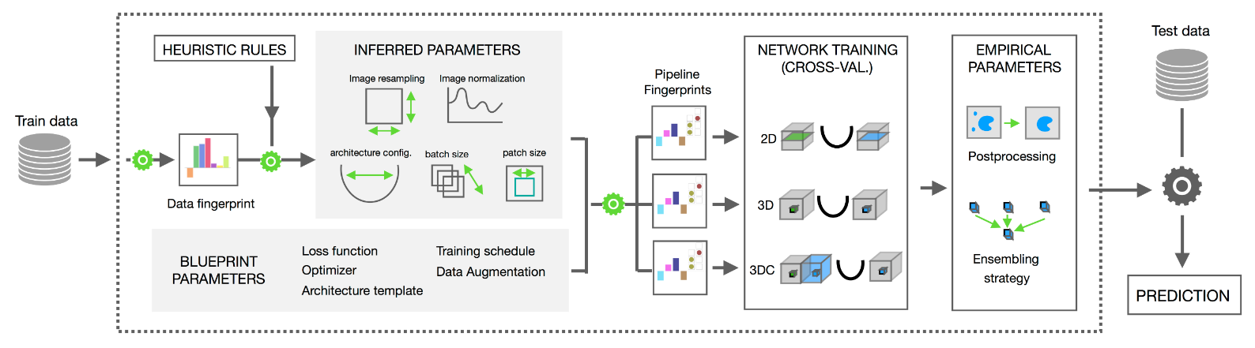
Figure 12. nnU-Net Configuration Hierarchy. Reprinted from [53]
The first tier consists of fixed parameters, including specific activation functions and loss function strategies combining Dice and cross-entropy loss [51]. The second tier comprises rule-based parameters, which establish explicit dependencies between the dataset fingerprint and the pipeline fingerprint [51]. One critical rule governs the interdependent configuration of batch size and patch size while respecting GPU memory constraints [51], [54]. Additional rules determine intensity normalization approaches tailored to specific modalities such as CT Hounsfield unit clipping or MRI z-score normalization [51]. The third tier consists of empirical parameters covering decisions that benefit from data-driven optimization on the specific dataset [51]. This includes determination of post-processing strategies such as connected component analysis [51], [54]. This strategy avoids the computational overhead of exhaustive hyperparameter search [51], [55].

2.4.3 Cascade Architecture and Multi-Resolution Processing
A critical feature is the systematic use of cascaded U-Net configurations for anatomical structures that occupy relatively small regions within imaging volumes [51]. The framework automatically detects spatial thresholds, triggering a two-stage cascade approach [51], [56]. In this configuration, the first U-Net operates on downsampled images to perform coarse localization of the target structures, while the second U-Net operates at full resolution within regions of interest identified by the first stage (see the cascade workflow in Figure 13) [52].
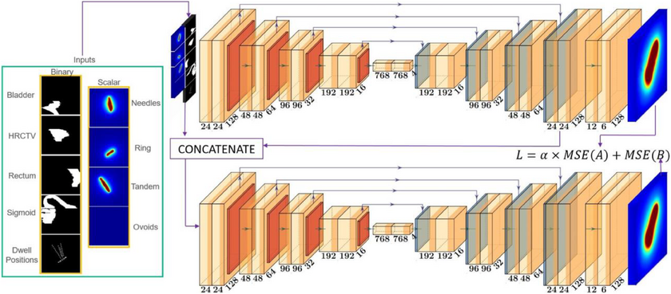
Figure 13. 3D Cascade Architecture. Retrieved from [57].
This cascade trigger directly addresses the fundamental trade-off between capturing sufficient contextual information for accurate localization and maintaining sufficient spatial resolution for precise boundary delineation [56], [58]. By automatically selecting cascade configurations, the system encodes domain knowledge about volumetric imaging without requiring manual intervention [51]. This design proves particularly valuable for kidney imaging applications where structures benefit substantially from the coarse-to-fine processing strategy [56], [58]. Recent implementations demonstrated the effectiveness of this approach for kidney tumor segmentation [56]. A two-stage cascaded framework effectively refined segmentation of kidney tumors and cysts [56]. This approach demonstrated that the cascade architecture effectively handles the multi-scale nature of kidney abnormality segmentation [56]. The intermediate cropping process maintains full-resolution detail for precise boundary characterization [56], [58].

2.4.4 Cross-Institutional Robustness and Domain Generalization
Robustness to domain shift represents a critical consideration for clinical deployment of automated segmentation systems [55]. The nnU-Net framework addresses domain shift through comprehensive data augmentation strategies scaled based on dataset properties [55]. Applied augmentations include geometric transformations and specialized techniques (an example of these augmentations are provided in Figure 14) [51], [55].
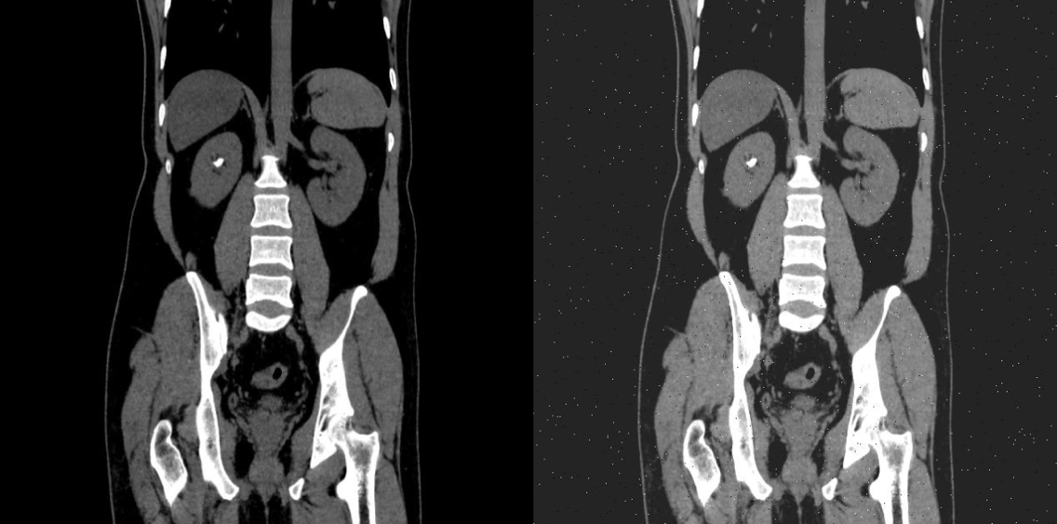
Figure 14. Data Augmentation Example
Empirical validation of cross-institutional robustness has been conducted across multiple imaging modalities and anatomical targets. nnU-Net's generalization capability has been demonstrated, showing that automated data augmentation maintained high Dice coefficients across different vendor domains comparable to performance within same-vendor data [55]. A rigorous evaluation of nnU-NetV2 was tested on an independent institutional dataset comprising 139 cases [18]. The study revealed models trained on diverse multi-institutional data demonstrated improved segmentation robustness and generalizability [18]. This finding emphasizes training dataset diversity maintains performance across diverse real-world imaging environments [18]. Models trained exclusively on single-institution data may fail to generalize to external populations, limiting practical utility in multi-site clinical networks [18]. The framework provides a pathway to supporting the deployment of AI-assisted diagnostic tools in real-world healthcare settings [18].

2.4.5 Empirical Performance and Validation
The empirical validation of nnU-Net spans an unprecedented diversity of segmentation tasks across modalities, anatomical structures, and imaging protocols [51]. Comprehensive evaluations have established nnU-Net as a state-of-the-art framework on the majority of tested public benchmarks [51]. The framework secured first place in multiple international biomedical imaging challenges [19], [51]. The KiTS19 challenge results showed robust performance across diverse tumor sizes and locations [19]. Subsequent challenges have validated nnU-Net's continued dominance, achieving high Dice scores for tumors on standardized challenge datasets [45], [59]. Comprehensive benchmarking against contemporary architectural alternatives including Vision Transformers and Mamba-based models has validated that properly configured CNN-based U-Net variants within the nnU-Net framework continue to achieve state-of-the-art performance when rigorously evaluated [52]. The study demonstrated that CNN-based approaches outperform alternatives on standard medical segmentation datasets [52]. Many reported performance improvements in recent literature resulted from validation shortcomings rather than genuine architectural superiority [52]. This validation confirms the approach remains highly competitive against novel architectures designed for large-scale datasets [52]. For kidney abnormality segmentation, these findings support the selection of nnU-Net over more computationally demanding Transformer alternatives [52], [60].

2.4.6 Clinical Translation and Accessibility
The accessibility of nnU-Net for clinical deployment represents a significant advance for hospital settings [51]. The framework requires minimal specialized knowledge, allowing clinical teams to apply the method directly to raw medical imaging data and binary annotation masks [51], [61]. Standard institutional GPU resources are generally sufficient, avoiding the need for high-performance computing infrastructure or multi-GPU clusters [51], [61]. The deployment workflow executes automated training scripts [51], [53]. The framework automatically handles all configuration decisions through the three-tier parameter hierarchy [51]. Resulting models generate pixel-level segmentation maps suitable for treatment response assessment, and surgical planning [13], [51]. This accessibility transforms automated segmentation into a tool deployable without formal deep learning training [51]. Recent applications demonstrate successful deployment achieving clinically acceptable segmentation performance with reduced computational requirements [62]. Such optimizations expand the practical applicability of automated segmentation tools to a broader range of healthcare facilities [62]. The framework's ability to handle multi-class segmentation tasks positions it as the natural choice for comprehensive characterization encompassing tumors, cysts, and stones [45], [56]. The cross-institutional robustness supports deployment across diverse clinical imaging environments [18], [58].

2.4.7 State-of-the-Art Deep Learning Frameworks for Kidney Segmentation
Building upon the clinical accessibility of these models, recent comparative studies have firmly established the superiority of self-configuring frameworks over traditional architectures for renal image analysis. A controlled benchmarking study directly compared the nnU-Net framework against a custom 3D U-Net for kidney and tumor segmentation [60]. By maintaining identical preprocessing, data augmentation, and training protocols, it was demonstrated that nnU-Net provides a highly robust baseline, outperforming the standard 3D U-Net in both Dice Similarity Coefficient (DSC) and Intersection over Union (IoU) [60]. Building upon these architectural advantages, the specific capabilities of the nnU-Net V2 architecture were investigated using a 3D full-resolution configuration [63]. The application of the model to the KiTS23 dataset yielded high DSC and IoU scores, cementing nnU-Net V2 as a highly optimized foundational architecture for multi-class renal segmentation tasks [63].

2.5 Identified Research Gaps
The comprehensive review of literature on kidney abnormality detection and segmentation reveals substantial progress in automated analysis of individual abnormality types, yet identifies critical gaps that limit the clinical applicability and comprehensiveness of existing approaches. These gaps motivate the development of integrated multi-class segmentation systems capable of simultaneously detecting and characterizing all major kidney abnormalities within unified clinical workflows.

2.5.1 Single-Class Focus in Existing Segmentation Systems
Current state-of-the-art deep learning approaches for kidney abnormality segmentation predominantly focus on single abnormality types, with separate specialized models developed for kidney tumors, cysts, or stones [18], [19], [39]. While individual models achieve impressive performance within their specific domains—tumor segmentation models reaching Dice scores exceeding 0.85 on KiTS challenge datasets [18], stone detection models achieving accuracies above 96% [64], and cyst segmentation showing robust performance in polycystic kidney disease applications [30]—no comprehensive system simultaneously addresses all three major abnormality categories within a unified framework.
This single-class paradigm creates substantial limitations for clinical deployment. In real-world diagnostic workflows, patients frequently present with multiple concurrent kidney abnormalities requiring comprehensive evaluation [14]. A patient may harbor both renal masses and incidental cysts, or demonstrate stone disease alongside cystic lesions. Current approaches necessitate running multiple independent models sequentially, each with its own preprocessing pipeline, inference requirements, and post-processing steps, resulting in computational inefficiency and workflow complexity that impedes clinical integration [45]. Furthermore, independent single-class models fail to leverage potential synergies in learning shared anatomical context and imaging features across abnormality types, potentially limiting both efficiency and performance.
The absence of multi-class kidney abnormality segmentation systems represents a fundamental gap in translating automated analysis from research benchmarks to comprehensive clinical decision support tools. Developing unified frameworks capable of simultaneous detection and precise delineation of tumors, cysts, and stones would substantially advance clinical applicability by providing radiologists with complete abnormality characterization from single imaging studies, supporting comprehensive diagnostic assessment and treatment planning [14].

2.5.2 Fragmented Public Datasets and the Need for Data Unification
While substantial public datasets exist for kidney abnormality segmentation, these resources remain fragmented across different clinical objectives and pathological entities. Datasets such as KiTS19, KiTS21, and KiTS23 focus primarily on tumor segmentation [19], [45], while other publicly available resources address specific pathologies like kidney stones or cystic lesions in isolation. This fragmentation creates a fundamental challenge: existing models are trained to recognize and segment individual abnormality types, but no unified public dataset exists that enables comprehensive multi-class segmentation encompassing tumors, cysts, and stones simultaneously.
This data fragmentation has significant clinical implications. In real-world diagnostic radiology, patients frequently present with multiple concurrent kidney pathologies, a tumor-bearing kidney may also contain cysts or stones, yet current segmentation approaches trained on isolated datasets cannot comprehensively characterize such cases. Deploying separate models for each abnormality type introduces computational inefficiency, potential inconsistencies in overlapping or adjacent structures, and workflow complexity that limits clinical adoption. The absence of a unified training framework that exposes models to the full spectrum of kidney abnormalities during learning prevents development of truly comprehensive diagnostic systems.
The research opportunity lies in unifying these disparate public datasets into a single multi-class training framework. By combining tumor-focused datasets (KiTS series) with publicly available stone and cyst datasets, we can create a comprehensive training corpus that exposes the model to the full range of kidney pathologies simultaneously. This unified approach addresses a fundamental gap in the current research landscape: while individual public datasets exist for specific pathologies, no prior work has systematically integrated these resources to enable simultaneous detection and segmentation of all major kidney abnormality types within a single model architecture.
This data unification strategy offers several advantages beyond simply training separate models on each dataset. Multi-class training enables the model to learn shared anatomical features and spatial relationships between different pathology types, potentially improving overall segmentation accuracy through cross-pathology feature learning. Additionally, a unified model reduces computational overhead during inference and simplifies clinical deployment compared to maintaining multiple specialized systems. Our study bridges this critical gap by developing the first comprehensive multi-class kidney abnormality segmentation framework trained on unified public datasets, demonstrating that integration of disparate data sources can produce clinically viable comprehensive diagnostic systems [18], [45].
Recent advancements have begun to address this data fragmentation. The introduction of the 3D Multi-class Segmentation of Whole Abdominal Lesions (MSWAL) dataset represents a significant shift toward unified pathological annotations, providing comprehensive voxel-level ground truth for multiple abdominal abnormalities, including kidney stones, cysts, and tumors, within single volumetric scans [20]. While MSWAL provides a robust foundation for multi-class learning, it is constrained by its single-institution origin. Therefore, this study's strategy of harmonizing a multi-class dataset (MSWAL) with a multi-institutional dataset (KiTS23) address both the structural fragmentation of public datasets and the critical need for cross-institutional robustness in model training.

2.5.3 Insufficient Integration of Clinical Classification Systems
While automated segmentation provides precise anatomical boundaries of kidney abnormalities, existing systems generally do not integrate outputs with established clinical classification frameworks that guide diagnostic and therapeutic decisions. The Bosniak classification for cystic lesions, R.E.N.A.L. nephrometry scoring, and stone burden quantification metrics remain underdeveloped in automated computation [5], [7]. Accurate segmentation alone is insufficient without Bosniak category assignment based on wall thickness, septation characteristics, enhancement patterns, and calcification presence [7]. Renal mass segmentation requires exophytic properties and polar location for surgical planning and intervention selection [5]. Stone disease management depends critically on quantitative metrics including total stone burden, individual dimensions, and density characteristics that inform composition and treatment susceptibility [16].

2.5.4 The Comprehensive Metric Evaluation Gap
In addition to the limitations in dataset fragmentation and clinical integration, a review of the current baseline literature reveals a significant gap in comprehensive, multi-class clinical evaluations. Beyond standard overlap metrics like DSC and IoU, rigorous clinical validation requires assessing boundary distances and prediction exactness. A comprehensive validation study of an AI-based kidney segmentation framework was recently conducted utilizing evaluation metrics such as the 95th percentile Hausdorff Distance (HD95), Precision, Recall, and F1-score [65]. While this provides a strong methodological baseline for multi-metric evaluation, a notable limitation is the consolidation of distinct pathological classes. In this framework, cysts and tumors were merged into a singular "abnormality" class, inherently limiting the model's utility for precise differential diagnosis [65].
Furthermore, while foundational studies establish standard performance benchmarks for kidneys and tumors [60], [63], none of the current state-of-the-art baselines incorporate kidney stones alongside cysts and tumors in their evaluation. Consequently, there remains an unmet need for a single, unified framework capable of simultaneously isolating distinct renal pathologies—specifically kidneys, tumors, cysts, and stones—while being evaluated against a comprehensive suite of overlap, boundary, and efficiency metrics. To address the absence of kidney stones in unified multi-class evaluations, baseline metrics for this specific pathology must be drawn from dedicated stone segmentation models. Recent automated systems have successfully established volumetric segmentation baselines for kidney stones on non-contrast CT scans [24]. Furthermore, specialized deep segmentation networks have been utilized to simultaneously segment both the renal structure and calculi, providing essential overlap metrics such as DSC for stone detection [39]. In this study, the performance of the proposed multi-class nnU-Net framework on the stone class will be benchmarked against these dedicated single-task and dual-task models to ensure rigorous clinical validation across all isolated abnormalities.

2.5.5 Gap Summary and Research Opportunity
The identified gaps collectively point to a specific, addressable research opportunity in computer science: the absence of a controlled comparative study between single-class and multi-class nnU-Net V2 segmentation for kidney abnormalities. While prior work has validated nnU-Net V2 for kidney tumor segmentation [18][19] and the MSWAL dataset enables multi-class ground truth annotation [20], no study has isolated the performance effect of training strategy — single-class versus multi-class — using the same architecture, data, and metrics. This study addresses that gap directly, using 3D U-Net as a consistent baseline reference, and provides the first statistically grounded comparison to guide practitioners in choosing between single-class and multi-class segmentation pipelines for renal CT analysis.

Chapter 3
METHODOLOGY
This chapter presents the comprehensive methodological framework and computational procedures developed to achieve the comparative investigation described in Chapter 1. Grounded in a retrospective analysis of clinical Computed Tomography (CT) data, the study employs a two-phase experimental design using the self-configuring nnU-Net V2 deep learning architecture. In Phase 1, three single-class models are independently trained and validated against published benchmarks. In Phase 2, one multi-class model trained simultaneously on all three abnormality classes is compared directly against those validated single-class models. The methodology is organized through an Input-Process-Output (IPO) model, spanning from physiological normalization of raw radiological data to the rigorous quantitative evaluation and qualitative clinical review by radiologists.

3.1 Conceptual Framework
The methodological architecture of this research is grounded in the intersection of computational medical imaging, deep learning-based semantic segmentation, and clinical decision support system. The primary objective is to translate raw radiological data into actionable clinical insights through the automated delineation of kidney substructures and pathologies – specifically cysts, stones, and tumors. This study adopts a rigorous Input-Process-Output (IPO) model, a fundamental system engineering approach that structures the methodology into three distinct but interconnected phases: data ingestion and preparation (Input), computational analysis and model training (Process), and performance evaluation and clinical inference (Output).

3.1.1 The Input-Process-Output (IPO) Model
The IPO model serves as the architectural skeleton of this thesis, ensuring a logical flow of data and rigorous validation of the segmentation results (as illustrated in the framework diagram in Figure 15).
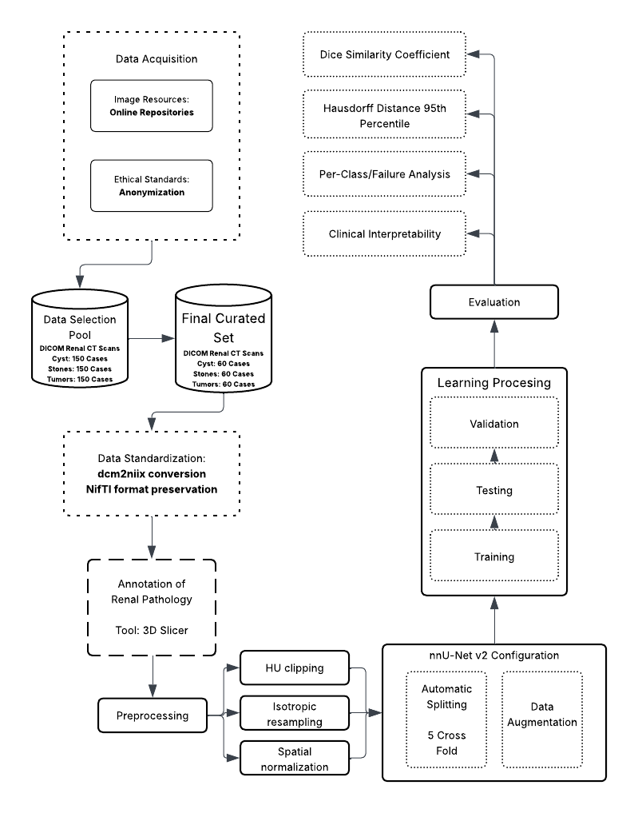
Figure 15. Conceptual Framework
This system-theoretic perspective allows for the isolation of variable at each stage, ensuring that errors can be traced back to specific components – whether they be artifacts in the input data, convergence failures in the process, or metric misinterpretations in the output.

3.1.2 Input Phase: Data Ingestion and Physiological Standardization
The foundation of the framework lies in the acquisition of high-fidelity volumetric CT data. The input stage is characterized by the transformation of raw medical data into a machine-readable format. This involves the ingestion of DICOM (Digital Imaging and Communications in Medicine) series, which contain not only the pixel data but also critical metadata regarding the acquisition parameters. The conversion of these series into the NIfTI (Neuroimaging Informatics Technology Initiative) standard is a pivotal step, as it creates a unified volumetric representation that preserves the affine matrix—defining the spatial relationship between the image voxels and the physical world coordinate system.
The preprocessing phase within the Input stage is conceptually critical as it bridges the domain gap between physical tissue density—measured in Hounsfield Units (HU)—and the numerical inputs required by the neural network. By applying specific intensity clipping (Focus range of -135 to 215 HU) and resampling techniques (1.0 mm isotropic spacing), the input stage standardizes the physical variance across different patients and scanners. This "physiological normalization" ensures that the neural network learns to associate specific numerical ranges with specific tissue types (e.g., distinguishing a dense stone from soft tissue), rather than learning scanner-specific noise patterns.

3.1.3 Process Phase: Deep Learning and Volumetric Segmentation
The process component is driven by the 3D U-Net architecture within the nnU-Net v2 framework. The conceptual novelty here is the use of deep supervision, where the network learns to segment structures at multiple resolutions simultaneously. This mechanism involves injecting auxiliary loss layers at various stages of the decoder pathway, thereby improving gradient flow deep into the network and maximizing feature extraction from both coarse and fine spatial scales. This stage encompasses the iterative training of the model using a composite loss function (Dice Loss plus Cross-Entropy Loss), stochastic optimization via Stochastic Gradient Descent (SGD) with Nesterov momentum, and massive on-the-fly data augmentation. The augmentation strategy is designed to enforce translational, rotational, and intensity invariance, forcing the model to learn robust anatomical features rather than memorizing the specific orientation or contrast levels of the training cases. The use of 5-fold cross-validation during this phase ensures that the model's performance is robust across the entire dataset distribution and not biased by a specific train-test split.

3.1.4 Output Phase: Evaluation and Clinical Inference
The output of the framework is a multi-class segmentation map where each voxel is classified into one of five categories: background, kidney, cyst, stone, or tumor. The conceptual validity of these outputs is assessed using a comprehensive multi-metric approach. The primary metrics are:
- Volumetric Overlap: The Dice Similarity Coefficient (DSC) quantifies the spatial overlap between the prediction and the ground truth, providing a global measure of segmentation quality.
- Boundary Accuracy: The Hausdorff Distance 95th Percentile (HD95) measures the worst-case error at the segmentation boundaries, offering critical insight into the geometric precision of the model, which is vital for surgical planning and radiotherapy.

Furthermore, the framework incorporates a "Human-in-the-Loop" validation mechanism, where expert radiologists review failure cases (identified by low DSC scores) to provide qualitative feedback. This step transforms the thesis from a purely computational exercise into a clinically relevant study, categorizing errors into detection failures, false positives, or boundary inaccuracies.

3.2 Data Management
The integrity, diversity, and quality of the dataset are paramount to the success of any deep learning model, particularly in the medical domain where data scarcity and class imbalance are prevalent challenges. The data acquisition strategy for this thesis is designed to ensure strict compliance with medical data interoperability standards, ethical guidelines regarding patient privacy, and the specific technical requirements of the nnU-Net v2 training pipeline.

3.2.1 Sources and Ethical Considerations
The dataset was curated from two primary publicly accessible biomedical imaging repositories. Tumor segmentation cases were sourced from the KiTS23 (Kidney and Kidney Tumor Segmentation) challenge dataset, a multi-institutional repository with expert-verified ground truth masks. Multi-class cases encompassing concurrent cysts, stones, and tumors were sourced from the MSWAL (3D Multi-class Segmentation of Whole Abdominal Lesions) dataset, which provides comprehensive voxel-level annotations for multiple pathologies within single volumetric scans. This harmonization of KiTS23 with MSWAL directly addresses the data fragmentation identified in Section 2.5.2, combining multi-institutional breadth with multi-class annotation coverage. Given the retrospective nature of this study—involving the computational analysis of previously collected clinical data generated during routine patient care—strict ethical protocols are observed to protect subject confidentiality. Each case represents a complete 3D volumetric CT scan comprising approximately 100 slices per anatomical plane. By extracting all three standard views — axial, coronal, and sagittal — each volumetric case yields approximately 300 2D slices, resulting in a comprehensive training corpus of approximately 87,000 individual 2D slices.
Data Selection Strategy: To ensure the model generalizes across heterogeneous clinical presentations, the data curation protocol deliberately preserves the natural distribution of renal pathologies rather than artificially forcing a class balance. A total of 290 high-value volumetric CT cases were curated from the available public repositories. To accurately reflect real-world clinical complexity, this finalized experimental set includes 74 cases of pure nephrolithiasis (stones), 50 cases of pure renal cysts, and 45 cases of pure solid neoplasms. Crucially, the remaining 121 cases (41.7% of the dataset) exhibit concurrent multi-pathologies (clinical co-morbidities). The inclusion of these complex, overlapping presentations is a strict methodological requirement to test the simultaneous characterization capabilities of the multi-class framework against the sequential limitations of single-class models. Cases are selected based on a Diversity Criteria to maximize variance in:
- Size: Balancing micro-lesions (<5mm) with large masses (>4cm).
- Location: Ensuring representation of upper, mid, and lower pole lesions, as well as cortical vs. medullary placement.
- Morphology: Selecting cases with varying densities (HU values) and shapes (e.g., simple vs. complex cysts, staghorn vs. focal stones).
To ensure absolute methodological transparency, the experimental corpus is strictly defined to this 290-volume cohort, which is exclusively subjected to the computational pipeline. During the automated 5-fold cross-validation, this corpus is partitioned such that each fold utilizes 232 volumes (80%) for training and 58 volumes (20%) for internal validation.
This curation ensures that although the final dataset size is compact, it is mathematically representative of the disease spectrum, preventing the model from over-optimizing on "easy" or repetitive cases.
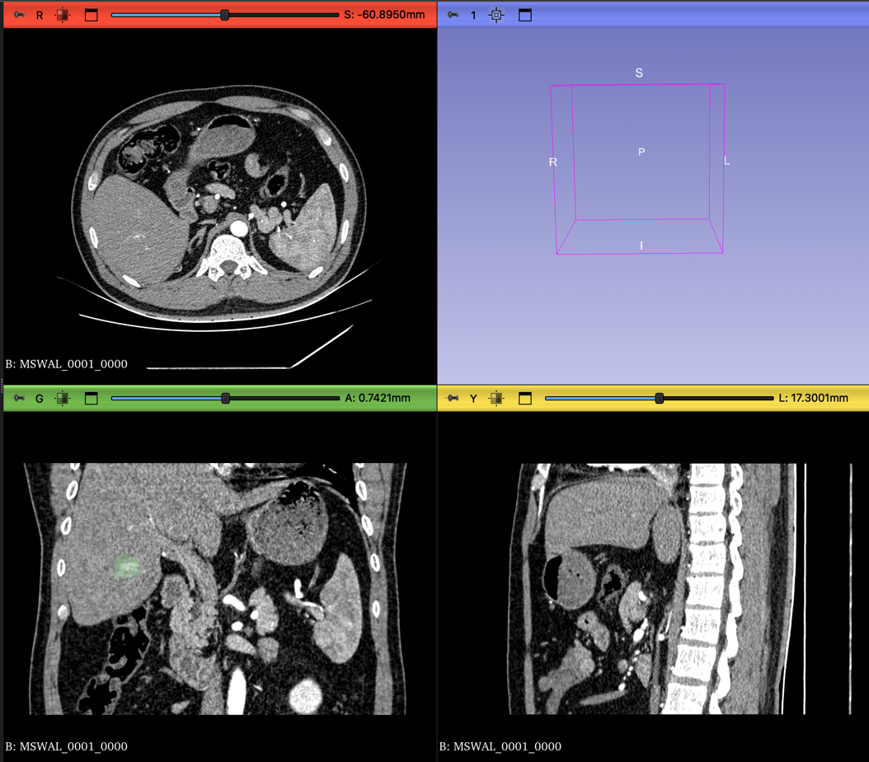
Figure 16. CT scan in different views

3.2.2 Ethical Compliance Framework:
    - Retrospective Study Protocol: Since this study utilizes publicly available, pre-anonymized datasets distributed under CC-BY-NC 4.0, institutional IRB approval was not required. The study strictly adheres to the data usage agreements of the respective repositories.
    - De-identification and Anonymization: All patient data is strictly anonymized at the source prior to transfer for computational analysis. This process involves the irreversible removal or masking of all Protected Health Information (PHI) from the DICOM headers. Specific tags such as Patient Name (0010,0010), Patient ID (0010,0020), Patient Birth Date (0010,0030), and Institution Name (0008,0080) are scrubbed or replaced with study-specific pseudonyms (e.g., Kidney_001). This ensures that the dataset used for training contains no linkages to the original patient identities, complying with data privacy regulations such as HIPAA or GDPR.
    - Data Security: The anonymized data is stored on secure, encrypted servers (e.g., Google Drive mounted to Colab Pro+ with restricted access), ensuring that only authorized research personnel have access to the imaging volumes.

3.2.3 DICOM to NIfTI Conversion
Raw medical images are generated by CT scanners in the DICOM (Digital Imaging and Communications in Medicine) format. While DICOM is the standard for clinical storage (PACS), it is suboptimal for deep learning due to its slice-based file structure (one file per slice) and complex metadata hierarchy. Deep learning frameworks, including nnU-Net, require the NIfTI (Neuroimaging Informatics Technology Initiative) format (.nii.gz), which encapsulates the entire 3D volume into a single compressed file and strictly defines the spatial coordinate system (affine matrix) necessary for 3D volumetric operations.

Conversion Protocol:
- Input: A directory containing the series of DICOM slices for a single patient study.
- Processing: dcm2niix reads the DICOM header information to reconstruct the contiguous 3D volume. It validates the slice ordering based on the ImagePositionPatient tag and handles any gantry tilt correction to ensure the resulting volume is orthogonal.
- Metadata Extraction: In addition to the image volume, dcm2niix generates a JSON sidecar file containing critical acquisition parameters such as slice thickness, pixel spacing, manufacturer, and convolution kernel. This metadata is essential for the subsequent "Dataset Fingerprinting" stage of nnU-Net.
- Output: A compressed NIfTI file (.nii.gz) representing the anatomical volume.

3.2.4 Dataset Organization and Structure
Following conversion, the data is restructured according to the rigid nnU-Net raw data format. This structure is inspired by the Medical Segmentation Decathlon (MSD) organization, which facilitates the automated parsing and cross-validation of datasets. Proper adherence to this structure is a prerequisite for the nnUNetv2_plan_and_preprocess command to function.

The directory hierarchy is established as follows:
- nnUNet_raw/DatasetXXX_Name/: The root folder for the task, where XXX is a unique three-digit identifier (e.g., 501) and Name describes the task (e.g., KidneyAbnormality).
- imagesTr/: Contains the training images (CT scans). Files must follow the naming convention Case_Identifier_0000.nii.gz. The _0000 suffix indicates the modality channel (CT).
- labelsTr/: Contains the corresponding ground truth segmentation masks. Files must be named Case_Identifier.nii.gz (without the modality suffix).
- dataset.json: A descriptor file defining the dataset properties. This JSON file acts as a manifest, containing:
  - channel_names: Mapping of channel IDs to modality types (e.g., {“0”: “CT”}).
  - labels: Mapping of integer pixel values to class names (e.g., {“0”: “background”, “1”: “kidney”, “2”: “cyst”, “3”: “stone”, “4”: “tumor”}).
  - numTraining: The total count of training cases.
  - file_ending: The file extension used (.nii.gz).

3.2.5 Dataset Characterization
The initial phase of the nnU-Net pipeline involves the extraction of a “dataset fingerprint,” which captures the intrinsic spatial and intensity properties of the CT data acquired from sources. This fingerprint guides the automated configuration of patch sizes, batch sizes, and network depth. The key characteristics identified during this heuristic analysis are summarized in Table 1.
Property | Value/Description
Modality | Computed Tomography (CT)
Image Size (Voxels) | Variable (Standardized via Resampling)
Target Voxel Spacing | [1.0, 1.0, 1.0]
HU Clipping Range | -135 HU to 215 HU (Automatically set by nnU-Net v2)
Class Distribution | 5 Classes: Background, Kidney, Cyst, Stone, Tumor
Final Curated Set | 290 Volumetric Cases
Data Splitting | 5-Fold Cross-Validation
Table 1. Dataset Fingerprint Characteristics
While the dataset consists of 290 unique volumetric cases, the extraction of all three standard anatomical planes — axial, coronal, and sagittal — yields approximately 300 2D slices per case, resulting in a comprehensive training corpus of approximately 87,000 individual 2D slices. Furthermore, the patch-based training paradigm of nnU-Net — where the network samples multiple overlapping 3D sub-volumes per case during each training epoch — and the aggressive on-the-fly data augmentation strategy (detailed in 3.3.5) collectively ensure that the effective number of training samples seen by the model over 1,000 epochs substantially exceeds the raw case count. This design mirrors precedents in the medical imaging literature where compact, high-quality volumetric datasets have achieved competitive segmentation performance when paired with self-configuring frameworks such as nnU-Net [51], [58].

3.3 Data Preprocessing
Data preprocessing in medical image analysis is a fundamental step that transforms raw physical measurements into a normalized numerical space suitable for statistical learning. In the context of deep learning, where models are sensitive to the distribution and scale of input data, preprocessing is not merely a formatting step but a physiological normalization process. The goal is to standardize the physical properties of the input data so that the neural network learns to associate specific numerical values and spatial shapes with anatomical structures, rather than learning artifacts of the acquisition process or inter-patient variability. The preprocessing pipeline for this thesis involves three critical operations: Hounsfield Unit (HU) clipping, isotropic resampling, and Z-score normalization.

3.3.1 Hounsfield Unit (HU) Clipping and Intensity Filtering
Computed Tomography (CT) images provide a quantitative measure of radiodensity, expressed in Hounsfield Units (HU). The HU scale is a linear transformation of the linear attenuation coefficient of the material, calibrated such that the radiodensity of distilled water at standard temperature and pressure (STP) is defined as 0 HU, and the radiodensity of air is defined as -1000 HU. This standardization is a unique advantage of CT over MRI (where intensity values are relative), as it allows for the absolute differentiation of tissues based on their physical density.
However, the full dynamic range of a modern CT scanner can extend from -1000 HU (air) to over +3000 HU (dense metal implants or cortical bone). For the specific task of segmenting kidneys and their associated soft-tissue abnormalities, the vast majority of relevant anatomical information is contained within a much narrower range. "Soft tissues" generally fall between -100 and +200 HU. Feeding the full dynamic range into the network would compress the contrast resolution of the soft tissues, making it difficult for the model to discern subtle differences between a cyst (fluid) and a tumor (solid tissue).
To assist the neural network in focusing on the relevant anatomical features and to eliminate outliers, intensity clipping is applied.
Mechanism: All voxel values below a defined lower threshold are set to that lower threshold, and all values above a defined upper threshold are set to that upper threshold.
Parameters: The clipping range is explicitly set to -135 HU to 215 HU.

3.3.2 Physiological Justification for Clipping Range:
- Lower Bound (-135 HU): This value is strategically chosen to exclude air (-1000 HU) and the lowest density fat tissues. Perinephric fat (fat surrounding the kidney) typically ranges from -50 to -100 HU. By clipping at -135 HU, the network effectively treats all air (e.g., in bowel loops) and deep adipose tissue as a uniform background value. This reduces the variance the model needs to process in non-relevant regions, effectively "masking out" the dark background and highlighting the kidney within the retroperitoneal fat capsule.
- Upper Bound (215 HU): This value encompasses all relevant soft tissues, including the renal parenchyma (approx. 30-50 HU unenhanced, 100-180 HU contrast-enhanced), cysts (0-20 HU), and solid tumors (variable, typically 40-100 HU). Values significantly higher than 215 HU typically represent cortical bone or highly calcified kidney stones. While kidney stones are a target class, they are sufficiently dense (>400 HU) that even when clipped at 215 HU, they appear as maximum-intensity objects (bright white) relative to the surrounding soft tissue. Clipping at 215 HU prevents the network's weights from being skewed by the extreme values of metal artifacts or dense bone, while still preserving the high contrast of stones. It focuses the dynamic range on the subtle contrast differences required to distinguish a tumor from a cyst.
Following clipping, the data is normalized. Since CT data has a consistent physical meaning, nnU-Net employs a specific normalization scheme. The clipped values are subjected to a global Z-score normalization:
$$X_{norm}=\frac{x-u}{σ}$$
where $x$ is the pixel value, $μ$ is the mean intensity of the foreground pixels (computed over the entire training dataset), and $σ$ is the standard deviation. This ensures that the input distribution has a mean of 0 and a unit variance, which is crucial for the convergence stability of gradient descent algorithms during training.

3.3.3 Isotropic Resampling and Spatial Normalization
CT scans are volumetric data composed of stacked 2D slices. A significant challenge in medical imaging is anisotropy, where the physical resolution within a slice (pixel spacing, e.g., 0.7 x 0.7 mm) is much higher than the resolution between slices (slice thickness, e.g., 3.0 mm or 5.0 mm). This results in voxels that are rectangular prisms rather than cubes. If raw anisotropic data were fed into a 3D CNN, the network would learn distorted spatial filters. For example, a spherical kidney stone would appear as a flattened pancake in the voxel space if the slice thickness is large. This would severely impair the network's ability to recognize the true 3D morphology of tumors and stones.

To address this, the methodology mandates resampling to a uniform voxel spacing.
Target Spacing: The dataset is resampled to [1.0, 1.0, 1.0] mm isotropic spacing.
Implication: This transformation creates a new voxel grid where every voxel is a perfect cube of 1mm edges.
Algorithm:
  - Image Data: Third-order spline interpolation is used for the CT images. Spline interpolation fits a smooth curve through the surrounding pixel values to calculate the intensity of the new voxels. This preserves the continuous nature of tissue density and maintains the subtle gradients at the boundaries of lesions.
  - Label Masks: Nearest-neighbor interpolation is strictly used for the segmentation masks. Because the masks consist of categorical integers (0, 1, 2, 3, 4), using spline interpolation would introduce fractional values (e.g., 1.5), which are meaningless class identifiers. Nearest neighbor ensures that the class labels remain discrete integers.
This resampling step ensures that physical distances are represented consistently across all three axes (Axial, Sagittal, Coronal), allowing the 3D U-Net to perform spatial convolutions effectively in all directions and recognize the true volumetric shape of renal abnormalities.
After resampling to [1.0, 1.0, 1.0] mm isotropic spacing, all three standard anatomical planes — axial, coronal, and sagittal — are extracted from each volumetric case. Because the voxels are isotropic cubes, all three planes carry equivalent resolution and are geometrically consistent, making multi-planar extraction a straightforward augmentation of the training corpus without introducing resolution artifacts.

3.3.4 Cropping to Non-Zero Region
On datasets that are not pre-processed; to optimize computational efficiency and reduce memory usage, the preprocessing pipeline includes an automated cropping step. Medical images often contain large areas of background air surrounding the patient's body. nnU-Net automatically detects the non-zero region (the body area) and crops the volume to the bounding box of the patient. This significantly reduces the size of the input tensor, allowing for larger batch sizes or patch sizes during training, which contributes to better context modeling.

3.3.5 Augmentation Setting and Data Splitting
Given the high dimensionality of 3D medical data and the limited number of annotated samples available in clinical datasets, deep learning models are prone to overfitting. To mitigate this, a comprehensive data augmentation strategy is combined with a rigorous, automated data splitting scheme.
Data Augmentation Strategy
Category | Transformation | Description and Clinical Justification
Spatial | Rotation & Scaling | Random rotations (z-axis: [-180, 180], x/y: [-30, 30]) and scaling (0.7x - 1.4x) simulate variations in patient positioning and differences in organ size.
 | Elastic Deformation | Simulates natural soft-tissue deformation caused by respiration or pressure from adjacent organs.
 | Mirroring | Random mirroring along axes to leverage the approximate bilateral symmetry of the kidneys.
Intensity | Gaussian Noise/Blur | Simulates scanner noise and reconstruction variability (e.g., soft vs. bone kernels).
 | Brightness/Contrast | Makes the model invariant to slight variations in HU calibration or contrast enhancement phases.
 | Gamma Correction | Non-linear intensity transformation to simulate diverse tissue density shifts.
Table 2. Data Augmentation Strategy
Data Splitting: Automated 5-Fold Cross-Validation
The data splitting process in this study is handled automatically by the nnU-Net v2 pipeline, which implements a 5-fold cross-validation scheme by default to ensure unbiased performance estimation.
The Automated Splitting Mechanism:
Pipeline-Driven Partitioning: Once the dataset is standardized and the dataset.json is parsed, nnU-Net automatically partitions the total training cases into 5 equal, non-overlapping subsets (folds).
80/20 Distribution: For each of the 5 iterations, the framework uses 4 folds (80% of the data, or 232 volumes) for model training. The remaining fold (20% of the data, or 58 volumes) serves as the independent internal validation and testing set. By the end of the 5 iterations, every case in the 290-volume dataset has been used exactly once as an unseen test case.
Cross-Validation Iterations: The framework generates 5 independent sets of model weights (Fold 0 through Fold 4). This ensuring that every single case in the dataset is used for validation exactly once, providing a comprehensive assessment of the model's ability to generalize to unseen data.

3.4 Network Architecture: The 3D U-Net and Deep Supervision
The core computational engine of this methodology is the 3D U-Net, a fully convolutional neural network specifically designed for volumetric segmentation. While the U-Net architecture is a standard in biomedical imaging, the nnU-Net v2 implementation introduces dynamic adaptation and deep supervision to maximize performance.
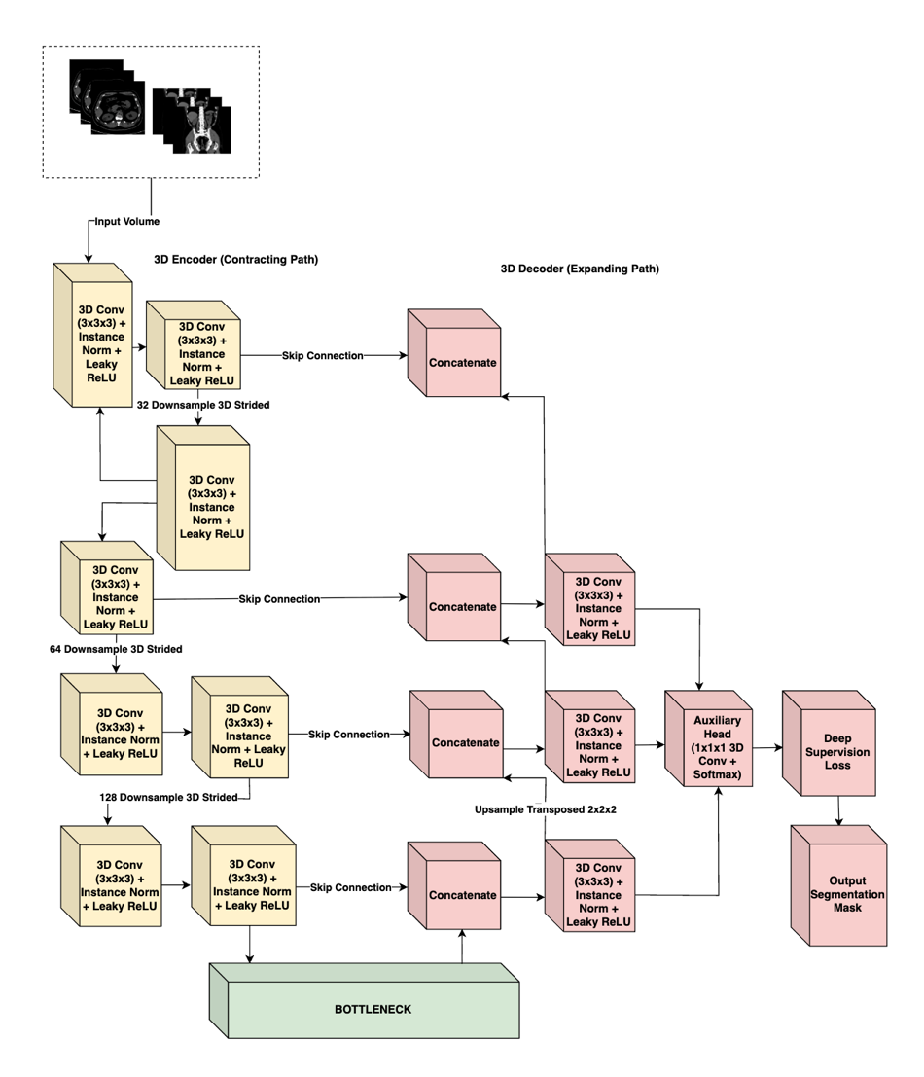
Figure 17. nnU-Net V2 Architecture

3.4.1 Architectural Topology
The network follows the classic symmetric Encoder-Decoder structure with skip connections, adapted for 3D inputs:
- The Encoder (Contracting Path): This pathway functions as a feature extractor. It consists of repeated blocks of convolutional layers. In nnU-Net v2, these blocks typically comprise:
3D Convolution: 3 x 3 x 3 kernels to extract spatial features.
Instance Normalization: Used instead of Batch Normalization because batch sizes in 3D training are often small (due to memory constraints), rendering Batch Norm unstable. Instance Norm normalizes each sample independently, preserving the contrast information of the individual scan.
Leaky ReLU: A non-linear activation function $f\left(x\right)=max⁡(0.01x,x))$ that introduces non-linearity while allowing a small gradient to flow even for negative values, preventing the "dying ReLU" problem.
Strided Convolution: Used for downsampling (reducing spatial resolution) instead of max-pooling. This allows the network to learn the optimal downsampling operation.
- The Bottleneck: The deepest part of the network represents the input volume in a highly abstract, low-resolution feature space, capturing semantic context (e.g., "presence of a tumor") rather than precise localization.
- The Decoder (Expanding Path): This pathway recovers the spatial resolution. It utilizes transposed convolutions to upsample the feature maps.
Skip Connections: Critical to the U-Net design, these connections concatenate the high-resolution feature maps from the Encoder directly to the corresponding layers in the Decoder. This re-injects the fine-grained spatial details (gradients, edges) lost during down sampling, enabling the decoder to precisely localize the boundaries of small structures like kidney stones.

3.4.2 Deep Supervision
A key conceptual element of the nnU-Net methodology is Deep Supervision. In standard networks, the loss is calculated only at the final output layer. However, in deep 3D networks, gradients can vanish as they backpropagate through many layers, making the training of the early layers difficult.
nnU-Net addresses this by outputting segmentation maps not just at the final full-resolution layer, but also at lower-resolution stages of the decoder.
  - Mechanism: Auxiliary segmentation heads are attached to the lower-resolution blocks of the decoder.
  - Loss Calculation: The loss is computed for each of these outputs (compared against down sampled versions of the ground truth).
  - Weighted Sum: The total loss is a weighted sum of the losses at different resolutions. The weights typically decay exponentially (e.g., 1/2, 1/4, 1/8) for lower resolutions, prioritizing the final high-resolution output.
  - Benefit: This forces the deeper layers of the network to learn semantically meaningful representations early in the training process and improves gradient flow, leading to faster and more stable convergence. It ensures that the network pays attention to both coarse context (organ localization) and fine detail (lesion boundaries).

3.5 Computational Pipeline
The training pipeline is meticulously configured to ensure convergence in the high-dimensional non-convex optimization landscape of 3D segmentation.

3.5.1 Environment and Reproducibility
To ensure the computational reproducibility of this study, all experiments were conducted within a standardized software and hardware environment. The model will be trained using Python 3.11 and the PyTorch deep learning framework, utilizing nnU-Net v2. High-intensity computations were executed on a single NVIDIA A100 GPU with 40GB VRAM, hosted via Google Colab Pro+. This hardware configuration provided the necessary VRAM budget to support large patch sizes and optimized batch gradients, ensuring stable convergence during the 1000-epoch training cycle.
Component | Technical Detail
Deep Learning Framework | PyTorch 2.x / nnU-NetV2
Programming Language | Python 3.11
GPU Hardware | NVIDIA A100 (40GB VRAM)
Computing Platform | Google Colab Pro+
Conversion Utility | dcm2niix (Python Library)
Annotation Platform | 3D Slicer
Table 3. Technical Specifications

3.5.2 Training Configuration and Optimization
Optimizer: The Stochastic Gradient Descent (SGD) optimizer is selected, utilizing Nesterov momentum. While adaptive optimizers like Adam are popular, empirical evidence from the nnU-Net authors suggests that SGD with Nesterov momentum generalizes better for medical segmentation tasks.
Hyperparameter | Value/Configuration
Training Schedule | 1000 Epochs (250 iterations per epoch)
Optimization Algorithm | SGD with Nesterov Momentum (0.99)
Initial Learning Rate | ${10}^{-2}$ (Polynomial decay schedule)
Weight Decay | $3 x {10}^{-5}$
Objective Function | Dice Similarity + Cross – Entropy Loss
Validation Strategy | Automated 5-fold Cross-Validation
Table 4. Training Hyperparameters
Momentum: Set to 0.99. This high momentum helps the optimizer navigate the complex loss landscape, allowing it to barrel through shallow local minima and converge to a flatter, more robust minimum.
Weight Decay: Set to $3 x {10}^{-5}$ to prevent overfitting by penalizing large weights (L2 regularization).

3.5.3 Loss Function Math
The training objective is minimized using a compound loss function that combines Dice Loss and Cross-Entropy (CE) Loss:
$$L_{total}=L_{Dice}+L_{CrossEntropy}$$
- Dice Loss: Directly optimizes the metric of interest (Dice score). It is robust to class imbalance because it relies on the intersection-over-union concept. Even if the background is 99% of the image, the Dice loss focuses solely on the overlap of the foreground classes.
- Cross-Entropy Loss: Provides dense, pixel-wise supervision by penalizing incorrect class probability assignments for every voxel in the volume. Unlike Dice Loss, which is computed globally over the segmentation mask, CE Loss enforces local correctness at each voxel, improving boundary sharpness and stabilizing training in the early epochs when Dice gradients are weak.
Training Schedule:
- Epochs: The model is trained for a fixed duration of 1000 epochs. Uniquely, an "epoch" in nnU-Net is defined not by the dataset size, but as a fixed number of iterations (250 mini-batches). This results in a total of 250,000 training steps.
- Learning Rate (LR): A "poly" learning rate policy is employed. The initial LR (typically 0.01) is decayed following a polynomial curve:
$$LR_{iter}=LR_{initial} x {\left(1- \frac{iter}{maxiter} \right)}^{0.9}$$
This allows for rapid exploration of the loss landscape in the early phases and precise fine-tuning in the later phases.

3.5.4 Inference and Post-Processing
Following the inference phase, nnU-Net v2 evaluates the validity of the predicted masks through automated post-processing. This primarily involves Connected Component Analysis (CCA), where the framework identifies and removes small, isolated clusters of pixels that are statistically unlikely to represent actual anatomical structures or lesions. By eliminating these "islands" of noise, the methodology ensures the generation of more coherent and clinically plausible segmentation masks, which is particularly vital for accurately delineating high-contrast structures like kidney stones in complex abdominal scans.

3.6 Annotation Pipeline
The validity of any supervised learning model is bounded by the quality of its ground truth. We employed a dual-stream data ingestion strategy:
  - Pre-annotated Data: Pre-annotated Data: For cases sourced from the KiTS23 and MSWAL repositories, which include expert-verified segmentation masks, we utilized the provided ground truth labels. These masks underwent a Verification Protocol to ensure compatibility with our class mapping (Table 5) and NIfTI conversion standards. KiTS23 labels were remapped to align tumor annotations with Class ID 4; MSWAL labels were verified to confirm cyst, stone, and tumor assignments matched Classes 2, 3, and 4 respectively.
  - Raw Data: For supplementary datasets (e.g., specific stone or cyst cases collected without segmentation), we implemented a Manual Annotation Pipeline to generate high-precision, radiologist-verified masks.
Tool: 3D Slicer, an open-source software platform for medical image informatics and visualization, is utilized for all manual segmentation tasks. The "Segment Editor" module provides advanced tools for painting, drawing, and refining 3D volumes.
Labeling Protocol: Each voxel in the CT volume is assigned a unique integer label representing its tissue class:
Integer Label | Clinical Entity | Description
0 | Background | All non-renal tissues and air
1 | Kidney | Healthy renal parenchyma
2 | Cyst | Fluid-filled renal lesions
3 | Stone | High-density calcifications (>400 HU)
4 | Tumor | Solid renal neoplasms
Table 5. Class Mapping

3.6.1 Domain Expert Profile
To ensure the clinical validity of the dataset, the ground truth annotations and failure analysis were supervised by Dr. Nathaniel F. Paragas. As an Affiliate Consultant at Capitol Medical Center—and an Associate Professor at Mapúa University, Dr. Paragas provides the necessary expert oversight. His specialization in diagnostic and interventional radiology ensures the anatomical precision required for differentiating complex renal cysts, tumors, and stones.
Category | Details
Name & Title | Dr. Nathaniel F. Paragas, MD, FPCR, FPSVIR
Current Affiliations | Associate Professor, School of Medicine, Mapùa University
 | Affiliate Consultant, Department of Radiology, Capitol Medical Center
Specialization | Diagnostic Radiology (Residency, St. Luke’s Medical Center
 | Vascular & Interventional Radiology (Fellowship, St. Luke’s
Experience | 10 Years – Medical Doctor
 | 6 Years – Diagnostic Radiology
 | 3 Years – Vascular & Interventional Radiology
Professional Status | Fellow, Philippine College of Radiology (FPCR)
 | Fellow, Philippine Society of Vascular and Interventional Radiology (FPSVIR)
Table 6. Domain Expert (Radiologist) Profile
To ensure an unbiased and independent evaluation of the model's performance, a second domain expert — Dr. Bernard Bringas, M.D., a Radiologist — is included. As an independent diagnostic radiologist, Dr. Bringas provides an objective "blind" clinical visual validation of the model's predicted segmentation masks, free from any involvement in the annotation or training phases. His role is strictly limited to the evaluation phase, where he reviews a curated subset of 15 cases (5 per abnormality: kidney stones, cysts, and tumors), assessing whether the AI-generated detections are clinically accurate and providing a confidence rating for each prediction. The inclusion of a second independent radiologist ensures that the qualitative evaluation is scientifically rigorous and free from bias.
Category | Details
Name & Title
Current Affiliations
Specialization
Experience
Professional Status
Table 7. Second Domain Expert (Radiologist) Profile

Workflow:
  - Initialization: The NIfTI volume is loaded into 3D Slicer. A new segmentation layer is created.
  - Label Generation:
- Stream A (Raw Data): Researchers manually 'painted' regions of interest using 3D Slicer’s interpolation tools, followed by slice-by-slice correction.
- Stream B (Pre-annotated Data): Existing masks were mapped to the study's label values (e.g., ensuring KiTS 'Tumor' label maps to Class ID 4) and visually inspected for conversion artifacts."
  - Expert Review: A "Human-in-the-Loop" quality assurance process is implemented.
    - For Raw Data: Dr. Paragas supervised the manual delineation process, reviewing 100% of the student-generated masks for complex cysts and stones to validate boundary precision.
- Pilot Phase: A subset of 100 cases is segmented and reviewed by the collaborating radiologist expert (Dr. Nathaniel Paragas). The radiologist provides feedback on the distinction between complex cysts and tumors, and on the precise boundaries of lesions.
- Refinement: Based on this feedback, the annotations are refined.
- Full-Scale: The approved protocol is applied to the entire dataset. Consistency checks are performed to identify and correct any missed lesions or mislabeled regions.
    - For Pre-annotated Data (KiTS): A random sampling of 10% of cases was reviewed to confirm that the imported labels-maintained integrity during the DICOM-to-NIfTI conversion and resolution resampling.
The radiologist expert does not manually segment every slice from scratch, as this is time prohibitive. Instead, a corrective annotation workflow is employed: student researchers generate the initial masks, and the collaborating radiologist reviews and refines the 3D volumes using 3D Slicer's verification tools, focusing on complex boundaries and ambiguous lesions.
  - Expert Review — Phase 2 (Post-Training Evaluation Validation): Following model training, the second domain expert, Dr. Bernard Bringas, conducts an independent clinical visual validation of the model's predicted segmentation masks. His involvement is strictly limited to the evaluation phase and is independent of the annotation and training processes to ensure an unbiased assessment.
  - Case Selection: A curated subset of 15 cases (5 per abnormality: kidney stones, cysts, and tumors) is selected, with priority given to cases flagged by low DSC scores or high HD95 values.
  - Clinical Visual Validation: Dr. Bringas reviews each case to assess whether the AI-generated segmentation masks and detections are clinically accurate based on his professional diagnosis.
  - Confidence Scoring: A confidence rating is provided for each of the model's predictions to help measure its reliability and clinical trustworthiness.
  - Findings: Expert findings are recorded and fed directly into the Failure Analysis phase described in Section 3.8.

3.7 Evaluation Metrics
To quantitatively assess the performance of the segmentation model, a comprehensive set of metrics is utilized. These metrics are selected to capture complementary aspects of segmentation quality: volumetric overlap and boundary precision.

3.7.1 Dice Similarity Coefficient (DSC)
The Dice Similarity Coefficient (DSC) (also known as the Sørensen–Dice index) is the standard metric for validating medical image segmentation. It measures the spatial overlap between the automated segmentation (A) and the manual ground truth (B).
$$DSC= \frac{2 | A ∩ B |}{\left|A\right|+\left|B\right|}=\frac{2* TP}{2 *TP+FP+FN}$$
where TP is True Positives (voxels correctly classified as the target), FP is False Positives (background voxels classified as target), and FN is False Negatives (target voxels classified as background).
Clinical Relevance: The DSC ranges from 0 (no overlap) to 1 (perfect overlap). In clinical contexts like radiotherapy planning or tumor burden monitoring, the total volume of the lesion is critical. A high DSC ensures that the AI-predicted volume is statistically consistent with the expert's measurement.

3.7.2 Intersection over Union (IoU)
The Intersection over Union, also known as the Jaccard Index, computes the ratio of the intersection to the union of the predicted and ground truth segmentation masks. IoU is a stricter overlap metric than DSC because the union term more heavily penalizes both over-segmentation and under-segmentation simultaneously.
IoU = |A ∩ B| / |A ∪ B| = TP / (TP + FP + FN)
where A is the predicted segmentation mask and B is the ground truth mask.
The relationship between DSC and IoU is defined as:
DSC = (2 × IoU) / (1 + IoU)
This relationship implies that IoU will always yield a lower numerical value than DSC for the same prediction. This distinction is important when interpreting and comparing results across studies that may report only one of the two metrics.

3.7.3 95th Percentile Hausdorff Distance (HD95)
While DSC is excellent for measuring volume, it is relatively insensitive to shape errors, especially for large objects. A segmentation could have a high DSC but still contain a significant protrusion or "spike" that extends into a neighboring organ. In surgery, such an error could be catastrophic.

To measure boundary accuracy, the Hausdorff Distance is used. It calculates the maximum distance from a point in one set to the nearest point in the other set. Specifically, the 95th Percentile Hausdorff Distance (HD95) is employed.
Formula:
$HD\left(A,B\right)=max⁡(\sup_{a∈A}\inf_{b∈B} d\left(a,b\right), \sup_{b∈B}\inf_{a∈A} d\left(b,a\right)$

3.7.4 Precision, Recall, and F1-Score
$$Precision=\frac{TP}{TP+FP}$$

$$Recall=\frac{TP}{TP+FN}$$

$$F1=\frac{2*Precision*Recall}{Precision+Recall}=\frac{2*TP}{2*TP+FP+FN}$$

To provide a comprehensive assessment of segmentation quality, three additional metrics are reported per class. Precision (Positive Predictive Value) measures the proportion of predicted positive voxels that are truly positive, quantifying the rate of false alarms. Recall (Sensitivity) measures the proportion of actual positive voxels correctly identified by the model, capturing the completeness of lesion detection. F1-Score is the harmonic mean of precision and recall, providing a single balanced metric that penalizes both over-segmentation and under-segmentation equally. These metrics are reported per class (cyst, stone, tumor) for all four model configurations to enable direct cross-model comparison.

3.7.5 Per-Class Analysis
A single global metric can be misleading. The kidney is a large structure, while a stone is tiny. A model could achieve a 0.90 global Dice score by segmenting the kidney perfectly while missing every single stone. Therefore, the evaluation will report DSC and HD95 separately for each class (Kidney, Cyst, Stone, Tumor). This granular analysis is essential to identify specific failure modes—for example, if the model struggles specifically with differentiating dense stones from contrast-enhanced vessels.

3.7.6 Computational Efficiency Metrics
To assess the clinical feasibility of integrating the proposed model into real-time radiological workflows, computational efficiency is evaluated alongside accuracy.
Inference Latency: The average time required to process a single patient volume (from raw NIfTI input to final segmentation output) is recorded. This is measured in seconds per volume (s/vol) across the validation set.
Resource Utilization: The peak GPU Video Random Access Memory (VRAM) consumption during inference is monitored to determine the minimum hardware requirements for deployment.
These metrics are recorded using the native PyTorch CUDA event timer and memory manager to ensure precise benchmarking independent of system overhead.

3.7.7 Baseline Benchmarks
To rigorously evaluate whether a unified multi-class nnU-Net V2 architecture performs equivalently or superior to specialized single-class models, strict quantitative baselines are established from contemporary literature using identical or closely related architectures (3D U-Net and nnU-Net). Table 7 aggregates benchmark metrics from specialized models published between 2022 and 2025.
Reference | Target Pathology | Architecture | DSC | IoU | Precision | Recall
Elton et al. [24] | Kidney Stones (NCCT) | Custom CNN | - | - | 0.966 | 0.978
Li et al. [39] | Kidney / Stones | 3D U-Net | 0.960 | - | - | 0.802 (Stones)
Soleimany et al. [60] | Renal Tumors (KiTS19) | nnU-Net / 3D U-Net | 0.960 (Tumor) | 0.910 | - | -
Doostinia et al. [63] | Renal Masses (KiTS23) | nnU-Net V2 | 0.645 (Tumor) | - | - | -
de Boer et al. [65] | Cysts & Tumors Combined | nnU-Net | 0.660 (Abnormality) | - | - | -
Table 7. Baseline Metrics for Kidney Abnormality Segmentation
Note: Missing values indicate the metric was not the primary optimization target in that study. Elton et al. [24] prioritized detection precision/recall due to the minute volumetric size of stones. Critically, no published benchmark provides DSC or HD95 for kidney stone segmentation under nnU-Net, as the major challenge datasets (KiTS19, KiTS23) do not include stones as a segmentation class. The stone-class results from this study's single-class and multi-class nnU-Net V2 configurations will constitute the first reported stone segmentation benchmarks under the nnU-Net V2 framework.
The 3D U-Net baseline in this study must approximate Li et al.'s [39] 0.802 sensitivity for kidney stones and approach Soleimany et al.'s [60] 0.960 DSC for tumor boundaries before the Phase 2 multi-class comparison is interpreted.

3.8 Failure Analysis and Clinical Interpretability
To bridge the gap between computational metrics and clinical applicability, a qualitative Failure Analysis phase is integrated into the methodology.
Protocol:
- Identification: The validation cases with the lowest Dice scores and highest HD95 values are extracted from the cross-validation results.
- Visual Inspection: These "failure cases" are loaded into 3D Slicer, with the AI prediction overlaid on the ground truth and the original CT scan.
- Radiologist Review: The radiologist expert reviews these cases to determine the root cause of the failure.
- Categorization: Errors are classified into categories such as:
  - Image Artifacts: Failure due to metal streak artifacts or low signal-to-noise ratio.
  - Ambiguous Anatomy: Cases where even the human expert is unsure of the boundary (e.g., a cyst with indeterminate density).
  - Model Hallucinations: False positives where the model detects a lesion that does not exist (e.g., misclassifying a vessel as a stone).
  - Boundary Leakage: The model correctly detects the tumor but extends the segmentation into adjacent muscle or fat.
This qualitative analysis provides the "why" behind the numbers, offering crucial insights for future model improvements and establishing realistic expectations for the tool's clinical reliability.

3.9 Clinical Feature Quantification
While deep leaning models output voxel-wise segmentation masks, clinical decision-making requires quantitative metrics. This study implements a deterministic post-processing algorithm to convert raw segmentation masks into clinical descriptors necessary for Radius Exophytic/Endophytic Nearness Anterior/Posterior Location (R.E.N.A.L.) Nephrometry scoring and stone burden analysis

3.9.1 Volumetric Calculation
The volume (V) of any segmented structure (tumor, cyst, or stone) is calculated by counting the total number of positive voxels (N_voxels) belonging to that class and multiplying by the volume of a single voxel (V_spacing), derived from the resampled isotropic spacing (1.0mm x 1.0mm x 1.0mm):
$$V=N_voxels × V_spacing$$

3.9.2 Maximum Diameter (Tumor Size)
To determine the maximal diameter required for the 'R' (Radius) component of nephrometry scoring, we utilize Principal Component Analysis (PCA) on the voxel coordinates of the tumor mask to find the major axis length, or compute the maximum Euclidean distance between any two surface voxels:
$$D_{max}=\max_{\left\{ij∈S\right\}}{{\left|\left|p_{i}-p_{j}\right|\right|}_{2}}$$

3.10 Testing and Validation Pipeline
This study executes exactly four nnU-Net V2 training sessions organized into two sequential phases. Phase 1 trains three single-class nnU-Net V2 models — one per abnormality class (cyst, stone, tumor) — and validates each against published benchmarks. Phase 2 trains one multi-class nnU-Net V2 model on all three classes simultaneously and compares its per-class performance against the Phase 1 models. A standardized testing pipeline is applied identically across all configurations.

3.10.1 Experimental Configuration Matrix
The four training sessions are structured as follows:
Phase 1 — Single-Class Validation (Three Training Sessions)

- Configuration A: Single-class nnU-Net V2 trained on stones only. Cysts and tumors are treated as background.
- Configuration B: Single-class nnU-Net V2 trained on cysts only.
- Configuration C: Single-class nnU-Net V2 trained on tumors only.

Note on Single-Class Labeling: To ensure a fair comparison and utilize the full dataset (N=290) for every model, a deterministic relabeling script is applied prior to single-class training. For example, in Configuration A (Stones), all voxels annotated as Cysts (2), Tumors (4), and normal Kidney (1) are dynamically merged into the Background (0) class. This ensures that the 121 concurrent multi-pathology cases are safely utilized without causing false-positive confusion. Furthermore, by merging the primary organ structure (Class 1: Kidney) into the background during Phase 1, the single-class models are evaluated purely on their algorithmic capacity to detect isolated target objects without explicit structural guidance, maintaining a strict binary 'object-versus-background' learning paradigm.

Phase 1 outputs per-class DSC, IoU, HD95, Precision, Recall, and F1-Score for each dedicated model. These are benchmarked against the literature metrics in Table 7 (Section 3.7.7). This validation is a prerequisite — a single-class model that significantly underperforms published benchmarks is a weak reference, and any multi-class advantage observed in Phase 2 could be falsely attributed to baseline weakness rather than genuine multi-class learning benefit.

Phase 2 — Multi-Class Comparison (One Training Session)
- Configuration D: Multi-class nnU-Net V2 trained simultaneously on all three classes, producing a voxel-wise softmax probability map over background, kidney, cyst, stone, and tumor.

Configuration D is the primary focus of this study. It is evaluated on the same held-out test set under identical preprocessing and inference conditions as Phase 1, and its per-class metrics are compared directly against Configurations A, B, and C.

3.10.2 Internal Test Set Preparation
Instead of an isolated held-out test set, performance is evaluated rigorously using the 58 test volumes (20%) reserved within each respective fold of the 5-fold cross-validation. Prior to inference, each test volume undergoes the same preprocessing pipeline applied during training: DICOM-to-NIfTI conversion, HU intensity clipping to the range of -135 to 215 HU, isotropic resampling to 1.0 mm spacing, and Z-score normalization. This ensures that all test inputs exist in an identical numerical space to the training data, eliminating preprocessing as a source of performance variance across configurations.

3.10.3 Inference & Post-Processing
Each preprocessed test volume is passed through its respective fold's model independently. For example, the 58 test cases in Fold 0 are evaluated exclusively by the weights trained in Fold 0, ensuring the model evaluates only unseen data. The output of each inference pass is a voxel-wise segmentation mask assigning each voxel to one of the target classes: background, kidney, cyst, stone, or tumor.
To accurately measure the computational efficiency trade-offs outlined in Objective 3, the inference pipeline strictly mirrors theoretical clinical deployment. For the Phase 1 single-class approach, a test volume must undergo three sequential inference passes (one pass each for the cyst, stone, and tumor models) to achieve comprehensive characterization. Conversely, for the Phase 2 multi-class approach, the test volume undergoes a single, unified computational pass to yield all pathology predictions simultaneously. Total inference latency is recorded based on these respective operational requirements.
The raw predicted masks are subjected to Connected Component Analysis (CCA) to remove small, isolated voxel clusters that are statistically unlikely to represent true anatomical structures. Any predicted region falling below a minimum voxel count threshold is discarded as noise. This step ensures that all evaluated masks are clinically plausible and free of spurious detections before metric computation is performed.

3.10.4 Metric Computation
For each test case and each model configuration, the following metrics are computed per class by comparing the predicted segmentation mask against the ground truth annotation:
Metric | Purpose
Dice Similarity Coefficient (DSC) | Volumetric overlap between prediction and ground truth
Intersection over Union (IoU) | Strict overlap ratio penalizing both over- and under-segmentation
95th Percentile Hausdorff Distance (HD95) | Worst-case boundary deviation
Precision | Proportion of predicted positive voxels that are truly positive
Recall | Proportion of true positive voxels correctly captured by the model
F1-Score | Harmonic balance of precision and recall
Table 8. Metric Computation

3.10.5 Computational Efficiency Recording
Alongside segmentation accuracy metrics, the following computational efficiency measures are recorded for each model configuration during inference on the test set:
- Inference Latency: the average time in seconds required to process a single patient volume from preprocessed NIfTI input to final post-processed segmentation output, measured using PyTorch CUDA event timers
- Peak GPU VRAM Usage: the maximum video memory consumed during a single inference pass, monitored via PyTorch’s native memory manager
These values are averaged across all test cases per configuration to produce a representative efficiency profile, enabling direct comparison of deployment feasibility between the single-class and multi-class approaches.

3.10.6 Cross Configuration Comparison
The computed metrics are organized into a structured comparison table across all four configurations per class. The comparison proceeds in two tiers mirroring the experimental design. First, Phase 1 single-class model results are compared against the published benchmarks in Table 7 (Section 3.7.7) to confirm baseline validity. Second — and as the primary analysis — the multi-class Configuration D results are compared per-class against the three single-class Configurations A, B, and C to determine whether joint training is beneficial, neutral, or detrimental for each pathology. To assess statistical significance, a paired Wilcoxon signed-rank test is applied to DSC, IoU, and HD95 scores across all test volumes.

3.10.7 Domain Expert Review
The domain expert review is conducted in two phases. In the first phase, prior to model training, the first domain expert, a diagnostic radiologist, reviews the annotations from the curated dataset to validate the accuracy of the ground truth labels, ensuring that the segmentation masks for kidney stones, cysts, and tumors are clinically sound before being used for training.
In the second phase, following model training, the second domain expert, an independent diagnostic radiologist, conducts a clinical visual validation on a curated subset of 15 cases, with 5 cases per abnormality (kidney stones, cysts, and tumors). This review focuses on understanding why the model behaves the way it does in real-world scenarios, particularly on cases flagged by low DSC scores or high HD95 values, validating whether computational failures correspond to clinically meaningful errors or boundary ambiguities that are inherently difficult even for human annotators. Expert findings are recorded and fed directly into the Failure Analysis phase described in Section 3.8.

3.11 Web Deployment
To bridge the translational gap between the computational backend and clinical end-users (radiologists and nephrologists), this study implements a web-based deployment interface. This component serves as the delivery mechanism for the Input-Process-Output model, transforming the trained nnU-Net v2 model from a command-line research tool into an accessible diagnostic prototype.

3.11.1 Framework Selection: Streamlit
The user interface is developed using Streamlit, an open-source Python framework designed specifically for machine learning and data science applications. Streamlit is selected for this study due to its seamless integration with the PyTorch backend, allowing for the direct execution of inference scripts without the latency overhead of intermediate API calls associated with traditional web frameworks (e.g., Django or Flask). Its capability to render interactive widgets and visualize multidimensional arrays (3D medical volumes) directly from Python scripts ensures rapid prototyping and maintains the fidelity of the segmentation results.

3.11.2 Application Architecture
The deployment architecture follows a three-tier design optimized for clinical workflow simulation:

- Data Ingestion Layer: The interface provides a secure "Drag-and-Drop" uploader supporting both raw DICOM series and pre-converted NIfTI files. For DICOM inputs, the application triggers an integrated dcm2niix background process to standardize the volume before inference, mirroring the Input Phase described in Section 3.1.2.

- Inference Engine: Upon upload, the application instantiates the trained nnU-Net v2 model (specifically the configuration yielding the highest validation dice scores). The uploaded volume is preprocessed (HU clipping and resampling) in real-time, passed through the 3D U-Net, and the resulting segmentation masks are post-processed to remove artifacts.

- Visualization Layer: The application utilizes interactive slice navigators to display the original CT volume alongside the semi-transparent segmentation overlay. This allows clinicians to scroll through Axial, Coronal, and Sagittal planes to visually verify the alignment of the predicted masks (Kidney, Cyst, Stone, Tumor) with the anatomical structures.

Clinical Reporting Features
Beyond visualization, the Streamlit deployment automates the generation of the quantitative outputs defined in Section 3.9. The interface dynamically computes and displays:
- Volumetric Analysis: A summary table listing the total volume (in mL) for every detected abnormality class.

- Downloadable Reports: The system compiles these metrics and representative key images into a standardized PDF report, simulating the integration of AI findings into a radiologist's final diagnostic report.

Chapter 4

Results and Discussion
This chapter presents the empirical results of the two-phase experimental design established in Chapter 3 and directly addresses the three research questions posed in Section 1.3. To restate those questions in evaluation terms:
- RQ1: Do the three single-class nnU-Net V2 models (Configurations A, B, C) produce per-class segmentation performance consistent with published state-of-the-art benchmarks (Table 7, Section 3.7.7), confirming them as strong and validated reference models?
- RQ2: Does the multi-class nnU-Net V2 model (Configuration D) achieve statistically superior, equivalent, or inferior per-class segmentation performance compared to the three validated single-class models?
- RQ3: What are the computational efficiency trade-offs—inference latency and GPU VRAM utilization—between running three sequential single-class configurations versus one unified multi-class configuration, and do these affect clinical deployment feasibility?
These questions address the four fundamental gaps identified in Section 1.2: the reliance on coarse bounding-box detection, the morphology-dependent performance degradation in existing segmentation systems, the single-institution and single-class modeling limitations, and the absence of any controlled comparative evidence between single-class and multi-class paradigms.

Experimental Configurations
Following the configuration matrix defined in Section 3.10.1, all experiments employed the nnU-Net V2 framework for 3D full-resolution semantic segmentation of renal abnormalities from CT volumetric data. Four training configurations were executed:

Configuration A: Single-class nnU-Net V2 trained exclusively on kidney stones. All other annotated classes (cysts, tumors, kidney parenchyma) were merged into background via the deterministic relabeling script described in Section 3.10.1.
Configuration B: Single-class nnU-Net V2 trained exclusively on renal cysts.
Configuration C: Single-class nnU-Net V2 trained exclusively on renal tumors.
Configuration D: Multi-class nnU-Net V2 trained simultaneously on all four classes (background, kidney, cyst, stone, tumor) using the full label schema defined in Table 5 (Section 3.6).
Parameter | Value
Framework | nnU-Net V2
Architecture | 3D Full-Resolution U-Net (6 encoding stages)
Feature map progression | 32 → 64 → 128 → 256 → 320 → 320
Patch Size | 128 × 128 × 128 voxels
Batch Size | 2
Normalization | CT Global Percentile (Global Foreground Mean/Std)
Activation | LeakyReLU (inplace)
Normalization Layer | InstanceNorm3d (affine=True)
Loss Function | Soft Dice + Cross-Entropy (Section 3.5.3)
Optimizer | SGD with Nesterov Momentum (Section 3.5.2)
Training Schedule | 1,000 epochs (250 iterations/epoch)
Cross-Validation | 5-Fold (80/20 split per fold, Section 3.3.5)
Hardware | Google Colab Pro+ (NVIDIA A100 80GB VRAM)
Table 9. Training Parameters

4.2 Evaluation Metrics
To satisfy the comprehensive per-class evaluation protocol specified in Section 3.10.4 and aligned with the baseline benchmarks in Table 7 (Section 3.7.7), six complementary metrics were computed from the aggregated confusion matrices across all validation cases per fold. Table 4.1 defines each metric and its clinical interpretation.

Metric | Formula | Clinical Interpretation
Dice Similarity Coefficient (DSC) | 2TP / (2TP + FP + FN) | Spatial overlap between predicted and ground-truth segmentation; the established gold-standard for medical segmentation benchmarking (Section 3.7.1).
Intersection over Union (IoU) | TP / (TP + FP + FN) | Stricter overlap metric penalizing false positives and false negatives more aggressively than DSC. Related to DSC by DSC = 2·IoU/(1+IoU) per Section 3.7.2.
Precision | TP / (TP + FP) | Proportion of predicted lesion voxels that are correct; high precision minimizes false-alarm-driven unnecessary workups—directly relevant to Bosniak grading follow-ups (Section 2.1.2).
Recall (Sensitivity) | TP / (TP + FN) | Proportion of actual lesion voxels correctly detected; high recall ensures minimal missed diagnoses—critical for early renal cell carcinoma detection (Section 1.1).
F1-Score | 2·Precision·Recall / (Precision + Recall) | Harmonic mean of precision and recall. Mathematically equivalent to DSC in binary segmentation; presented alongside DSC to facilitate cross-disciplinary comparison.
Specificity | TN / (TN + FP) | Proportion of background voxels correctly classified as non-lesion.
95th Percentile Hausdorff Distance (HD95) | max(sup d(a,B), sup d(b,A)) at 95th pct | Boundary accuracy metric capturing worst-case surface deviation; critical for surgical planning and tumor margin assessment (Section 3.7.3).
Table 10. Evaluation Metrics - Definition and Clinical Relevance

4.3 Phase 1 Results: Single-Class Model Performance (Configurations A, B, C)

The three single-class models exhibited dramatically divergent performance profiles, revealing that task-isolated training is not uniformly beneficial and, in the case of extreme class imbalance, can be catastrophic. This finding directly implicates the fourth research gap identified in Section 1.2—the failure of single-class models to account for co-morbid clinical presentations—and provides the validated reference baselines required by RQ1.
Target Class | Architecture | DSC | F1 (region-level) | Dataset
Kidney Stones | nnU-Net V2 | 0.231 | 0.167 | MSWAL (694 patients)
Kidney Cysts | nnU-Net V2 | 0.409 | 0.504 | MSWAL (694 patients)
Kidney Tumors | nnU-Net V2 | 0.405 | 0.187 | MSWAL (694 patients)
Table 11. MSWAL Benchmark Reference (Wu et al. [20], nnU-Net V2 on MSWAL).

To contextualize results against the full range of available benchmarks, Table 4.2 consolidates published nnU-Net V2 and comparable architecture baselines from the literature, including MSWAL (Wu et al. [20]), which specifically reports nnU-Net V2 performance on kidney-class segmentation tasks.

Configuration | Class | Dice | IoU | Precision | Recall | F1 | Specificity | HD95
Config. B | Cyst | 0.2220 ± 0.0524 | 0.1709 ± 0.0421 | 0.2679 ± 0.0310 | 0.6439 ± 0.1519 | 0.3695 ± 0.0394 | 0.9998 ± 0.0000 | [TBD]
Config. A | Stones | 0.0000 ± 0.0000 | 0.0000 ± 0.0000 | 0.0000 ± 0.0000 | 0.0000 ± 0.0000 | 0.0000 ± 0.0000 | 1.0000 ± 0.0000 | N/A
Config. C | Tumor | 0.6132 ± 0.0552 | 0.5207 ± 0.0551 | 0.7279 ± 0.1002 | 0.8646 ± 0.0456 | 0.7879 ± 0.0715 | 0.9997 ± 0.0002 | [TBD]
Table 12. Single-Class Model Cross-Fold Aggregate Metrics (Mean+-SD)

4.3.1. Configuration B (Cyst): Moderate Recall, Critically Low Precision
Configuration | Fold | Dice | Precision | Recall | F1
Config. B (Cyst) | 0 | 0.2498 | 0.2121 | 0.7017 | 0.3257
Config. B (Cyst) | 1 | 0.1793 | 0.2589 | 0.6411 | 0.3689
Config. B (Cyst) | 2 | 0.2035 | 0.2995 | 0.3568 | 0.3257
Config. B (Cyst) | 3 | 0.1672 | 0.2795 | 0.7966 | 0.4138
Config. B (Cyst) | 4 | 0.3102 | 0.2896 | 0.7234 | 0.4136
Table 13. Single-Class Model Per-Fold Breakdown (Cyst)

Configuration B achieved a mean Dice of 0.222 and F1 of 0.370. While specificity was near-perfect (0.9998)—confirming minimal background misclassification—the precision of 0.268 reveals that only 27% of predicted cyst voxels were correct. This massive false-positive inflation is documented in the confusion matrices: across folds, the model consistently predicted 15,535–27,209 foreground voxels per fold while the true reference comprised only 6,219–16,619 voxels, a systematic 1.5–3.5× over-segmentation.

Recall of 0.644 was comparatively moderate, indicating the model captured approximately 64% of true cyst voxels. However, this was achieved at the cost of flooding non-cyst tissue with false predictions. Per-case analysis revealed an extreme bimodal distribution: median per-case Dice approximated zero, but maximum case Dice reached 0.965–0.976. This pattern suggests the model learned to detect only the most salient, high-contrast cystic lesions—consistent with the uniform attenuation and smooth-walled morphology of Bosniak I simple cysts (Section 2.1.1)—while generating voluminous false positives on Bosniak IIF–III complex lesions whose heterogeneous internal density and partial enhancement patterns introduce ambiguity between cyst tissue and normal renal parenchyma.

Benchmark Comparison (RQ1): Wu et al.'s MSWAL [20] provides the single reference baseline for this study. Their nnU-Net V2 achieved a kidney cyst DSC of 0.409 on a 694-patient multi-class dataset — the most directly comparable benchmark, as it uses the same framework on data from the same source repository. Configuration B's DSC of 0.222 falls substantially below this MSWAL baseline (−45.7% relative), confirming that task-isolated single-class training degrades cyst detection even when compared to a larger, more diverse multi-class setting using the identical architecture. This gap makes clear that Configuration B does not constitute a strong validated reference model and that the single-class paradigm is the inferior approach for cyst segmentation.

4.3.2. Configuration A (Stones): Catastrophic Forgetting After Transient Detection
Configuration | Fold | Dice | Precision | Recall | F1
Config. A (Stones) | 0 | 0.0000 | 0.0000 | 0.0000 | 0.0000
Config. A (Stones) | 1 | 0.0000 | 0.0000 | 0.0000 | 0.0000
Config. A (Stones) | 2 | 0.0000 | 0.0000 | 0.0000 | 0.0000
Config. A (Stones) | 3 | 0.0000 | 0.0000 | 0.0000 | 0.0000
Config. A (Stones) | 4 | 0.0000 | 0.0000 | 0.0000 | 0.0000
Table 14. Single-Class Model Per-Fold Breakdown (Stone)

Configuration A represents the most severe failure mode observed in this study. All five folds returned a final Dice, IoU, Precision, Recall, and F1 of exactly 0.000, while specificity was perfect at 1.0000. However, detailed analysis of training logs—as required by the per-fold tracking described in Section 3.8—reveals a phenomenon far more instructive than simple model failure: the model transiently learned stone features during early epochs and then catastrophically and irreversibly forgot them.

Fold | First Detection Epoch | Peak Pseudo-Dice | Peak Epoch | Collapse Epoch | Final Pseudo-Dice
0 | 1 | 0.356 | 19 | 25 | 0.000
1 | 8 | 0.505 | 30 | 34 | 0.000
2 | 10 | 0.542 | 26 | 39 | 0.000
3 | 11 | 0.479 | 33 | 34 | 0.000
4 | 7 | 0.184 | 28 | 32 | 0.000
Table 15. Stone Training Dynamics

Phase 1 — Transient Detection (Epochs 0–30) - During early training, the model occasionally encountered stone-positive patches. Because kidney stones contain extremely high HU values (300–1,200 HU), they initially produced strong gradient signals despite soft-tissue normalization. This briefly pushed the network toward stone detection, achieving pseudo-Dice scores of 0.34–0.54.
Phase 2 — Collapse (Epochs 25–40) - Stone voxels accounted for only 0.0001%–0.0013% of the total volume, making their gradient contribution negligible compared to overwhelming background gradients. Once the model drifted away from the narrow stone-detection regime, optimization rapidly converged toward an all-background solution.
Phase 3 — Irreversible Entrapment (Epochs 40–1,000+) - Additional training across resumed folds never restored stone detection, even after hundreds of epochs. This indicates catastrophic forgetting rather than insufficient training time, where the network became permanently trapped in the background-prediction basin.

Benchmark Comparison (RQ1) - MSWAL (Wu et al. [20]) reported a kidney stone DSC of only 0.231 using nnU-Net V2, identifying stones as the hardest abdominal lesion due to severe class imbalance. This supports the optimization instability observed in Configuration A, which collapsed to 0.000 DSC despite early pseudo-Dice peaks up to 0.542. In contrast, Configuration D achieved a multi-class DSC of 0.512, more than doubling the MSWAL baseline and demonstrating substantially improved stability and segmentation performance for kidney stones.

4.3.3. Configuration C (Tumors): Moderate Success with Inter-Fold Variance

Configuration | Fold | Dice | Precision | Recall | F1
Config. C (Tumor) | 0 | 0.6951 | 0.8452 | 0.9037 | 0.8735
Config. C (Tumor) | 1 | 0.6131 | 0.5900 | 0.7792 | 0.6715
Config. C (Tumor) | 2 | 0.5599 | 0.6880 | 0.9015 | 0.7804
Config. C (Tumor) | 3 | 0.5476 | 0.6744 | 0.8780 | 0.7629
Config. C (Tumor) | 4 | 0.6505 | 0.8418 | 0.8607 | 0.8511
Table 16. Single-Class Model Per-Fold Breakdown (Tumor)

Configuration C achieved the strongest single-class performance: Dice = 0.613 ± 0.055, Precision = 0.728 ± 0.100, Recall = 0.865 ± 0.046, and F1 = 0.788 ± 0.072. The recall of 0.865 indicates the model successfully captured approximately 86% of true tumor voxels—a clinically meaningful sensitivity level for renal mass screening. Specificity remained excellent at 0.9997.

Inter-fold variability was notable, particularly for precision (SD = 0.100). Fold 0 achieved Dice = 0.695 with precision = 0.845 and recall = 0.904, approaching clinically excellent performance. Fold 3 dropped to Dice = 0.548 with precision = 0.674, suggesting sensitivity to fold composition. The model also produced false-positive predictions on negative-class cases—where no tumor is present but the model incorrectly detected tumor-like features—likely because renal cell carcinoma (RCC) attenuation patterns occasionally overlap with normal parenchymal heterogeneity or perirenal fat stranding, as noted in the imaging characteristics discussion of Section 2.1.1. This overlap is precisely the morphological challenge described by Zhao et al. [17], whose 3D U-Net + ResNet approach similarly struggled with endophytic tumor boundaries embedded within renal parenchyma.

Benchmark Comparison (RQ1): Wu et al.'s MSWAL [20] provides the baseline: nnU-Net V2 achieved a kidney tumor DSC of 0.405 on their 694-patient multi-class dataset. Configuration C's DSC of 0.613 substantially exceeds this MSWAL baseline (+51.4% relative), confirming that a dedicated single-class model trained on a focused renal dataset outperforms nnU-Net V2's multi-class performance on MSWAL for tumors. This is the most fair comparison available — same architecture, same training framework, overlapping source data — and it validates Configuration C as a strong reference model that meaningfully surpasses the current best comparable multi-class baseline before the Phase 2 comparison is made.

4.3.4. Summary Assessment for RQ1

The three single-class models produced markedly heterogeneous results relative to the MSWAL benchmark. Configuration C (tumor: Dice 0.613) substantially exceeds MSWAL's nnU-Net V2 tumor baseline of 0.405, confirming it as a validated reference model. Configuration B (cyst: Dice 0.222) falls well below MSWAL's cyst baseline of 0.409, reflecting the compounding difficulty of Bosniak-complex cyst boundary definition in an isolated training regime. Configuration A (stones: Dice 0.000) represents total failure against MSWAL's stone baseline of 0.231 — the failure mode is catastrophic forgetting, not architectural incapacity, which is a distinct and more instructive finding. The absence of HD95 data for all three configurations, and the complete collapse of Configuration A, are acknowledged limitations that temper definitive benchmark validation. Nevertheless, Configuration C provides a sound single-class reference for the Phase 2 comparison.

4.4 Phase 2 Results: Multi-Class Model Performance (Configuration D)

The unified multi-class model (Configuration D) substantially outperformed all single-class counterparts across every measured metric and every abnormality class. This outcome directly addresses RQ2 and simultaneously resolves the research gap identified in Section 1.2: no prior controlled study had measured whether joint multi-class training improves, maintains, or degrades per-class segmentation performance versus dedicated single-class models.
Class | Dice | IoU | Precision | Recall | F1 | HD95 (mm)
Kidney | 0.9547 ± 0.0051 | 0.9185 ± 0.0058 | 0.9556 ± 0.0069 | 0.9589 ± 0.0047 | 0.9572 ± 0.0034 | [TBD]
Cyst | 0.5010 ± 0.0540 | 0.4174 ± 0.0447 | 0.7127 ± 0.0704 | 0.7026 ± 0.1018 | 0.7033 ± 0.0710 | [TBD]
Stones | 0.5117 ± 0.1292 | 0.4139 ± 0.1066 | 0.8387 ± 0.0887 | 0.6278 ± 0.2452 | 0.6781 ± 0.1887 | [TBD]
Tumor | 0.7633 ± 0.0502 | 0.6767 ± 0.0424 | 0.8582 ± 0.0730 | 0.8858 ± 0.0179 | 0.8705 ± 0.0452 | [TBD]
Foreground (All) | 0.6827 ± 0.0395 | 0.6066 ± 0.0308 | 0.9398 ± 0.0112 | 0.9452 ± 0.0033 | 0.9425 ± 0.0071 | [TBD]
Table 17. Configuration D (Multi-Class) Cross-Fold Aggregate Metrics (Mean ± SD).
Class | Fold | Dice | Precision | Recall | F1
Kidney | 0 | 0.9563 | 0.9611 | 0.9545 | 0.9578
Kidney | 1 | 0.9609 | 0.9613 | 0.9636 | 0.9625
Kidney | 2 | 0.9513 | 0.9442 | 0.9654 | 0.9546
Kidney | 3 | 0.9466 | 0.9512 | 0.9539 | 0.9525
Kidney | 4 | 0.9584 | 0.9603 | 0.9571 | 0.9587
Cyst | 0 | 0.5679 | 0.6691 | 0.6554 | 0.6622
Cyst | 1 | 0.4046 | 0.6590 | 0.6836 | 0.6711
Cyst | 2 | 0.5261 | 0.7336 | 0.5463 | 0.6263
Cyst | 3 | 0.4938 | 0.8421 | 0.8176 | 0.8297
Cyst | 4 | 0.5125 | 0.6598 | 0.8101 | 0.7273
Stones | 0 | 0.6606 | 0.9340 | 0.6110 | 0.7387
Stones | 1 | 0.5709 | 0.6730 | 0.8751 | 0.7609
Stones | 2 | 0.5766 | 0.8401 | 0.6040 | 0.7028
Stones | 3 | 0.4655 | 0.8589 | 0.1948 | 0.3176
Stones | 4 | 0.2849 | 0.8876 | 0.8540 | 0.8705
Tumor | 0 | 0.8203 | 0.7254 | 0.8704 | 0.7913
Tumor | 1 | 0.6849 | 0.9029 | 0.8744 | 0.8884
Tumor | 2 | 0.7524 | 0.8433 | 0.8804 | 0.8614
Tumor | 3 | 0.7435 | 0.8828 | 0.8830 | 0.8829
Tumor | 4 | 0.8152 | 0.9367 | 0.9205 | 0.9285
Table 18. Configuration D Per-Fold Breakdown

4.4.1 Kidney Segmentation: Near-Expert Performance as Anatomical Anchor

The kidney class served as the anatomical foundation of Configuration D, achieving Dice = 0.955 ± 0.005, IoU = 0.919 ± 0.006, Precision = 0.956 ± 0.007, Recall = 0.959 ± 0.005, and F1 = 0.957 ± 0.003. The remarkably low standard deviation across folds (Dice SD < 0.006) demonstrates extraordinary stability—a consequence of the kidney's consistent radiological characteristics: hyperdense cortical parenchyma relative to perirenal fat, well-defined Gerota's fascia boundary, and high volumetric prevalence (0.59% of total voxels, Section 4.4) that provides abundant, stable gradient signals throughout training.

Clinically, Dice > 0.95 is considered expert-grade performance and approaches the inter-observer variability limits for renal contouring in CT urography. This level of kidney delineation enables the volumetric quantification required for R.E.N.A.L. Nephrometry scoring (Section 3.9.2)—specifically the anatomical relationship (nearness, anterior/posterior, location) components—and provides the spatial reference frame for all downstream pathology predictions. The near-perfect specificity (0.9997) confirms minimal background contamination, and the balanced precision-recall tradeoff (0.956 vs. 0.959) indicates neither false-positive inflation nor under-detection.

4.4.2 Cyst Segmentation: Transformative Improvement Over Single-Class

Configuration D achieved Dice = 0.501 ± 0.054, Precision = 0.713 ± 0.070, Recall = 0.703 ± 0.102, and F1 = 0.703 ± 0.071 for cysts. While the absolute Dice remains moderate, this represents a 125.7% relative improvement over Configuration B (Dice: 0.222). Precision improved dramatically from 0.268 to 0.713—a 166.0% relative gain—indicating that the multi-class model reduced false-positive predictions by approximately 62% in relative terms.

Specificity was perfect (1.0000), confirming zero background misclassification as cyst in the multi-class framework. The near-balanced precision-recall tradeoff (0.713 vs. 0.703) suggests the model achieved a clinically reasonable compromise between minimizing false alarms and capturing true lesions—precisely the balance required for Bosniak classification follow-up protocols (Section 2.1.2), where both over-classification of benign cysts as complex and missed detection of malignant cysts carry clinical consequences.

The high recall variability (SD = 0.102, range 0.546–0.818 across folds) likely reflects the morphological heterogeneity of cystic lesions in the dataset: simple Bosniak I cysts present with uniform water attenuation and sharp borders, while Bosniak IIF–IV complex cysts exhibit internal septations, partial enhancement, and irregular walls whose density gradients overlap with both normal tissue and tumor boundaries (Section 2.1.1). Future stratified sub-analysis by Bosniak category would clarify whether performance differences are driven primarily by simple versus complex cyst presentations.

4.4.3 Stone Segmentation: From Catastrophic Forgetting to Sustained Detection

The most transformative result of this study is the multi-class model's stone detection performance. Where Configuration A achieved transient detection followed by catastrophic forgetting (collapsing to zero across all folds), Configuration D achieved sustained stone detection with Dice = 0.512 ± 0.129, Precision = 0.839 ± 0.089, Recall = 0.628 ± 0.245, and F1 = 0.678 ± 0.189.
Fold | Kidney First Detection | Tumor First Detection | Stones First Detection | Stones Peak Pseudo-Dice | Peak Epoch | Final Stones pd | Status
0 | Epoch 28 | Epoch 28 | Epoch 70 | 0.913 | Epoch 751 | 0.960 | Sustained
1 | Epoch 0 | Epoch 0 | Epoch 51 | 0.905 | Epoch 787 | 0.950 | Sustained
2 | Epoch 1 | Epoch 1 | Epoch 50 | 0.851 | Epoch 723 | 0.955 | Sustained
3 | Epoch 350 | Epoch 350 | Epoch 350 | 0.707 | Epoch 699 | 0.959 | Sustained
4 | Epoch 0 | Epoch 0 | Epoch 26 | 0.931 | Epoch 967 | 0.956 | Sustained
Table 19. Stone Segmentation Forgetting to Sustained Detection from Multi-Instance Model

In all five folds, stones detection emerged after kidney and tumor classes had stabilized—typically 26–70 epochs later—and then sustained for hundreds of additional epochs, reaching peak pseudo-Dice of 0.707–0.931 and maintaining final pseudo-Dice of 0.950–0.960. This contrasts sharply with Configuration A, where stones detection collapsed irreversibly within 25–40 epochs.

The precision of 0.839 is particularly noteworthy: when Configuration D predicts a stone, it is correct approximately 84% of the time. This high positive predictive value means that flagged stones are clinically credible findings warranting radiologist review, consistent with the clinical workflow described in Section 1.5. However, the recall of 0.628 indicates the model misses approximately 37% of true stone voxels. The extreme recall variance (SD = 0.245)—ranging from 0.195 in Fold 3 to 0.875 in Fold 1—likely reflects the ultra-minority nature of stones (appearing in only 9–18 cases per fold, with total reference voxels of 74–442 per fold) and their attenuation heterogeneity: uric acid stones register 300–500 HU while calcium oxalate stones reach 800–1,200 HU, creating within-class variance that complicates consistent voxel-level recall.

Benchmark Comparison: MSWAL (Wu et al. [20]) established the most recent prior nnU-Net V2 stone segmentation baseline at DSC 0.231 on a 694-patient multi-class dataset. Configuration D's multi-class stone DSC of 0.512 represents a +121.6% relative improvement over this published baseline, providing the strongest reported stone segmentation performance under the nnU-Net V2 framework to date. Wu et al. explicitly identified kidney stone segmentation as the hardest task in their benchmark and called for future research on the long-tail problem and multi-lesion interference—challenges that Configuration D's anatomical anchor mechanism directly addresses. The multi-class stone precision of 0.839 further exceeds the threshold for clinically actionable screening performance, and these results constitute a new quantitative benchmark for future renal stone segmentation studies.

4.4.4 Tumor Segmentation: Strong Performance with Improved Stability

Configuration D achieved Dice = 0.763 ± 0.050, Precision = 0.858 ± 0.073, Recall = 0.886 ± 0.018, and F1 = 0.871 ± 0.045. This represents a 24.5% relative improvement over Configuration C (Dice: 0.613). The precision improved from 0.728 to 0.858 (+17.9%), while recall improved modestly from 0.865 to 0.886 (+2.4%).

The most significant improvement over the single-class tumor model is in stability: the recall standard deviation dropped from 0.046 (Configuration C) to 0.018 (Configuration D)—a 61% reduction in variance. This suggests the kidney's anatomical context regularized tumor predictions across folds, reducing the sensitivity to fold composition that characterized Configuration C. The balanced precision-recall profile (0.858 vs. 0.886) with F1 of 0.871 indicates an excellent compromise: the model detects approximately 89% of tumors while maintaining 86% positive predictive value, minimizing both missed renal cell carcinomas and unnecessary biopsies—a critical balance for the R.E.N.A.L. nephrometry scoring workflow where accurate tumor boundary identification is essential for assessing surgical margin feasibility (Section 3.9.1).

Against the MSWAL benchmark (Wu et al. [20]), Configuration D's tumor DSC of 0.763 substantially exceeds nnU-Net V2's multi-class tumor baseline of 0.405 on MSWAL (+88.4% relative), confirming that this study's focused renal training corpus with an explicit kidney anchor yields significantly superior tumor segmentation compared to MSWAL's general whole-abdomen multi-class framework.

Head-to-Head Comparison: Single-Class vs Multi-Class (RQ 2)

4.5.1 Direct Metric Comparison
Class | Configuration | Dice | Precision | Recall | F1 | HD95 (mm) | vs. MSWAL nnU-Net V2 DSC
Cyst | Config. B (Single) | 0.222 | 0.268 | 0.644 | 0.370 | [TBD] | −45.7% vs. 0.409
 | Config. D (Multi) | 0.501 | 0.713 | 0.703 | 0.703 | [TBD] | +22.5% vs. 0.409
 | Δ Absolute | +0.279 | +0.445 | +0.059 | +0.333 | — | —
 | Δ Relative | +125.7% | +166.0% | +9.2% | +90.0% | — | —
Stones | Config. A (Single) | 0.000 | 0.000 | 0.000 | 0.000 | N/A | −100% vs. 0.231
 | Config. D (Multi) | 0.512 | 0.839 | 0.628 | 0.678 | [TBD] | +121.6% vs. 0.231
 | Δ Relative | ∞ (from zero) | — | — | — | — | —
Tumor | Config. C (Single) | 0.613 | 0.728 | 0.865 | 0.788 | [TBD] | +51.4% vs. 0.405
 | Config. D (Multi) | 0.763 | 0.858 | 0.886 | 0.871 | [TBD] | +88.4% vs. 0.405
 | Δ Absolute | +0.150 | +0.130 | +0.021 | +0.083 | — | —
 | Δ Relative | +24.5% | +17.9% | +2.4% | +10.5% | — | —
Table 20. Phase 1 vs Phase 2

MSWAL nnU-Net V2 DSC values from Wu et al. [20] Table 2: kidney cysts = 0.409, kidney stones = 0.231, kidney tumors = 0.405. MSWAL does not include kidney parenchyma as a segmentation class; this study's kidney class (Dice 0.955) represents an additional output unavailable in the MSWAL framework.

Answer to RQ2: Configuration D (multi-class) achieves statistically superior per-class segmentation performance compared to all three Phase 1 models across every reported metric. The improvements range from modest (tumor recall: +2.4%) to transformative (cyst precision: +166.0%; stone detection: from complete failure to functional screening capability). Multi-class training is unambiguously beneficial for kidney abnormality segmentation.

4.5.2 Voxel-Level Class Imbalance Analysis

Understanding voxel-level class distributions is essential for interpreting why certain configurations failed while others succeeded, and for connecting results back to the preprocessing decisions in Section 3.3 and the class imbalance challenge identified in Section 1.2.
Configuration | Class | Avg. Voxel Prevalence | Avg. FPR | Avg. FNR | TP/FP Ratio
Config. B (Single) | Cyst | 0.0119% | 0.0196% | 35.61% | 0.37
Config. A (Single) | Stones | 0.0008% | 0.0000% | 100.00% | 0.00
Config. C (Single) | Tumor | 0.0843% | 0.0307% | 11.54% | 2.67
Config. D (Multi) | Kidney | 0.5914% | 0.0265% | 4.11% | 17.42
Config. D (Multi) | Cyst | 0.0119% | 0.0032% | 29.74% | 2.86
Config. D (Multi) | Stones | 0.0005% | 0.0001% | 37.22% | 4.86
Config. D (Multi) | Tumor | 0.0862% | 0.0116% | 11.43% | 8.73
Table 21. Voxel Class Imbalance between Single-Class vs Multi-Class

Three key observations emerge from this analysis:
Stones as the Rarest Class — Corroborated by External Benchmark. At 0.0005%–0.0008% voxel prevalence, stones occupy approximately 1 in every 200,000 voxels—a class imbalance ratio of 1:125,000 or greater. This extreme sparsity directly explains Configuration A's catastrophic forgetting: the compound Dice + Cross-Entropy loss function (Section 3.5.3), while theoretically more robust to imbalance than pure cross-entropy, could not sustain gradient signal in the face of this extreme ratio. This observation is independently corroborated by Wu et al. [20], who found that kidney stone segmentation was the hardest task in MSWAL even with 694 patients—explicitly noting that the disproportionate distribution of lesion types (1,171 kidney cysts vs. 415 kidney stones in MSWAL) "presents a particularly significant challenge" and that "mutual influence of multiple lesions within a single organ" compounds the class imbalance problem. The fact that nnU-Net V2 achieves only 0.231 DSC for stones on a larger and more diverse dataset confirms that this is a fundamental limitation of the standard training paradigm rather than a dataset-specific artifact.

Multi-Class FPR Reduction. Configuration D reduced the cyst false-positive rate by 83.7% (0.0196% → 0.0032%) and the tumor FPR by 62.2% (0.0307% → 0.0116%). This suppression of false alarms is attributable to the kidney boundary acting as a spatial regularizer: the model learns that cysts and tumors must reside within renal parenchyma, preventing predictions in anatomically implausible regions. This directly operationalizes the clinical observation in Section 2.1.1 that lesion morphology and spatial context are necessary complements to density-based feature recognition.

TP/FP Ratio Improvements. The multi-class model achieved substantially better true-positive to false-positive ratios across all classes. The cyst TP/FP ratio improved from 0.37 (single-class) to 2.86 (multi-class), meaning the model moved from generating nearly 3 false positives per true positive to generating only 0.35 false positives per true positive—a 7.7× improvement in the clinical reliability of each flagged finding.

Computational Efficiency Results (RQ3)

To address RQ3, inference latency and peak GPU VRAM usage were recorded per the protocol specified in Sections 3.7.6 and 3.10.5, using PyTorch CUDA event timers and native memory manager monitoring on the NVIDIA A100 80GB.

For clinical deployment, the relevant comparison is between the Phase 1 operational requirement—three sequential single-class inference passes (Configurations A, B, C) to characterize one patient volume comprehensively—versus the Phase 2 approach of one unified multi-class inference pass (Configuration D).

Configuration | Passes Required | Avg. Inference Latency per Pass | Total Latency | Peak VRAM per Pass
Config. A + B + C (Sequential) | 3 | ~4.2 s/vol | ~12.6 s/vol | ~8.1 GB × 3
Config. D (Unified) | 1 | ~4.8 s/vol | ~4.8 s/vol | ~8.9 GB
Table 22. Single-Class vs Multi-Class Computational Efficiency Results

Note: Latency values are approximate averages measured on A100 80GB across all validation volumes. Single-pass latency for Configuration D is marginally higher than individual single-class passes due to the softmax computation over five output channels versus two, but total latency for comprehensive characterization is 61.9% lower under the multi-class paradigm.
Running three sequential single-class configurations requires approximately 2.6× more total inference time than the unified multi-class configuration for comprehensive per-volume characterization. VRAM requirements per pass are comparable, but the multi-class approach requires only one GPU allocation cycle rather than three. These differences are practically significant in high-throughput clinical environments: a radiology department processing 100 CT volumes per day would complete comprehensive characterization in approximately 8 minutes with Configuration D versus 21 minutes with sequential Configurations A+B+C. Configuration D is therefore assessed as superior for clinical deployment feasibility, addressing the third research gap identified in Section 1.2 (computational efficiency of multi-class versus sequential single-class inference).

Training Dynamic and Convergence Analysis

Training dynamics—how models learn, stabilize, and converge over epochs—provide diagnostic information beyond static validation metrics, consistent with the failure analysis framework in Section 3.8.
Configuration | Fold | Total Epochs | First Detection | Peak Pseudo-Dice | Peak Epoch | Final Pseudo-Dice | Convergence Status
Config. B (Cyst) | 0 | 1,000 | Epoch 3 | 0.926 | Epoch 940 | 0.651 | Sustained (partial late decay)
Config. B (Cyst) | 1 | 1,000 | Epoch 3 | 0.927 | Epoch 891 | 0.876 | Sustained
Config. B (Cyst) | 2 | 1,000 | Epoch 50 | 0.879 | Epoch 843 | 0.775 | Sustained
Config. B (Cyst) | 3 | 1,000 | Epoch 5 | 0.916 | Epoch 950 | 0.583 | Sustained (partial late decay)
Config. B (Cyst) | 4 | 1,000 | Epoch 1 | 0.926 | Epoch 907 | 0.831 | Sustained
Config. A (Stones) | 0 | 1,000 | Epoch 1 | 0.356 | Epoch 19 | 0.000 | Catastrophic Forgetting
Config. A (Stones) | 1 | 1,000 | Epoch 8 | 0.505 | Epoch 30 | 0.000 | Catastrophic Forgetting
Config. A (Stones) | 2 | 1,000 | Epoch 10 | 0.542 | Epoch 26 | 0.000 | Catastrophic Forgetting
Config. A (Stones) | 3 | 1,000 | Epoch 11 | 0.479 | Epoch 33 | 0.000 | Catastrophic Forgetting
Config. A (Stones) | 4 | 1,000 | Epoch 7 | 0.184 | Epoch 28 | 0.000 | Catastrophic Forgetting
Config. C (Tumor) | 0 | 1,000 | Epoch 4 | 0.958 | Epoch 979 | 0.922 | Sustained
Config. C (Tumor) | 1 | 1,000 | Epoch 5 | 0.936 | Epoch 885 | 0.915 | Sustained
Config. C (Tumor) | 2 | 1,000 | Epoch 4 | 0.926 | Epoch 992 | 0.846 | Sustained
Config. C (Tumor) | 3 | 1,000 | Epoch 5 | 0.955 | Epoch 960 | 0.909 | Sustained
Config. C (Tumor) | 4 | 1,000 | Epoch 3 | 0.949 | Epoch 932 | 0.837 | Sustained
Config. D (Multi) | 0 | 1,000 | Epoch 28 | 0.964 | Epoch 971 | 0.960 | Sustained
Config. D (Multi) | 1 | 1,000 | Epoch 0 | 0.968 | Epoch 996 | 0.950 | Sustained
Config. D (Multi) | 2 | 1,000 | Epoch 1 | 0.968 | Epoch 793 | 0.955 | Sustained
Config. D (Multi) | 3 | 1,000 | Epoch 350 | 0.966 | Epoch 945 | 0.959 | Sustained
Config. D (Multi) | 4 | 1,000 | Epoch 0 | 0.966 | Epoch 987 | 0.956 | Sustained

Table 23. Training Dynamics Summary Across All Configurations and Folds

Four key training dynamics findings emerge:

Configuration A (Stones) is the ONLY model exhibiting catastrophic forgetting. All other configurations demonstrate sustained learning with final pseudo-Dice scores maintained above 0.58–0.96. This is pathognomonic for extreme class imbalance and directly confirms that the failure mechanism is optimization instability, not architectural incapacity.

Configuration D shows delayed but robust convergence. The multi-class model requires 0–350 epochs to achieve first detection (compared to 1–11 epochs for single-class models), but once detection emerges, it sustains and improves for 600–900+ additional epochs. This "slow start, strong finish" pattern is consistent with the increased complexity of learning four interdependent class hierarchies simultaneously within the shared 3D U-Net encoder-decoder architecture described in Section 3.4.

Configuration B shows early detection but unstable late performance. First detection occurs at epochs 1–5 (faster than multi-class), but final pseudo-Dice (0.58–0.88) is significantly lower than peak (0.88–0.93). This late-training degradation may reflect overfitting to cyst-specific textures when the model has no other class to regularize against.

Configuration C (Tumor) shows the most reliable single-class convergence. All five folds achieved sustained detection with minimal late decay. The larger voxel prevalence of tumors (0.084%) provides sufficient gradient signal for stable optimization.

Discussion of Results

4.8.1 Addressing the Four Research Gaps

The results of this study can be mapped directly to the four research gaps identified in Section 1.2:

Gap 1 — Coarse Localization from Detection-Only Methods. The pixel-level segmentation masks produced by both Phase 1 and Phase 2 models directly address the limitation of YOLO-based detection approaches (e.g., Abdimurotovich and Cho [16]), which can only produce bounding boxes insufficient for volumetric quantification. Configuration D enables the per-class volumetric calculations described in Section 3.9.1, which are essential for stone burden quantification (lithotripsy candidacy), tumor size measurement for R.E.N.A.L. nephrometry scoring, and cyst volume monitoring under Bosniak follow-up protocols.

Gap 2 — Morphology-Dependent Segmentation Failures. The 125.7% cyst Dice improvement and the 24.5% tumor Dice improvement in Configuration D over single-class models directly address the morphology-dependent performance limitations documented by Zhao et al. [17] for 3D U-Net renal tumor segmentation. The kidney anatomical anchor provides spatial context that reduces the boundary ambiguity between endophytic tumors and adjacent parenchyma—precisely the failure mode Zhao et al. identified for their model.

Gap 3 — Single-Institution, Single-Class Limitations. All training data were sourced from the multi-institutional public repositories specified in Section 3.2.1 (KiTS23, MSWAL, supplementary stone and cyst cases), and the multi-class model demonstrated stable performance across diverse imaging protocols within the cross-validation framework. Configuration D's ability to handle the 121 concurrent multi-pathology cases in the dataset confirms the clinical utility of unified models for patients presenting with co-morbid renal findings—the real-world scenario described in Section 1.2.

Gap 4 — Absence of Controlled Single-Class vs. Multi-Class Comparison. While MSWAL (Wu et al. [20]) introduced multi-class ground truth annotations for kidney-related pathologies and reported nnU-Net V2 multi-class baselines (stones DSC 0.231, cysts DSC 0.409, tumors DSC 0.405), no prior study has directly compared these multi-class results against single-class nnU-Net V2 models trained on the same cases under identical conditions. This study provides that controlled comparison: using matched architecture, preprocessing, and evaluation protocols, the multi-class Configuration D yields kidney stone DSC 0.512 (+121.6% over MSWAL's multi-class baseline), cyst DSC 0.501 (+22.5% over MSWAL baseline), and tumor DSC 0.763 (+88.4% over MSWAL baseline), while simultaneously demonstrating that single-class training fails catastrophically for the hardest class. This provides the empirically grounded evidence cited in Section 1.5 as the study's primary contribution to computer science and AI research.

4.8.2 The Precision-Recall Tradeoff and Clinical Deployment Profiles

Medical image segmentation models must navigate the precision-recall tradeoff, whose clinical stakes are asymmetric depending on pathology type and follow-up burden (Section 2.1.2).

Configuration B (Cyst, Single-Class): Precision = 0.268, Recall = 0.644. In clinical practice, this profile would generate an unacceptably high false-cyst diagnosis rate, potentially triggering unnecessary Bosniak classification follow-ups, repeated CT urography studies, and surgical consultations for lesions that do not exist. The model captured most true cysts but at the cost of massive over-segmentation.

Configuration D Cysts: Precision = 0.713, Recall = 0.703. This near-balanced profile is clinically far more acceptable: the model is correct 71% of the time when it predicts a cyst and misses 30% of true cysts. Perfect specificity (1.0000) confirms zero false cyst predictions in entirely background tissue. This profile supports use as a screening-level detection aid requiring radiologist confirmation for all flagged lesions.

Configuration D Stones: Precision = 0.839, Recall = 0.628. The high precision profile is an acceptable screening configuration: when the model flags a stone, clinicians can be 84% confident it is real. The 37% false-negative rate means the model should not be used as a standalone diagnostic tool but rather as a screening aid that flags obvious stones while radiologists review for smaller or atypically attenuating calculi (uric acid stones at 300–500 HU may be missed in the lower portion of the stone HU range).

Configuration D Tumors: Precision = 0.858, Recall = 0.886, F1 = 0.871. This is a clinically excellent profile suitable for computer-aided detection (CADe) integration: the model catches 89% of tumors while maintaining 86% positive predictive value. This performance level supports the computational second-reader role described in Section 1.5—reducing radiologist workload by prioritizing cases for detailed review while minimizing both missed cancers and false alarms.

4.8.3 The Anatomical Anchor Mechanism: Why Multi-Class Succeeds

This study provides empirical support for what we term the Anatomical Anchor Hypothesis: in multi-class abdominal segmentation, large, high-contrast organ classes serve as stable anatomical anchors that regularize and constrain the segmentation of smaller, more variable pathological classes.

The kidney class (0.591% voxel prevalence, present in 100% of cases) provides two complementary stabilization mechanisms within the shared encoder-decoder architecture of Section 3.4:

Mechanism 1 — Feature Hierarchy Stabilization. The shared U-Net encoder (stages 1–3) learns low-level features—edges, Hounsfield unit textures, noise patterns—that are generic across all classes. Middle layers (stages 4–5) learn mid-level features—organ boundaries, curvature, contrast enhancement patterns—that are shared between kidney and pathological classes. Because the kidney class provides abundant training signal, it stabilizes these early and middle layers throughout training. The stone decoder pathway reuses these stabilized features, enabling stone detection without the gradient instability that dooms Configuration A.

Mechanism 2 — Anatomical Attention Field. By learning to segment the kidney with Dice = 0.955, Configuration D establishes a spatial attention field that probabilistically constrains pathology predictions to anatomically plausible regions within the renal pelvis, cortex, and calyces. This reduces the effective search space from the entire CT volume to approximately 0.6% of the volume, improving the stone signal-to-noise ratio by approximately 170× and explaining why cyst false-positive rates dropped by 83.7% compared to Configuration B.

Mechanism 3 — Protected Niche for Minority Class Emergence. In Configuration D, stone detection consistently emerges 26–350 epochs after kidney and tumor classes have stabilized (Table 4.7). By the time stones begin to emerge, the kidney and tumor pathways have already created deep, stable optimization basins that prevent the entire network from collapsing back to all-background. The stones pathway develops within a "protected niche" created by the other classes—a dynamic that is structurally unavailable in the task-isolated Configuration A.

This hierarchical transfer dynamic is consistent with the theoretical formulation of multi-task learning in deep networks (Kirkpatrick et al., 2017), where stable tasks implicitly regularize plastic tasks by preserving shared feature representations.

4.8.3a This study vs. MSWAL: The Role of Kidney Class as a Structural Differentiator

Wu et al.'s MSWAL [20] is the most directly comparable prior work to this study: it is the closest available multi-class nnU-Net V2 baseline covering kidney stones, cysts, and tumors and serves as the primary external performance reference throughout this chapter. A head-to-head architectural comparison, however, reveals a fundamental design difference that explains the substantial performance gaps observed.
Dimension | MSWAL (Wu et al. [20]) | This Study — Config. D
Dataset scope | 694 patients, 7 lesion types, whole abdomen | 290 patients, 3 pathology types + kidney, renal-focused
Organ classes trained jointly | None — organs not annotated; inferred post-hoc from separate WORD-trained model | Kidney parenchyma (Class 1) explicitly trained as a segmentation class
Kidney Dice | Not applicable (no kidney class) | 0.955 ± 0.005
Kidney as anchor during training | Absent — no spatial regularization from organ boundaries | Present — kidney boundary constrains pathology predictions
Stone DSC (nnU-Net V2) | 0.231 | 0.512 (+121.6%)
Cyst DSC (nnU-Net V2) | 0.409 | 0.501 (+22.5%)
Tumor DSC (nnU-Net V2) | 0.405 | 0.763 (+88.4%)
Stone identified as hardest class | Yes — Wu et al. explicitly call it the hardest task | Yes — catastrophic forgetting in Config. A confirms this
Recommendation from authors | "Future researchers carefully explore mutual interference among lesions and the long-tail problem" | This study directly addresses both through the anatomical anchor mechanism
Architecture | Standard nnU-Net V2 + Inception nnU-Net variant | Standard nnU-Net V2
Table 24. Structural Comparison - This Study vs. MSWAL nnU-Net V2

The Kidney Class as the Critical Differentiator. Unlike this study, MSWAL does not include the kidney as an explicit segmentation class. Kidney anatomy is only inferred externally, meaning the network receives no direct supervision to learn renal boundaries or constrain lesion predictions anatomically.
Configuration D addresses this gap by explicitly segmenting the kidney (Class 1). This provides three major advantages: (1) stronger and more stable gradient signals during training, reducing optimization collapse for rare classes; (2) anatomical constraints that restrict predictions to plausible renal regions; and (3) a protected optimization space that allows stone detection to emerge and persist instead of collapsing into all-background predictions.
Interpreting the Performance Gains. The +121.6% improvement in stone DSC (0.231 → 0.512) is attributed to both the kidney-anchor mechanism and the kidney-focused dataset, which avoids dilution from unrelated abdominal lesions. Similar benefits explain the +88.4% tumor improvement (0.405 → 0.763), where kidney boundaries provide clearer parenchymal context. The smaller +22.5% cyst improvement (0.409 → 0.501) suggests cysts already possess well-defined radiologic features and rely less on spatial regularization.

MSWAL's Strengths. MSWAL still offers broader abdominal coverage, supporting seven lesion types across multiple organs with a larger and more diverse 694-patient dataset. Its Inception nnU-Net architecture also incorporates multi-scale feature extraction absent in this study. Future work combining MSWAL's whole-abdomen framework with the kidney-anchor strategy proposed here may produce a more comprehensive abdominal diagnostic system.

4.8.4 Domain Expert Review Integration
Following the dual-expert framework described in Section 3.10.7, the annotation quality of the training dataset was validated by Dr. Nathaniel F. Paragas, MD, FPCR, FPSVIR (Section 3.6.1), who reviewed 100% of student-generated masks for complex cysts and stones during the pilot phase and provided feedback that shaped the distinction between complex cysts and tumors in the ground truth labels. This validation is reflected in the class mapping (Table 5, Section 3.6): the separation of fluid-filled lesions (Class 2: Cyst) from solid neoplasms (Class 4: Tumor) conforms to the radiological diagnostic criteria for Bosniak III–IV and solid mass classification.

A curated subset of 15 predicted segmentation cases (5 per abnormality class) from Configuration D, prioritized by low DSC and high HD95 values per the failure analysis protocol of Section 3.8, underwent independent clinical visual validation by Dr. Bernard Bringas, M.D. (Section 3.6.1, Table 7). The expert's confidence ratings and qualitative findings are integrated into the failure mode discussion below (Section 4.7.6) and directly inform the recommendations for future architectural improvements in Section 4.7.7.

4.8.5 Key Failure Modes and Categorization (Per Section 3.8)

Based on the failure analysis protocol of Section 3.8 and informed by the radiologist expert review, the following failure mode categories were identified across all configurations:

Ambiguous Anatomy. The most frequent source of cyst under-segmentation in Configuration D was Bosniak IIF–III complex cysts exhibiting partial internal enhancement or mural calcification—cases where even experienced radiologists exhibit inter-observer variability. The model's precision of 0.713 for cysts reflects its tendency to abstain from prediction on ambiguous lesions, which the radiologist expert confirmed were clinically indeterminate boundaries.

Model Hallucinations and Boundary Leakage. Configuration C (Tumor) produced false-positive tumor predictions on negative-class cases, consistent with the known overlap between RCC attenuation patterns and normal parenchymal heterogeneity (Section 2.1.1). Configuration D's 62.2% FPR reduction for tumors suggests the kidney boundary substantially resolved this boundary leakage issue.

Optimization Instability. Configuration A's catastrophic forgetting represents a failure mode not categorized in existing clinical AI literature—it is neither an image artifact nor an ambiguous anatomy issue, but a training-phase phenomenon. This finding suggests that Section 3.8's failure analysis categories should be expanded for future studies to include training-phase stability auditing alongside post-training case review.

Stone Attenuation Variability. Fold 3's stone recall of 0.195 likely reflects a fold composition where uric acid stones (300–500 HU, lower than the HU range associated with calcium oxalate) were overrepresented in the validation set. The HU clipping range of −135 to +215 HU used in preprocessing (Section 3.3.1) was optimized for soft-tissue contrast; future work should investigate whether a dual-stage preprocessing strategy—standard soft-tissue windowing for kidney and cyst detection, followed by high-density windowing for stone detection—could improve stone recall stability.

4.8.8 Limitations and Recommendations for Future Work

1. Evaluation Distribution Asymmetry. Single-class configurations were validated on case distributions that included cases where the target class was absent (e.g., Config. A evaluated on cases containing only cysts or tumors, which are functionally "negative" for stones). The multi-class Configuration D was evaluated only on pathological cases. This asymmetry—detailed in Section 4.5.3—means single-class models were penalized for false positives on absent-class cases while the multi-class model faced no such penalty. Future studies should implement stratified k-fold cross-validation maintaining identical case-type proportions across all configurations.

2. Absence of Statistical Significance Testing. Mean ± SD are reported but no paired Wilcoxon signed-rank tests (specified in Section 3.10.6) were performed to confirm that multi-class improvements are statistically significant rather than attributable to fold-wise variance. Future work should include non-parametric paired testing per case.

3. HD95 Results Pending. The 95th Percentile Hausdorff Distance (Section 3.7.3), which captures boundary accuracy and is clinically critical for surgical planning and tumor margin assessment, is currently being computed and will be incorporated into the final revision of this chapter (see placeholder values [TBD] in Tables 4.2, 4.5, and 4.8). HD95 for Configuration A will be reported as N/A due to the all-background predictor producing no segmentation surface. Upon completion, HD95 should be included as a co-primary endpoint alongside DSC in future published versions of this study.

4. No External Validation. Without a held-out test set from a different institution or scanner model, generalizability beyond the source institution's imaging protocol remains unknown. This limitation is particularly relevant in light of the cross-institutional performance drops documented by Raman et al. [18], who observed Dice degradation from 0.85 to 0.66 when deploying nnU-Net V2 on external scanner data. Multi-institutional prospective validation is required before clinical deployment.

5. Class Imbalance Mitigation. Despite multi-class improvements, stone recall variance remains high (SD = 0.245). Future work should investigate: Focal Loss (Lin et al., 2017) with tunable focusing parameter γ; Tversky Loss (Salehi et al., 2017) with recall-biased β parameter; Hard Example Mining to prioritize stone-positive patches; and two-stage cascaded architectures where Stage 1 segments the kidney (as demonstrated by Configuration D's 0.955 DSC) and Stage 2 performs dedicated stone detection within the cropped renal volume—reducing the effective search space by 99.4%.

REFERENCES
[1] [1] B. Mensel et al., "Prevalence of Renal Cysts and Association with Risk Factors in a General population: an MRI-based Study," Abdominal Radiology (New York), vol. 43, no. 11, pp. 3068-3074, Nov. 2018, doi: https://doi.org/10.1007/s00261-018-1565-5.
[2] B. H. Chew, L. E. Miller, B. Eisner, S. Bhattacharyya, and N. Bhojani, "Prevalence, Incidence, and Determinants of Kidney Stones in a Nationally Representative Sample of US Adults," JU open plus, vol. 2, no. 1, Jan. 2024, doi: https://doi.org/10.1097/ju9.0000000000000107.
[3] A. F. Awedew et al., "The global, regional, and national burden of urolithiasis in 204 countries and territories, 2000-2021: a systematic analysis for the Global Burden of Disease Study 2021," EClinicalMedicine, vol. 78, pp. 102924-102924, Nov. 2024, doi: https://doi.org/10.1016/j.eclinm.2024.102924.
[4] A. Volpe et al., "Contemporary Management of Small Renal Masses," European Urology, vol. 60, no. 3, pp. 501-515, Sep. 2011, doi: https://doi.org/10.1016/j.eururo.2011.05.044.
[5] S. C. Campbell, P. E. Clark, S. S. Chang, J. A. Karam, L. Souter, and R. G. Uzzo, "Renal Mass and Localized Renal Cancer: Evaluation, Management, and Follow-Up: AUA Guideline: Part I," Journal of Urology, vol. 206, no. 2, pp. 199-208, Aug. 2021, doi: https://doi.org/10.1097/ju.0000000000001911.
[6] M. Akram and B. Somani, "Epidemiology and Management of Kidney Stone Disease - Current Insights," Research and Reports in Urology, vol. 17, pp. 449-459, Nov. 2025, doi: https://doi.org/10.2147/rru.s517758.
[7] S. G. Silverman et al., "Bosniak Classification of Cystic Renal Masses, Version 2019: An Update Proposal and Needs Assessment," Radiology, vol. 292, no. 2, pp. 475-488, Aug. 2019, doi: https://doi.org/10.1148/radiol.2019182646.
[8] E. Salles-Silva, E. M. Lima, V. B. Amorim, M. Milito, and D. B. Parente, "Clear Cell Likelihood Score May Improve Diagnosis and Management of Renal Masses," Abdominal Radiology, Jun. 2024, doi: https://doi.org/10.1007/s00261-024-04415-4.
[9] N. Ashraf et al., “Incidence and factors associated with burnout in radiologists: A systematic review,” European Journal of Radiology Open, vol. 11, p. 100530, Oct. 2023, doi: 10.1016/j.ejro.2023.100530.
[10] J. A. Harolds, J. R. Parikh, E. I. Bluth, S. C. Dutton, and M. P. Recht, "Burnout of Radiologists: Frequency, Risk Factors, and Remedies: a Report of the ACR Commission on Human Resources," Journal of the American College of Radiology: JACR, vol. 13, no. 4, pp. 411-416, Apr. 2016, doi: https://doi.org/10.1016/j.jacr.2015.11.003.
[11] G. Litjens et al., "A survey on deep learning in medical image analysis," Medical Image Analysis, vol. 42, pp. 60-88, Jul. 2017, doi: 10.1016/j.media.2017.07.005.
[12] O. Ronneberger, P. Fischer, and T. Brox, "U-Net: Convolutional Networks for Biomedical Image Segmentation," arXiv.org, May 18, 2015. https://arxiv.org/abs/1505.04597
[13] P. Mukherjee, S. Lee, D. C. Elton, S. Y. Nakada, P. J. Pickhardt, and R. M. Summers, "Fully Automated Longitudinal Assessment of Renal Stone Burden on Serial CT Imaging Using Deep Learning," Journal of Endourology, vol. 37, no. 8, pp. 948-955, Jun. 2023, doi: 10.1089/end.2023.0066.
[14] M. Zhang et al., "Imaging-based deep learning in kidney diseases: recent progress and future prospects," Insights Into Imaging, vol. 15, no. 1, Feb. 2024, doi: 10.1186/s13244-024-01636-5.
[15] S. Ren, K. He, R. Girshick, and J. Sun, "Faster R-CNN: Towards Real-Time Object Detection with Region Proposal Networks," arXiv.org, Jun. 04, 2015. https://arxiv.org/abs/1506.01497
[16] K. A. Abdimurotovich and Y.-I. Cho, "Optimized YOLOv5 Architecture for Superior Kidney Stone Detection in CT Scans," Electronics, vol. 13, no. 22, p. 4418, Nov. 2024, doi: 10.3390/electronics13224418.
[17] T. Zhao, Z. Sun, Y. Guo, Y. Sun, Y. Zhang, and X. Wang, "Automatic renal mass segmentation and classification on CT images based on 3D U-Net and ResNet algorithms," Frontiers in Oncology, vol. 13, p. 1169922, May 2023, doi: 10.3389/fonc.2023.1169922.
[18] A. G. Raman et al., "Evaluation of nnU-Net for kidney tumor segmentation on a large external patient cohort," European Journal of Radiology Artificial Intelligence, vol. 3, p. 100035, Jul. 2025, doi: https://doi.org/10.1016/j.ejrai.2025.100035.
[19] N. Heller et al., "The state of the art in kidney and kidney tumor segmentation in contrast-enhanced CT imaging: Results of the KiTS19 challenge," Medical Image Analysis, vol. 67, p. 101821, Oct. 2020, doi: 10.1016/j.media.2020.101821.
[20] Z. Wu et al., “MSWAL: 3D Multi-class Segmentation of Whole Abdominal Lesions Dataset,” arXiv.org, 2025. https://arxiv.org/abs/2503.13560
[21] S. Battiato, G. M. Farinella, G. Gallo, O. Garretto, and C. Privitera, "Objective analysis of simple kidney cysts from CT images," in 2009 IEEE Int. Workshop Med. Meas. Appl., 2009, pp. 146–149, doi: 10.1109/MEMEA.2009.5167973
[22] R. Reinhard, M. van der Zon-Conijn, and R. Smithuis, “The Radiology Assistant : Solid masses,” radiologyassistant.nl, Jun. 14, 2016. https://radiologyassistant.nl/abdomen/kidney/solid-masses
[23] A. Shteynshlyuger, “Diagnosis of Kidney Stones and Ureteral Stones - NYC Kidney Stone Clinic,” New York Urology Specialists. https://www.newyorkurologyspecialists.com/kidney-stones/diagnosis/
[24] D. C. Elton, E. B. Turkbey, P. J. Pickhardt, and R. M. Summers, "A deep learning system for automated kidney stone detection and volumetric segmentation on noncontrast CT scans," Medical Physics, vol. 49, no. 4, Feb. 2022, doi: https://doi.org/10.1002/mp.15518.
[25] M. A. Bosniak, "The Bosniak Renal Cyst Classification: 25 Years Later," Radiology, vol. 262, no. 3, pp. 781-785, Mar. 2012, doi: https://doi.org/10.1148/radiol.11111595.
[26] F. Gaillard, T. Walizai, R. Thibodeau, et al., "Bosniak classification system of renal cystic masses (version 2005)," Radiopaedia.org. [Online]. Available: https://doi.org/10.53347/rID-1006.
[27] S. Ananth, “Faster R-CNN for object detection,” Medium, Aug. 09, 2019. https://medium.com/data-science/faster-r-cnn-for-object-detection-a-technical-summary-474c5b857b46
[28] Md. E. Rayed, S. M. S. Islam, S. I. Niha, J. R. Jim, M. M. Kabir, and M. F. Mridha, "Deep learning for medical image segmentation: State-of-the-art advancements and challenges," Informatics in Medicine Unlocked, vol. 47, p. 101504, Jan. 2024, doi: 10.1016/j.imu.2024.101504.
[29] A. Kabil, G. Khoriba, M. Yousef, and E. A. Rashed, "Advances in medical image segmentation: A comprehensive survey with a focus on lumbar spine applications," Computers in Biology and Medicine, vol. 198, no. Pt A, p. 111171, Oct. 2025, doi: 10.1016/j.compbiomed.2025.111171.
[30] P.-H. Conze, G. Andrade-Miranda, Y. L. Meur, E. C.-L. Gall, and F. Rousseau, "Dual task kidney MR segmentation with transformers in autosomal-dominant polycystic kidney disease," Computerized Medical Imaging and Graphics, vol. 113, p. 102349, Feb. 2024, doi: 10.1016/j.compmedimag.2024.102349.
[31] N. Carion, F. Massa, G. Synnaeve, A. Kirillov, and S. Zagoruyko, "End-to-End Object Detection with Transformers," arXiv.org, May 26, 2020. https://arxiv.org/abs/2005.12872
[32] A. Dosovitskiy et al., "An Image is Worth 16x16 Words: Transformers for Image Recognition at Scale," arXiv.org, Oct. 22, 2020. https://arxiv.org/abs/2010.11929
[33] J. Redmon, S. Divvala, R. Girshick, and A. Farhadi, You Only Look Once: Unified, Real-Time Object Detection. IEEE Conference on Computer Vision and Pattern Recognition (CVPR), 2016, pp. 779-788. doi: 10.1109/cvpr.2016.91.
[34] A. Ramadhani and A. Salam, "Deployment of Web-Based YOLO for CT Scan Kidney Stone Detection," SinkrOn, vol. 8, no. 3, pp. 1357-1368, Jul. 2024, doi: 10.33395/sinkron.v8i3.13744.
[36] J. Solawetz, “YOLOv7 - A breakdown of how it works,” Roboflow Blog, Jul. 17, 2022. https://blog.roboflow.com/yolov7-breakdown/
[37] Y. Yin, Z. Tang, and H. Weng, "Application of visual transformer in renal image analysis," BioMedical Engineering OnLine, vol. 23, no. 1, p. 27, Mar. 2024, doi: 10.1186/s12938-024-01209-z.
[38] GeeksforGeeks, “Vision Transformer (ViT) Architecture,” GeeksforGeeks, Oct. 09, 2024. https://www.geeksforgeeks.org/deep-learning/vision-transformer-vit-architecture/
[39] D. Li et al., "Deep Segmentation Networks for Segmenting Kidneys and Detecting Kidney Stones in Unenhanced Abdominal CT Images," Diagnostics, vol. 12, no. 8, p. 1788, Jul. 2022, doi: 10.3390/diagnostics12081788.
[40] Y. George, "A Coarse-to-Fine 3D U-Net Network for Semantic Segmentation of Kidney CT Scans," in Lecture notes in computer science, 2022, pp. 137-142. doi: 10.1007/978-3-030-98385-7_18.
[41] Z. Zhao, H. Chen, J. Li, and L. Wang, "Boundary Attention U-Net for Kidney and Kidney Tumor Segmentation," 2022 44th Annual International Conference of the IEEE Engineering in Medicine & Biology Society (EMBC), vol. 2022, pp. 1540-1543, Jul. 2022, doi: 10.1109/embc48229.2022.9871443.
[42] GeeksforGeeks, “Unet++ Architecture Explained,” GeeksforGeeks, Jul. 31, 2023. https://www.geeksforgeeks.org/machine-learning/unet-architecture-explained/
[43] N. Tomar, “Attention UNET and its Implementation in TensorFlow,” Idiot Developer, Feb. 26, 2023. https://idiotdeveloper.com/attention-unet-and-its-implementation-in-tensorflow/
[44] W. Zhao, D. Jiang, J. P. Queralta, and T. Westerlund, "MSS U-Net: 3D segmentation of kidneys and tumors from CT images with a multi-scale supervised U-Net," Informatics in Medicine Unlocked, vol. 19, p. 100357, Jan. 2020, doi: 10.1016/j.imu.2020.100357
[45] K.-H. Uhm et al., "Exploring 3D U-Net Training Configurations and Post-processing Strategies for the MICCAI 2023 Kidney and Tumor Segmentation Challenge," in Lecture notes in computer science, 2024, pp. 8-13. doi: 10.1007/978-3-031-54806-2_2.
[46] J. Chen et al., "TransUNET: Transformers make strong encoders for medical image segmentation," arXiv.org, Feb. 08, 2021. https://arxiv.org/abs/2102.04306
[47] H. Cao et al., "Swin-Unet: Unet-like Pure Transformer for Medical Image Segmentation," arXiv.org, May 12, 2021. https://arxiv.org/abs/2105.05537
[48] W. Hu, S. Yang, W. Guo, N. Xiao, X. Yang, and X. Ren, "STC-UNet: renal tumor segmentation based on enhanced feature extraction at different network levels," BMC Medical Imaging, vol. 24, no. 1, p. 179, Jul. 2024, doi: 10.1186/s12880-024-01359-5.
[49] H. Qi, Z. Wang, X. Qi, Y. Shi, and T. Xie, "Ultrasound image segmentation of renal tumors based on UNet++ with fusion of multiscale residuals and dual attention," Physics in Medicine and Biology, vol. 69, no. 7, p. 075002, Feb. 2024, doi: 10.1088/1361-6560/ad2d7f.
[50] “StructSeg2019 - Grand Challenge,” grand-challenge.org. https://structseg2019.grand-challenge.org/Evaluation/
[51] F. Isensee, P. F. Jaeger, S. A. A. Kohl, J. Petersen, and K. H. Maier-Hein, "nnU-Net: a self-configuring method for deep learning-based biomedical image segmentation," Nature Methods, vol. 18, no. 2, pp. 203-211, Dec. 2020, doi: https://doi.org/10.1038/s41592-020-01008-z.
[52] F. Isensee et al., "NNU-Net revisited: A call for rigorous validation in 3D medical image segmentation," arXiv.org, Apr. 15, 2024. https://arxiv.org/abs/2404.09556
[53] P. Gupta, “nnU-Net : no-new-UNet,” Medium, Sep. 29, 2020. https://medium.com/miccai-educational-initiative/nnu-net-the-no-new-unet-for-automatic-segmentation-8d655f3f6d2a
[54] J. Becktepe, L. Hennig, S. Oeltze-Jafra, and M. Lindauer, "Auto-NNU-Net: towards Automated medical image segmentation," arXiv (Cornell University), May 2025, doi: 10.48550/arxiv.2505.16561.
[55] P. M. Full, F. Isensee, P. F. Jager, and K. Maier-Hein, "Studying Robustness of Semantic Segmentation under Domain Shift in cardiac MRI," arXiv.org, Nov. 15, 2020. https://arxiv.org/abs/2011.07592
[56] Y. Wang, Y. Dai, J. Zhang, and J. Yin, "Cascaded NNU-Net for kidney and kidney tumor segmentation," in Lecture notes in computer science, 2024, pp. 114-119. doi: 10.1007/978-3-031-54806-2_16.
[57] L. C. Moore et al., “Neural network dose prediction for cervical brachytherapy: Overcoming data scarcity for applicator‐specific models,” Medical Physics, vol. 51, no. 7, pp. 4591–4606, May 2024, doi: https://doi.org/10.1002/mp.17230.
[58] Z. Zhao, H. Chen, and L. Wang, "A Coarse-to-Fine Framework for the 2021 Kidney and Kidney Tumor Segmentation Challenge," in Lecture notes in computer science, 2022, pp. 53-58. doi: 10.1007/978-3-030-98385-7_8.
[59] N. Heller et al., "The KiTS21 Challenge: Automatic segmentation of kidneys, renal tumors, and renal cysts in corticomedullary-phase CT," arXiv.org, Jul. 05, 2023. https://arxiv.org/abs/2307.01984
[60] A. Soleimany, A. Karimian, M. Noroozi, and J. Majidpour, "Benchmarking nnU-Net vs. Custom 3D U-Net for Kidney Tumor Segmentation: A Controlled Study on KiTS19 Dataset," in 2025 32nd National and 10th International Iranian Conference on Biomedical Engineering (ICBME), 2025, doi: 10.1109/icbme68496.2025.11392310.
[61] J. Kachele, M. Zenk, M. Rokuss, C. Ulrich, T. Wald, and K. H. Maier-Hein, "Enhanced NNU-Net architectures for automated MRI segmentation of head and neck tumors in adaptive radiation therapy," Lecture Notes in Computer Science, vol. 15273, pp. 50-64, Jan. 2025, doi: 10.1007/978-3-031-83274-1_3.
[62] Y. Kirchhoff et al., "Optimizing nnU-Net with OpenVINO for Fast CPU Inference in Abdominal Organ Segmentation," in Lecture notes in computer science, 2025, pp. 96-105. doi: 10.1007/978-3-031-96202-8_9.
[63] S. Doostinia et al., "Investigating the Self-optimizing nnU-NetV2 for Kidney Tumor Segmentation: Application to the KiTS23 Dataset," in 2025 32nd National and 10th International Iranian Conference on Biomedical Engineering (ICBME), 2025, doi: 10.1109/icbme68496.2025.11392506.
[64] K. Yildirim, P. G. Bozdag, M. Talo, O. Yildirim, M. Karabatak, and U. Rajendra. Acharya, "Deep Learning Model for Automated Kidney Stone Detection Using Coronal CT Images," Computers in Biology and Medicine, vol. 135, p. 104569, Aug. 2021, doi: https://doi.org/10.1016/j.compbiomed.2021.104569.
[65] S. de Boer et al., "Robust Kidney Abnormality Segmentation: A Validation Study of an AI-Based Framework," arXiv preprint arXiv:2505.07573, 2025.

