**Zero@Design — AI-Driven Sustainable Design Intelligence Platform**

Eco-Design @ Source | Design for Net Zero

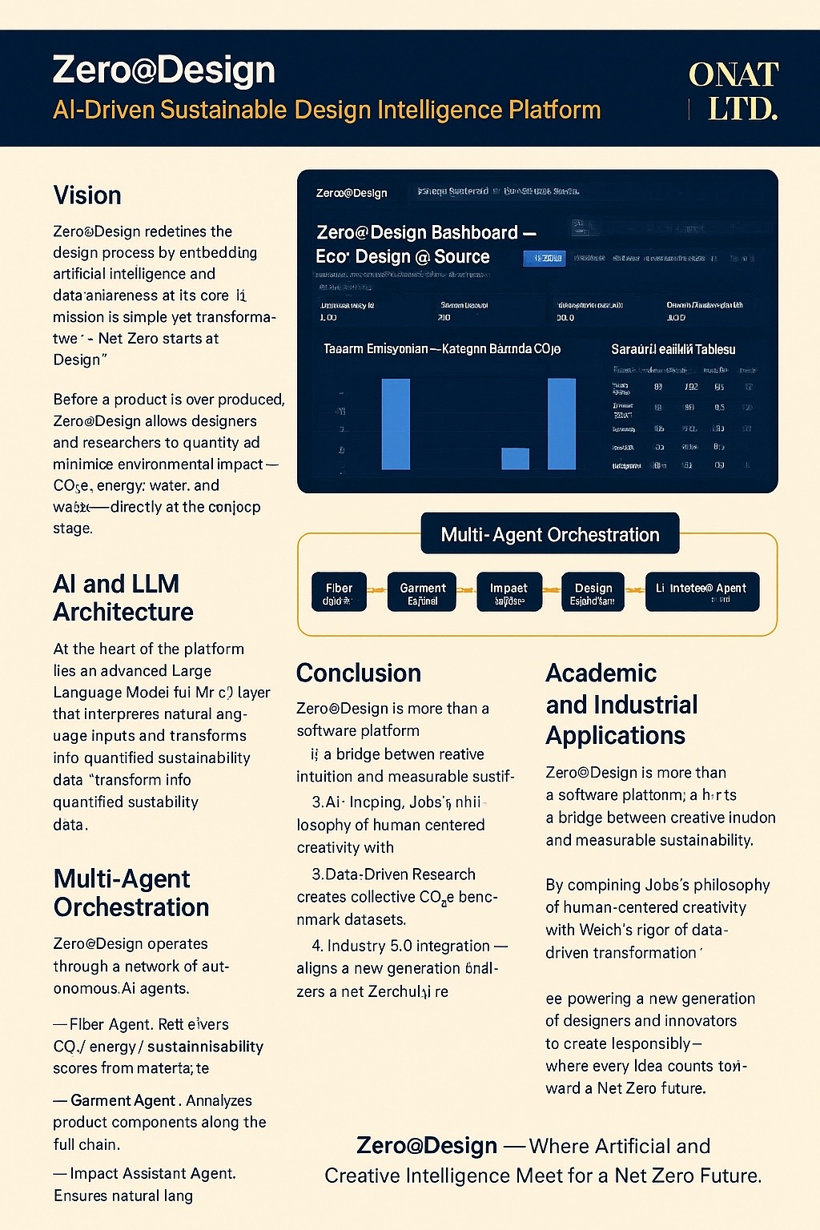

**Vision**

Zero@Design redefines the design process by embedding artificial intelligence and data awareness at its core.  
Its mission is simple yet transformative: “Net Zero starts at Design.”   
Before a product is ever produced, Zero@Design allows designers and researchers to quantify and minimize environmental impact — CO₂e, energy, water, and waste — directly at the concept stage.  
Inspired by Steve Jobs’s belief that technology should disappear into creativity and Jack Welch’s philosophy that you can’t improve what you don’t measure, Zero@Design merges intuitive design with measurable intelligence.

**AI and LLM Architecture**

At the heart of the platform lies an advanced Large Language Model (LLM) layer that interprets natural-language inputs and transforms them into quantified sustainability data.  
Example: “Design a dress made from recycled polyester and viscose, dyed with low-energy pigments.”  
The LLM interprets the request, retrieves fiber and process data, calculates CO₂e, and recommends lower-impact alternatives — all in real time.

**Multi-Agent Orchestration**

Zero@Design operates through a network of autonomous AI agents:  
• Fiber Agent — Retrieves CO₂ / energy / sustainability scores from the fiber library.  
• Garment Agent — Analyzes product components along the full chain.  
• Impact Agent — Calculates live CO₂e, energy, water, and waste impacts.  
• Design Assistant Agent — Suggests lower-impact materials and processes.  
• LLM Interface Agent — Enables natural-language interaction and insight.  
All agents run within an n8n + FastAPI orchestration layer, ensuring smooth communication and automatic generation of Digital Product Passport (DPP) data for every design.

**Academic and Industrial Applications**

Zero@Design is a scalable tool for design schools, research labs, and industry innovation centers:  
1. Eco-Design Studio — visualizes the environmental footprint of every design decision.  
2. AI-Assisted Studio Practice — provides real-time guidance and alternatives.  
3. Data-Driven Research — creates collective CO₂e benchmark datasets.  
4. Industry 5.0 Integration — aligns academic and industrial ecosystems with the EU Green Deal, CSRD, and DPP standards.

**Conclusion**

Zero@Design is more than a software platform; it is a bridge between creative intuition and measurable sustainability.  
By combining Jobs’s philosophy of human-centered creativity with Welch’s rigor of data-driven transformation, Zero@Design empowers a new generation of designers and innovators to create responsibly — where every idea counts toward a Net Zero future.

Zero@Design — Where Artificial and Creative Intelligence Meet for a Net Zero Future.