Quiz question is the same in all experimental conditions and provided below. The order of choices is randomized.

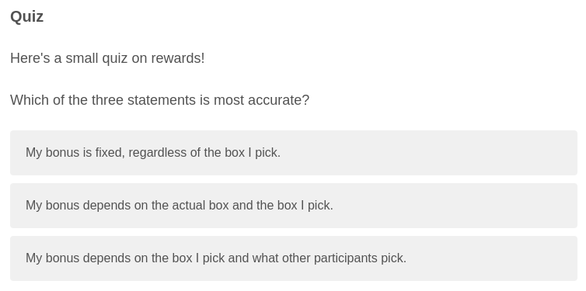

Participants receive feedback according to their answer. In the PPM condition, the correct answer is “My bonus depends on the box I pick and what other participants.” If the correct answer is reported, the following is displayed:

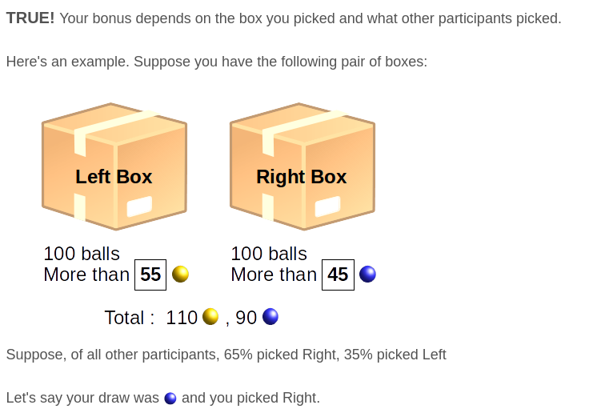

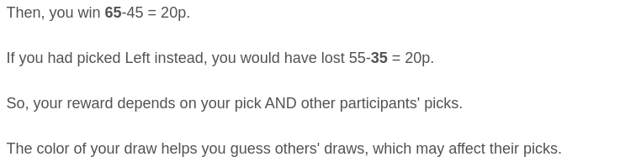

If a participant picks one of the wrong answers, the following is displayed:

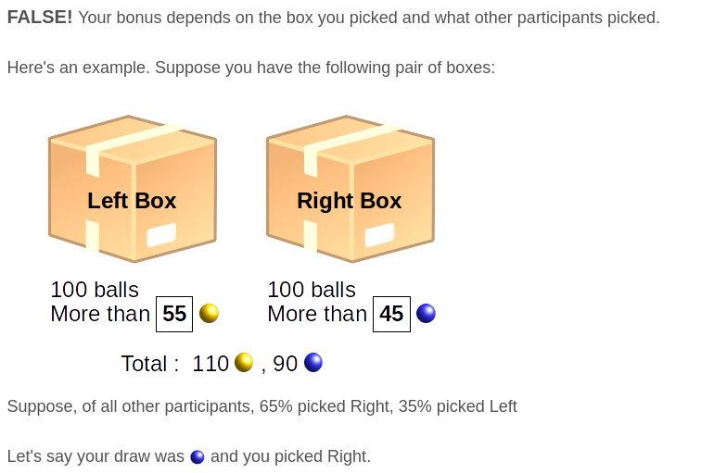
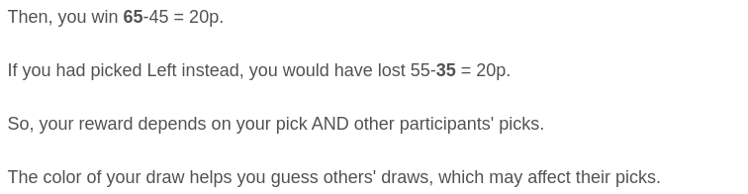

In the Flat condition, the correct answer is “My bonus is fixed, regardless of the box I pick.” If the correct answer is reported, the following is displayed:

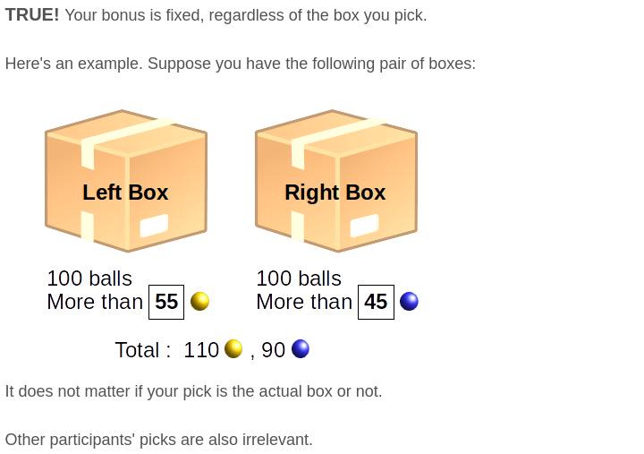

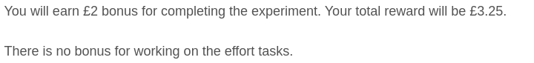

If a participant picks one of the wrong answers, the following is displayed:

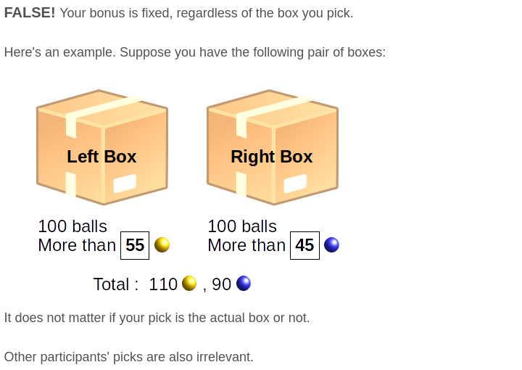

In the Accuracy condition, the correct answer is “My bonus depends on the actual box and the box I picked.” If the correct answer is reported, the following is displayed:

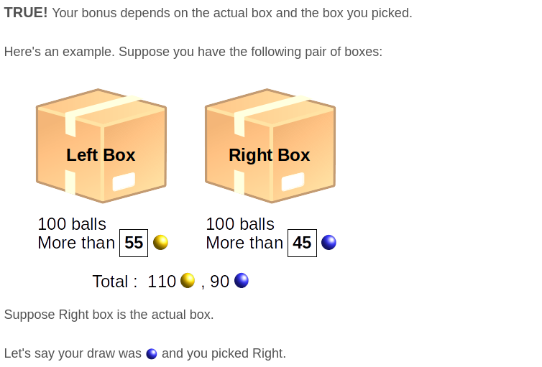



If a participant picks one of the wrong answers, the following is displayed:

