

**Middle East Technical University**

Electrical and Electronics Engineering Department

**EE463 Static Power Conversion I**

Hardware Project Complete Simulation Report

**Elif Çağla Kılınç**

**Cemre Yüce**

**M. Aytunç Evlice**

**M. Salih Kibar**

Table of contents

1. Introduction 3

2. Problem Statement 3

3. Comparison of Topologies 4

3.1. Comparison of Rectifiers 4

3.1.1. Single-Phase Full-Wave Diode Rectifier 4

3.1.2. Three-Phase Full-Wave Diode Rectifier 5

3.1.3. Three-Phase Full-Wave Thyristor Rectifier 7

3.2. Comparison of Buck Converters 9

3.2.1. Buck Converter (1 Diode + 1 Switch) 9

3.2.2. Synchronous Buck Converter (2 Switch) 9

4. Proposed Design 10

4.1 Three-Phase Full Wave Rectifier Design 10

4.2 Buck Converter Design 11

4.3 MOSFET Gate Driver Design 13

5. Power Loss Considerations 14

6. Expected Bonus 15

7. Conclusion 15

# 1. Introduction

Rectifiers and buck converters are key components in motor drive systems, allowing the conversion of AC power to DC for various needs. This project focuses on designing and analyzing an AC/DC converter to efficiently power a DC motor. In this report, different rectifier and buck converter designs are compared by looking at their advantages and disadvantages. The goal is to find the design that best fits the project requirements. The simulations focus only on the selected topology, analyzing its performance in detail. First, simulations are conducted with all components set to ideal conditions, and the results are obtained. Then, the components are adjusted to non-ideal settings, and new simulation results are generated for comparison. By comparing options and selecting the most suitable one, this report helps guide the development of a reliable and effective solution.

# 2. Problem Statement

The goal of this project is to design an efficient system to convert AC power into a stable DC voltage for driving a DC motor. The system will use a rectifier to convert AC power from the Turkish grid into DC, followed by a buck converter to adjust and regulate the DC voltage. The power input can be either from a single-phase or three-phase AC grid, which is adjustable using a variac. The system must provide stable DC output with the following specifications:

* **Power Input:** Single-phase or three-phase AC grid (Turkish Grid System)
* **Maximum DC Output Voltage:** 180 V
* **Adjustable Output Voltage:** Yes
* **Machine Properties:**

***Table 1: Machine Properties***

|  |  |  |  |  |  |
| --- | --- | --- | --- | --- | --- |
| **Armature Winding** | **Shunt Winding** | **Interpoles Winding** | **Rated Current** | **Rated Voltage** | **RPM** |
| 0.8 Ω, 12.5 mH | 210 Ω, 23 H | 0.27Ω,12 mH | 23.4 A | 220V | 1500 |

# 3. Comparison of Topologies

In this section, we analyzed **three** different rectifier topologies and **two** buck converter designs. We compared the advantages and disadvantages of the three rectifiers and evaluated the strengths and weaknesses of the two buck converters relative to each other.

## 3.1. Comparison of Rectifiers

In this section, we examined three different rectifier topologies: the single-phase full-wave diode rectifier, the three-phase full-wave diode rectifier, and the three-phase full-wave thyristor rectifier.

### diyagram, taslak, teknik çizim, plan içeren bir resim Açıklama otomatik olarak oluşturuldu3.1.1. Single-Phase Full-Wave Diode Rectifier

**Figure 1: Single-Phase Full Wave Diode Rectifier**

diyagram, çizgi, öykü gelişim çizgisi; kumpas; grafiğini çıkarma içeren bir resim

Açıklama otomatik olarak oluşturuldu

**Figure 2: Input Current, Input Voltage and Output Voltage Waveform of Single-Phase Full Wave Diode Rectifier**

$$V_{DC}= \frac{2\sqrt{2}}{π} × V_{S }≅0.9 V_{S}$$

**Advantages of Single-Phase Full-Wave Diode Rectifier**

* **Simple and Cost-Effective:** This topology is not expensive, requires less components and is easy to implement.
* **Lower Voltage Ripple:** Compared to a half-wave rectifier, the full-wave rectifier reduces the ripple output, as it utilizes both halves of the AC waveform.
* **Higher Average DC Voltage:** Provides a higher average DC output voltage compared to a half-wave rectifier.
* **Higher Efficiency:** Due to the use of both halves of the AC cycle, more energy is utilized, making it efficient.

**Disadvantages of Single-Phase Full-Wave Diode Rectifier**

* **Low Power Factor (PF):** Power factors are generally low in single-phase systems.
* **Higher Total Harmonic Distortion (THD):** Full-wave rectifiers have more harmonic content, which can lead to effect in other systems.
* **Limited Current Capacity:** Single-phase rectifiers are not suitable for high-power applications due to their lower current carrying capacity.

### diyagram, çizgi içeren bir resim Açıklama otomatik olarak oluşturuldu3.1.2. Three-Phase Full-Wave Diode Rectifier

**Figure 3: Three-Phase Full-Wave Rectifier**

taslak, çizgi içeren bir resim

Açıklama otomatik olarak oluşturuldu

**Figure 4: Output Voltage Waveform of Three-Phase Full Wave Diode Rectifier**

diyagram, plan, teknik çizim, çizgi içeren bir resim

Açıklama otomatik olarak oluşturuldu

**Figure 5: Input Current Waveforms of Three-Phase Full Wave Diode Rectifier**

$$V_{DC}= \frac{3\sqrt{6}}{π} × V_{S }≅1.35 V_{S}$$

**Advantages of Three-Phase Full-Wave Diode Rectifier**

* **Higher Efficiency:** Utilizes three-phase AC, which allows for better conversion efficiency compared to single-phase systems.
* **Lower Voltage Ripple:** The DC output voltage is smoother with lower ripple, as the ripple frequency is three times that of a single-phase rectifier.
* **Higher Power Factor (PF):** Three-phase systems generally have a much higher power factor than single-phase systems.
* **Higher Current Capacity:** Three-phase rectifiers are capable of dealing with much higher power and current demands.

**Disadvantages of Three-Phase Full-Wave Diode Rectifier**

* **More Complex and Expensive:** Three-phase rectifiers require more components and are more complicated to design and implement.
* **Higher THD:** With large loads, the harmonic distortion may increase,so leading to potential power quality issues.

### 3.1.3. Three-Phase Full-Wave Thyristor Rectifier

diyagram, teknik çizim, çizgi, plan içeren bir resim

Açıklama otomatik olarak oluşturuldu

çizgi, diyagram, taslak, beyaz içeren bir resim

Açıklama otomatik olarak oluşturuldu

**Figure 7: Output Voltage Waveform of Three-Phase Full Wave Thyristor Rectifier**

**Figure 6: Three-Phase Full-Wave Thyristor Rectifier**

$$V_{DC}= \frac{3\sqrt{6}}{π} × V_{S }× \cos{∝}≅1.35 V_{S} ×\cos{∝}$$

**Advantages of Three-Phase Full-Wave Thyristor Rectifier**

* **Controlled Output:** Thyristors allow for controlled DC output, making it possible to adjust the output voltage via phase control.
* **High Efficiency:** This topology is highly efficient for high-power applications due to its reduced conversion losses.
* **High Power Factor (PF):** Provides a higher power factor compared to other rectifier types.
* **Higher Power Capacity:** Ideal for systems requiring very high power, such as industrial applications.

**Disadvantages of Three-Phase Full-Wave Thyristor Rectifier**

* **Higher Cost:** Thyristors and associated control circuits are more expensive than diode-based systems.
* **Complex Control System:** Requires a more complex control mechanism for output voltage regulation (phase control).
* **Higher THD:** Uncontrolled thyristor operation can result in significant harmonic distortion.
* **Start-up Delay:** Thyristors have a delayed start-up time, which may be a disadvantage for applications requiring immediate power response.

***Table 2: Comparison of alternative Topologies with each other.***

|  |  |  |  |
| --- | --- | --- | --- |
| **Feature** | **Single-Phase Diode Rectifier** | **Three-Phase Diode Rectifier** | **Three-Phase Thyristor Rectifier** |
| **Simplicity and Cost** | Simple and low-cost | More complex and higher cost | Most complex and expensive |
| **Output Voltage Ripple** | Moderate ripple | Low ripple | Low ripple (depending on phase control) |
| **Power Factor** | Low pf | Higher pf | Higher pf |
| **THD** | Higher THD | Moderate THD | Higher THD (due to controlled switching) |
| **Efficiency** | Moderate efficiency | High Efficiency | High Efficiency |
| **Output Voltage Control** | Fixed output depends on AC voltage | Fixed output depends on AC voltage | Adjustable output using phase control |
| **Current Capacity** | Limited, suitable for low power app. | Higher, suitable for medium/higher power | Very high, suitable for industrial app. |
| **Complexity** | Simple | Moderate | High |

## 3.2. Comparison of Buck Converters

In this section, we analyzed two different buck converter topologies: the classical buck converter and the synchronous buck converter.

### diyagram, çizgi, plan, teknik çizim içeren bir resim Açıklama otomatik olarak oluşturuldu3.2.1. Buck Converter (1 Diode + 1 Switch)

**Figure 8: Buck Converter (1 Diode + 1 Switch)**

### 3.2.2. Synchronous Buck Converter (2 Switch)

diyagram, teknik çizim, çizgi, plan içeren bir resim

Açıklama otomatik olarak oluşturuldu

**Figure 9: Synchronous Buck Converter (2 Switch)**

The classical buck converter in Figure 8 is simpler and easier to control than the synchronous buck converter in Figure 9, which requires more complex control and dead-time management. While the synchronous design is more efficient, especially at low voltages, and offers faster switching, it is also more expensive and harder to implement in Figure 9. For this project, we chose the classical buck converter because it is cost-effective, reliable, and easier to design, providing adequate performance for the DC motor drive without the need for ultra-high efficiency.

# 4. Proposed Design

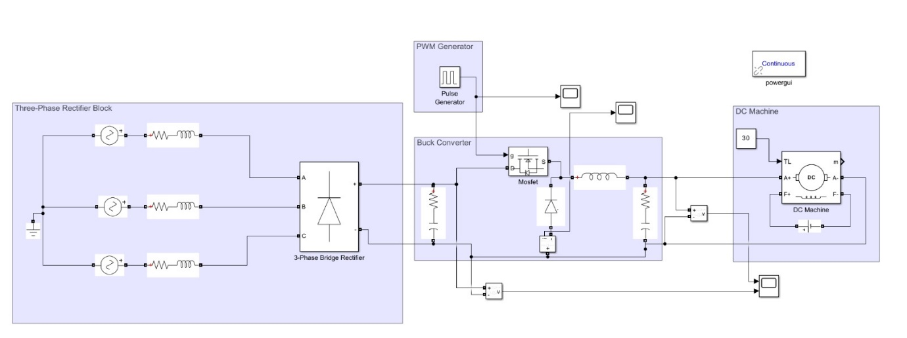

**Figure 10: Full design of the selected topology.**

## 4.1 Three-Phase Full Wave Rectifier Design

In the design, a three-phase full-wave rectifier will be used whose output will be connected to the buck converter block and be its DC input voltage. As mentioned above, this topology was chosen since it has a lower output voltage ripple and would be more appropriate overall for implementation. Instead of using 6 separate diodes, a bridge rectifier module will be used in the hardware implementation for simplicity and compactness. Using 6 diodes for the three-phase rectifier implementation seems to be open to receiving unexpected results more and can make our job harder in the hardware section. Instead using a modular and compact bridge rectifier would be a more economical choice as well as help us gain from the space we will work on. The bridge rectifier's maximum repetitive reverse voltage and maximum output current ratings are usually high which will be more than enough for our project. Since at the rectifier side of the implementation, the operating frequency is 50 Hz at the input and 300 Hz at the output, we do not expect switching-based losses or problems to affect our simulations on a big scale at this point. Some bridge rectifier models we will consider are given below:

**Table 3: Comparison of the different bridge rectifier parameters.**

|  |  |  |  |
| --- | --- | --- | --- |
| Model Name | VRRM | Output Current | VF |
| GUO40-12NO1 | 1200 V | 40 A | 1.28V |
| S80NA30D | 800 V | 30A | 1.2V |
| FUO22-12N | 1200 V | 30A | 1.62V |

The output of the rectifier bridge is Vs (input voltage) for the buck converter hence an appropriate input current should be provided to the rectifier bridge so that the following equations are satisfied:

$$V_{DC}= \frac{3\sqrt{6}}{π} × V_{S }≅1.35 V_{S}$$

$$V_{s}×D=V_{o}=180 V$$

The duty cycle selection and the buck converter implementation will be investigated further in the next part.

## 4.2 Buck Converter Design

For the DC-DC power conversion of the project, a simple buck converter consisting of a MOSFET, a diode and an LC filter was implemented. Since three-phase rectifier output voltage could be selected arbitrarily by changing the Variac percentage, a buck converter can efficiently convert the rectified output to a range between 0 to 180V (maximum value required for the DC motor) by changing the duty cycle. Some advantages of using a buck converter is cost efficiency as the topology requires minimal components, ease of implementation and low ripple/noise output voltage. Also, the maximum duty cycle which gives 180 V output was selected as 0.7 i.e for D= 0.7, output voltage has the average value of 180 V.

For practical implementation, 400V 10A rated IRF740 MOSFET and similarly 400V 10A rated DPG10I400PA diode are proposed as potential components. There could be changes and adjustments based on real experimental outcomes and performance analysis.  
 The output waveforms of the pulse generator, three-phase rectifier output voltage and buck converter output voltage can be seen below in Figures 11,12 and 13, respectively.

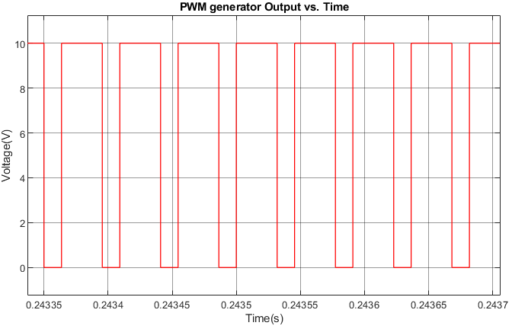

**Figure 11: Pulse generator output voltage for D=0.7**

metin, çizgi, öykü gelişim çizgisi; kumpas; grafiğini çıkarma, diyagram içeren bir resim

Açıklama otomatik olarak oluşturuldu

**Figure 12: Three-phase rectifier output voltage vs. time**

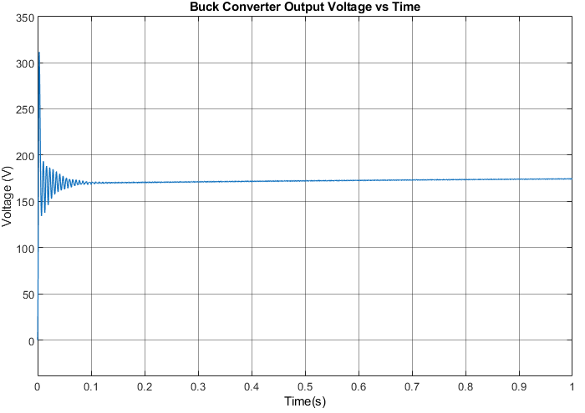

**Figure 13:Buck converter output voltage vs. time.**

## 4.3 MOSFET Gate Driver Design

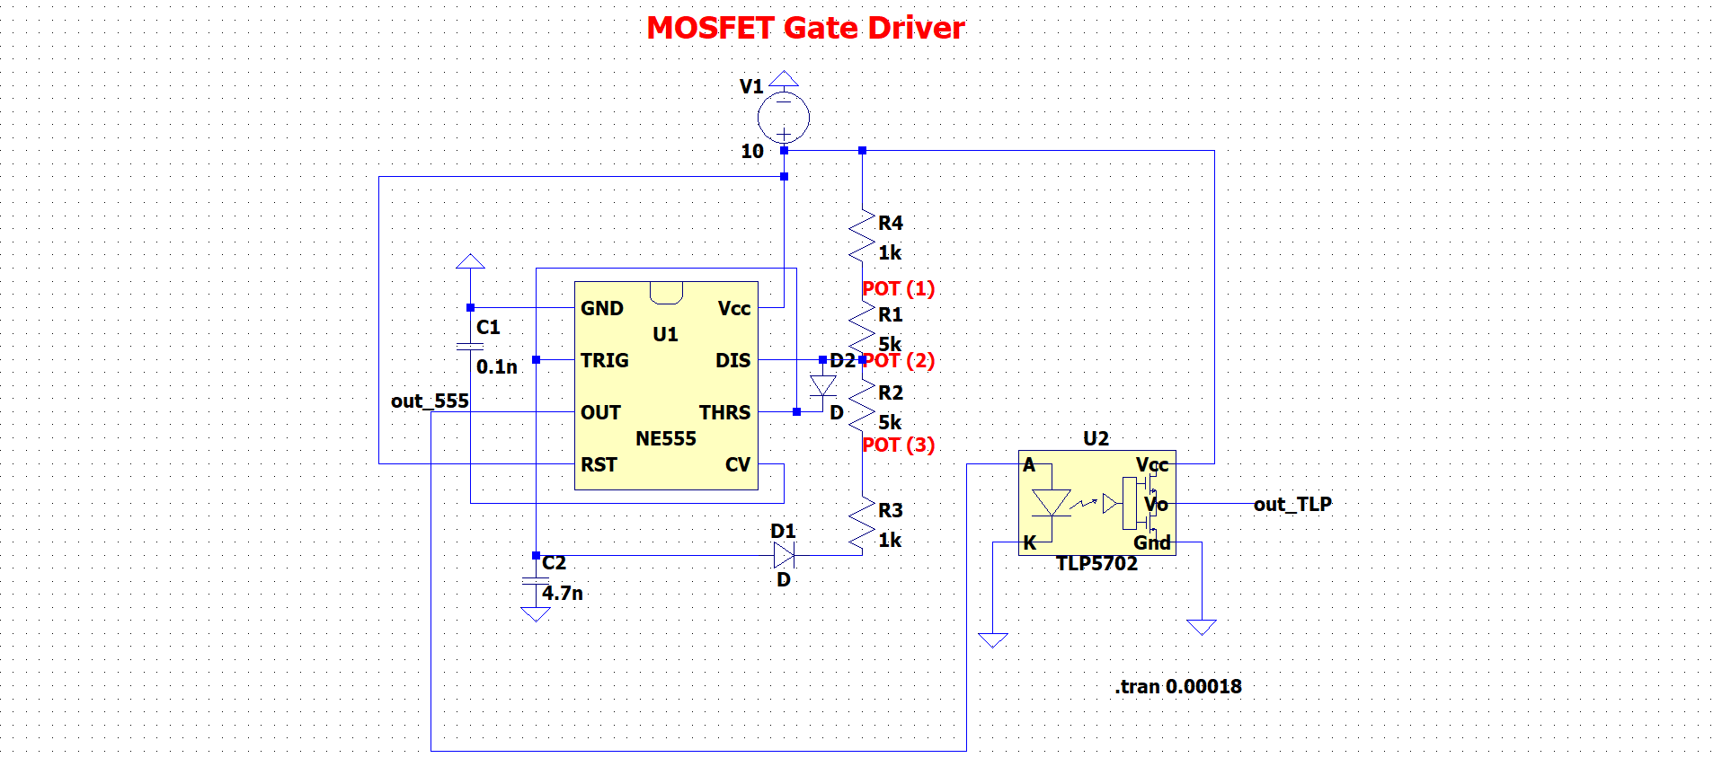In order to drive the MOSFET in the buck converter design, NE555 timer and TLP5702 optocoupler are determined to use. The simulated circuit and simulation results are given in Figures 14 and 15.

**Figure 14: MOSFET Gate Driver Topology.**

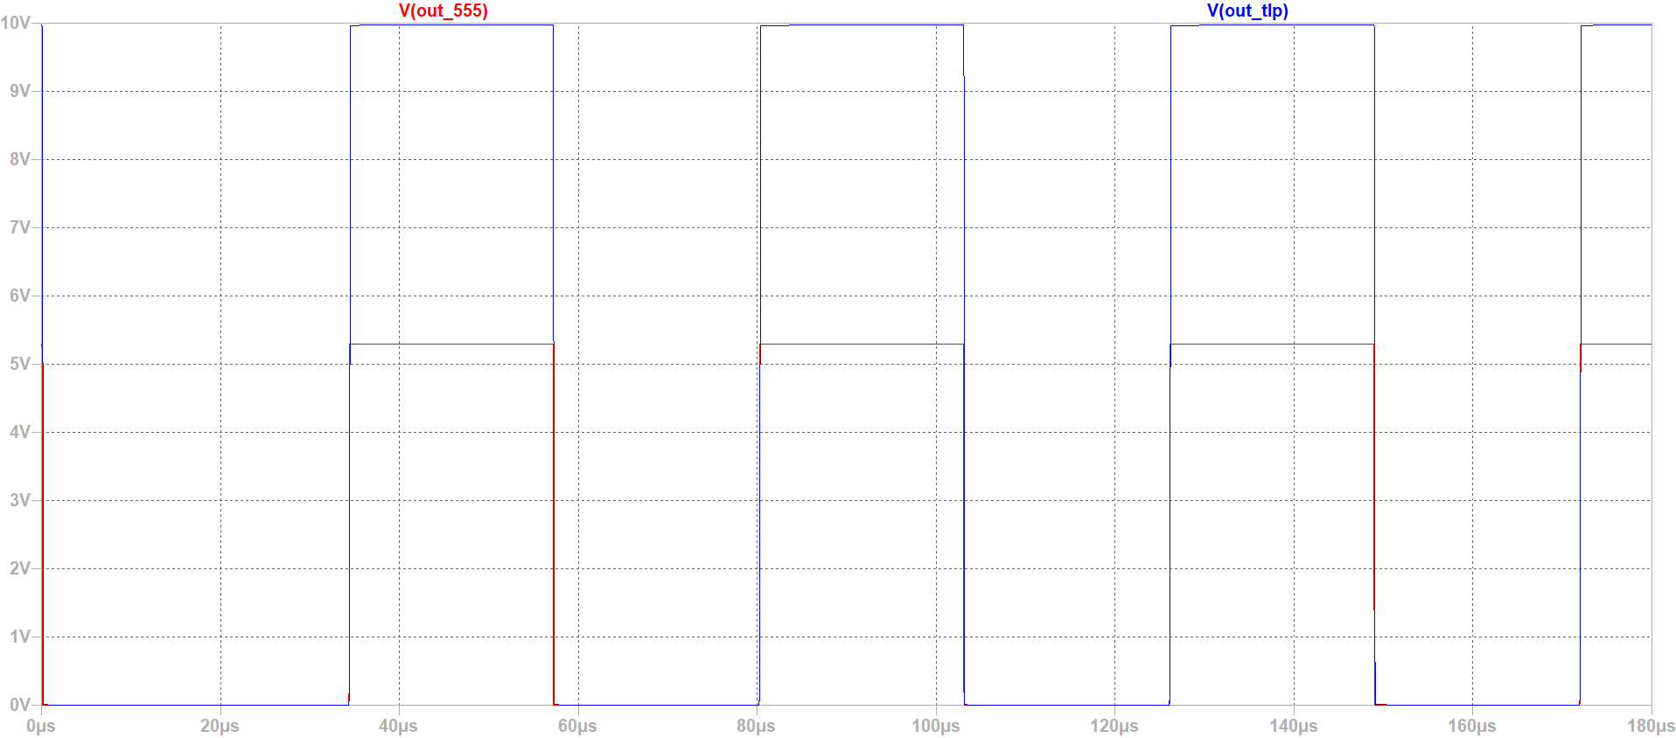

**Figure 15: NE555 and TLP5702 output voltage waveforms with POT12=POT23=5 kΩ .**

We chose to use analog ICs to drive the MOSFET because they make the system more compact and use smaller components compared to an Arduino module. Additionally, by using an optocoupler IC (TLP5702), we were able to isolate the control circuit from the power circuit, which improves reliability and ensures the MOSFET operates correctly.

Figure 11 shows that a potentiometer (POT) is connected to the circuit to adjust the duty cycle of the PWM signal. The effect of changing the potentiometer on the duty cycle is shown in Figures 16 and 17.

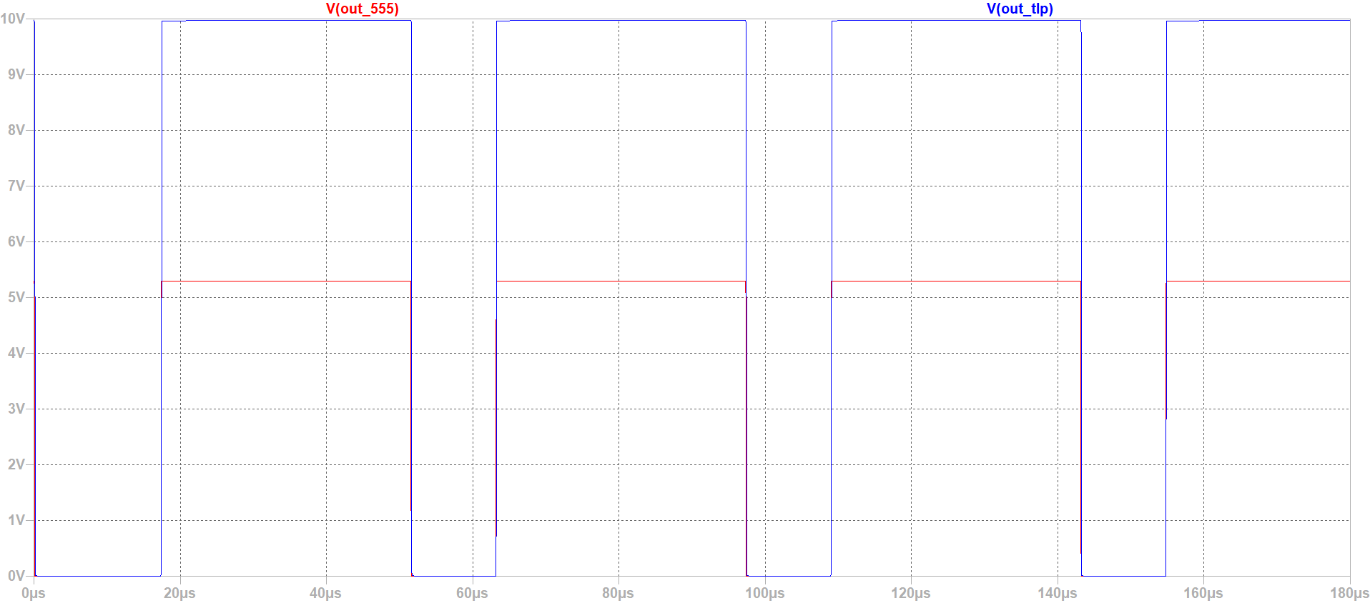

**Figure 16: NE555 and TLP5702 output voltage waveforms with POT12=8 kΩ POT23=2 kΩ.**

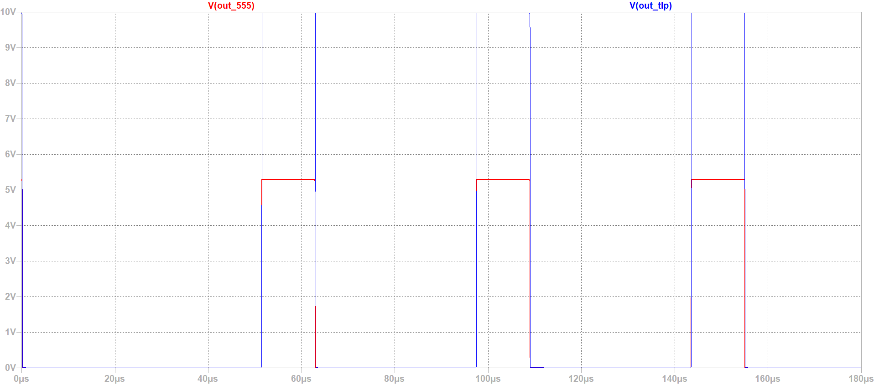

**Figure 17: NE555 and TLP5702 output voltage waveforms with POT12=2 kΩ POT23=8 kΩ.**

Initially, we aimed to generate a 25 kHz PWM. However, in the simulation, we set the frequency to 22 kHz to use more readily available components which are a 4.7 nF capacitor and a 10 kΩ POT.

# 5. Power Loss Considerations

There will be conduction and switching losses in both the diodes and the MOSFET during operation. These losses generate heat, which can lead to thermal stress and reduce the efficiency and lifespan of the components if not properly managed. To address this, we will perform thermal calculations to estimate the heat generated under typical operating conditions. Based on these calculations, we will select and attach appropriate heat sinks to the components to dissipate the heat effectively, ensuring reliable operation and preventing the overall circuit from overheating.

# 6. Expected Bonus

* **Tea Bonus**
* **Efficiency Bonus**
* **Industrial Design Bonus**
* **Single Supply Bonus**

In this project, our primary focus is to meet the essential and definite requirements of design. While we aim to achieve the bonus mentioned above, our priority is to ensure the main goals of the project are successfully accomplished. Once we fulfill these main requirements, we will then attempt to work on achieving the bonuses. The reason behind this approach is to avoid deviating from the main objective while striving for bonus points. As a result, we aim to achieve the bonuses into the design only after the primary goals have been met.

# 7. Conclusion

In this report, proposed solution methods and simulation results for these systems were analyzed in detail. Three different rectifier topologies and two versions of a buck converter were compared. Three phase full-wave rectifier along with a classical buck converter was chosen as the final design. The MOSFET of the buck converter is planned to be controlled using a 555 timer IC along with an optocoupler. The three-phase rectifier proved a righteous choice with the stable DC output voltage with low ripple while the buck converter was successful at converting this output to desired voltage levels while maintaining low-loss and acceptable ripple levels necessary to power the DC motor. The combination of 555 Timer with the optocoupler creates a reliable MOSFET gate driver ensuring the correct application and allowing for the duty cycle selection that can be used to soft start the DC motor.  
 Power loss considerations was addressed and will be further analyzed along with thermal design to allow for acceptable stability of operation. Overall, the proposed topologies and sub-modules show their premises through the simulation results and which will be beneficial as a starting point for hardware implementation.