**Istanbul Technical University**

**Faculty of Computer and Informatics**



**BLG440E Computer Project 2**

**Project 3B: Mining Chrome Repository**

**Group No: 17**

**İrem Ertürk 150140725**

**Cem Yusuf Aydoğdu 150120251**

*GitHub Link:* [*https://github.com/cemysf/blg440e_project3b_group17*](https://l.facebook.com/l.php?u=https%3A%2F%2Fgithub.com%2Fcemysf%2Fblg440e_project3b_group17&h=BAQE5SFF5)

*YouTube Link:* *https://www.youtube.com/watch?v=pZATGk02KVk&feature=youtu.be*

1. **Extracting Useful Data**

First of all, we determine the working repositary from the Chromium project and clone the whole repository to our desktops by the following command:

*$git clone https://chromium.googlesource.com/chromium/src/build/*

Then we realize the that, we need to query some useful data sets which helps us while mining chrome repositories.

* File Name List

with folders: *$ls -ld $(find .) | awk '{print $9}' | sed 's/^..//' | sed -n 'p;$='*

without folders: *$ls -ldp $(find .) | grep -v '/$' | awk '{print $9}' | sed 's/^..//'*

* Developer List

alphabetic developer names:

*$git log --pretty=format:"%cn" | sort | uniq*

developer names and comit counts in numeric order:

*$git log --pretty=format:"%cn" | sort | uniq --count | sort -nr*

1. **Implementation Details**

***Identify Top Developers***

For identying the top developers that contribute most in file changes, we implement the findTopDeveloper() function in 440_S_FindTopStatistics.sh file. That function takes the total commit count and the required percentage as parameter**.**

developer_list**=**"440_F_DeveloperList_Numeric.txt"

**declare** **-**i total_commit

total_commit**=**"$(git rev-list --all --count)"

findTopDevelopers**(){** #$1=total_commit, $2=%x

**declare** **-**i thresold

**declare** **-**i temp

temp**=**0

thresold**=**total_commit**\***$2**/**100

**while** IFS**=** read -r line #while read line;

**do**

current**=**$(echo $line | awk '{print $1}')

percent**=**$(echo "$(echo "($current*100)/$total_commit" | bc -l)" | awk '{printf "%.10f\n",$1}')

temp**=$((**$temp**+**$current**))**

dev**=**$(echo $line | awk '{ for(i=2; i<NF; i++) printf "%s ", $i OFS; if(NF) printf "%s",$NF; printf ORS}')

**echo** -e $percent '\t' $dev

**if** **[** $temp **-**ge $thresold **]**

**then**

**break**

**fi**

**done** **<** "$developer_list" #<<<"$(git log --pretty=format:\"%cn\" | sort | uniq --count | sort -nr)"

**}**

As seen above, findTopDevelopers() function travels through the 440_F_DeveloperList_Numeric.txt which contains the commit counts of each developers with descendent order.In that manner, at the beginning of the function the required commit value(threshold) is calculated with the :: thresold**=**total_commit**\***$2**/**100.($2 represents the percentage value.) And the function stop looking for each line. And the top developers names and their own contribution percentages are written to the 440_FO_TopDevelopers_80.txt file.

***Identify Top Edited Files***

For finding the top edited files, we need a new file which contains the filename and edition number of each files. For that reason findCommitCountOfFiles() function loop through the "440_F_FileList.txt" file and use *$(git log --oneline -- $line | wc -l)* command to get number of editions to specific file.

file_list**=**"440_F_FileList.txt"

findCommitCountOfFiles**(){**

**while** IFS**=** read -r line

**do**

#echo $line

**echo** "$(git log --oneline -- $line | wc -l)" $line

**done** **<** "$file_list"

**}**

Because findTopFiles() function in 440_S_FindTopStatistics.sh file need that the above code creates a new file 440_F_FilesCommitCounts_sorted.txt file. Then findTopFiles() function travel through that by considering total commit count and the required percentage as parameter**.**

topfile_list**=**"440_F_FilesCommitCounts_sorted.txt"

findTopFiles**(){**

**declare** **-**i thresold

**declare** **-**i temp

temp**=**0

thresold**=**total_commit**\***$2**/**100

**while** IFS**=** read -r line

**do**

#echo $line

#echo "$(git log --oneline -- $line | wc -l)" $line

current**=**$(echo $line | awk '{print $1}')

percent**=**$(echo "$(echo "($current*100)/$total_commit" | bc -l)" | awk '{printf "%.10f\n",$1}')

temp**=$((**$temp**+**$current**))**

dev**=**$(echo $line | awk '{ for(i=2; i<NF; i++) printf "%s ", $i OFS; if(NF) printf "%s",$NF; printf ORS}')

**echo** -e $percent '\t' $dev

**if** **[** $temp **-**ge $thresold **]**

**then**

**break**

**fi**

**done** **<** "$topfile_list"

***}***

As seen above, findTopFiles() function travels through the 440_F_FilesCommitCounts_sorted.txt which contains the file names in alphabetic order with the edition numbers.In that manner, at the beginning of the function the required commit value(threshold) is calculated with the :: thresold**=**total_commit**\***$2**/**100.($2 represents the percentage value.) And the function stop looking for each line whenever temp value reacehes the predefined threshold value. And the top developers names and their own contribution percentages are written to the 440_FO_TopFiles_80.txt file.

***Create Adjacency Matrix***

#! /bin/bash

committer_list**=**"440_F_DeveloperList_Alphabetic.txt"

file_list**=**"440_F_FileList.txt"

**declare** -A names

Map each developers name to an integer value and use it whenever the developer contibute the change in file.

# print commiter names in the first line

**declare** **-**i index

index**=**0

**while** IFS**=** read -r name

**do**

names**[**"\"$name\""**]=**$index

**((**index++**))**

**done** **<** "$committer_list"

# Construct adj matrix

**declare** **-**i column_number

**declare** **-**i row_number

**To create the adjacency matrix for representing contributions to each files, we first create and initialize the Adjacency matrix with all zeros by using the initializeMatrix() function. Rows represent the files and the columns represents the developers.**

initializeMatrix**()**

**{**

**local** index**=**0

**local** total**=$((**$row_number **\*** $column_number**))**

**while** **[** "$index" **-**lt "$total" **]**

**do**

AdjMatrix**[**$index**]=**0

**let** "index += 1"

**done**

**}**

printMatrix**()**

**{**

**local** index**=**0

**for** **((**r**=**0**;** r**<**row_number**;**r++**))**

**do**

**for** **((**c**=**0**;** c**<**column_number**;** c++**))**

**do**

**let** "index = $r*$column_number + $c"

**echo** -n "${AdjMatrix[$index]} "

**done**

**echo** ""

**done**

**}**

printRow**()** #$1:row

**{**

**local** index**=**0

**for** **((**c**=**0**;** c**<**column_number**;** c++**))**

**do**

**let** "index = $1*$column_number + $c"

**echo** -n "${AdjMatrix[$index]} "

**done**

**echo** ""

**}**

modifyValue**()** ## $1=row $2=col $3=value

**Modify value fuction takes the row, column and new_value as parameters. Because we store adjacency matrix in one one dimensional array rather than 2d array, we calculate the index by using row and column values. And change the value with one.**

**{**

**local** index**=**0

**let** "index = $1*$column_number + $2"

AdjMatrix**[**"$index"**]=**$3

**}**

# for each file in the list, check its collaborators

**declare** **-**i row_count

**declare** **-**i temp

**declare** **-**i constant_v

row_count**=**0

temp**=**0

constant_v**=**1

**declare** -a AdjMatrix

row_number**=**1

**The main flow of algorithm is done here. The blue highlighted code loops through the "440_F_FileList.txt" file and for each file finds the file contributers. As you can see in the inner while loop we call the modifyValuefunction to change value in adjacency matrix. After all contributers of files modified in inner loop we print the rows.**

column_number**=**${#names[@]}

**while** IFS**=** read -r item

**do**

initializeMatrix

**while** **read** n**;**

**do**

temp**=**${names[$n]}

modifyValue 0 ${names[$n]} 1

**done** <<<"$(git log --pretty=format:\"%cn\" -- $item | sort | uniq )"

printRow

**done** **<** "$file_list"

1. **Matrix Visualization**

#! /usr/bin/env python

At the last step of our project, we encounter with problem about visualization tools. First of all, there exists no download link in given SocialAction website. Then, we try to use Gephi social network visualization tool. However, its comma separated format is not suitable for our adjacency matrix format. For that reason we write a python code which represents our adjacency matrix.

# -*- coding: utf-8 -*-

**import** matplotlib**.**pyplot **as** plt

**import** numpy **as** np

input_file**=**"440_FO_Matrix.txt"

matrix**=[]**

# Read file into an array

**with** open**(**input_file**)** **as** f**:**

**for** line **in** f**:**

matrix**.**append**(**line**.**split**())**

# Copy matrix into numpy array

numpy_array**=**np**.**array**(**matrix**,** dtype**=**np**.**float**)**

# Plot numpy array

fig **=** plt**.**figure**()**

ax**=** fig**.**add_subplot**(**1**,**1**,**1**)**

ax**.**imshow**(**numpy_array**,** cmap**=**plt**.**cm**.**Greens**,** origin**=**"lower"**)**

ax**.**xaxis**.**tick_top**()**

ax**.**spines**[**'top'**].**set_visible**(**False**)**

ax**.**spines**[**'right'**].**set_visible**(**False**)**

ax**.**spines**[**'bottom'**].**set_visible**(**False**)**

ax**.**spines**[**'left'**].**set_visible**(**False**)**

plt**.**gca**().**invert_yaxis**()**

# Show and write

plt**.**show**()**

fig**.**savefig**(**"adjMatrix_output.png"**,** dpi**=**350**)**

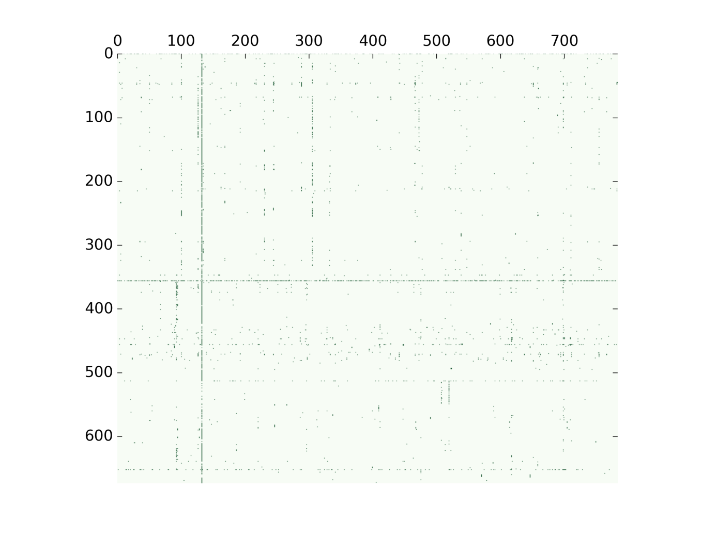

1. **Results**

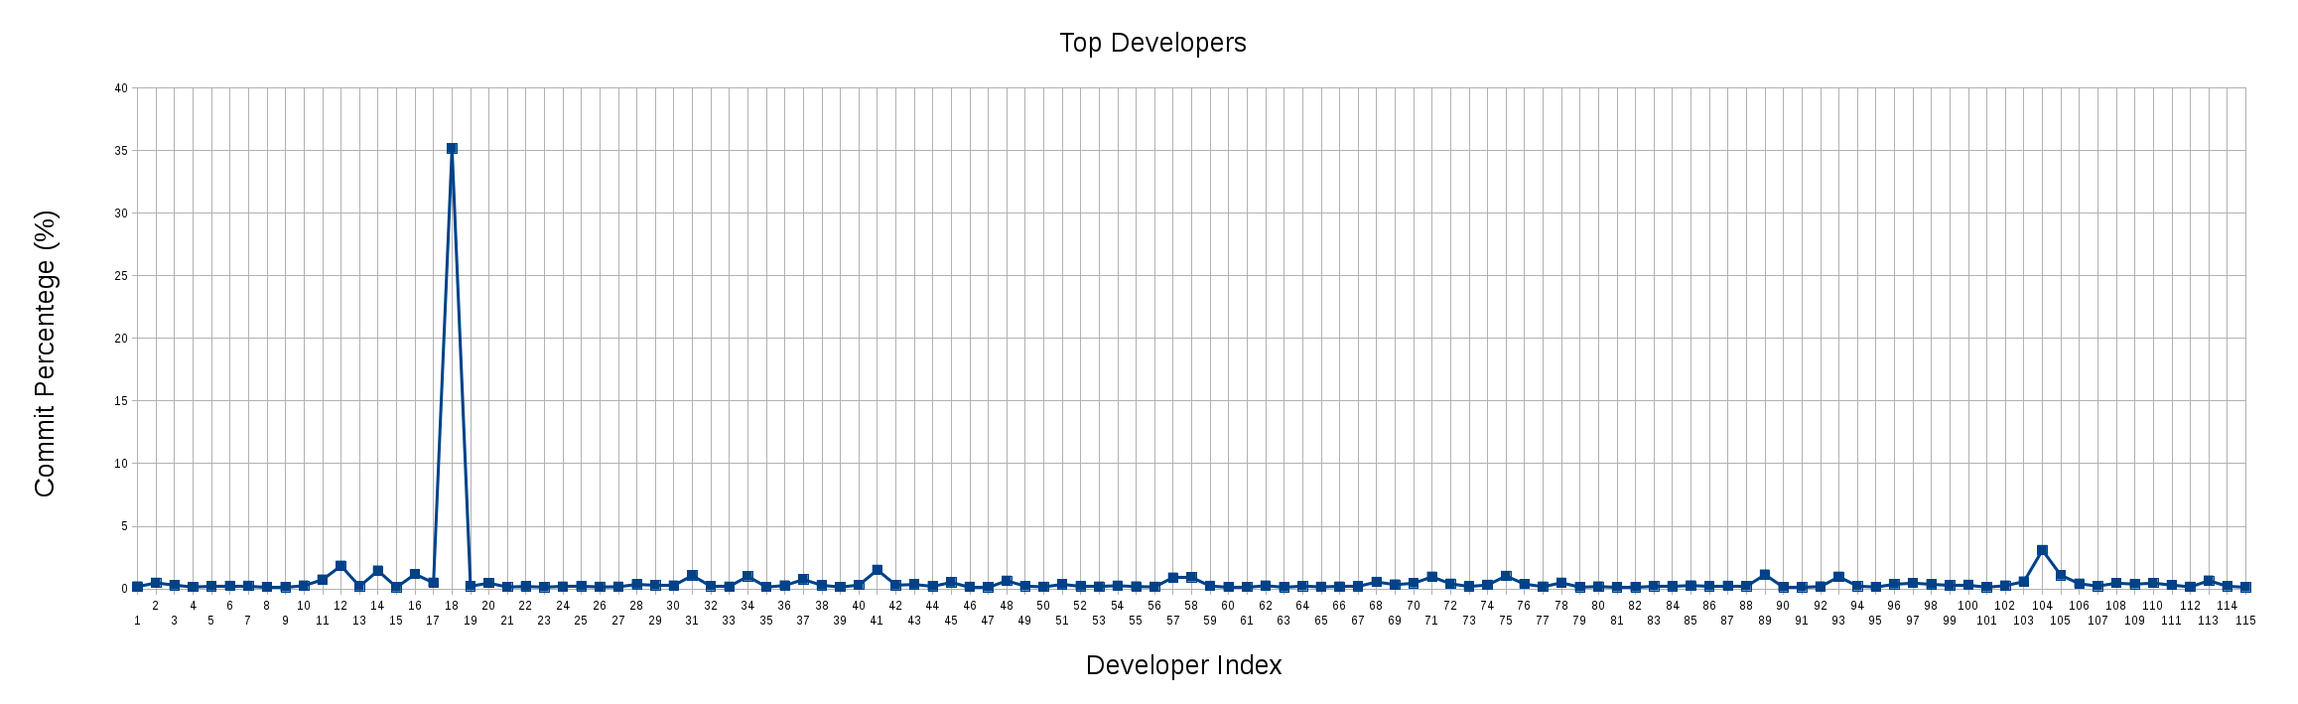

|  |  |
| --- | --- |
| 0.1835872958 | aberent@chromium.org |
| 0.477326969 | agl@chromium.org |
| 0.2937396732 | ajwong@chromium.org |
| 0.1468698366 | andrewhayden@chromium.org |
| 0.2019460253 | apatrick@chromium.org |
| 0.2294841197 | aurimas@chromium.org |
| 0.2386634845 | ben@chromium.org |
| 0.1468698366 | blundell@chromium.org |
| 0.1376904718 | boliu@chromium.org |
| 0.2570222141 | bradnelson@chromium.org |
| 0.734349183 | bradnelson@google.com |
| 1.8450523224 | brettw@chromium.org |
| 0.2019460253 | Brett Wilson |
| 1.4503396365 | bulach@chromium.org |
| 0.128511107 | cevans@chromium.org |
| 1.1749586929 | cjhopman@chromium.org |
| 0.4865063338 | cmp@chromium.org |
| 35.1569671379 | Commit bot |
| 0.2203047549 | cpu@chromium.org |
| 0.4589682394 | craigdh@chromium.org |
| 0.1468698366 | csharp@chromium.org |
| 0.1927666605 | davemoore@chromium.org |
| 0.1376904718 | derat@chromium.org |
| 0.174407931 | dfalcantara@chromium.org |
| 0.2019460253 | digit@chromium.org |
| 0.1560492014 | dkegel@google.com |
| 0.1652285662 | dmichael@chromium.org |
| 0.3579952267 | dpranke@chromium.org |
| 0.2937396732 | erg@chromium.org |
| 0.2570222141 | eugenis@chromium.org |
| 1.0648063154 | evan@chromium.org |
| 0.2203047549 | evanm@google.com |
| 0.1652285662 | fischman@chromium.org |
| 1.0005507619 | frankf@chromium.org |
| 0.1468698366 | frankf@google.com |
| 0.2662015789 | gkanwar@chromium.org |
| 0.7527079126 | glider@chromium.org |
| 0.2845603084 | hans@chromium.org |
| 0.1468698366 | hclam@chromium.org |
| 0.302919038 | iannucci@chromium.org |
| 1.51459519 | ilevy@chromium.org |
| 0.2937396732 | jam@chromium.org |
| 0.3488158619 | jamesr@chromium.org |
| 0.2019460253 | james.wei@intel.com |
| 0.5140444281 | jbudorick@chromium.org |
| 0.1560492014 | jknotten@chromium.org |
| 0.1376904718 | jln@chromium.org |
| 0.6425555352 | jochen@chromium.org |
| 0.2203047549 | joi@chromium.org |
| 0.1560492014 | joth@chromium.org |
| 0.3579952267 | jrg@chromium.org |
| 0.2019460253 | jrg@google.com |
| 0.174407931 | jschuh@chromium.org |
| 0.2478428493 | jshin@chromium.org |
| 0.1835872958 | kjellander@chromium.org |
| 0.1560492014 | kkania@chromium.org |
| 0.8903983844 | mark@chromium.org |
| 0.9271158436 | maruel@chromium.org |
| 0.2294841197 | michaelbai@chromium.org |
| 0.1468698366 | michaelbai@google.com |
| 0.1468698366 | mithro@mithis.com |
| 0.2570222141 | mkosiba@chromium.org |
| 0.128511107 | mmentovai@google.com |
| 0.2203047549 | mmoss@chromium.org |
| 0.1560492014 | mmoss@google.com |
| 0.174407931 | mnaganov@chromium.org |
| 0.1927666605 | mostynb@opera.com |
| 0.5507618873 | navabi@google.com |
| 0.3396364972 | newt@chromium.org |
| 0.4497888746 | Nico Weber |
| 0.9638333027 | nileshagrawal@chromium.org |
| 0.4038920507 | nsylvain@chromium.org |
| 0.1927666605 | oshima@chromium.org |
| 0.3120984028 | peter@chromium.org |
| 1.0280888563 | phajdan.jr@chromium.org |
| 0.3855333211 | piman@chromium.org |
| 0.174407931 | pkasting@chromium.org |
| 0.4865063338 | pliard@chromium.org |
| 0.1376904718 | primiano@chromium.org |
| 0.1835872958 | qsr@chromium.org |
| 0.1376904718 | rmcilroy@chromium.org |
| 0.128511107 | robertshield@chromium.org |
| 0.2203047549 | rsesek@chromium.org |
| 0.1927666605 | rsleevi@chromium.org |
| 0.2662015789 | sadrul@chromium.org |
| 0.2111253901 | saintlou@chromium.org |
| 0.2386634845 | sbc@chromium.org |
| 0.2203047549 | scherkus@chromium.org |
| 1.1382412337 | scottmg@chromium.org |
| 0.1376904718 | scottmg@google.com |
| 0.1376904718 | sebmarchand@chromium.org |
| 0.1835872958 | sergeyu@chromium.org |
| 0.9638333027 | sgk@google.com |
| 0.2203047549 | shashishekhar@chromium.org |
| 0.1468698366 | shouqun.liu@intel.com |
| 0.3671745915 | sivachandra@chromium.org |
| 0.4589682394 | sky@chromium.org |
| 0.3579952267 | skyostil@chromium.org |
| 0.2753809436 | spang@chromium.org |
| 0.3120984028 | stuartmorgan@chromium.org |
| 0.1376904718 | tapted@chromium.org |
| 0.2570222141 | tc@google.com |
| 0.5782999816 | tfarina@chromium.org |
| 3.0934459335 | thakis@chromium.org |
| 1.083165045 | thestig@chromium.org |
| 0.4130714155 | thomasvl@chromium.org |
| 0.2203047549 | timurrrr@chromium.org |
| 0.4589682394 | tony@chromium.org |
| 0.3763539563 | tonyg@chromium.org |
| 0.4589682394 | torne@chromium.org |
| 0.302919038 | wangxianzhu@chromium.org |
| 0.1560492014 | willchan@chromium.org |
| 0.6517348999 | yfriedman@chromium.org |
| 0.2111253901 | yongsheng.zhu@intel.com |
| 0.128511107 | zty@chromium.org |

|  |  |
| --- | --- |
| % | Developer |

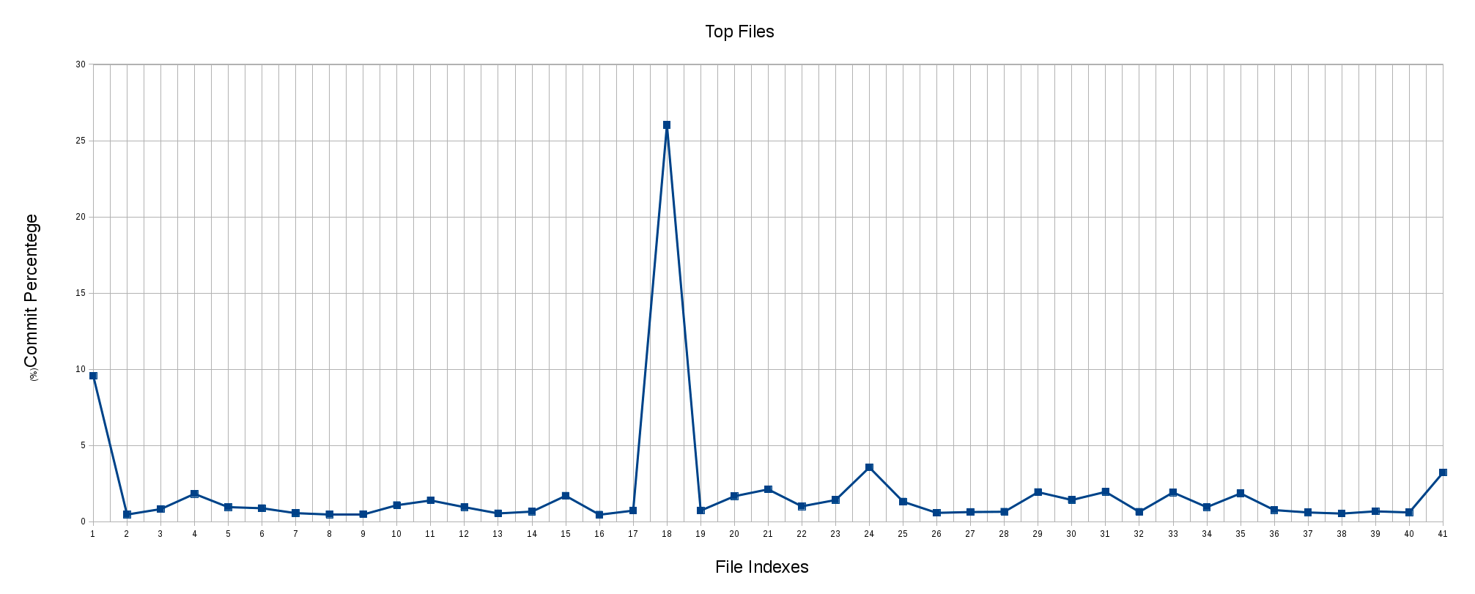

|  |  |
| --- | --- |
| % | File |
| 9.5557187443 | all.gyp |
| 0.4589682394 | android/adb_install_apk.py |
| 0.8169634661 | android/buildbot/bb_device_status_check.py |
| 1.817514228 | android/buildbot/bb_device_steps.py |
| 0.9454745732 | android/buildbot/bb_run_bot.py |
| 0.8720396549 | android/envsetup.sh |
| 0.5507618873 | android/gyp/javac.py |
| 0.4681476042 | android/gyp/util/build_utils.py |
| 0.477326969 | android/PRESUBMIT.py |
| 1.0739856802 | android/provision_devices.py |
| 1.386084083 | android/pylib/device/device_utils.py |
| 0.9454745732 | android/pylib/gtest/filter/content_browsertests_disabled |
| 0.5324031577 | android/pylib/gtest/gtest_config.py |
| 0.6517348999 | android/pylib/perf/test_runner.py |
| 1.689003121 | android/test_runner.py |
| 0.4497888746 | android/tombstones.py |
| 0.7159904535 | build_config.h |
| 26.0234991739 | common.gypi |
| 0.7159904535 | config/android/config.gni |
| 1.6614650266 | config/android/internal_rules.gni |
| 2.1112539012 | config/android/rules.gni |
| 1.0005507619 | config/BUILDCONFIG.gn |
| 1.4136221773 | config/BUILD.gn |
| 3.5524141729 | config/compiler/BUILD.gn |
| 1.3034697999 | config/features.gni |
| 0.5691206169 | config/linux/BUILD.gn |
| 0.6241968056 | config/win/BUILD.gn |
| 0.6425555352 | get_landmines.py |
| 1.9276666055 | gn_migration.gypi |
| 1.4136221773 | gyp_chromium |
| 1.946025335 | install-build-deps.sh |
| 0.6333761704 | isolate.gypi |
| 1.9093078759 | java_apk.gypi |
| 0.9454745732 | java.gypi |
| 1.8450523224 | linux/system.gyp |
| 0.7527079126 | sanitizers/tsan_suppressions.cc |
| 0.5966587112 | toolchain/gcc_toolchain.gni |
| 0.5232237929 | toolchain/mac/BUILD.gn |
| 0.6700936295 | toolchain/win/BUILD.gn |
| 0.5966587112 | vs_toolchain.py |
| 3.2127776758 | whitespace_file.txt |

