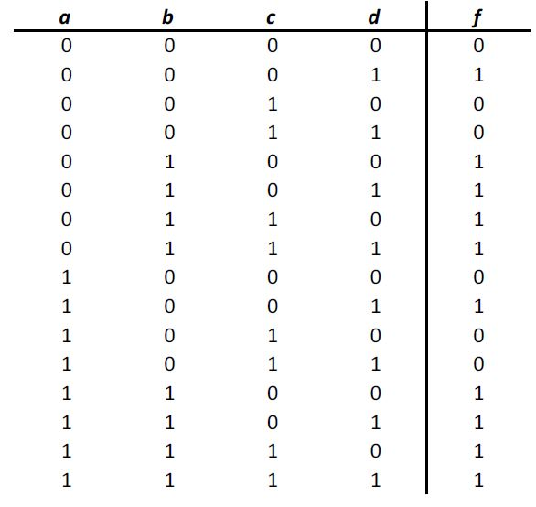 **1-a)** 1st canonical form: PoS

f=Σm(1,4,5,6,7,9,12,13,14,15)

f=a’b’c’d + a’bc’d’ + a’bc’d + a’bcd’ + a’bcd + ab’c’d + abc’d’ + abc’d + abcd’ + abcd

2nd canonical form: SoP

f=ΠM(0,2,3,8,10,11)

f=(a+b+c+d)(a+b+c’+d)(a+b+c’+d’)(a’+b+c+d) (a’+b+c’+d)(a’+b+c’+d’)

**b)** f=(a+b+c+d)(a+b+c’+d)(a+b+c’+d’)(a’+b+c+d)(a’+b+c’+d)(a’+b+c’+d’)

=(a+b+d)(~~c+c’~~)(b+c’+d’)(~~a+a’~~)(a’+b+d)(~~c+c’~~)

=(a+b+d)(b+c’+d’)(a’+b+d)

=(b+d)(~~a+a’~~)(b+c’+d’)

=(b+d)(b+c’+d’)(b+c’) consensus

=(b+d)(b+c’)(~~1+d’~~)

=bb+bc’+bd+c’d

=b(1+c’)+bd+c’d

=b+bd’c’d

=b(1+d)+c’d

=b+c’d

c’d=(c+d)’ ((b+c’d)’ )’=f

