**1)** f1: A>B and A>C A-B>0 (A+(B’+1))>0 A-C>0 (A+(C’+1))>0

f2: A>B and A<C, or , A<B and A>C.

f3: A<B and A<C A-B<0 (A+(B’+1))<0 A-C<0 (A+(C’+1))<0

if A<B, C1(carry 1)=0 A<C, C2(carry 2)=0

Bits of A-B(s1) and A-C(s2) are separately combined with 4 input or-gates(X1, X2) in order to eliminate A=B and A=C cases. A 2:4 decoder is used.

If A=B, X1 gives ‘0’; if A=C, X2 give ‘0’. Else, they give ‘1’ as output.

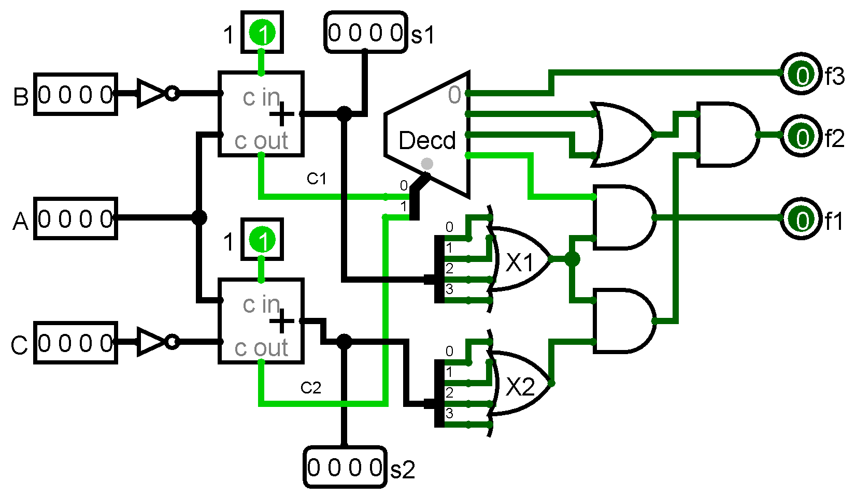

**2)**

a b c d f

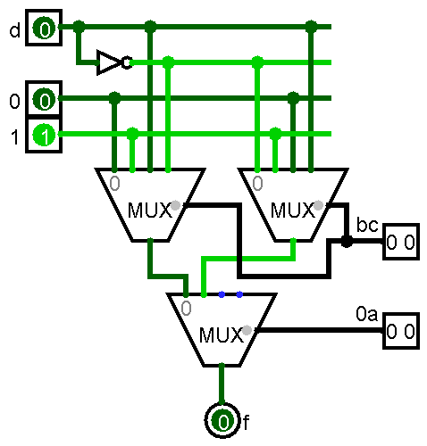0 0 0 0 0

0

0 0 0 1 0

0 0 1 0 1

1

0 0 1 1 1

0 1 0 0 0

d

0 1 0 1 1

0 1 1 0 1

d’

0 1 1 1 0

1 0 0 0 1

d’

1 0 0 1 0

1 0 1 0 1

1

1 0 1 1 1

1 1 0 0 0

0

1 1 0 1 0

1 1 1 0 0

d

1 1 1 1 1