**Istanbul Technical University**

**Faculty of Computer and Informatics**



**BLG322E Computer Architecture**

**Homework 2**

**Cem Yusuf Aydoğdu**

**150120251**

**Date of Submission : 7.4.2015**

1. a. Representation of the system

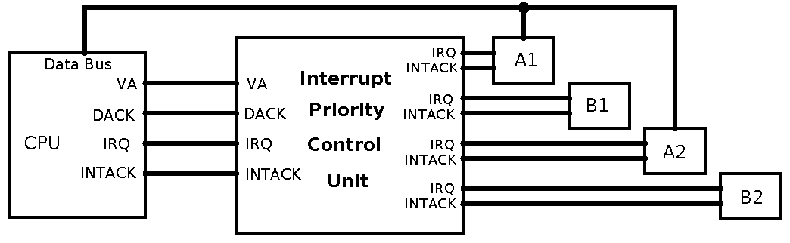

1. b. Serial priority circuit and connections

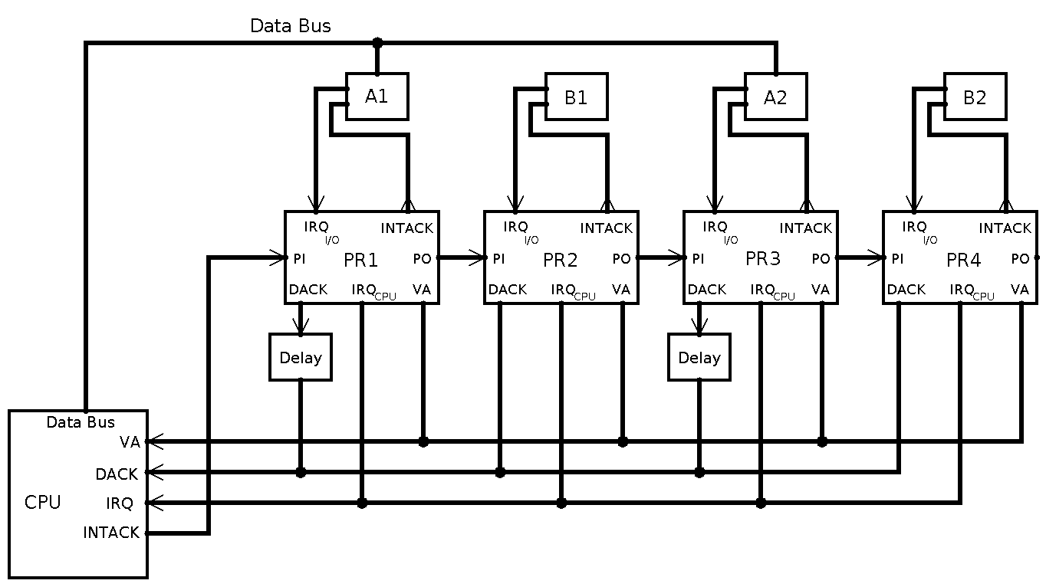

Inside priority chains for A:

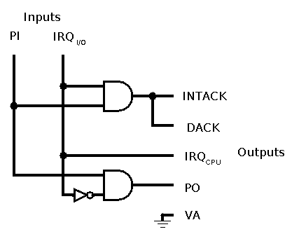

Inside priority chain for B1:

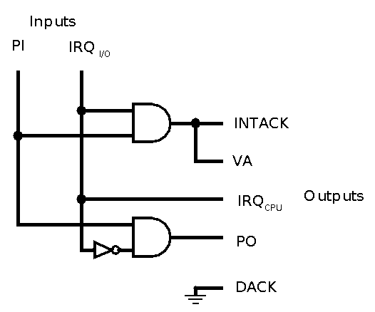

Inside priority chain for B2:

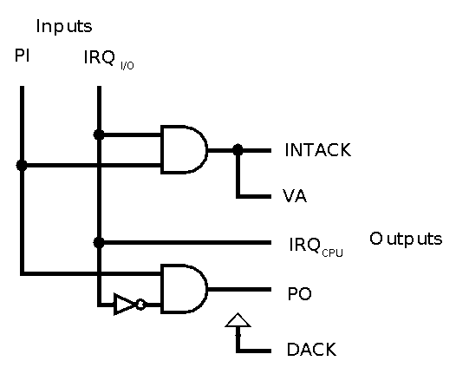

1. c. Parallel circuit

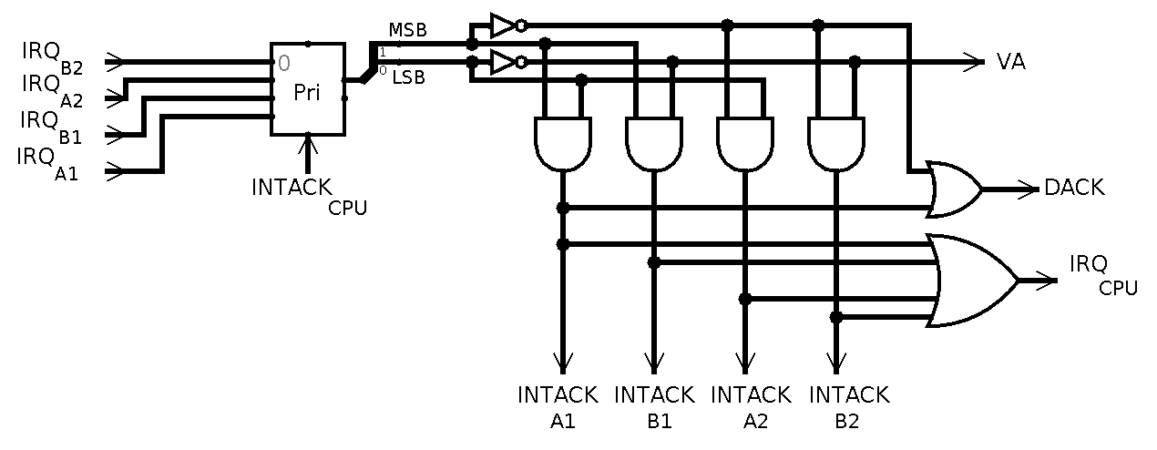

1. In both connection types, if the request comes from one of the A devices, chain circuit outputs VA=0 and DACK=1, and the relevant device puts its interrupt address to the data bus.

If the B1 device requests an interrupt, chain circuit outputs VA=1 and DACK=0. If the B2  device requests an interrupt, its chain circuit outputs VA=1 and DACK=1.