**Istanbul Technical University**

**Faculty of Computer and Informatics**



**BLG335E Analysis of Algorithms 1**

**Project 4 Report**

**Cem Yusuf Aydoğdu**

**150120251**

# Part A

1. Because hash tables provide retrive, delete, insert operations in constant time in average, since keys are mapped into a smaller number of set and index of a key can be calculated in constant time.
2. Since hashing is an effective method, it is widely used in compiler design, error checking, database indexing, caching, software integrity verification, password authentication and many other applications.

# Part B

UML diagram of the classes in the code is shown below.

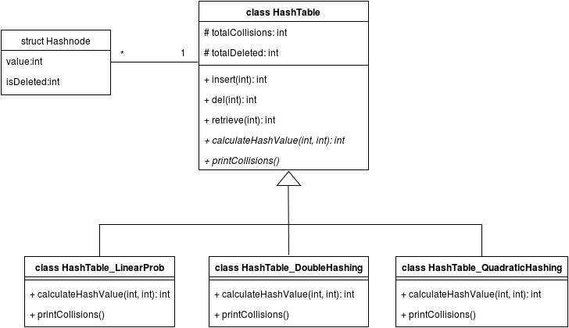

Number of collision for each strategy, using hash table size m=2477 is shown below. Linear probing is heavily effected from load factor of the table in the long run, therefore it has more collisions. Quadratic hashing perfoms better than linear probing because using a quadratic function as probe decreases the probability of clustering. The result shows that double hashing is the most effective method, because using two different hash function decrements the collision probability dramatically, compared to other strategies.

|  |  |  |
| --- | --- | --- |
| Linear | Quadratic | Double |
| 7452 | 3525 | 3118 |