**Istanbul Technical University**

**Faculty of Computer and Informatics**



**BLG335E Analysis of Algorithms 1**

**Project 5 Report**

**Cem Yusuf Aydoğdu**

**150120251**

1. Age is key in the implementation, therefore in order to update a key, deleting the node and inserting it again with its new value will be equivalent to updating a key.

Firstly, deletion operation requires additional work according to relevant case.

**Case 1:** When deleting a node, if the node has no left child, it is deleted and its right child becomes its successor(swiches to position of the deleted node).

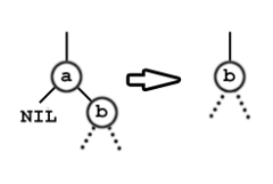

**Case 2:**Similar to case 1, if the node has no right child, it is deleted and its left child becomes its successor.

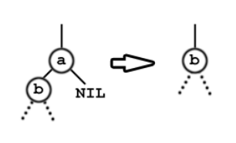

**Case 3:** If the node has both childs and its right child has no left child, its right child becomes its successor after deletion. Also, left child of the deleted node becomes left child of the new node.

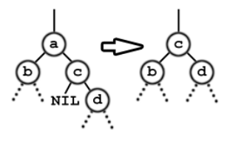

**Case 4:** If the node has both childs and its right child has left children, that left children becomes the successor of deleted node, and its children becomes its grandchildren from right side.

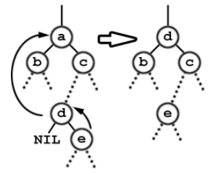

After these cases, color correction is done if required. Then, new node with updated value is inserted.

1. Gender is not key, therefore finding the person using the key iteratively or recursively, and then changing the gender value is enough. This operation will not change binary tree properties, so no other operations needed.