**Istanbul Technical University**

**Faculty of Computer and Informatics**



**BLG336E Analysis of Algorithms 2**

**Project 3**

**Report**

**Cem Yusuf Aydoğdu**

**150120251**

The problem can be formulated as a maximum flow problem. Visualization output of the problem which is produced by graphviz dot graph tool is given below. Code for producing this dot graph is also provided in the implementation.

Numbers above each edge represent flow value and capacity of respectively. Source has edges with one capacity to each object. Objects are connected to their compatible robots with single capacity edges, since each object should be assigned to only one robot. Edge capacities from each robot to sink node is equal to capacity of the corresponding robot.

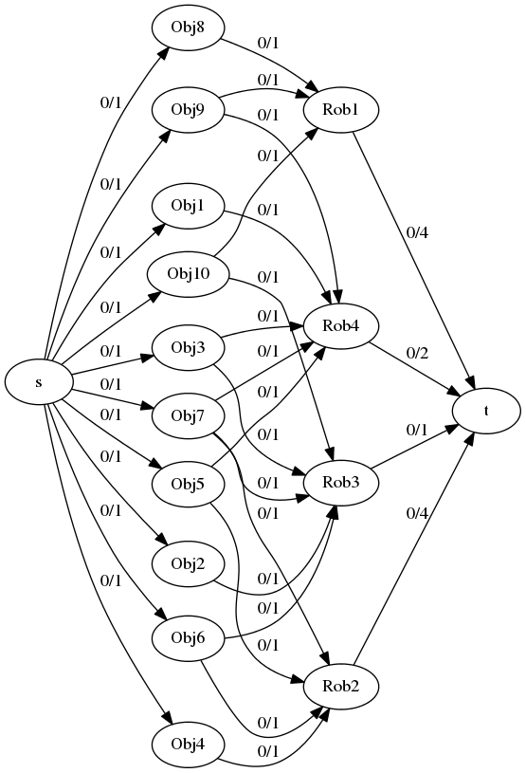

Figure 1: Visualization before assignment of objects to robots

Visualization about an optimal solution of the problem is given below. Unused edges are shown as black, used but still avaible edges are blue, used and not avaible edges are red. Residual edges are not shown in the graph.

Success criteria is to achieve the maximum flow, which can be obtained by assigning every object to a robot, with respect to some properties such as conservation of flow, capacity constraints. The solution below provides these requirements.

The solution is obtained by implementing Ford-Fulkerson algorithm to the constructed model. This algorithm calculates the maximum possible flow by augmenting paths which are paths with available capacity, and by producing a residual graph which consists forward and backward edges, after each augmentation. Backward edges refer to previously pushed flow and forward edges denote still available flow values. Algorithm pushes the maximum possible flow from sink to source, until no path is available from sink to source. Complexity of the algorithm is $O(Cm)$ where $C$ is the maximum flow and $m$ is number of edges.

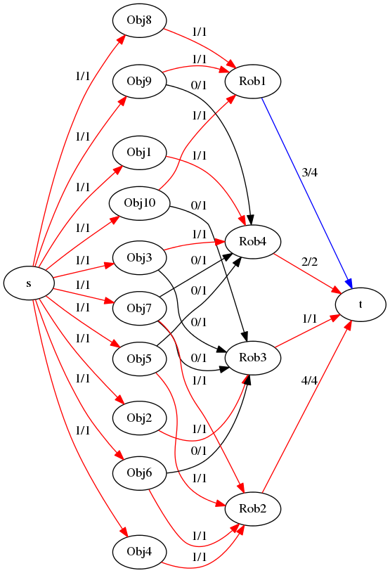

Figure 2: Visualization after assignment of objects to robots