Istanbul Technical University

Faculty of Computer Informatics



Report : 3D Modelling Tools

Cem Yusuf Aydoğdu

February 2015

By definition, 3D modelling is creating three dimentional graphics in computer, with specific tools and specific programming languages. 3D modelling is used in entertainment widely, but it is also used in medicine and engineering.[1] Softwares used in 3D modelling are mostly commercial licenced, but there are free and open source programs like Blender, Open Cascade, Art of Illusion.

First of all, Blender is one of the well known open source program in 3D modelling tools category. Blender allows users wide variety of tools for operations like modelling, mapping, animation. Blender is a cross platform tool with OpenGL, which means it can work on many operating systems. It is small in size and there are many user forums, tutorials are avaible, which provides better support.[2]

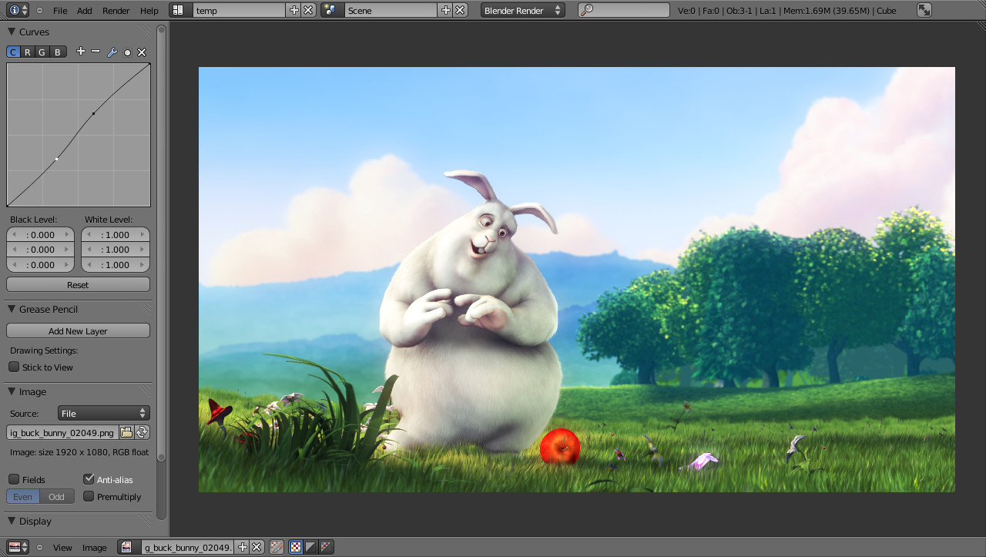

Figure 1 : “A rendered image being post-processed” [2]

Secondly, Open Cascade is an open source computer aided design (CAD) program, which is used for engineering applications. Open Cascade offers solutions for industrial areas, like aerospace and automotive Open Cascade requires no payment for licence but for commercial support. [3]

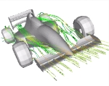

Figure 2: “Aerodynamic flows over the Formula One car” [3]

Lastly, Art of Illusion is also a 3D modelling and rendering studio, for high quality image and animation generating. Art of Illusion has several editors for texture and material properties, and it has an easy usage. There are several forum and board sites about Art of Illusion. [4]

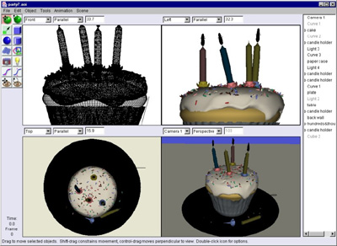

Figure 3: A 3D model created by Art of Illusion [5]

To sum up, program choice depends on application, but it can be said that Blender is more advantageous compared to Art of Illusion, because of more variety of tools and wider technical support. In engineering applications Open Cascade can be a good alternative for commercial non-free softwares.

References

[1] A. Ghosh, *“*What is 3D Modeling?” [Online] 2015, http://www.wisegeek.com /what-is-3d-modeling.htm (Accesed 20 Feb. 2015)

[2] Introduction, Blender Wiki [online], http://wiki.blender.org/index.php/Doc:2.6/Manual/Introduction (Accesed 20 Feb. 2015)

[3] Open Cascade [online], http://www.opencascade.org/ (Accesed 20 Feb. 2015)

[4] Art of Illusion Basics [online], http://www.artofillusion.org/docs/AoI%20Manual/layout.html#overview (Accesed 20 Feb. 2015)

[5] Screenshots, Art of Illusion [online], http://www.artofillusion.org/screenshots (Accesed 20 Feb. 2015)