

**ISTANBUL TECHNICAL UNIVERSITY**

**SOFTWARE ENGINEERING**

**ASSIGNMENT 4**

|  |  |
| --- | --- |
| **PROJECT TITLE** | Package Deliverer Drones |
| **REPORT NAME** | Design Specification |
| **TEAM NAME** | Team Ratchet |
| **GROUP NUMBER** | **6** |

|  |  |
| --- | --- |
| **TEAM MEMBERS** | |
| **NAME** | **STUDENT NUMBER** |
| Mehmet Taner ÜNAL | 150130702 |
| Cem Yusuf AYDOĞDU | 150120251 |
| Ozan ÖZYEĞEN | 150120115 |

**CONTENTS**

1. INTRODUCTION

2. DATA MODEL

2.1 General Data Model

2.2 Important Data Considerations

2.3 Data Flow

3. SOFTWARE MODEL

3.1 System Architecture

3.2 Component Diagram

3.3 Class Diagrams

3.4 Sequence Diagrams

4. USER INTERFACE MODEL

**DESIGN DPECIFICATION**

# INTRODUCTION

This section introduces the design specification document for the Package Deliverer Drones. It provides the purpose of the system and the organization of contents in this document.

The drones take the package from the sender and bring it to the receiver. In addition, all the activity of the drones can be monitored from software that is used by the Control Operator and Drone Crew. This system helps greatly to the cargo companies, reduces the manpower needed to deliver packages and makes easier to send and receive packages.

This design specification document describes the models specified for this Package Deliverer Drones System. It brings detailed information about the design of the system, such as data structures, components and the user interface. The development of this program is involved in the “Software Engineering” course. The objectives are to be able to develop a product by managing its several phases by following some methods and models. It enables us being familiar with the way products are developed in a professional context.

# DATA MODEL

## General Data Model

This entity relationship diagram is based on the conceptual model which is given in the requirements specification document. Thus, they contain many similarities. Both of the models have aimed to Show how the system Works by using entities and relationships. However, since the conceptual model is an early model it is not as specific as the entity relationship diagram. The entity relationship diagram is created by considering how the data will be stored in the system.

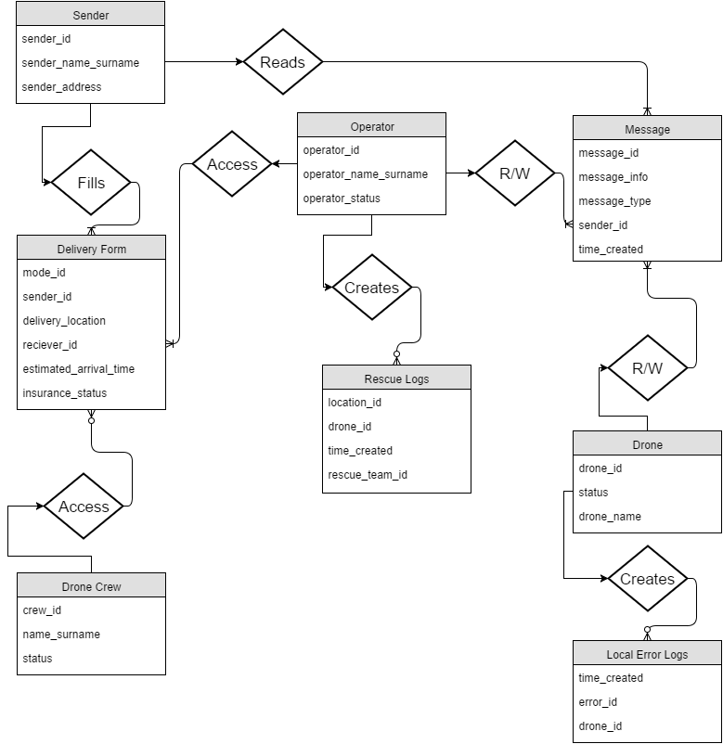

## Important Data Considerations

In this part, the information about the other data formats is given. The system gets the weather information in order to decide whether the drones should fly or not. To do this, our system uses the API of openweathermap.org. System gets the weather information by making JSON calls. Example JSON calls and responds are given below:

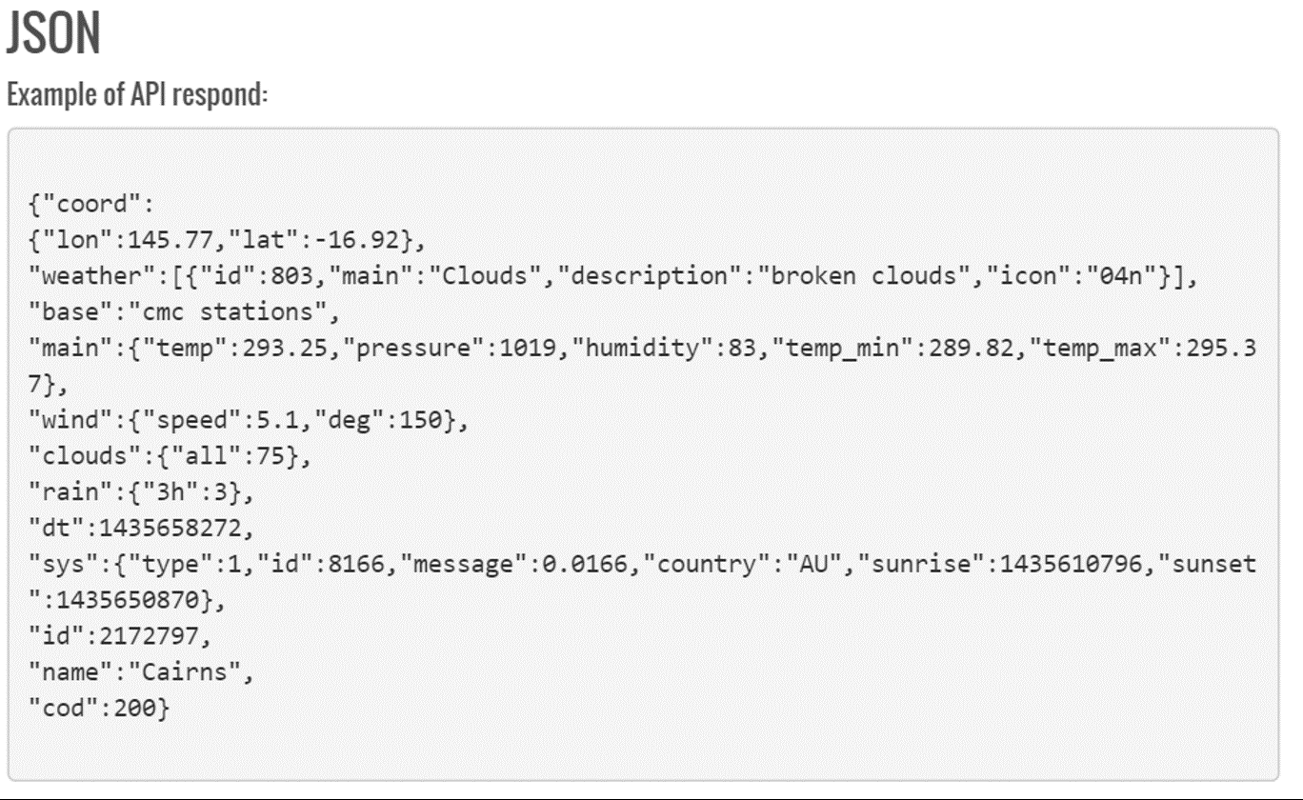

Another important data consideration for the drone delivery system is delivery form page. The sender needs to fill the delivery form on a browser. Hence, a delivery form web page is created. PHP, Ajax and Bootstrap are used on the delivery form page. After the user click send bottom at the page, it sends the information to the system in JSON form. Then the system receives and processes the delivery request.

Screenshots of the Bootstrap Datetimepicker which is used in the delivery form is given below:

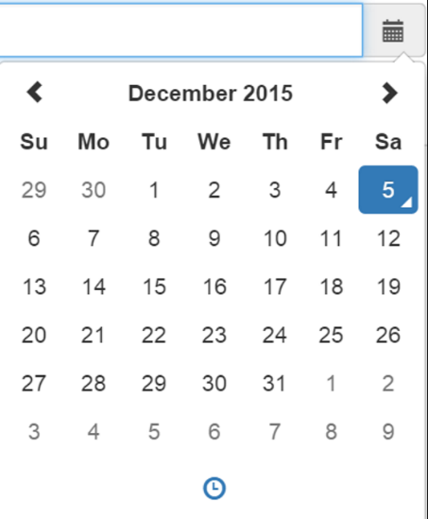 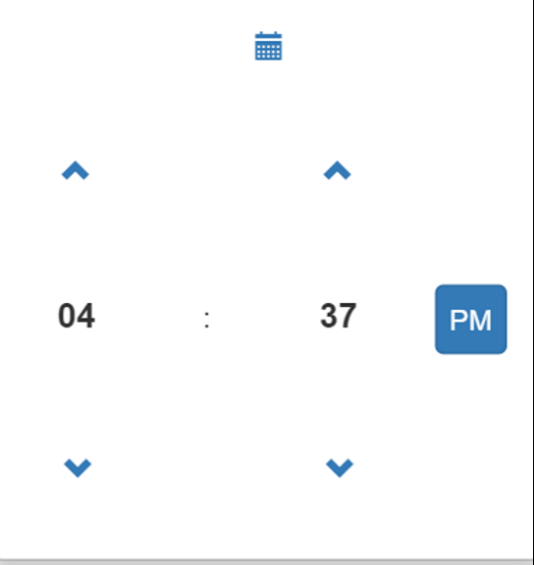

## Data Flow

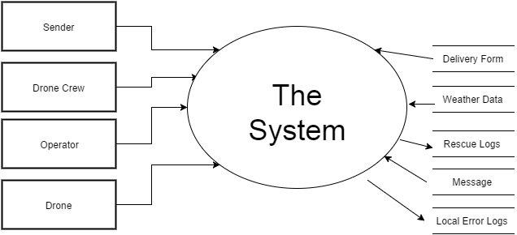

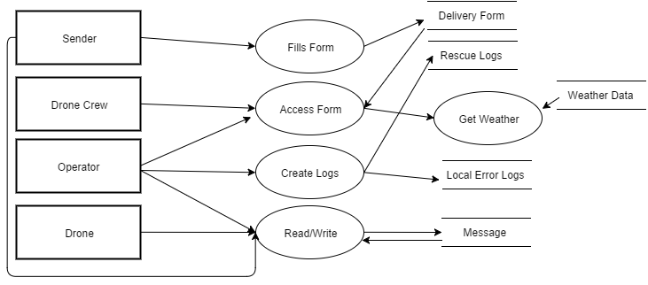

# SOFTWARE MODEL

## System Architecture

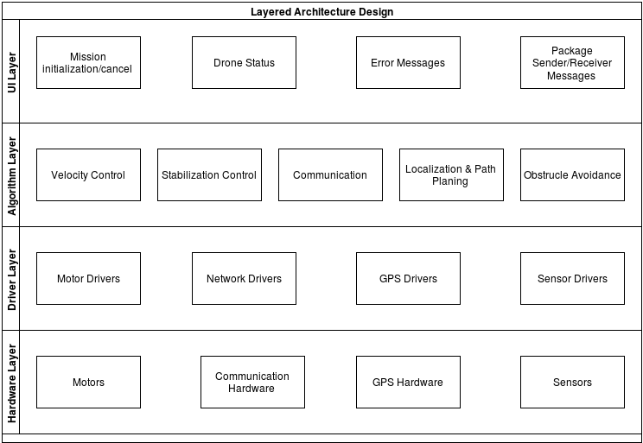

## 

## Component Diagram

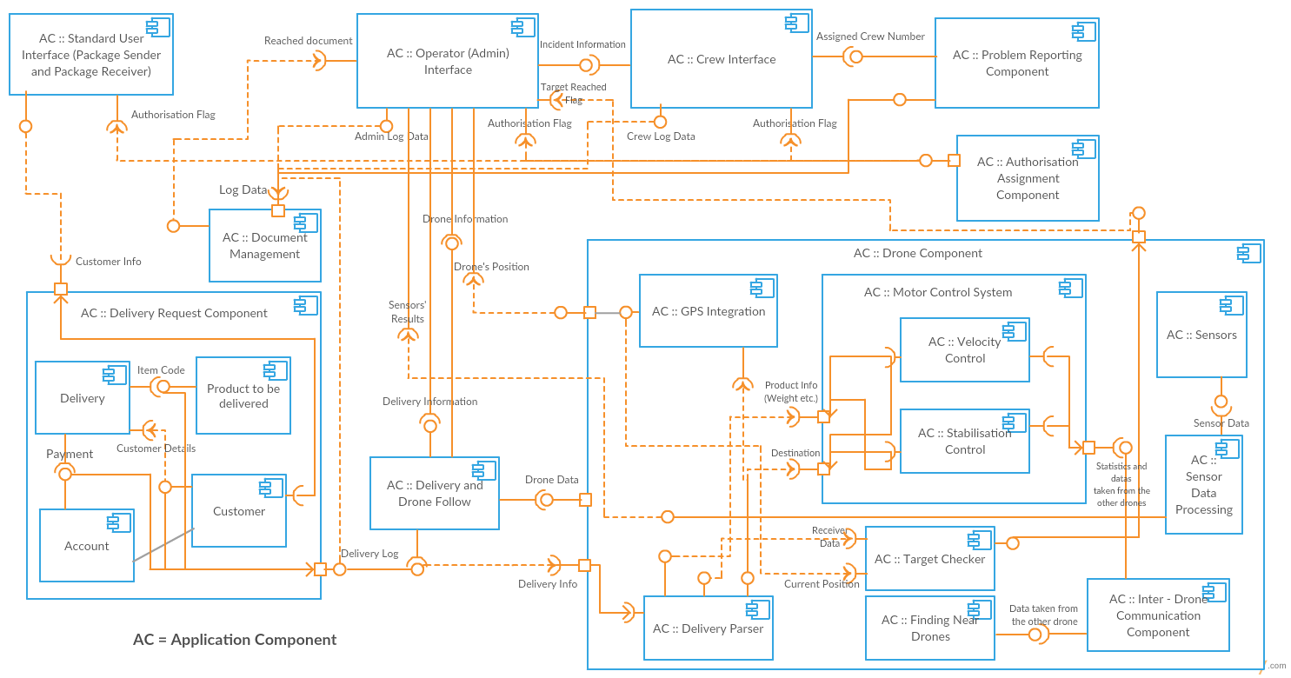

## Class Diagrams

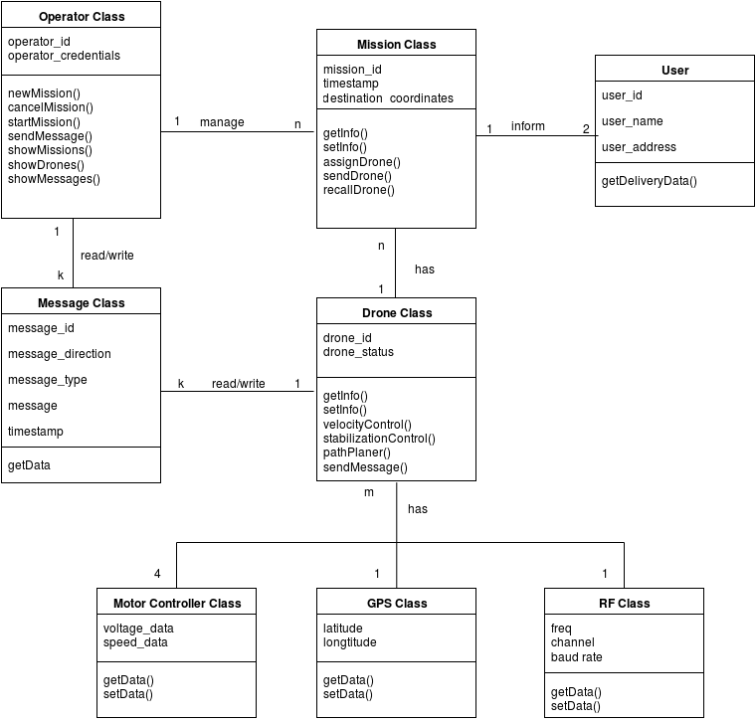

## Sequence Diagrams

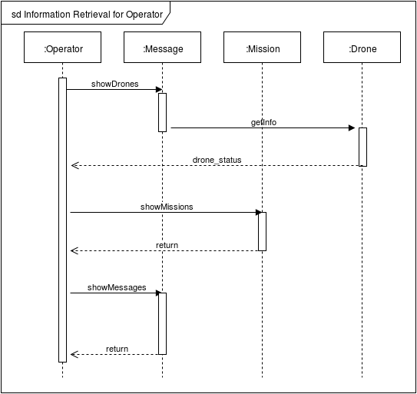

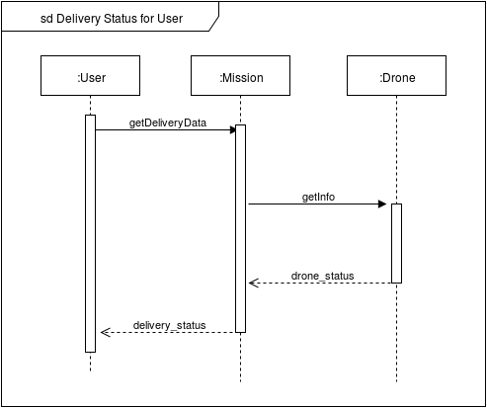

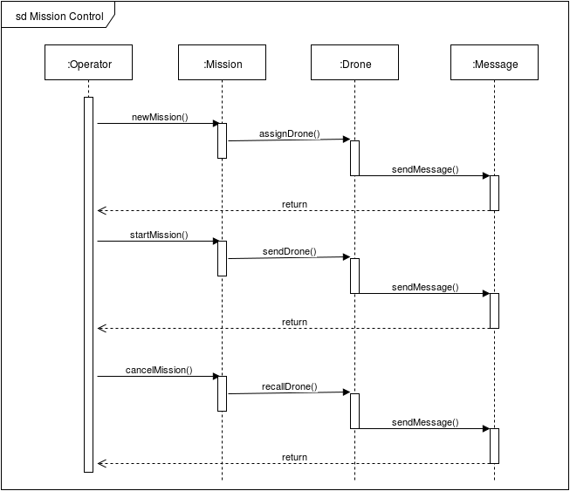

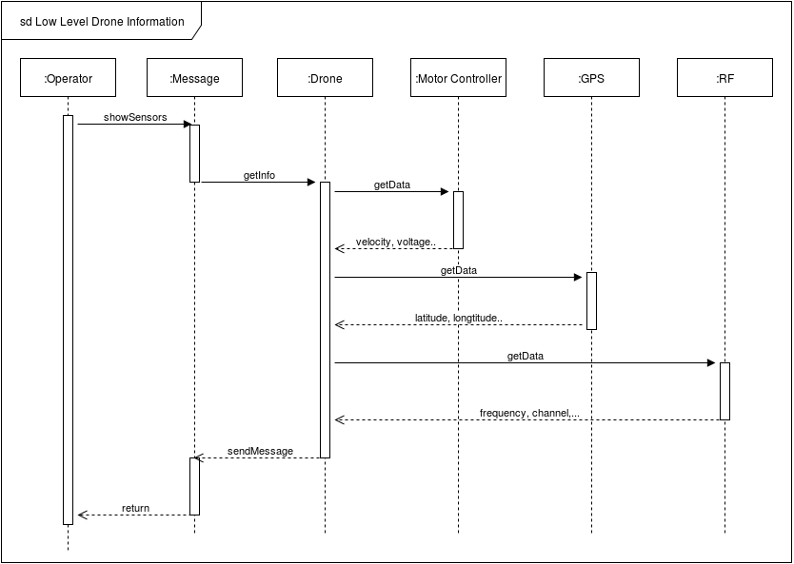

# USER INTERFACE MODEL

