2. Usage Scenario

2.1 User Types

|  |  |
| --- | --- |
| User Type | Description |
| Package Sender | Provides the package and destination information |
| Package Receiver | Receiver of the package |
| Drone Crew | Responsible for general maintenance of the drone  and loads package to drone |
| Control Operator | Responsible to provide location coordinates to drone  and checks the delivery operation in real time |

2.2 Use Case Diagram

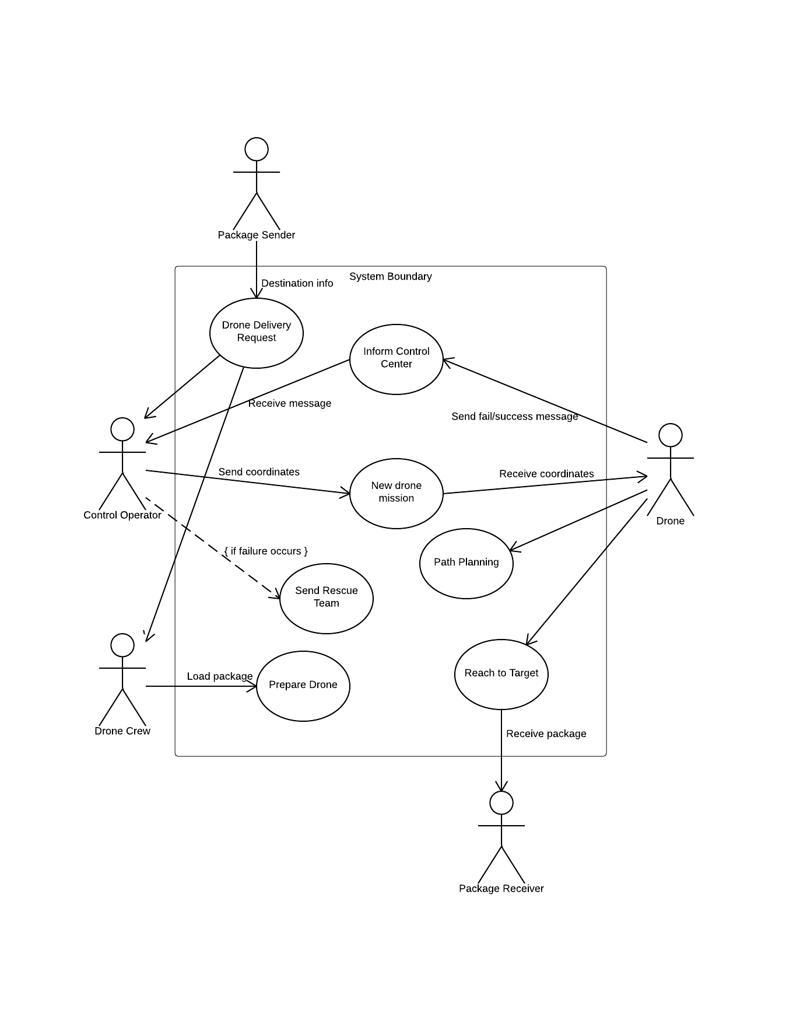System Use Case Diagram:

2.3 Use Cases

|  |  |
| --- | --- |
| Title | Drone Delivery Request |
| ID | UC-1 |
| Version | 1.0 |
| Actors | Package Sender (primary)  Drone Crew  Control Operator |
| Level | Kite Level |
| Brief | Sender requests drone for his/her package delivery process |
| Preconditions | Drone delivery is avaible |
| Postconditions | A new drone mission emerges |
| Basic Flow | 1. Sender fills delivery form 2. Sender specifies delivery with drone |

|  |  |
| --- | --- |
| Title | Prepare Drone |
| ID | UC-2 |
| Version | 1.0 |
| Actors | Drone crew (primary) |
| Level | Fish Level |
| Brief | Drone crew prepares the drone |
| Preconditions | A drone mission |
| Postconditions | Drone is ready to flight |
| Basic Flow | 1. Drone crew checks and prepares the drone for flight 2. Drone crew loads the package to the drone |

|  |  |
| --- | --- |
| Title | New Drone Mission |
| ID | UC-3 |
| Version | 1.0 |
| Actors | Control Operator (primary)  Drone |
| Level | Fish Level |
| Brief | Control operator sends required initial information  to drone |
| Preconditions | A drone mission |
| Postconditions | Drone is ready to delivery |
| Basic Flow | 1. Control operator establishes destination coordinates from package sender’s information 2. Operator sends coordinates to the drone 3. Operator checks all required conditions and sends lift-off message to the drone |

|  |  |
| --- | --- |
| Title | Path Planning |
| ID | UC-4 |
| Version | 1.0 |
| Actors | Drone |
| Level | Clam Level |
| Brief | Drone calculates path to the destination and moves according to that plan |
| Preconditions | Drone is ready to delivery |
| Postconditions | Drone moves to the target |
| Basic Flow | 1. Drone automation system calculates the path 2. Automation system provides required speed data for the path 3. Drone lifts-off and starts to move to destination |

|  |  |
| --- | --- |
| Title | Inform Control Center |
| ID | UC-5 |
| Version | 1.0 |
| Actors | Drone (primary)  Control Operator |
| Level | Fish Level |
| Brief | Drone informs the control center about delivery process periodically |
| Preconditions | Drone is airborne |
| Postconditions | Drone continues to move or waits for rescue |
| Basic Flow | 1. While moving, drone regularly checks different sensor informations for failure detection 2. Drone sends success messages when it acquires a checkpoint 3. If drone detects a failure, it sends an appropriate failure message depending on the failure    1. If the failure has low-priority(slight change in route etc..) drone logs the information about its current state and continues to move    2. If the failure has high-priority(e.g. drone hits an object or detects system failure), drone tries to land safely, sends its location and waits for help |

|  |  |
| --- | --- |
| Title | Send Rescue Team |
| ID | UC-6 |
| Version | 1.0 |
| Actors | Control Operator (primary)  Drone |
| Level | Kite Level |
| Brief | Operator sends a team to rescue the drone and complete the delivery |
| Preconditions | Drone fails and requires help |
| Postconditions | Continue the delivery without drone |
| Basic Flow | 1. Rescue team arrives to location of the drone 2. Team picks the drone 3. Team completes the delivery |

|  |  |
| --- | --- |
| Title | React to Target |
| ID | UC-7 |
| Version | 1.0 |
| Actors | Drone  Package Receive |
| Level | Kite Level |
| Brief | Drone arrives to target and delivers the package |
| Preconditions | Drone moves to target area without a fatal failure |
| Postconditions | Drone completes the delivery |
| Basic Flow | 1. Drone arrives to target 2. It delivers the package 3. It returns to the base following same path backward |