2 - Test Plan

2.1 – Testing Strategies

In this project, “sandwich integration” strategy from incremental integration methods is chosen. Sandwich integration strategy is a combination of “top-down” and “bottom-up” strategies.

Our motivation to select sandwich integration strategy is based on significant advantages of this strategy, as given below:

* It has advantages of both top-down and bottom-up strategies which are fault isolation, detection of major design problems earlier, testing both operational and logic artifacts.
* Top and bottom layers of testing can be implemented in parallel.
* Test cases can be constructed easily.
* This strategy is compatible with our project, since our project is large project with many sub-projects.

However, this approach also has some disadvantages that should be mentioned:

* It is more costly comparing to other strategies.
* Isolating problems are harder.
* This strategy consists of partial big-bang integration in the middle layer.

2.2 – Test Subjects

Diagram of the testing strategy is given below. Interfaces are tested using top-down approach and modules about drone are tested using bottom-up approach in parallel. Drone module and connections of drone module with interfaces are tested in the middle layer.

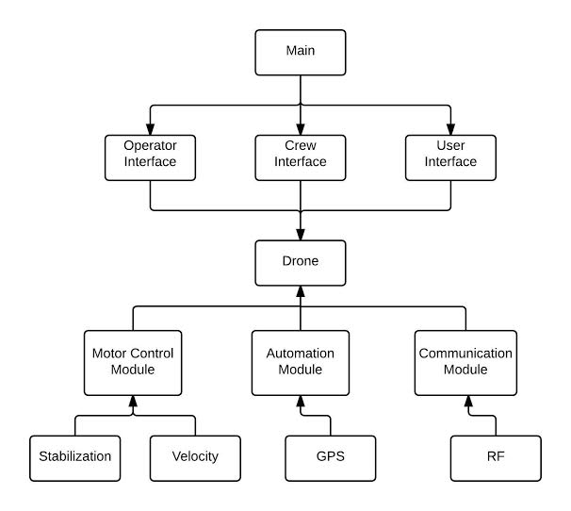

2.3 Equivalence Partitioning

2.3.1 Operator Interface

2.3.1.1 Login Page

|  |  |  |  |
| --- | --- | --- | --- |
| Input | Condition | Valid Equivalence Class | Invalid Equivalence Class |
| Username, password | Must be between  4-30 characters  Should not contain invalid characters  Should exist in the database | Username and password are between 4-30 characters  Username and password are alphanumeric  Username and password are valid in the database | Length of username or password are not in boundaries  Username or password contain non-alphanumeric characters  Username and password does not exist in database |

2.3.1.2 Main Page

|  |  |  |  |
| --- | --- | --- | --- |
| Input | Condition | Valid Equivalence Class | Invalid Equivalence Class |
| New Mission | Mission information must be valid and consistent | Valid sender information, destination information  Drone selection from idle and ready drones  Sender info is alphanumeric  Destination coordinates are numeric and valid | Invalid or inconsistent sender information, destination information  Drone selection from busy drones  Sender info contains invalid characters  Destination coordinates contain invalid characters  Destination coordinates refers to a invalid place |

2.3.1.3 Mission Page

|  |  |  |  |
| --- | --- | --- | --- |
| Input | Condition | Valid Equivalence Class | Invalid Equivalence Class |
| Change Destination | Destination change must check new values | New destination coordinates are numeric and valid | New destination coordinates contain invalid characters |

2.3.2 User Interface

|  |  |  |  |
| --- | --- | --- | --- |
| Input | Condition | Valid Equivalence Class | Invalid Equivalence Class |
| Delivery ID | Delivery ID should be valid | Delivery ID contains numerical character  Delivery ID maps to the correct delivery | Delivery ID contains illegal characters  Delivery ID refers to another delivery or does not refer to any information |