

**ISTANBUL TECHNICAL UNIVERSITY**

**SOFTWARE ENGINEERING**

**ASSIGNMENT 5**

|  |  |
| --- | --- |
| **PROJECT TITLE** | Package Deliverer Drones |
| **REPORT NAME** | Test Specification |
| **TEAM NAME** | Team Ratchet |
| **GROUP NUMBER** | **6** |

|  |  |
| --- | --- |
| **TEAM MEMBERS** | |
| **NAME** | **STUDENT NUMBER** |
| Mehmet Taner ÜNAL | 150130702 |
| Cem Yusuf AYDOĞDU | 150120251 |
| Ozan ÖZYEĞEN | 150120115 |

**1. Introduction**

This is the test spesification document for the drone delivery system project. Drone Delivery System is planned and designed by all the members of group 6 as an assignment for Software Engineering course at ITU. Drone Delivery System provides autonomous, intelligent, fast delivery systems.

The aim of this plan is to ensure that the Drone Delivery System project provides all the properties that are required for a basic version of the project. Test plan and test procedure are mentioned in this software development model. In test plan, parts of the project which are tested will be explained. Then, in test procedure, it will be mentioned how these parts were tested. Detailed information will be defined in next chapters.

**1.1 Goals and Objectives**

The primary use of software testing is to find errors in the system and handle them. In our project, we detected many errors, then fixed these errors by using our test codes in the testing process. Test process is a crucial process which inreases the quality of the software. There are several tests in the development phase. These tests find general errors and fix them. All these tests are used to create a better platform to users.

**1.2 Statement of Scope**

In every software project, we use testing to check whether the software is working as it is expected or not. Thus, a good testing project have to be performed at different levels of development. In this document, we will explain our test strategies and initial definitions for the test cases.

**2 Test Plan**

**2.1 Testing Strategies**

In this project, “sandwich integration” strategy from incremental integration methods is chosen. Sandwich integration strategy is a combination of “top-down” and “bottom-up” strategies.

Our motivation to select sandwich integration strategy is based on significant advantages of this strategy, as given below:

* It has advantages of both top-down and bottom-up strategies which are fault isolation, detection of major design problems earlier, testing both operational and logic artifacts.
* Top and bottom layers of testing can be implemented in parallel.
* Test cases can be constructed easily.
* This strategy is compatible with our project, since our project is large project with many sub-projects.

However, this approach also has some disadvantages that should be mentioned:

* It is more costly comparing to other strategies.
* Isolating problems are harder.
* This strategy consists of partial big-bang integration in the middle layer.

**2.2 Test Subjects**

Diagram of the testing strategy is given below. Interfaces are tested using top-down approach and modules about drone are tested using bottom-up approach in parallel. Drone module and connections of drone module with interfaces are tested in the middle layer.

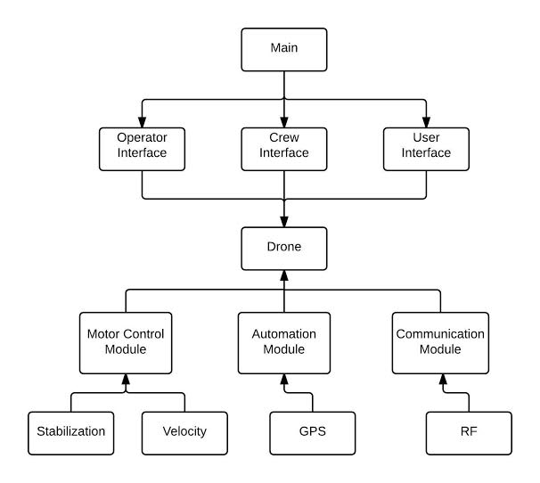

**2.3 Equivalence Partitioning**

**2.3.1 Operator Interface**

**2.3.1.1 Login Page**

|  |  |  |  |
| --- | --- | --- | --- |
| Input | Condition | Valid Equivalence Class | Invalid Equivalence Class |
| Username, password | Must be between  4-30 characters  Should not contain invalid characters  Should exist in the database | Username and password are between 4-30 characters  Username and password are alphanumeric  Username and password are valid in the database | Length of username or password are not in boundaries  Username or password contain non-alphanumeric characters  Username and password does not exist in database |

**2.3.1.2 Main Page**

|  |  |  |  |
| --- | --- | --- | --- |
| Input | Condition | Valid Equivalence Class | Invalid Equivalence Class |
| New Mission | Mission information must be valid and consistent | Valid sender information, destination information  Drone selection from idle and ready drones  Sender info is alphanumeric  Destination coordinates are numeric and valid | Invalid or inconsistent sender information, destination information  Drone selection from busy drones  Sender info contains invalid characters  Destination coordinates contain invalid characters  Destination coordinates refers to a invalid place |

**2.3.1.3 Mission Page**

|  |  |  |  |
| --- | --- | --- | --- |
| Input | Condition | Valid Equivalence Class | Invalid Equivalence Class |
| Change Destination | Destination change must check new values | New destination coordinates are numeric and valid | New destination coordinates contain invalid characters |

**2.3.2 User Interface**

|  |  |  |  |
| --- | --- | --- | --- |
| Input | Condition | Valid Equivalence Class | Invalid Equivalence Class |
| Delivery ID | Delivery ID should be valid | Delivery ID contains numerical character  Delivery ID maps to the correct delivery | Delivery ID contains illegal characters  Delivery ID refers to another delivery or does not refer to any information |

**3 UNIT TESTS**

**3.1 Test Cases**

The main objective of unit tests is to test each individual units of the source code because all modules of the system must work in efficiency properly. For that reason, white box and black box tests are applied. The unit tests will be handled for separate components in the system. The components are Operator Interface and User Interface.

**3.2 Scripts**

**3.2.1 Cases for Operator**

|  |  |  |
| --- | --- | --- |
| Test Number | Test Description / Sample Input | Expected Result |
| 1 | Invalid Operator User Name and Password Combination | Show an error window and keep waiting on the login page. |
| 2 | Invalid characters on User Name and Password | Show an error window and keep waiting on the login page. |
| 3 | Valid Operator User Name and Password Combination | Open the default home page for the Operator User |
| 4 | Valid new mission insertion | Add the new mission to the mission list. |
| 5 | Information validation check request | Show the result of the check process |
| 6 | New mission insertion with invalid information | Warn the Operator and request a new insertion attempt. |
| 7 | New destination for the mission (Update) | Update the destination information for the requested mission. |
| 8 | List all the missions | Information of the all missions must be read from the database and listed. |
| 9 | Show Operator Information | Read the operator information from the database and show them on a new page. |
| 10 | Show a Specific User’s Information | Read the user information from the database and show them on a new page. |
| 11 | Log Out Request | Log the operator out from the system and direct the operator to the site’s main page. |
| 12 | Show Information for a Specific Mission | Show the information for the requested mission on a new page. |
| 13 | Request of getting the statistical data for the requested time period | Read data from the database and after doing required calculations show the statistical data to the operator. |
| 14 | Print the requested mission/s | Print the mission/s with the information taken from the database |

**3.2.2 Cases for User**

|  |  |  |
| --- | --- | --- |
| Test Number | Test Description / Sample Input | Expected Result |
| 1 | Invalid characters on User Name and Password | Show an error window and keep waiting on the login page. |
| 2 | No match for entered User Name and Password on the Database | Show an error window and keep waiting on the login page. |
| 3 | A match is found for the entered User Name and Password on the Database | Open the default home page for the User. |
| 4 | Valid delivery information | Show a notification window and insert the delivery request to the system. |
| 5 | Invalid delivery ID | Do not accept the delivery request and show a notification window. |
| 6 | Personal information change request and valid new information for the user | Show a notification telling about the requirement of an e-mail confirmation for the new information |
| 7 | Help Request | Direct the user to Operator Help Page |
| 8 | Show Personal Information | Read the user information from the database and show them on a new page. |
| 9 | Show Last Deliveries | Read the delivery information from the database for the user and list them. |
| 10 | Log Out Request | Log the user out from the system and direct the user to the site‘s main page. |
| 11 | Search an item | Search for the requested item on database and show the information related with it on a new page. |
| 12 | Show the status of the current mission | Show the requested mission’s information by its ID from the database |
| 13 | Print request for the mission | Print the mission information |

**4 Addinitional Tests**

**4.1 Security Testing**

Security testing is a type of non-functional test where the software is checked for any security flaws and drawbacks. All the security testing regarding this project will be held by an outsourced security team.

Within this scope, drones delivery system project can be tested for the following situations;

1. XSS vulnerabilities: Cross site scripting is a common way of attacking servers. Thus, system will also tested for any XSS vulnerabilities.
2. SQL injection: SQL injection can be used to access the database. Therefore, cargo tracking page should be tested for any vulnerability.
3. Penetration Testing: After the system started to use by a customer company a 2 week penetration testing will be held by the security team. In this test, security experts will try to gain more authority over the system. At first, they will try this without any information about the system. Later, they will try to hack the system with equal authority of operator.

**4.2 Performance Testing**

Performance testing is a type of functional test that shows how the system performs after a spesific workload. The system needs to handle many inputs from user, operator and drones. Therefore, a performance testing is required.

**4.3 Load and Stress Testing**

Stress testing is the term that shows how many users constitute a workload in a system and how far system can endure to this workload. In our project, C,C++ and php shows good performance. However, since it is a real time system which can process thousands of data from hundreds of drones, it is essential to test the systems performance. Performance problems may cause misbehaviour of the drones. Thus, system should be tested according to the user amounts and thereby total workload.

**4.4 Acceptance Testing**

Acceptence testing is such a testing that shows whether the requirements in the project are satisfied or not. For this project, the requirements are given in the Requirements Sepesification document. The document and the system will be checked in order to complete the acceptence test.