**Istanbul Technical University**

**Faculty of Computer and Informatics**



**BLG438E Digital Signal Processing Lab**

**Experiment 5**

**Cem Yusuf Aydoğdu**

**150120251**

In this experiment, a Finite Impulse Response (FIR) filter was implemented on the TMS320 C5515 DSP kit. Equation of the filter is given below. In this equation, output depends on the past two values of the input, so this equation shows that the filter is a second order filter.

$$Y_{n}=A_{0}X_{n}+A_{1}X_{n-1}+A_{2}X_{n-2}$$

Transfer function of the filter is:

$$H\left(z\right)=Y(z)/X(z)=A_{0}+A_{1}z^{-1}+A_{2}z^{-2}$$

Coefficients of the filter was found from Matlab for 100 Hz frequency as $A_{0}=0.038$,

$A_{1}=0.2$ and $A_{2}=0.0038$. Block diagram of the filter is given below:

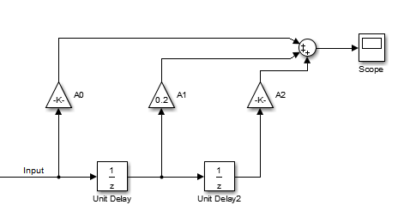

Figure 1 Block diagram of the filter

Following Matlab script is written in order to obtain bode diagram of the filter. First, transfer function is obtained using numerators and denumerators. Then, bode diagram is obtained from the transfer function. Corresponding Matlab code and bode diagram is shown below:

num = [0.038, 0.2, 0.0038]; %% A0, A1, A2

denum = [1];

transfer_func = filt(num, denum);

bode(transfer_func);



Figure 2 Bode diagram of the filter

Code implementation of the given FIR filter for TMS C5515 DSP kit is given below. This code runs in an interrupt.

**float** A0 = 0.038, A1 = 0.2, A2 = 0.0038;

**float** x[3] = {0.0, 0.0, 0.0}; // x, xz^-1, xz^-2

**while**(1)

{

**while**((XmitR & I2S0_IR) == 0);//Wait for transmit interrupt to be pending

x[2] = x[1];

x[1] = x[0];

x = I2S0_W0_MSW_R;

//write to output

I2S0_W0_MSW_W = (Int16)(A0*x[0] + A1*x[1] + A2*x[2]);

I2S0_W0_MSW_L = 0;

I2S0_W1_MSW_W = (Int16)(A0*x[0] + A1*x[1] + A2*x[2]);

I2S0_W1_MSW_L = 0;

}