**Istanbul Technical University**

**Faculty of Computer and Informatics**



**BLG440E Computer Project 2**

**Project 2 – Tetris Bot**

**Report**

**Group 17**

**Cem Yusuf Aydoğdu**

**150120251**

**İrem Ertürk**

**150140725**

# Introduction

In this project, a bot was implemented for competitive 1 vs 1 ranked matches of a modified tetris game. In the classic tetris game, the only requirement to get scores is clearing lines in order to not overflow the board. But, scoring rules of this modified tetris game states that cleared line count should be at least two in one movement, in order to gain scores. Furthermore, when a bot scores by clearing at least two lines, it also sends a ‘garbage line’ to the opponent. Also, there are other scoring types such as combos, spins.

# Algorithm

There are well-known tetris playing algorithms for the classic tetris game with classic rules, such as the one-piece algorithm by Dellachiere, based on considering every placement of each rotation of current piece on the board, and determining best movement with highest score [1]. Also, Fahey recommends advancing the algorithm by considering the next piece according to same principle, if it is known beforehand [1].

Our algorithm is also based on that basic principle of classic tetris playing algorithms. It checks for every rotation of every current and next piece, abstractly places pieces to every possible location, and then calculates score of that placement. However, the scoring procedure differs from the classic approaches due to requirements of the game. Finally, it executes the movement with the highest score.

However, since the corresponding tetris game is different from the classical tetris game, the algorithm for that tetris game will differ from the classic tetris game.

~~Our algorithm is based on Fahey’s algorithm for the classic tetris game. Fahey states that ***~~

According to Fahey, [1].

Our algorithm is also based on classic tetris game algorithms. It considers current and next piece with current board, places the ***

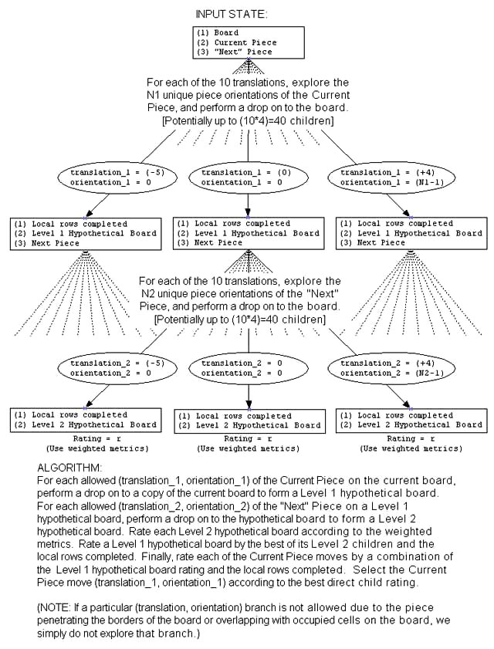

# Results

# References