Istanbul Technical University

Faculty of Computer and Informatics



BLG477E Multimedia Computing

Term Project Report

Cem Yusuf Aydoğdu

150120251

Mehmet Taner Ünal

1501***

# Abstract

# Introduction

# System

In order to examine the system in detail, one should study the terminology first. According to Glossary of Telecommunication terms published by National Communication System, the term *frame* refers to a full image consist of several images, the term *field* refers to a partial frame which consists nth line of a frame [5]. In an interlaced video system, a frame consists of two fields, top and bottom fields for even and odd numbered lines respectively [1] [2].

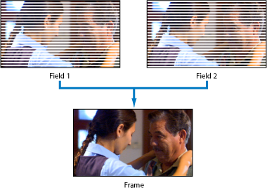

Fig ** relation between a frame and its fields [6]

*Coded picture* denotes a compressed video frame, m*acroblock* refers to a fixed sized region in the frame or coded picture, with 16x16 luma, 8x8 Cr and 8x8 Cb components, and *slice* refers to “a set of macroblocks”[1]. There are five slice types in the H.264/AVC, *I*, *P*, *B*, *SI* and *SP* [3]. “Intra” I slices are produced using current frame, whereas “predictive” P and “bi-predictive” B slices are produced using previously referenced frames [3]. Furthermore, “switching P” SP and “switching I” SI slices refer to changing bit rates of encoding [3].

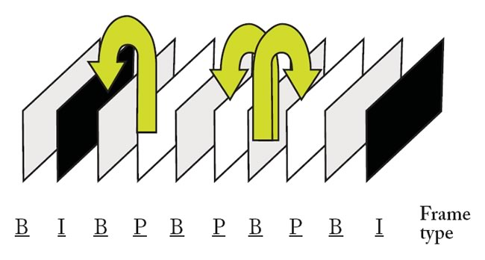

Fig ** Different frame types based on *I*, *P*, *B* slices [7]

Encoder and decoder block diagrams are shown below. In the diagram of encoder, ME stands for “Motion Estimation” In order to create coded picture, the system uses previous frames and current frame.

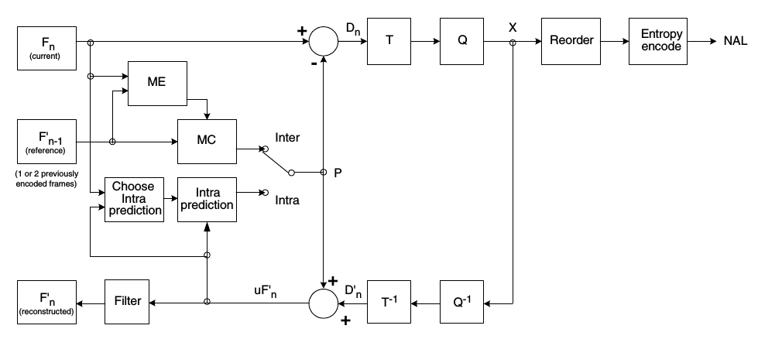

Fig ** System blocks of H.264 encoder [1]

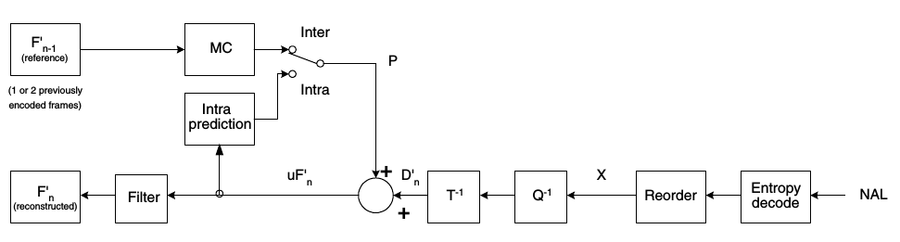

Fig ** System blocks of the H.264 decoder [1]

//[1]’deki sıralama:

İntro

Codec

Structure

Profiles:

Baseline

Main

Extended

[2] sıralama:

İntro

Applications/feature highlights

NAL (Network abstraction layer)

VCL (video coding layer)

Profiles

History

[3] fidelity range extension’a daha detay giriyor

İntro/history

Application/ curr. Status

High level overview of VCL

Main innovative features of VCL

Profiles and levels

...

[4] sıra:

1. Intro

1.1 History

1.2 FRExt Amendment

2. Coding tools

2.1 I-Slice

2.1.1 Intra Spatial Prediction

2.1.2 Transform and Quant.

2.1.3 Perceptual based quant mat

2.1.4 Scanning

2.1.5 Entropy Coding

2.1.5.1 VLC, UVLC...

2.1.5.2 CABAC

2.1.6 Lossless macroblock modes

2.2 P-Slices

2.3 B-Slices

2.4 SP and SI slices

2.5 Deblocking Filter

2.6 Error resilience tools

2.7 Color space and Residual Color Transform Support

3. Supplemental info

4. Profiles, levels

4.1 Baseline, main, extended profiles

4.2 New high profiles...

4.3 Levels

5. Simulation results

...

Buradaki muhtemel sıralama:

Overview (Genel bilgi-terimler, feature highlights, Block diagrams(encoder ve decoder)... )

kaynaklar:

[1] Richardson, H.264 and MPEG-4 Video Compression (kitap)

[2] Overview of the H.264/AVC Video Coding Standard, IEEE TRANSACTIONS ON CIRCUITS AND SYSTEMS FOR VIDEO TECHNOLOGY, VOL. 13, NO. 7, JULY 2003

[3] The H.264/MPEG4 advanced video coding standard and its applications, IEEE Communications Magazine, Aug. 2006, 10.1109/MCOM.2006.1678121

[4] "The H.264/AVC Advanced Video Coding Standard: Overview and Introduction to the Fidelity Range Extensions" (PDF)

[5] http://www.its.bldrdoc.gov/fs-1037/fs-1037c.htm

[6] https://documentation.apple.com/en/finalcutpro/usermanual/index.html#

chapter=C%26section=9%26tasks=true

[7] https://www.adobe.com/devnet/adobe-media-server/articles/h264_encoding.html

http://www.eetimes.com/document.asp?doc_id=1225770

Overview of the Scalable Video Coding Extension of the H.264/AVC Standard, IEEE Transactions on Circuits and Systems for Video Technology, Sept. 2007, 10.1109/TCSVT.2007.905532

# Experimental Results