http://searchsecurity.techtarget.com/definition/walled-garden

On the Internet, a walled garden is an environment that controls the user's access to Web content and services.

In effect, the walled garden directs the user's navigation within particular areas, to allow access to a selection of material, or prevent access to other material. An Internet service provider (ISP) may or may not allow users to select some of the Web sites contained or barred from the garden.

Although the walled garden does not actually prevent users from navigating outside the walls, it makes it more difficult than staying within the environment.

ISPs want to fence in users for a number of reasons.

In 1999, for example, America Online (AOL) UK's Kid Channel established a walled garden to prevent access to inappropriate Web sites. However, a common reason for the construction of walled gardens is for the profits they generate: vendors collaborate to direct consumer's Internet navigation to each others' Web sites and to try to keep them from accessing the Web sites of competitors.

https://www.macmillandictionary.com/dictionary/british/walled-garden

(computing) a service provider on the Internet that controls users’ access to content from other sources

http://www.webopedia.com/TERM/W/walled_garden.html

On the Internet, a walled garden refers to a browsing environment that controls the information and Web sites the user is able to access.

This is a popular method used by ISPs in order to keep the user navigating only specific areas of the Web, whether for the purpose of shielding users from information -- such as restricting children's access to pornography -- or directing users to paid content that the ISP supports.

America Online is a good example of an ISP that places users in a walled garden.
Schools are increasingly using the walled garden approach in creating browsing environments in their networks. Students have access to only limited Web sites, and teachers need a password in order to leave the walled garden and browse the Internet in its entirety.

https://www.techopedia.com/definition/2541/walled-garden-technology

A walled garden refers to a limited set of technology or media information provided to users with the intention of creating a monopoly or secure information system.

(...)

Walled garden also refers to a limited environment to which an unauthenticated user is given access and allowed to set up an account. Once the account is set up, the user is allowed to leave the walled garden.

In the realm of open and free Internet, the term walled garden refers to a browsing environment where users are restricted to certain content on a website and allowed to navigate only particular areas of the website. The main purpose of creating a walled garden is to shield users from certain kinds of information. This method is often used by an Internet service provider (ISP) to restrict users from accessing some websites.

http://www.netlingo.com/word/walled-garden.php

A favorite term by those in the industry, a "walled garden" refers to certain Web sites or OSPs (Online Service Providers) that give their members easy access to their own content (and their partners' content) but no access to the content of their competition.

This is in contrast to most other Web sites or ISPs (Internet Service Providers) that give users open access to all Internet sites and content.

The most famous early example of a walled garden is AOL. More recently some social networking sites such as Facebook, are also considered walled gardens due to the fact that the information and photos you post on Facebook are only accessible by other members of Facebook.

http://what-when-how.com/technology-terms/walled-garden-to-wavelet-technology-terms/

http://www.digitaltrends.com/photography/instagram-blocks-snapchat-telegram-links/

//güncel örnek

http://www.scmp.com/comment/insight-opinion/article/1826330/alibaba-tencent-and-walled-gardens-history-repeats-itself

//hist. About walled-garden

https://books.google.com.tr/books?id=QQBGAQAAQBAJ&pg=PA487&lpg=PA487&dq=walled+garden+history+john+malone&source=bl&ots=DDHYnN-jCa&sig=eUvsmUozRA3QAx8nSghFYyWnbvc&hl=tr&sa=X&ved=0ahUKEwj34Kqb3InMAhXBO5oKHd3rADcQ6AEIPjAF#v=onepage&q=walled%20garden%20history%20john%20malone&f=false

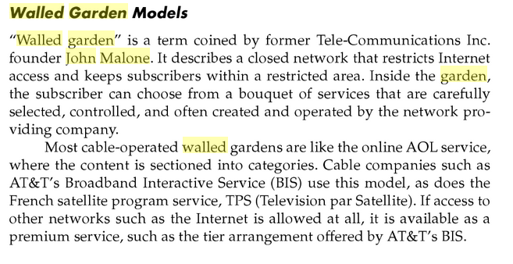

https://www.fastcompany.com/3015418/from-inside-walled-gardens-social-networks-are-suffocating-the-internet-as-we-know-it

“HootSuite CEO Ryan Holmes breaks down how social networks are killing the open web, and what it means for the future of connectivity and user experience”
“In the past few years, major social networks have grown increasingly restrictive with their APIs..”
“There’s no doubt that freewheeling hacker culture was and is behind many of the Internet’s innovations.”

https://blog.codinghorror.com/avoiding-walled-gardens-on-the-internet/

“no matter how wonderful your walled garden is, it can't compete with the public, open internet”

https://www.w3.org/2008/09/msnws/papers/The_Future_Of_Social_Networking.html
“restricting your ability to interact with outside sites”

https://www.w3.org/2007/Talks/1114-tbl/text.html

Escaping the Walled Garden: Growing the Mobile Web with Open Standards

http://www.forbes.com/sites/sachinkamdar/2015/10/18/3-things-about-walled-gardens-that-drive-digital-publishers-up-the-wall/#81618334cba0

https://cloud4wi.zendesk.com/hc/en-us/articles/200537836-Walled-Garden-for-the-Social-Login-web-sites-domains-to-open-

http://www.windley.com/archives/2004/10/walled_gardens.shtml

http://appcarousel.com/walled-gardens-back-fashion-right-reasons/

https://pando.com/2012/11/03/how-ecosystems-became-the-new-walled-gardens/

//güncel örnekler

//open internet tanım vs
https://www.fcc.gov/general/open-internet

