

DENEY RAPORU

|  |  |
| --- | --- |
| **Deney Adı** | Linear Power Supplies |
| **Deneyi Yaptıran Ar. Gör.** | Ayan Derya |
| **Raporu Hazırlayan**  **(İsim / Numara / Bölüm)** | Cem Yusuf Aydoğdu / 150120251 / BLGE |
| **Grup Numarası ve**  **Deney Tarihi** | D27 / 21.11.2014 |

|  |  |  |
| --- | --- | --- |
| **Rapor Notu** | **Teslim Edildiği Tarih** | **Teslim Alındığı Tarih** |
|  |  |  |

**Linear Power Supplies**

In this experiment basic operation principles of positive power supplies, negative power supplies and positive regulated power supplies are studied.

Power supplies are used to convert AC to DC in order to operate electronic circuits. Power supplies can be examined in two main categories: linear power supplies and switch mode power supplies. Linear power supplies are studied in this experiment.

**Positive Power Supplies**

For the experiment (1) and (2), positive rectifier circuit in Fig. 1.4 is constructed. In the first experiment, only half of the sinusoidal wave is obtained because of the switch. Peak voltage and current values for V0 and IRL are observed as 26 V and 142 mA correspondingly, after maintaining IRL(DC) to 50 mA. R2 resistor in our circuit is taken as 1.2 Ω, time period of the wave is 20 ms.

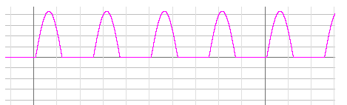

*Measured Values*

Voltmeter = 8.11 V Ampermeter = 50.2 mA

*Calculated Values*

Vo = 26 V / π = 8.2 V I = 142 mA / π = 45.2 mA

In the second part of experiment, rectifier turned to full-wave with switch. Values and graph are given below. Peak values are same.

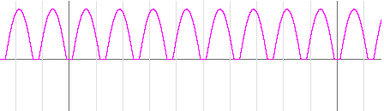

*Measured Values*

Voltmeter = 15.9 V Ampermeter = 98.4 mA

*Calculated Values*

Vo = 2*(26 V / π) = 16.4 V I = 2*(142 mA / π) = 45.2 mA

**Negative Power Supplies**

In the third experiment, negative rectifier circuit is built, IRL(DC) = -50 mA regulated while the switch is off. Same procedures in first experiment are applied. Negative peak values are detected as -26 V and -142 mA. Other results are revealed below.

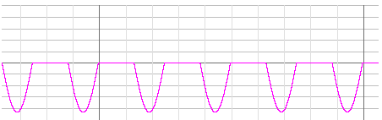

*Measured Values*

Voltmeter = -7.9 V Ampermeter = -49.4 mA

Forth experiment which gives negative full-rectified wave, is also similar to second experiment. Peak values are same as third experiment.

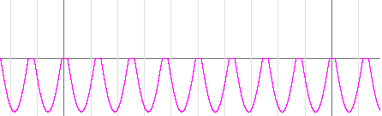

*Measured Values*

Voltmeter = -16.1 V Ampermeter = -99.3 mA

**Positive Regulated Power Supplies**

For fifth experiment, in addition to previous configurations; capacitor, zener diode and transistor are added to circuit in order to generate stabilized DC output. , IRL(DC) =100 mA adjusted, C=0 is selected, only the clipping effect of the zener diode is observed in Vo.

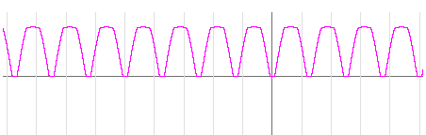

*Measured Values*

Voltmeter = 8.9 V Ampermeter = 99.8 mA

In sixth experiment, C is selected as 470 µF. Capacitor adjusts output as shown in the graph. Details for graph are given in the protocol paper.

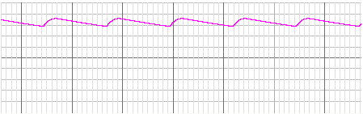

*Measured Values*

Voltmeter = 12.28 V Ampermeter = 130.37 mA

C = 4700 µF is selected for last experiment. Increasing capacitance results more regulated output which is more useful than previous one.

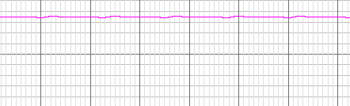

*Measured Values*

Voltmeter = 12.34 V Ampermeter = 128.5 mA