

DENEY RAPORU

|  |  |
| --- | --- |
| **Deney Adı** | BJT and MOS Amplifier Circuits |
| **Deneyi Yaptıran Ar. Gör.** | Alican Uysal |
| **Raporu Hazırlayan**  **(İsim / Numara / Bölüm)** | Cem Yusuf Aydoğdu / 150120251 / BLGE |
| **Grup Numarası ve**  **Deney Tarihi** | D27 / 26.09.2014 |

|  |  |  |
| --- | --- | --- |
| **Rapor Notu** | **Teslim Edildiği Tarih** | **Teslim Alındığı Tarih** |
|  | 08.10.2014 |  |

**BJT and MOS Amplifier Circuits**

**Introduction**

An amplifier is an electronic circuit, which has the capability to increase input voltage, current, or power to the output. There are several types of amplifiers. In this experiment, only BJT amplifier with common emitter configuration is used, with and without a coupling capacitor.

The difference between input and output is gain, which is represented by the ratio of output and input voltage/current/power values. Necessary formulas and figures for the experiment is given in the experiment sheets.

**Experiment**

Before the experiment, operating voltages are calculated for Figure 2.a, and equations are also written to the Protocol Sheet.

*DC Analysis*

For biasing circuit in Fig 2.a, VBE =0.6 V and β=290 are given

VTH = (33kΩ * 15V) / (220kΩ + 33kΩ) = 1.95 Thevenin Voltage for transistor base node

RTH = 220kΩ // 33kΩ = 28.7 kΩ Thevenin Resistance, same base node

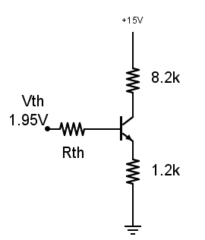

Applying Kirshoff from Thevenin voltage through transistor to the ground, and from VCC to ground, IC = 1.039mA IB = 1.039mA VC =6.8V

VB=1.85V VE=1.24 are calculated.

*AC Analysis*

With C3

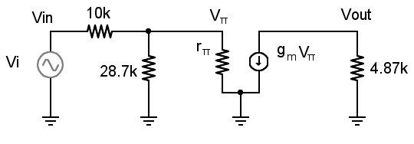

gm= Ic/Vt = 0.041 rπ= β/gm ≈ 7k Av=Vπ / Vin * Vout/Vπ

Vout / Vπ = -gm * 4.87k = 0.199 *103

Vπ / Vin = (28.7k // 7k) / ((28.7k // 7k) +10k) = 0.35

Av = 0.199 *103 * 0.35 = 69.65 calculated value

In the experiment, biasing circuit is constructed and the following values measured:

Vc=6.67V VB=1.87V VE=1.24V Ic=1.034mA

After that, function generator with 1 kHz sinusoidal signal is connected with other necessary connections, input and output waves are sketched on the protocol paper.

Av=60 with C 3 and Av=13.37 without C3 is measured. Phase shift is π and no clipping observed. Measured and calculated values are close. C3 caused significant gain difference, because RE is coupled.

|  |  |  |
| --- | --- | --- |
|  | Calculated | Measured |
| VC | 6.8V | 6.67V |
| VB | 1.85V | 1.87V |
| VE | 1.24V | 1.24V |
| IC | 1.039mA | 1.034mA |
| AV | 69.65 (with C3) | 60 (with C3)  13.37 (without C3 ) |