

DENEY RAPORU

|  |  |
| --- | --- |
| **Deney Adı** | Linear Applications of Operational Amplifiers |
| **Deneyi Yaptıran Ar. Gör.** | Serkan Yıldız |
| **Raporu Hazırlayan**  **(İsim / Numara / Bölüm)** | Cem Yusuf Aydoğdu / 150120251 / BLGE |
| **Grup Numarası ve**  **Deney Tarihi** | D27 / 10.10.2014 |

|  |  |  |
| --- | --- | --- |
| **Rapor Notu** | **Teslim Edildiği Tarih** | **Teslim Alındığı Tarih** |
|  |  |  |

**Linear Applications of Operational Amplifiers**

In this experiment basic operation principle and some mathematical functions of the operational amplifier, which is a very common electronic amplifier device, have been studied. Linear application denotes that the output of the operational amplifier bellows the saturation voltage.

**Exp 4.1**

Inverting configuration was constructed, +15V and -15V values were supplied to the op-amp, a sinusoidal wave was applied as input, and gain was calculated with this formula below.

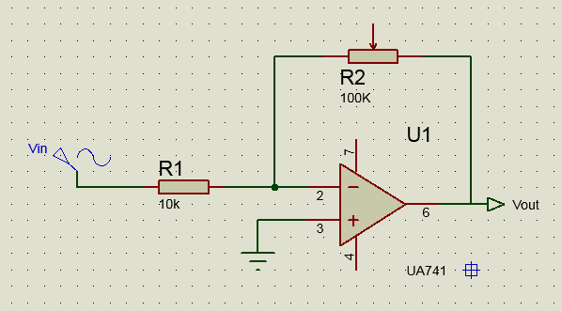

$$V_{out}=-V_{in}×\frac{R2}{R1}$$

$V_{in}=2V$ (peak to peak)

|  |  |  |
| --- | --- | --- |
|  | Vout | |
| R2 | Calculated | Measured |
| 100k | -20V | -17.7V |
| 75k | -15V | -13.3V |
| 25k | -5V | -4.66V |

(Values are peak to peak)

Plot for Exp 4.1

**Exp 4.2**

First experiment was repeated with non-inverting configuration as seen as the figure below. Same resistor and voltages were applied. Results were also written to the protocol sheet, except the Vout - R2plot.

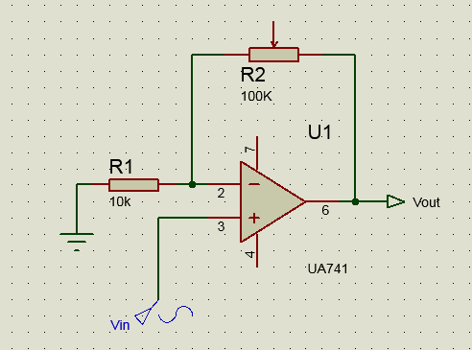

|  |  |  |
| --- | --- | --- |
|  | Vout | |
| R2 | Calculated | Measured |
| 100k | 22 V | 20.6 V |
| 75k | 17 V | 15.9 V |
| 25k | 7 V | 8.32 V |

Plot for Exp 4.2

**Exp 4.3**

Summing amplifier was set up. Resistors are selected for a=1, b=3 in the formula. 5V DC voltage was applied to V1 and a 6V sine wave was applied to the V2.

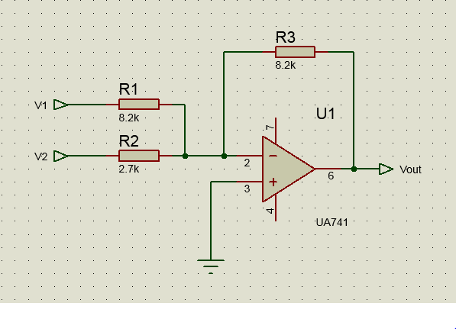



Plot for Exp 4.3

**Exp 4.4**

Integrator op-amp circuit was built, with given properties. Symmetric square wave is applied to the input and a triangular wave is observed, which is the integral of the input.

