**2 a)** Complex CMOS Desing

x1=1, x2=0, x3=1, x4=1

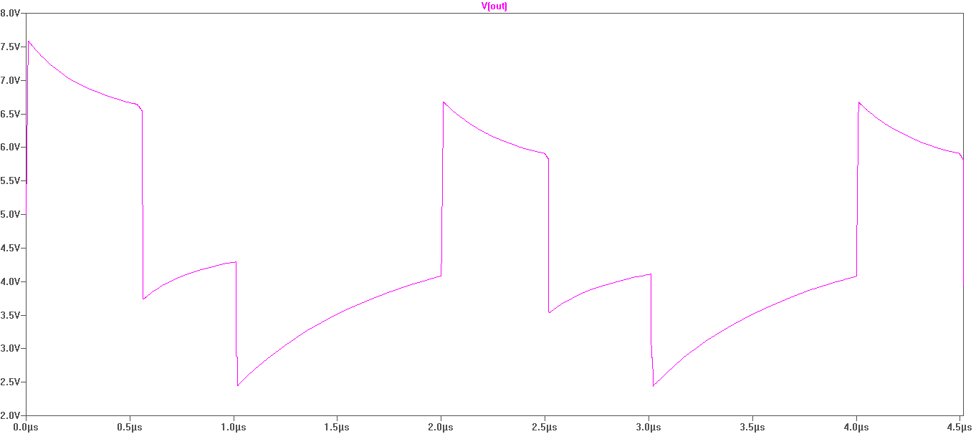

x1=0, x2=1, x3=0, x4=1