**CEN 4010 Principles of Software Engineering, Summer 2018**

**Milestone 1: Project Proposal and High-Level Description**

**1. Team Information:**

Name: Rice & Beans

Project Name: Circle

Team Number: 06

Members:

Chantel Ma (Team Lead) E-Mail: [cma2@fau.edu](mailto:cma2@fau.edu)

Sze-Lai Choi E-Mail: [schoi4@fau.edu](mailto:schoi4@fau.edu)

Cesar Jaimes E-Mail: [cjaimes2014@fau.edu](mailto:cjaimes2014@fau.edu)

Rong Zheng E-Mail: [rzheng@fau.edu](mailto:rzheng@fau.edu)

**2. Date:** June 18, 2018

**3. History Table**

|  |  |
| --- | --- |
| **DATE** | **ACTIVITIES (SUBMISSIONS/REVISIONS/INSTRUCTOR FEEDBACK)** |
| 06/18/2018 | MILESTONE 1: INITIAL PROPOSAL SUBMISSION |
|  |  |
|  |  |
|  |  |
|  |  |
|  |  |

1. **Executive Summary**

Circle is a social media platform with the ability to conveniently report issues, concerns, or highlight current events around campus. It is designed exclusively for students, faculty and staff members associated to the university campus that they represent. Users will have the ability to share a quick moment via a photo along with a description on what the photo pertains to. For example, Florida Atlantic University Boca Raton Campus was having construction down in their main breezeway causing an inconvenience on pedestrian traffic around campus. Circle would have informed students to plan their walk/travel time from one side of the campus to the other accordingly. Using a campus social media proprietary to the college campus would show how innovative the college/university is, which would entice more prospective students to attend the college/university.

Circle was developed to attract potential and current students and faculty members to easily take a photo and showcase campus life. It will help the university understand how to make their campus more secure, safe, fun, and convenient. It is meant to be easy to use by taking a quick photo and writing a short comment about the photo and posting it. Once submitted an administrator will go through the posts daily and submit a request on maintenance or check and address when certain maintenance or construction will be completed to the user.

**II. Competitive Analysis**

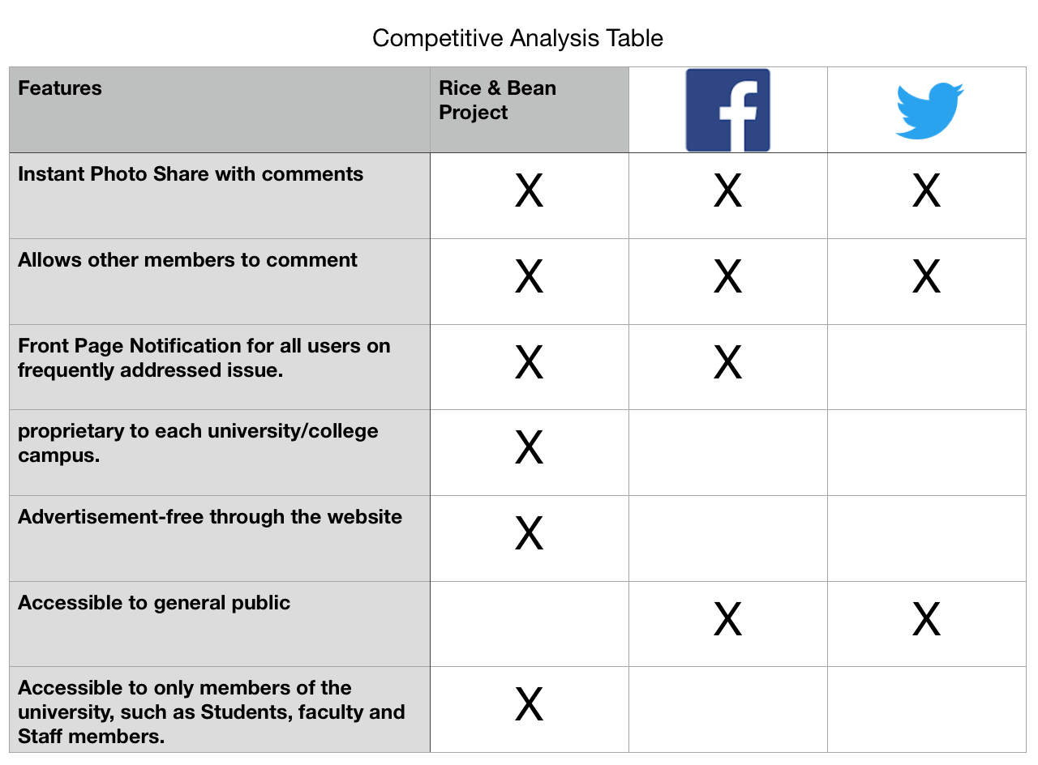

On October 2010, Kevin Systrom and Mike Krieger launched Instagram, a social networking app that allows users to share photos and videos with pre-approved followers. The service is intuitive and readily accessible to anyone who has registered. However, the user may get overwhelmed with ads and news from family and friends. Twitter, a similar social networking interface, is based on brief messages and search queries. Due to the information’s short length, messages transferred fast and large audiences are gathered for quick breaking news and opinions.

Circle focuses on campus news and activities for FAU students and faculties only. It provides a safe and secure social media environment, where non-school members will have no access to the on campus life and activities information. Circle will provide a front page with news notification for all users on campus. It will have planned features such as generate reports for different school-issues, help students find parking spots, provide major updates on campus constructions, etc. Faculties and students will have the opportunities to post campus life and events. A comment section will be provided for all major events to get feedbacks for future improvements.

**III. Data Definition**

**User:** Students and faculty members from the campus who signed up for the service.

**Admin:** School staff members with special privileges, such as updating school maintenance status, removing inappropriate comments and images.

**Subscription:** Users need to create an account to view/post comments and images

**Flag:** Reports of any inappropriate comments or images

**Report:** A general school maintenance list, such as broken faucet, road repair, toilet overflow, etc.

**Like:** increase positive/popularity ratings of comments and images

**Events:** information on fun activities and events happening around campus.

**IV. Overview, Scenarios and Use Cases**

**Overview:**

Circle, a social media platform with the ability to report issues, concerns, or highlight current events around campus with a quick photo, short caption and share. It is designed exclusively for students, faculty and staff members associated to the university campus that they represent. Users will have the ability to share a quick moment with a photo along with a description on what the photo pertains to. Administrators will review posts daily and submit a request on maintenance or check and address when a certain maintenance or construction will be completed to the users. Everyone will have the ability to view the high rated photos and comments on the main page as a notification.

**Scenarios:**

(As Student/Faculty User)

As a Student or Faculty member of the campus, if they were walking towards their next class and noticed one of the ceiling light fixtures were broken. The user can take a photo of the broken light fixture, select “report a problem”, and caption “wow this can be hazardous”. This will not only warn other people on campus to be cautious when approaching the affected area, but it will flag campus administrators or maintenance to fix the light fixture as soon as possible.

(As Administrator User)

An Administrator logs into the application and can instantly see any problematic issues posted by users on the application. Upon login to the application, the administrator has the ability to generate a report of all issues that has been posted. The administrator would see a post regarding a “broken light fixture”. The administrator can now report the problem to the maintenance staff to have it repaired. After notifying the maintenance staff, the admin can select “Update estimated time of repair” to update the repair time status to the picture. This would let the user who posted the picture know that the issue has been acknowledged and a fix is on the way.

**Use Cases:**

1. I as a generic user need subscription service to be able to log in to post photos and make comments.
2. I as a administrative user needs functionality of being able to update repair status or concerns.
3. I as admin user need functionality to be able to delete inappropriate comments or posts to maintain the integrity and image of the campus.
4. I as admin user need functionality to generate reports and give ETA on repairs and maintenance
5. I as the generic user need functionality of being able to report inappropriate posts or comments.
6. I as the generic user wants the functionality of being able to be notified about any highly commented posts on the front page.

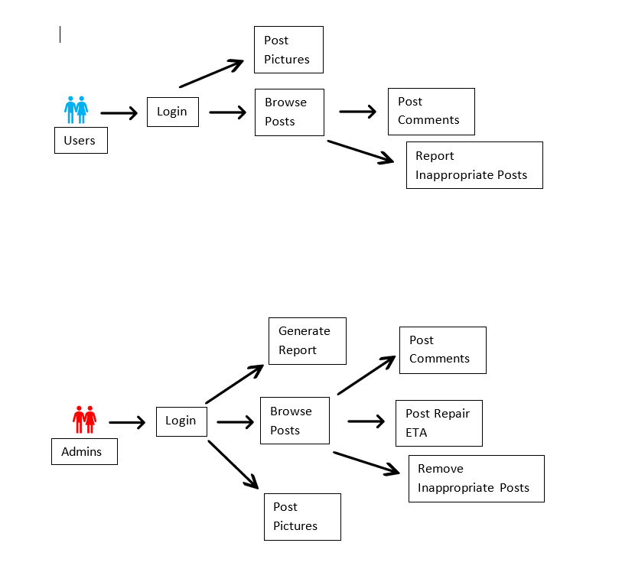

**V. Initial List of High-Level Functional Requirements**

1. Reporting of posts and comments.
2. Removal of posts and comments by admin.
3. Front page notification of high commented posts.
4. Estimated time and date of important maintenance repairs.
5. Ability to limit registration to only students, faculty, and staff members of the school.
6. Ability to automatically generate reports of posts

**VI. List of Non-Functional Requirements**

1. Mobile access to the application.
2. Expect high load levels during normal campus hours.
3. High storage levels for picture posts.
4. Application is only available to registered users.
5. User-friendly interface for posting and commenting.

**VII. High-Level System Architecture**

For database, HTML, PHP, MySQL, and Java Script will be used. The platform will be focus on web development. Bootstrap, a code library released under MIT license, will be used as a framework for the website. The webpage will work on Google Chrome, Firefox, Safari, Internet Explorer, Microsoft edge, and all mobile devices with web browser capabilities.

**VIII. Team**

Scrum Master : Sze-Lai Choi

Product Owner : Chantel Ma

UI Design : Cesar Jaimes

Database : Rong Zheng

**IX. Checklist**

|  |  |
| --- | --- |
| a) Team decided on basic means of communications | DONE |
| b) Team found a time slot to meet outside of the class | DONE |
| c) Front and back end team leads chosen | DONE |
| d) Github master chosen | DONE |
| e) Team ready and able to use the chosen back-end and front-end frameworks | ON TRACK |
| f) Skills of each team member defined and known to all | DONE |
| g) Team lead ensured that all team members read the final M1 and agree/understand it before submission | DONE |