**CEN 4010 Principles of Software Engineering, Summer 2018**

**Milestone 3: Project Proposal and High-Level Description**

**1. Team Information:**

**Name:** Rice & Beans

**Project Name:** Circle

**Team Number:** 06

**Members:**

Chantel Ma (Team Lead) E-Mail: [cma2@fau.edu](mailto:cma2@fau.edu)

Sze-Lai Choi E-Mail: [schoi4@fau.edu](mailto:schoi4@fau.edu)

Cesar Jaimes E-Mail: [cjaimes2014@fau.edu](mailto:cjaimes2014@fau.edu)

Rong Zheng E-Mail: [rzheng@fau.edu](mailto:rzheng@fau.edu)

**2. Date:** July 23, 2018

**(History Table in the next page)**

**3. History Table**

|  |  |
| --- | --- |
| **DATE** | **ACTIVITIES (SUBMISSIONS/REVISIONS/INSTRUCTOR FEEDBACK)** |
| 06/18/2018 | MILESTONE 1: INITIAL PROPOSAL SUBMISSION |
| 07/19/2018 | INSTRUCTOR FEEDBACK ON MILESTONE 1:  *A very well written project proposal, beautifully formatted, easy to follow and read. Nice Executive summary, comparative analysis is also very good. Like your data definition. Wonderful usage scenarios and use cases. Your diagrams are particularly wonderful.  *For non-functional requirements, you should like quality attributes, such as accessibility, usabilities, security etc. |
| 07/19/2018 | INSTRUCTOR FEEDBACK ON MILESTONE 2:  Love the name "circle". Although you have simple clean landing page, probably it would be better at your landing page add some description of what your website is about. Love your note description of what each nav bar means. Very thoughtful. Beautifully designed and layout webpage. Love it. Another great work of your group. Well done! |
| 07/23/2018 | REVISIONS FROM M1 SHOWN IN M3:  - Added a statement in Executive summary stating the availability of the application.  - Extra terms were added to data definition.  - Expanded on High-Level Functional Requirements and prioritized the requirements/specifications.  - Added security protocol for registration in the Non-Functional Requirements based on instructor’s feedback.  - Updated the High-level system architecture and database organization with a DB Schema and other listed requirements.  - High-level UML class diagrams and UML Component and deployment diagrams are added.  - Possible Risks are added |
| 07/23/2018 | REVISIONS ON MILESTONE 2:  - In Upload, “general” and “event” post has been merged.  - Main Homepage, breif intro of what “Cirlce” does.  - In admin options, deleting a post best on copyright violation.  - Welcome/Recent page displays a message to contact admin if an image is violating copyrights.  - In “Report a problem”, there is now a copyright infringement option. |
| 07/23/2018 | MILESTONE 3: PROTOTYPE SUBMISSION |

1. **Executive Summary**

Circle is a social media platform with the ability to conveniently report issues, concerns, or highlight current events around campus. It is designed exclusively for students, faculty and staff members associated to the university campus that they represent. Users will have the ability to share a quick moment via a photo along with a description on what the photo pertains to. For example, Florida Atlantic University Boca Raton Campus was having construction down in their main breezeway causing an inconvenience on pedestrian traffic around campus. Circle would have informed students to plan their walk/travel time from one side of the campus to the other accordingly. Using a campus social media proprietary to the college campus would show how innovative the college/university is, which would entice more prospective students to attend the college/university. Currently only available to Florida Atlantic University, in the future we want to expand to other university/college campuses.

Circle was developed to attract potential and current students and faculty members to easily take a photo and showcase campus life. It will help the university understand how to make their campus more secure, safe, fun, and convenient. It is meant to be easy to use by taking a quick photo and writing a short comment about the photo and posting it. Once submitted an administrator will go through the posts daily and submit a request on maintenance or check and address when certain maintenance or construction will be completed to the user.

**II. Competitive Analysis**

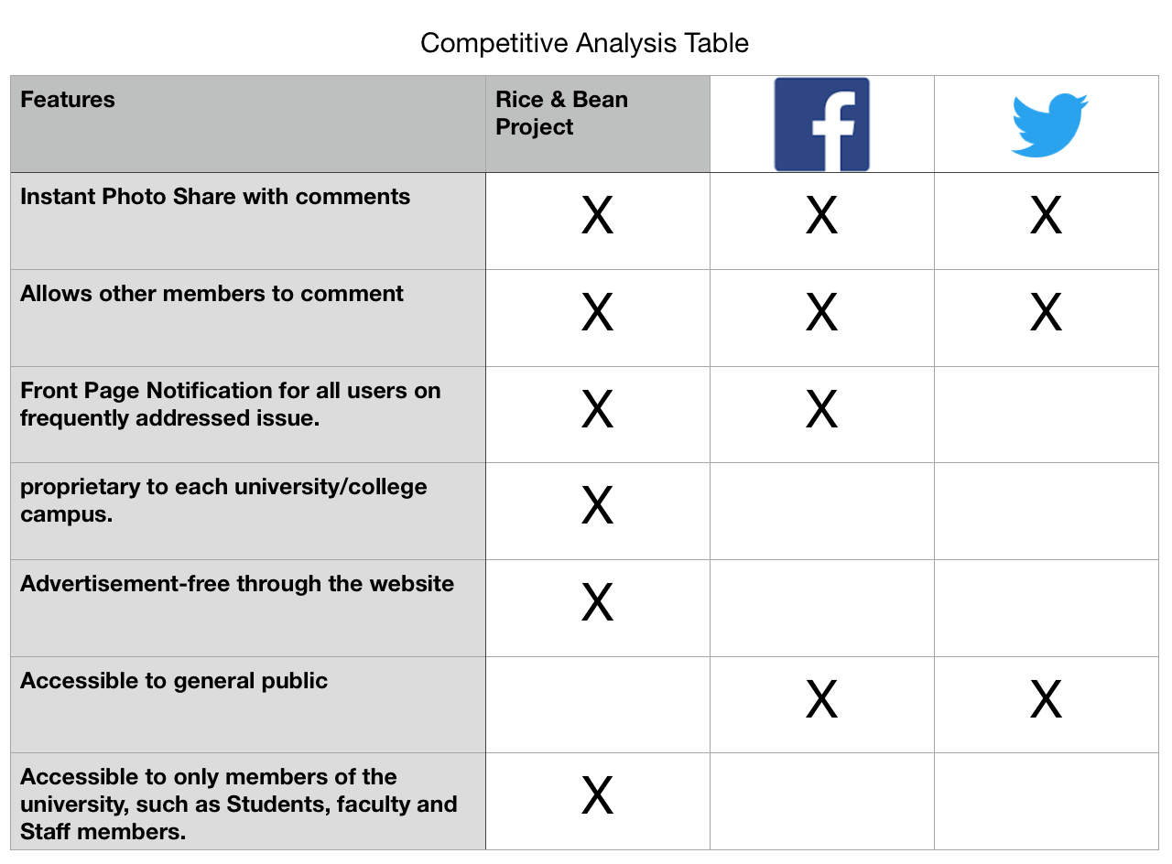

On October 2010, Kevin Systrom and Mike Krieger launched Instagram, a social networking app that allows users to share photos and videos with pre-approved followers. The service is intuitive and readily accessible to anyone who has registered. However, the user may get overwhelmed with ads and news from family and friends. Twitter, a similar social networking interface, is based on brief messages and search queries. Due to the information’s short length, messages transferred fast and large audiences are gathered for quick breaking news and opinions.

Circle focuses on campus news and activities for FAU students and faculties only. It provides a safe and secure social media environment, where non-school members will have no access to the on campus life and activities information. Circle will provide a front page with news notification for all users on campus. It will have planned features such as generate reports for different school-issues, help students find parking spots, provide major updates on campus constructions, etc. Faculties and students will have the opportunities to post campus life and events. A comment section will be provided for all major events to get feedbacks for future improvements.

**III. Data Definition**

**User:** Students and faculty members from the campus who signed up for the service.

**Admin:** School staff members with special privileges, such as updating school maintenance status, removing inappropriate comments and images.

**Register:** Users need to create an account to view/post comments and images

**Report Post:** Reports of any inappropriate comments or images

**Hazard Post:** A general school maintenance list, such as broken faucet, road repair, toilet overflow, etc.

**Spam Post:** Reports of any advertisement/soliciting posts

**Like/Upvote:** Increase positive/popularity ratings of comments and images

**General/Events Post:** Information on fun activities and events happening around campus.

**Announcements:** Administrator announcement directly from the university to notify all users of what changes and updates are happening around campus.

**Recent:** Displays most recently added posts

**Trending:** Displays most popular posts based on likes/upvotes

**E.T.A: “**Estimated Time of Arrival”; the approximate time of when “hazards” or maintenance is completed.

**IV. Overview, Scenarios and Use Cases**

**Overview:**

Circle, a social media platform with the ability to report issues, concerns, or highlight current events around campus with a quick photo, short caption and share. It is designed exclusively for students, faculty and staff members associated to the university campus that they represent. Users will have the ability to share a quick moment with a photo along with a description on what the photo pertains to. Administrators will review posts daily and submit a request on maintenance or check and address when certain maintenance or construction will be completed to the users. Everyone will have the ability to view the high rated photos and comments on the main page as a notification.

**Scenarios:**

(As Student/Faculty User)

As a Student or Faculty member of the campus, if they were walking towards their next class and noticed one of the ceiling light fixtures were broken. The user can take a photo of the broken light fixture, select “report a problem”, and caption “wow this can be hazardous”. This will not only warn other people on campus to be cautious when approaching the affected area, but it will flag campus administrators or maintenance to fix the light fixture as soon as possible.

(As Administrator User)

An Administrator logs into the application and can instantly see any problematic issues posted by users on the application. Upon login to the application, the administrator has the ability to generate a report of all issues that has been posted. The administrator would see a post regarding a “broken light fixture”. The administrator can now report the problem to the maintenance staff to have it repaired. After notifying the maintenance staff, the admin can select “Update estimated time of repair” to update the repair time status to the picture. This would let the user who posted the picture know that the issue has been acknowledged and a fix is on the way.

**Use Cases:**

1. I as a generic user need subscription service to be able to log in to post photos and make comments.
2. I as a administrative user needs functionality of being able to update repair status or concerns.
3. I as admin user need functionality to be able to delete inappropriate comments or posts to maintain the integrity and image of the campus.
4. I as admin user need functionality to generate reports and give ETA on repairs and maintenance
5. I as the generic user need functionality of being able to report inappropriate posts or comments.
6. I as the generic user wants the functionality of being able to be notified about any highly commented posts on the front page.

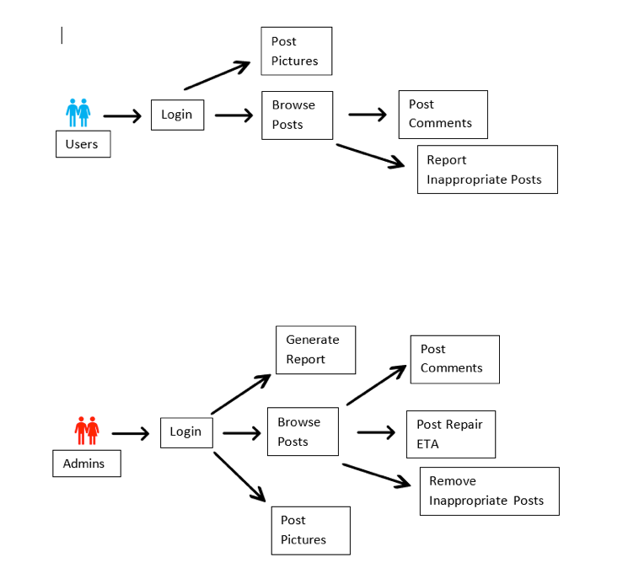

**V. High-Level Functional Requirements**

|  |  |  |
| --- | --- | --- |
| **#** | **Functional Requirements** | **Priority** (1 = Must Have, 2 = Desired, 3 = Opportunistic) |
| **1** | Reporting of posts and comments. | **1** |
| **2** | Removal of posts and comments by admin. | **1** |
| **3** | Front-page notification of high commented posts or Hazards reported.   |  |  |  | | --- | --- | --- | | 3.1 | Pop-up announcement addressing most frequently posted hazards. | 2 | | **2** |
| **4** | Estimated time and date of important maintenance repairs replies. | **3** |
| **5** | Ability to limit registration to only students, faculty, and staff members of the school.   |  |  |  | | --- | --- | --- | | 5.1 | When entering their email, the only email they can put in is @fau.edu, which is automatically programmed into the registration page. | 2 | | **1** |
| **6** | Ability to automatically generate reports of posts. (P1)   |  |  |  | | --- | --- | --- | | 6.1 | Most reported and hazardous / maintenance posts are all sectioned to its own pages. | 2 | | 6.2 | Posts are listed and admin will just click on the link of the post and will be rerouted to the post. | 2 | | 1 |
| **7** | Upload posts and comments.   |  |  |  | | --- | --- | --- | | 7.1 | Users will only get to upload images and captions as a post or comment on their own or other posts made by different users. | 1 | | 7.2 | Admin users will also have the same options as general users, and have an additional “Admin Options” tab to delete, comment, or send a notification to the general user of the post. | 2 | | 1 |

**VI. List of Non-Functional Requirements**

1. Mobile access to the application.
2. Expect high load levels during normal campus hours.
3. High storage levels for picture posts.
4. Application is only available to registered users.
5. User-friendly interface for posting and commenting.
6. High storage levels for comments.
7. Security feature that limits registration and platform usage to only students, teachers, and faculty staff members associated to the University.
8. Strict Upload feature that only allow users to load only images and captions, in order to prevent malicious use of the function.

**VII. High-Level System Architecture & Database Organization**

1. For database, HTML, PHP, MySQL, JQuery AJAX and Java Script will be used. The platform will be focus on web development. Bootstrap, a code library released under MIT license, will be used as a framework for the website. The webpage will work on Google Chrome, Firefox, Safari, Internet Explorer, Microsoft edge, and all mobile devices with web browser capabilities.
2. Main Database ERD Schema below describes how our tables are being built in our LAMP server for each component in the “Circle” platform.

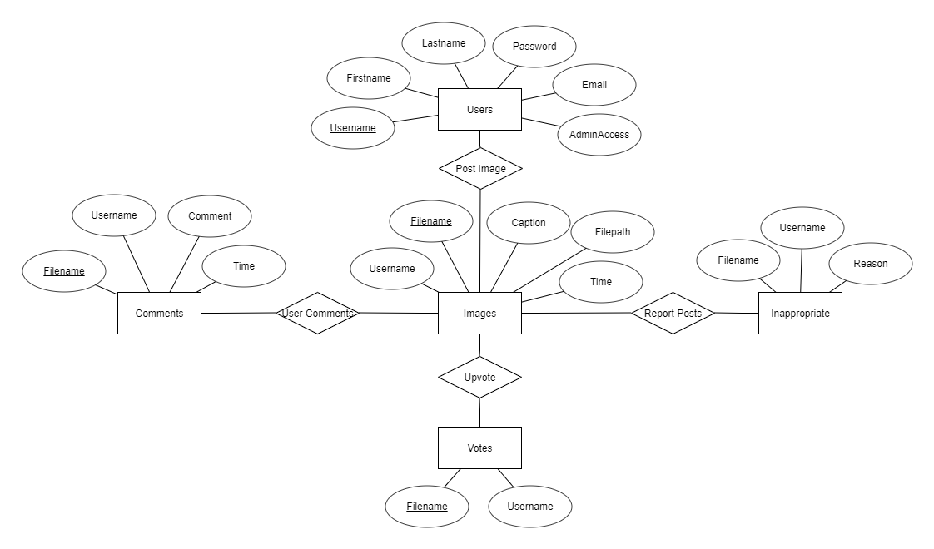

1. All the images and comments posted by users are going to be kept in a file system on the LAMP server. Currently our platform is not utilizing any options with posting audio, video, or gps tracking system.
2. All comments posted will be kept in the same database table, but will be filtered based on the image filename. For our main “welcome” and “recent” page, all posts with images and captions will be kept in the same database table. The “Welcome”/”Recent” page will be coded to show 10 most recently uploaded, which is based on the time and date of when the post is uploaded. “Trending” will also be grabbing from the same database as “Welcome”/”Recent”. In addition, “Trending” will also be looking into another database table for how many “likes”/”upvotes” a post gets from other users. The algorithm we will use for trending will sort the most popular posts based on the filename and the number of “likes” it receives. Administrative reports will be in its own database table. The reports will be displayed according to its priority, which is based on how many times the same post/comment was reported by other users.
3. Currently Circle is not using any APIs to interact with anything else other than what is already in our own database.
4. “Likes” are currently being generated on a table based on filename and the user who liked it. The information is then processed by filtering out the number of results from searching for the filename. “Inappropriate Reports” are generated on its own table based on the filename, user who reported the post, the reason, and the number of times it has been reported by other users. The information is then processed by sorting out the number results from searching for the filename and the number of times it has been reported. “Recent” posts are sorted based on the timestamp that was recorded on the table for the images.

**VIII. High-Level UML Diagrams**

1. Below are two UML class diagrams to showcase how we are implementing the core functionality of our social platform.

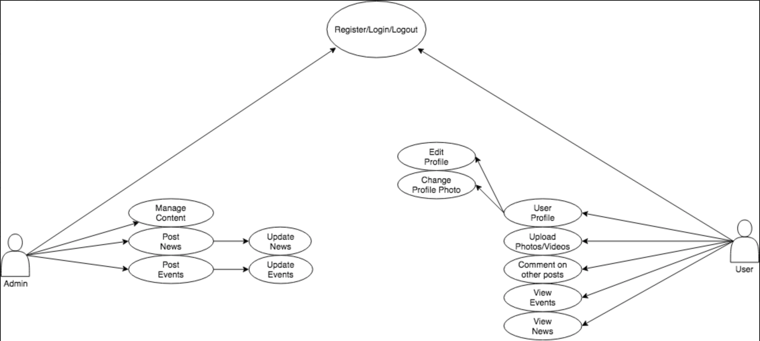

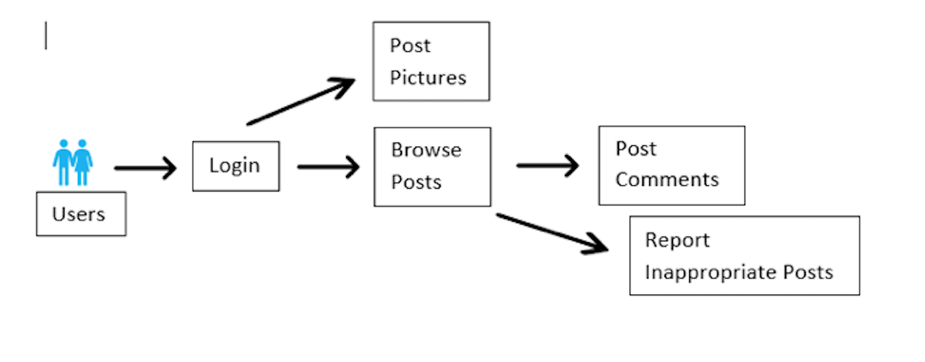

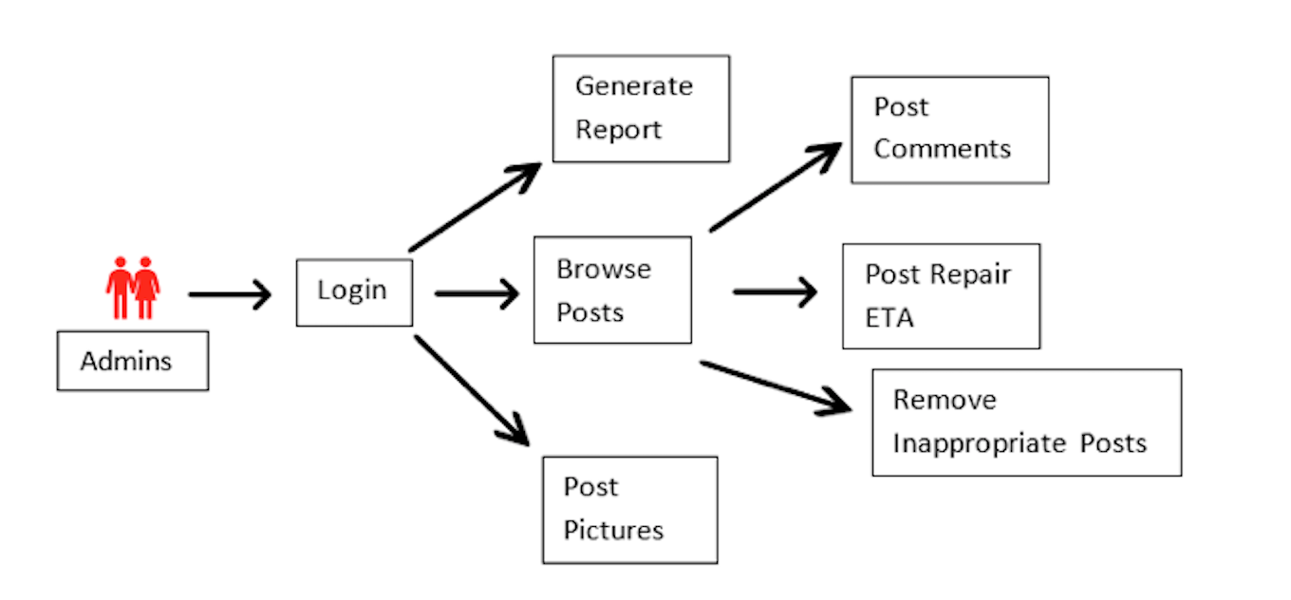

1. Component and Deployment UML Diagram

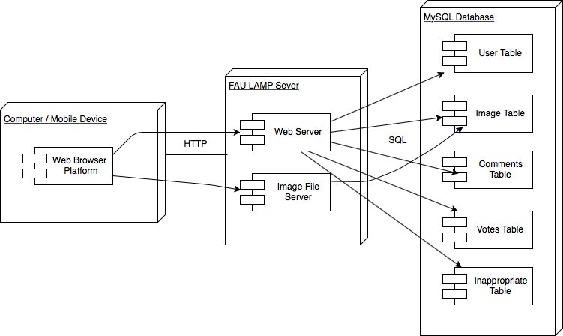

**IX. Identify Actual Key Risks**

1. **Skill Risks:** This is our first time working on a project involving PHP, CSS, Java Script, MySQL, JQuery, and AJAX. We are learning these scripting languages and interfaces as we go. Assignments were given to each team members based on their proficiency. Whenever there are complications with any sections for any member of the team, we conference call or group message each other to overcome those obstacles together.
2. **Schedule Risk:** Due to everyone having different work schedules and physical location, we have very limited time to work as a group. Most of the works are done based on our individual availability. This becomes difficult when we are trying to merge our code together. Our temporary solution is utilizing group messages and conference calls to work on our project together.
3. **Technical Risk:** Due to the nature of us uploading files to a file system instead of a database, it could expose us to hackers where the images/files are kept. Also, when registering a new user, there is no student/faculty member verification in place. Anyone can create an account and join in on the platform. We plan on whitelisting certain file types to be uploaded. For example, only allowing users to upload JPG and PNG files. We are exploring the possibility of using an antivirus scan when images are being uploaded. In terms, of user member verification, we are looking at the option of email verification through the university or .edu email provided by the new user.
4. **Teamwork Risk:** Since we are working individually and then compiling the code together, we have to be consistent in how we name variables and functions in our code. Comments should be added to everything within the code in order for someone else other than the original author of the work can make changes.
5. **Legal/Content Risk:** We do not expect to have any legal/content risk from the design portion. We might need to find out if there will be any legal risks of images posted by the users due to copyright or privacy reasons. To avoid the risk of copyright infringement, we will have a statement on the main homepage for anyone to contact the admin user directly. Once they are contacted that there are images that violates any copyrights, the admin user will take down the image.