CEN 4010 Principles of Software Engineering Spring 2021

Milestone 3: Team Project Proposal and Description

Group 11: DIVOC Forum

Zachary Goldstein, Alena Krause, Carlos Salazar,

Shannon Soulard, Brandon Que

6 April 2021

Version History:

|  |  |  |
| --- | --- | --- |
| 1.01 | Document Template | 11 February 2021 |
| 1.02 | Initial Draft | 15 February 2021 |
| 1.03 | Final Draft | 16 February 2021 |
| 1.04 | Milestone 3 Adjustments | 6 April 2021 |

# Executive Summary

The COVID-19 Forum, “DIVOC” is a software project in development by CEN4010 Group 11. DIVOC will be used to associate people whose lives have been affected by the world’s current pandemic.

DIVOC will be accessible via web browser and will allow users to view posts created by others. Users can create accounts to interact with other people within the forum. Features such as creating, liking, and commenting on posts will be made available to further enhance the engagement amongst the users. DIVOC will be organized by topics such as “news” and “emotional support” in order to let users navigate to content they wish to see in a seamless manner. Those with an account can choose to “follow” topics of their choice so one may tailor their feed to their liking. Additionally, DIVOC will be optimized for viewing on mobile devices, ensuring that anyone can access anything within the forum with ease no matter where they are - be it news, emotional support, etc.

The goal of DIVOC is to connect users through shared experiences and feelings that have been caused by the Corona virus pandemic. This global catastrophe has drastically changed the lives of everyone in the entire world. Group 11 hopes that DIVOC will encourage people to join and share information about the ongoing epidemic; whether it be scientific data or emotional support resources, DIVOC will be a place to bring a sense of normalcy upon users during such an abnormal time.

People who choose not to create an account will still be able to navigate through the site, but with some limitations on the features they may interact with. Features such as creating, commenting on, or liking posts will only be available to those with an account - along with the ability to follow topics. Therefore, in order to experience everything that DIVOC has to offer, Group 11 recommends creating an account. We in Group 11 believe such valuable information should be available to everyone, thus we have made posts available for viewing by anyone at any time.

Users who are registering for an account will input information such as their name, email address, and desired password. Group 11 is dedicated to protecting the information of all users and will put in place top-tier security measures to ensure that data is encrypted and secure.

Group 11 understands that connecting during these times of social distancing can feel impossible. We hope that DIVOC will bring people together by offering a supportive community that encourages educational and positive discussion regarding an objectively negative situation.

# Competitive analysis

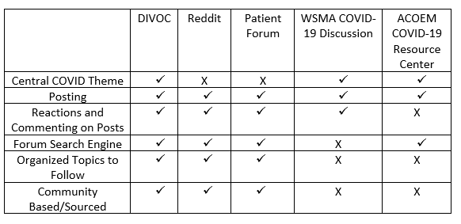

DIVOC will have a search engine that easily filters through posts via keywords, tagged posts will take priority over untagged posts. From there we will implement a feature for authorized users to customize their feed by choosing topics to follow. When posting to DIVOC, the authorized user will be prompted to enter a required title and an optional body of text to include as part of their post. After that, the authorized user will also be able to select some of the tags to have their post be found within the given topics. As far as interacting and building a community out of DIVOC, the authorized users will be able to comment on posts as well as give reactions through likes and dislikes.

Unlike our competitors, DIVOC will combine elements of social media platforms as well as elements from resource forums to form an educational and community-based site all in one. The WSMA and ACOEM discussion boards are not accessible to the public and focus primarily on information sharing between physicians and medical practitioners. DIVOC will keep information easily accessible to all authorized and unauthorized users. While Reddit has a plethora of content related to anything and it is tiresome to find correct information, DIVOC will have certified Administration/Doctors give COVID information to keep users educated and informed.

# Data definition

|  |  |  |
| --- | --- | --- |
| **User Account** | | |
| *Attribute* | *Description* | *Type* |
| username | A user’s display name on the website displayed for both unauthorized and authorized users | Text |
| password | A user’s hashed password to log in to the website | Text |
| first_name | A user’s first name that is displayed for both authorized and unauthorized users | Text |
| last_name | A user’s last name that is displayed for authorized users only | Text |
| email | A user’s email that is used for account creation and log in that is displayed for an authorized user viewing their personal account | Text |
| Telephone_number | A user’s telephone number that is displayed only on a user’s personal account | Text |
| social_links | A user’s list of social links if they choose to provide them that is displayed for authorized users only | Text |
| total_post | Number of posts created by a user that is displayed for both unauthorized and authorized users | Integer |
| thread_count | Number of threads a user is following that is displayed only to authorized users | Integer |
| Followed_threads | A list of followed topics displayed for authorized users only | Text |
| status | Indicates if a user has the status of administrator that is displayed for authorized users only | Boolean |
| **Threads** | | |
| recently_updated | The date for the most recent post made on a topic | Timestamp |
| subject | The subject (title) of a thread | Text |
| followers | Total number of accounts that follow a specific topic | Integer |
| **Posts** | | |
| Created | The date for when a post was first created | Timestamp |
| Text_body | The body of text for the main portion of a post | Text |
| likes | Number of positive reactions on a post | Integer |
| dislikes | Number of negative reactions on a post | Integer |
| tags | List of central topics to help categorize posts (i.e. emotional support, news, etc) | Text |
| comments | Number of comments on a post | Integer |

# Overview, scenarios and use cases

Accessible to anyone who has a personal computer or a smartphone, DIVOC is a platform created to help people from all over the world to connect with each other during this difficult time. It is a place for users to create, share, and discuss their personal experiences related to COVID, while managing to stay in the loop regarding official news about the CoronaVirus. DIVOC attracts a wide set of audience and can easily become the preferred platform to exchange/gain knowledge about the COVID-19 virus.

Users are able to create flexible posts/replies. Therefore, the site administrators have full site privileges in order to make sure that the terms and guidelines are being followed. Site administrators will be able to remove any discussion, thread, and/or reply they see unfit for the site. DIVOC visitors who do not have an account will be able to view the forum but are limited in terms of engagement. These individuals may not like, create, or comment on posts and additionally will not be able to follow topics to customize their feed. Users with an account will have access to all the aforementioned features and additionally will have their own profile page.

When creating a post, users will be able to choose which topic they wish to contribute to. Users will be prompted to add a post title and body of text. Additionally, any attempted contributions to information based topics, such as news, will have a dedicated field for placing sources. This ensures that credible and non-credible information are easily distinguishable.

DIVOC can be used to share information such as tips for soothing one’s anxiety levels, finding new ways to keep safe, and expanding one’s general knowledge about the virus.

Thus, DIVOC can be an excellent research tool where users can easily kindle new ideas/opinions about the virus. No matter if a user is simply an observer or someone who participates regularly in discussions, everyone will be allowed to observe the same amount of information.

# Initial list of high-level functional requirements

FR01 – An unauthorized user will be able to create a unique account.

FR01.1 – An authorized user will have a unique username.

FR01.2 – An authorized user will have a unique profile picture.

FR01.3 – An authorized user will be able to comment on posts, create posts, and like posts.

FR02 – An unauthorized user will not be able to create posts.

FR02.1 – An authorized user will be able to create a post that contributes to a defined set of threads.

FR02.2 – An authorized user will be prompted to give the created post a title and a body of text.

FR02.3 – An authorized user will be prompted to give the post an optional amount of predefined tags based on topics, to enable people to easily find the given post.

FR02.4 – An authorized user will be able to add an image instead of a body of text.

FR03 – An unauthorized user will not be able to interact with posts, only view them.

FR03.1 – An authorized user will be able to react to posts with a “like” or “dislike.”

FR03.2 – An authorized user will be able to comment on other posts.

FR04 – An unauthorized user will not be able to “follow” specific topics.

FR04.1 – An authorized user will be able to customize what they see by “following” any desired topic.

FR05 – An unauthorized user will be able to search through forum posts using keywords.

FR05.1 – An authorized user will be able to search through forum posts using keywords.

FR05.2 – The system will search for the keywords in the tagged section of a post first.

FR05.3 – The system will then find results of the keywords as part of the text body after.

FR06 – An unauthorized user will be able to view the profiles of other users.

FR06.1 – An authorized user will be able to view the profiles of other users.

FR06.2 – The system will display the username, first name, posts created by that user, and the number of posts created when viewing another user’s profile whether the viewing user is authorized or not.

FR06.3 – The system will display your username, first and last name, location, email you signed up with, a bio, a list of topics you follow, posts you’ve created, number of posts you’ve created, other social media links or telephone number if you include it, admin status, as well as an edit profile button under your own profile tab.

FR07 – The system will organize the posts in chronological order, with most recent at the top for both authorized and unauthorized users.

FR07.1 – The system will organize different topics in chronological order, with most recent at the top for both authorized and unauthorized users.

FR07.2 – The system will display suggested topics to follow to authorized users on the home page.

FR08 – The system will display COVID-19 data from a COVID-19 Data API for both authorized and unauthorized users.

FR Priority:

1 (must have) – FR01, FR01.1, FR01.3, FR02, FR02.1, FR02.2, FR03, FR03.1, FR03.2, FR05, FR05.1, FR06, FR06.1, FR06.2

2 (desired) – FR01.2, FR02.3, FR02.4, FR04, FR04.1, FR05.2, FR5.3, FR07, FR07.1

3 (opportunistic) – FR06.3, FR07.2, FR08

# List of non-functional requirements

1. Security
   1. Captcha verification for login
   2. Password hashing to ensure data security for users.
2. Portability
   1. Website optimization for access on a personal computer or mobile device.
   2. Compatible with all modern browsers including Firefox, Safari, Chrome, and Edge.
3. Expected Load
   1. Limit the number of requests made by a single user to avoid server crashes due to high traffic
   2. Users can only make up to 500 requests per minute.
4. Usability
   1. Information is available to any site visitor.
   2. Features such as commenting on, liking, and creating posts are limited to only those who possess an account.
5. Storage
   1. Data retained will be restricted to the capabilities of the Firebase Firestore Database.
   2. Any images exceeding 5MB will be compressed to optimize storage.
   3. Posts will have a 2,000 character limit.
6. Accessibility
   1. Site is easy to use and intuitive for users of any age.
   2. Aesthetically pleasing and organized UI.
   3. Site will not require any specialized training for use.

# High-level system architecture and database organization

Software/Tools:

* Firebase Firestore Database will be used as the primary database for the software.
* npm: package management system
* Brackets/Visual Studio Code: Code editor used for HTML, CSS, JavaScript, etc.
* GitHub: Version control software used for source code management.

Programming Languages:

* HTML: Programming language will be used for website appearance and design.
* CSS: Programming language will be used for overall presentation of the website.
* Javascript: Scripting language will be used for programming site functionality.

Frameworks:

* Bootstrap - Responsive CSS framework used for website presentation.
  + Discussion page template: <https://www.bootdey.com/snippets/view/bs4-forum>
  + User profile page template: <https://www.bootdey.com/snippets/view/User-profile-with-friends-and-chat>
  + Forum homepage template: <https://www.bootdey.com/snippets/view/Forum-post-list>

DB organization:

* Database will consist of a collection for each user and collections for each of the multiple topics.
* Within a user collection will be documents of all said user’s posts. Additionally, this collection will store the profile information for the user.
* Within the topic collection will be documents of all the posts within the topic, along with a document on the number of posts in the topic. Within the post documents will be a field of the post ID and a field of the post title and post text.
* Searching will be conducted by looking for matching documents within a collection based on a given user input.
* User profile pictures will be stored on the database using Firebase Cloud Storage in a given user’s collection.

APIs:

* COVID-19 Data API: Used for reporting data on the COVID-19 virus. (<https://covidtracking.com/data/api>)

# High-level UML diagrams

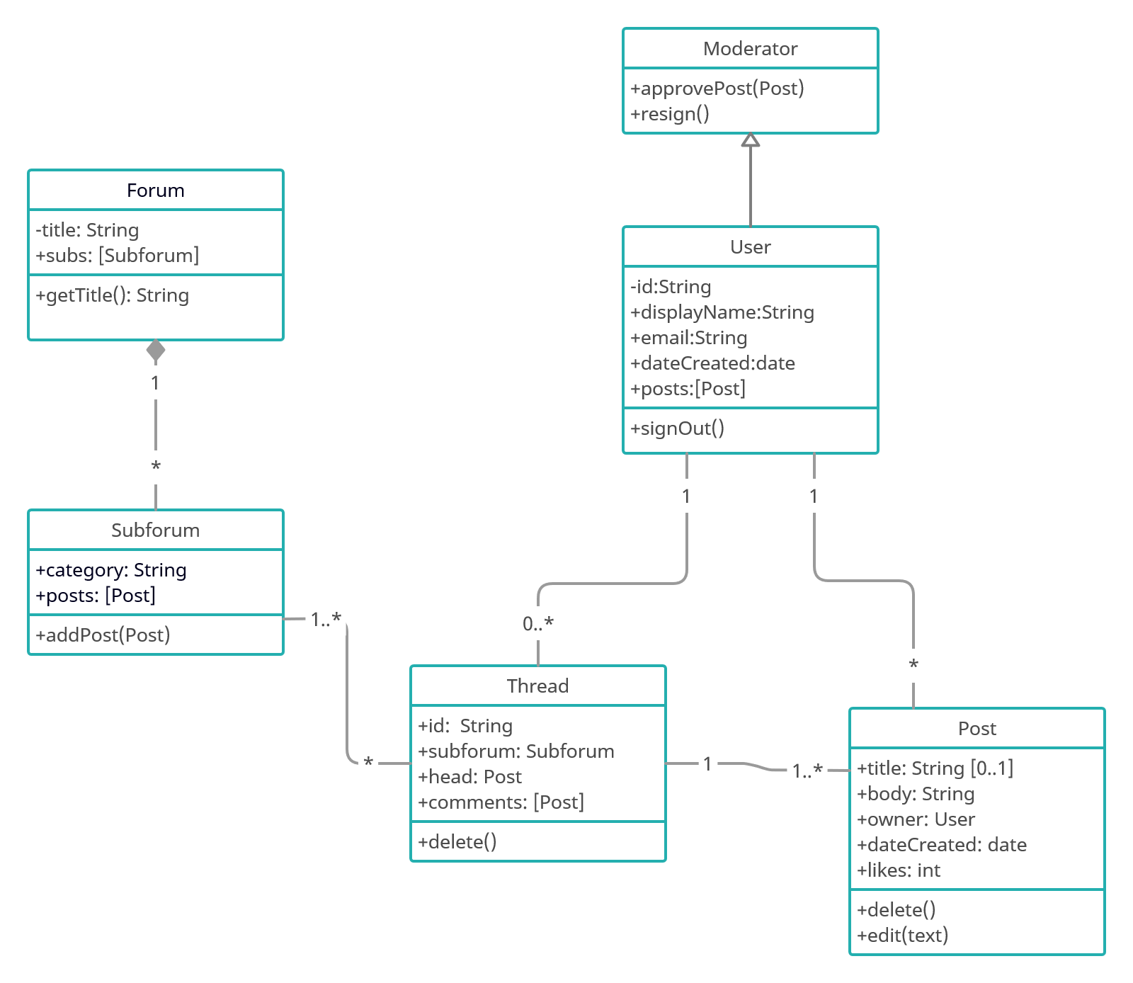

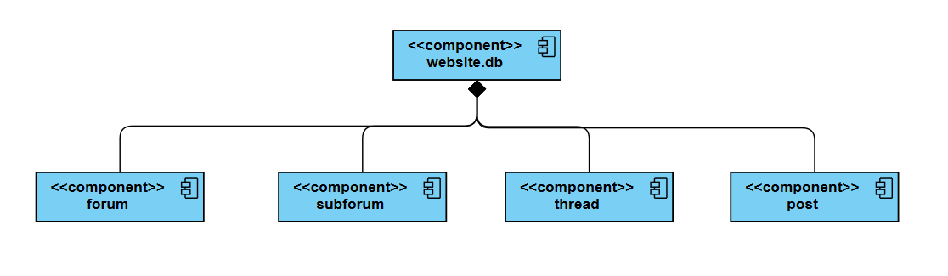

# 

# 

# Identify actual key risks for your project at this time

1. **Skill risks –** The back-end developers have prior experience with Firebase and PHP. We will have to take time however to research on how to integrate Firebase into a website. The front-end developers have taken courses in web design and so already have the required skills for developing the front-end of the website.

2. **Schedule risks –** Since the start of the development cycle we had to strip down planned features to make sure we can meet the scheduled release. As of now we are on track to release on time.

3. **Technical risks –** We can only make an approximate estimation for how much storage will be required to store every post. Throughout the development cycle we will have to monitor the storage requirement of the website as we open it up for beta testing. Another risk we must monitor is bandwidth. If a lot of users are connected to the website at once it will drive up the bandwidth of the website and could cause it to crash.

4. **Teamwork risks** - Team members naturally have different schedules/agendas, therefore not everyone in the team will be available to participate in meetings and discussions 100% of the time. With that said, communication can be hindered because participation is a key factor when it comes to teamwork. All team members are encouraged to free a specific time of the week in order to update one another about the progress of development. Additionally, due to the pandemic, team members are not able to meet face to face so they are forced to participate in voice chats or zoom meetings only.

5. **Legal/content risks** - Some of the legal risks involved in our website involve, Data Protection Legislation, Licensing for API’s, Defamation, and Copyright. We ask for personal information on our website such as first name and last name and we plan to have some other social media links as well as telephone numbers so that could be a civil claim. We will have at least one API supplying us COVID-19 information, we could run into complications for licensing the API. On our website we allow authorized users to edit the information on our website so that can cause defamation. The last legal risk we could run into is copyright, we are considering allowing authorized users to upload their own picture but using google to log in they could have a copyrighted photo already.

# Team

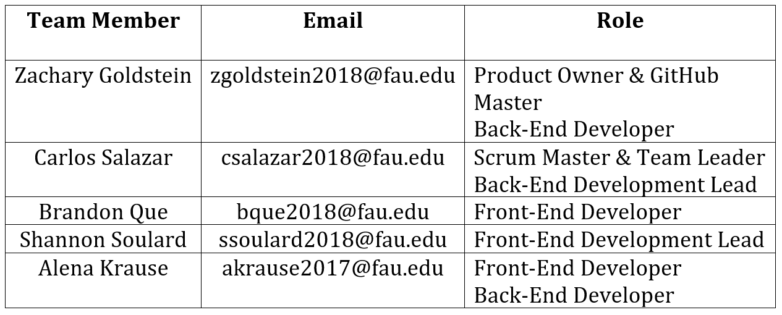

# 

# Vertical Software Prototype

A demo version of a sample topic page can be found at the link below. Users are able to sign in with an existing google account or by creating a username and password. Login functionality is enabled through firebase. Upon logging in, visitors can view the posts that have been contributed to the “Mental Health” topic. Additionally, posts can be created by users and added to the forum. All of the posts are saved to the user’s collection as well as the topic’s collection.

YouTube Demo: <https://www.youtube.com/watch?v=f8CYV4wNzQo&t=5s>

<https://lamp.eng.fau.edu/~cen4010_s21_g11/forum-topic-prototype/www/login.html>

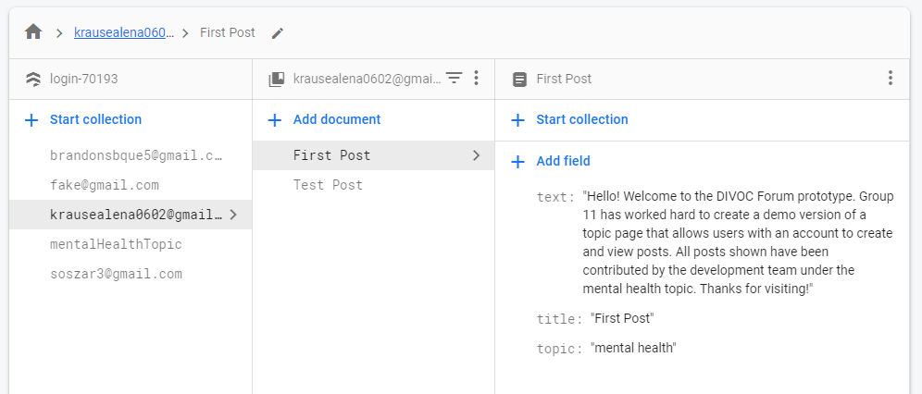

Sample user collection with saved posts in firebase

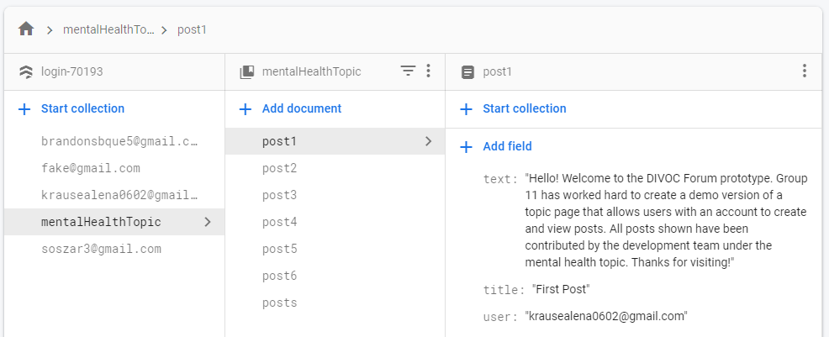

Sample topic collection with saved posts in firebase

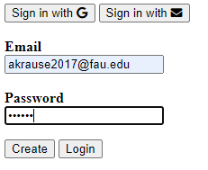

Login page for prototype

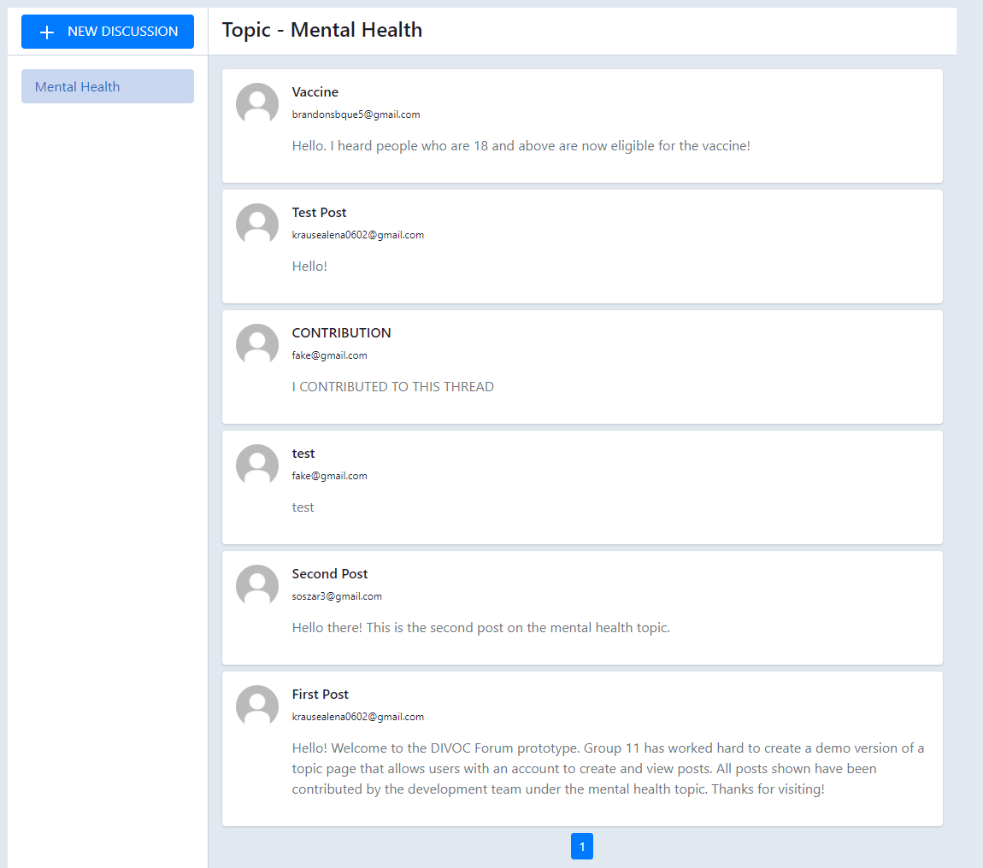

Sample topic page of prototype